Assumptions made:
- The input for ApprovalRequest is entered on command prompt in format - "Client Security Quantity"
- The Requests are processed and reply is sent (in the code the reply is printed only).
- Business logic to calculate approved volume is based on limit volume that is maintained in a cache (in ApprovalLimitCache). If requested volume < available_limit_volume in cache, then approved volume = requested volume. Otherwise approved volume = available_limit_volume
- Validation rules for Approval request : -
- Request cannot be null
- None of the fields in the request are empty (client, security, quantity)
- Quantity with 0 value is not valid

Enhancements can be made:
1. Define a protocol for communication between clients (who will send the requests) and server ( to receive and send back the reply). In this case the ApprovalServiceBootstap code will change and won't have to listen to inputs over command prompt. Also ApprovalResponseServiceImpl code will send the reply back to client using the protocol.
2. Business logic may vary to calculate the approved volume depending on requirements gathered from business stakeholders.
3. Logging can be done using third party libraries. In which case the System.out.println will be removed from the current project
4. More validation logic can be added depending on business requirement

Description of design and implementation:
- ApprovalServiceBootstrap is the main entry point to bootstrap the application
- ApprovalLimitCache is initialized with some data which is stores it in Concurrent cache.
- ApprovalServiceBootstrap calls ApprovalServiceController.init() - which initialize the beans used by ApprovalServiceController - ApprovalSource, ApprovalService, ApprovalDecisionService
- Validations on input are done in ValidationRules class
- Blocking queue is initialized in ApprovalServiceController. Also a fixedThreadpool is instantiated in ApprovalServiceController.
- ApprovalServiceController.processRequest() - this method calls the validationRules on given inputs. If validations pass then it submits the request to a Blocking queue.
- The same blocking queue is injected to ApprovalSource which gets the next approval request from the queue
- The ApprovalProcessor is a Runnable task which is submitted to threadpool in ApprovalServiceController.processRequest once the validations pass.
- ApprovalProcessor consumes the Approval request from blocking queue and further processes it by calling ApprovalDecisionService.processRequest. The business logic her e is based on availability of limit quantity for a given Client+Security in ApprovalLimitCache, the quantity is approved for the received ApprovalRequest. This method returns the ApprovalResponse which then directs to ApprovalResponseService.sendResponse.

Class diagram:
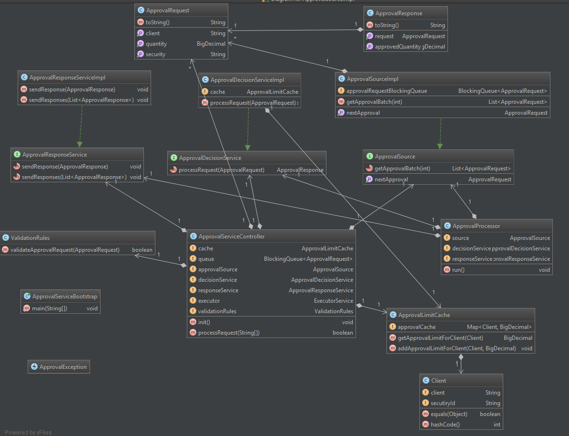

Code test coverage :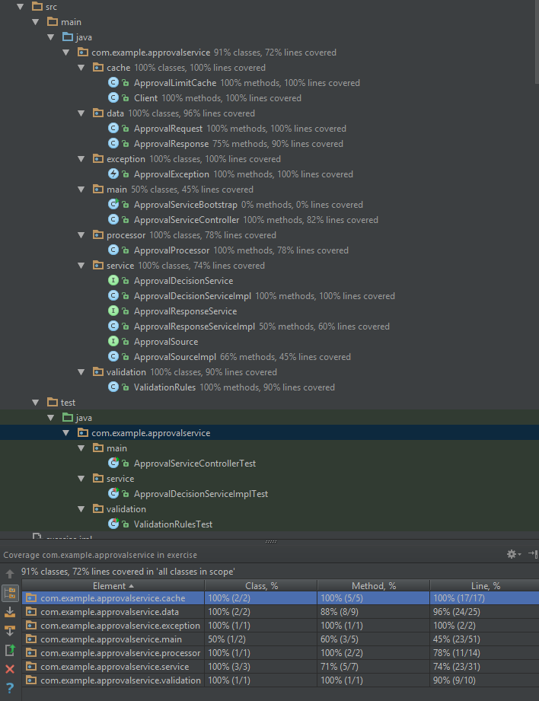
Program Execution Steps:
- Valid data configured for project is as below:
Client1 Security1 1000000000
Client2 Security2 1000000000
Client3 Security2 1000000000
Client1 Security2 1000000000
Client2 Security2 1000000000

- Run ApprovalServiceBootstrap
- Enter input - "Client1 Security1 1000000000"
- Expect output -
Sending response :ApprovalResponse{request=ApprovalRequest{client='Client1', security='Security1', quantity=1000000000}, approvedQuantity=1000000000}

- Now that all the limit quantity has been approved for Client1+Security1, if any further ApprovalRequests are received for the same, then 0 approved quantity is expected.
- Enter input - "Client1 Security1 1000000000"
Sending response :ApprovalResponse{request=ApprovalRequest{client='Client1', security='Security1', quantity=10000}, approvedQuantity=0}

- Enter input for other client - "Client2 Security1 50000"
Sending response :ApprovalResponse{request=ApprovalRequest{client='Client2', security='Security1', quantity=50000}, approvedQuantity=50000}

- Enter invalid (client only)- "Client1"
Invalid input. Please enter input in format -'Client Security Quantity'

- Enter invalid (client and security but no quantity) - "Client1 Security1"
Invalid input. Please enter input in format -'Client Security Quantity'

Captured output of above execution logs -
