Reading ALADIN data – get_aladin_fields.F90
Data are read from ALADIN grib files in such a way that for 3D field, e.g. Alad_uWind(i,j,k), index
- i increases from west to east,
- j increases from south to north
- k increases from ground to top

For more details see get_aladin_fields.F90.

GRIB API scanning modes ( http://tigge.ecmwf.int/grid.html ):
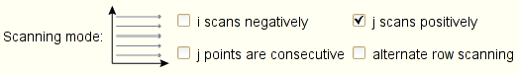

If ConfAladCAMxLevIndexing=.FALSE. Which means that ALADIN levels are numbered from top to bottom, then

ALADIN CAMx
level level
indexing indexing
1 -------------------------------

2 -------------------------------

...

n -------------------------------

n+1 -------------------------------

...

Aladin_nLev ------------------------------- 1

What is done with uWind field
- Read by get_aladin_filed.F90
- missing values replaced by zeroes
- if smoother_switch=.true. Then horizontal smoothing – module_smoothing_handler.F90
- interpolation to Arakawa C scheme
- horizontal and vertical interpolation to needed grid

Changes
In module smoothing_handler
real (kind=wp), dimension(2), parameter :: xnu = (/ 0.50_wp , -0.52_wp /)
replaced by
real (kind=wp), dimension(2), parameter :: xnu = (/ 0.50_wp , -0.50_wp /)

1 -------------------------------
