

3216



1779



6174



9135



5239



SIA’s chandelier (cut)



5021



9589



4606



3069



8778



9188



6305



4781



4428



4080



6883

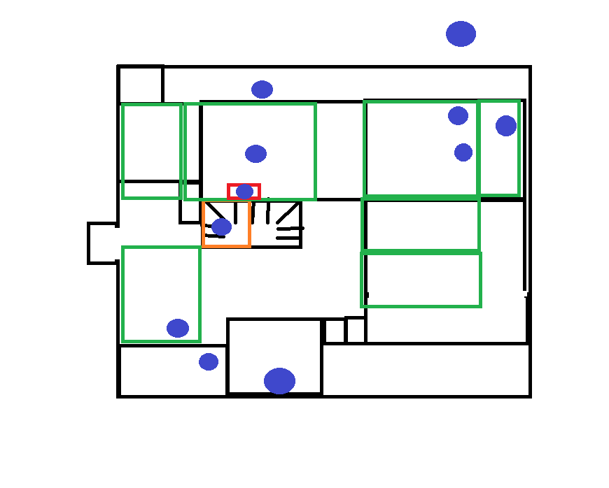

 

 



Questions? Email

[scavengethehunt@gmail.com](mailto:scavengethehunt@gmail.com)

please do not move unless necessary

Questions? Email

[scavengethehunt@gmail.com](mailto:scavengethehunt@gmail.com)

please do not move unless necessary

Questions? Email

[scavengethehunt@gmail.com](mailto:scavengethehunt@gmail.com)

please do not move unless necessary

Questions? Email

[scavengethehunt@gmail.com](mailto:scavengethehunt@gmail.com)

please do not move unless necessary

Questions? Email

[scavengethehunt@gmail.com](mailto:scavengethehunt@gmail.com)

please do not move unless necessary

Questions? Email

[scavengethehunt@gmail.com](mailto:scavengethehunt@gmail.com)

please do not move unless necessary



happy hunting 😊

