Milestone 4

Deployed JavaScript-enabled site – validated, tested

Chen, Chang (Victor)

Cheng, Yijia (Grace)

Jiang, Jianhui (Samuel)

Wang, Zibo (Bob)

Contents

Milestone 4 3

Define validation requirements 3

Implement validation requirements 3

Test form 3

JavaScript or jQuery third party widget 5

Testing with JavaScript disabled 5

Publish site and test 5

Appendix 6

Milestone 1 6

Topic 6

Functional requirements 7

Work Plan 7

Milestone 2 8

Sitemap 8

Page layout 9

Sample of site color 19

Milestone 3 20

A/B Test 20

Still working on 20

# Milestone 4

## Define validation requirements

|  |  |  |
| --- | --- | --- |
| FROM on page: Contact.html | | |
| Field ID | **Data Format or RegExp** | **Explanation** |
| form_name | /^[A-Za-z]+$/ | Can be ignored case but should be at least one letter |
| form_gender | radios | At least one radio should be selected |
| form_email | /^\w+@\w+.com|.ca|.org$/ | At least one letter before @  At least one letter between @ and .com or .ca or .org |
| form_phone | /^\d{3}$/ and /^\d{4}$/ | The first one should be three digital numbers  The second one should be four digital numbers |
| form_sel | It’s a select list | Should be choose one of the options |
| form_comments | It’s optional | No validation for this one because it is optional |

## Implement validation requirements

We implemented our validation field by field. When users click the submit button, all the wrong information will be successfully highlighted in the field. Also, we use jQuery to provide the friendly feedback.

## Test form

|  |  |  |
| --- | --- | --- |
| TEST DOCUMENTATION for FORM on page: Contact Us | | |
| FIELD LEVEL TESTING | | |
| Field ID | **Problem** | **Improvements made** |
| txtEmail | The string without @ signal can pass the validation test such as [www.google.com](http://www.google.com). | We fixed the problem and use regular expression to write the it instead of JavaScript. |
| txtPhone_0, txtPhone_1 and txtPhone_2 | Letter would be valid. | We fixed the problem at first. Then we did a little improvement. On the final version, JavaScript is replaced by the regular expression. |
| FORM LEVEL TESTING | | |
| Form Flow | **Problem** | **Improvements made** |
| N/A | N/A | N/A |

Here are two original code screenshots, one is from txtEmail and the other one is from txtPhone_0, txt_Phone1 and txtPhone_2. The improvement and final version are below them.

**“txtEmail” original code in JavaScript:**

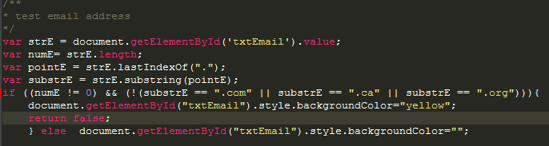

**“txtEmail “final code in JavaScript (Regular Expression):**

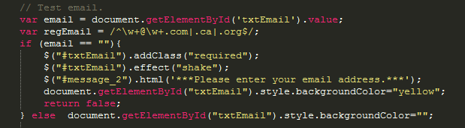

**“txtPhone_0”, “txtPhone_1” and “txtPhone_2” original code in JavaScript:**



**“txtPhone_0”, “txtPhone_1” and “txtPhone_2” improved code in JavaScript:**



**“txtPhone_0”, “txtPhone_1” and “txtPhone_2” final code in JavaScript (Regular Expression):**

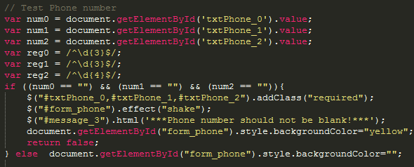

## JavaScript or jQuery third party widget

We chose a jQuery library form code.jquery.com. We chose it because of this open source website. Its effects are very convenient and powerful, such as shake the text box when validation did not pass. Therefore, it is easier for users to locate where they wrote the wrong information.

## Testing with JavaScript disabled

When PHP validation disabled, our jQuery can still work perfectly. The shake effect and friendly feedback will still be provided to users. When all JavaScript disabled, the submission and the form will still work.

## Publish site and test

There is no problem in test and publish. It had been pasted on the W3C validation website.

List of what we have done:

1. JavaScript validation
2. Import jQuery (including shake effect and message feedback)
3. Test website
4. Website makeup modified
5. Print layout
6. A/B Test Data
7. Web content and format correction

List of we will do in the future:

1. User registration
2. User authentication
3. Server side functions











































# Appendix

## Milestone 1

Project Team Members:

Chen, Chang (Victor)

Cheng, Yijia (Grace)

Jiang, Jianhui (Samuel)

Wang, Zibo (Bob)

### Topic

1. The purpose of our website is to promote and popularize Chinese food culture all over the world. People can learn about Chinese food culture and present their feedback on this website.
2. The goal of our website is to attract people who is interested in Chinese food and culture. Moreover, a platform is provided on the side to share their own dietary habit. The reason why we decide to create this website is only a small number of Chinese food culture sites, which can be referred on the Internet, though oriental diet has become world-widely recent years.
3. The target audience for this side is people who enjoy cooking Chinese food and interested in Chinese food culture.
4. The website is intended to accomplish three goals: hover effects, forum and clear design. A simple site interface will be displayed on the side.
5. The type of content should include text which has a readable font, warm-toned graphics which use high resolution “.jpg” files. Also the side has media which will be uploaded to the server.
6. In order to approach a successful website, it is necessary to maintain the website frequently, keep information updating and use email to interact with users.

Website 1: Food Tour and Travel

http://www.intrepidtravel.com/us/theme/food

Website 2: Chinese Highlights

<http://www.chinahighlights.com/travelguide/chinese-food/>

These websites contain a number of amazing pictures and well-knit structures. However, the index of these websites are chaotic. The websites include too much information on the title pages. For our website, we will make a clear index, main information will be displayed on the title page, for example use navigation bar. Also put rest of details to other sides. Our website will include compact structure and fantastic graphics in each side.

### Functional requirements

1. The forum is going to use namely site registration system to contact with members. The content of forum is focusing on members posing and commenting the information they are interested in.
2. The list of website will be simplified. It covers “home”, “video”, “forum” and “contact us” tags.

### Work Plan

The project will be separated and all the members in our team will do their own part first, hence everyone has chance to use their own knowledge and experience to figure out all problems at each part of project. Then all the work will be gathered together and organized every weekend before the deadline. We are going to organize meetings every Wednesday and Friday.

## Milestone 2

### Sitemap

This sitemap can shows all of our website information tidy and simple, these information clearly reflects the all constant have included in our website.

### Page layout

#### Home Page

|  |  |  |  |  |
| --- | --- | --- | --- | --- |
| Site Name | | | | |
| Home | Five Flavors | Forum | About us | Contact us |
| **A video about five flavors**  Heading  An introduction about our topic   * Chinese food * Five Flavors | | | | |
| footer | | | | |

The homepage which we decided looks simple and easy. It is easy for user to find the information what they want. Each part of our site, for example logo, pictures and text look really orderly.

#### Five Flavors

|  |  |  |  |  |
| --- | --- | --- | --- | --- |
| Site Name | | | | |
| home | Five Flavors | Forum | About us | Contact us |
| *Introduce the cuisine style of the flavor which the mouse hovers on*  *xxxxxxxxxxxxxxxxxxxxxxxxxxxxxxxxxxxxxxxxxxxxxxxxxxxxxxxxxxxxxxxxxxxxxxxxxxxxxxxxxxxxxxxxxxxxxxxxxx* | | | | |
| Footer | | | | |

#### Flavor 1- Sour

|  |  |  |  |  |
| --- | --- | --- | --- | --- |
| Sour | | | | |
| Home | Five Flavors | Forum | About Us | Contact Us |
| Representative: xxxxxxCuisine   * **Introduction：** * Area * History   Featured photos   * Category * Specialty      * **Cultural Heritage:** * Museums * Activates * **Cooking Process:** | | | | |
| footer | | | | |

This page shows the specific information of sour, such as introduction and cultural heritage. Also the cooking process and the reflect video is quite interesting.

|  |  |  |  |  |
| --- | --- | --- | --- | --- |
| Sweet | | | | |
| Home | Five Flavors | Forum | About Us | Contact Us |
| Representative:xxxxxx Cuisine   * **Introduction：** * Area * History   Featured photos   * Category * Specialty      * **Cultural Heritage:** * Museums * Activates * **Cooking Process:** | | | | |
| footer | | | | |

#### Flavor 2-Sweet

This page shows the specific information of sweet as introduction and cultural heritage. Also the cooking process and the reflect video is quite interesting.

#### Flavor 3- Bitter

This page shows the specific information of bitter as introduction and cultural heritage. Also the cooking process and the reflect video is quite interesting.

|  |  |  |  |  |
| --- | --- | --- | --- | --- |
| Bitter | | | | |
| Home | Five Flavors | Forum | About Us | Contact Us |
| Representative: xxxxxx Cuisine   * **Introduction：** * Area * History   Featured photos   * Category * Specialty      * **Cultural Heritage:** * Museums * Activates * **Cooking Process:** | | | | |
| footer | | | | |

#### Flavor 4-Spicy

|  |  |  |  |  |
| --- | --- | --- | --- | --- |
| Spicy | | | | |
| Home | Five Flavors | Forum | About Us | Contact Us |
| Representative: xxxx Cuisine   * **Introduction：** * Area * History   Featured photos   * Category * Specialty      * **Cultural Heritage:** * Museums * Activates * **Cooking Process:** | | | | |
| footer | | | | |

This page shows the specific information of spicy as introduction and cultural heritage. Also the cooking process and the reflect video is quite interesting.

|  |  |  |  |  |
| --- | --- | --- | --- | --- |
| Salty | | | | |
| Home | Five Flavors | Forum | About Us | Contact Us |
| Representative: Shanxi Cuisine   * **Introduction：** * Area * History   Featured photos   * Category * Specialty      * **Cultural Heritage:** * Museums * Activates * **Cooking Process:** | | | | |
| footer | | | | |

#### Flavor 5-Salty

This page shows the specific information of salty as introduction and cultural heritage. Also the cooking process and the reflect video is quite interesting.

#### Forum: fluid

|  |  |  |  |  |
| --- | --- | --- | --- | --- |
| Forum | | | | |
| Home | FiveFlavors | Forum | About Us | Contact Us |
| |  |  | | --- | --- | | Sign up | Sign in |   Main plates  Content of forum  Topics  Post new topic  Topic 1  Topic 2  Topic 3 | | | | |
| footer | | | | |

The layout of this page is easy for users to sign in our website.

|  |  |  |  |  |
| --- | --- | --- | --- | --- |
| About us | | | | |
| Home | Five Flavors | Forum | About us | Contact us |
| **Picture about us**    **Introduction of our team and background of our team.** | | | | |
| footer | | | | |

#### About us: fluid

Logo

The layout of this page is easy for users to know about us.

|  |  |  |  |  |
| --- | --- | --- | --- | --- |
| Contact us | | | | |
| home | FiveFlavors | forum | About us | Contact us |
| Email address:  Name:  Inquiries:  Message:  Send to us | | | | |
| footer | | | | |

#### Contact us

The layout of this page is easy for users to connect us.

### Sample of site color

|  |  |  |  |  |
| --- | --- | --- | --- | --- |
| SiteName | | | | |
| home | FiveFlavors | forum | About us | Contact us |
| A video about fiveflavors  Heading  An introduction about our topic   * Chinese food * FiveFlavors | | | | |
| footer | | | | |

The reason why we choose this color is because our site is about Chinese food. The warm tone color can make people feel hot and passion, and the red represents “China”.

The reason we choose this kind of layout is that it is simple. Our site is mainly introducing foods. A complicated layout is meaningless, and it is easier to be maintained.

## Milestone 3

### A/B Test

A/B test has been done. The layout2 has been chosen because there are four people did the test and all of them chosen the layout 2.

Layout1 Layout2

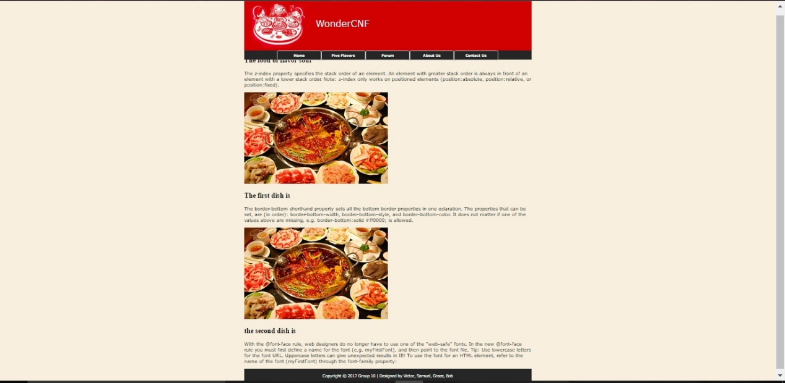 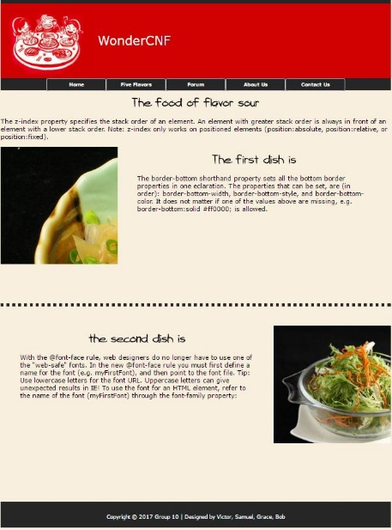

### Still working on

JavaScript functions

More hover effects

Page markup modification

Forum function

Registration function

#### Base page

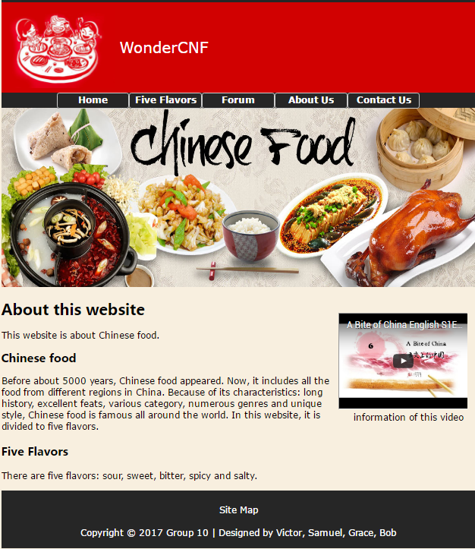

#### Table page

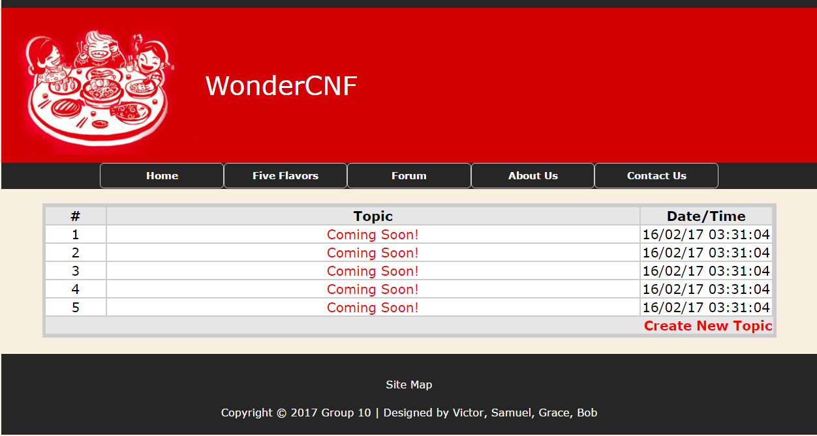

#### Forum page

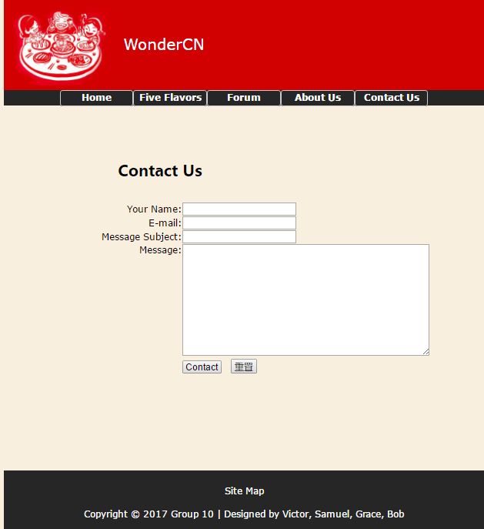

#### CSS file

body {

background-color: #f8efdf;

font-family: "Lucida Grande", Verdana, sans-serif;

margin:0;

padding:0;

}

header {

background-color:#d10101;

position: relative;

width: 100%;

border-top: #262626 solid 10px;

color: white;

}

#container{

margin: 0 auto;

width: 1000px;

height:auto;

}

.banner {

width: 1000px;

margin-left: auto;

margin-right: auto;

padding-top: 10px;

padding-bottom: 10px;

font-size: 2em;

line-height: 100px;

position: relative;

display: flex;

align-items: center;

}

.banner img{

padding-right: 10px;

height: 170px;

}

.navbar {

width: 100%;

position: absolute;

align-items: center;

font-size: 12px;

font-weight: bolder;

margin-left: auto;

margin-right: auto;

display: flex;

flex-direction: column;

background-color: #262626;

height:32px;

z-index:999;

}

.navbar ul{

margin: 0px;

padding-left: 0px;

}

.navbar li{

list-style-image: none;

list-style-type: none;

background-color: #262626;

float:left;

text-align: center;

border-radius: 5px;

}

.navbar li li{

float:none;

border-style:none;

}

.navbar li a {

color: white;

text-decoration: none;

margin: 0px;

display: block;

width: 150px;

height: 30px;

line-height: 30px;

border: 1px solid #CCC;

border-radius: 5px;

}

.navbar li:hover ul {

display:block;

}

.navbar ul ul {

position:absolute;

display:none;

margin: auto;

padding-left: 0px;

}

.navbar ul ul li{

width:100%;

}

.navbar li a:hover {

background-color: #0099CC;

}

.border_first{

border-left-width: 5px;

border-left-style: solid;

border-left-color: #d10101;

}

#main {

width:100%;

height:100%;

margin-left:auto;

margin-right:auto;

display:block;

position:relative;

}

.image{

margin-left:auto;

margin-right:auto;

max-width:100%;

margin-top:10px;

}

.video{

padding-right:10px;

float:right;

margin-top:50px;

}

.text {

width:70%;

text-align:left;

}

@font-face{

font-family: myFirstFont;

src: url(AlexBrush-Regular.ttf);

}

@font-face{

font-family: mySecondFont;

src: url(Attackofthecucumbers.ttf);

}

h1{

font-family: myFirstFont;

font-size:xx-large;

text-align:left;

}

h2 {

font-family: mySecondFont;

font-size:x-large;

text-align:left;

}

h3 {

font-family: mySecondFont;

font-size:x-large;

text-align:left;

}

p {

text-align:left;

}

footer {

width: 100%;

position:relative;

background-color: #262626;

padding-top: 30px;

padding-bottom: 20px;

}

#copyright {

text-align: center;

font-size:small;

color: white;

margin:0px;

top: 0px;

}

#copyright a {

color: white;

text-decoration: none;

}

#copyright a:hover{

background-color: #0099CC;

}