DR. RVR NRI INSTITUTE OF TECHNOLOGY
Department of Computer Science and Engineering
PYTHON PROGRAMMING
ACTIVITY-BASED LEARNING (ABL) ASSIGNMENT
10 Python Case Studies
Submitted by
Student Name | Venkata Lakshmi Durga Gayatri Putta ______________________________
Roll Number | _26001175_______________________________
Branch / Section | _CSM5__________________________
Academic Year | _2026-2030_______________________________
Submitted to: Python Programming Faculty / Lab Mentor

Assignment Overview
This report documents ten Python case studies using the structure required by the institute circular: problem statement, objectives, assumptions, algorithm, flowchart, pseudocode, Python source code, test cases, sample output, and conclusion. The programs use introductory Python concepts such as lists, tuples, nested lists, loops, conditions, arithmetic operations, string processing, and sorting by swapping.

Selected Case Studies
- Student Timetable Conflict Detection
- Text Compression Using Character Runs
- Water Distribution Fairness Analysis
- Multi-Route Courier Dispatch Planning
- Food Supply Chain Stock Reconciliation
- Environmental Monitoring Data Analyzer
- Integrated Campus Energy and Water Audit
- Disaster Relief Supply Allocation
- Smart Campus Incident and Maintenance Prioritization
- Examination Result and Grace-Mark Validation

Important Notes on the Submitted Code
- The timetable program detects a same-room conflict; it does not independently validate student schedule overlaps.
- The courier program displays priorities but does not sort packages by priority or use destination zones.
- The campus audit uses a cost limit of 2500, and all three sample buildings exceed it.
- The incident program calculates scores but does not sort incidents into a ranked list.
- The examination program does not implement grace marks or subject-wise marks; it performs pass/fail checking for one mark per student.
- Two submitted topics were not selected as main case studies: student group formation (the greedy method does not guarantee balanced groups) and the final code block (library book availability code, despite being labelled attendance recovery). These are listed as alternatives at the end.

Case Study 1: Student Timetable Conflict Detection

1. Problem Statement
Check a proposed timetable for classes scheduled on the same day and period in the same room. Report room conflicts and finish with a completion message.

2. Objectives
- Represent each class using a tuple containing subject, day, period, and room.
- Compare timetable entries without comparing an entry with itself.
- Identify classes that use the same room at the same time.

3. Assumptions
- A period number identifies a time slot within a day.
- A room conflict occurs when two classes have the same day, period, and room.
- The supplied dataset is small and is stored in a Python list of tuples.

4. Algorithm
- Start.
- Store the timetable as a list of tuples.
- Use two nested loops to compare each pair of entries once.
- If day and period match, compare room names.
- If the room also matches, print the conflict details; otherwise, report that the pair has no room conflict.
- Print the completion message and stop.

5. Flowchart
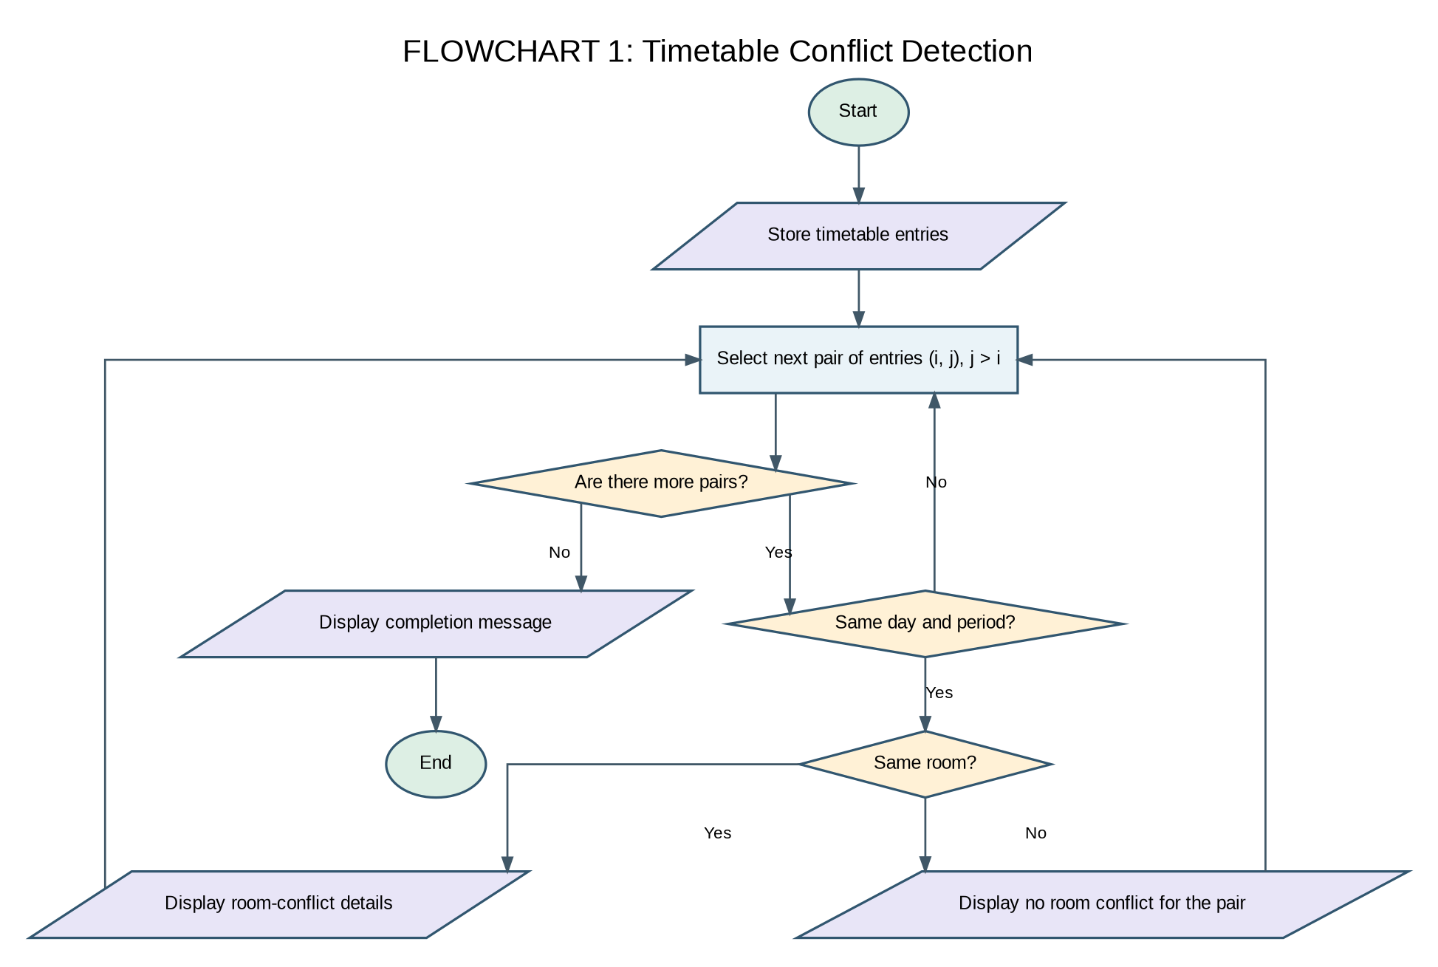

6. Pseudocode
BEGIN
FOR each pair of timetable entries (i, j), where j > i
IF day[i] = day[j] AND period[i] = period[j]
IF room[i] = room[j]
DISPLAY conflict details
ELSE
DISPLAY no room conflict for the pair
END IF
END IF
END FOR
DISPLAY 'Timetable checking completed'
END

7. Python Source Code
timetable = [
("Python", "Monday", 1, "R101"),
("Maths", "Monday", 2, "R102"),
("Web", "Monday", 1, "R103"),
("English", "Tuesday", 1, "R101"),
("AI", "Monday", 1, "R101")
]

for i in range(len(timetable)):
for j in range(i + 1, len(timetable)):
subject1, day1, period1, room1 = timetable[i]
subject2, day2, period2, room2 = timetable[j]

if day1 == day2 and period1 == period2:
if room1 == room2:
print("Room conflict detected")
print("Subjects:", subject1, "and", subject2)
print("Day:", day1)
print("Period:", period1)
print("Room:", room1)
else:
print("No room conflict between",
subject1, "and", subject2)

print("Timetable checking completed")

8. Test Cases
Input / Scenario | Expected Result
Python and AI, Monday period 1, R101 | Room conflict detected
Python and Web, Monday period 1, different rooms | No room conflict between Python and Web
Maths, Monday period 2, no matching entry | No conflict message for Maths

9. Sample Output
No room conflict between Python and Web
Room conflict detected
Subjects: Python and AI
Day: Monday
Period: 1
Room: R101
No room conflict between Web and AI

Timetable checking completed
The student timetable conflict detection case study demonstrates how basic Python constructs can solve a practical problem using structured data, loops, and conditional statements.

Review / Alternative Improvement
Important limitation: the program detects a room conflict, not a student's overlapping class schedule. If the goal is to validate both, check same day and period separately for student/course clashes, and check same day, period, and room for room clashes.

Case Study 2: Text Compression Using Character Runs

1. Problem Statement
Encode consecutive repeated characters using run-length encoding and compare the encoded length with the original length to determine whether the encoding is beneficial.

2. Objectives
- Identify consecutive runs of the same character.
- Build an encoded string containing each character and its run count.
- Compare original and encoded string lengths.

3. Assumptions
- The input is a string.
- Each run is encoded as character followed by its count, including count 1.
- This simple format is for demonstration and does not handle escaping digits or special symbols.

4. Algorithm
- Start with the input string and an empty compressed string.
- Set the current run count to 1.
- Scan from the second character onward.
- If the current character matches the previous character, increment the count.
- Otherwise append the previous character and count, then reset the count.
- Append the final run if the string is not empty.
- Display both strings and lengths, then compare lengths.

5. Flowchart
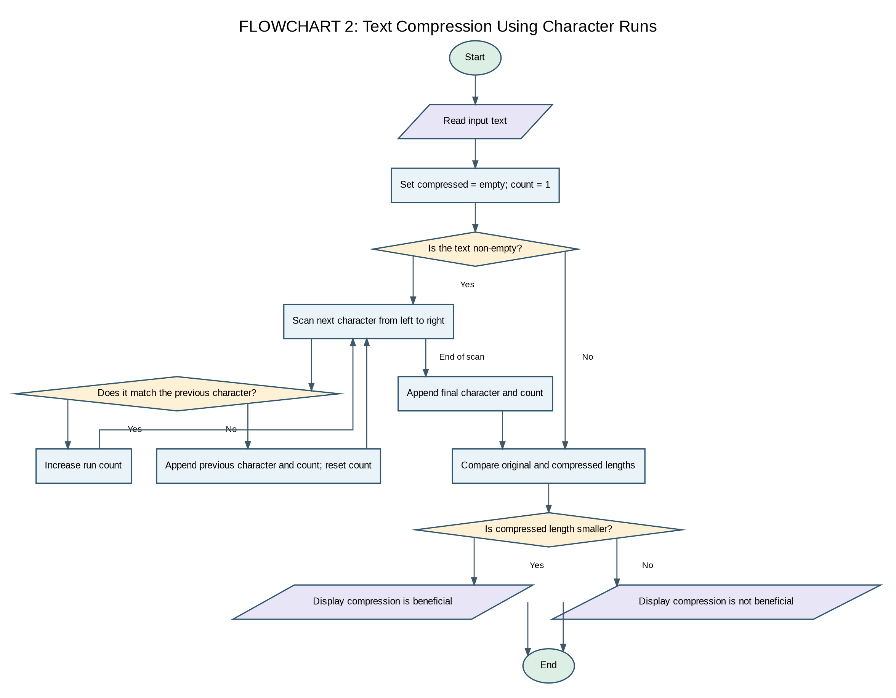

6. Pseudocode
BEGIN
text ← input string
compressed ← empty string; count ← 1
FOR i from 1 to length(text) - 1
IF text[i] = text[i - 1] THEN count ← count + 1
ELSE append text[i - 1] and count; count ← 1
END IF
END FOR
IF text is not empty, append final character and count
DISPLAY original and compressed strings and lengths
IF compressed length < original length, DISPLAY beneficial
ELSE DISPLAY not beneficial
END

7. Python Source Code
text = "aaabbccccdd"
compressed = ""
count = 1

for i in range(1, len(text)):
if text[i] == text[i - 1]:
count = count + 1
else:
compressed = compressed + text[i - 1] + str(count)
count = 1

if len(text) > 0:
compressed = compressed + text[-1] + str(count)

print("Original text:", text)
print("Compressed text:", compressed)
print("Original length:", len(text))
print("Compressed length:", len(compressed))

if len(compressed) < len(text):
print("Compression is beneficial")
else:
print("Compression is not beneficial")

8. Test Cases
Input / Scenario | Expected Result
aaabbccccdd | Compressed text: a3b2c4d2; compression is not beneficial for this sample
abcdef | Encoded length is longer; not beneficial
empty string | Should remain empty; the current code handles it

9. Sample Output
Original text: aaabbccccdd
Compressed text: a3b2c4d2
Original length: 11
Compressed length: 8
Compression is beneficial

10. Conclusion
The text compression using character runs case study demonstrates how basic Python constructs can solve a practical problem using structured data, loops, and conditional statements.

Review / Alternative Improvement
The sample output is beneficial because the encoded string has 8 characters and the original has 11. For real-world compression, the format must also safely represent digits and special characters that appear in the original text.

CASE STUDY 3: STUDENT GROUP FORMATION WITH SCORE BALANCING

1. Problem Statement
Form two student groups by assigning students according to their scores. Each student is allocated to the group with the lower current total score to maintain a reasonable balance between the two groups.

2. Objectives
- Store student names and scores using Python lists.
- Divide students into two groups based on their scores.
- Use conditional statements to select the group with the lower total score.
- Calculate and compare the final scores of both groups.

3. Assumptions
- Each student has a name and a numerical score.
- The student names and scores contain the same number of elements.
- Students are processed in the given order.
- Each student is assigned to exactly one group.
- The greedy approach attempts to balance the totals but does not guarantee the mathematically optimal division.

4. Algorithm
- Start.
- Store the student names and their corresponding scores.
- Create two empty groups and initialize their total scores to zero.
- Process each student one by one.
- Compare the total scores of both groups.
- Assign the student to the group with the lower total score.
- Update the selected group's total score.
- Repeat until all students have been assigned.
- Display the students in both groups and their total scores.
- Calculate and display the difference between the group totals.
- Stop.
5. Flowchart
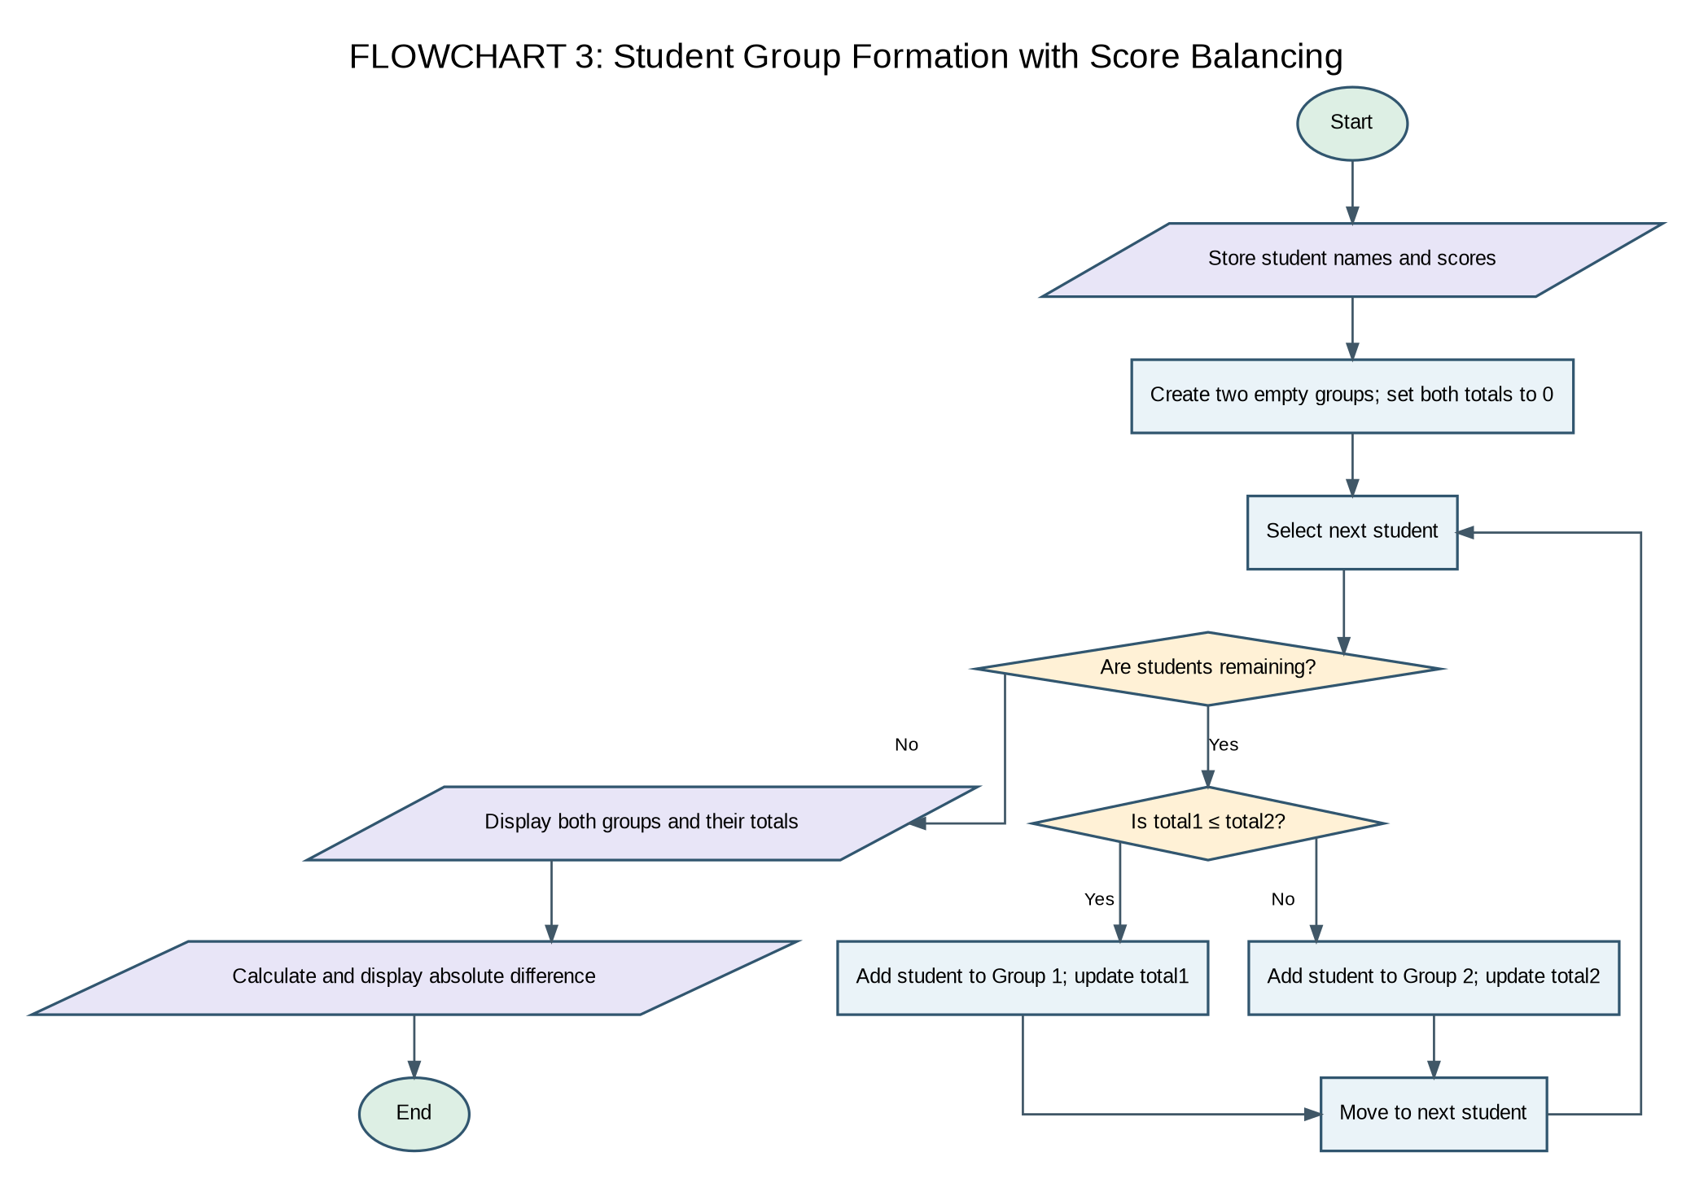

6. Pseudocode
BEGIN
STORE student names and scores

CREATE Group1 and Group2

SET total1 = 0

SET total2 = 0

FOR each student

IF total1 <= total2 THEN

ADD student to Group1

total1 = total1 + student score

ELSE

ADD student to Group2

total2 = total2 + student score

END IF

END FOR

DISPLAY Group1 and total1

DISPLAY Group2 and total2

difference = ABS(total1 - total2)

DISPLAY difference
END

7. Python Source Code
students = [
("Asha", 80),
("Balu", 70),
("Charan", 90),
("Divya", 60),
("Esha", 85),
("Farhan", 75)
]

group1 = []
group2 = []

total1 = 0
total2 = 0

for student in students:
name, score = student

if total1 <= total2:
group1.append(student)
total1 = total1 + score
else:
group2.append(student)
total2 = total2 + score

print("Group 1:")
for student in group1:
print(student[0], "-", student[1])

print("Total score of Group 1:", total1)

print()

print("Group 2:")
for student in group2:
print(student[0], "-", student[1])

print("Total score of Group 2:", total2)

difference = abs(total1 - total2)

print("Difference between group totals:", difference)

8. Test Cases
Input / Scenario | Expected Result
Six students with the scores shown in the code | All students are assigned to one of the two groups.
Group 1 has a lower total score | The next student is assigned to Group 1.
Group 2 has a lower total score | The next student is assigned to Group 2.
All students have been processed | Both groups, their totals, and the difference are displayed.

9. Sample Output
Group 1:
Asha - 80
Charan - 90
Esha - 85
Total score of Group 1: 255

Group 2:
Balu - 70
Divya - 60
Farhan - 75
Total score of Group 2: 205

Difference between group totals: 50

10. Conclusion
The Student Group Formation with Score Balancing case study demonstrates how Python lists, tuples, loops, conditional statements, and arithmetic operations can be used to divide students into two groups based on their scores. The greedy approach attempts to maintain balanced group totals by assigning each student to the group with the lower current score.

Review / Alternative Improvement
The greedy method is simple and easy to implement, but it does not always produce the most balanced groups. An improved version could compare multiple possible allocations to find a smaller difference between the final group totals.

Case Study 4: Water Distribution Fairness Analysis

1. Problem Statement
Compare area-wise water supply with demand over multiple days, calculate total and average supply, determine shortages, and classify each area as underserved or sufficiently supplied.

2. Objectives
- Store daily supply readings in nested lists.
- Calculate total demand, total supply, and average supply per area.
- Calculate shortage and classify the supply status.

3. Assumptions
- Each area has the same number of daily readings.
- Demand is a per-day requirement.
- A positive shortage means total supply is below total demand.

4. Algorithm
- Start.
- Store area names, daily demand, and daily supply.
- For each area, sum its daily supply values.
- Calculate total demand as daily demand multiplied by number of days.
- Calculate shortage and average supply.
- Print the results and classify the area.
- Repeat for all areas.

5. Flowchart
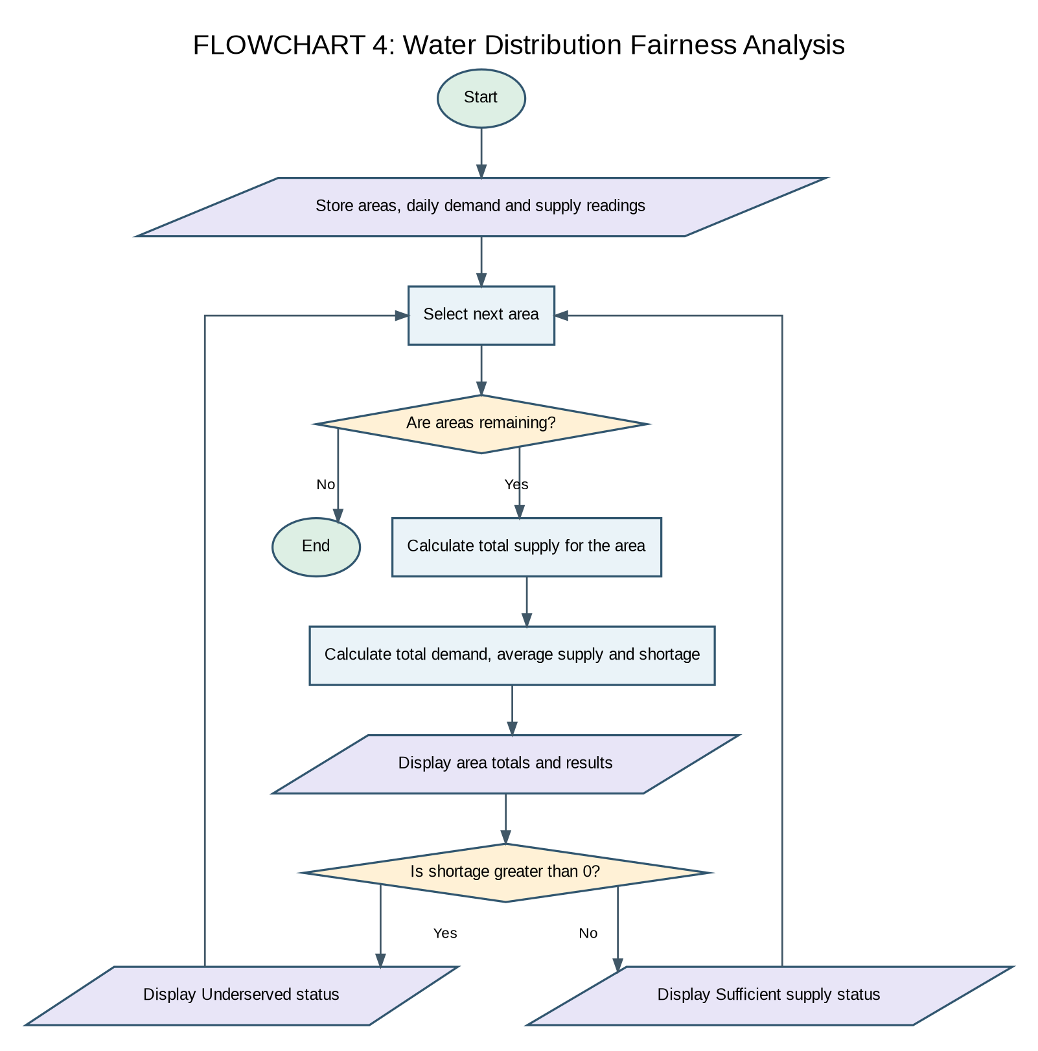

6. Pseudocode
BEGIN
FOR each area i
total ← sum of supply[i]
total_demand ← demand[i] × number of days
shortage ← total_demand − total
average ← total ÷ number of days
DISPLAY totals, average, shortage
IF shortage > 0 DISPLAY 'Underserved'
ELSE DISPLAY 'Sufficient supply'
END FOR
END

7. Python Source Code
areas = ["Area A", "Area B", "Area C"]
demand = [100, 120, 80]

supply = [
[90, 80, 100],
[70, 90, 60],
[80, 75, 80]
]

for i in range(len(areas)):
total = 0

for j in range(len(supply[i])):
total = total + supply[i][j]

total_demand = demand[i] * len(supply[i])
shortage = total_demand - total
average = total / len(supply[i])

print("Area:", areas[i])
print("Total demand:", total_demand)
print("Total supply:", total)
print("Average supply:", round(average, 2))
print("Shortage:", shortage)

if shortage > 0:
print("Status: Underserved")
else:
print("Status: Sufficient supply")

print()

8. Test Cases
Input / Scenario | Expected Result
Area A: supply 90, 80, 100; demand 100/day | Total demand 300; total supply 270; shortage 30
Area B: supply 70, 90, 60; demand 120/day | Total demand 360; total supply 220; shortage 140
Area C: supply 80, 75, 80; demand 80/day | Total demand 240; total supply 235; shortage 5

9. Sample Output
Area: Area A
Total demand: 300
Total supply: 270
Average supply: 90.0
Shortage: 30
Status: Underserved

Area: Area B
Total demand: 360
Total supply: 220
Average supply: 73.33
Shortage: 140
Status: Underserved

Area: Area C
Total demand: 240
Total supply: 235
Average supply: 78.33
Shortage: 5
Status: Underserved

10. Conclusion
The water distribution fairness analysis case study demonstrates how basic Python constructs can solve a practical problem using structured data, loops, and conditional statements.

Review / Alternative Improvement
The code calculates area-wise shortages correctly for the given data. A useful extension is to rank areas by shortage so that the most underserved area is shown first.

Case Study 5: Multi-Route Courier Dispatch Planning

1. Problem Statement
Assign packages to vehicles while respecting each vehicle's weight capacity. Process packages in the given order and report packages that cannot fit into any vehicle.

2. Objectives
- Represent packages as tuples containing ID, weight, and priority.
- Track the current load of each vehicle.
- Assign each package to the first vehicle with enough remaining capacity.

3. Assumptions
- Package weights are positive numbers.
- A package cannot be split between vehicles.
- Packages are considered in their list order; priority is displayed but does not affect sorting.

4. Algorithm
- Start.
- Store package data, vehicle capacities, and initial loads.
- For each package, check vehicles in order.
- If a vehicle has enough capacity, assign the package and update its load.
- If no vehicle can fit the package, report it as undispatched.
- Display the final load of each vehicle.

5. Flowchart
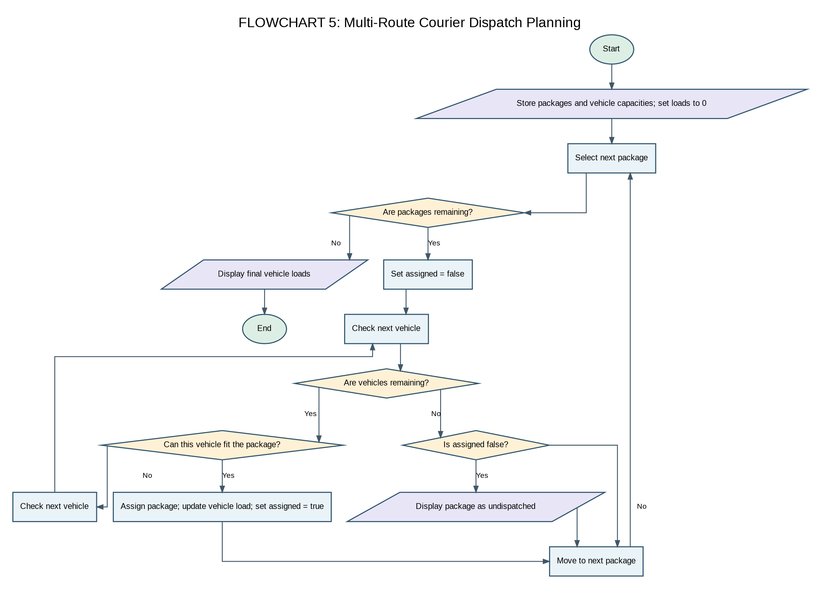

6. Pseudocode
BEGIN
load for each vehicle ← 0
FOR each package
assigned ← false
FOR each vehicle
IF load[vehicle] + package weight ≤ capacity[vehicle]
add package weight to load
DISPLAY assignment
assigned ← true; BREAK
END IF
END FOR
IF not assigned DISPLAY cannot be dispatched
END FOR
DISPLAY final vehicle loads
END

7. Python Source Code
packages = [
("P101", 8, "Urgent"),
("P103", 6, "Urgent"),
("P105", 10, "Urgent"),
("P102", 12, "Normal"),
("P104", 15, "Normal")
]

capacity = [20, 25]
load = [0, 0]

for package in packages:
package_id, weight, priority = package
assigned = False

for i in range(len(capacity)):
if load[i] + weight <= capacity[i]:
load[i] = load[i] + weight
print("Package:", package_id)
print("Priority:", priority)
print("Assigned to Vehicle", i + 1)
assigned = True
break

if assigned == False:
print("Package:", package_id)
print("Status: Cannot be dispatched")

print()

for i in range(len(capacity)):
print("Vehicle", i + 1, "load:", load[i])

8. Test Cases
Input / Scenario | Expected Result
P101, weight 8, capacity initially 20 | Assigned to Vehicle 1
P104, weight 15 after earlier allocations | Cannot be dispatched because remaining capacity is insufficient
Final vehicle loads | Vehicle 1 load: 14; Vehicle 2 load: 22

9. Sample Output
Package: P101
Priority: Urgent
Assigned to Vehicle 1

Package: P103
Priority: Urgent
Assigned to Vehicle 1

Package: P105
Priority: Urgent
Assigned to Vehicle 2

Package: P102
Priority: Normal
Assigned to Vehicle 2

Package: P104
Status: Cannot be dispatched

Vehicle 1 load: 14
Vehicle 2 load: 22

10. Conclusion
The multi-route courier dispatch planning case study demonstrates how basic Python constructs can solve a practical problem using structured data, loops, and conditional statements.

Review / Alternative Improvement
The current code prints priority but does not actually sort by priority or use destination zones. If the assignment requires priority-aware dispatch, sort urgent packages first before allocation. The current first-fit method is a simple heuristic, not a guaranteed optimal packing solution.

Case Study 6: Food Supply Chain Stock Reconciliation

1. Problem Statement
Reconcile received, distributed, damaged, and recorded stock for multiple locations. Identify mismatches and calculate replenishment needs when recorded stock is below a minimum threshold.

2. Objectives
- Calculate expected stock from received, distributed, and damaged quantities.
- Compare expected stock with recorded stock.
- Identify discrepancies and compute replenishment quantity.

3. Assumptions
- All quantities use the same unit.
- Expected stock equals received minus distributed minus damaged.
- The minimum stock level is 100 units.

4. Algorithm
- Start.
- Store location-wise stock details.
- For each location, calculate expected stock.
- Compare expected stock with recorded stock.
- Print whether the stock matches; if not, print the difference.
- If recorded stock is below 100, calculate replenishment required.
- Repeat for all locations.

5. Flowchart
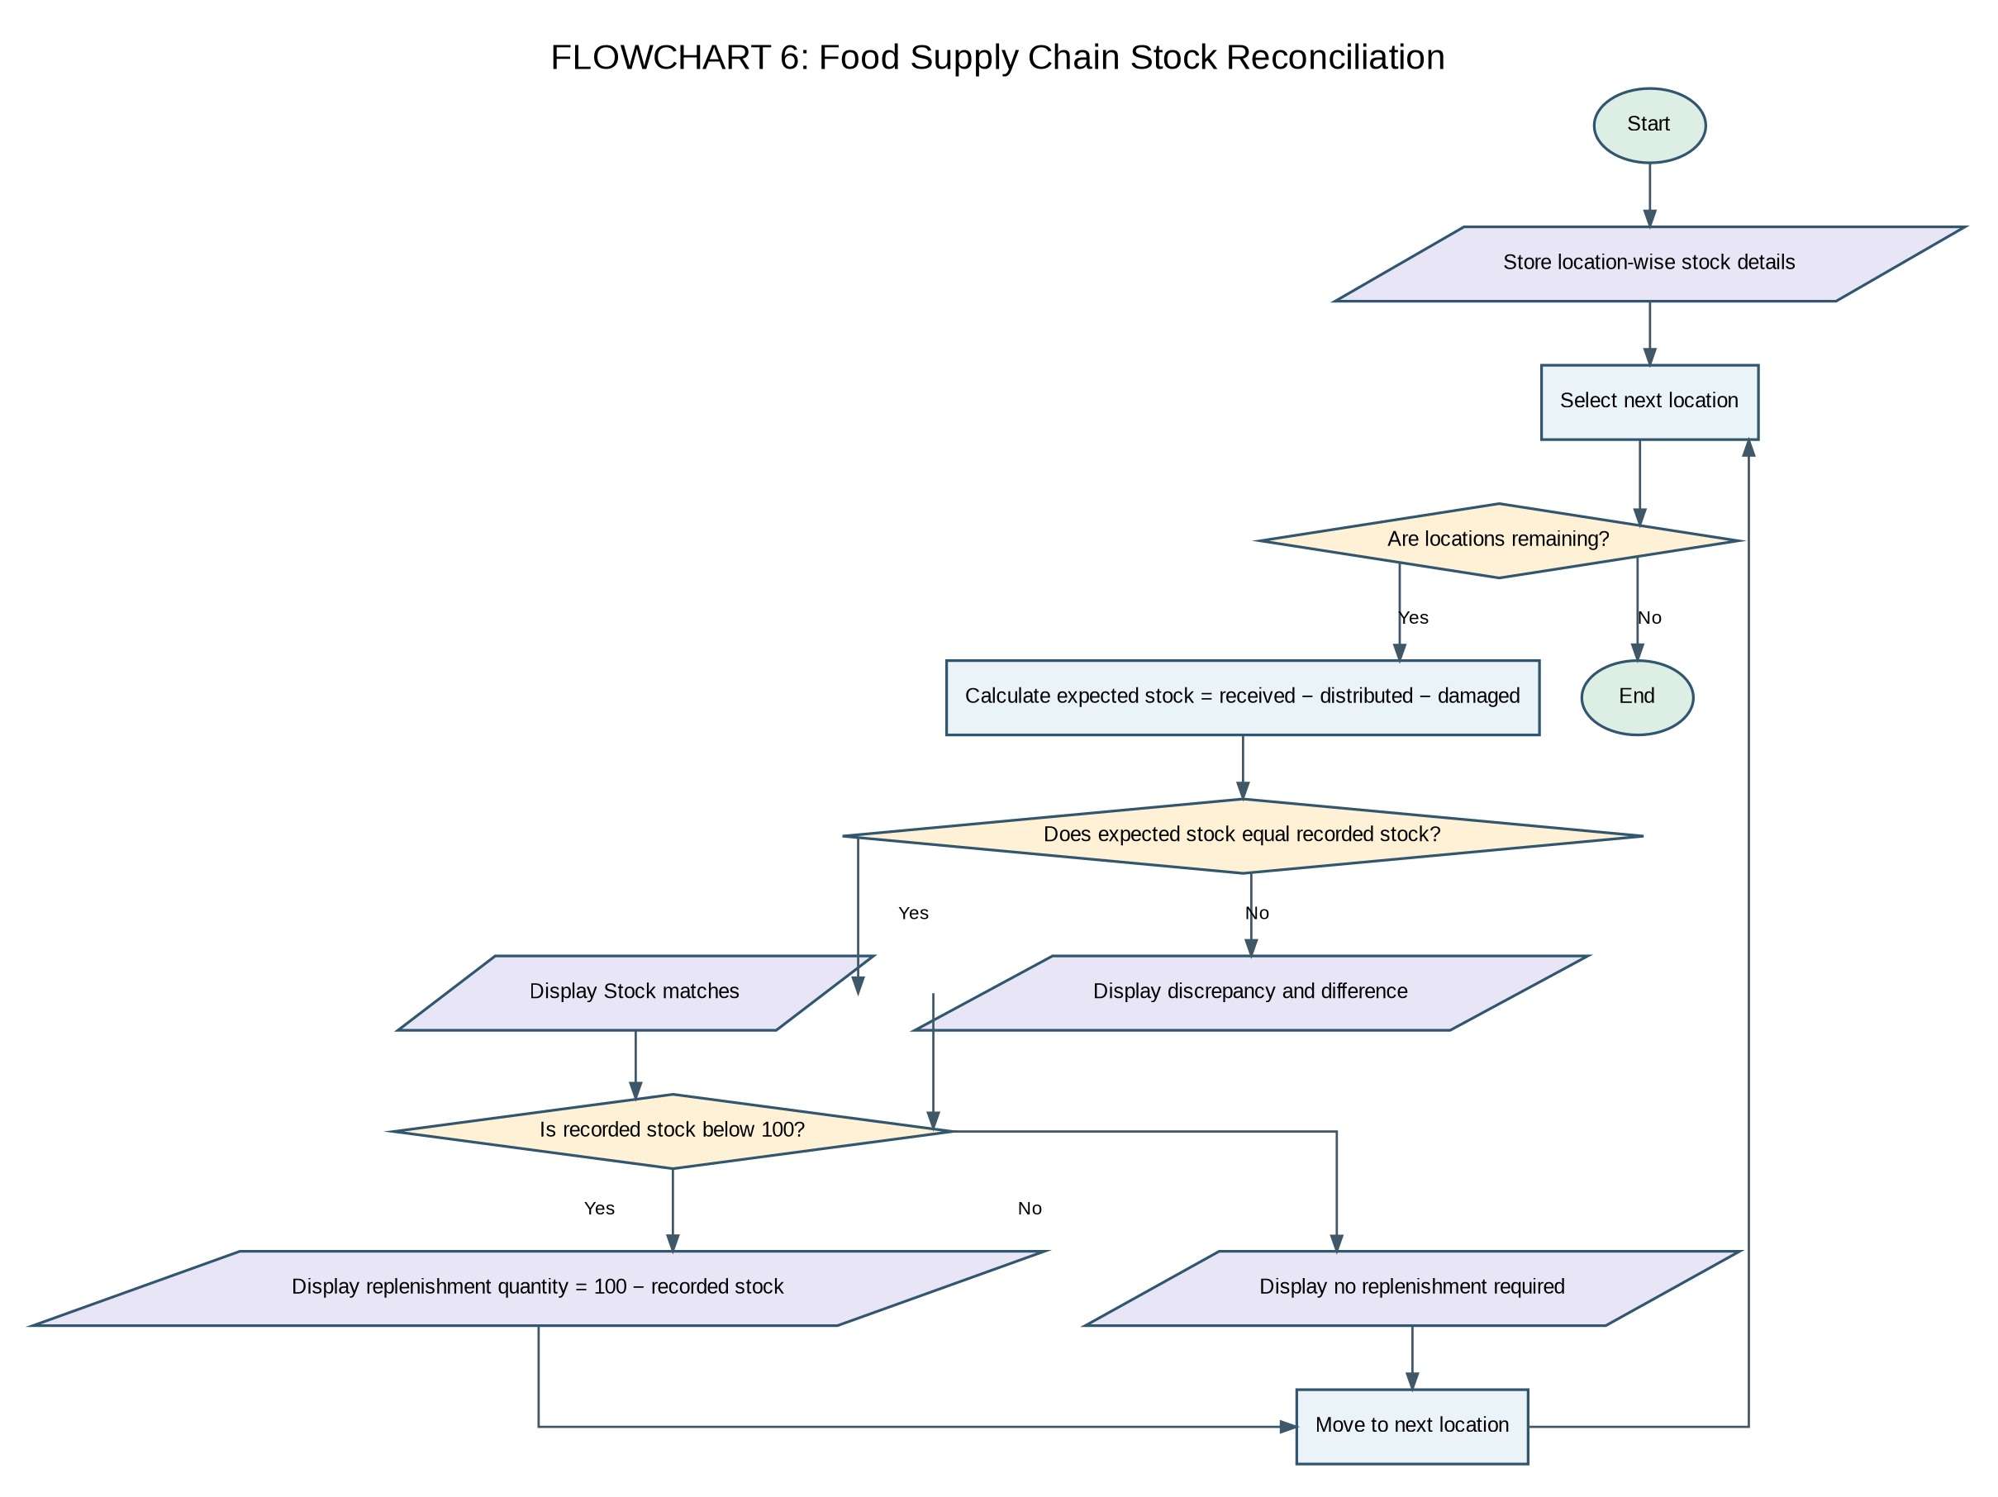

6. Pseudocode
BEGIN
FOR each location i
calculated ← received[i] − distributed[i] − damaged[i]
DISPLAY stock details
IF calculated = remaining[i] DISPLAY 'Stock matches'
ELSE DISPLAY discrepancy and difference
IF remaining[i] < 100 DISPLAY 100 − remaining[i] as replenishment
ELSE DISPLAY no replenishment required
END FOR
END

7. Python Source Code
locations = ["Location A", "Location B", "Location C"]
received = [500, 400, 300]
distributed = [350, 250, 200]
damaged = [20, 30, 10]
remaining = [120, 100, 90]

for i in range(len(locations)):
calculated = received[i] - distributed[i] - damaged[i]

print("Location:", locations[i])
print("Received:", received[i])
print("Distributed:", distributed[i])
print("Damaged:", damaged[i])
print("Recorded stock:", remaining[i])
print("Calculated stock:", calculated)

if calculated == remaining[i]:
print("Status: Stock matches")
else:
print("Status: Discrepancy detected")
print("Difference:", calculated - remaining[i])

if remaining[i] < 100:
print("Replenishment required:", 100 - remaining[i])
else:
print("Replenishment not required")

print()

8. Test Cases
Input / Scenario | Expected Result
Location A: 500 received, 350 distributed, 20 damaged, 120 recorded | Calculated 130; discrepancy +10; no replenishment
Location B: 400 received, 250 distributed, 30 damaged, 100 recorded | Calculated 120; discrepancy +20; no replenishment
Location C: 300 received, 200 distributed, 10 damaged, 90 recorded | Calculated 90; matches; replenishment 10

9. Sample Output
Location: Location A
Received: 500
Distributed: 350
Damaged: 20
Recorded stock: 120
Calculated stock: 130
Status: Discrepancy detected
Difference: 10
Replenishment not required

Location: Location B
Received: 400
Distributed: 250
Damaged: 30
Recorded stock: 100
Calculated stock: 120
Status: Discrepancy detected
Difference: 20
Replenishment not required

Location: Location C
Received: 300
Distributed: 200
Damaged: 10
Recorded stock: 90
Calculated stock: 90
Status: Stock matches
Replenishment required: 10

10. Conclusion
The food supply chain stock reconciliation case study demonstrates how basic Python constructs can solve a practical problem using structured data, loops, and conditional statements.

Review / Alternative Improvement
The discrepancy sign is calculated stock minus recorded stock. A positive result means the calculated stock is greater than the recorded stock.

Case Study 7: Environmental Monitoring Data Analyzer

1. Problem Statement
Analyze readings for several locations, calculate average, highest, and lowest values, and classify each location according to a supplied limit.

2. Objectives
- Process nested lists of environmental readings.
- Calculate average, maximum, and minimum readings without built-in max/min.
- Compare the highest reading with a threshold.

3. Assumptions
- Each location has at least one reading.
- The limit is 60 units for this example.
- A reading above 60 is treated as exceeding the limit.

4. Algorithm
- Start.
- Store locations, readings, and threshold.
- For each location, initialize total, highest, and lowest from the first reading.
- Loop through readings to update total, highest, and lowest.
- Calculate the average.
- Display statistics and classify the location.

5. Flowchart
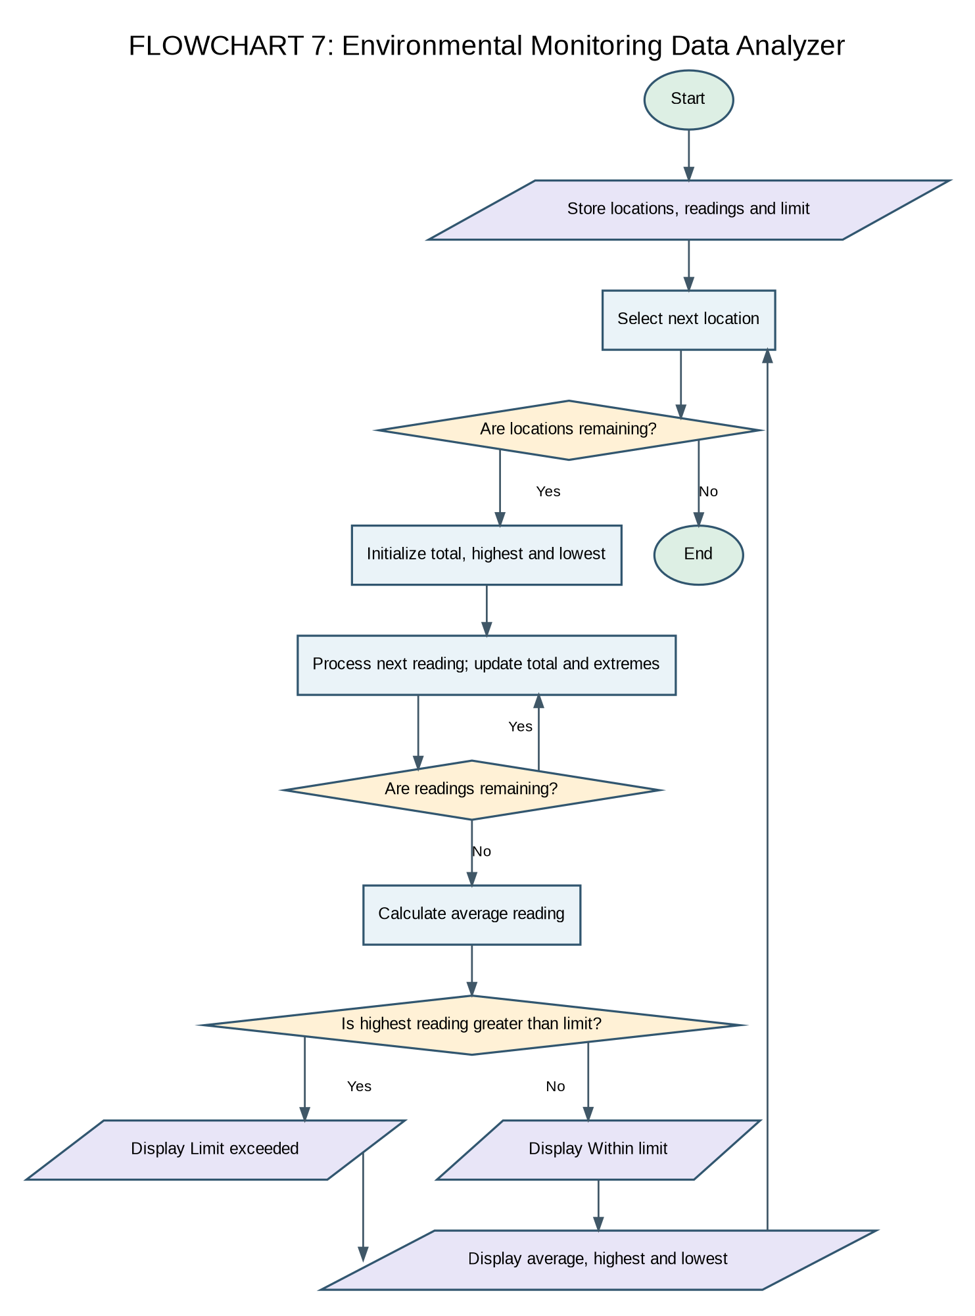

6. Pseudocode
BEGIN
FOR each location i
total ← 0; highest ← first reading; lowest ← first reading
FOR each reading value
add value to total
update highest and lowest when needed
END FOR
average ← total ÷ number of readings
DISPLAY average, highest, lowest
IF highest > limit DISPLAY 'Limit exceeded'
ELSE DISPLAY 'Within limit'
END FOR
END

7. Python Source Code
locations = ["College Gate", "Library", "Laboratory"]

readings = [
[45, 50, 55],
[30, 35, 40],
[75, 85, 90]
]

limit = 60

for i in range(len(locations)):
total = 0
highest = readings[i][0]
lowest = readings[i][0]

for j in range(len(readings[i])):
value = readings[i][j]
total = total + value

if value > highest:
highest = value

if value < lowest:
lowest = value

average = total / len(readings[i])

print("Location:", locations[i])
print("Average reading:", round(average, 2))
print("Highest reading:", highest)
print("Lowest reading:", lowest)

if highest > limit:
print("Status: Limit exceeded")
else:
print("Status: Within limit")

print()

8. Test Cases
Input / Scenario | Expected Result
College Gate: 45, 50, 55 | Average 50.0; highest 55; within limit
Library: 30, 35, 40 | Average 35.0; highest 40; within limit
Laboratory: 75, 85, 90 | Average 83.33; highest 90; limit exceeded

9. Sample Output
Location: College Gate
Average reading: 50.0
Highest reading: 55
Lowest reading: 45
Status: Within limit

Location: Library
Average reading: 35.0
Highest reading: 40
Lowest reading: 30
Status: Within limit

Location: Laboratory
Average reading: 83.33
Highest reading: 90
Lowest reading: 75
Status: Limit exceeded

10. Conclusion
The environmental monitoring data analyzer case study demonstrates how basic Python constructs can solve a practical problem using structured data, loops, and conditional statements.

Review / Alternative Improvement
This program checks whether the highest reading exceeds the limit. If the policy is based on average readings or every individual reading, change the condition accordingly.

Case Study 8: Integrated Campus Energy and Water Audit

1. Problem Statement
Calculate electricity and water consumption costs for campus buildings, calculate percentage change in electricity use, flag high-cost buildings, and rank buildings by total cost.

2. Objectives
- Sum consumption across multiple days.
- Calculate electricity and water costs using fixed rates.
- Calculate percentage change between the first and last electricity readings.
- Rank buildings from highest to lowest total cost.

3. Assumptions
- Each building has the same number of daily readings.
- Electricity rate is 8 cost units per unit; water rate is 2 cost units per unit.
- A total cost above 2500 is classified as excessive.

4. Algorithm
- Start.
- Store buildings and daily electricity/water readings.
- For each building, sum both types of consumption.
- Calculate costs and percentage change from day one to day three.
- Print details and cost status; store each total cost.
- Sort building names and costs together in descending cost order.
- Display the ranking.

5. Flowchart
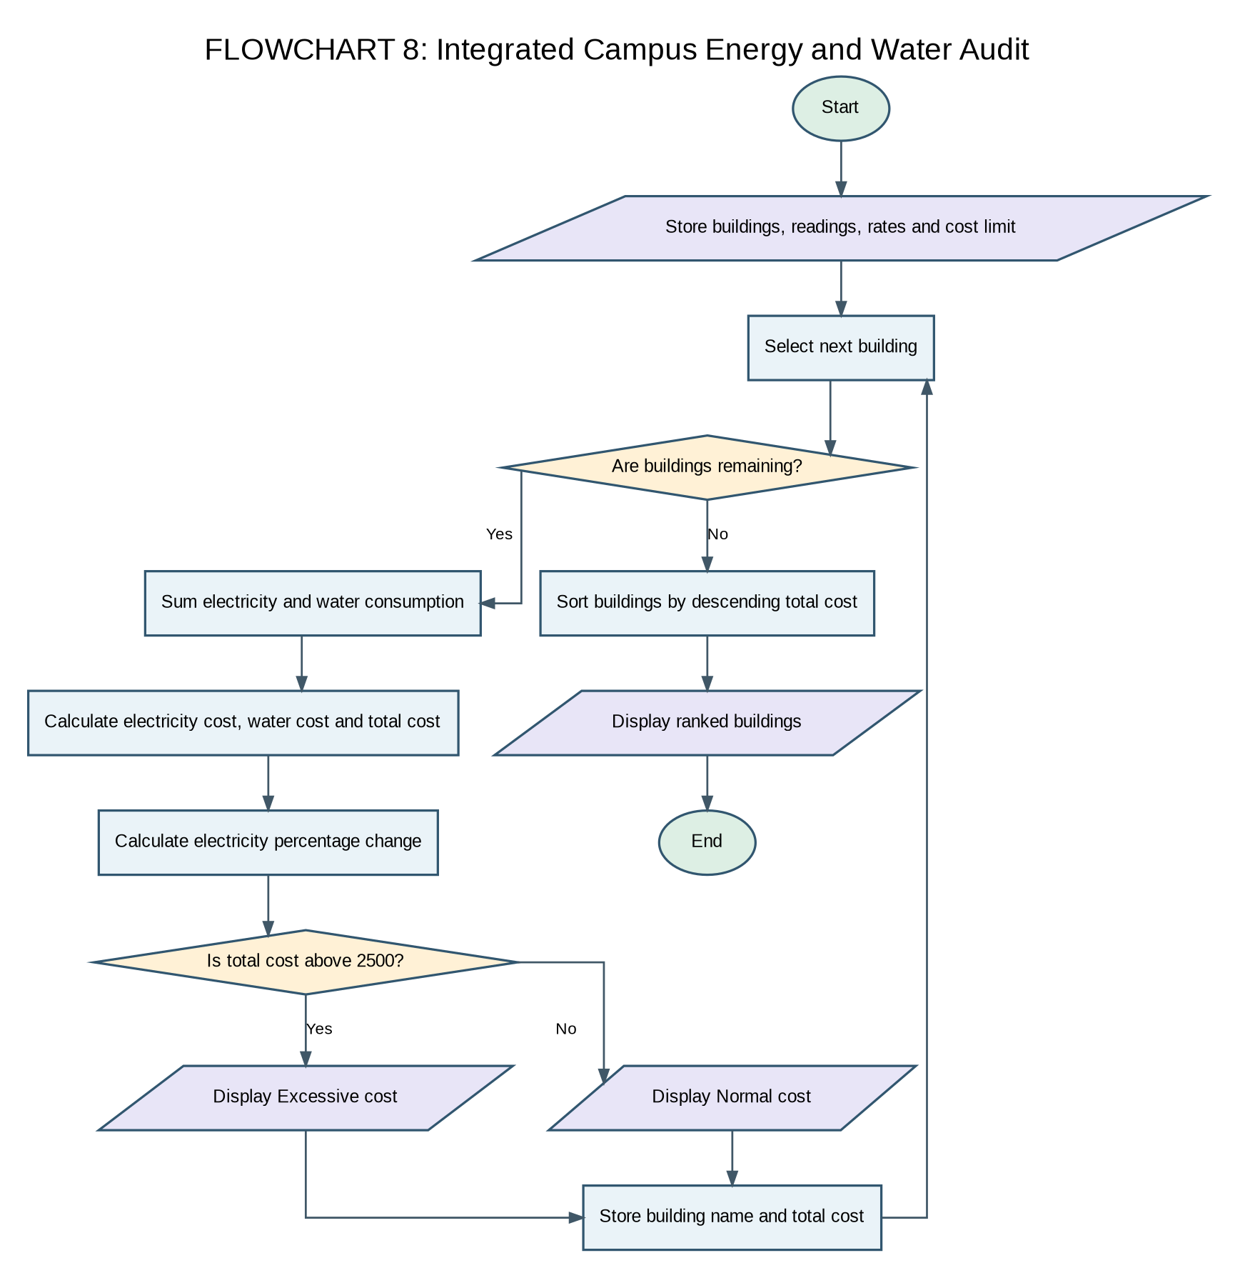

6. Pseudocode
BEGIN
FOR each building i
calculate total electricity and total water
electricity_cost ← electricity total × electricity rate
water_cost ← water total × water rate
total_cost ← electricity_cost + water_cost
change ← (last electricity − first electricity) ÷ first electricity × 100
DISPLAY details and status based on cost limit
save total_cost
END FOR
SORT building names and costs together by descending cost
DISPLAY ranked buildings
END

7. Python Source Code
buildings = ["Block A", "Block B", "Block C"]

electricity = [
[100, 120, 110],
[150, 160, 170],
[80, 90, 100]
]

water = [
[500, 550, 520],
[700, 750, 800],
[400, 420, 450]
]

electricity_rate = 8
water_rate = 2
limit = 2500
costs = []

for i in range(len(buildings)):
energy_total = 0
water_total = 0

for j in range(len(electricity[i])):
energy_total = energy_total + electricity[i][j]
water_total = water_total + water[i][j]

energy_cost = energy_total * electricity_rate
water_cost = water_total * water_rate
total_cost = energy_cost + water_cost
costs.append(total_cost)

change = ((electricity[i][2] - electricity[i][0])
/ electricity[i][0]) * 100

print("Building:", buildings[i])
print("Electricity used:", energy_total)
print("Water used:", water_total)
print("Electricity cost:", energy_cost)
print("Water cost:", water_cost)
print("Total cost:", total_cost)
print("Electricity change:", round(change, 2), "%")

if total_cost > limit:
print("Status: Excessive cost")
else:
print("Status: Normal cost")

print()

for i in range(len(costs)):
for j in range(i + 1, len(costs)):
if costs[j] > costs[i]:
costs[i], costs[j] = costs[j], costs[i]
buildings[i], buildings[j] = buildings[j], buildings[i]

print("Buildings ranked by total cost:")

for i in range(len(buildings)):
print(i + 1, buildings[i], "-", costs[i])

8. Test Cases
Input / Scenario | Expected Result
Block A | Electricity 330; water 1570; total cost 5780; excessive
Block B | Electricity 480; water 2250; total cost 8340; excessive
Block C | Electricity 270; water 1270; total cost 4700; excessive

9. Sample Output
Building: Block A
Electricity used: 330
Water used: 1570
Electricity cost: 2640
Water cost: 3140
Total cost: 5780
Electricity change: 10.0 %
Status: Excessive cost

Building: Block B
Electricity used: 480
Water used: 2250
Electricity cost: 3840
Water cost: 4500
Total cost: 8340
Electricity change: 13.33 %
Status: Excessive cost

Building: Block C
Electricity used: 270
Water used: 1270
Electricity cost: 2160
Water cost: 2540
Total cost: 4700
Electricity change: 25.0 %
Status: Excessive cost

Buildings ranked by total cost:
1 Block B - 8340
2 Block A - 5780
3 Block C - 4700

10. Conclusion
The integrated campus energy and water audit case study demonstrates how basic Python constructs can solve a practical problem using structured data, loops, and conditional statements.

Review / Alternative Improvement
The code labels all buildings as excessive because all calculated costs exceed 2500. The ranking logic correctly swaps each building name together with its cost. The percentage change assumes the first electricity reading is non-zero.

Case Study 9: Disaster Relief Supply Allocation

1. Problem Statement
Allocate limited relief stock to areas according to priority, then calculate the quantity allocated and unmet demand for each area.

2. Objectives
- Store each area's requirement and priority.
- Sort areas by priority before allocation.
- Allocate stock without exceeding available supply.
- Calculate unmet demand and remaining stock.

3. Assumptions
- A larger priority number means higher priority.
- Areas are served in descending priority order.
- Stock is allocated to each area up to its requirement before moving to the next area.

4. Algorithm
- Start.
- Store areas, required quantities, and priority values.
- Sort all three lists together in descending priority order.
- For each area, allocate the full requirement if stock is sufficient; otherwise allocate the remaining stock.
- Update stock and calculate unmet demand.
- Print each allocation and remaining stock.

5. Flowchart
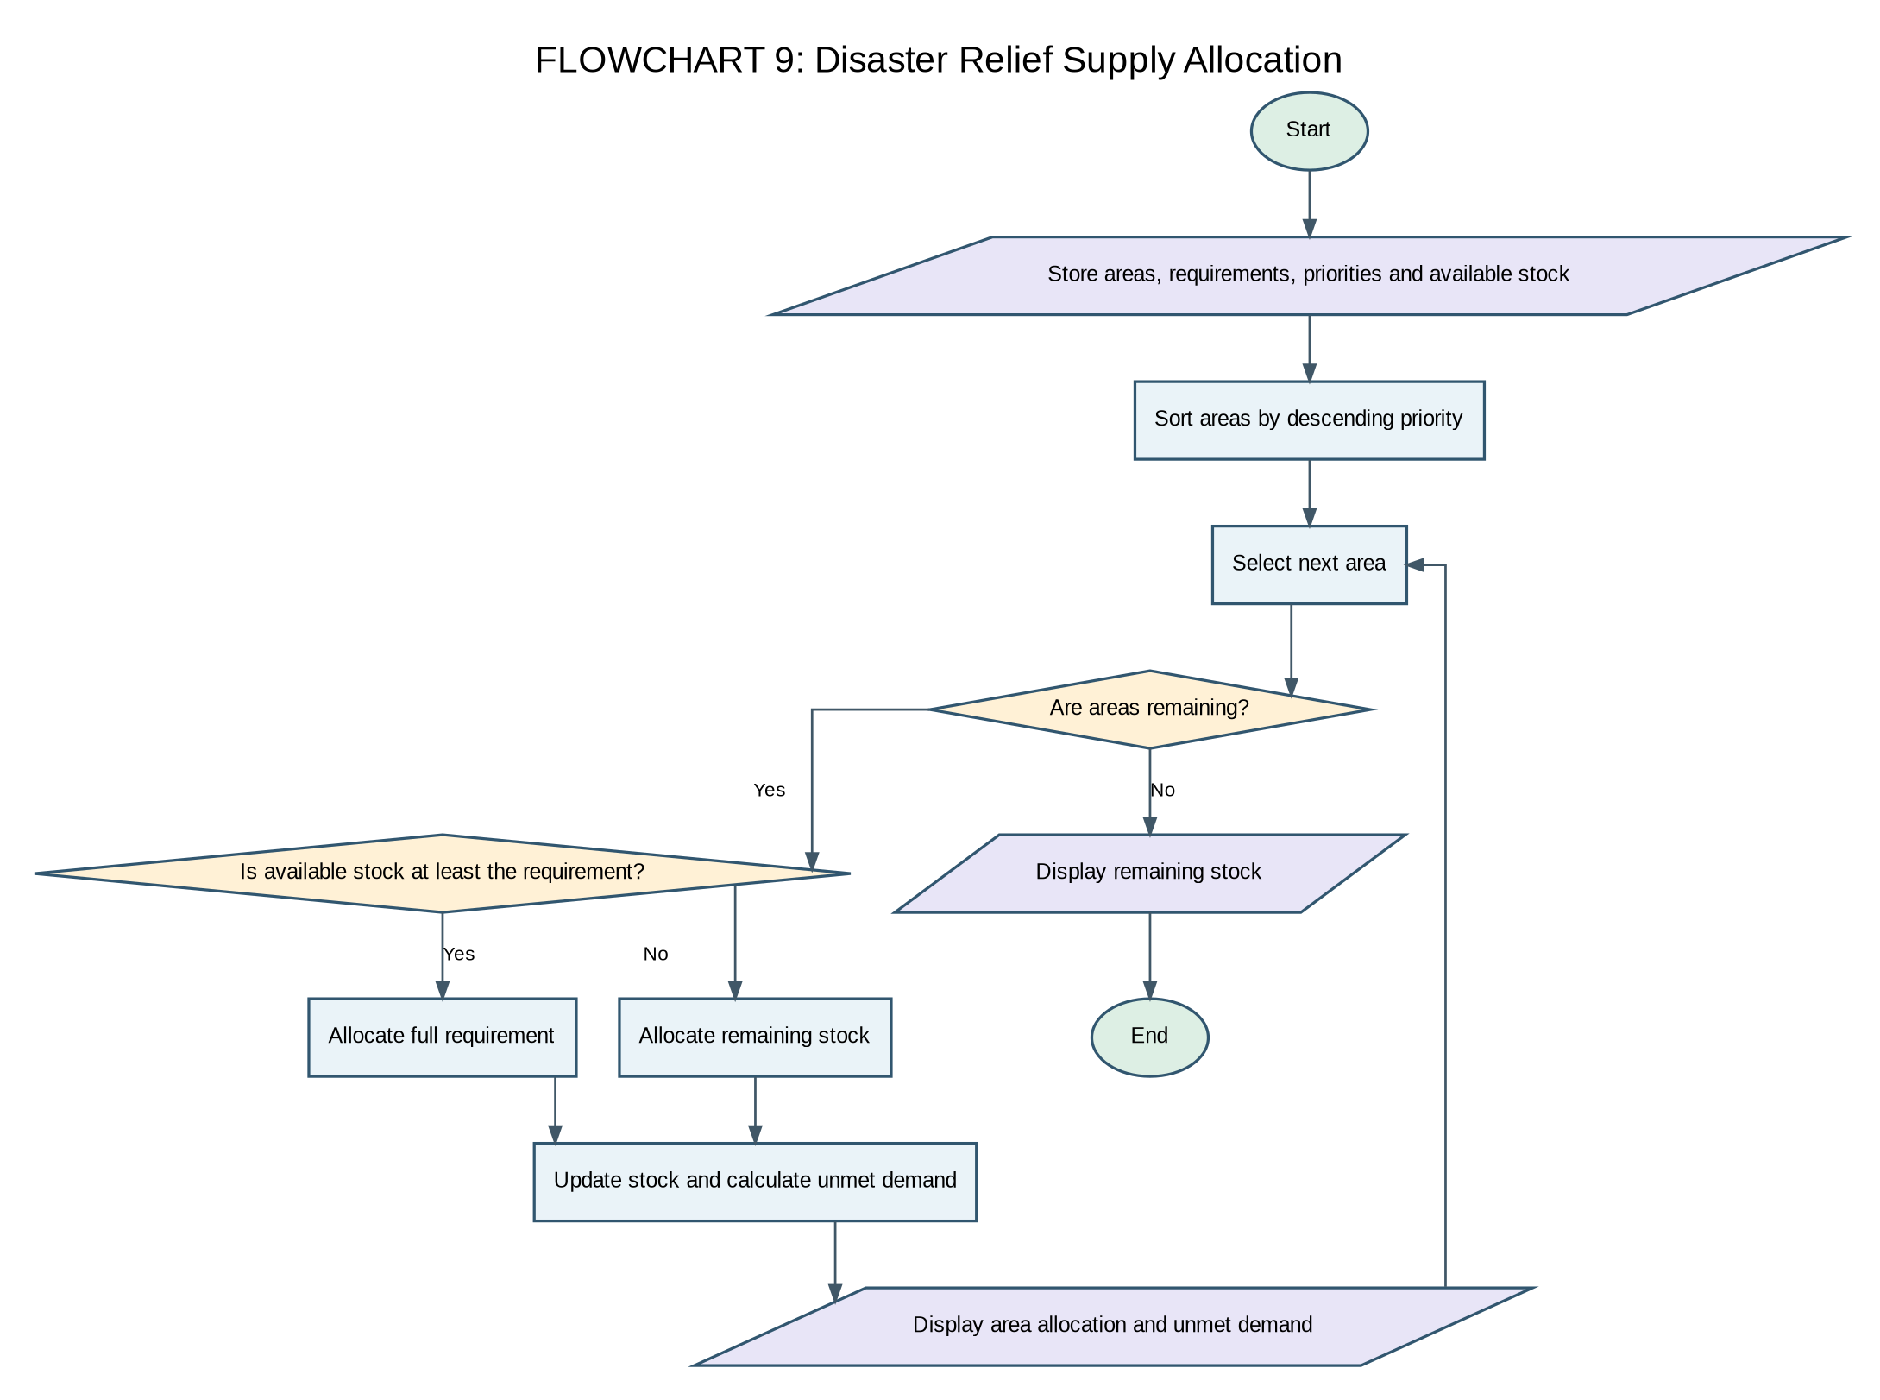

6. Pseudocode
BEGIN
FOR each pair of areas i and j where j > i
IF priority[j] > priority[i], swap priority, requirement, and area values
END FOR
FOR each area i
allocated ← minimum(stock, required[i])
stock ← stock − allocated
shortage ← required[i] − allocated
DISPLAY area, allocation, shortage
END FOR
DISPLAY remaining stock
END

7. Python Source Code
areas = ["Area A", "Area B", "Area C", "Area D"]
required = [100, 80, 60, 50]
priority = [3, 1, 2, 1]
stock = 200

for i in range(len(areas)):
for j in range(i + 1, len(areas)):
if priority[j] > priority[i]:
priority[i], priority[j] = priority[j], priority[i]
required[i], required[j] = required[j], required[i]
areas[i], areas[j] = areas[j], areas[i]

for i in range(len(areas)):
if stock >= required[i]:
allocated = required[i]
else:
allocated = stock

stock = stock - allocated
shortage = required[i] - allocated

print("Area:", areas[i])
print("Required:", required[i])
print("Allocated:", allocated)
print("Unmet demand:", shortage)
print()

print("Remaining stock:", stock)

8. Test Cases
Input / Scenario | Expected Result
Initial stock 200; Area A priority 3, requirement 100 | Allocate 100; unmet demand 0
Area C priority 2, requirement 60 after Area A | Allocate remaining 60; unmet demand 0
Areas with priority 1 after stock is exhausted | Allocation 0; full requirement remains unmet

9. Sample Output
Area: Area A
Required: 100
Allocated: 100
Unmet demand: 0

Area: Area C
Required: 60
Allocated: 60
Unmet demand: 0

Area: Area B
Required: 80
Allocated: 40
Unmet demand: 40

Area: Area D
Required: 50
Allocated: 0
Unmet demand: 50

Remaining stock: 0

10. Conclusion
The disaster relief supply allocation case study demonstrates how basic Python constructs can solve a practical problem using structured data, loops, and conditional statements.

Review / Alternative Improvement
Areas B and D have equal priority. The program preserves their relative order for this input. The policy is greedy: it completely serves higher-priority areas first, even if lower-priority areas receive nothing.

Case Study 10: Smart Campus Incident and Maintenance Prioritization

1. Problem Statement
Calculate a priority score for maintenance incidents using severity and report frequency, and classify each incident into high, medium, or low priority.

2. Objectives
- Represent incident information using tuples.
- Calculate a weighted priority score.
- Classify incidents based on severity.

3. Assumptions
- Severity values range from 1 to 3.
- The score formula is severity × 10 + frequency × 5.
- Severity 3 is high priority, severity 2 is medium, and severity 1 is low.

4. Algorithm
- Start.
- Store incident name, location, severity, and frequency.
- For each incident, calculate the score.
- Display incident details and score.
- Classify priority according to severity.
- Repeat for all incidents.

5. Flowchart
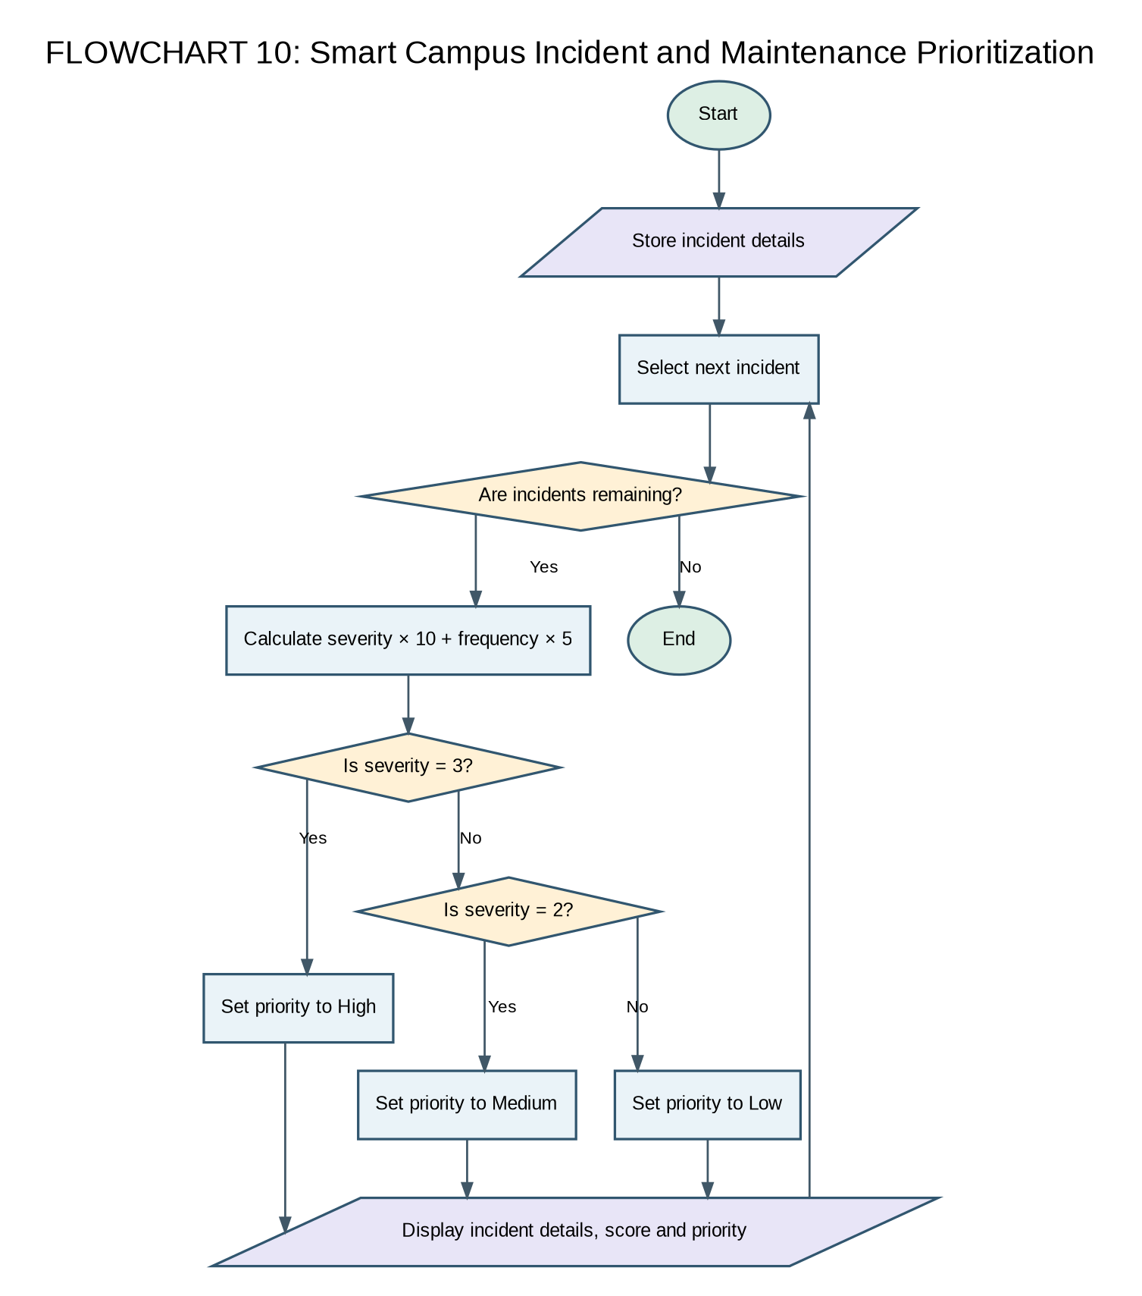

6. Pseudocode
BEGIN
FOR each incident
score ← severity × 10 + frequency × 5
DISPLAY incident, location, score
IF severity = 3 DISPLAY High
ELSE IF severity = 2 DISPLAY Medium
ELSE DISPLAY Low
END FOR
END

7. Python Source Code
incidents = [
("Water Leakage", "Hostel", 3, 4),
("Broken Fan", "Classroom", 1, 2),
("Electrical Fault", "Laboratory", 3, 3),
("Damaged Bench", "Classroom", 1, 1)
]

for incident in incidents:
name, location, severity, frequency = incident
score = severity * 10 + frequency * 5

print("Incident:", name)
print("Location:", location)
print("Priority score:", score)

if severity == 3:
print("Priority: High")
elif severity == 2:
print("Priority: Medium")
else:
print("Priority: Low")

print()

8. Test Cases
Input / Scenario | Expected Result
Water Leakage: severity 3, frequency 4 | Score 50; High
Broken Fan: severity 1, frequency 2 | Score 20; Low
Electrical Fault: severity 3, frequency 3 | Score 45; High

9. Sample Output
Incident: Water Leakage
Location: Hostel
Priority score: 50
Priority: High

Incident: Broken Fan
Location: Classroom
Priority score: 20
Priority: Low

Incident: Electrical Fault
Location: Laboratory
Priority score: 45
Priority: High

Incident: Damaged Bench
Location: Classroom
Priority score: 15
Priority: Low

10. Conclusion
The smart campus incident and maintenance prioritization case study demonstrates how basic Python constructs can solve a practical problem using structured data, loops, and conditional statements.

Review / Alternative Improvement
The score is printed but incidents are not sorted by score. If the task requires ranking, sort incidents in descending score order and display the rank. The current priority label is based on severity only.

Case Study 11: Examination Result and Grace-Mark Validation

1. Problem Statement
Process marks for multiple students, classify each student as pass or fail using a pass mark of 50, and calculate total, average, highest, and lowest marks.

2. Objectives
- Use lists and loops to process student marks.
- Apply a pass/fail condition.
- Calculate summary statistics.

3. Assumptions
- Each mark is out of 100.
- A mark of 50 or more is a pass.
- The supplied code does not apply grace marks or process multiple subjects.

4. Algorithm
- Start.
- Store student names and marks.
- Initialize total, highest, and lowest.
- For each student, update total and extremes, then classify pass/fail.
- Calculate the average after processing all students.
- Display summary statistics.

5. Flowchart
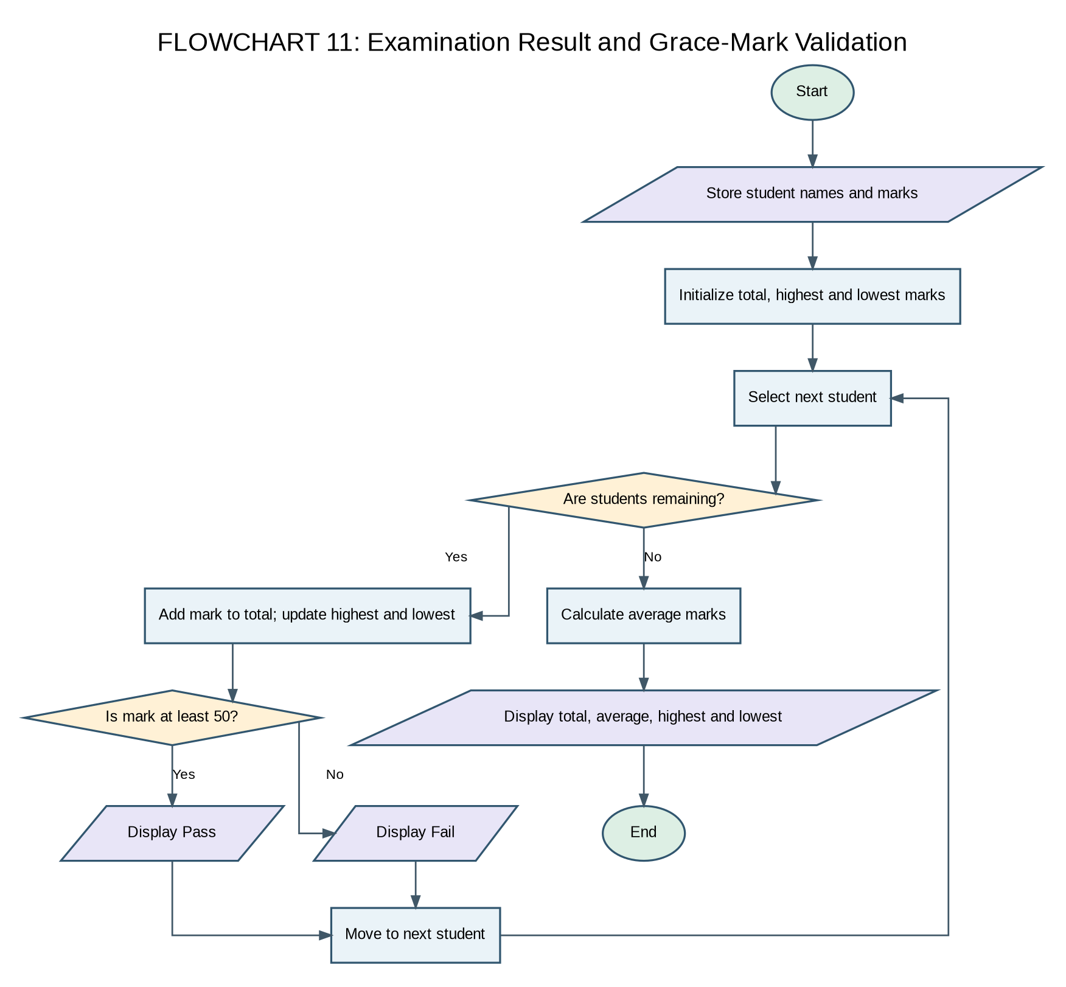

6. Pseudocode
BEGIN
total ← 0; highest and lowest ← first mark
FOR each student i
total ← total + marks[i]
update highest and lowest
DISPLAY student and marks
IF marks[i] ≥ 50 DISPLAY Pass
ELSE DISPLAY Fail
END FOR
average ← total ÷ number of marks
DISPLAY total, average, highest, lowest
END

7. Python Source Code
students = ["Asha", "Balu", "Charan", "Divya"]
marks = [85, 45, 92, 68]

total = 0
highest = marks[0]
lowest = marks[0]

for i in range(len(students)):
total = total + marks[i]

if marks[i] > highest:
highest = marks[i]

if marks[i] < lowest:
lowest = marks[i]

print("Student:", students[i])
print("Marks:", marks[i])

if marks[i] >= 50:
print("Result: Pass")
else:
print("Result: Fail")

print()

average = total / len(marks)

print("Total marks:", total)
print("Average marks:", round(average, 2))
print("Highest marks:", highest)
print("Lowest marks:", lowest)

8. Test Cases
Input / Scenario | Expected Result
Asha, 85 | Pass
Balu, 45 | Fail
All marks: 85, 45, 92, 68 | Total 290; average 72.5; highest 92; lowest 45

9. Sample Output
Student: Asha
Marks: 85
Result: Pass

Student: Balu
Marks: 45
Result: Fail

Student: Charan
Marks: 92
Result: Pass

Student: Divya
Marks: 68
Result: Pass

Total marks: 290
Average marks: 72.5
Highest marks: 92
Lowest marks: 45

10. Conclusion
The examination result and grace-mark validation case study demonstrates how basic Python constructs can solve a practical problem using structured data, loops, and conditional statements.

Review / Alternative Improvement
The submitted code does not implement grace marks, subject-wise pass criteria, or a maximum-mark cap. Its current behavior is a single-mark pass/fail and statistics program. To match the full title, add subject-wise marks and a clearly defined grace-mark policy.

Alternative Case Studies from the Submitted Code
The circular requires ten case studies. The following two submitted programs are retained as alternatives in case the faculty list or your selected topics require a replacement.

Alternative A: Student Group Formation with Score Balancing
Purpose: Assign students to two groups while attempting to keep group score totals close.
Review: The current greedy approach adds the next student to whichever group currently has the smaller total. It is simple, but it does not guarantee the smallest possible difference, and the result can depend on student order.
Suggested improvement: Sort students by descending score and assign each student to the group with the smaller current total. For a small fixed class, an exhaustive search of possible groupings can find the optimal split, but that is more advanced.
students = ["Asha", "Balu", "Charan", "Divya", "Esha", "Farhan"]
scores = [90, 75, 85, 60, 80, 70]

group1 = []
group2 = []
total1 = 0
total2 = 0

for i in range(len(scores)):
if total1 <= total2:
group1.append(students[i])
total1 = total1 + scores[i]
else:
group2.append(students[i])
total2 = total2 + scores[i]

print("Group 1:", group1)
print("Group 1 total:", total1)
print("Group 2:", group2)
print("Group 2 total:", total2)

difference = total1 - total2
if difference < 0:
difference = -difference
print("Difference between groups:", difference)

Alternative B: Library Book Availability Check
Purpose: Search a list of book titles without case sensitivity and report the number of available copies.
Important correction: This code was labelled 'Attendance Recovery Computation' in the submitted message, but the actual program checks library books. It should be renamed to 'Library Book Availability Check' unless you provide the intended attendance program.
books = ["Python", "Java", "HTML", "CSS", "Database"]
available = [5, 0, 3, 2, 0]

search_book = input("Enter book name: ")
found = False

for i in range(len(books)):
if books[i].lower() == search_book.lower():
found = True
print("Book:", books[i])
print("Available copies:", available[i])

if available[i] > 0:
print("Status: Book is available")
else:
print("Status: Book is not available")

if found == False:
print("Book not found in the library")

print("Library checking completed")

CASE STUDY 12: LIBRARY BOOK AVAILABILITY CHECKEROriginal code labelled as Attendance Recovery Computation

1. Problem Statement
Develop a Python program to search for a book in a library collection and determine whether it is available. If the requested book is found, display its available copy count and availability status. Otherwise, display a message indicating that the book was not found.

2. Objectives
Store book names and their available copy counts using Python lists.
Accept a book name from the user.
Search the library collection for the requested book.
Perform a case-insensitive comparison of book names.
Display the availability status and number of copies when a match is found.

3. Assumptions
The library contains a predefined list of book names.
Each book has a corresponding number of available copies.
The book names and available-copy lists have the same number of elements.
The search is case-insensitive.
The program checks only the books included in the predefined collection.

4. Algorithm
Start.
Store the book names and their available copy counts.
Ask the user to enter the name of the book to search for.
Initialize a variable to indicate whether the book has been found.
Traverse the list of books using a loop.
Compare the requested book name with each stored book name without considering letter case.
If a match is found, display the book name, available copies, and availability status.
Mark the book as found and stop searching.
If no match is found after checking the list, display a book-not-found message.
Stop.
5. Flowchart
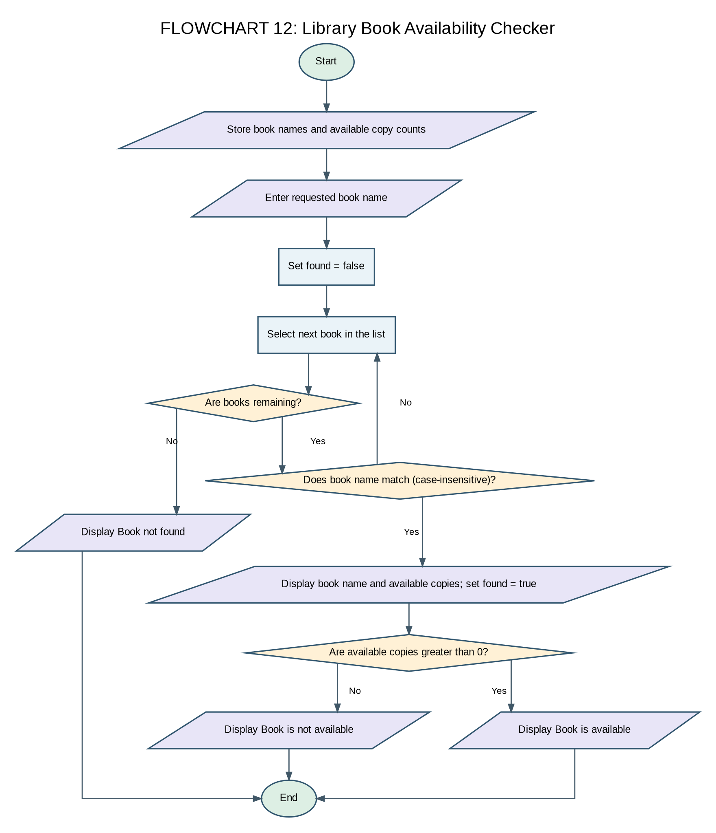

6. Pseudocode
BEGIN
STORE book names

STORE available copy counts

INPUT requested_book

SET found = false

FOR each book in the library

IF lowercase(book) = lowercase(requested_book) THEN

DISPLAY book name

DISPLAY available copies

DISPLAY availability status

SET found = true

BREAK

END IF

END FOR

IF found = false THEN

DISPLAY "Book not found"

END IF
END

7. Python Source Code
books = [
"Python Programming",
"Data Structures",
"Computer Networks",
"Database Systems",
"Artificial Intelligence"
]

available_copies = [5, 3, 0, 4, 2]

search_book = input("Enter the book name to search: ")

found = False

for i in range(len(books)):
if books[i].lower() == search_book.lower():
print("Book found:", books[i])
print("Available copies:", available_copies[i])

if available_copies[i] > 0:
print("Status: Available")
else:
print("Status: Currently unavailable")

found = True
break

if found == False:
print("Book not found in the library")

8. Test Cases
Input / Scenario | Expected Result
Python Programming | Book found; 5 copies available.
Data Structures | Book found; 3 copies available.
Computer Networks | Book found; 0 copies; currently unavailable.
ARTIFICIAL INTELLIGENCE | Book found despite different letter case; 2 copies available.
Operating Systems | Book not found in the library.

9. Sample Output
Test Case 1: Book Available
Enter the book name to search: Python Programming
Book found: Python Programming
Available copies: 5
Status: Available
Test Case 2: Book Currently Unavailable
Enter the book name to search: Computer Networks
Book found: Computer Networks
Available copies: 0
Status: Currently unavailable
Test Case 3: Book Not Found
Enter the book name to search: Operating Systems
Book not found in the library

10. Conclusion
The Library Book Availability Checker demonstrates the use of Python lists, loops, conditional statements, string methods, and Boolean variables to search a library collection. The program identifies whether a requested book exists and displays its available copy count and status.

Review / Alternative Improvement
The program can be extended to allow users to add new books, update copy counts, borrow books, and return books. A larger library system could also use a dictionary or database to manage book information more efficiently.
Important Note: Case Study 12 above matches the library-search code, not the Attendance Recovery Computation title. If the assignment requires attendance recovery, use an attendance-based program instead of submitting the library program under that title.

All students have been processed Final Conclusion
The ten selected case studies demonstrate the use of Python data structures, iteration, decisions, string handling, arithmetic, and simple sorting to address practical problems. The review notes identify places where the supplied programs can be extended so that their implementation more fully matches their original descriptions.

