WEB DEVELOPMENT
PROJECT DOCUMENTATION
Five HTML & CSS Website Projects
Name: PUTTA VENKATA LAKSHMI DURGA GAYATRI
DEPARRTMENT: COMPUTER SCIENCE -ARTIFICIAL INTELLIGENCE& MACHINE LEARNING
SECTION: CSM5
Project overview • Features • File references • Run instructions • Screenshot spaces

How to Use This Document
This editable document covers five website projects. Each project includes an overview, technologies, main features, filenames, run instructions, and five labelled screenshot spaces.
- In Word, use Insert → Pictures → This Device to add each output screenshot.
- Resize images from a corner to preserve proportions.
- Remove any unused screenshot placeholder if needed.
- Keep HTML, CSS, and local image assets together when running a project.

1. Learnora — Online Learning Platform
Learnora is an online learning dashboard that organizes student learning information. It presents courses, learning progress, weekly activity, course categories, and instructor details.

Technologies Used
HTML5 and CSS3

Main Features
- Sidebar navigation for Dashboard, My Courses, Explore Courses, My Progress, and Instructors.
- Student profile and notification area.
- Welcome section and learning summary cards.
- Course cards with lesson counts, ratings, and progress indicators.
- Weekly activity visualization and learning-goal indicator.
- Course categories and instructor information.
- CSS cards, colour accents, transitions, layout rules, and responsive adjustments.
Files used: 1onlineclass.html and 1onlineclass.css

How to Run the Project
- Keep both files in the same folder.
- Open 1onlineclass.html in a browser or preview it in Visual Studio Code.
Note: Dashboard statistics and course details are front-end sample content unless a backend is connected.

Output Screenshots
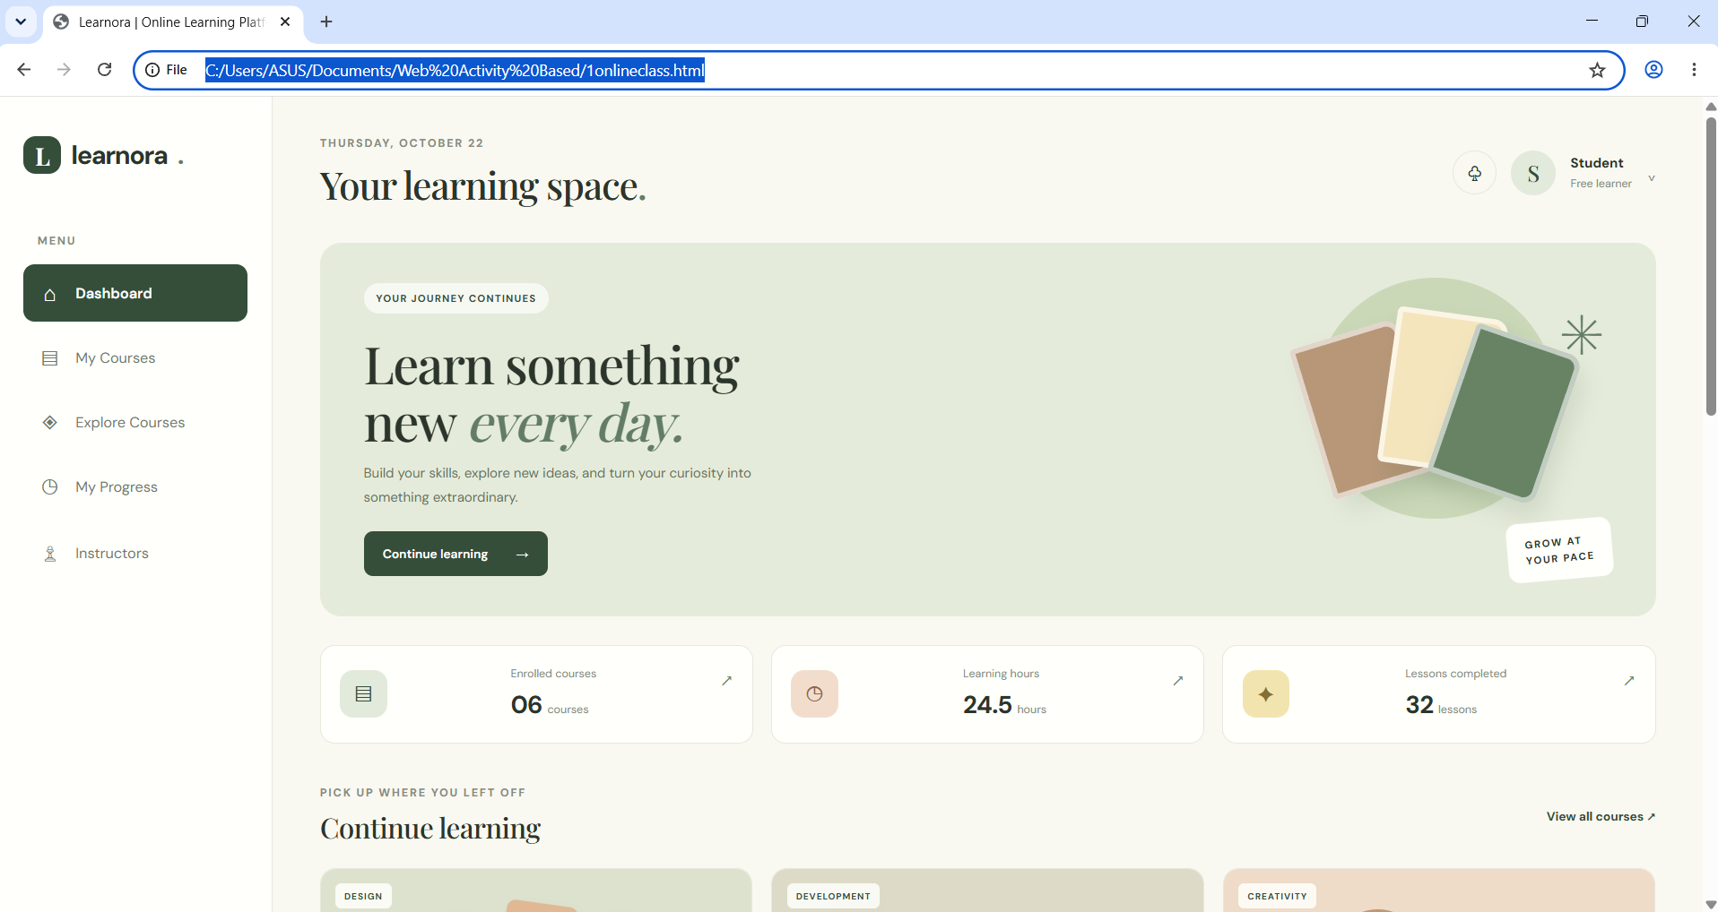
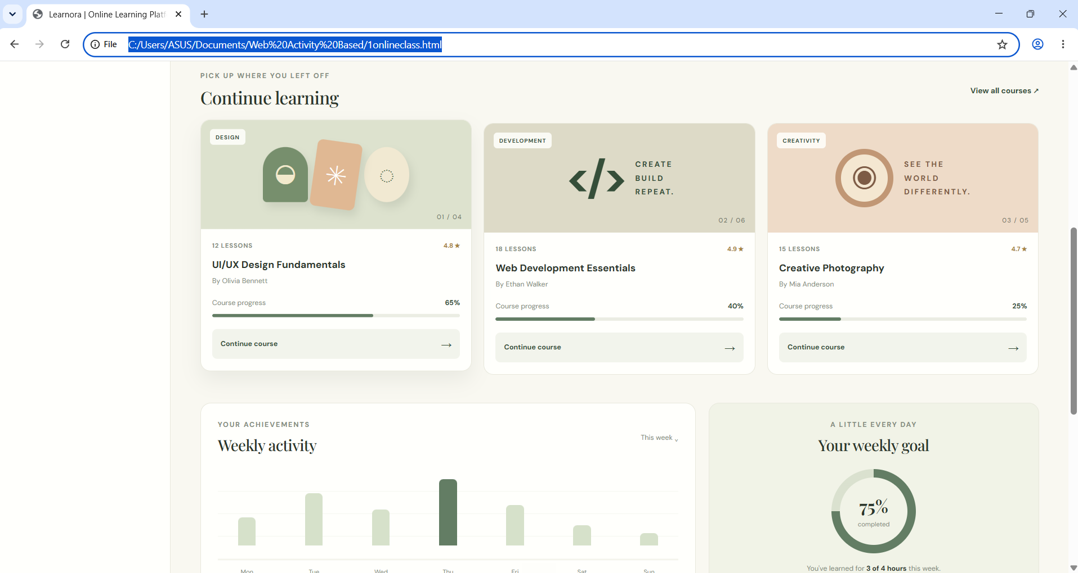

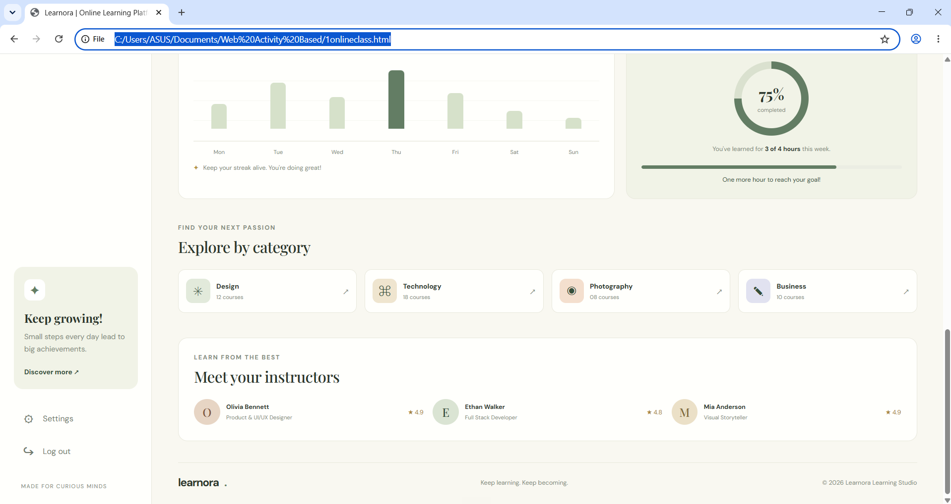

2. Dr. RVR NRIIT — College Website
The college website is a homepage concept bringing together college branding, navigation, campus information, academics, facilities, announcements, a gallery, and contact or enquiry details.

Technologies Used
HTML5 and CSS3

Main Features
- College header and branding.
- Navigation for Home, About, Academics, Facilities, News, and Contact.
- Hero section with a welcome message and call-to-action.
- Quick links for admissions and college information.
- Academics and facilities sections.
- News or announcements and campus gallery.
- Contact information and enquiry form layout.
- CSS layout, colours, image styling, and responsive presentation.
Files used: 2collegeadmission.html and 2collegeadmission.css

How to Run the Project
- Keep the HTML and CSS files together.
- Place referenced image files in the correct folder and check their filenames.
- Open 2collegeadmission.html in a browser.
Note: Static links and forms may need additional code or a service to perform real actions.

Output Screenshots
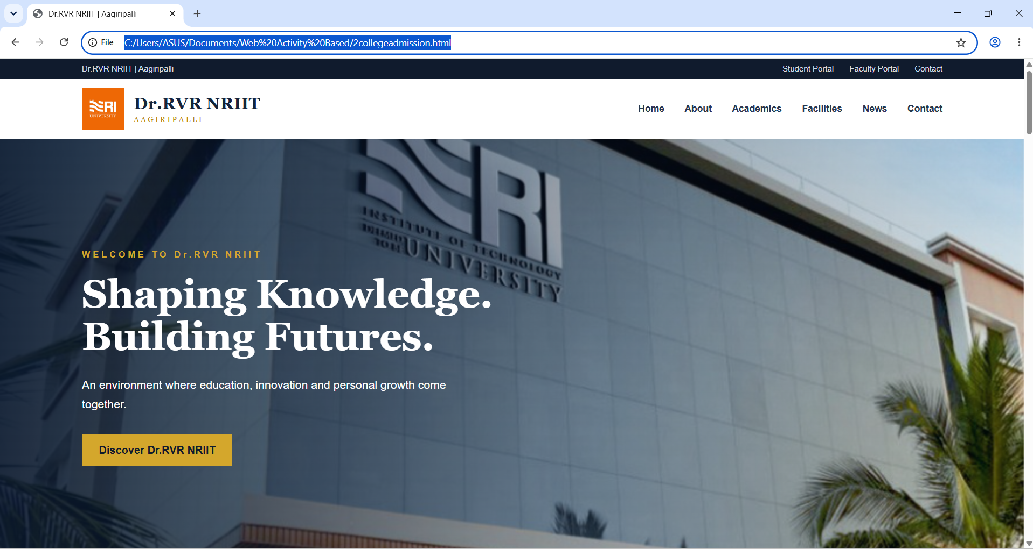

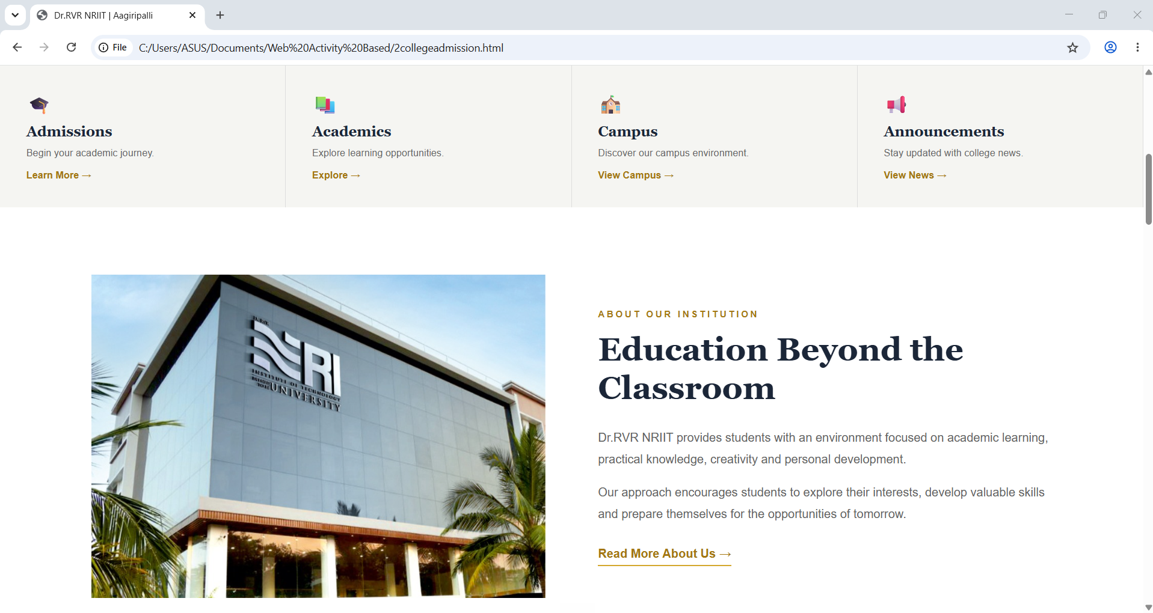
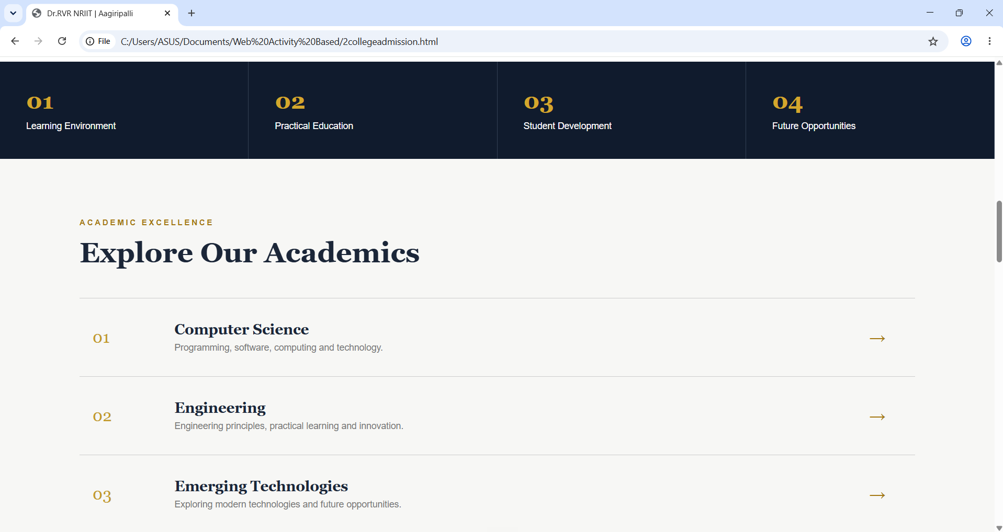
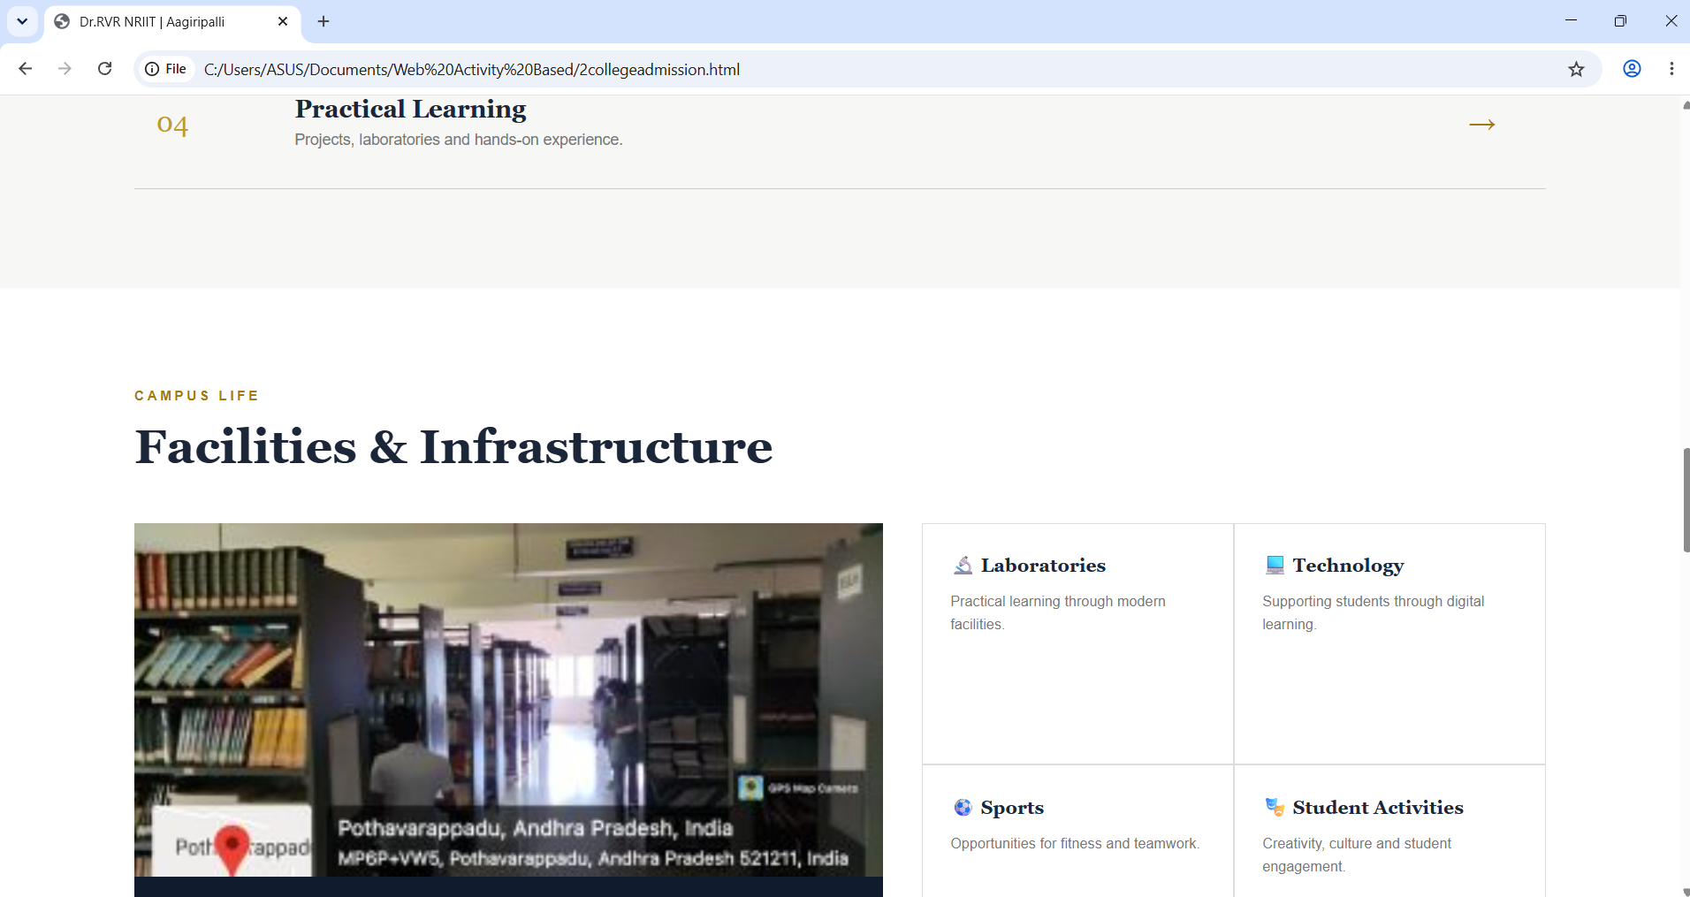
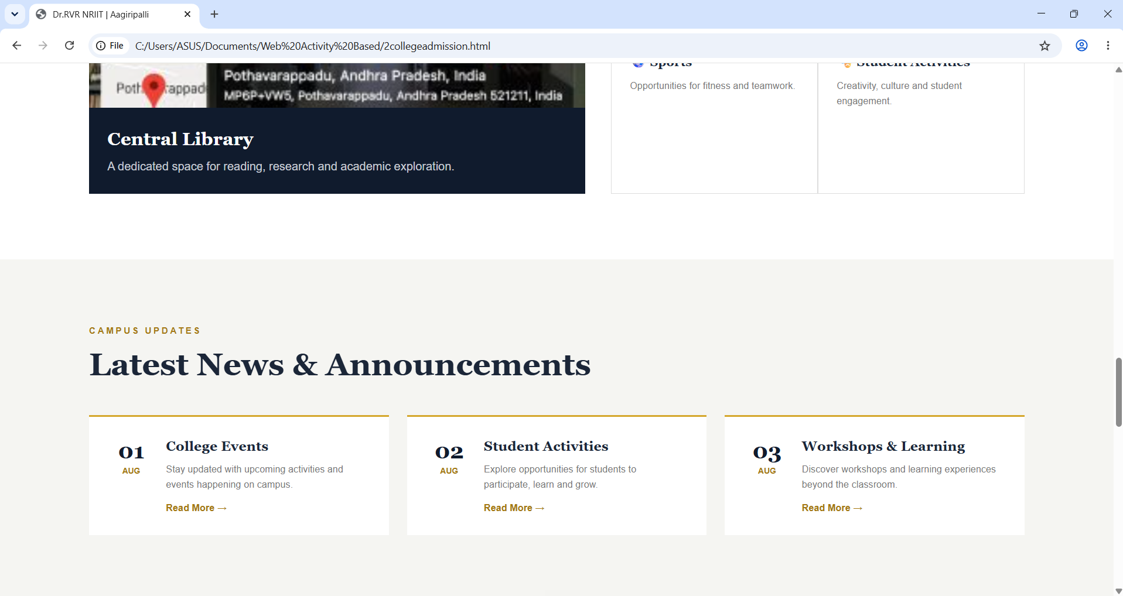
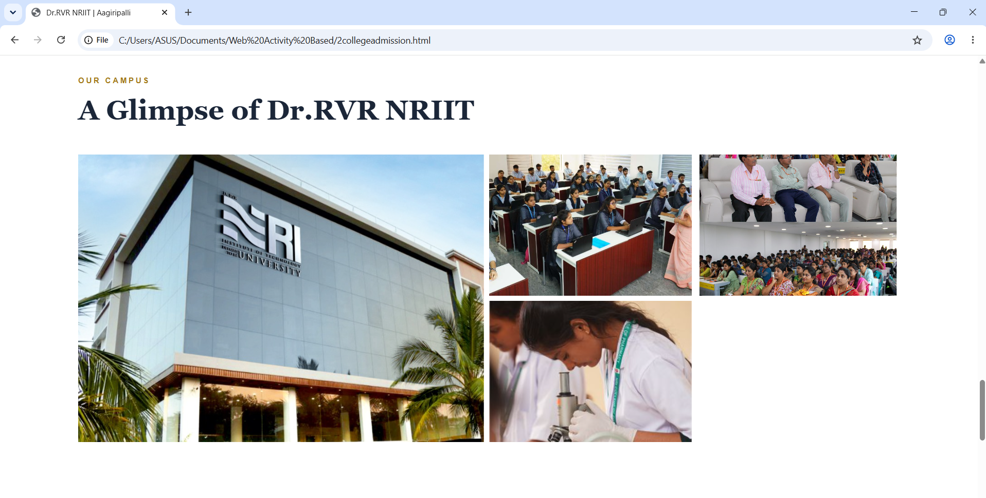
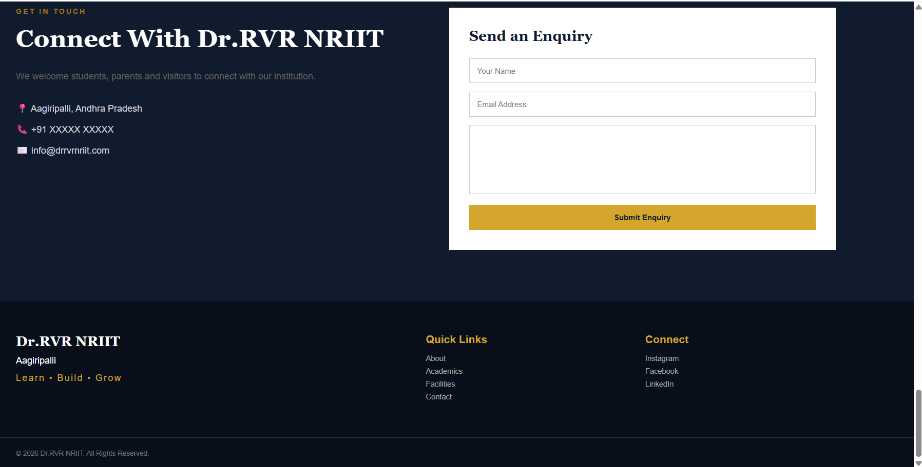

3. Dr. RVR NRIIT FEST 2026 — College Fest Website
The FEST 2026 website introduces a college festival with the theme “Celebrate • Connect • Create”. It presents festival information, a schedule, guests and performers, activities, food stalls, DJ Night, highlights, and contact information.

Technologies Used
HTML5 and CSS3

Main Features
- Navigation to the main fest sections.
- Hero section promoting FEST 2026.
- About section describing the festival theme.
- Event schedule with time, event, and location.
- Guest and performer cards with images.
- Games, activities, food stalls, and DJ Night sections.
- Festival highlights and contact/interest form.
- Dark theme with yellow or gold accents, hover effects, transitions, and responsive styling.
Files used: 26fest.html and 26fest.css

How to Run the Project
- Keep 26fest.html and 26fest.css together.
- Keep referenced guest images in the correct location.
- Check image filenames and open 26fest.html in a browser.
Note: External images may need internet access. The schedule and form are static unless connected to a backend service
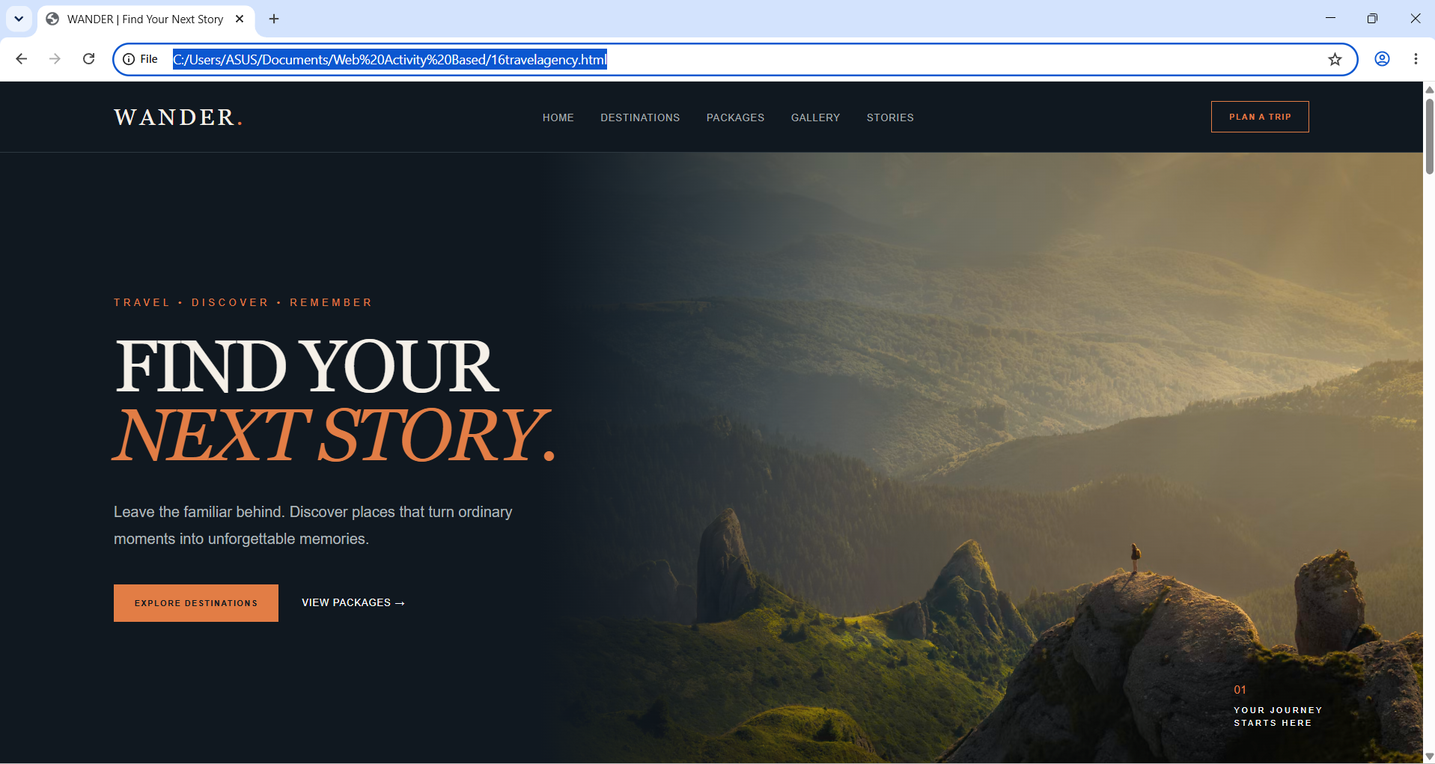
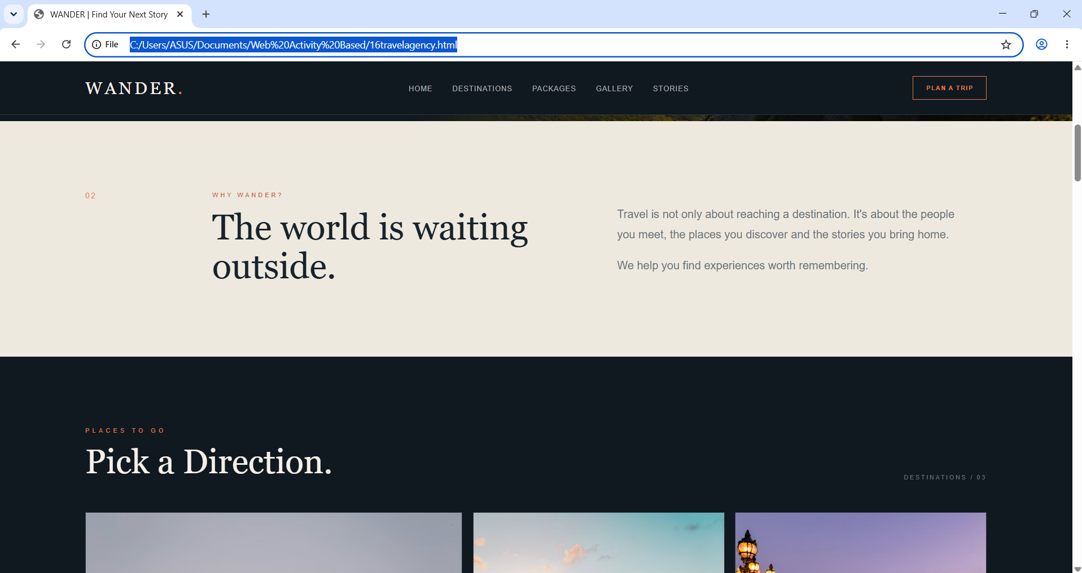
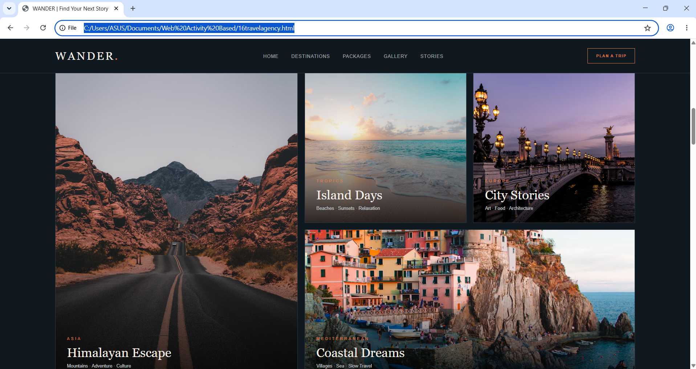
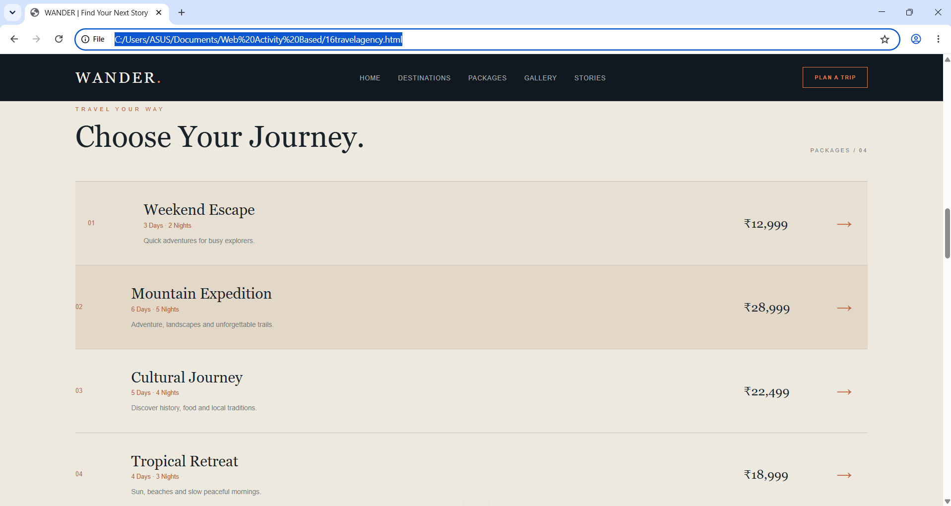

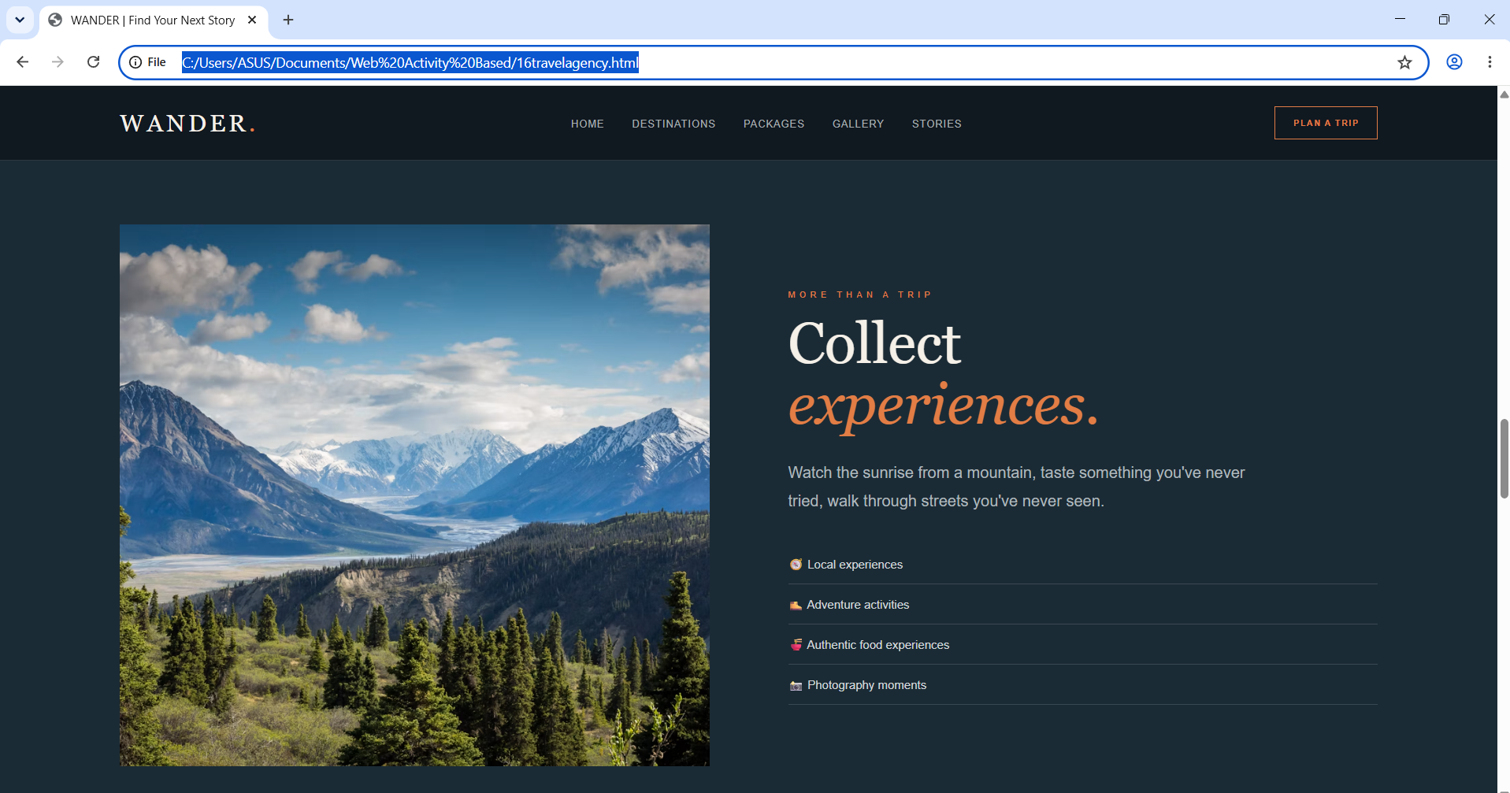

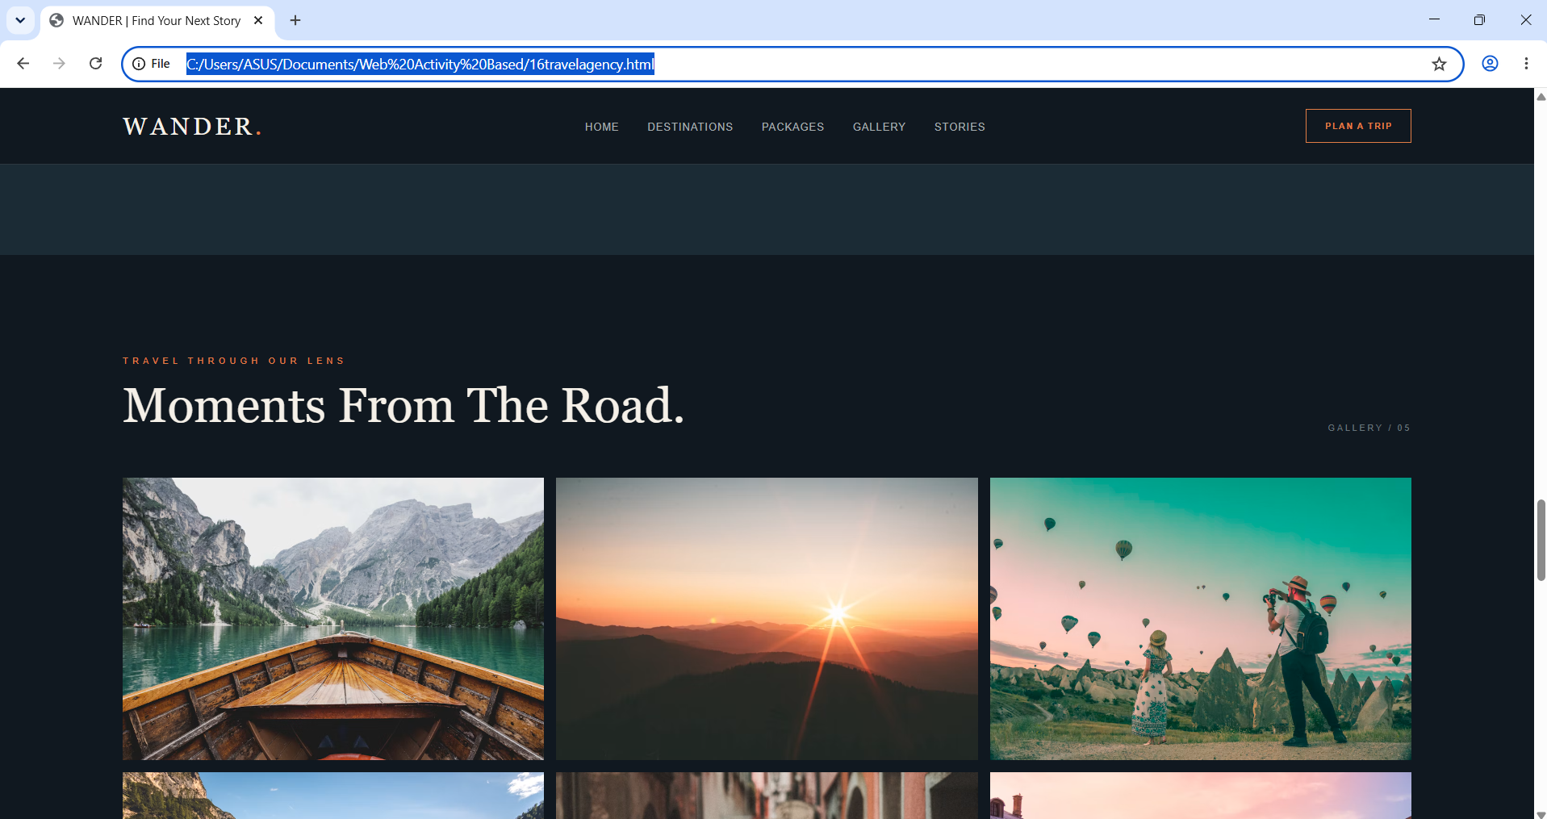

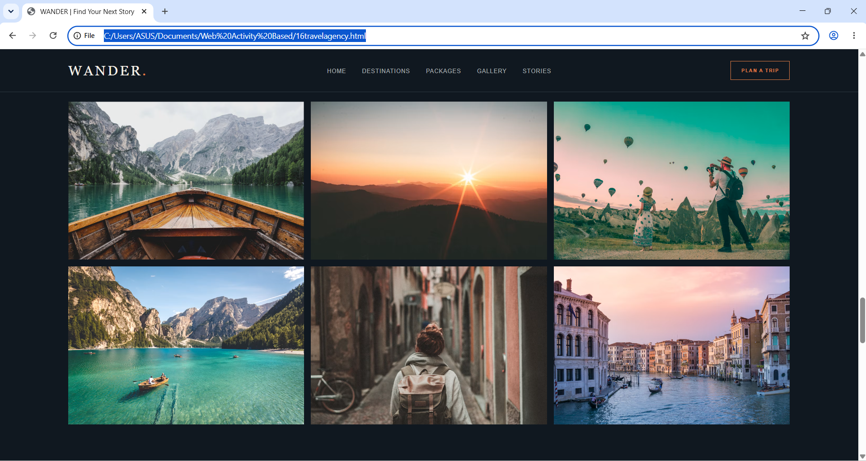

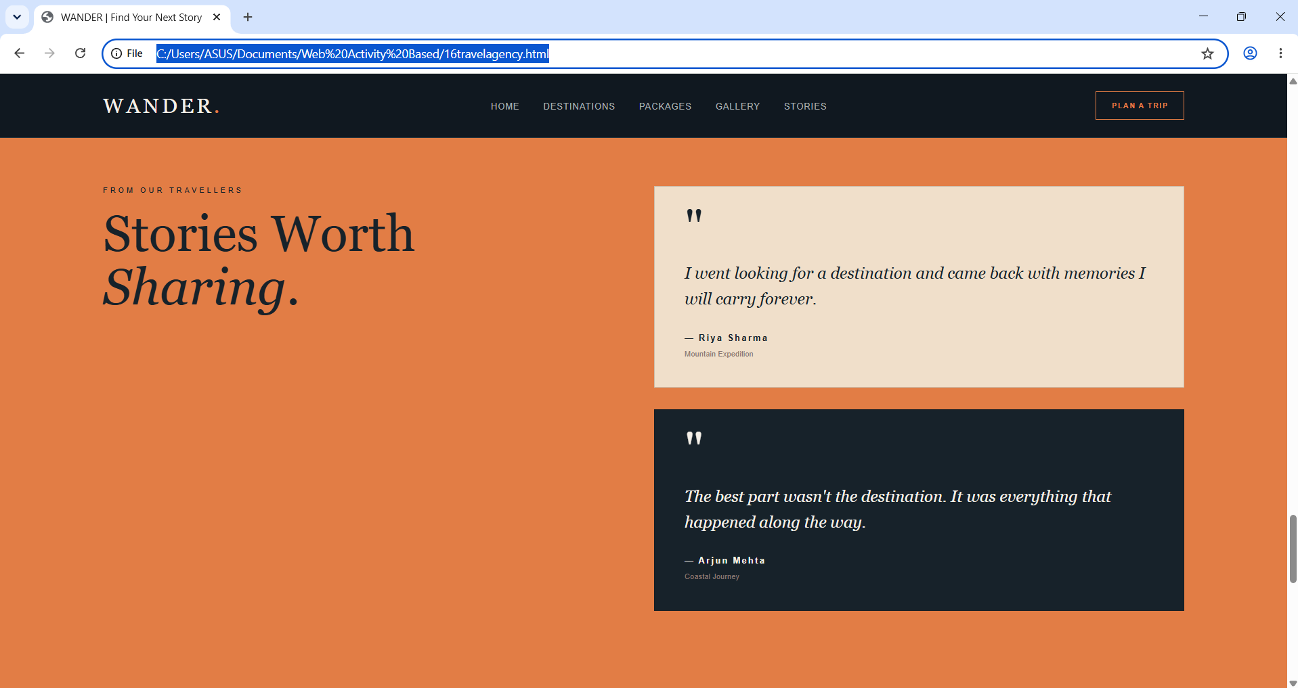

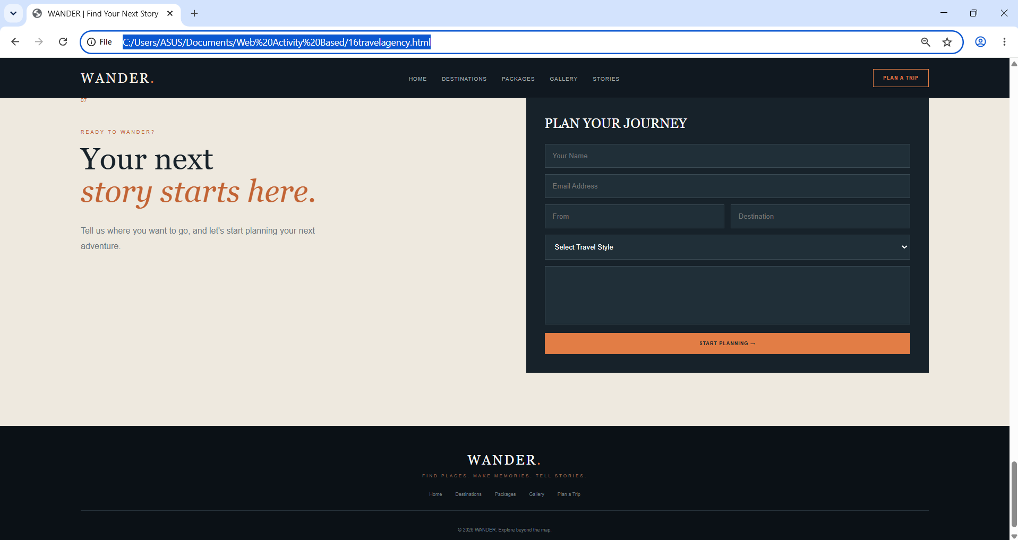

4. Velvet Table — Fine Dining Website
Velvet Table is a fine-dining restaurant website concept with an elegant dark visual style. It introduces the restaurant and organizes the menu, chef's special, dining experience, customer reviews, and reservations.

Technologies Used
HTML5 and CSS3

Main Features
- Navigation for Home, Menu, Experience, Reviews, and Reserve.
- Hero section with a reservation call-to-action.
- Restaurant introduction and chef's special feature.
- Menu section for food items and categories.
- Dining experience information and customer review cards.
- Reservation form with guest details, date/time, party size, and requests.
- Dark and gold-inspired theme, typography, interactive styling, and responsive rules.
Files used: 20restaurent.html and 20restaurent.css

How to Run the Project
- Keep 20restaurent.html and 20restaurent.css together.
- Place referenced local images in the correct folder and check their paths.
- Open 20restaurent.html in a browser.
Note: Menu details, reviews, and reservation controls are front-end content; actual booking requires a connected service.

Output Screenshots
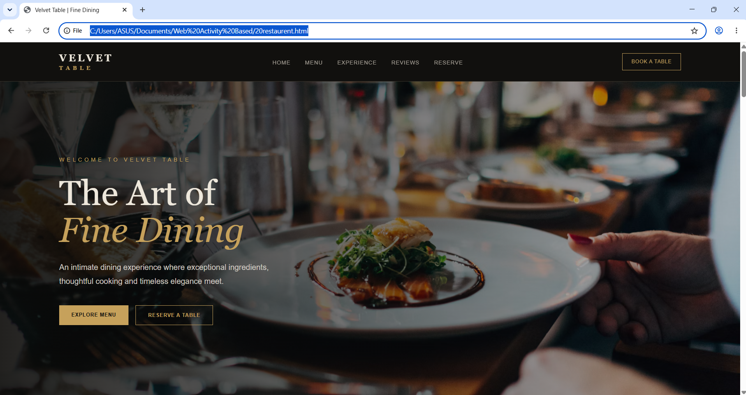

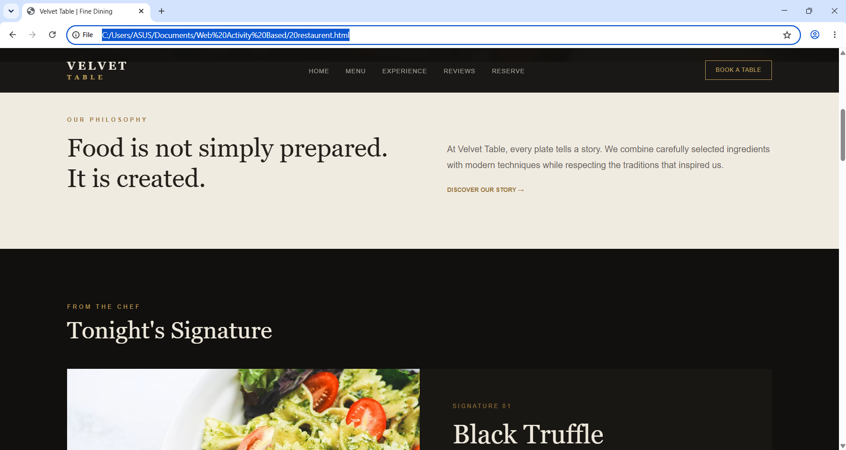

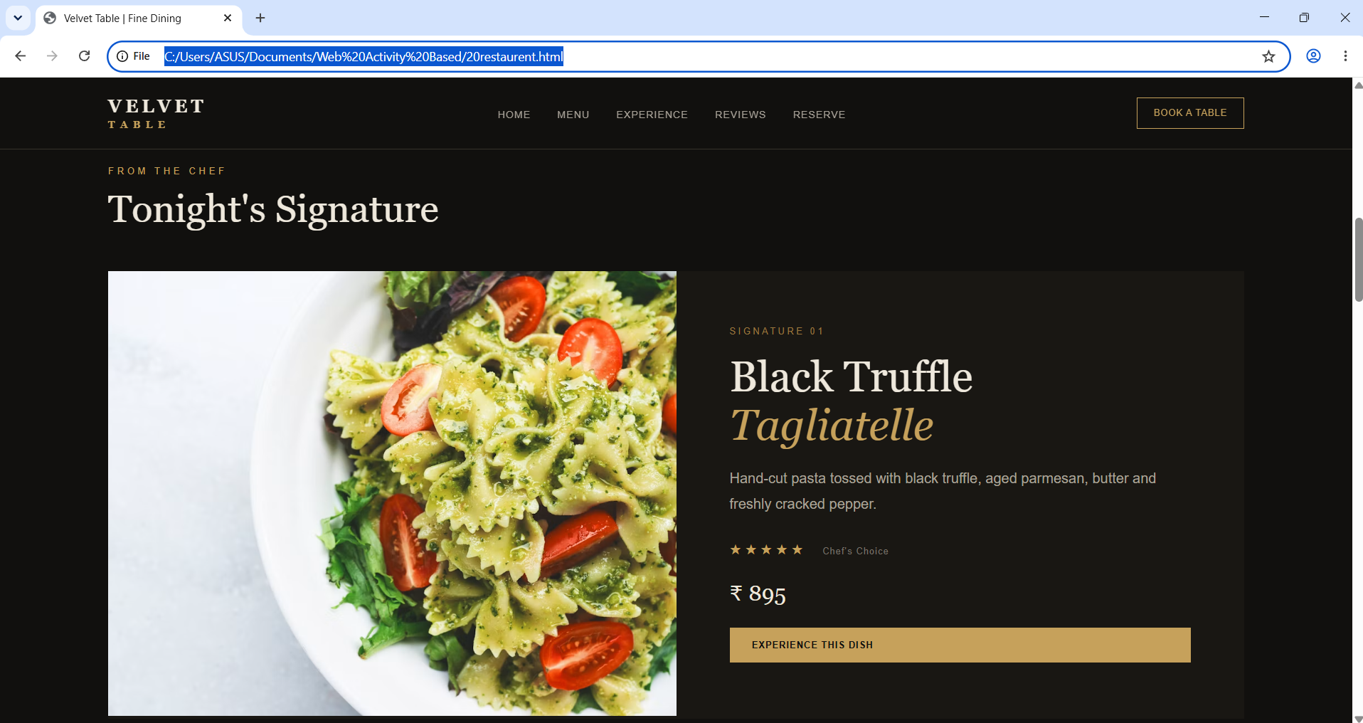

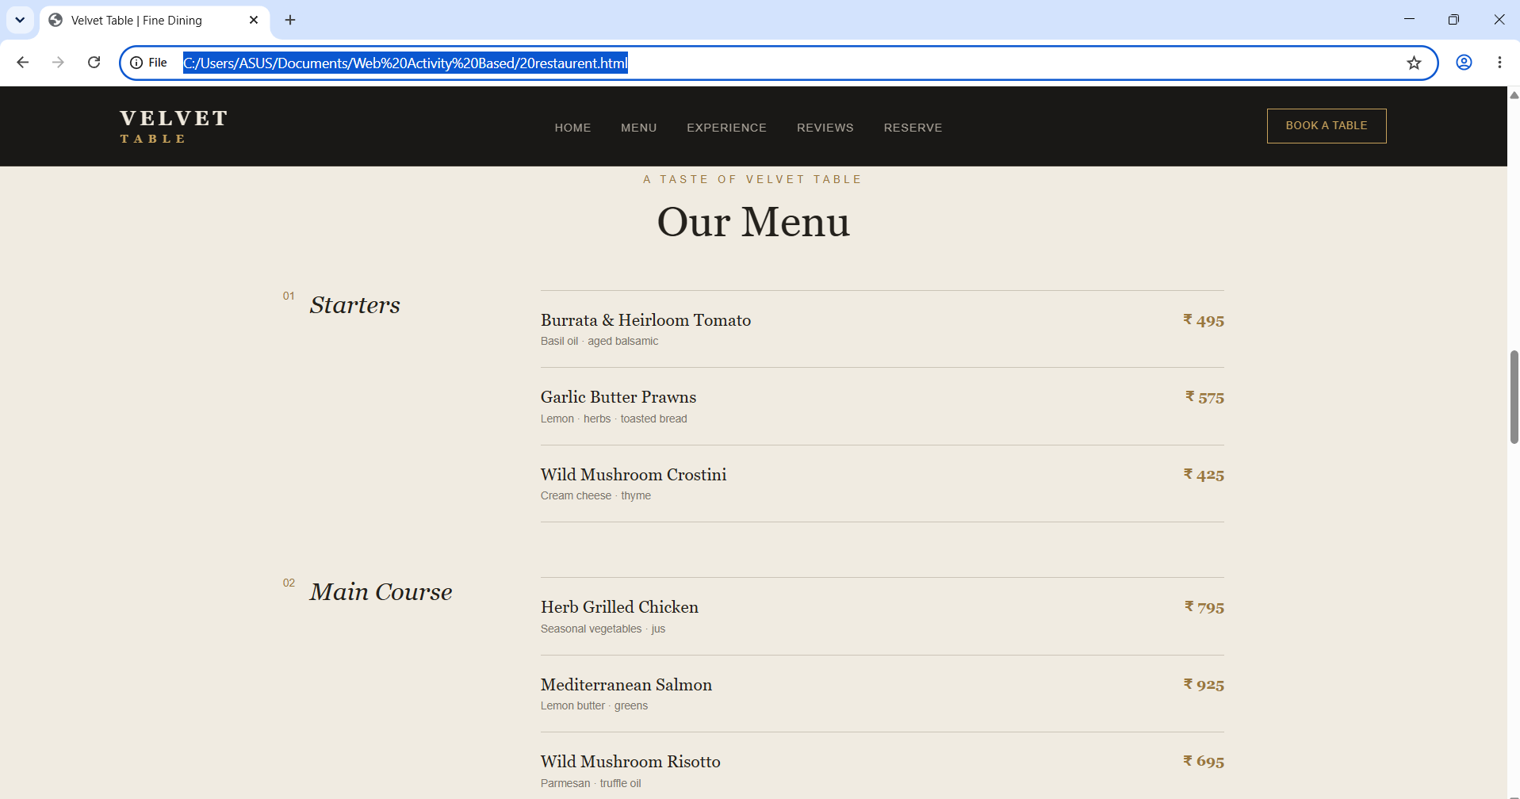

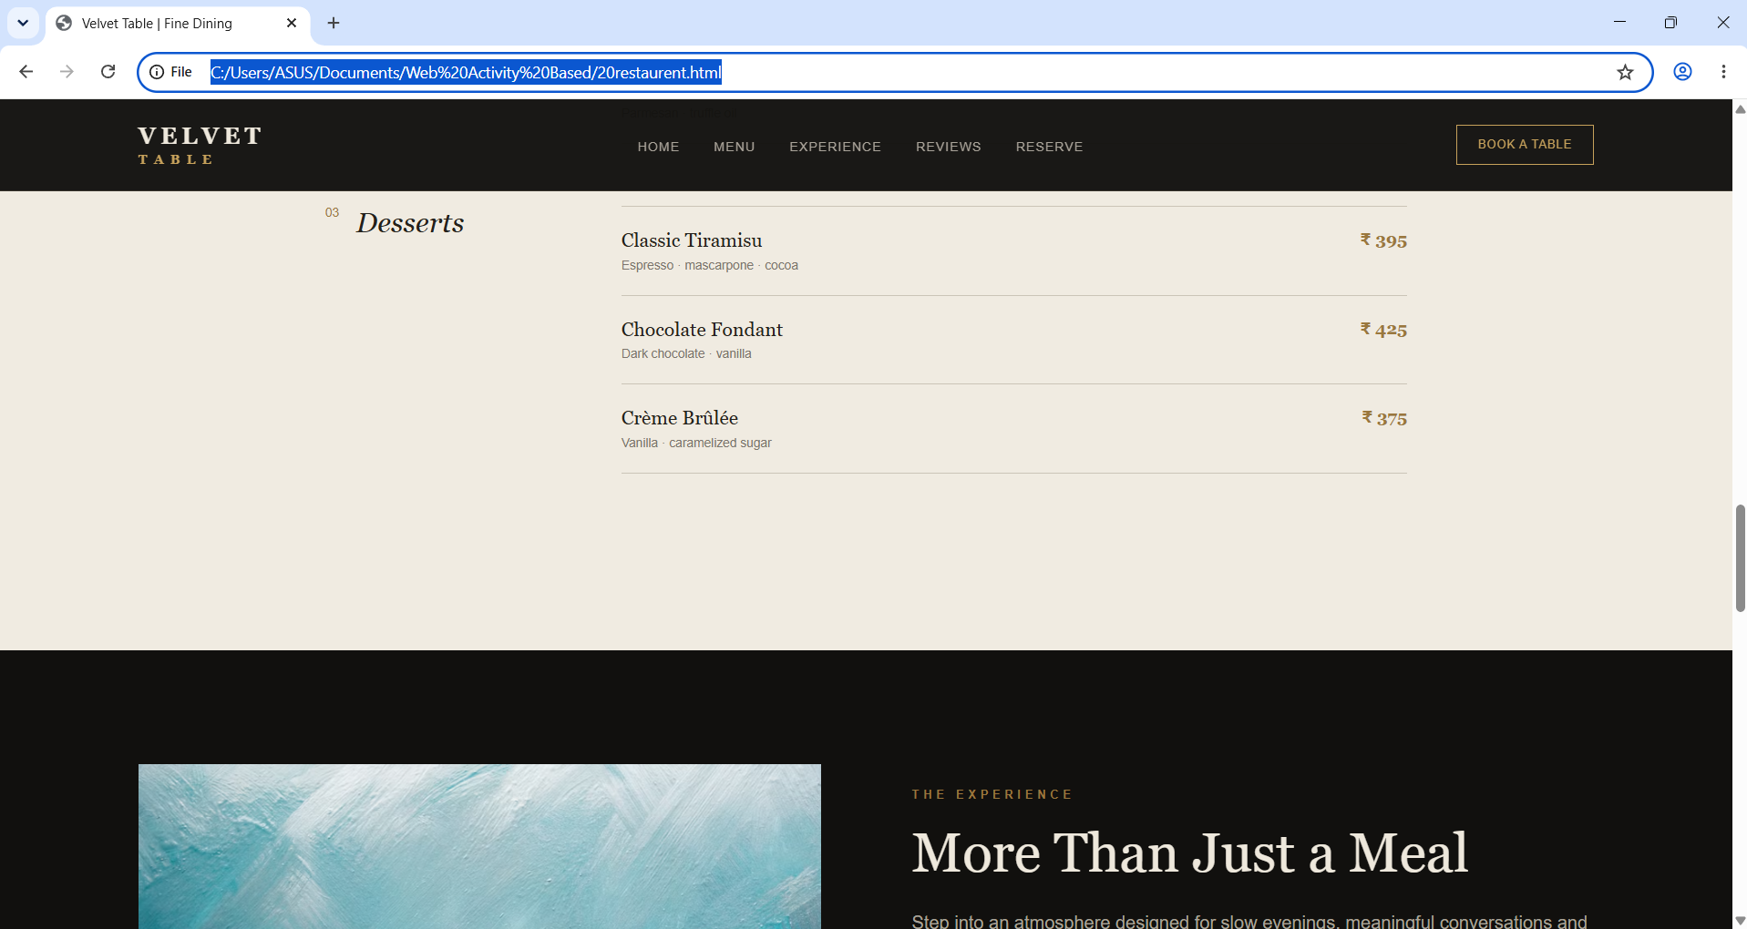

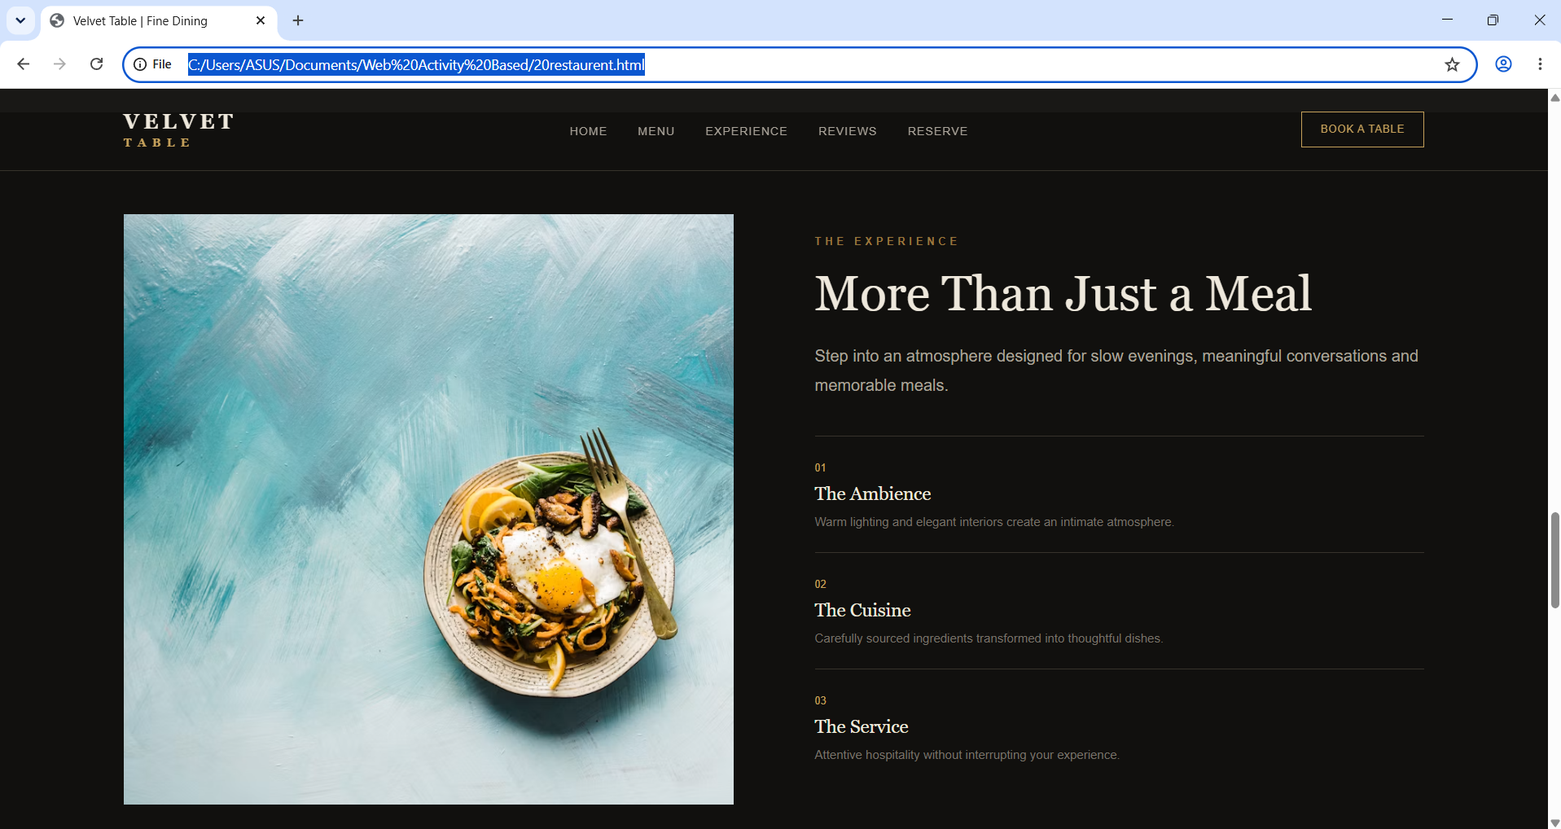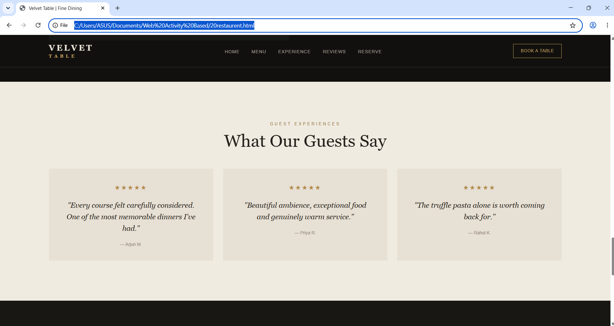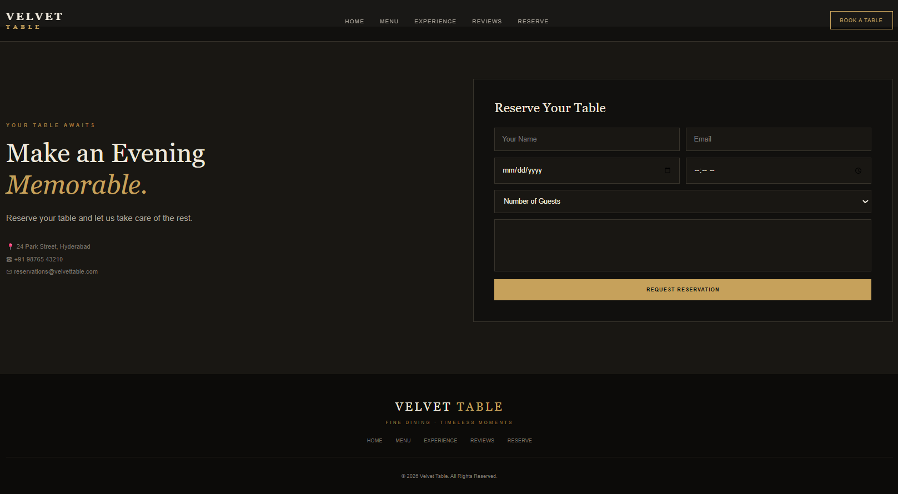

5. WANDER — Travel Agency Website
WANDER is a travel agency website concept focused on destination discovery and trip inspiration. Its message, “Find Your Next Story,” introduces sections for destinations, packages, a gallery, traveller stories, and trip planning.

Technologies Used
HTML5 and CSS3

Main Features
- Navigation for Home, Destinations, Packages, Gallery, and Stories.
- Plan a Trip call-to-action.
- Hero section introducing the travel theme.
- Destination cards and sample travel packages.
- Travel photo gallery.
- Traveller stories or testimonials.
- Trip-planning form section.
- Image overlays, structured layouts, hover effects, and responsive styling.
Files used: 16travelagency.html and 16travelagency.css

How to Run the Project
- Keep 16travelagency.html and 16travelagency.css together.
- Ensure referenced local images are available.
- Open 16travelagency.html in a browser.
Note: External images may require internet access. Actual trip booking requires a connected service or backend.

Output Screenshots
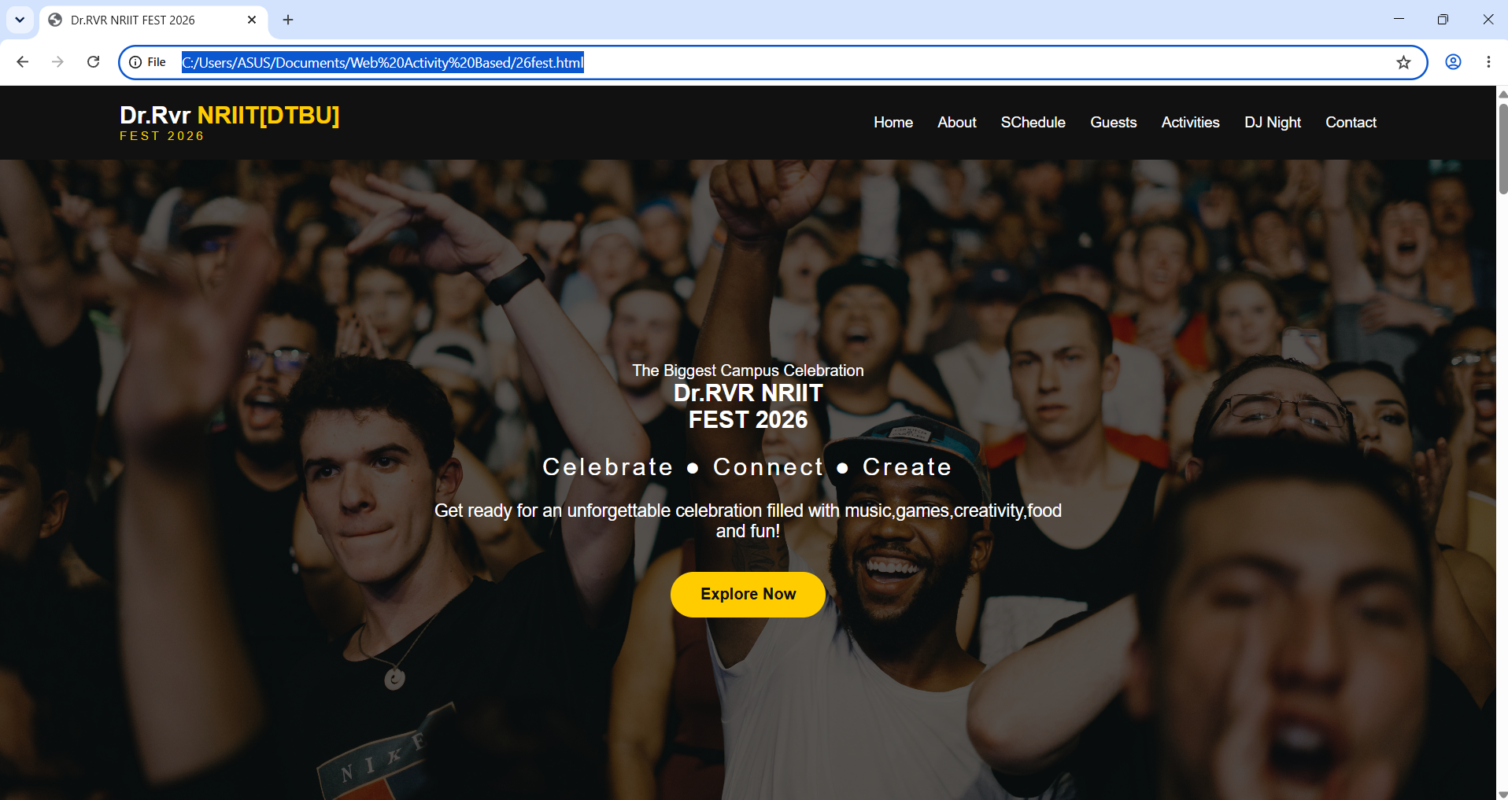

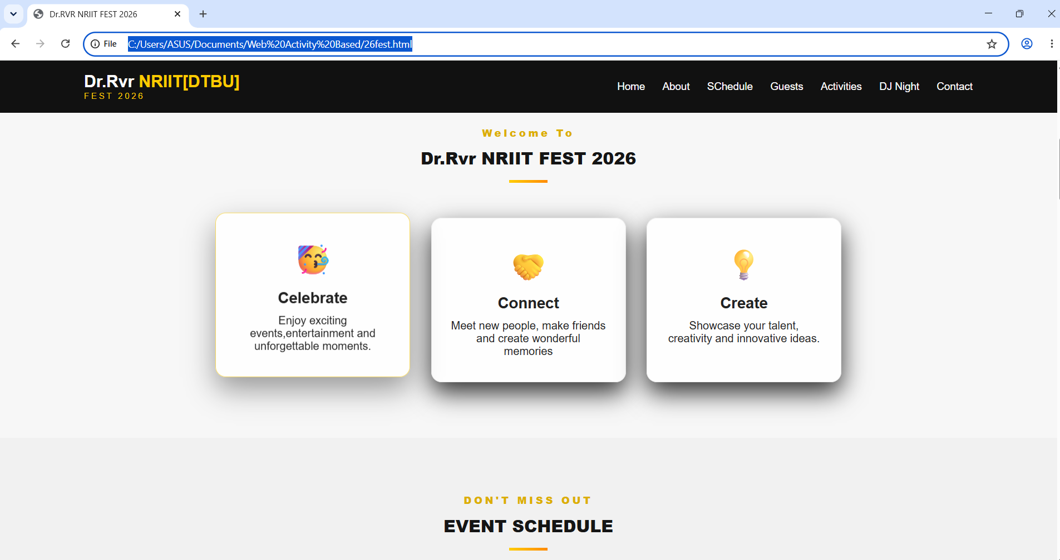

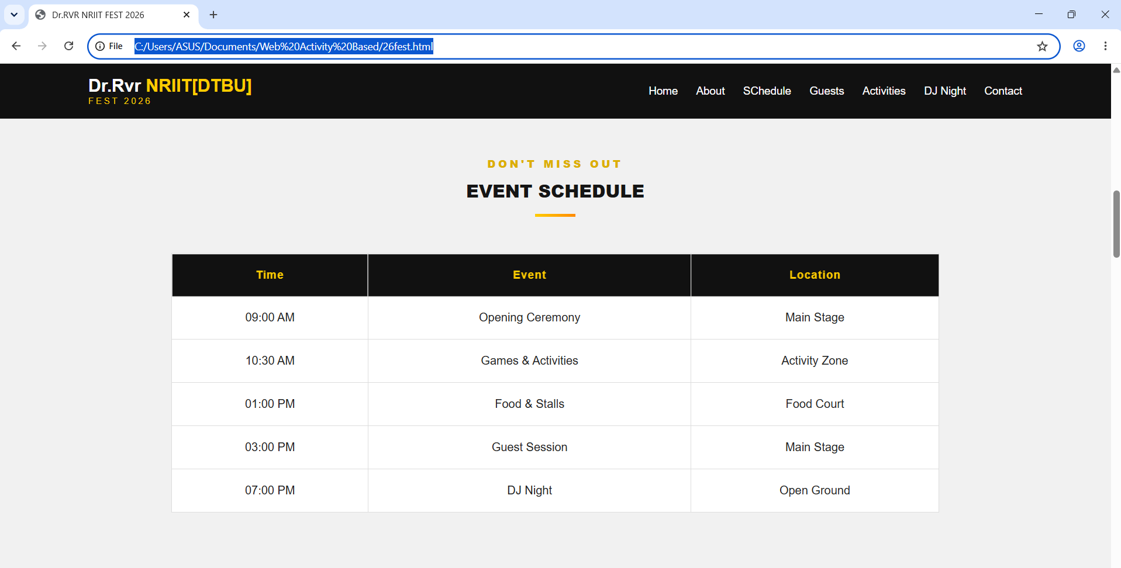

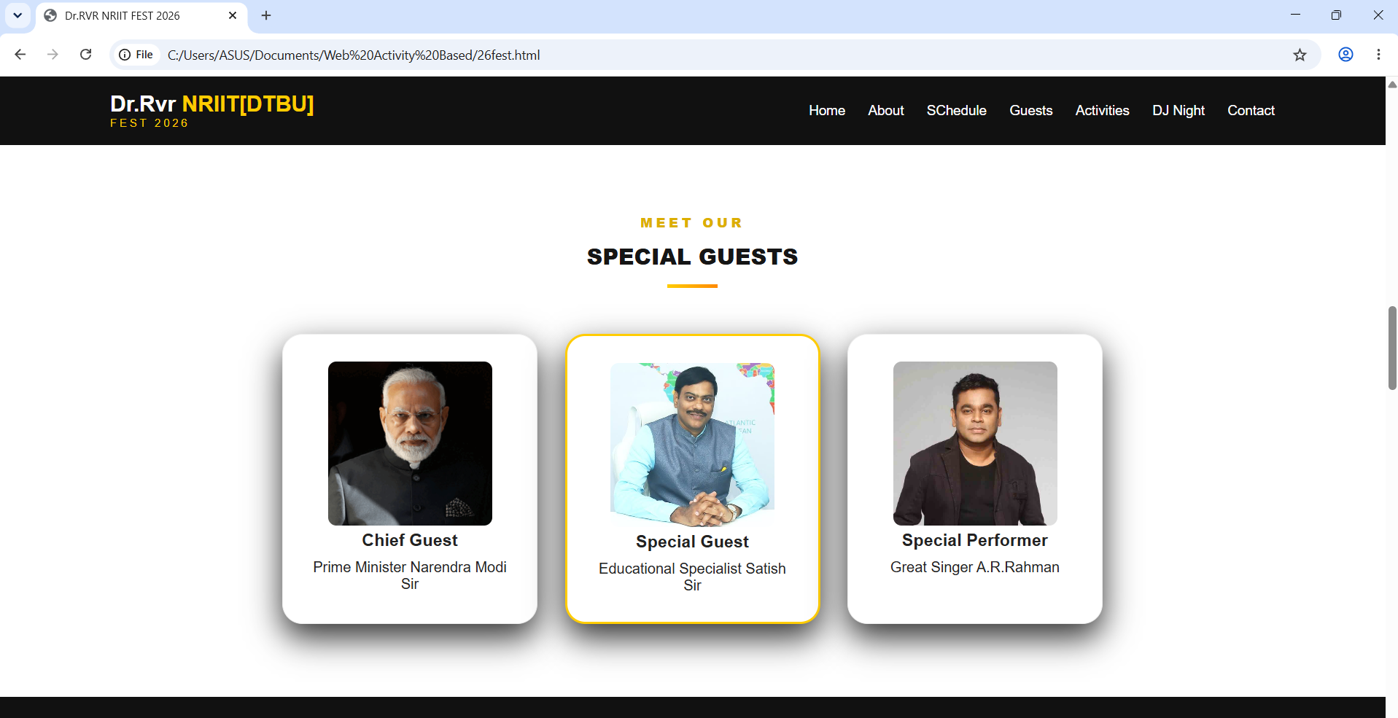

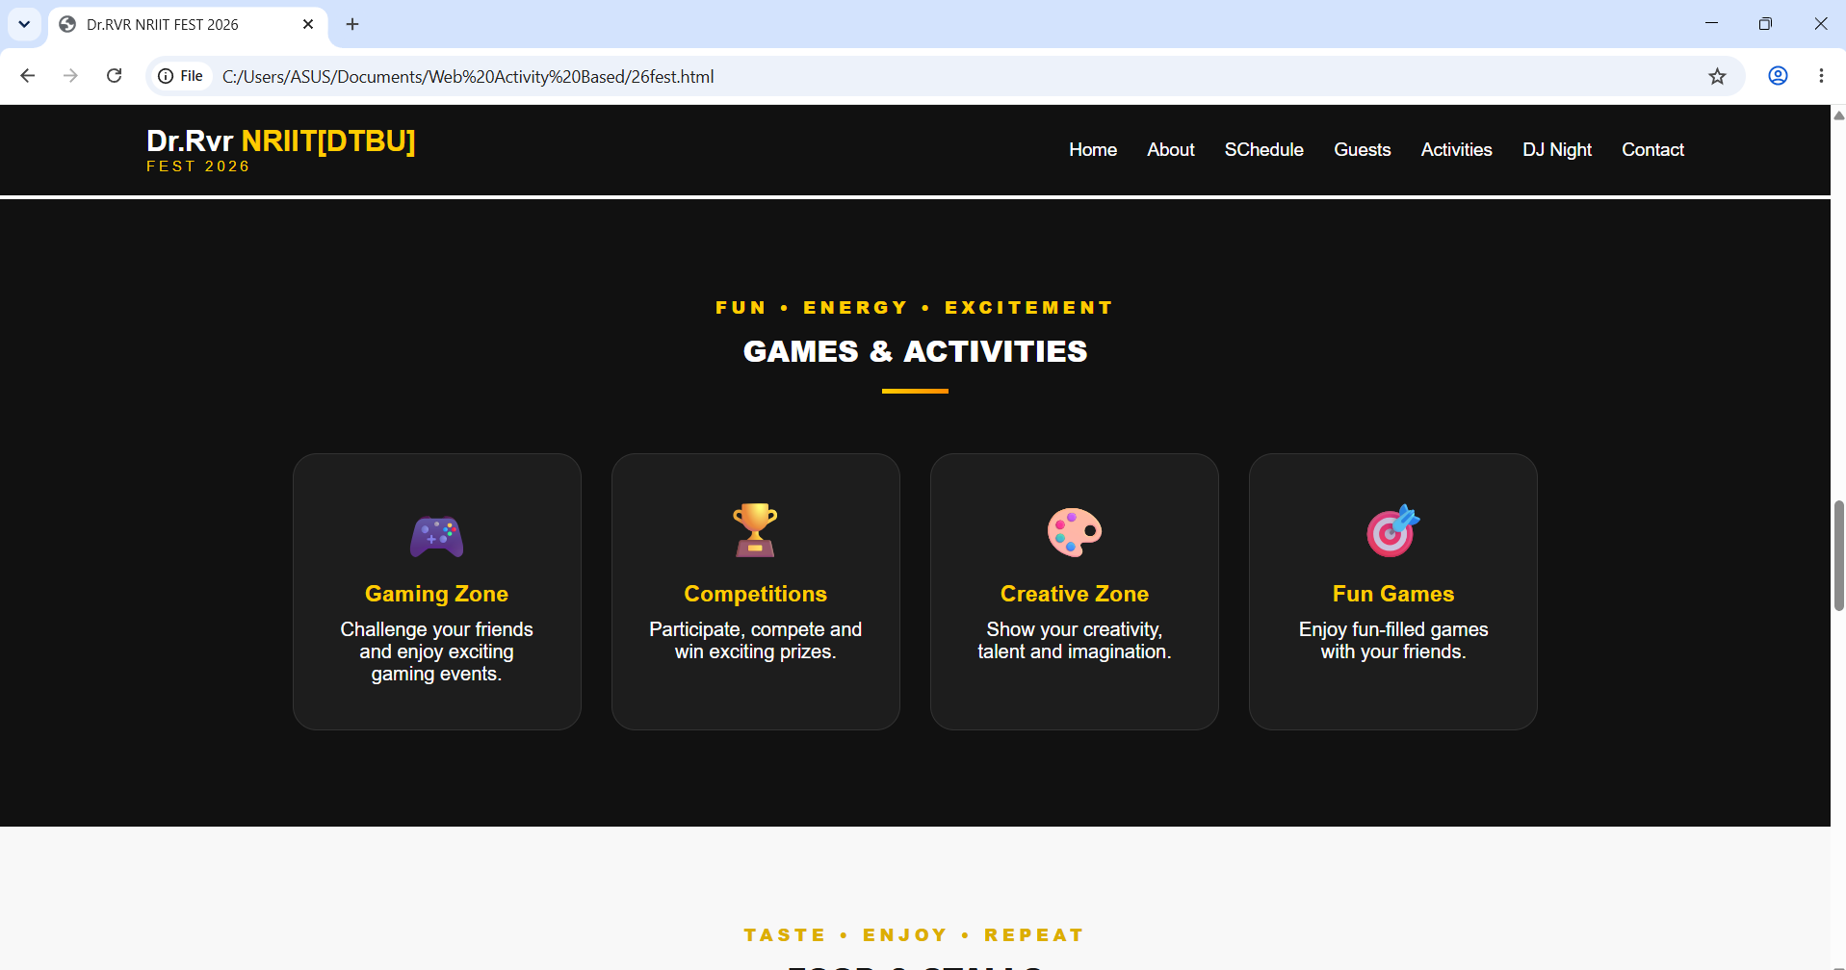

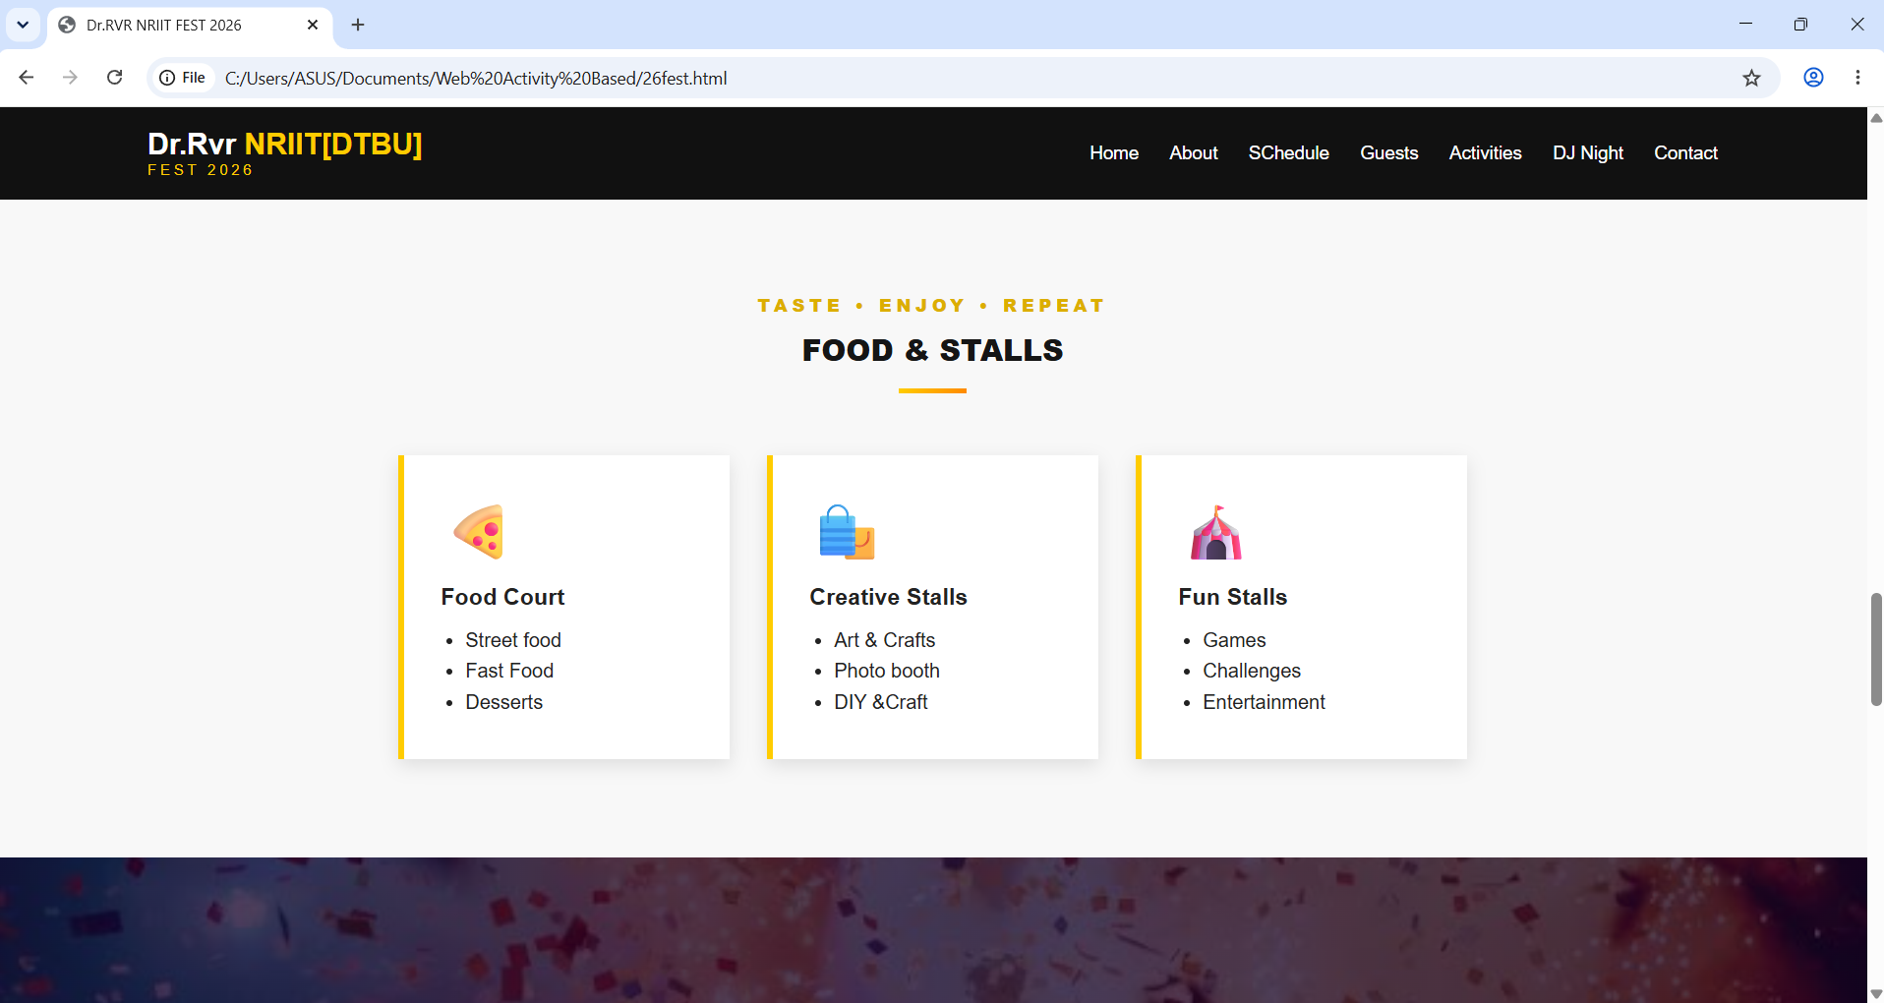

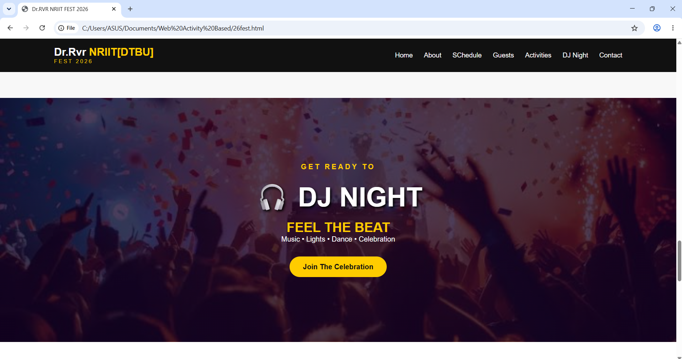

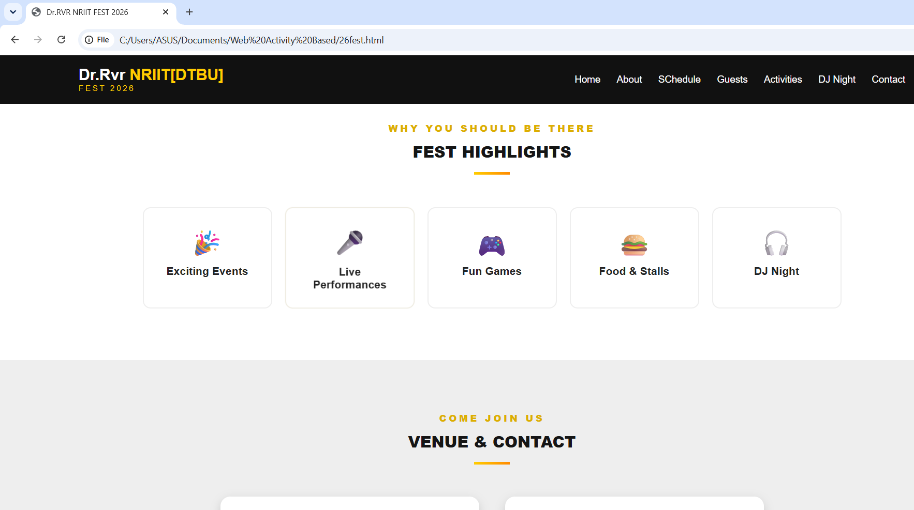

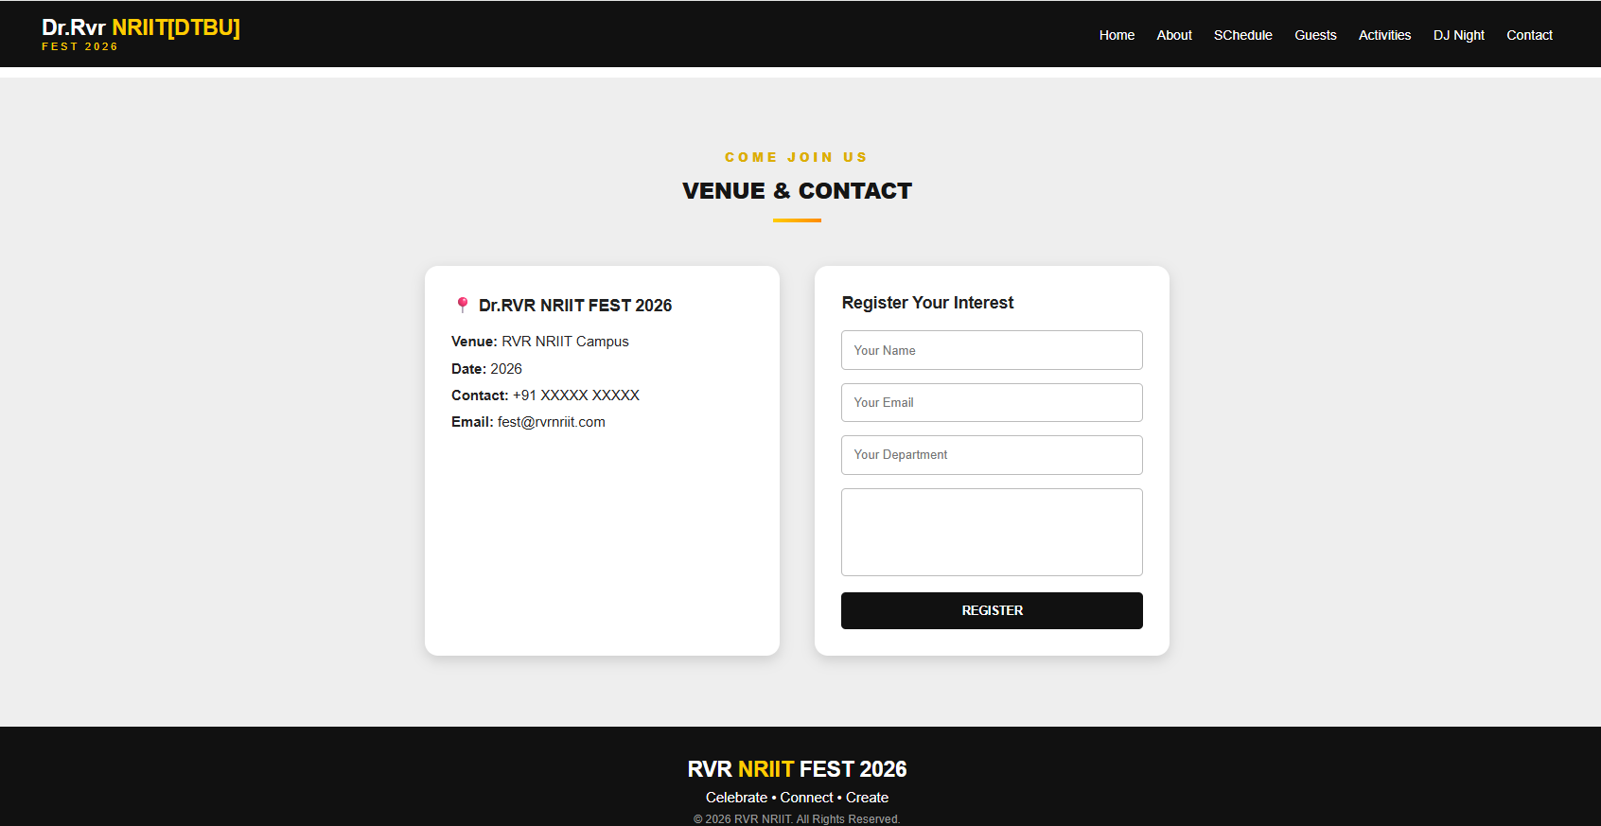

Conclusion
These five projects demonstrate practical use of HTML and CSS to build an online learning dashboard, a college website, a college festival website, a restaurant website, and a travel agency website. Together, they provide practice with webpage structure, navigation, cards, forms, tables, images, visual styling, and responsive layouts.

