# Kinematics and Dynamics of Fixed Wing UAVs[1]

Vladimir, Dobrokhodov

Naval Postgraduate School, Mechanical and Aerospace Engineering department

Monterey, CA

United States

## Abstract (A 250 word brief about the chapter. The online version will feature this)

The chapter provides a review of fundamental knowledge required for accurate mathematical modelling of flight of a fixed wing aircraft modelled as a rigid body. The chapter provides an introduction to the coordinate frames, coordinate frames transformations and differential rotations. Kinematics of the coordinate frames is what connects position and orientation coordinates and transforms forces and moments acting in different frames. Understanding of reference frames and their dynamics will be essential for the guidance, navigation and control systems design. The chapter further provides the detailed derivation of the equations of motion using Newtonian approach.

It is shown that these two techniques complement each other in the cases when environmental or structural interactions of the UAV need to be taken into account. The chapter explains when each of the techniques need to be employed and shows the point of convergence where the results provided by both techniques are the same.

## Introduction

The chapter objective is to provide an overview of the necessary theoretical material to enable reliable mathematical modelling of the free and controlled motion of a generic fixed wing UAV. Besides the equations of motion describing the kinematics and dynamics of a rigid body motion, the tools and methods developed in this chapter contribute significantly into the UAV flight dynamics, system identification, control, guidance and navigation. Although the subject is not new and is well presented in existing literature, the rapid advancements of last decade in research and development of fixed wing UAV technologies open new applications that require revision of the existing assumptions. New materials, novel structural designs, new aerodynamic configurations, advanced onboard instrumentation including miniature sensors, actuators, and tremendous onboard processing power enable much wider operational envelop of fixed wing UAVs and significantly higher utility of their payloads. Depending on the UAV configuration the standard 12 equations of motion might not suffice the task at hand and require deeper consideration of the UAV components interaction.

The chapter starts with some preliminaries required to describe kinematics of a rigid body free motion in 3D space. Thus, the kinematics of 3D rotation is introduced first. The most commonly used coordinate frames that are utilized in the description of UAV states are presented next. Applying the kinematics of rotating frames to a set of specific coordinate frames builds the basis for a convenient description of the forces and moments acting on a fixed wing airplane. The derivation of linear and angular momentum equations results in the generalized set of 6 Degree of Freedom kinematic and dynamic equations. A brief discussion of the fluid dynamics approaches most widely used to describe the aerodynamics forces and moments acting on an airplane concludes the chapter.

The Lagrangian formulation, in contrast, is independent of the coordinates, and the equations of motion for a non-Cartesian coordinate system can typically be found immediately using it

## Reference Frames and Coordinate Transformations

In order to accurately describe a body motion it is required to define (i) the forces and moments acting on the body and thus resulting in the body motion, and (ii) the coordinate system that can be used as a reference for the motion states definition. It is important to note that there two types of forces acting on a body in free motion. First, the inertial forces and moments that depend on the velocities and accelerations relative to an inertial reference frame. Second, are the aerodynamic forces and moments resulting from interaction of the body with the surrounding airflow and therefore relative to the air. Since the airflow might not be stationary and in turn can be arbitrarily moving with respect to the body, it is therefore convenient to describe the resulting aerodynamic forces and moments caused by the air-body interaction in the coordinate frames connected to the body and to the air surrounding it. The resulting motion can be conveniently described in terms of the position, velocity, and acceleration – the navigation states of the moving body. These navigation states, in turn, need to be defined with respect to a reference which choice is defined by the specifics of the UAV application. Thus, the information carried by various reference frames is what facilitates the complete and convenient definition of the free body motion.

Therefore, the section starts with a generalized definition of a coordinate frame and the description of the coordinate frame rotation. The reference frames required to represent the aerodynamic forces and moments and facilitating the solution of the navigation states are introduced next. Communication of the states information occurring during the coordinate frame transformation is presented next for the major coordinate frames. The section ends with a set of kinematic equations required to represent the transition of linear and angular accelerations.

### Kinematics of moving frames

The objective of this subsection is to define a coordinate frame transformation and the associated mathematical formalism. Namely, the direct cosine matrix is introduced and its key properties are presented. The DCM formalism is then followed by a differential rotation that defines the rate of change of the rotation matrix. A fundamental property of simple summation of angular rates is introduced next. The section end with a detailed presentation of the coordinate frames used to describe the six degree of freedom motion of a rigid body. The formal results of this initial development are heavily utilized along the entire chapter.

An arbitrary motion of a rigid body can be described by a transformation that consists of translational and rotational components. First, address the pure rotation of a rigid body. Consider the two orthogonal coordinate frames rotated with respect to their mutual origin by angle as and a vector  as shown in Figure 1.

|  |  |
| --- | --- |
|  |  |

From this geometrical setup it can be easily demonstrated that vector  can be uniquely defined in both frames as follows.

Figure . The same plane rotation considered with respect to two and three axes



Introducing matrix notation for the linear transformation above results in a simple form that relates the vector  components in  frame to the corresponding components in frame:



The resulting rotation matrix is called a directional cosine matrix (DCM); the matrix consists of cosine and sine functions which are the direction cosines between corresponding axes of the new and old coordinate systems. Following the same approach it can be easily demonstrated that for the case of three axes, the same rotation results in transformation

,

where for clarity the subscript  denotes the axes of rotation. Proceeding similarly, a right handed rotations of the coordinate frame about the  and axis give



It is worth noting that the DCM transformation has the following easy to remember properties that simplify its application, see more details in :

1. The transformed vector components along the axis of rotation remain unchanged with the rotation about that axis; elements of DCM are either 0 or1.
2. The remaining element of DCM are either or of the angle of rotation.
3. The  elements are on the diagonal with elements on off-diagonal.
4. Negative  component corresponds to the component rotated “outside” of the quadrant formed by the original frames.
5. Columns (rows) of a DCM matrix form an orthonormal set.

It is straightforward to verify that a DCM matrix have the following properties:



and therefore belongs to a general class of orthonormal transformation matrices. For a sequence of rotations performed with respect to each of the orthogonal axis the resulting transformation can be obtained by a matrix composed of three sequential rotations, called Euler angles, starting from the original frame of reference, see Figure 2.

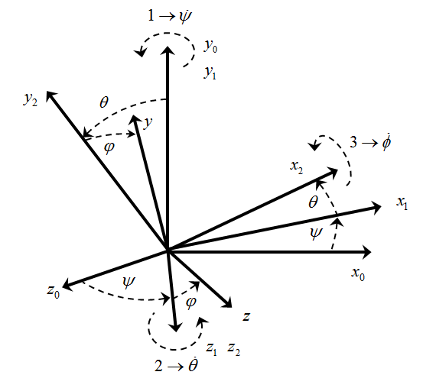

Figure 2. Three consecutive rotations.

Formally, this transformation is accomplished by rotating through the ordered sequence of Euler angles, where the numerical indexes define the ordered sequence of transformations.



It t is worth noting here that the corresponding Euler angles are also widely used instead, so that in the following notation is possible. Therefore, a vector  described in one coordinate frame can be described in another coordinate frame of arbitrary orientation with respect to the original frame by a transformation matrix  composed of three sequential rotations as follows.





This matrix, that represents a transformation resulting from three sequential Euler angles rotations, will be used throughout the chapter.

Overall, any DCM matrix has a number of properties. They are summarized here for completeness; an interested reader is referred to reference for more details:

* Rotation matrices are orthogonal.
* The determinant of a rotation matrix is unity.
* Successive rotations can be represented by the ordered product of the individual rotation matrices.
* Rotation matrices are not commutative, hence, in general case.
* A nontrivial[2] rotation matrix has only one eigenvalue equal to unity with other two being a complex conjugate pair with unity magnitude.

The time rate of change of the DCM matrix that defines the dynamics of the attitude states is important in derivation of the kinematic equations of motion. As it will be shown shortly it enables relating the sensor measurement obtained in a body fixed frame to the time derivatives of the Euler angles describing the attitude of a body in an inertial frame.

Obtaining the time derivative of a DCM matrix can be obtained utilizing a linearization technique. Consider the variation of the DCM matrix resulting from three infinitely small consecutive rotations performed over an interval of time. Utilizing the small angles approximations of  and  functions and neglecting the higher order terms it follows that:



Utilizing at any given time, the values of at the time can be expressed by

,

where .

The time rate of change of the DCM matrix is then defined as





where



and is the vector of angular velocities. The rotation matrix  can be viewed as a rotation of the frame with respect to frame  measured in the frame. It can be observed that matrix is a skew symmetric matrix  and therefore the transposed equivalent of the rate of rotation is



Another useful general property of angular velocities is called the angular velocities addition theorem . The theorem states that for angular velocity vectors coordinated in a common frame the resulting angular velocity of the cumulative rotation is a plain sum of the contributing rotations. In application, for example, to  in the theorem results in, where  are the directional unity vectors defining the intermediate coordinate frames. Now, if a rotating frame is given by a set of time varying Euler angles defined with respect to a stationary frame, then it is straightforward to determine the components of the angular velocity vector as if it was measured in the rotating frame. Starting from an initial stationary frame  (see Figure 2) and using two intermediate frames whose relative angular velocities are defined by the Euler angle rates, and utilizing the angular velocities addition theorem, we obtain



Substituting the corresponding DCM matrices from results



Inverting the last equation results



which defines the derivatives of the Euler angles in terms of the angles itself and the rates . These equations define the rotational kinematics of a rigid body; they contribute to the final set of equations of motion.

Analysis of the equation shows that four elements of the inverted matrix become singular when second rotation angle  approaches. This problem is usually called a *kinematic singularity* or a *gimbal lock*, and is one of the issues associated with the use of Euler angels for the attitude determination. For differently ordered Euler rotation sequences the kinematic singularity will occur at different point. Therefore, one way to avoid the singularity is to switch or change the Euler angle sequences when approaching the singularity. Next, depending on the available computing power, the integration of kinematic equation can be computationally expensive because it involves calculation of trigonometric functions. Furthermore, it can be observed that the Euler angles based DCM matrix is redundant; it requires only 3 out of 9 elements of the DCM matrix to uniquely define the Euler angles. These shortcomings usually results in applying different parameters describing the attitude and its dynamic transformation.

In applications to the fixed wing UAV attitude determination, the Rodriguez–Hamilton parameters or quaternion is one of the most widely used approaches. Utilizing the quaternion approach is very powerful because it gives a singularity free attitude determination at any orientation of a rigid body. Next, since the equations of motion of a rigid body are linear differential equations in the components of quaternion, then it is a desirable property especially when developing estimation and control algorithms. Furthermore, the quaternion is a relatively computationally efficient approach since, it does not involve trigonometric functions to compute the attitude matrix, and has only one redundant parameter, as opposed to the six redundant elements of the attitude matrix. However, it is also worth noting that quaternion and Euler angles techniques are well connected with simple analytical representations of the DCM matrix and Euler angles though quaternion parameters. An interested reader is referred to an extensive historical survey of attitude representations and references for more details in the alternative methods of attitude determination.

### Coordinate frames

Deriving equations of motion of a fixed wing UAV requires a definition of coordinate frames where forces and moments acting on the airplane can be conveniently defined and where the motion states including the position, velocity, acceleration and attitude can be suitably described. Considering the desired nomenclature of coordinate frames it is also important to account for a maximum duration of UAV mission and the corresponding operational range. With the latest advances in power technologies a long duration mission becomes a reality. As an example, the solar power technology is one of the alternatives that can make 24/7 flight of a fixed wing solar powered autonomous soaring gliders feasible. Thus, long duration and great operational distances require considering the UAV flight operations with respect to the rotating Earth. Therefore, in this subsection we define the following coordinate frames:

* 1. Earth-Centered-Earth-Fixed Frame {e}
  2. Geodetic Coordinate System {λ, φ, h}
  3. Tangent Plane Coordinate System {u}
  4. Body-Carried Frame {n}
  5. Body-Fixed Frame {b}
  6. Wind frame {w}

#### Depending on the duration of flight and operational range both dictated by a specific UAV application, first three frames can be considered as inertial frames with the remaining three frames being body fixed. The inertial and body frames are related by a plain translation, while the body frames relate to each other by pure rotations. Details of the frames definition and their relations are the subject of this section.

#### Earth-Centered Earth Fixed and Geodetic Coordinate Frames

The *Earth centered Earth Fixed* (ECEF) orthogonal coordinate system is fixed to the Earth and therefore it rotates at the Earth sidereal rate. The frame is usually marked with in subscript. It has its origin at the center of the Earth with  and axes placed in the equatorial plane and axis aligned with the direction of the Earth’s rotation vector, see Figure 3. The axis is usually attached to the intersection of the Greenwich meridian and the equator, and the axis completes the right hand system[3]. It is worth noting that the ECEF axes definition may vary, however the definition always states the attachment of two vectors to the direction of the earth rotation and the Greenwich meridian as the inherent Earth properties. The sidereal rate  is the rate of Earth rotation with respect to the distant stars (the true inertial frame). For the purpose of UAV flight description this rate can be accurately approximated by one full rotation in 23h56’4.099” thus resulting in 15.04106718 deg/h.

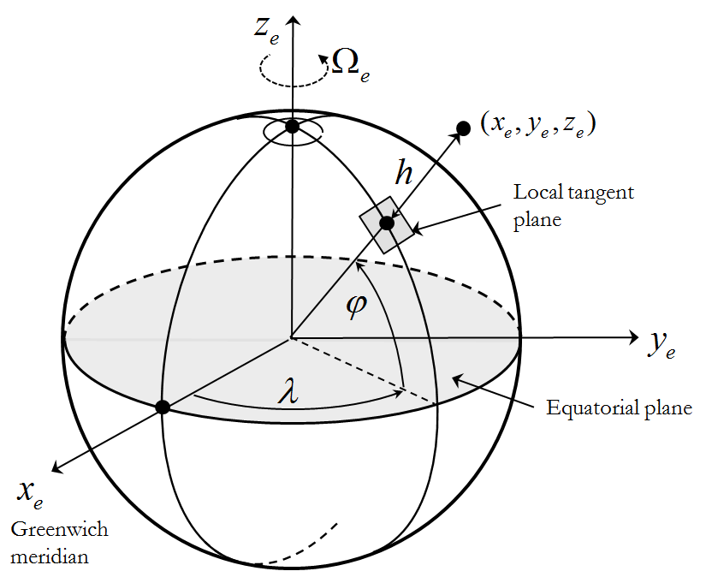

Figure 3. ECEF and geodetic coordinate frames.

*Local Geodetic* { } frame is usually associated with the ECEF frame, see Figure 3. It has the same origin at the center of the Earth. The frame defines the orientation of the line normal to the Earth surface and passing through the point of interest. The orientation of the line is defined by two angles – geographic latitude and – geographic longitude, with the height above the Earth surface; these three parameters along with the components of velocity vector are the major navigation states. For the most UAV applications it is sufficiently accurate to model the Earth surface as an oblate spheroid with given -equatorial and -polar radiuses or one of the radiuses and the -ellipticity. Last revisited in 2004 datum of World Geodetic System (WGS-84) provides the following parameters for the oblate spheroid modeling: ,. The resulting transformation from the geodetic { } to the ECEF frame is as follows:



where - the eccentricity of oblate ellipsoid is defined as



#### Local Tangent Plane Coordinate System

The origin of the *Local Tangent Plane* (LTP) is fixed to the surface of the Earth with two of its axes attached to the plane tangent to the surface, see Figure 4. The frame is usually marked with the subscript. The frame’s  and axes are in the tangent plane and most often aligned with the North and East directions correspondingly, the  axis completes the right hand coordinate system, thus pointing down. Quite often the order and alignment of the LTP frame principal axes change. In such cases the LTP coordinate system explicitly specifies its type; in the nominal case presented above it can be also defined as an NED frame.

When the origin of LTP frame is defined in terms of its geographic latitude, longitude and altitude above the ground surface, then the equations can be applied to define the kinematics of navigation states.

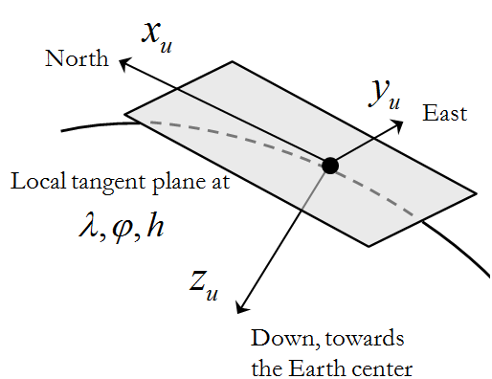

Figure 4. Local tangent plane definition; NED.

#### Body- Carried and Fixed Frames

In flight dynamics body-fixed reference frames usually have their origin at the center of gravity (CG) of an airplane, therefore these frames are moving. The *body carried* frame  is an orthogonal frame originated at the CG of the UAV. All its axes are permanently stabilized and aligned with the LTP frame axes as it was connected to the CG, see Figure 5. This frame is connected to the LTP frame by means of a plain translation.

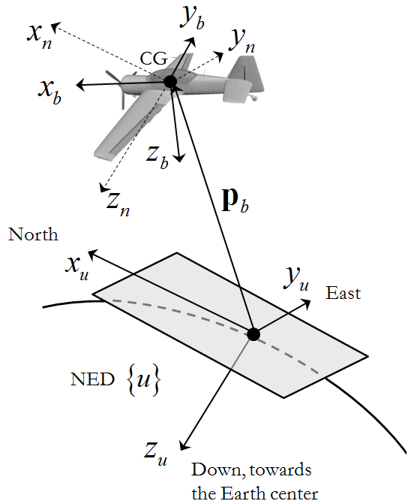

Figure 5. Definition of the body fixed frame with respect to LTP frame.

The *body fixed* frame is an orthogonal frame defined with respect to the body-carried frame. Its origin is at the CG of UAV and its axes are rigidly connected to the body. The frame is usually marked with the subscript. It can be proven that for every rigid body there is always an orthogonal coordinate system, usually called principal, in which cross-products of inertia terms are zero. This feature is typical to bodies with planes of symmetry. Assuming that a typical UAV has at least one plane of symmetry (geometric and mass symmetry) results in two of the body fixed axes lying in the plane of symmetry. When the axes are aligned along the principal axes of inertia of the body, as it will be shown in the following chapter, the dynamic equations of motion become significantly simplified. In majority of fixed wing UAV configurations the axes of frame match the principal axes of inertia. The typical orientation of the body fixed axes is as follows (see Figure 5): if the UAV has a plane of symmetry then  and lie in that plane of symmetry;  is points towards the direction of flight and  points downward and points right thus completing the right hand system.

As body moves, its attitude is defined with reference to the body-carried frame by three consecutive Euler rotations by -yaw, -pitch and -roll angles, see their graphical illustration in Figure 2 where frames {0} and {1} relate to the frames and correspondingly. The Euler angles formal definition in the application to an airplane attitude specification is presented here for completeness:

* - yaw is the angle betweenand the projection of on the local horizontal plane.
* -pitch is the angle between the local horizon and the axis measured in the vertical plane of symmetry of UAV.
* -roll is the angle between the body fixed axis and the local horizon measured in the plane 

As it follows from the attitude representation section, the DCM matrix transforming the body-carried to body fixed  frame can be constructed as follows:



Here subscripts () denote rotation from the LTP to the body fixed frame

#### Wind Frame

Aerodynamics forces and moments resulting from the body-air interaction as the airframe moves through the air depend on the body orientation with respect to the surrounding air, in other words, it depends on the vector representing the wind. The velocity vector calculated with respect to the possibly moving surrounding air (wind velocity) is denoted, see Figure 6. The magnitude of  is called an *airspeed*; as oppose to the velocity vector defined in LTP with respect to the ground – ground speed vector. The orientation of the wind frame defined bywith respect to the body fixed is defined by two angles.

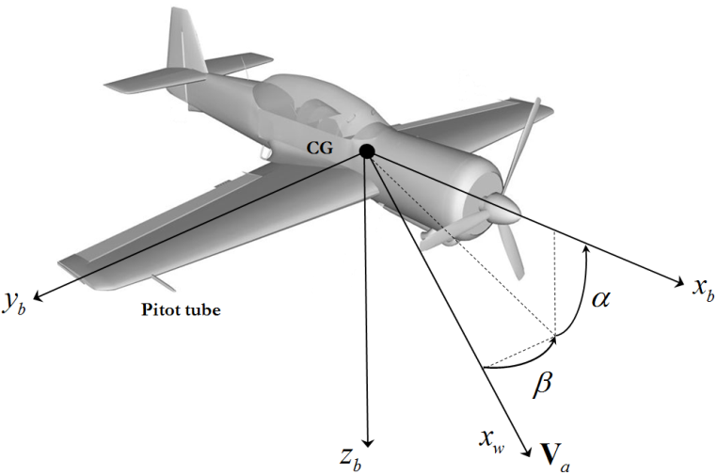

Figure 6. Wind frame and Body fixed frames. Definition of the angle of attack and the side slip.

To generate the lift force in flight, the wing of the UAV must be oriented at a positive angle with respect to the vector. This angle is called the *angle of attack*. The angle of attack is also one of the key parameters that define the longitudinal stability of an airplane. Therefore, quite often, the coordinate frame that results from a single rotation from the body fixed frame on angle is called a stability frame . As illustrated in Figure 6, the angle of attack is defined by the projection of into a vertical plane of symmetry of UAV (spanned by axes  in frame) and the longitudinal axis of UAV. It is positive when a leading edge of the wing rotates upward with respect to the. In turn, the angle between the velocity vector  projected into the “wing level” plane (spanned by axes  in frame) and the longitudinal axis of UAV is called the *side-slip angle*. It is denoted by.

Applying the DCM matrix approach to represent the complete transformation from the body fixed frameto the wind frameresults in the following:



The inverse transformation from the wind frame to the body fixed frame is the transpose of:.

The importance of the wind frame in application to UAVs flying in wind conditions that might contribute up to 100% of the nominal airplane speed cannot be overestimated. As an example, imagine an autonomous glider that is designed to utilize the wind energy to sustain the long duration flight. Therefore it is necessary to clearly understand the difference between airspeed, represented by the velocity vector defined with respect to the air and the ground speed, represented with respect to the LTP frame. Consider the graphical representation of the relation between these vectors in Figure 7. Assuming that constant wind is present, these velocities are related by the equation that is often called “wind triangle”:



where is the wind velocity defined in the LTP frame.

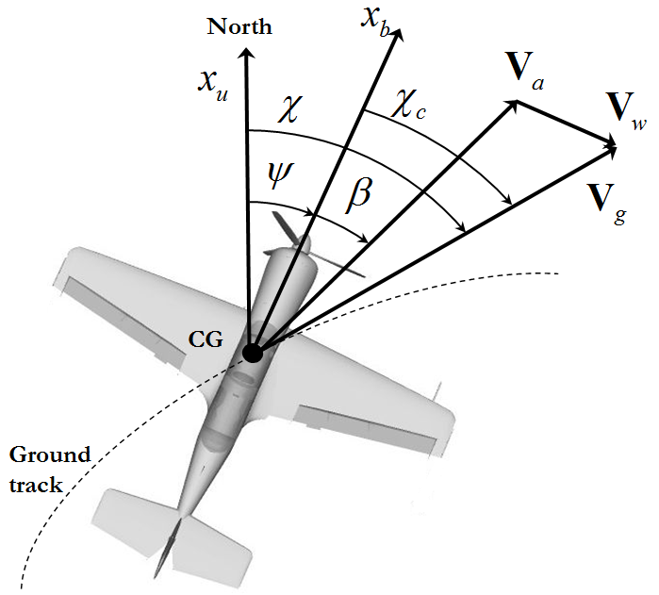

Figure . Wind triangle in 2D plane. Definition of the yaw, side slip, course over the ground and the crab angles.

The objective of the following development is to define the relations among these velocities defined in three different frames, while being measured or estimated by the algorithms and sensors installed in the body fixed and in LTP frames. First, define the components of all three vectors in body fixed frame. Let the UAV velocity in LTP frame expressed in body frame be, the wind velocity in LTP frame expressed in body frame be . Observe, that  defined in frame can be expressed asand let be its components expressed in the body frame. Utilizing the definition of the angles of attack and sideslip relating the wind frame to the body fixed frame and the “wind triangle” equation expressed in the body frame results in the following



This last equation relates the airspeed components of resolved in the body frame with the airspeed and the angles of attack and sideslip. In turn, if the wind components resolved in the body frame are known then inverting the last equation allows for calculation of the airspeed and the  angles.



Consider the fact that most of modern UAVs are equipped with a GPS receiver providing the measurements of speed over the ground in geodetic frame and a differential pressure transducer (Pitot tube) providing the measurements of the airspeed with respect to the moving air.

#### Trajectory Frame

??? Primarily related to navigation

#### Generalized Motion.

In the development of dynamic equations of motion it will be necessary to calculate the absolute time derivative of a vector defined in coordinate frames that are rotating and moving with respect to each other. In application to the UAV kinematics this can be justified by a necessity to calculate the absolute time derivative of a position vector in inertial space that results in the inertial speed. Similarly, the second time derivative defines the body inertial acceleration.

Consider two coordinate frames {} and {} where - stands for inertial not rotating frame, and -stands for the rotating frame. The first objective is to calculate the derivative of a unity vector defined in {} attached to a rigid body rotating with respect to the {} with angular speed, see Figure 8. Denote the DCM transformation from {} to {} as .



Taking the derivative results



where the time derivative of  is zero due to the rigid body assumption.

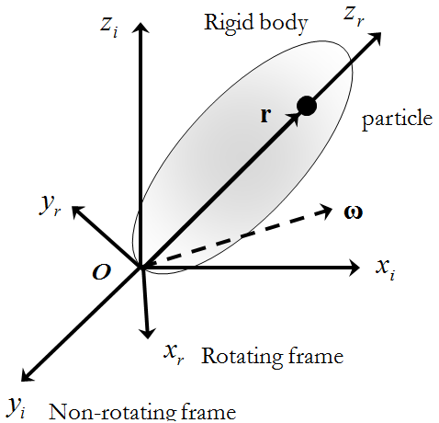

Figure . Deriving the time derivative of a vector.

Next, using the same setup, calculate the absolute time derivative of an arbitrary time varying vector defined in {}. Defining the vector in terms of its components in both frames and taking its time derivative in the inertial frame results

.

Taking the absolute time derivative of both expressions gives



Applying the previously obtained result allows to rewrite the last equation as



which expresses the derivative of the vector in inertial frame{} in terms of its change () calculated in a rotating frame {} and its relative rotation defined by the angular speed. The result in formally represents the Coriolis theorem. The second derivative of  defines a generalized expression for the body acceleration and is used in the development of the dynamic equations. The second derivative is obtained in similar manner by recursively applying the Coriolis theorem, thus leading to





The following chapter heavily relies on the results in and when it develops the dynamic equations of motion.

#### Summary of Kinematics

There are numerous publications describing kinematics of moving frames. Most of the publications originate in the area of classical mechanics and rigid body dynamics. The publications in the area of flight dynamics and control always contain material addressing the attitude representation techniques and differential rotations and thus can be a good source of reference information. The most recent and thorough presentation of the same topics can be found in where authors specifically address the kinematics and dynamics of small UAVs.

## Rigid Body Dynamics

This section addresses the development of the dynamics of a rigid body. The discussion is based on the application of the Newton’s laws for the cases of linear and angular motion. In particular, the second law of motion states, that the sum of all external forces acting on a body must be equal to the time rate of change of its linear momentum. On the other hand, the sum of the external moments acting on a body must be equal to the time rate of change of its angular momentum. Applying these laws is the objective of this chapter.

We consider a fixed wing UAV as the rigid body and define its dynamics with respect to the body fixed coordinate system. Relations necessary to translate inertial forces to the body fixed frame are also presented.

Before proceeding to the derivation it is necessary to present some assumptions typical for the fixed wing UAVs:

* The mass of the UAV remains constant during the flight
* The UAV is a rigid body
* An Earth fixed frame can be considered as an inertial frame.

The relations derived in this chapter are general and can be applied to any rigid body; however, the treatment of the aerodynamic forces and moments acting on the body will be specific to the aerodynamically controlled fixed wing UAVs.

### Conservation of Linear momentum

First, assume that a rigid body consists of a set of -“isolated” elementary particles with mass  exposed to the external force while being connected together by the internal forces. Since the set of particles comprises a rigid body structure, the net force exerted by all the particles is . The set of external forces acting on the body is a combination of the gravity force acting in an inertial frame and the aerodynamic and propulsion forces defined with respect to the body fixed frame but expressed in inertial frame. Thus, the linear momentum of a single particle expressed in an inertial frame obeys the equality



It is worth noting that the time derivative is taken in inertial frame as well, thus calling for the results in and . Summing up all  particles comprising the body gives the linear momentum equation of the entire body



The left part of this equation represents the sum of all forces (gravitational, propulsion and aerodynamic) expressed in an inertial frame, while the right part depends on the velocity of the body defined in an inertial frame. Observing that (i) the individual inertial velocities are not independent (they comprise a rigid body), assuming (ii) that the mass is constant, and utilizing the result in for the total velocity of the -th particle in an inertial frame, allows calculating the absolute time derivative in an inertial frame in the following form



Here represents the angular velocity of the UAV body defined with respect to the inertial frame, see. Defining the CG location as , where  is the total mass of the body, simplifies the linear momentum equation.



Assuming that the location of CG does not change with time and applying the result in to the absolute derivatives of vectors and  results



where

- the externally applied forces expressed in the body frame;

- the inertial velocity components defined in the body frame;

- the body angular rates defined in the body frame;

- the body referenced location of the center of gravity;

Translation of the inertial forces to the body frame is justified by the need to calculate the local body frame derivatives of theandexpressed in the body frame; the first one results in , while the derivative of  is independent on the coordinate frame ().

Utilizing the double vector product identity  allows expending the linear momentum equation in the most general scalar form as follows:



The last set of equation allows for the most general mass distribution inside the body. This set of equations might be useful when there is a need to model the placement of the body frame origin away from its CG. If the origin of the body fixed frame is chosen at the CG, the last set of equations can be significantly simplified by substituting thus leading to





Resolving with respect to the body accelerations gives the final set of three differential equations of translational dynamics of UAV become



### Conservation of Angular momentum

Applying the law of conservation of angular momentum to an -th particle in a moving frame is very similar to the approach used above. Consider a particle exerted to the internal and external moments. Similarly to the linear momentum case, the sum of internal moments acting on the particle should be equal to zero (), while the external moments arise from the inertial gravity and the body attached forces such as aerodynamic and propulsion. Thus, the conservation of angular momentum calculated across the entire rigid body results



Since the sum of internal moments cancel, and applying the Coriolis theorem



The first term can be expanded by utilizing the definition of the CG. 

Utilizing the double vector product identity allows expanding the second term as follows



Recognizing the moments of inertia and combining them into the matrix form defines the inertia tensor that allows converting the entire double vector product into very compact form. The diagonal terms of are called the moments of inertia. The off-diagonal terms are called the products of inertia, they define the inertia cross coupling. The moments of inertia are directly proportional to the the UAV’s tendency to oppose angular acceleration about a specific axis of rotation. For a body with axes of symmetry the inertia tensor has zero off diagonal term that significantly simplifies its form and the final equations of angular momentum.

The last term in utilizes the same double cross product expansion twice thus leading to



Denoting the body components of the total moment acting on the UAV as and combining the results in - lead to the following complete angular momentum equations



In case of a UAV with a vertical plane of symmetry spanned by body axes  the two pairs of the off-diagonal terms of matrix become zero, namely and . This significantly simplifies the above equations:



Equations represent the complete rotational dynamics of a typical fixed wing UAV with a longitudinal plane of symmetry.

### Complete set of 6DOF Equations of Motion







Please enter your text here …

## Aerodynamic Forces and Moments Acting on the Airplane

1. Definition of Wind frame. Angle of Attack and side slip
2. Control surface deflection
3. Static Stability

Please enter your text here …

## Introduction to Mathematical Implementation in of 6DOF Equations of Motion

Please enter your text here …

## Conclusions

Please enter your text here …

## Cross-References

Please find the complete list of all entries at <http://oesys.springer.com/uav> by going to “download current List of Contributions as a PDF document”.

Please enter your list of cross references here:

→ …

→ …

→ …

## References [max. 75]

Beard, Randal, and Timothy McLain. *Small Unmanned Aircraft: Theory and Practice.* Princeton University Press, 2012.

Etkin, Bernard, and Lloyd Duff Reid. *Dynamics of Flight: Stability and Control.* 3rd. Wiley, 1995.

Goldstein, Herbert. *Classical Mechanics.* 2 nd. Addison-Wesley, 1980.

Rogers, Robert M. *Applied Mathematics in Integrated navigation Systems.* 2nd. Reston, Virginia: AIAA, 2003.

Shuster, Malcolm D. "A Survey of Attitude Representations." *The Journal of Astronautical Sciences* 41, no. 4 (1993): 439-517.

1. Word range: 8000-10,000
2. Trivial rotation is the one described by an identity matrix, thus no rotation takes place.
3. A coordinate system in which the axes satisfy the right-hand rule is called a right-handed coordinate system. The right-hand rule defines the orientation of the resulting vector in the vector cross product multiplication.