#### Earth-Centered Earth Fixed and Geodetic Coordinate Frames

The *Earth Centered Earth Fixed* (ECEF) orthogonal coordinate system is fixed to the Earth and therefore it rotates at the Earth’s sidereal rate with respect to the *Earth Centered Inertial* (ECI) frame. The ECI frame is usually denoted {*i*} while the ECEF frame is denoted. Both frames are orthogonal and have their origins at the center of the Earth. The ECI frame has its axis aligned with the direction of the Earth’s rotation vector,  and axes placed in the equatorial plane with fixed in some celestial reference direction; for example a line connecting the Sun’s center and the Earth’s position at vernal equinox. The ECEF has  and axes placed in the equatorial plane and axis aligned with the direction of the Earth’s rotation vector, see Figure 1 where the Earth is modeled as a spheroid. The axis is usually attached to the intersection of the Greenwich meridian and the equator, and the axis completes the right hand system.

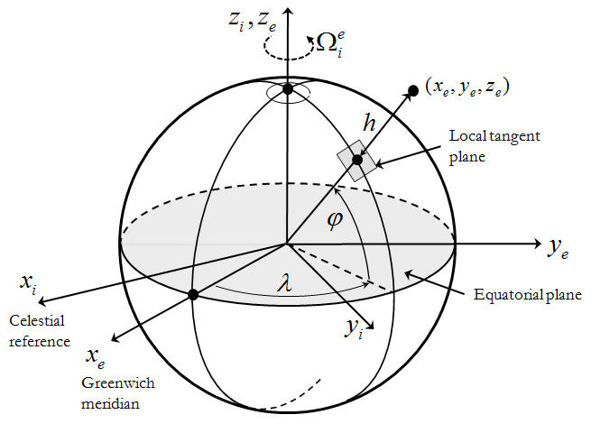

Figure 1. ECI, ECEF and geodetic coordinate frames.

It is worth noting that the ECEF axes definition may vary; however, the definition always states the attachment of two vectors to the direction of the Earth rotation and the Greenwich meridian as the inherent Earth properties. The sidereal rate  is the rate of ECEF rotation with respect to the ECI; the latter one is often call the true inertial frame. If necessary, for the purpose of UAV flight description, this rate can be accurately approximated by one full rotation in 23h56’4.099”, thus resulting in 15.04106718 deg/h. Therefore, the transformation from ECI to ECEF frame is a plain rotation around the  axis defined primarily by a single rotation by an angle , where **- is the time interval.

The *Local Geodetic* { } frame is usually associated with the ECEF frame, see Figure 1. It has the same origin at the center of the Earth. The frame defines the orientation of the line normal to Earth’s surface and passing through the point of interest. The orientation of the line is defined by two angles, – geographic latitude and – geographic longitude, with the height above the Earth’s surface; these three parameters, along with the components of velocity vector, are the major navigation states. For most UAV applications it is sufficiently accurate to model Earth’s surface as an oblate spheroid with given -equatorial and -polar radiuses, or one of the radiuses and the -ellipticity. Last revisited in 2004, the datum of World Geodetic System (WGS-84) provides the following parameters for the oblate spheroid modeling: ,. The resulting transformation from the geodetic { } to the ECEF frame is as follows:



where - the eccentricity of oblate ellipsoid is defined as

.

#### Accounting for the Earth Rotation rate

The complete set of 6DOF equations of motion presented above is still an approximation of the rigid body kinematics and dynamics and is valid as long as the assumption of flat Earth model satisfies the task at hand. During the long duration and extended range missions the precision of the derived states will suffer from omitting the sidereal rate of the rotating Earth. . Thus, the following derivation outlines how the Earth rotation can be easily accounted for in the derivation of the inertial velocity and acceleration vectors.

First, define the ECI as the true inertial frame. Next, by using simplifying properties of defining the free motion with respect to the CG of a rigid body, resolve the absolute time derivative of the CG position vector in the true inertial frame as follows

.

Taking the second time derivative and assuming that that the sidereal rate of the Earth rotation is constant results in

.

In as before the vector  denotes the vector of inertial angular speed resolved in the body frame, and  is the same as ****. Using the angular velocities addition theorem, the can be represented as a sum of the angular velocity vector  of body frame {*b*} resolved in the body-carried frame {*n*}, the angular velocity vector  of body-carried frame {*n*}resolved in ECEF frame {*e*}, and the sidereal rate of the Earth rotation vector resolved in the true inertial frame {*i*},. Thus the last equation can be also written as

.

The term is the Coriolis and the term is the centripetal accelerations introduced above. The angular velocity vector can be obtained from the geodetic latitude () and longitude () rates, which in turn can be calculated from the NED components of .