# Kinematics and Dynamics of Fixed Wing UAVs

Vladimir, Dobrokhodov

Naval Postgraduate School, Mechanical and Aerospace Engineering department

Monterey, CA

United States

I think you need to define nomenclature clearly: resolved in and with respect to and use it

throughout including velocity vectors. I think bold faced letters are confusing

## Abstract

The chapter provides a review of basic knowledge required for accurate mathematical modelling of flight of a fixed wing UAV. These include the kinematics and dynamics of motion, and the transformation of forces and moments acting on the airplane. The detailed discussion of the “Kinematics-Dynamics-Actions” triad in application to a generic fixed wing UAV is the main objective of this chapter. Therefore, the presentation starts with an introduction to the coordinate frames, their transformations and differential rotations. Kinematics of the coordinate frames is what connects states of a fixed wing UAV and transforms forces and moments acting in different coordinate frames. Understanding of reference frames and their dynamics is essential for the guidance, navigation and control systems design. Next, the chapter provides a detailed derivation of the equations of motion using the Newtonian approach. Assuming that a fixed wing UAV can be represented as a rigid body moving in an inertial space, allows for the derivation of the linear and angular momentum equations. Starting in an inertial frame, it is shown how the final form of translational and rotational equations of motion become written in a body fixed coordinate frame. The development of both the kinematic and dynamic equations is carried out first in a general vector form; then, using simplifying assumptions applicable to a generic fixed wing symmetric UAV, the vector equations are expanded into a scalar form to better represent the details of remaining terms. Finally, the chapter presents the principles of defining the forces and moments acting on a generic fixed wing airplane. Since the forces and moments found on an airplane act in a number of coordinate frames including inertial, body fixed and wind frames, the chapter utilizes the concepts and tools built in the kinematics section to transform the forces and moments into the body fixed frame. Such transformations complete the presentation of the “Kinematics-Dynamics-Actions” triad.

## Introduction

The chapter objective is to provide an overview of the necessary theoretical material to enable a reliable mathematical modelling of the free and controlled motion of a generic fixed wing UAV. Although the subject is not new and is well presented in existing literature, the rapid advancements of the last decade in research and development of fixed wing UAV technologies open new applications that require a revision of the existing assumptions. New materials, novel structural designs, new aerodynamic configurations, advanced onboard instrumentation including miniature sensors, actuators, and tremendous onboard processing power enable much wider operational envelop of fixed wing UAVs and significantly higher utility of their payloads. Depending on the UAV configuration and its intended operational use, the standard 12 equations of motion might not suffice for the task at hand and require deeper consideration of the UAV components interaction. Does the chapter actually revise existing assumptions?

The chapter starts with some preliminaries required to describe kinematics of a rigid body motion in three dimensional (3D) space. Thus, the kinematics of 3D rotation is introduced first. The most commonly used coordinate frames that are utilized in the description of UAV states are presented next. Applying the kinematics of rotating frames to a set of specific coordinate frames builds the basis for a convenient description of the forces and moments acting on a fixed wing airplane. Understanding of reference frames and their dynamics(???) is essential for the eventual development of the guidance, navigation and control systems architecture. Next, the chapter provides a detailed derivation of the equations of motion using the classical Newtonian approach. Assuming that a fixed wing UAV can be represented as a rigid body moving in an inertial space allows for the derivation of the linear and angular momentum equations. Starting in an inertial frame, it is shown how the final form of translational and rotational equations of motion can be written in a body fixed coordinate frame. The development of both the kinematic and dynamic equations is carried out first in a general vector form, and then, using simplifying assumptions applicable to a generic fixed wing symmetric UAV, the vector equations are expanded into a scalar form to better represent the details of the remaining terms. Since the forces and moments found on an airplane act in a number of coordinate frames including inertial, body fixed and wind frames, the chapter utilizes the concepts and tools built in the kinematics description to transform the forces and moments into the body fixed frame. Thus, the complete derivation of linear and angular momentum equations, along with of the forces and moments acting on a rigid body, result in the generalized set of 6 Degree of Freedom (6DOF) equations of motion.

## Reference Frames and Coordinate Transformations

In order to accurately describe a body motion, it is required to define (i) the forces and moments acting on the body and thus resulting in the body motion, and (ii) the coordinate system that can be used as a reference for the motion states definition. It is important to note that there are two types of forces acting on a body in free motion. First, the inertial forces and moments that depend on the velocities and accelerations relative to an inertial reference frame; the classical Newtonian dynamics equations hold only in the inertial frame. The second group consists of the aerodynamic forces and moments resulting from interaction of the body with the surrounding airflow and therefore relative to the air. Since the airflow might not be stationary it is therefore convenient to describe the resulting aerodynamics in the coordinate frames connected to the body and to the surrounding air. The resulting motion can be conveniently described in terms of the position, velocity, acceleration and attitude coordinates which comprise the states of the moving body. Some of these states, in turn, need to be defined with respect to a reference frame which choice is defined by the specifics of the UAV application. Thus, the information carried by various reference frames is what facilitates the complete and convenient definition of the free body motion.

Therefore, this section starts with a definition of a coordinate frame and the description of the coordinate frame rotation. The reference frames required to represent the aerodynamic forces and moments and facilitating the solution of the navigation states are introduced next. Communication of the states information occurring during the coordinate frame transformation is presented for the major coordinate frames. The section ends with a set of kinematic equations required to represent the transition of linear and angular accelerations.

### Kinematics of moving frames

The objective of this subsection is to define a coordinate frame transformation and the associated mathematical formalism. Namely, the directional cosine matrix (DCM) is introduced and its key properties are presented. The **rotational** matrix formalism (what is the difference between DCM and rotation matrices??) is then followed by a differential rotation that defines the rate of change of the rotation matrix. A fundamental property of the simple summation of angular rates is introduced next. The section ends with a detailed presentation of the coordinate frames used to describe the 6DOF motion of a rigid body. The results of this development are heavily utilized throughout the entire chapter.

An arbitrary motion of a rigid body can be described by a transformation that consists of (Goldstein 1980) translational and rotational components. First, we address a pure rotation of a rigid body. Consider a vector  defined in two orthogonal coordinate frames rotated with respect to their mutual origin by angle , as shown in Figure 1.a.

|  |  |
| --- | --- |
|  |  |
| 1. two dimensional coordinates | b)three dimensional coordinates |

From this geometrical setup it can be demonstrated that vector  can be uniquely defined in both frames as follows:

Figure 1. The same plane rotation considered with respect to two and three axes

 where p resolved in {1} = … and p resolved in {0} = …..

Introducing the matrix notation for the linear transformation above results in a simple form that relates the vector  components in  frame to the corresponding components in frame:



The resulting rotation matrix is called a directional cosine matrix (DCM). The DCM matrix consists of the cosine and sine functions which are the direction cosines between corresponding axes of the new and old coordinate systems denoted in the superscript and the subscript correspondingly. Following the same approach, it can be demonstrated that for the case of right-handed coordinate system represented by three orthogonal axes (see Figure 1.b), the same right hand rotation results in transformation

,

where, for clarity, the subscript  denotes the axes of rotation. Proceeding similarly, right handed rotations of the coordinate frame about the  and axis give



It is worth noting that the DCM transformation has the following easy-to-remember properties that simplify its application, see more details in (Rogers 2003):

1. The transformed vector components along the axis of rotation remain unchanged with the rotation about that axis; elements of DCM are either 0 or1.
2. The remaining elements of DCM are either or functions of the angle of rotation.
3. The  elements are on the main diagonal with elements on off-diagonal.
4. The negative  component corresponds to the component rotated “outside” of the quadrant formed by the original frames.
5. Columns (rows) of a DCM matrix form an orthonormal set.

It is straightforward to verify that a DCM matrix have the following properties:



and therefore it belongs to a general class of orthonormal transformation matrices. For a sequence of rotations performed with respect to each orthogonal axis, the resulting transformation can be obtained by a matrix composed of three sequential rotations, called Euler angle rotations, starting from the original frame of reference, see Figure 2.

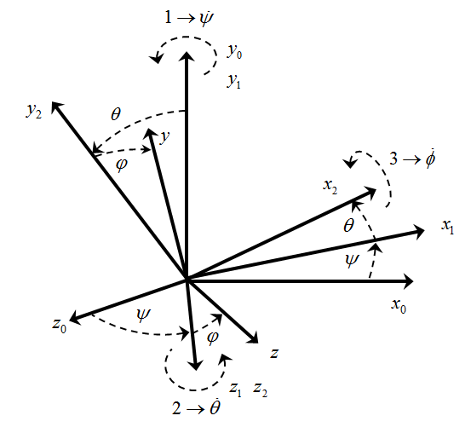

Figure 2. Three consecutive rotations.

Formally, this transformation is accomplished by rotating through the ordered sequence of Euler angles, where the numerical indexes define the ordered sequence of rotations.



This notation is not clear, represents a component of a vector, whereas suffix 0 represents a coordinate system, perhaps: 

It t is worth mentioning that the corresponding Euler angles are also widely used to express elementary rotation matrices:. Therefore, a vector  (perhaps ) described in one coordinate frame can be described in another coordinate frame of arbitrary orientation with respect to the original frame by a transformation matrix  composed of three sequential rotations as follows:





This matrix, that represents a transformation resulting from three sequential Euler angles rotations, will be used throughout the chapter.

Overall, any DCM matrix has a number of properties. (DCM matrix does not have to be orthonormal whereas rotation matrix does. DCM can be defined using two nonorthogonal coordinate systems) They are summarized here for completeness; an interested reader is referred to reference (Goldstein 1980) for more details:

* Rotation matrices are orthogonal.
* The determinant of a rotation matrix is unity.
* Successive rotations can be represented by the ordered product of the individual rotation matrices.
* Rotation matrices are not commutative, hence, in general case.
* A nontrivial rotation matrix has only one eigenvalue equal to unity with other two, being a complex conjugate pair with unity magnitude; a trivial rotation is described by an identity matrix.

The time rate of change of the DCM matrix that defines the dynamics of the attitude states is important in derivation of the kinematic equations of motion. As it will be shown shortly, it enables relating the sensor measurements obtained in a body fixed frame to the time derivatives of the Euler angles describing the attitude of a body in an inertial frame.

Deriving the time derivative of a DCM matrix can be obtained by utilizing a linearization technique. Consider the variation of the DCM matrix resulting from three infinitely small consecutive rotations performed over an interval of time. Utilizing the small angle approximation of  and  and neglecting the higher order terms, it follows that:



Utilizing at any given time , the values of at the time can be expressed by

,

where . The time rate of change of the DCM matrix is then defined as



,

where



and  This is not true: Euler angles and their rates are not vectors. The derivation above only works for small angle approximations and fails otherwise. The rotation. Starting from an initial stationary frame  (see Figure 2) and using two intermediate frames whose relative angular velocities are defined by the Euler angle rates, and utilizing the angular velocities addition theorem, the following kinematic equation can be obtained:

.

Note, derived in (1.10) is the one that must appear in equation above

Substituting the corresponding DCM matrices from results in

.

Inverting the last equation results in equation



that defines the derivatives of the Euler angles in terms of the angles themselves and the rates as they were measured in the frame . These equations define the rotational kinematics of a rigid body; they contribute to the final set of 6DOF equations of motion. If Euler rates were vectors (1.12) would include a rotation matrix

Analysis of the equation shows that four elements of the inverted matrix become singular when the second rotation angle  approaches. This problem is usually called a *kinematic singularity* or a *gimbal lock* in navigation, and is one of the issues associated with the use of Euler angles for the attitude determination. For differently ordered Euler rotation sequences the kinematic singularity will occur at a different point. Therefore, one way to avoid the singularity is to switch or change the Euler angle sequences when approaching the singularity. Next, depending on the available computing power, the integration of the kinematic equation can be computationally expensive because it involves calculation of trigonometric functions. Furthermore, it can be observed that the Euler angles based DCM matrix is redundant; it requires only 3 out of 9 elements of the DCM matrix to uniquely define the Euler angles. These shortcomings usually result in applying different parameters describing the attitude and its dynamic transformation.

In applications to the fixed wing UAV attitude determination, the Rodriguez–Hamilton parameters, or quaternion, is one of the most widely used alternatives (Goldstein 1980). Utilizing the quaternion approach is very powerful because it gives a singularity-free attitude determination at any orientation of a rigid body. Next, since it can be shown that the equations of motion of a rigid body are linear differential equations in the components of quaternion, then it (linearity) is a desirable property, especially when developing estimation and control algorithms. Furthermore, the quaternion is a relatively computationally efficient approach since it does not involve trigonometric functions to compute the attitude matrix, and has only one redundant parameter, as opposed to the six redundant elements of the attitude matrix. However, it is also worth noting that the quaternion and Euler angles techniques are well ???? with simple analytical representations of the DCM matrix and Euler angles through the parameters of quaternion. An interested reader is referred to an extensive historical survey of attitude representations (Shuster 1993) and references (Rogers 2003, Goldstein 1980) for more details in the alternative methods of attitude determination.

### Coordinate frames

Deriving equations of motion of a fixed wing UAV requires a definition of coordinate frames where forces and moments acting on the airplane can be conveniently defined, and where the states including the position, velocity, acceleration and attitude can be suitably described. Considering the desired nomenclature of coordinate frames, it is also important to account for a maximum duration of UAV mission and the corresponding operational range. With the latest advances in power technologies, a mission of long duration becomes a reality. As an example, solar power technology is one of the alternatives that can make the 24/7 flight of a fixed wing solar powered autonomous soaring gliders feasible. Thus, long duration and great operational distances require considering the UAV flight operations with respect to the rotating Earth. Therefore, this subsection defines the following coordinate frames:

* 1. Earth-Centered-Earth-Fixed Frame {*e*}
  2. Geodetic Coordinate System {*λ, φ, h*}
  3. Tangent Plane Coordinate System {*u*}
  4. Body-Carried Frame {*n*}
  5. Body-Fixed Frame {*b*}
  6. Wind frame {*w*}

#### Earlier on you only mentioned {i}, {b}, {w} as important ones

#### Depending on the duration of flight and operational range, both dictated by a specific UAV application, the first three frames can be considered inertial frames, with the remaining three frames are body fixed. The positioning of inertial and body frames are related by a plain translation, while the orientation of body frames relate to each other by pure rotations. Details of the frames definition and their relations are the subject of this section.

#### Earth-Centered Earth Fixed and Geodetic Coordinate Frames

The *Earth Centered Earth Fixed* (ECEF) orthogonal coordinate system is fixed to the Earth and therefore it rotates at the Earth’s sidereal rate. The frame is usually denoted . It has its origin at the center of the Earth with  and axes placed in the equatorial plane and axis aligned with the direction of the Earth’s rotation vector, see Figure 3. The axis is usually attached to the intersection of the Greenwich meridian and the equator, and the axis completes the right hand system. It is worth noting that the ECEF axes definition may vary; however, the definition always states the attachment of two vectors to the direction of the Earth rotation and the Greenwich meridian as the inherent Earth properties. The sidereal rate  is the rate of Earth’s rotation with respect to the distant stars (the true inertial frame). If necessary, for the purpose of UAV flight description, this rate can be accurately approximated by one full rotation in 23h56’4.099” , thus resulting in 15.04106718 deg/h.

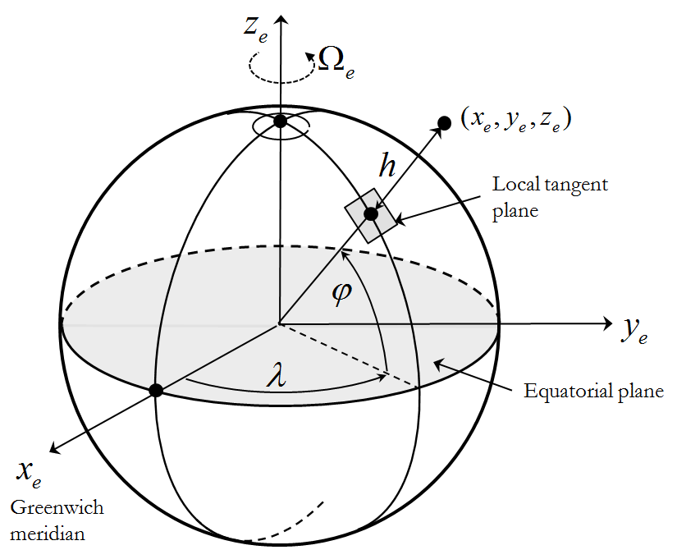

Figure 3. ECEF and geodetic coordinate frames.

The *Local Geodetic* { } frame is usually associated with the ECEF frame, see Figure 3. It has the same origin at the center of the Earth. The frame defines the orientation of the line normal to Earth’s surface and passing through the point of interest. The orientation of the line is defined by two angles, – geographic latitude and – geographic longitude, with the height above the Earth’s surface; these three parameters, along with the components of velocity vector, are the major navigation states. For most UAV applications it is sufficiently accurate to model Earth’s surface as an oblate spheroid with given -equatorial and -polar radiuses, or one of the radiuses and the -ellipticity. Last revisited in 2004, the datum of World Geodetic System (WGS-84) provides the following parameters for the oblate spheroid modeling: ,. The resulting transformation from the geodetic { } to the ECEF frame is as follows:



where - the eccentricity of oblate ellipsoid is defined as

.

#### Local Tangent Plane Coordinate System

The origin of the *Local Tangent Plane* (LTP) is fixed to the surface of the Earth with two of its axes attached to the plane tangent to the surface, see Figure 4. The frame is usually marked with the subscript and serves the purpose of an inertial frame in most short duration UAV applications. The frame’s  and axes are in the tangent plane and most often aligned with the North and East directions correspondingly; the  axis completes the right hand coordinate system, thus pointing down. Quite often the order and alignment of the LTP frame principal axes change. In such cases the LTP coordinate system explicitly specifies its type; in the nominal case presented above, it can be also defined as an NED frame.

When the origin of the LTP frame is defined in terms of its geographic latitude, longitude and altitude above the ground surface, then the equations can be applied to define the kinematics of navigation states.

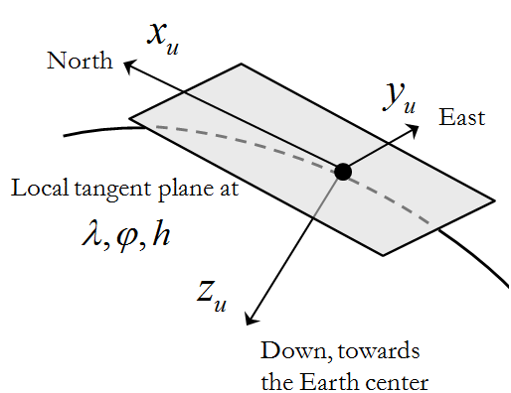

Figure 4. Definition of the Local Tangent Plane; NED.

#### Body- Carried and Fixed Frames

Is there a need for body-carried frame?

In flight dynamics, the body-attached reference frames usually have their origin at the center of gravity (CG) of an airplane; therefore, these frames are moving. The *body-carried* frame  is an orthogonal frame originated at the CG of the UAV. All its axes are permanently stabilized and aligned with the LTP frame axes as if it was attached to CG, see Figure 5. This frame is connected to the LTP frame by means of a plain translation.

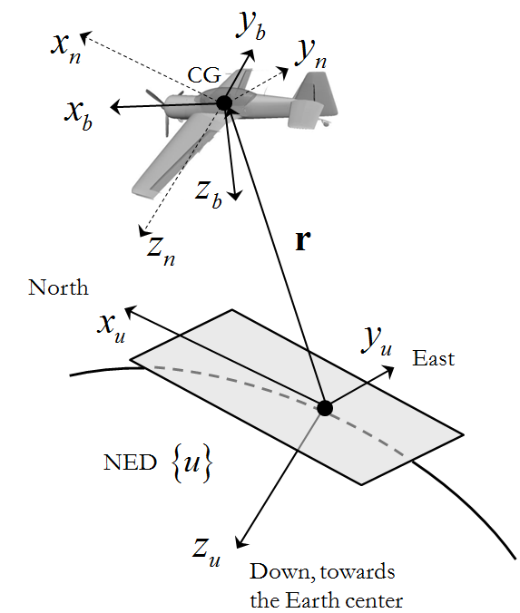

Figure 5. Definition of the body fixed frame with respect to LTP frame.

The *body-fixed* frame is an orthogonal frame defined with respect to the body-carried frame. Its origin is at the CG of UAV and its axes are rigidly connected to the body, therefore the frame rotates with the body. The frame is usually marked with the subscript. **It can be proven (Goldstein 1980) that for every rigid body there is always an orthogonal coordinate system, usually called principal, in which the cross-products of inertia terms are zero.. Assuming that a typical UAV has at least one plane of symmetry (geometric and mass symmetry), results in two of the body-fixed axes lying in the plane of symmetry. When the axes are aligned along the principal axes of inertia of the body, as will be shown in the following chapter, the dynamic equations of motion become significantly simpler. In a majority of fixed wing UAV configurations, the axes of frame match the principal axes of inertia**. (Why are inertia tensor properties discussed here?) The typical orientation of the body fixed axes is as follows (see Figure 5): if the UAV has a vertical plane of symmetry, then  and lie in that plane of symmetry;  points towards the direction of flight and  points downward and points right, thus completing the right hand system.

As the body moves, its attitude is defined with reference to the body-carried frame  by three consecutive Euler rotations by -yaw, -pitch and -roll angles. See their graphical illustration in Figure 2 where frames {0} and {1} relate to the frames and correspondingly. The formal definition of the Euler angles in the application to an airplane attitude specification is presented here for completeness:

* - yaw is the angle betweenand the projection of on the local horizontal plane.
* -pitch is the angle between the local horizon and the axis measured in the vertical plane of symmetry of the UAV.
* -roll is the angle between the body fixed axis and the local horizon measured in the plane.

As it follows from the attitude representation section, the DCM matrix transforming the body-carried to the body-fixed  frame can be constructed as follows:

.

Here subscripts () denote the rotation from the LTP to the body fixed frame; and frames are always aligned by the definition of body-carried frame. This rotation matrix has already been defined. Can it simply be referenced?

The application of the rotation matrix immediately follows from the need to describe the UAV translational motion in an inertial frame of reference by utilizing the inertial velocity measurements taken in the body fixed frame -. To this end, consider Figure 5 where vector denotes the position of an airplane CG with respect to the LTP (NED) frame attached to the Earth. Relating the translational velocity and position, and accounting for the fact that *body-carried* frame is stabilized with respect to the non-rotating frame results in

.

Why introduce the geodetic frame and talk about accounting for Earth’s curvature if you only consider flight in LTP?

The relation between the Euler angles defining the relation between the stabilized frame and the body fixed frame  were already derived in -. They define the dynamics of Euler angles defined in an inertial frame with respect to the rates measured in the body fixed frame. Thus, the kinematic equations and represent the dynamics of translational and rotational coordinates, and therefore are the part of the final set of equations of motion.

#### Wind Frame

Aerodynamic forces and moments resulting from the body-air interaction as the airframe moves through the air depend on the body orientation with respect to the surrounding air. In other words, they depend on the vector representing the wind. The velocity vector calculated with respect to the possibly moving surrounding air (wind) is denoted, see Figure 6. The magnitude of  is called an *airspeed*, as opposed to the velocity vector defined in LTP with respect to the ground – *ground speed* vector. The orientation of the wind frame defined bywith respect to the body fixed is defined by two angles.

Perhaps it’s a good idea to show relationship between  and  as well as illustrating it in Fig 6 instead of adding an extra figure

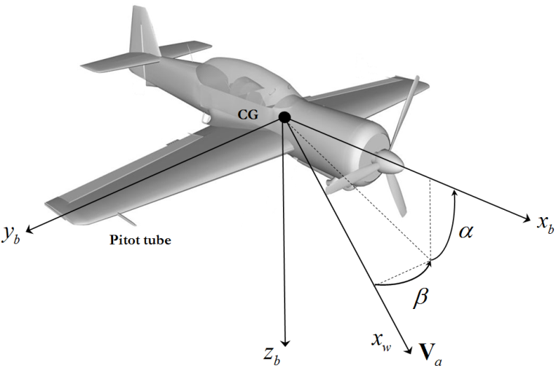

Figure 6. Wind frame and Body fixed frames. Definition of the angle of attack and the side slip.

To generate the lift force in flight, the wing of the UAV must be oriented at a positive angle with respect to the vector. This angle is called the *angle of attack*. The angle of attack is also one of the key parameters that define the longitudinal stability of an airplane. Therefore, quite often, the coordinate frame that results from a single rotation from the body-fixed frame on angle is called a stability frame (Beard and McLain 2012, Etkin and Reid 1995). As illustrated in Figure 6, the angle of attack is defined by the projection of into a vertical plane of symmetry of the UAV (spanned by axes  in frame) and the longitudinal axis of the UAV. It is positive when a leading edge of the wing rotates upward with respect to the. In turn, the angle between the velocity vector  projected into the “wing level” plane (spanned by axes  in frame) and the longitudinal axis of UAV is called the *side-slip angle*. It is denoted by.

Then the transformation from the body fixed frameto body-fixed wind frame is given by:

.

The inverse transformation from the wind frame to the body fixed frame is the transpose of:.

The importance of the wind frame in application to the UAVs flying in wind conditions that might contribute up to 100% of the nominal airplane speed cannot be overestimated. As an example, imagine an autonomous glider that is designed to utilize the wind energy to sustain the long duration of flight. Therefore, it is necessary to understand the difference between airspeed, represented by the velocity vector defined with respect to the air and the ground speed, represented with respect to the LTP frame. Consider the graphical representation of the relation between these vectors in Figure 7. In the presence of constant wind these velocities are related by the equation that is often called the “wind triangle”:



where is the wind velocity defined in the LTP frame.

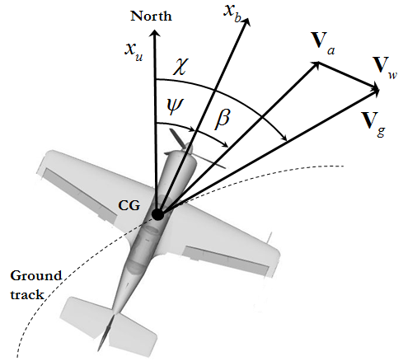

Figure 7. Wind triangle in 2D plane. Definition of the yaw, side slip and course over the angles.

The objective of the following development is to define the relations among these velocities defined in three different frames, while being measured or estimated by the sensors installed in the body fixed and in the LTP frames. First, define the components of all three vectors in the body fixed frame. Let the UAV velocity in the LTP frame expressed in the body frame be, and let the wind velocity in the LTP frame expressed in body frame be. Observe, that  defined in frame can be expressed asand let be its components expressed in the body frame. Utilizing the definition of the angles of attack and sideslip relating the wind frame to the body-fixed frame and the “wind triangle” equation expressed in the body frame results in the following:

.

This last equation relates the airspeed components of resolved in the body frame with the airspeed and the angles of attack and sideslip. In turn, if the wind components resolved in the body frame are known, then inverting the last equation allows for calculation of the airspeed and the  angles.



What is *a* in 1.19?

#### Generalized Motion.

In the development of dynamic equations of motion, it will be necessary to calculate the absolute time derivative of a vector defined in coordinate frames that rotate and move with respect to each other. In an application to the UAV kinematics, this can be justified by a necessity to relate the absolute time derivative of a position vector in inertial space (inertial velocity) that is defined based on the measurements taken in a body frame. Similarly, the second time derivative defines the body inertial acceleration.

Consider two coordinate frames {} and {}, where - stands for an inertial not rotating frame, and -stands for the rotating frame. The first objective is to calculate the derivative of a unity vector defined in {} attached to a rigid body rotating with respect to the {} with angular speed, see Figure 8. Denote the DCM transformation from {} to {} as.



Taking the derivative results in

,

where the time derivative of  is zero due to the rigid body assumption.

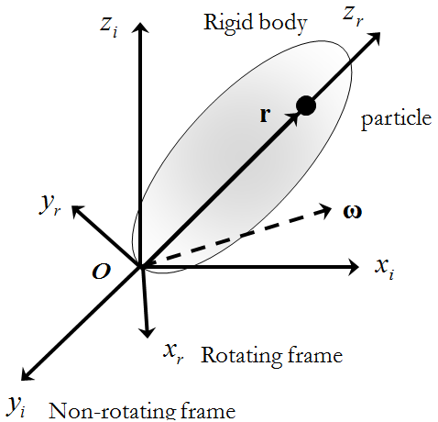

Figure 8. Deriving the time derivative of a vector.

Next, using the same setup, calculate the absolute time derivative of an arbitrary time varying vector defined in {}. Defining the vector in terms of its components in both frames and taking its time derivative in the inertial frame results in

.

Taking the absolute time derivative of both expressions gives

.

Applying allows us to rewrite the last equation as

,

which expresses the derivative of the vector in the inertial frame{} in terms of its change () calculated in a rotating frame {} and its relative rotation defined by the angular speed. The result in is known as the Coriolis theorem. The second derivative of  defines the body acceleration and is used in the development of the dynamic equations. It is obtained in a similar manner by recursively applying the Coriolis theorem, thus leading to

,

.

The following chapter heavily relies on the results in and when it develops the dynamic equations of motion.

#### Summary of Kinematics

This section developed the fundamental kinematic equations that not only define the kinematics of states and contribute to the final set of 6DOF equations of motion, but also serve as the basis for the design of the guidance and navigation tasks. There are numerous publications describing the kinematics of moving frames. Most of the publications originate in the area of classical mechanics and rigid body dynamics. The publications in the area of flight dynamics and control always contain material addressing the attitude representation techniques and differential rotations, and thus can be a good source of reference information. The most recent and thorough presentation of these topics can be found in (Beard and McLain 2012) where the authors specifically address the kinematics and dynamics of small UAVs.

## Rigid Body Dynamics

This section addresses the development of the dynamics of a rigid body. The discussion is based on the application of the Newton’s laws in the cases of linear and angular motion. In particular, Newton’s second law of motion states that the sum of all external forces acting on a body in an inertial frame must be equal to the time rate of change of its linear momentum. On the other hand, the sum of the external moments acting on a body must be equal to the time rate of change of its angular momentum. The application of these laws is the objective of this chapter.

Thus, a fixed wing UAV is considered as the rigid body and its dynamics is defined with respect to the body fixed coordinate system. Relations necessary to translate the inertial forces to the body fixed frame are also presented. Before proceeding to the derivation, it is necessary to present some assumptions typical for the fixed wing UAVs:

* The mass of the UAV remains constant during flight.
* The UAV is a rigid body.
* . Again, why all the previous Intro of {e} and {n}

The relations derived in this chapter are general and can be applied to any rigid body; however, the treatment of the aerodynamic forces and moments acting on the body will be specific to the aerodynamically controlled fixed wing UAVs.

### Conservation of Linear momentum

First, assume that a rigid body consists of a set of -“isolated” elementary particles with mass  exposed to the external force while being connected together by the internal forces. Since the set of particles comprises a rigid body structure, the net force exerted by all the particles is . The set of external forces acting on the body is a combination of the gravity force acting in an inertial frame and the aerodynamic and propulsion forces defined with respect to the body fixed frame but expressed in the inertial frame. Thus, the linear momentum of a single particle expressed in an inertial frame obeys the equality

.

It is worth noting that the time derivative is taken in an inertial frame as well, Not yet. Summing up all the  particles comprising the body gives the linear momentum equation of the entire body

.

The left hand side of this equation represents the sum of all forces (gravitational, propulsion and aerodynamic) expressed in an inertial frame, with the right side depending on the velocity of the body defined in an inertial frame. Observing that (i) the individual inertial velocities are not independent (they comprise a rigid body), assuming that (ii) the mass is constant (I would enumerate Assumptions you made earlier, i.e A1, A2,… and simply state using assumptions A1, etc) , and utilizing the result in for the total velocity of the -th particle in an inertial frame, allows for the calculation of the absolute time derivatives in an inertial frame in the following form

.

Here represents the angular velocity of the UAV body defined with respect to the inertial frame, see. Defining -the vector of CG location as, where  is the total mass of the body, simplifies the linear momentum equation.

.

Assuming that the location of CG does not change with time and applying the result in to the absolute derivatives of vectors and  results

, 

where

- the externally applied forces expressed in the body frame;

- the inertial velocity components defined in the body frame;

- the body angular rates defined in the body frame;

- the body referenced location of the center of gravity.

The translation of the inertial forces to the body frame is justified by the convenience of calculating the local body frame derivatives of theandexpressed in the body frame; the first one results in , while the derivative of  is independent on the coordinate frame ().

Utilizing the double vector product identity  allows for the expansion of the linear momentum equation in the scalar form as follows:

.

. What does this mean? This set of equations might be useful when there is a need to model the placement of the body frame origin away from its CG. If the origin of the body-fixed frame is chosen at the CG, the last set of equations can be significantly simplified by substituting , thus leading to

.

Expanding the cross product results in the following form of the linear momentum equation.

.

Resolving equations with respect to the derivatives (accelerations in the body frame) leads to the standard form of differential equations suitable for immediate mathematical modeling.

.

### Conservation of Angular momentum

Applying the law of conservation of angular momentum to an -th particle in a moving frame is very similar to the approach used above. Consider a particle subjected to the internal and external moments. Similar to the linear momentum case, the sum of internal moments acting on the particle should be equal to zero (), while the external moments arise from the inertial gravity and the forces acting on the body, such as aerodynamic and propulsion, gravity?. Thus, the conservation of angular momentum calculated across the entire rigid body results in

.

How did you derive 1.31? This needs to be explained. Should it be  This is what you use later

Since the sum of internal moments cancel each other out, applying the Coriolis theorem leads to

.

The first term can be expanded by utilizing the definition of the CG. .

Utilizing the double vector product identity allows for the expansion of the second term, as follows:

.

The equation is obtained by recognizing the moments of inertia, their symmetrical properties and combining them into a matrix form defines the inertia tensor that allows the conversion of the entire double vector product into a very compact form.

.

The diagonal terms of are called the moments of inertia. The off-diagonal terms are called the products of inertia, they define the inertia cross coupling. The moments of inertia are directly proportional to the UAV’s tendency to resist angular acceleration about a specific axis of rotation. For a body with axes of symmetry, the inertia tensor has zero off-diagonal terms that significantly simplify its form and the final equations of angular momentum.

The last term in utilizes twice the same double cross product expansion, thus leading to

.

Denoting the body components of the total moment acting on the UAV as , and combining the results in - lead to the following complete angular momentum equations in an expanded form:

.

In the case of a typical UAV with a vertical plane of symmetry spanned by body fixed axes  the two pairs of the off-diagonal terms of  matrix become zero, namely and . This significantly simplifies the above equations:

.

These equations represent the complete rotational dynamics of a typical fixed wing UAV with a longitudinal plane of symmetry.

### Complete set of 6DOF Equations of Motion

The final set of 6DOF equations of motion describing the kinematics and dynamics of a generic UAV with a longitudinal plane of symmetry modeled as a rigid body can be summarized as follows:







.

these equations are nonlinear and coupled, i.e. each differential equation depends upon variables which are described by other differential equations. In general case their analytical solutions are not known and they can only be solved numerically. There are 12 states describing the free motion of a rigid body subject to external forces () and moments (). In the control system design these variables are called state variables because they completely define the state of a rigid body at any instance of time. The state variables are summarized in Table 1.

Table 1. State variables of the 6DOF equations of motion.

|  |  |
| --- | --- |
| State variable | Definition |
|  | Vector of inertial position of the UAV and its components |
|  | Vector of inertial velocity components defined in the body-fixed frame |
|  | Euler angles that define the attitude of body-fixed frame with respect to the inertial frame |
|  | The body angular rates defined in the body-fixed frame |

What remains in the description of 6DOF equations of motion is to define the forces and moments acting on the airplane. This will be the objective of the next section.

## Forces and Moments Acting on the Airplane

The objective of this section is to present a generalized approach to defining the external forces and moments acting on a fixed wing UAV as functions of its states. The primary forces and moments acting on an airplane are the gravitational, thrust of the propulsion system, aerodynamic, and disturbances due to the flight in unsteady atmosphere. The most challenging task here is in defining the aerodynamic forces and moments resulting from the air-body interaction. Although the aerodynamic description of airfoils defining a fixed wing is not a new subject, the varieties of shapes, aspect ratios and aerodynamic configurations of modern fixed wing UAVs does not allow thorough presentation of all configurations. As an example, possible aerodynamic configurations of aerodynamic surfaces include tandem, variable span wings, joined wings, twin boom, V-tail configuration, just to name a few. However, a generalization is possible. An interested reader is referred to the most relevant survey (Mueller and DeLaurier 2003) of aerodynamics of small UAV that describes the modeling approaches and their limitations.

### Gravitation

Assuming that the flight altitude is negligible in comparison to the radius of the Earth, it is sufficient to consider the gravity’s magnitude constant. Then, the effect of the Earth’s gravitation can be naturally modeled in the body-carried frame by the force applied to the CG of the UAV; the gravitational force is proportional to the gravitational constant  and is called the weight of the UAV.

.

Before substituting this force expression into the equations of motion, it needs to be transformed into the body frame. The inertial to body rotation  enables this transformation:

.

Since the gravitational force acts at the CG of the airplane, the corresponding moment contribution is zero,. Only if the origin is chosen at CG

### Propulsion

The configuration of the propulsion system of modern fixed wing UAVs varies greatly. The architectures can be categorized by the number of engines, their type, and their installation arrangement in the airframe. A thorough review of the existing configurations along with some future projections and trends in the modern and future UAV systems, can be found in (OSD 2001). However, what is common across all possible configurations is that the vector of thrust in all systems is set parallel to the existing axes of symmetry; the thrust vectoring is not a common feature of fixed wing UAVs.

The thrust is naturally represented in the body fixed reference system. The direction of the thrust vector  is usually fixed and lies in the plane of symmetry or is parallel to it; however, it may not be aligned with the longitudinal -axis. If the orientation of the thrust vector  varies in its reference to the airframe, then a separate coordinate system analogous to the wind axes should be defined, thus introducing the required rotation of the thrust vector to the body fixed coordinate system. It is a common design requirement that the installation of multiple engines should not introduce any unbalanced moments, thus not inducing any loss of control efforts for the UAV stabilization. For the analysis of a nominal flight regime, the thrust vector  is considered fixed with respect to the body fixed frame.

For the sake of simplicity, consider a typical fixed wing UAV architecture where the installation of one or multiple engines results in the cumulative thrust vector passing through the CG, and the only moment being the torque generated by the reactive force from the rotating propeller. Thus, the net force of thrust in  direction and the moment around axis can be considered proportional to the thrust control command. Moreover, thrust characteristics of most conventional engines are always functions of the air density and the airspeed. Thus, the contributing force and moment resulting from the propulsion system can be presented as follows:

.

I don’t understand how thrust would cause a roll moment.

A particular example of modeling the propulsion force for the case of a micro UAV can be found in (Beard and McLain 2012).

### Unsteady atmosphere

In the previous discussion of the wind frame, it was assumed that the wind defined in the LTP frame is constant, thus the velocities are related by the “wind triangle” equation:

.

The most common approach (McRuer, Ashkenas and Graham 1999) in wind modeling is to consider the two components contributing to the wind. The first one defines the steady wind in the Earth fixed frame, and therefore it can be presented by the measurements in the LTP frame. The second component  is stochastic, which represents the short period disturbances or gusts expressed in the body fixed frame. Since the equations of motion are written in the body fixed frame, then

.

From the components of the wind and the UAV velocity, both resolved in the body frame, it is therefore possible to find the body frame components of the air velocity as

.

These body frame components of the air velocity enable straightforward calculation of the airspeed and the angles of attack and sideslip as



What is *a*?Modeling of the stochastic and steady components of wind is based primarily on experimental observations expressed using linear filters. The most widely used techniques are represented by von Karman and Dryden wind turbulence models (Hoblit 2001). Both methods are well supported with their numerical implementations.

### Aerodynamics

Aerodynamic forces and moments depend on the interaction of an aircraft with the airflow, which may also be in motion relative to the Earth. However, for the purpose of representing the nominal aerodynamic effects, the large-scale motion of the atmosphere is not critical and therefore will be considered constant; in fact, it will only affect the navigation of the UAV.

The small perturbation theory (Ashley and Landahl 1985) is one of the approaches used in describing the aerodynamic interaction of a given aerodynamic shape with airflow. The perturbations in aerodynamic forces and moments are functions of variations in state variables and control inputs. The control inputs here are the deflections of the control surfaces of an airplane that modify the airflow around the body, thus generating the desired aerodynamic effects. The nomenclature of the control surfaces and their control mechanization depends on the particular aerodynamic composition of the airplane. Nevertheless, the principles describing the effects of the control surface deflection on the generated forces and moments are the same. Consider the following control effectors of a classical aerodynamic configuration: the elevator, the aileron, and the rudder (see Figure 9). In this configuration the ailerons are used to control the roll angle, the elevator is used to control the pitch angle, the rudder controls the yaw angle.

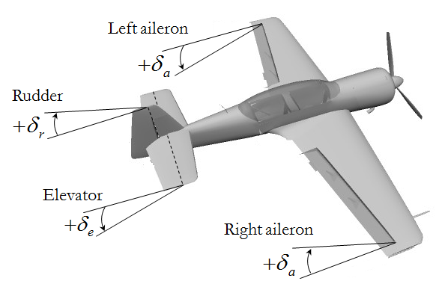

Figure 9. Control surfaces of a classical aerodynamic configuration.

Their deflections are denoted as - for the aileron, - for the elevator, and - for the rudder. The positive deflection of a control surface is defined by applying the right-hand rule to the rotation axis of the surface. The positive direction of the aileron, elevator and rudder deflections is also depicted in .

Deflection of the control surfaces results in modification of the pressure distribution around the body. For example, deflecting the elevator primarily changes the pitching moment acting on the airplane. In turn, this results in changing the angle of attack of the wing that increases the lifting power of the airplane. The calculation of aerodynamic characteristics of one or more lifting surfaces with variable deflections of the control surfaces at various attitudes with respect to the airflow can be accomplished by utilizing well-developed linear panel methods (Hess 1990, Henne 1990) conveniently implemented in various software packages (Fearn 2008, Kroo 2012).

The panel methods capture the effect of pressure distribution in the form of parameterized forces and moments versus the angles of attack and side-slip, and airspeed; they play a role of states here. For example, considering the longitudinal plane, the effect of aerodynamic pressure acting on a fixed wing can be modeled using a total force and pitching moment acting on the wing. It is common to project the total force to the wind axes, thus resulting in the lift  and drag force components. Figure 10 demonstrates the approach to modeling aerodynamic effects in the wind and body fixed frames with respect to the vector of free airstream.

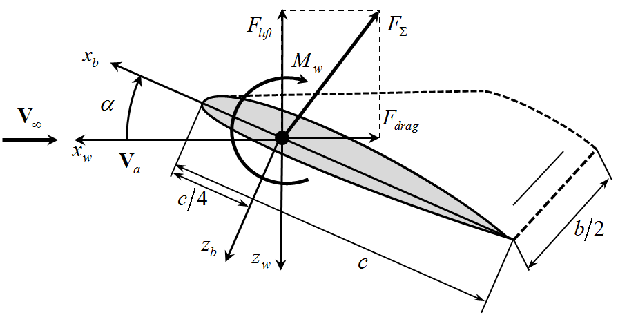

Figure 10. Definition of lift, drag and pitching moment in the wind frame.

As shown in Figure 10, the lift and drag forces act in the wind frame and are applied at the aerodynamic center of the lifting surface that is located at the quarter-chord point (- is the length of the mean aerodynamic chord). The pitching moment acts around the aerodynamic center. Then, the forces and moment are represented in a form connecting a number of surface specific parameters and the states in the following form:

,

where  are the nondimensional aerodynamic coefficients (to be parameterized),  is the planform area of the wing surface, and are the mean aerodynamic chord and the wing span. The same approach is applied to each of the aerodynamic surfaces comprising the airplane.

It is common practice to consider the total aerodynamic forces and moments in projections to the longitudinal and lateral planes of the airplane. The benefit of this approach is in the simplicity of representing the aerodynamic effects and in providing a natural ground for the nonlinear model decomposition at the next step of the control system design. Thus, the longitudinal forces and moments consist of lift, drag and pitching moment acting in the vertical plane of symmetry. The lateral side force and yawing moment are caused by the asymmetric airflow around the airplane; the asymmetry can be caused by the side wind or intentional deflection of the rudder. For the majority of fixed wing UAVs, the key states that define the parameterization of the aerodynamic coefficient are the angle of attack, the side slip, body rates, and the controls which are the surface deflections. The most general functional form of the longitudinal and lateral aerodynamics can be presented as follows:

Table 2. Parameterization of longitudinal and lateral aerodynamics

|  |  |
| --- | --- |
| Longitudinal channel | Lateral channel |
|  | . |

Without delving deeper into the intricacies of aerodynamic parameterization, it is sufficient to demonstrate the final form of forces and moments defined in the wind coordinate frame:

* longitudinal plane



* lateral plane



The presented parameterization is a simple linear approximation of the aerodynamics given by the Taylor series expansion taken with respect to the given trim conditions. The coefficients - are the nondimensional partial derivatives of the corresponding forces and moment (denoted in the subscript) defined with respect to the corresponding state or control (denoted in the superscript). The coefficients with zero in the subscript denote the forces and moments calculated when all states, including the control surface deflection, are zero; for example  denotes the roll moment coefficient estimated at. The common naming convention suggests that those derivatives defined with respect to states  are called the stability derivatives, and those with respect to controls are called the control derivatives. The static stability of an aircraft with respect to disturbances in some variable is directly reflected in the sign of a particular derivative. For example, the sign of should be negative to guarantee static stability in pitching motion, while the sign of  should be positive for the directional static stability.

Each of the presented coefficients is usually a function of states. The precision requirement of the linear parameterization greatly depends on the operational envelop of the UAV and its intended use; the higher the maneuverability of the UAV, the more terms necessary to accurately represent the aerodynamics. Each of the coefficients has very intuitive physical meaning and is usually studied separately. An interested reader is referred to (Beard and McLain 2012) for a detailed discussion of the aerodynamic coefficients of small and micro fixed wing UAVs.

One last step needs to be performed before the aerodynamics- defined in the wind coordinates can be plugged into the equations of motion - defined in the body fixed frame. The transformation from the wind to the body frame serves this purpose.

Therefore, the total forces and moments acting on the fixed wing UAV can be presented as follows:



.

## Conclusion

The objective of this chapter was to provide a review of the theoretical material required to enable accurate mathematical modelling of the free and controlled motion of a generic fixed wing UAV. The key building blocks presented were the coordinate frames and their transformations, kinematics of rotation, dynamics of motion, and the definition of forces and moments acting on the airplane. The kinematics of spatial rotation is what connects the three building blocks of the “Kinematics-Dynamics-Actions” triad. In addition to the 6DOF equations of motion describing the kinematics and dynamics of a rigid body motion, the tools and methods developed in this chapter contribute significantly into the UAV flight dynamics, system identification, control, guidance and navigation.

## References

* Ashley, Holt, and Marten Landahl. *Aerodynamics of Wings and Bodies(Dover Books on Aeronautical Engineering).* Dover Publications, 1985.
* Beard, Randal, and Timothy McLain. *Small Unmanned Aircraft: Theory and Practice.* Princeton University Press, 2012.
* Etkin, Bernard, and Lloyd Duff Reid. *Dynamics of Flight: Stability and Control.* 3rd. Wiley, 1995.
* Fearn, R.L. "Airfoil Aerodynamics Using Panel Methods." *The Mathematica Journal* (Wolfram Research) 10, no. 4 (2008): 15.
* Goldstein, Herbert. *Classical Mechanics.* 2 nd. Addison-Wesley, 1980.
* Henne, P. *Applied Computational Aerodynamics (Progress in Astronautics and Aeronautics).* AIAA, 1990.
* Hess, J.L. "Panel Methods in Computational Fluid Dynamics." *Annual Review of Fluid Mechanics* 22 (January 1990): 255-274.
* Hoblit, F.,. *Gust Loads on Aircraft: Concepts and Applications.* AIAA Education Series, 2001.
* Kroo, Ilan. "LinAir 4. A Nonplanar, Multiple Lifting Surface Aerodynamics Program." *DesktopAeronautics.* April 10, 2012. http://www.desktop.aero/linair.php (accessed April 10, 2012).
* McRuer, D., I. Ashkenas, and D. Graham. *Aircraft Dynamics and Automatic Control.* Princeton University Press, 1999.
* Mueller, Thomas J., and James D. DeLaurier. "Aerodynamics of Small Vehicles." *Annual Review in Fluid Mechanics*, 2003: 89-111.
* OSD. *Unmanned Aerial Vehicles Roadmap 2000 – 2025.* Washington , DC: Office of the Secretary of Defence, 2001.
* Rogers, Robert M. *Applied Mathematics in Integrated navigation Systems.* 2nd. Reston, Virginia: AIAA, 2003.
* Shuster, Malcolm D. "A Survey of Attitude Representations." *The Journal of Astronautical Sciences* 41, no. 4 (1993): 439-517.