ACTIVE VIBRATION CONTROL OF A UAV BY MEANS

OF PIEZOELECTRIC ACTUATORS

# Tuan D A Le B.S., Portland State University, 2007

THESIS

Submitted in partial satisfaction of

the requirements for the degree of

MASTER OF SCIENCE

in

MECHANICAL ENGINEERING

at

# CALIFORNIA STATE UNIVERSITY, SACRAMENTO

SPRING

2010

*© 2010*

Tuan D A Le

ALL RIGHTS RESERVED

ACTIVE VIBRATION CONTROL OF A UAV BY MEANS

OF PIEZOELECTRIC ACTUATORS

A Thesis

by

Tuan D A Le

Approved by:

__________________________________, Committee Chair

Ilhan Tuzcu, Ph.D

__________________________________, Second Reader

Akihiko Kumagai, Ph.D

____________________________

Date

Student: Tuan D A Le

I certify that this student has met the requirements for format contained in the University format manual, and that this thesis is suitable for shelving in the Library and credit is to be awarded for the thesis.

__________________________, Graduate Coordinator ___________________

Kenneth S. Sprott, Ph.D Date

Department of Mechanical Engineering

Abstract

of

ACTIVE VIBRATION CONTROL OF A UAV BY MEANS

OF PIEZOELECTRIC ACTUATORS

by

Tuan D A Le

In recent years, a special attention is given to the research on the dynamics and control of a flexible aircraft. However, dynamic models, especially control of the flexible aircraft, remains to be one of the most challenging problems in engineering. This is mostly due to the fact that the types of actuators used to control aircraft are limited to the control surfaces and engine thrust. In addition to these actuators, piezo-electric actuators can perhaps be used for control purposes. In fact, smart materials are good candidates for the vibration control due to their light weights, deforming controllability and ease in implementation. In an earlier paper, Tuzcu and Meirovitch have applied the idea of employing the smart materials to reduce a flexible aircraft’s bending displacements. The perturbation approach is applied to control both rigid and perturbed system on a flexible aircraft. The purpose of the study is to efficiently control not only the rigid but also perturbed system using distributed piezoelectric actuators. Ability of controlling the perturbed system helps us to predict the aircraft’s or vehicles’ stability in certain conditions. However, the authors only developed the control system for the bending vibrations. In this paper, we will extend the study and use the same approach to develop a control system for not only bending but also torsional displacement in addition to executing smart material actuators on an Unmanned Aerial Vehicles (UAV).

_______________________, Committee Chair

Ilhan Tuzcu, Ph.D

_______________________

Date

ACKNOWLEDGMENTS

First of all, I would like to take this opportunity to express my sincerest appreciation to my committee chair, Dr. Ilhan Tuzcu, for his guidance in the completion of my thesis. Without his assistance and persistent help this thesis would not have been possible.

Second, I would like to thank Professor Akihiko Kumagai for reviewing and making suggestions in my thesis.

Lastly, I am grateful to my parents who have given support throughout my life. Without their helps, my achievements had become impossible.

Tuan D A Le

B.S. Mechanical Engineering

July, 2007

TABLE OF CONTENTS

Page

Acknowledgments……………………………………………………………………….vii

List of Tables……………………………………………………………………………...x

List of Figures…………………………………………………………………………….xi

Chapter

1. INTRODUCTION OF AN UAV AND PIEZOELECTRIC ACTUATORS…….……1

1.1. Unmanned Aerial Vehicles (UAVs)..................................................................1

1.2. Use of the Piezoelectric Actuators………….……………………….………..…2

1.3. An Approach for a Control System…….…………………………………………4

2. USE OF THE PIEZO ACTUATORS ON A CANTILEVER BEAM………….…….6

2.1. A Bending and Torsional Response of a Beam System……………..……….…...6

2.2. Derivation of the Piezoelectric Actuators Added to the System’s Responses…....8

2.3. Numerical Result………………………………………………………………...12

2.4. Conclusion……………………………………………………………………….16

3. DEPLOYMENT OF THE PIEZO ACTUATORS ON THE UAV SYSTEM…....…19

3.1. Introduction to a UAV’s Frame and Approach for a Solution.………………..…19

3.2. Equations of Motions……………..……………………………………….……..21

3.3. Generalized and Distributed Forces…………………….……………………….27

3.4. Induction of the Piezoelectric to the UAV’s System…………………...……….28

3.5. Perturbation Approach…………………………………………...……………...32

3.6. Control Design…………………………………………………………...….......34

4. NUMERICAL SOLUTION FOR UAV MODEL…………………….…...………..38

4.1. First Order State Solution………...……………...………………………………39

4.2. The First Order Controlled Equation of Motion by the Piezo Actuators………..40

4.3. The Input Control Design…………………………………...…………………...42

4.4. Motions of the Wings ..………………………………..………….………….….44

4.5. Conclusion……………………………………………………………………….47

Appendix….……………….………………...…………………….…………………..…48

A.1. Direction Cosines and Relating Eulerian Velocities………………………...….48

A.2. Mass Matrix………………...………………………..…………….……..….….49

A.3. Total Generalized Forces from the Actuators………..…………………..….…..50

A.4. Constant Coefficient Matrix A, B and Bp and Weighting Matrix R and Q……..51

Bibliography…………………………….……………………………………………….53

# LIST OF TABLES

Page

1. Table 2.1: Stainless Steel Dimensions and Properties Collected from [7]…..….12

2. Table 2.2: Dimensions and Properties of PZT G-1195….………………..…….13

3. Table 4.1: Dimensions and Properties of the Wings…………..…….………….39

4. Table 4.2: Dimensions and Properties of PZT G-1195 Used for UAV…..…….41

5. Table 4.3: Eigenvalues of the Controlled System …………..………………….43

# LIST OF FIGURES

Page

1. Figure 1.1: A Rogue UAV from US Air Force [9]…………………………….…1

2. Figure 1.2: Change in Strain Based on Varied Voltage……………….…………3

3. Figure 2.1: A Beam Controlled by a Piezo Actuator and an External Force…...14

4. Figure 2.2: The Front View of the Beam and Actuators….….…………………14

5. Figure 2.3: The Tip Bending Displacement………………….…….…………...16

6. Figure 2.4: The Tip Twisted Displacement………………….………………….17

7. Figure 2.5: The Tip Bending Displacements at Various Angles…………..……18

8. Figure 2.6: The Tip Torsional Displacements at Various Angles………..….….18

10. Figure 3.1: A UAV Model…………………………………………..…………..23

11. Figure 3.2: The Right Wing Carrying the Piezo Actuators………….………….29

12. Figure 4.1: The Tip Bending Displacements…………………...…...…………..45

13. Figure 4.2: The Tip Torsion Displacements………………….…………………45

14.Figure 4.3. The First Order Position Vector……………….…………………...46

15, Figure 4.4. The First Order Euler Angle vector……………….……………......46

Chapter 1

INTRODUCTION OF AN UAV AND PIEZOELECTRIC ACTUATORS

*1.1 Unmanned Aerial Vehicles (UAV)*

UAVs are a powered aircraft remotely piloted without a human operator on board. They have been widely used in reconnaissance, intelligence-gathering role and high-risk to human life missions for military and civilian purposes. In the military, they can fly over combat zones, drop supplies to troops, fire weapons or scout enemy forces such as the rouge UAV in Figure 1.1. For the civilian services, it can search for missing people or suspects by employing heat seeking devices or provide important data to ground stations in adverse weathers or situations.

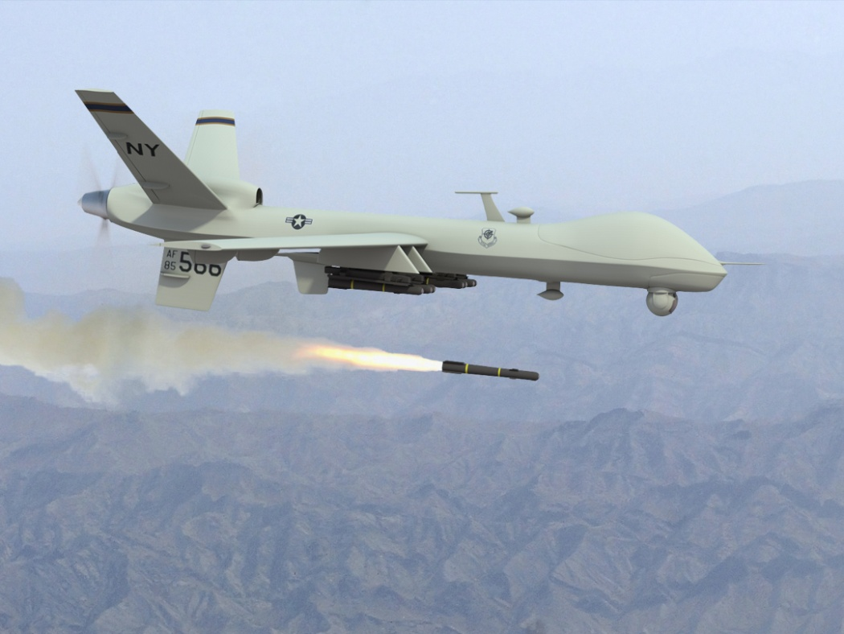

**Figure 1.1: A Rogue UAV from US Air Force** [9]

UAVs are driven on preprogrammed routes to their destinations. However, surrounding conditions are not often ideal enough for UAVs to complete their missions. And there are always disturbances that try to disturb UAVs’ performances. Hence, a feedback control system need to be developed to eliminate those disturbances on UAVs or conventional aircrafts. Without such control system, UAVs could easily fail on the missions due to poor flying conditions; however, developing such a control system is not simple due to aerodynamic and control design complexities.

According to task requirements, UAVs are usually light and able to carry a nonstructural weight and possess high-aspect-ratio wings due to their low drag. In addition, the safety is not a priority during their performances. These features imply that the UAVs are much more flexible than conventional manned aircrafts. Thus, the flexibility of UAV requires a feedback control system that must contain both elastic and rigid body dynamics.

*1.2. Use of the Piezoelectric Actuators*

An aircraft usually employs only four control inputs: engine thrust, and aileron, elevator and rudder angles. Nonetheless, an ability to control that high dimensional system such as UAVs requires the feedback control system which essentially involves more than the four systems above to compel the aircraft having aptitudes to adapt any adverse dynamic situations. However, it is not simple to design such a system due to their accurate aeroelastic model requirement and large elastic degree of freedoms. Instead of building such a complex system, in [1] Tuzcu and Meirovitch propose a system that utilizes the numerous piezo-electric materials (or called smart materials), attached over the flexible components of the aircraft, in addition to the four control inputs, to stabilize the aircraft and eliminate the disturbances in the elastic deformations of the aircraft’s components.

A piezoelectric material has an ability which modifies its shape when electrical voltage is applied through it. When the shape changes, it exhibits mechanical stresses (strains) which depend on the applied voltage. Figure 1.2 displays the basic principles of the piezoelectric material having an extensional characteristic.

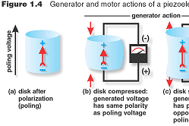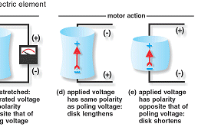

**Figure 1.2: Change in Strain Based on Varied Voltage** [10]

Accordingly, not only the study [1] but also many researches and designs have extensively applied the smart materials in damping vibrations and functioning as a control system. In [2], Park and Chopra have theoretically and experimentally shown success of using the smart material as an actuator attached on an Euler-Bernoulli cantilever beam to damp its bending, extensional and torsional vibration. The mechanical stress generated from the piezo material forms a virtual work on the attached beam that sufficiently damps its mechanical responses. In [3], Edery-Azulay and Abramovich have successfully studied use of piezoceramic materials as actuators to damp a vibrating piezo-composite beam. Also, the study [4] has employed the smart materials as a cooling actuator for a semiconductor. The cooling device couples shape of nozzle geometry and piezo material property so that it has a capability of flowing air.

Nevertheless, the thoughts of applying the smart materials on flexible structures are not still extensive due to its dynamical and structural complexity. In [1], they have efficiently accumulated the piezo actuators, dispersed over the flexible components, into the feedback control system to control the bending displacement of the aircraft components. The study has based on several previous studies and separated the control system into two parts: a quasi-rigid flight dynamic system for the large flight variables and an extended system for the perturbations in the small flight variables and elastic vibration. In conclusion, the study has proposed that the inclusion of the piezoelectric actuators in both the quasi-rigid and extended perturbation systems obtains an ability that effectively damps the bending vibration of a conventional aircraft’s components.

*1.3. An Approach for a Control System*

The result in the study [1] is significant but still limited to its bending control. Numbers of the piezo actuators are placed horizontally in the purpose of only controlling the bending displacements. Hence, we decide to extend their study in controlling both bending and torsion by tilting the piezo actuators at a certain angle so that the actuators are able to involve not only the bending but also the torsional displacement as similarly presented in [3] on the beam’s control. In our study, a number of piezoelectric materials tilted at a certain angle will be attached along the wings. As mentioned in [1], the purpose of the actuators is not for steering the aircraft but only for furthering the damping on the aircraft’s components. Also, note that our piezoelectric actuators will only control the elastic bending and torsional velocities but not the rigid ones.

First, we will testify if a piezoelectric actuator has an ability to control system’s responses on an Euler-Bernoulli cantilever beam. The virtual work theory and Galerkin method are used for the defined problem. Subsequently, the idea of employing the piezoelectric actuators will be extended on the UAV model if it succeeds on the beam.

Initially, the equations of UAVs’ motions will be briefly derived without the piezoelectric actuators as shown in [4]. And then the piezo actuators are introduced as additional terms into the equations of the motions. We will use the perturbation approach as depicted in [1] to define the control system into two parts: an open-loop control for steering the aircraft on predefined paths and a close-loop control to suppress the displacements and perturbations in the rigid body motion. Finally, numerical results and plots will be briefly shown and concluded.

Chapter 2

USE OF THE PIEZO ACTUATORS ON A CANTILEVER BEAM

*2.1. A Bending and Torsional Response of a Beam System*

In a non-uniform system, obtaining an exact solution for eigen-values is not feasible. Alternatively, an approximated solution is seemed as an only possible approach to acquire its solution. In [6], Meirovitch illustrates the “assumed-modes method” or Galerkin method in Lagrange’s equations of motions to approximate the solution for a response system. Thus, the elastic bending and torsional displacement are assumed in forms of a series of:

$w\left(x,t\right)=\sum_{i=1}^{n}{Y_{i}(x)q_{i}(t)}$ (2.1)

$Θ\left(x,t\right)=\sum_{i=1}^{n}{ψ_{i}(x)ξ_{i}(t)}$ (2.2)

in which: $Y_{i}\left(x\right)=[(sin\left(β_{i}L\right)-\sinh\left(β_{i}L\right))(\sin\left(β_{i}x\right)-\sinh\left(β_{i}x\right)]+[(cos\left(β_{i}L\right)+\cosh\left(β_{i}L\right))(\cos\left(β_{i}x\right)+cos⁡(β_{i}x)]$

$ψ_{i}\left(x\right)=i\sin\left(\frac{πx}{2L}\right)$ (2.3)

$Y_{i}\left(x\right) and ψ_{i}\left(x\right)$ are shape functions of the bending and torsional responses, respectively, $q_{i}\left(t\right)and ξ_{i}(t)$ generalized bending and torsional displacements of a typical mass *m*, *n* the total number of modes used for approximation, and subscript “*i*” presents the individual modes, applied for approximating the responses of the system.

$β_{i}$ can be acquired from:

$\cos{(β_{i}L)\cosh\left(β_{i}L\right)=}-1$ where *i =1,2,3,…,n*

And the equations of motions of the beam system can be written as:

$\sum_{j=1}^{n}{m_{ij}{\ddot{q}}_{j}(t)}+\sum_{j=1}^{n}{c_{ij}{\dot{q}}_{j}(t)}+\sum_{j=1}^{n}{k_{ij}q_{j}(t)}=Q(t)$ (2.4)

*Q* is the generalized and external forces exerting on the beam. And kinetic and potential energy for coupling bending and torsional displacements and respectively have the terms of:

$T\left(t\right)=\frac{1}{2}\sum_{i=1}^{n}{\sum_{j=1}^{n}{m_{ij}{\dot{q}}_{i}}}\left(t\right){\dot{q}}_{j}\left(t\right)=mv^{2}=m{[Y\left(x\right)+rψ\left(x\right)]}^{2}$ (2.5)

$V\left(t\right)=\frac{1}{2}\sum_{i=1}^{n}{\sum_{j=1}^{n}{k_{ij}q_{i}}}\left(t\right)q_{j}\left(t\right)=\frac{EI}{2}{\left(\frac{∂^{2}Y\left(x\right)}{∂x^{2}}\right)}^{2}+\frac{GJ}{2}{\left(\frac{∂ψ\left(x\right)}{∂x}\right)}^{2}$ (2.6)

Here, *r* is the distance from a center to the twist displacement, *I* and *J* is the second moment and polar inertia of the system.

The constant mass $m_{ij}$, stiffness $k_{ij}$ and damping coefficient $c_{ij}$ matrices can be computed in the formula as shown:

$m_{ij}=\int_{0}^{L}{m{\left(Y\left(x\right)+rψ\left(x\right)\right)}^{2}}dx$ (2.7)

$k_{ij}=\int_{0}^{L}{EI{\left(\frac{∂^{2}Y\left(x\right)}{∂x^{2}}\right)}^{2}+GJ{\left(\frac{∂ψ\left(x\right)}{∂x}\right)}^{2}}dx$ (2.8)

$c_{ij}= Ck_{ij}$ (2.9)

where $C=\frac{2ξ}{\sqrt{ω}}$ is proportionality constant, $ξ$ a structural damping factor and $ω$ the lowest natural frequency of the respective components.

The Equation (2.4) can be simply converted into a compact state space form as below:

$\dot{x}\left(t\right)=Ax\left(t\right)+ Q$ (2.10)

where: $A= \left[\begin{matrix}0 & I \\ -{m_{ij}}^{-1}{ k}_{ij} & { -{m_{ij}}^{-1}c}_{ij}\end{matrix}\right]$

$x\left(t\right)=\left[\begin{matrix}\dot{q}(t) \\ q(t)\end{matrix}\right]$ is a state vector.

In our problem, we assume to accumulate the beam in two modes. Thus, the matrix in Equation (2.10) for *x*(*t*) will be a matrix of 8 by 1, A is 8 by 8, $q\left(t\right)=\left[\begin{matrix}q_{i}(x) \\ ξ_{i}(x)\end{matrix}\right]$ is 4 by 1 matrix. And $I$ is an identity 4 by 4 and $Q=\left[\begin{matrix}0 \\ {{m_{ij}}^{-1} Q}_{r}\end{matrix}\right]$ 8 by 1.

*2.2. Derivation of the Piezoelectric Actuators Added to the System’s Responses*

The mass of the piezoelectric actuators will be neglected due to its light weight characteristic so that the kinetic energy for the response systems is still constantly remained. However, they provide additional stiffness and external force *Q*, resulted from strain energies and controlled by input voltages for the piezoelectric actuators, to the structure.

The additional piezo actuators’ stiffness and external forces contributing to the motion of the beam in Equation (2.4) can conveniently be depicted by the total virtual work theory. The displacements in the *x*, *y* and *z* direction of the Euler-Bernoulli beam are dictated as:

$u_{p}=-z\frac{∂w}{∂x}$, $v_{p}=-zΘ(x)$ and ${ w}_{p}=w+yΘ(x)$ (2.11)

The nonzero strains in the beam are:

$ϵ_{xx}=-z\frac{∂^{2}w}{∂x^{2}}$, $γ_{xy}=-z\frac{∂Θ}{∂x}$ and $γ_{xz}=y\frac{∂Θ}{∂x}$ (2.12)

We assume that the piezo actuators have high aspect ratios so that they only induce strain energy along their longitudinal axes. The induced strain can be obtained in [1] as:

$Λ=\frac{d_{31}V}{h}$ (2.13)

in which *V* is a input voltage, $d_{31}$ a piezoelectric constant and *h* thickness of the piezo.

Since the actuators are tilted at an angle *β*, the induced strains in the *x* and *y* direction are:

$Λ_{xx}=Λ \cos^{2}β , Λ_{xy}=Λ sinβ cosβ$ (2.14)

Substituting Equation (2.14) into (2.12) gives us:

$ϵ_{xx}=-z\frac{∂^{2}w}{∂x^{2}}-Λ \cos^{2}β$, $γ_{xy}=-z\frac{∂Θ}{∂x}-Λ sinβ cosβ$, $γ_{xz}=y\frac{∂Θ}{∂x}$ (2.15)

And the stresses are:

$σ_{xx}=E_{p}ϵ_{xx} , τ_{xy}=G_{p}γ_{xy} , τ_{xx}=G_{p}γ_{xz}$ (2.16)

Besides, reference [6] defines that the virtual work principle is “a statement of the static equilibrium of a mechanical system.” It is similar to the real work principle; however, it performs a work in virtual displacements, described in [6] that they are “not the true displacements but small variations in the coordinates resulting from imagining the system in a slightly displaced position, a process that does not necessitate any corresponding change in time.” In brief, the virtual work principle can be formulated as multiplication of forces and small variation in displacements below:

$δW=\sum_{i=1}^{N}{F δr}$ (2.17)

Next, the virtual work conducted on the response systems by the piezo actuators is shortly defined in Equation (2.17) as:

$δW_{p}=\int_{0}^{V}{\sum_{i=1}^{N}{{(σ}_{xx}}δϵ_{xx}+τ_{xy}δγ_{xy}+τ_{xz}δγ_{xz})dV}$

$=\int_{0}^{V}{\sum_{i=1}^{N}{\left\{\begin{aligned}E_{p}\left[z^{2}\frac{∂^{2}w}{∂x^{2}}+Λ \cos^{2}β\right]δ\left(\frac{∂^{2}w}{∂x^{2}}\right)+ \\ G_{p}\left[\left(y^{2}+z^{2}\right)\frac{∂Θ}{∂x}+zΛsinβ cosβ\right]δ\left(\frac{∂Θ}{∂x}\right)\end{aligned}\right\}}}dV$

$=\int_{0}^{L}{\sum_{i=1}^{N}{\left\{\begin{aligned}E_{p}\left[I\left(x\right)\frac{∂^{2}w}{∂x^{2}}+Q\left(x\right)Λ \cos^{2}β\right]δ\left(\frac{∂^{2}w}{∂x^{2}}\right)+ \\ G_{p}\left[J(x)\frac{∂Θ}{∂x}+QΛsinβ cosβ\right]δ\left(\frac{∂Θ}{∂x}\right)\end{aligned}\right\}}}dx$ (2.18)

where *L* and *V* are the length and volume of the cantilever beam, and:

$Q_{p}\left(x\right)=\int_{A}{zdA}, { I}_{p}\left(x\right)=\int_{A}{z^{2}dA} , J_{p}\left(x\right)=\int_{A}{\left(y^{2}+z^{2}\right)dA}$ (2.19)

are the first, second and polar moment of inertia, respectively, and *A* is the cross-sectional of the piezo actuators. Introducing Equation (2.1) and (2.2) into Equation (2.18), the virtual work can be expressed in the compact form:

$δW_{p}=δq^{T}\left(K_{p}q+Q_{p}\right)+δξ^{T}(κ_{p}ξ+Φ_{p})$ (2.20)

The potential energy from the piezo actuators is:

$V_{p}\left(t\right)=\frac{1}{2}\sum_{i=1}^{n}{\sum_{j=1}^{n}{K_{p}q_{i}}}\left(t\right)q_{j}\left(t\right)=\frac{E_{p}I_{p}(x)}{2}{\left(\frac{∂^{2}Y\left(x\right)}{∂x^{2}}\right)}^{2}+\frac{G_{p}J_{p}}{2}{\left(\frac{∂ψ\left(x\right)}{∂x}\right)}^{2}$

and

$K_{p}=\int_{0}^{L}{E_{p}I_{p}(x)\left(\frac{∂^{2}Y(x)}{∂x^{2}}\frac{∂^{2}Y(x)}{∂x^{2}}\right)}dx$

$κ_{p}=\int_{0}^{L}{G_{p}J_{p}(x)\left(\frac{∂ψ\left(x\right)}{∂x}\frac{∂ψ\left(x\right)}{∂x}\right)}dx$ (2.21)

are the total piezo actuators’ stiffness matrix for both bending and torsion, respectively.

From Eq. (2.18) and (2.20), $Q_{p}$ and $Φ_{p}$ can be equalized into:

$Q_{p}=E_{p}\cos^{2}β\int_{0}^{L}{Q_{p}\left(x\right)Λ\frac{∂^{2}Y}{∂x^{2}}dx}$

$Φ_{p}=G_{p}sinβ cosβ\int_{0}^{L}{Q_{p}\left(x\right)Λ\frac{∂ψ}{∂x}dx}$ (2.22)

are the piezo actuators’ generalized force matrices for both bending and torsion, respectively.

Addition of the piezo actuators’ stiffness from Equation (2.21) and generalized forces (2.22) to the Equation (2.10) gives us:

$x\left(t\right)=A_{p}x\left(t\right)+ Q+Q_{p}$ (2.23)

$A_{p}= \left[\begin{matrix}0 & I \\ -{m_{ij}}^{-1}{(k}_{ij}+K_{pi}) & {-{m_{ij}}^{-1}c}_{ij}\end{matrix}\right]$ (2.24)

$Q_{p}= \left[\begin{matrix}F_{p} \\ Φ_{p}\end{matrix}\right]$ (2.25)

Note that $F_{p}$ and $Φ_{p}$ are linear functions of the supplied voltage. The response systems are controlled by the supplied voltage as well as by the various angle placements of the piezo actuators. Next, our system control is simulated as obtained in Eq. (2.23) to numerically illustrate significance of the piezo actuators to the control system. The results will clarify if the actuators have the ability to control the response systems.

*2.3 Numerical Result:*

The dimensions and properties of the cantilever beam, assumed to be made by stainless steel, are summarized in the table below:

|  |  |
| --- | --- |
| Legnth L (m) | 200.0 |
| Height h (m) | 5.0 |
| Width w (m) | 40.0 |
| Modulus Elasticity E (GPa) | 190.0 |
| Modulus Rigidity G (GPa) | 73.0 |
| Unit Weight $w (\frac{kN}{m^{3}})$ | 76.0 |

**Table 2.1: Stainless Steel Dimensions and Properties Collected from [7]**

The same piezo actuator used as in [1], PZT (lead zirconate titanate) G-1195, will be bonded on the top of the beam. Also, it will be attached all the way to a tip of the beam. Thus, its length and width of the actuator are necessarily chosen to fit in the top surface area of the beam at the angle *β* and constrained in the boundary condition of these geometries:

$L_{p}=L/{cosβ} and L_{p} sinβ+w_{p}≤w_{b}$ (2.26)

The needed properties of the actuator for computation are listed below at an angle of 9o:

|  |  |
| --- | --- |
| Legnth Lp (mm) | 202 |
| Height hp (mm) | 3.0 |
| Width wp (mm) | 28.3 |
| Modulus Elasticity Ep (GPa) | 63.0 |
| Modulus Rigidity Gp (GPa) | 35.0 |
| Piezo electric Constant d31 $(\frac{pm}{V})$ | 190 |
| Max Voltage per thickness $ϵ_{max} (\frac{kV}{m})$ | 600 |

**Table 2.2: Dimensions and Properties of PZT G-1195**

An impact is exerted on the tip of the top surface which shortly holds the tip till .01 seconds and then releases. This force is represented by a unit step function and conducts a bending in *z*-direction and twist around *x*-axis displacement along the beam. The problem is graphically described as in Figure 2.1 and 2.2.

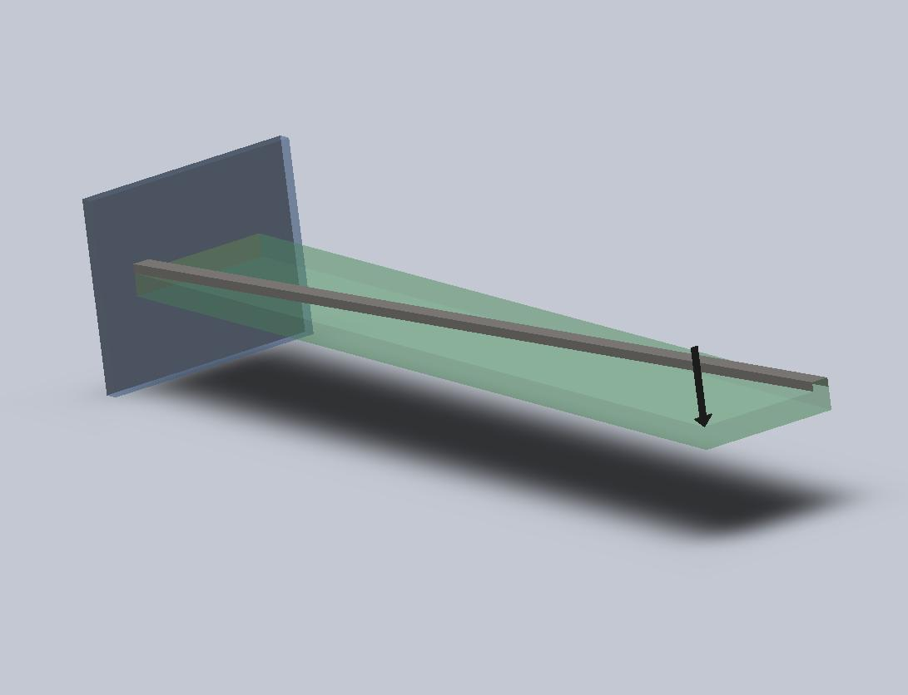

**Figure 2.1: A Beam Controlled by a Piezo Actuator and an External Force**

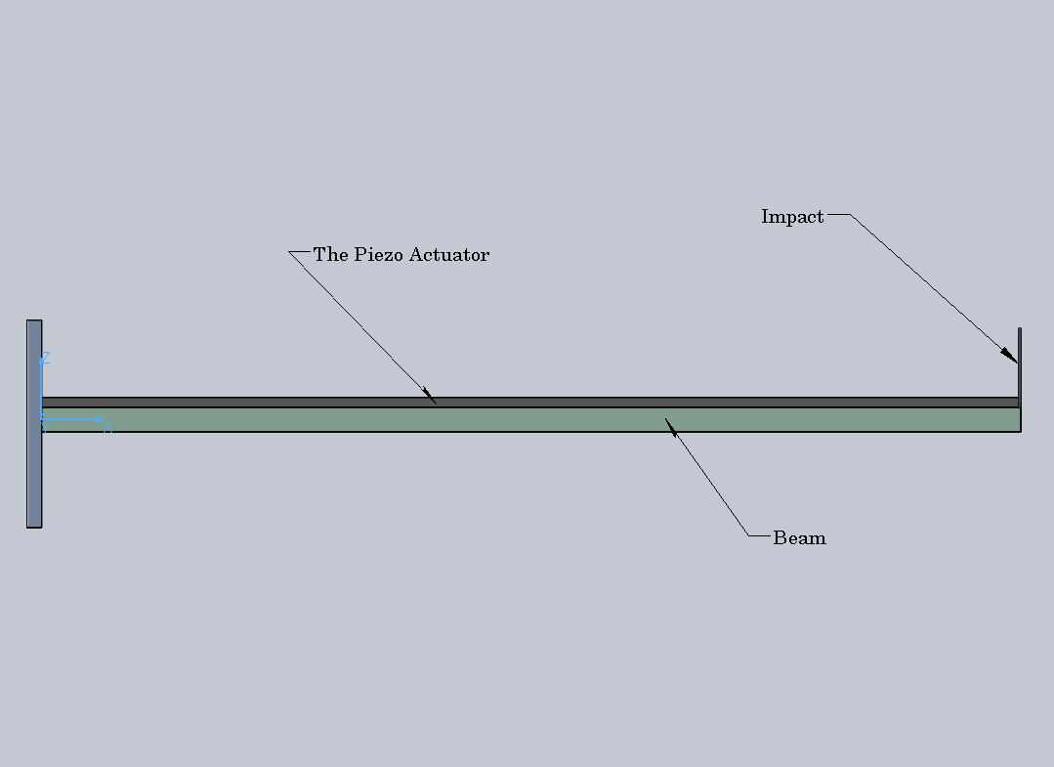

**Figure 2.2: The Front View of the Beam and Actuators**

The state-vector *x* in Eq. (2.23) is written in a convenient form of a transpose matrix as below:

$$x(t)={\left[\begin{matrix}q_{1}(t) & q_{2}(t) & ξ_{1}(t) & ξ_{2}(t) & {\dot{q}}_{1}(t) & {\dot{q}}_{2}(t) & {\dot{ξ}}_{1}(t) & {\dot{ξ}}_{2}(t)\end{matrix}\right]}^{T}$$

The generalized force and moment can be briefly revealed as:

$F_{i}=-Y_{i}\left(L\right)\left[H\left(t\right)-H\left(t-.01\right)\right]$

$M_{i}=-\frac{w}{2}ψ_{i}\left(L\right)\left[H\left(t\right)-H\left(t-.01\right)\right]$ (2.27)

Adding Eq. (2.22) to (2.27) gives us:

$Q+Q_{p}=\left[\begin{matrix}F_{i} \\ M_{i}\end{matrix}\right]+\left[\begin{matrix}F_{p} \\ Φ_{p}\end{matrix}\right]$ (2.28)

Simulating the first order differential Equation (2.23) provides functions of $q\left(t\right) and ξ(t)$. And substituting them into Equation (2.1) and (2.2) and coupling with Equation (2.3) solves the bending and torsion responses of the systems. The plots for these motions relatively compared with the free motion system will be presented.

The mass, stiffness including the induced stiffness from the actuator and damping matrices from Equation (2.7), (2.8), (2.9) and (2.21) and the distributed forces from (2.28) initially supplied voltage is supplied at 5V are numerically computed:

$$m_{ij}=\left[\begin{matrix}.463 & 0 & 0 & 0 \\ 0 & .246 & 0 & 0 \\ 0 & 0 & .0000109 & 0 \\ 0 & 0 & 0 & .0000109\end{matrix}\right]$$

$$k_{ij}+k_{p}=\left[\begin{matrix}54641.8 & 0 & 0 & 0 \\ 0 & 54641.8 & 0 & 0 \\ 0 & 0 & 3.451 & 0 \\ 0 & 0 & 0 & 3.451\end{matrix}\right]$$

$$c_{ij}=C\left(k_{ij}+k_{p}\right)=\left[\begin{matrix}-12.849 & 0 & 0 & 0 \\ 0 & -12.849 & 0 & 0 \\ 0 & 0 & -7.500 & 0 \\ 0 & 0 & 0 & -67.492\end{matrix}\right]$$

$$Q+Q_{p}=\left[\begin{matrix}.007-2.7244 (UnitStep\left[t\right]-UnitStep[t-.01] \\ .00028+1.964 (UnitStep\left[t\right]-UnitStep[t-.01] \\ -.005 (UnitStep\left[t\right]-UnitStep[t-.01] \\ -.005 (UnitStep\left[t\right]-UnitStep[t-.01]\end{matrix}\right]$$

*2.4. Conclusion*

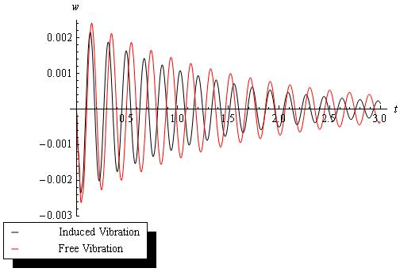

**Figure 2.3: The Tip Bending Displacement**

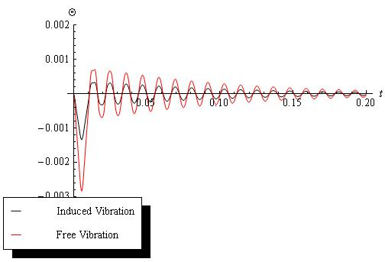

**Figure 2.4: The Tip Twisted Displacement**

The plots (2.3) and (2.4) drastically conclude the piezoelectric material as an effective participant in the control system. As noted in the legends, the red behaviors are the free vibrations and the black ones are damped by the actuator. When released, the beam starts bending in the z- and twisting in counter-clockwise direction. Appearance of the actuators in the system provides additional stiffness and generalized forces which add effectiveness in damping.

In Figure (2.5) and (2.6) below, the actuator is warped at different angles of 3o, 6o, 9o. It is essential to recall the Equation (2.15), which presents the contributed strain energies so that our numerical result can be testified. The elastic strain $ϵ_{xx}$ is a cosine function of the angles. Thus, decreasing in degree of the actuator’s angle will radically lower the contributed energy to the bending system as shown in Figure (5). At 3o (the blue line,) the system is damped faster and more effectively than the others. In contrast, the strain energy $γ_{xy}$ is a sine function, implying that decreasing in the angles provides less energy to the torsional system. In other words, the control system at 9o (the dashed line) will be the most effective control for the torsional system as shown in Figure (6.)

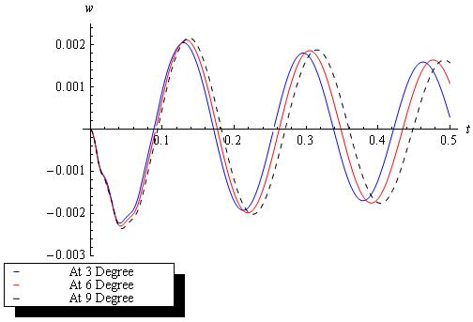

**Figure 2.5: The Tip Bending Displacements at Various Angles**

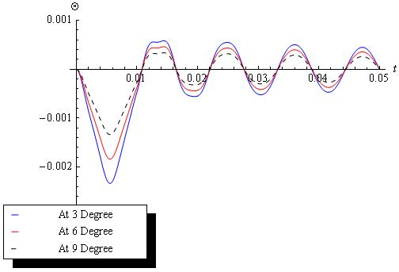

**Figure 2.6: The Tip Torsional Displacements at Various Angles**

Chapter 3

DEPLOYMENT OF THE PIEZO ACTUATORS ON THE UAV SYSTEM

*3.1. Introduction to a UAV’s Frame and Approach for a Solution*

Before continuing our study to the UAV model, we succinctly introduce the equations of a UAV model’s motion used in [5], originated from [8], and show how piezo patches are added to the equations of the motion presented in [1]. For a flexible aircraft, two types of reference frames are: fixed in the undeformed body and moving relative to the undeformed body. For the fixed type, any translations and rotations of the origin of the reference frame can be assumed as the motion of the rigid body; furthermore, any frame displacements are possibly considered as elastic displacements. However, in the moving one, the reference axes, or called mean axes, need to be essentially chosen to eliminate linear and angular momentum vectors according to the elastic deformations. These axes are not fixed as the first type but incessantly moving since the elastic displacements are varied in time. In addition, if the origin of the mean axes coincides with the mass center all the time, then the rigid body translations and rotations and the elastic displacements are all inertially decoupled.

Generally, there are three sets of body axes: one attached on the undeformed fuselage and other two on the undeformed wings and empennage but linked to the fuselage’s axes. Hence, the fuselage axes are normally treated as the reference frame for the whole aircraft. Choosing that reference frame is not unique for every model due to prevention of the origin of the reference frame from coinciding with the mass center and the reference axes with the principal axes at all time. In our study, we choose the most appropriate frame’s geometry for the defined problem.

In [8], Meirotvich and Tuzcu formulate equations of motions in term of quasi-coordinates, including ordinary differential equations for the rigid body translations and rotations of the whole aircraft and partial differential equations for the elastic motions of the components. The equations are originated from extensively applying Hamilton principle in function of a potential and kinetic energy and virtual work. In brief, the kinetic energy is developed from movement of each component. The potential energy is the strain energy. And the virtual work is done by external and generalized forces such as aerodynamics, propulsion and gravitation. In ease of integrating the system and control design, the ordinary equations are then transformed into a set of state-space equations following with a set of momentum equations.

However, there will be difficulties in simulating the state-space equations for stability analysis and control design because of their high order, non-linearity due to the aerodynamic forces and rigid body motions and inconsistent variables. And the perturbation approach seemed to be dedicated for solving these difficulties. Accordingly, the system is separated into two main parts: a zero-order part for the rigid body motions and a first-order part for the elastic displacements and perturbed rigid body motions*.*

In general, the flight dynamic equations are nonlinear but able to maneuver the aircraft. In order for maneuvering, an engine thrust and control surface angles need to be found. These solutions are not difficult to find if the aircraft is assumed at a steady level turn maneuver. Consequently, the zero-order motions and forces adequately turn out to be constant and the first-order equations then become linear in time. Using Linear Quadratic Gaussian (LQG) method gives us abilities to stabilize the aircraft and design the control system about certain steady circumstances.

In the next section, a description for UAV motions will be given from [5]. Since the wings are the most dominant aerodynamic and structural components, they are the only flexible components considered in establishing the control system using actuators for the UAVs. And other components, the fuselage and empennages, are assumed as rigid. In the following section, introducing the piezo actuators to the equations of the UAVs’ motion are quickly derived as shown in the cantilever beam section.

*3.2. Equations of Motions*

The wings of the aircraft are consisted of two symmetrical parts: left and right half wings are both treated as cantilever beams. The left part is designated in a subscript $l$ and the right one in a $r$ subscript in the equations of motions. Furthermore, a set of reference axes is attached on the body, and two set of axes are on the left and right half wings as shown in Figure 3.1 below. For convenience, the three axes are assumed to share the same origin, meaning that the origin of *xyz*, $x_{r}y_{r}z_{r}$ and $x_{l}y_{l}z_{l}$ are coincided. Thus, the motions can be defined by six degrees of freedom, three translations and rotations relative to the body axes, and elastic deformation of the wing. The equations of motions in [5] are written as follow:

$\frac{d}{dt}\left(\frac{∂L}{∂v}\right)+\tilde{ω}\frac{∂L}{∂v}=F$

$\frac{d}{dt}\left(\frac{∂L}{∂ω}\right)+\tilde{v}\frac{∂L}{∂v}+\tilde{ω}\frac{∂L}{∂ω}=M$

$\frac{∂}{∂x}\left(\frac{∂\hat{L}}{∂v_{i}}\right)-\frac{∂\hat{L}}{∂u_{i}}+\frac{∂{\hat{F}}_{i}}{∂{\dot{u}}_{i}}+{L_{i}u}_{i}={\hat{U}}_{i}$

$\frac{∂}{∂x}\left(\frac{∂\hat{L}}{∂α_{i}}\right)+\frac{∂{\hat{J}}_{i}}{∂{\dot{\dot{ψ}}}_{i}}+{H_{i}ψ}_{i}={\hat{Ψ}}_{i}$ (3.1)

where *i* = $r and l$

$L = T-V$, in which *T* and *V* are kinetic and potential energy, is Lagrangian equation

$v ={ \left[\begin{matrix}U & V & W\end{matrix}\right]}^{T}$, a translational velocities vector.

$ω = {\left[\begin{matrix}P & Q & R\end{matrix}\right]}^{T}$, an angular velocities vector.

$R ={ \left[\begin{matrix}X & Y & Z\end{matrix}\right]}^{T},$ the position vector of the origin *O* relative to *XYZ*

$θ = {\left[\begin{matrix}Φ & θ & ψ\end{matrix}\right]}^{T}$, the vector of Eulerian angles between *xyz* and *XYZ*

$\hat{F} =$ Rayleigh’s dissipation bending function density

$\hat{J} =$ Rayleigh’s dissipation torsinoal function density

$L =$ a matrix of stiffness operators for bending system

$H=$ a matrix of stiffness operators for torsional system

$u_{i}={ \left[\begin{matrix}0 & 0 & w_{i}\end{matrix}\right]}^{T}$, an elastic bending displacement

$v_{i} ={\dot{u}}_{i}$, a bending velocity for body.

$ψ_{i}= {\left[\begin{matrix}φ_{i} & 0 & 0\end{matrix}\right]}^{T},$ an elastic torsional displacement

$α_{i} = {\dot{ψ}}_{i}$, a torsionanl velocity vector.

**F $=$** aresultant of gravity, aerodynamic, propulsion and control force vector

**M $=$** a resultant of gravity, aerodynamic, propulsion and control moment vector

**U $=$** adensity vector of resultant of gravity, aerodynamic, propulsion and

control forces.

$Ψ$ $=$ adensity vector of resultant of gravity, aerodynamic, propulsion and

control moments.

$\tilde{ω} =$ a skew matrix in term of $ω$

$\tilde{v} =$ a skew matrix in term of $v$

$\tilde{ω}=\left[\begin{matrix}0 & -R & Q \\ R & 0 & -P \\ -Q & P & 0\end{matrix}\right] ,\tilde{v}=\left[\begin{matrix}0 & -W & V \\ W & 0 & -U \\ -V & U & 0\end{matrix}\right]$

${L_{i}u}_{i}=\left[\begin{matrix}0 \\ {L_{i}v}_{i} \\ {L_{i}w}_{i}\end{matrix}\right] , {{ H}_{i}ψ}_{i}=\left[\begin{matrix}H_{i}φ_{i} \\ 0 \\ 0\end{matrix}\right]$

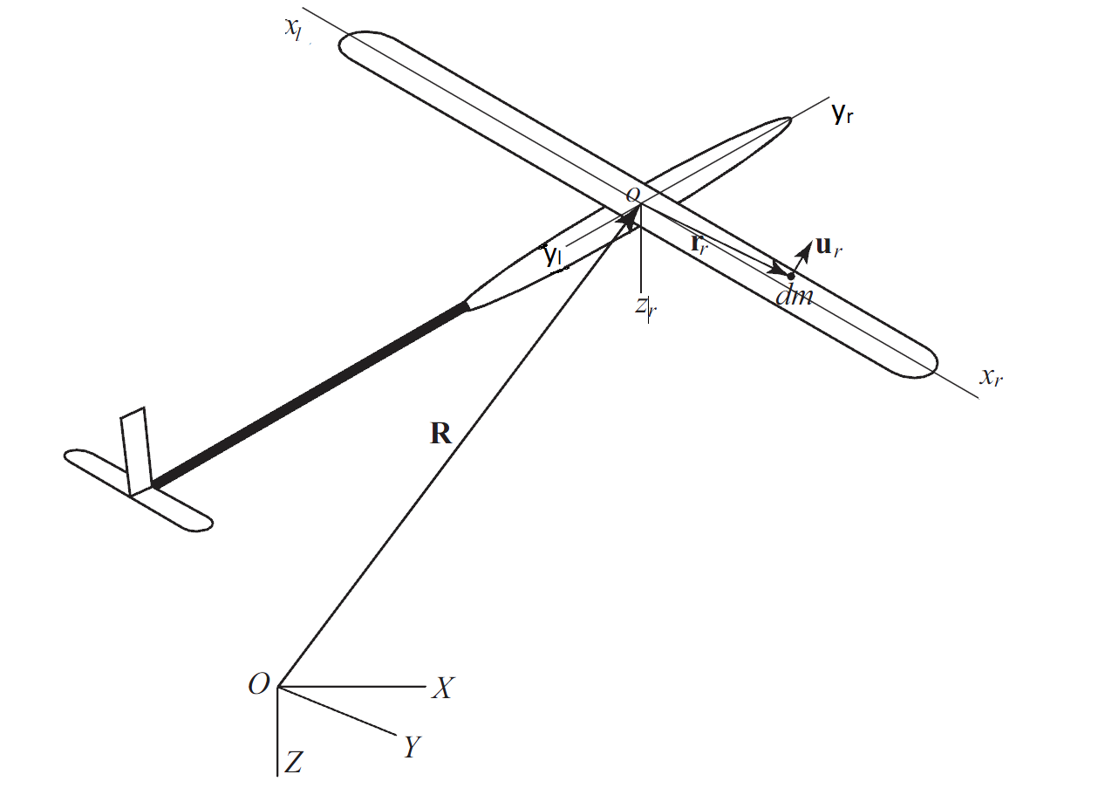

**Figure 3.1: A UAV Model**

To obtain a solution for Equations (3.1), such an approximating approach to discretize the nonlinear variables needs to be implicitly assumed. Thus, the Galerkin method is used for approximating the results to initiate the spatio-temporal expansion in [8]. The displacements for bending and torsion are in terms of two separate functions respecting to distance and time, which are:

$u_{i}\left(r_{i},t\right)=U_{i}\left(r_{i}\right){ q}_{i}(t)$, $ψ_{i}\left(r_{i},t\right)=ψ_{i}\left(r_{i}) ξ_{i}(t\right)$ (3.2)

where: $r_{i}=(x_{i},y_{i},z_{i})$ is a radius vector from *O* to a typical point on the wing, $U_{i}\left(r_{i}\right) and$ $ψ_{i}\left(r_{i}\right)$ the matrices of shape functions and ${ q}_{i}\left(t\right) and ξ_{i}(t)$ corresponding vectors of generalized coordinates. The shape functions are assumed as eigen-functions of an uniform cantilever beam for the bending and uniform clamped-free shaft for torsion.

Discrete equations of motions developed in [8] can be rewritten from Eq. (3.1):

$\dot{R}=C^{T}v , \dot{θ}=E^{-1}ω$

${\dot{q}}_{r}=s_{r} ,$ ${\dot{q}}_{l}=s_{l} , {\dot{ξ}}_{r}=η_{r} , {\dot{ξ}}_{l}=η_{l}$

${\dot{p}}_{v}=-\tilde{ω}p_{v}+F$

${\dot{ρ}}_{ω}=-\tilde{v}p_{v}-\tilde{ω}p_{ω}+M$

${\dot{p}}_{r}=\frac{∂T}{∂q_{r}}-K_{r}q_{r}-D_{r}s_{r}+Q_{r}$

${\dot{p}}_{l}=\frac{∂T}{∂q_{l}}-K_{l}q_{l}-D_{l}s_{l}+Q_{l}$

${\dot{ρ}}_{r}=-K_{r}ξ_{r}-D_{r}η_{r}+Θ_{r}$

${\dot{ρ}}_{l}=-K_{l}ξ_{l}-D_{l}η_{l}+Θ_{l}$**(**3.3)

where $K and K$ are the corresponding stiffness matrices of the bending and torsion system, *D* and $D$ the structural damping matrices, $Q and Θ$ the generalized force vectors,

$p_{v}=\frac{∂T}{∂v} , p_{ω}=\frac{∂T}{∂ω} , p_{i}=\frac{∂T}{∂s_{r}} , ρ_{i}=\frac{∂T}{∂η_{i}}, i=r,l$ (3.4)

the momenta vectors, *C* is a matrix of direction cosines between *xyz* and inertial axes *XYZ*, *E* a matrix relating Eulerian velocities of the wings can be retrieved from [8] and ${ s}_{i}\left(t\right) and η_{i}(t)$ the vectors of generalized velocities.

The total kinetic energy of the aircraft can be precisely written in a compact form:

$T=\frac{1}{2}\sum_{i}{\int{{\overline{v}}_{i}dm_{i}}} , i=r,l, f,h,v$ (3.5)

in which ${\overline{v}}_{i}$ is the velocity of a typical point on the component $i$. It can be expressed in term of:

${\overline{v}}_{i}\left(r_{i},t\right)=C_{i}v+{\tilde{χ}}_{i}^{T}C_{i}ω+U_{i}s_{i}+{\tilde{r}}_{i}^{T}ψ_{i}η_{i} , i=r,l$

${\overline{v}}_{i}\left(r_{i},t\right)=v+{{\tilde{r}}_{i}}^{T}ω , i=f, h,v$ where ${\tilde{χ}}_{i}={\tilde{r}}_{i}+\tilde{U_{i}q_{i}}$ (3.6)

$r_{i}$ is the nominal position of the mass element $dm_{i}$, $\tilde{r}$ is the skew matrix corresponding to $r_{i}.$

Combining Equation (3.5) and (3.6) generates a kinetic form in matrix of:

$T=\frac{1}{2}V^{T}MV$ (3.7)

in which $V={\left[\begin{matrix}v^{T} & ω^{T} & s_{r}^{T} & s_{r}^{T} & η_{r}^{T} & η_{l}^{T}\end{matrix}\right]}^{T}$ and *M* is the system mass matrix, simply a compact matrix form of:

$$M=\left[\begin{matrix}mI & {\tilde{S}}^{T} & C_{r}^{T}\int{U_{r}dm_{r}} & C_{l}^{T}\int{U_{l}dm_{l}} & C_{l}^{T}\int{{\tilde{r}}_{r}^{T}ψ_{r}dm_{l}} & C_{l}^{T}\int{{\tilde{r}}_{l}^{T}ψ_{l}dm_{l}} \\ & J & C_{r}^{T}\int{{\tilde{χ}}_{r}U_{r}dm_{r}} & C_{r}^{T}\int{{{\tilde{χ}}_{l}U}_{l}dm_{l}} & C_{r}^{T}\int{{\tilde{χ}}_{r}{\tilde{r}}_{r}^{T}ψ_{r}dm_{r}} & C_{r}^{T}\int{{\tilde{χ}}_{l}{\tilde{r}}_{l}^{T}ψ_{l}dm_{l}} \\ & & \int{U_{r}^{T}U_{r}dm_{r}} & 0 & \int{U_{r}^{T}{\tilde{r}}_{r}^{T}ψ_{r}dm_{r}} & 0 \\ & & & \int{U_{l}^{T}U_{l}dm_{l}} & 0 & \int{U_{l}^{T}{\tilde{r}}_{l}^{T}ψ_{l}dm_{l}} \\ & & Symmetric & & \int{ψ_{r}^{T}{\tilde{r}}_{r}{\tilde{r}}_{r}^{T}ψ_{r}dm_{r}} & 0 \\ & & & & & \int{ψ_{l}^{T}{\tilde{r}}_{l}{\tilde{r}}_{l}^{T}ψ_{l}dm_{l}}\end{matrix}\right]$$

where $\tilde{S}$ and *J* are the first and second moment inertia matrices of the aircraft, respectively.

$\tilde{S}=\sum_{i=r,l}{\int{C_{i}^{T}{\tilde{χ}}_{i}C_{i}dm_{i}}}+\sum_{i=h,v}{\int{{\tilde{r}}_{i}dm_{i}}}$

$J=\sum_{i=r,l}{\int{C_{i}^{T}{\tilde{χ}}_{i}{\tilde{χ}}_{i}^{T}C_{i}dm_{i}}}+\sum_{i=h,v}{\int{{\tilde{r}}_{i}{\tilde{r}}_{i}^{T}dm_{i}}}$ (3.8)

The momenta vector for the whole aircraft is:

$p=\left[\begin{matrix}p_{v}^{T} & ρ_{ω}^{T} & p_{r}^{T} & p_{l}^{T} & ρ_{r}^{T} & ρ_{l}^{T}\end{matrix}\right]=\frac{∂T}{∂V}=MV$ (3.9)

The stiffness matrices can be computed at:

$K_{i}=\int_{0}^{L}{EI(x)\frac{∂U_{i}^{T}}{∂x_{i}^{2}}\frac{∂U_{i}}{∂x_{i}^{2}}}dx_{i} , K_{i}=\int_{0}^{L}{GJ(x)\frac{∂ψ_{i}^{T}}{∂x_{i}^{2}}\frac{∂ψ_{i}}{∂x_{i}^{2}}}dx_{i} , i=r,l$ (3.10)

in which *E* is the Young’s modulus, *G* the shear modules elasticity, *I* the area and *J* the area polar moment inertia. The structural damping is assumed to be proportional to the stiffness matrices as:

$D_{i}=\frac{2ζ}{\sqrt{ω_{U}}}K_{i} , { D}_{i}=\frac{2ζ}{\sqrt{ω_{Θ}}}K_{i}$ (3.11)

where $ζ$ is a structural damping factor and $ω_{U}and ω_{Θ}$ are the lowest natural frequencies of half-wing in bending and torsion, respectively.

*3.3. Generalized and Distributed Forces:*

The four generalized force terms in Equation (3.3) include the distributed forces from the aerodynamic and gravity and the engine thrust **T** all over the wing components. The forces are clearly described in [8] and compacted into summation of the distributed forces and engine thrust as:

$F=\sum_{i=r,l}{C_{l}^{T}\int_{D_{i}}{\left[f_{i}++Tδ\left(r_{i}-r_{T}\right)\right]dD_{i}}}+\sum_{i=h,v}{\int_{D_{i}}{f_{i}}}dD_{i}$

$M=\sum_{i=r,l}{C_{l}^{T}\int_{D_{i}}{\left({\tilde{r}}_{i}+\tilde{U_{i}q_{i}}\right)\left[f_{i}++Tδ\left(r_{i}-r_{T}\right)\right]dD_{i}}}+\sum_{i=h,v}{\int_{D_{i}}{{{\tilde{r}}_{i}f}_{i}}}dD_{i}$

$Q_{i}=\int_{D_{i}}{U_{i}^{T}\left[f_{i}++Tδ\left(r_{i}-r_{T}\right)\right]dD_{i}}$

$Θ_{i}=\int_{D_{i}}{ψ_{i}^{T}{\tilde{r}}_{i}\left[f_{i}++Tδ\left(r_{i}-r_{T}\right)\right]dD_{i}}$ (3.12)

The distributed forces over the wing components which consist of lift and drag are formulated at use of a quasi-steady and strip theory:

$f_{ai}=l_{i}\left[\begin{matrix}0 \\ α_{i} \\ -1\end{matrix}\right]-d_{i}\left[\begin{matrix}0 \\ 1 \\ α_{i}\end{matrix}\right] , i=r,l$ (3.13)

in which $l_{i}=q_{i}c_{i}\left(C_{L0}+C_{Lαi}α_{i}+C_{La}δ_{a}\right) , d_{i}=q_{i}c_{i}\left(C_{D0}+k_{i}C_{Lαi}^{2}α_{i}^{2}\right) , q_{i}=\frac{1}{2}ρ{\left|{\overline{v}}_{i}\right|}^{2}$ are the lift and drag per unit span, respectively. Here, *c* is the chord, $C_{Lα}$ the slope of the lift curve, $δ_{a}$ an aileron rotation, $C_{La}$ a control effectiveness coefficient and $C_{L0} and C_{D0}$ the lift and drag coefficient at $α=0$, respectively. And the local angle-of-attack is different for the left and right part, which is: $α_{r}={{\overline{v}}_{rz}}/{{\overline{v}}_{ry}}-φ_{i}$, $α_{l}={{\overline{v}}_{lz}}/{{\overline{v}}_{lx}}-φ_{l}$.

The gravitational forces acting on the wings are:

$f_{gi}=C_{i}C_{f}\left[\begin{matrix}0 \\ 0 \\ m_{i}g\end{matrix}\right], i=r,l$ (3.14)

*3.4. Induction of the Piezoelectric Actuators to the UAV’s System*

A similar approach to the beam system will be retrieved. Yet, for the aircraft model multiple piezoelectric materials are attached on both right and left side of the wing. A unit step function is essentially incorporated for designing a control system. Recalling from Equation (2.18) to (2.21) in addition with the unit step functions present the additional stiffness and generalized forces for bending and torsional system of the wings.

The additional stiffness matrices for bending and torsion can be rewritten as:

$K_{pi}=\sum_{j=1}^{N}{\int_{0}^{L}{E_{p}I_{ij}(x)\left(\frac{∂^{2}U_{i}^{T}}{∂x_{i}^{2}}\frac{∂^{2}U_{i})}{∂x_{i}^{2}}\right)H_{ij}}dx}$

$K_{pi}=\sum_{j=1}^{N}{\int_{0}^{L}{G_{p}J_{ij}(x)\left(\frac{∂ψ_{i}^{T}}{∂x}\frac{∂ψ_{i}}{∂x}\right)H_{ij}}dx}$ $(3.15)$

And the generalized forces of the actuators are:

$Q_{pi}=E_{p}\cos^{2}β\sum_{j=1}^{N}{\int_{0}^{L}{Q_{ij}\left(x\right)Λ_{ij}\frac{∂^{2}U_{i}^{T}}{∂x_{i}^{2}}\left[\begin{matrix}0 \\ 0 \\ 1\end{matrix}\right]H_{ij}dx}}$

$Θ_{pi}=G_{p}sinβ cosβ\sum_{j=1}^{N}{\int_{0}^{L}{Q_{p}\left(x\right)Λ_{ij}\frac{∂ψ_{i}^{T}}{∂x}\left[\begin{matrix}1 \\ 0 \\ 0\end{matrix}\right]H_{ij}dx}} , i=r,l$ (3.16)

Here, $Λ_{ij}$ is the defined piezoelectric strain in Equation (2.13). And we assume that all the actuators use the same type of piezoelectric materials. In other words, $Λ_{ij}$ is constant at every point where the actuators are located. N is the total number of the piezo actuators on each side. And $H_{ij}$ is the unit step function located the actuators’ positions on the wing and is formulated in equation and figure below:

$H_{ij}=H\left[x_{i}-\left(a_{j}-l_{p}\cos{β}\right)\right]-H\left[x_{i}-\left(a_{j}+l_{p}\cos{β}\right)\right]$ (3.17)

in which $l_{p}$ is the length of the piezo actuator and $a_{j}$ the distance from the center of the actuator to the origin *O* as seen in Figure 3.1.

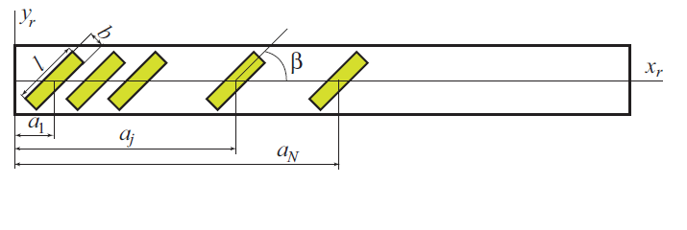

**Figure 3.2: The Right Wing Carrying the Piezo Actuators**

Adding Equation (3.15) to (3.10) and (3.16) to (3.12) slightly modifies the state equations of motion with further terms due to the actuators:

$\dot{R}=C^{T}v , \dot{θ}=E^{-1}ω$

${\dot{q}}_{r}=s_{r} ,$ ${\dot{q}}_{l}=s_{l} , {\dot{ξ}}_{r}=η_{r} , {\dot{ξ}}_{l}=η_{l}$

${\dot{p}}_{v}=-\tilde{ω}p_{v}+F$

${\dot{ρ}}_{ω}=-\tilde{v}p_{v}-\tilde{ω}p_{ω}+M$

${\dot{p}}_{r}=\frac{∂T}{∂q_{r}}-\left(K_{r}+K_{pr}\right)q_{r}-D_{r}s_{r}+Q_{r}+Q_{pr}$

${\dot{p}}_{l}=\frac{∂T}{∂q_{l}}-\left(K_{l}+K_{pl}\right)q_{l}-D_{l}s_{l}+Q_{l}+Q_{pl}$

${\dot{ρ}}_{r}=-{(K}_{r}+K_{pr})ξ_{r}-D_{r}η_{r}+Θ_{r}+Θ_{pr}$

${\dot{ρ}}_{l}=-{(K}_{l}+K_{pl})ξ_{l}-D_{l}η_{l}+Θ_{l}+Θ_{pl}$ (3.18)

in combination with: $p_{v}=\frac{∂T}{∂v} , p_{ω}=\frac{∂T}{∂ω} , p_{i}=\frac{∂T}{∂s_{i}} , ρ_{i}=\frac{∂T}{∂η_{i}}, i=r,l$

The discrete Equation s (3.18) can be simply put in a state space, which is:

$\dot{q}=SV$

$\dot{p}=-Kq-DV+f(q,V,u,u_{p})$ (3.19)

where:

$$q={\left[\begin{matrix}R & θ & q_{r} & q_{l} & ξ_{r} & ξ_{l}\end{matrix}\right]}^{T}$$

$V={\left[\begin{matrix}v & ω & s_{r} & s_{l} & η_{r} & η_{l}\end{matrix}\right]}^{T}$

$$u={\left[\begin{matrix}T & δ_{a} & δ_{e} & δ_{r}\end{matrix}\right]}^{T}$$

$$u_{p}={\left[\begin{matrix}V_{r1} & V_{r2} & ⋯ & V_{rN} & V_{l1} & ⋯ & V_{lN}\end{matrix}\right]}^{T}$$

$$K=\left[\begin{matrix}0 & 0 & 0 & 0 & 0 & 0 \\ 0 & 0 & 0 & 0 & 0 & 0 \\ 0 & 0 & K_{Tr} & 0 & 0 & 0 \\ 0 & 0 & 0 & K_{Tl} & 0 & 0 \\ 0 & 0 & 0 & 0 & K_{Tr} & 0 \\ 0 & 0 & 0 & 0 & 0 & K_{Tl}\end{matrix}\right]$$

and $K_{Ti}=K_{i}+K_{pi} , {K_{Ti}=K}_{i}+K_{pi} , i=r,l$

$$S=\left[\begin{matrix}C^{T} & 0 & 0 & 0 & 0 & 0 \\ 0 & E^{-1} & 0 & 0 & 0 & 0 \\ 0 & 0 & I & 0 & 0 & 0 \\ 0 & 0 & 0 & I & 0 & 0 \\ 0 & 0 & 0 & 0 & I & 0 \\ 0 & 0 & 0 & 0 & 0 & I\end{matrix}\right]$$

$$D=\left[\begin{matrix}0 & -{\tilde{p}}_{v} & 0 & 0 & 0 & 0 \\ -{\tilde{p}}_{v} & -{\tilde{p}}_{ω} & 0 & 0 & 0 & 0 \\ 0 & 0 & D_{r} & 0 & 0 & 0 \\ 0 & 0 & 0 & D_{l} & 0 & 0 \\ 0 & 0 & 0 & 0 & D_{r} & 0 \\ 0 & 0 & 0 & 0 & 0 & D_{l}\end{matrix}\right]$$

$$f={\left[\begin{matrix}F & M & \frac{∂T}{∂q_{r}}+Q_{r} & \frac{∂T}{∂q_{l}}+Q_{l} & Θ_{r}+Θ_{pr} & Θ_{l}+Θ_{pl}\end{matrix}\right]}^{T}$$

***f*** is a nonlinear function, where **u** is acontrol vector consisting of the engine throttles and control surfaces and **u**p are the control vector from the piezo actuators. To establish two indicated control systems for the non-linear state space system of equation (3.19), a dedicated perturbation approach is employed.

*3.5. Perturbation Approach*

From [8], Tuzcu and Meirovitch predefine the control design of the aircraft into two types: one system, called a zero-order, for steering the rigid body of the aircraft and another one, a first-order, for eliminating the disturbances acting on the elastic deformations of the components. The zero-order system can be formulated for steering or maneuvering the aircraft in space and the first-order for controlling the disturbances acting on the aircraft. The variables in Equation (3.19) can be separated in rigid and perturbation expression as follows:

$R=R^{0}+R^{1} , θ=θ^{0}+θ^{1} , v=v^{0}+v^{1}$

$$ω=ω^{0}+ω^{1} , q_{i}={q_{i}}^{0}+{q_{i}}^{1} , s_{i}={s_{i}}^{0}+{s_{i}}^{1}$$

$ξ_{i}={ξ_{i}}^{0}+{ξ_{i}}^{1} , η_{i}={η_{i}}^{0}+{η_{i}}^{1} , i=r,l$ (3.20)

where superscript “0” dictates for zero-order quantities and superscript “1” for first-order ones.

Substituting Equation (3.20) into (3.19) and separating the zero-order and first-order term gives us the motion of two systems, the rigid and perturbed rigid body as follow:

${\dot{q}}^{0}=S^{0}V^{0}$

${\dot{p}}^{0}=-K^{0}q^{0}-D^{0}V^{0}+f^{0}(q^{0},V^{0},u^{0})$ (3.21)

and

${\dot{q}}^{1}=S^{0}V^{1}+S^{1}V^{0}$

${\dot{p}}^{1}=-\left(K_{T}^{0}q^{1}+K_{T}^{1}q^{0}\right)-{(D}^{0}V^{1}+D^{1}V^{0})+f^{1}(q^{1},V^{1},u^{1},u_{p}^{1})$ (3.22)

Equation (3.22) points out that the piezo actuators only control the perturbed part only and have an ability to control it due the control vector $u_{p}$.

The zero- and first-order momentum from Equation (3.9) are:

$p^{0}=M^{0}V^{0}$

$p^{1}=M^{0}V^{1}+M^{1}V^{0}$ (3.23)

$M^{0}$ is the rigid part, and $M^{1}$ is the perturbation partof the mass matrix.

Since $M^{1}$ is linear with **q**1, can be replaced with $H^{0}V^{1}$ in Equation (3.23) such as**:**

$p^{1}=M^{0}V^{1}+H^{0}V^{1}$ (3.24)

Then Equation (3.21) can be rewritten in a compact state form of:

${\dot{x}}^{0}\left(t\right)=f\left[x^{0}\left(t\right) ,u^{0}(t)\right]$ (3.25)

where $x^{0}\left(t\right)={\left[\begin{matrix}R^{0 T} & θ^{0 T} & p_{v}^{0 T} & p_{ω}^{0 T}\end{matrix}\right]}^{T}$ is the zero-order state vector and $u^{0}\left(t\right)={\left[\begin{matrix}F_{E}^{0} & δ_{a}^{0} & δ_{e}^{0} & δ_{r}^{0}\end{matrix}\right]}^{T}$ the control vector of the zero-order part.

So does Equation (3.22) as:

${\dot{x}}^{1}\left(t\right)=Ax^{1}\left(t\right)+Bu^{1}\left(t\right)+B_{p}u_{P}$ (3.26)

where ${\dot{x}}^{1}\left(t\right)=\left[\begin{matrix}{\dot{R}}^{(1)T} & {\dot{θ}}^{(1)T} & {\dot{q}}_{r}^{\left(1\right)T} & {\dot{q}}_{l}^{\left(1\right)T} & {\dot{ξ}}_{r}^{\left(1\right)T} & … & {\dot{p}}_{r}^{\left(1\right)T} & … & {\dot{ρ}}_{l}^{\left(1\right)T}\end{matrix}\right]$

*A* and *B* coefficient matrix are computed as indicated:

$A=\left(\frac{∂g}{∂x} | x=x^{0},u=u^{0}\right)$

$B=\left(\frac{∂g}{∂u} | x=x^{0},u=u^{0}\right)$

$B_{p}=\left(\frac{∂g}{∂u_{p}} | x=x^{0},u=u^{0}\right)$ (3.27)

in which $g={\left[\begin{matrix}I & 0 \\ H^{0} & M^{0}\end{matrix}\right]}^{-1}\left[\begin{matrix}SV \\ -Kq-DV+f(q,V,u,u_{pi})\end{matrix}\right]$

$u_{pi}={\left[\begin{matrix}V_{1i}(t) & V_{2i}(t) & … & V_{Ni}(t)\end{matrix}\right]}^{T} , i=r, l$

$x^{0}, u^{0}$ are when the aircraft is at the equilibrium point.

*3.6. Control Design*

The input control vector $u_{P}$ is designed in order to compel the generalized coordinate terms of the state vector $x^{1}\left(t\right)$. In [5], authors use a linear quadratic regulator (LQR) method and assume the input controls as optimal controls to optimize the quadratic performance measure below:

$J=\frac{1}{2}x^{\left(1\right)T}\left(t_{f}\right)Hx^{\left(1\right)T}\left(t_{f}\right)+\frac{1}{2}\int_{t_{0}}^{t_{f}}{\left[x^{\left(1\right)T}\left(t\right)Q\left(t\right)x^{\left(1\right)T}\left(t\right)+u^{\left(1\right)T}\left(t\right)R\left(t\right)u^{\left(1\right)}(t)\right]dt}$ (3.28)

where *H* and *Q* are real symmetric positive semidefinite matrices, *R* real symmetric positive definite matrix and *t0* and *tf* initial and final time.

To simplify the problem, the optimal control vectors can be rewritten as shown:

$u^{\left(1\right)}\left(t\right)=-Gx^{1}(t)$ (3.29)

$u_{pi}(t)=-G_{pi}s_{i}^{1}(t)$ (3.30)

where $G=R^{-1}B^{T}K and G_{P}$ are the gain matrices of the optimal control vectors. To be able to obtain the best design for the input control, the weighting matrix *R* and *Q* need to be adjusted to achieve the most optimal performance system.

From [5], *K* can be computed at $K=EF^{-1}$ where *E* and *F* can be solved from a set of linear equation:

$\left[\begin{matrix}\dot{E} \\ \dot{F}\end{matrix}\right]=\left[\begin{matrix}{-A}^{T} & -Q \\ -BR^{-1}B^{T} & A\end{matrix}\right]\left[\begin{matrix}E \\ F\end{matrix}\right]$ (3.31)

To obtain the gain matrix *G*p, we consider that the generalized force vectors ***Q***p and ***Θ***p and input control **u**pi from the actuators are in relation of:

$\left[\begin{matrix}Q_{pi}\left(t\right) \\ Θ_{pi}\left(t\right)\end{matrix}\right]=\left[\begin{matrix}E_{upi} \\ E_{ψpi}\end{matrix}\right]u_{pi}$ (3.32)

where Eupi and Eψpi are constant matrices for bending and torsion, respectively. Next, the generalized force vectors are assumed to be proportional to the structural damping term such as:

$\left[\begin{matrix}Q_{pi}\left(t\right) \\ Θ_{pi}\left(t\right)\end{matrix}\right]=-\hat{β}\left[\begin{matrix}D_{i} \\ D_{i}\end{matrix}\right]s_{i}\left(t\right)$ (3.33)

where $\hat{β}$ is proportional constant.

Substituting Equation (3.30) into (3.32) and combining with Equation (3.33) gives the gain matrix *Gp* in an equation of:

$G_{upi}=\hat{β}{ E}_{upi}^{-1}{ D}_{i}$

$G_{ψpi}=\hat{β}{ E}_{ψpi}^{-1} D_{i}$ (3.34)

Note that ***E***up*i* and $E_{ψpi}$ should be a non-singular square matrix and have the same dimension of matrix as the structural damping coefficient. Otherwise, the input control design from the actuators somehow needs to be chosen to satisfy the relation of $:$

$${ E}_{upi}G_{upi}=\hat{β}{ D}_{i}$$

$${ E}_{ψpi}G_{ψpi}=\hat{β} D_{i}$$

Substituting Equation (3.29) and (3.30) into Equation (3.26) simplifies our state-space equation to the function of only the state vector $x^{1}(t)$ as below:

${\dot{x}}^{1}\left(t\right)=Ax^{1}\left(t\right)-BGx^{1}\left(t\right)-(B_{pr}G_{pr}+B_{pl}G_{pl})x^{1}\left(t\right)$

$=\left(A-BG-B_{pr}G_{pr}-B_{pl}G_{pl}\right) x^{1}\left(t\right)$ (3.35)

First, the stability of the aircraft can be evaluated by the eigenvalues of $A-BG-B_{p}G_{p}$. And it is stable only when all of the computed eigenvalues are pure imaginary and/or complex with negative real part. Also, the piezo control system can also be determined if it has an ability to control the aircraft by the eigenvalues. Subsequently, Equation (3.32) can be simulated with additional gust acting along the wings so that the actuators can be revealed whether they have a dominant ability in damping the system.

Chapter 4

NUMERICAL SOLUTION FOR UAV MODEL

The purpose of this study is to show if the piezo actuators have an ability to damp out the bending and torsional vibration of the flexible wings. The full bending and torsional motion of the wings including the piezo actuators are depicted in the Equation (3.26) where the constant matrices A, B and Bp can be simply obtained from Equation (3.27.) Note that the Equation (3.25) is only expressed for steering the aircraft.

The matrix of direction cosines *C* and relating Eulerian velocities of the wing *E* is revealed from Appendix A.1. The first and polar moment inertia from Equation (3.8) are computed in quantities of:

$$S=\left[\begin{matrix}0 & -29.84 & 0 \\ 29.84 & 0 & 5.6 \\ 0 & -5.6 & 0\end{matrix}\right] and J=\left[\begin{matrix}2374.25 & 0 & -1.6 \\ 0 & 277.463 & 0 \\ -1.6 & 0 & 2612.28\end{matrix}\right]$$

Assumed that the bending displacement is only displaced in the *z*-direction $u=\left[\begin{matrix}0 & 0 & u_{z}\end{matrix}\right]$, and torsional displacement is in the *x*-direction $u=\left[\begin{matrix}ψ_{x} & 0 & 0\end{matrix}\right]$ since the displacements in other directions are relatively small.

As mentioned in Section 3.2, for the first approximation the wings are modeled as beams clamped at the origin of the respective body axes that tolerate a bending and torsional vibration. According to Galerkin method, two modes of the shape functions for each displaced components are used. The shape function of a uniform clamped-free cantilever beam and shaft for the bending and torsion are:

$$U_{ir}=\sin{β_{r}}x_{i}-\sinh{β_{r}}x_{i}-\frac{\sin{β_{r} L_{i}}+\sin{β_{r}}L_{i}}{\cos{β_{r} L_{i}}+\cos{β_{r}}L_{i}}\left(\cos{β_{r}x_{i}}-\cosh{β_{r}x_{i}}\right)$$

$ψ_{ir}=\sin{(2r-1)π{x_{i}}/{2L_{i}}} , r=1,2 , i=r,l$ (4.1)

where $β_{r}$ can be computed from $\cos{β_{r}L }\cosh{β_{r}L}=-1$ and L is the length of the half-wing. The properties used for computation is listed in the Table 4.1 below.

|  |  |
| --- | --- |
| Length L (m) | 16.0 |
| Height h (m) | .04 |
| Modulus Elasticity EI (kPa) | 36.0 |
| Modulus Rigidity GJ (kPa) | 10.0 |

**Table 4.1: Dimensions and Properties of the Wings**

The stiffness matrices $K_{i} and K_{i}$ from Equation (3.10) can be integrated in conjunction with the two shape functions as given:

$$K_{l}=K_{r}=\left[\begin{matrix}45.27 & 0 \\ 0 & 1778.0\end{matrix}\right]$$

$${K_{l}=K}_{r}=\left[\begin{matrix}771. & 0 \\ 0 & 6939.\end{matrix}\right]$$

*4.1. First Order State Solution*

Due to the constant zero-order forces, the aircraft endure constant static deformations, the first-order quantities. The constant first-order velocity is stated in a form of:

$V_{f}^{1}=C_{f}^{0}\left\{{\left[\begin{matrix}V^{1} & 0 & 0\end{matrix}\right]}^{T}-C_{f}^{1}V_{f}^{0}\right\}$ and $ω_{f}^{1}=0$ (4.3)

Hence, the first-order momentums are constant according to the constant first-order velocities. It indicates from Equation (3.22) that:

$F^{1}=0 , M^{1}=0$

$-K_{i}q_{i}+Q_{i}=0 , {-K}_{i}ξ_{i}+Θ_{i}=0$ (4.4)

Solving the group of Equations (4.4) gives us the zero-order pitch angle, elevator angle, engine thrust and the static generalized displacements $q_{i}$ and $ξ_{i}$, which are:

$T^{0} = 14.65 , θ^{0 }= .1864 , δ_{e}^{0} = -.0924$

$q_{r}^{0}={\left[\begin{matrix}1.322 & .0896\end{matrix}\right]}^{T}$, $q_{l}^{0}={\left[\begin{matrix}1.322 & .0896\end{matrix}\right]}^{T}$

$ξ_{r}^{0}={\left[\begin{matrix}.0765 & .004\end{matrix}\right]}^{T}$, $ξ_{l}^{0}={\left[\begin{matrix}.0765 & .0037\end{matrix}\right]}^{T}$ (4.5)

To obtain the constant matrix A, B and Bp from Equation (3.27), the mass matrix in Equation (3.8) need to be found and given in Appendix A.2.

*4.2. The First Order Controlled Equation of Motion by the Piezo Actuators*

Multiple piezoelectric materials PZT G-1195 are employed on the aircraft. The list of their dimensions and properties used for computation is shown in Table 4.2 below.

|  |  |  |
| --- | --- | --- |
| Number of actuators | N | 12 |
| Length | Lp (m) | .6 |
| Thickness | tp (m) | .0025 |
| Width | Wp (m) | .05 |
| Angle | Β (degree) | 30.0 |
| Modulus elasticity | Ep (GPa) | 63.0 |
| Rigid elasticity | Gp (GPa) | 26.0 |
| Gap between actuators | d (m) | .05 |

**Table 4.2: Dimensions and Properties of PZT G-1195 Used for UAV**

The total additional stiffness matrices of the piezo actuators for both bending and torsion are:

$$K_{pi}=\left[\begin{matrix}47.21 & -239.5 \\ -239.5 & 1231.5\end{matrix}\right] , K_{pi}=\left[\begin{matrix}33.74 & -171.2 \\ -171.2 & 881.1\end{matrix}\right]$$

The structural damping system from Equation (3.11) is figured from the accumulation between the stiffness of the wing and the total amount of the piezo actuators attached on the wing, which are:

$D_{i}=\frac{2ζ}{\sqrt{ω_{U}}}{(K}_{i}+K_{pi}) , { D}_{i}=\frac{2ζ}{\sqrt{ω_{Θ}}}\left(K_{i}+K_{pi}\right) , i=r,l$ (4.6)

The natural frequencies of bending and torsion are:

$$ω_{U}=\det\left[K+K_{p},M\right] , ω_{ψ}=det⁡[K+K_{ψ},M]$$

$ζ$ damping factor is chosen to be 0.01, and the natural frequency of bending and torsion in Equation (4.6) above, the smallest natural frequencies, are $ω_{U}=13.12$ and $ω_{ψ}=963.8 {rad}/s$. The damping matrices in Equation (4.6) are then found at:

$$D=\left[\begin{matrix}.1767 & 0 \\ 0 & 6.941\end{matrix}\right] and { D}_{ψ}=\left[\begin{matrix}.4967 & 0 \\ 0 & 4.471\end{matrix}\right]$$

The generalized forces generated from the actuators from Equation (3.16) are functions of the input voltage and are given in Appendix A.3.

Then the constant matrix A, B and Bp in Equation (3.26) can be computed and specified in Appendix A.4.

*4.3. The Input Control Design*

After several trials, the weighting matrix R and Q to optimize the performance equation (3.28) are chosen and given in Appendix A.4. Subsequently solving the set of linear equation in Equation (3.31) and plugging the results into $G=R^{-1}B^{T}K$ give us:

$$G=\left[\begin{matrix}-.440 & 0 & 0.001 & 0 \\ 0 & -0.001 & 0 & .0002 \\ -31.6 & 0 & -.0 & 0 \\ 0 & -1.28 & 0 & .137 \\ 3221. & 0 & -.116 & 0 \\ 0. & -.305 & 0 & .052 \\ 0. & -.025 & 0 & .003 \\ -60.0 & 0 & .0025 & 0 \\ 0. & -.144 & 0 & .013 \\ 44.6 & 0 & .0 & 0 \\ 471.2 & 0 & -.016 & 0 \\ 0. & -.262 & 0 & 0.04\end{matrix}\right]$$

From Equation (3.32), the constant matrix ${{ E}_{upi} and E}_{ψpi}$ can be computed by taking the first derivative of the generalized forces $Q_{pi} and Θ_{pi}$ respect to the input voltage control vectors. Plugging these values into Equation (3.34) generates the gain matrix for bending and torsion in quantities of:

$$G_{pr}=\left[\begin{matrix}-1.22×{10}^{8} & -2.20×{10}^{8} & 1.60×{10}^{8} & -4.93×{10}^{7} \\ 3.70×{10}^{8} & 6.65×{10}^{8} & -4.85×{10}^{8} & 1.51×{10}^{8} \\ -3.72×{10}^{8} & -6.70×{10}^{8} & -4.89×{10}^{8} & -1.54×{10}^{8} \\ 1.25×{10}^{8} & 2.25×{10}^{8} & -1.64×{10}^{8} & 5.25×{10}^{7}\end{matrix}\right]$$

$G_{pl}=G_{pr}$

Thus, the eigenvalues vector of A *–* B*G* – $B_{pr}G_{pr}-B_{pl}G_{pl}$ are computed and listed in the table below:



**Table 4.3: Eigenvalues of the Controlled System**

First, the eigenvalues of both systems are real negative or complex with negative real parts so that our systems are stable. Second, the system with the control of the piezo actuators is much smaller than the system without the control. In other words, the controlled system is damped faster and stronger. Even though in the few last eigenvalues are little bit different, it is still significant in damping.

*4.4. Motions of the Wings*

Before obtaining solution for Equation (3.32,) a gust force is distributed along the wings in the form of:

$$f_{W}^{R}=\left[\begin{matrix}0 & 0 & -(4.5-{3x}/{2L_{w} })\end{matrix}\right]$$

${ f}_{W}^{L}=\left[\begin{matrix}0 & 0 & -(4.5+{3x}/{2L_{w} })\end{matrix}\right]$ (4.7)

where $0<x_{w}^{i}<L_{w}$ and Lw is the total length of right/left wing.

Substituting the Equation (4.7) into $Q_{i} and Θ_{i}$ from Equation (3.18) produces an external force for equation (3.35), which can be re-written as:

${\dot{x}}^{1}\left(t\right)=\left(A-BG-B_{pr}G_{pr}-B_{pl}G_{pl}\right){ x}^{1}\left(t\right)+F_{e}$ (4.8)

where $F_{e}=\left[\begin{matrix}0 & I\end{matrix}\right]\left[\begin{matrix}f_{W}^{R} \\ f_{W}^{L}\end{matrix}\right]$

Simulating the first-order sate-space Equation (4.8) gives solutions of the first order state-vector $x^{1}\left(t\right)$ including the position vector ***R***, Euler angle vector ***θ***, generalized coordinates $q_{i}\left(t\right) and ξ_{i}(t)$ and their generalized velocities $s_{i}\left(t\right) and η_{i}(t)$. Substituting the found generalized coordinates into Equation (3.2) gives the bending and torsion displacement of the wings, plotted in Figure 4.1-4.2.

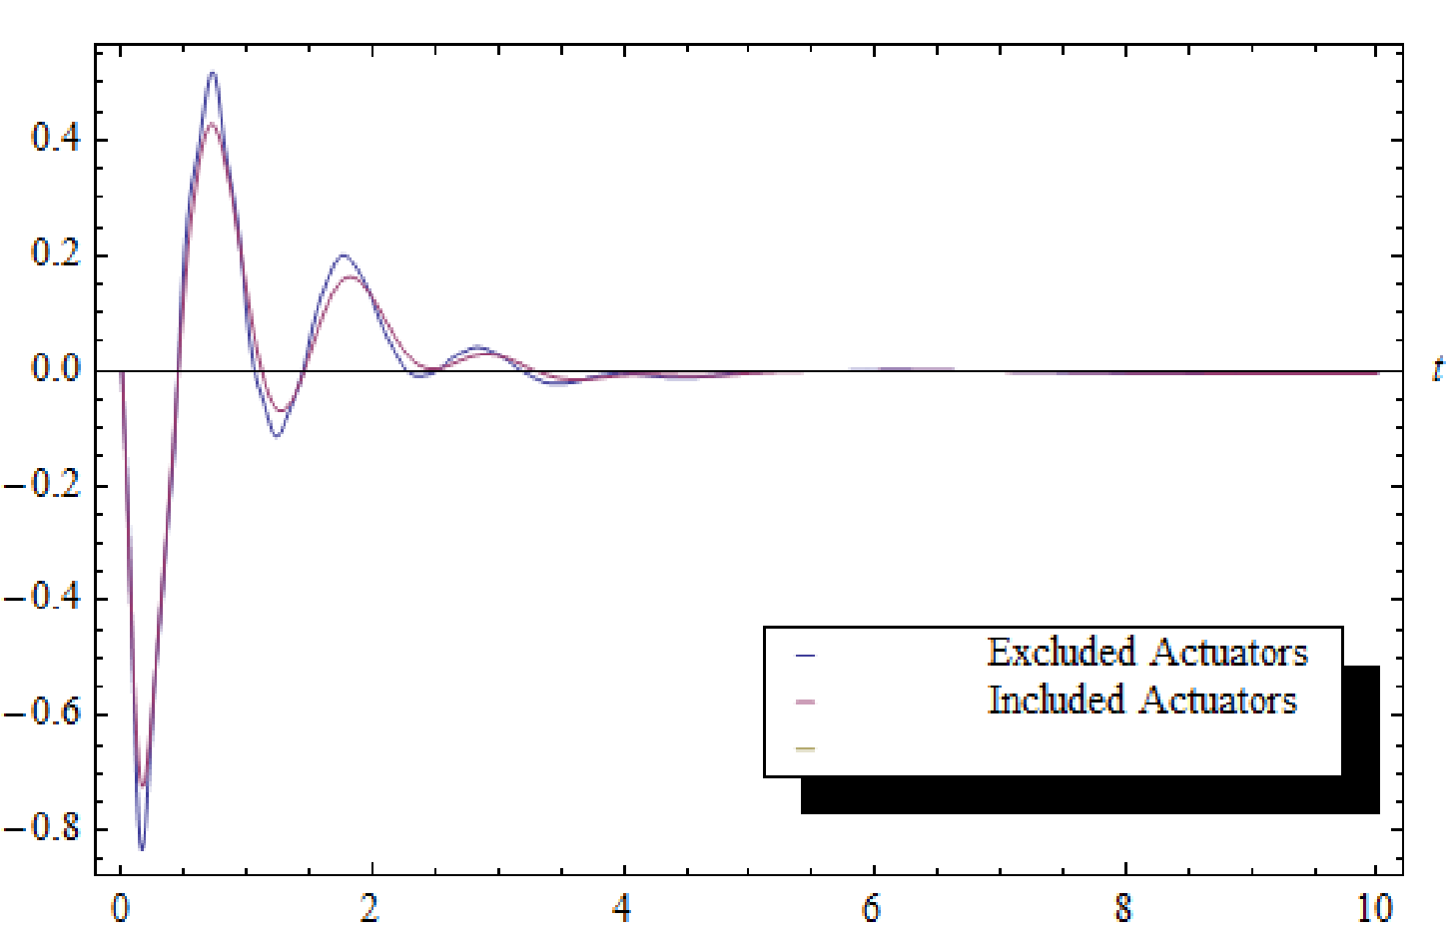

**Figure 4.1: The Tip Bending Displacements**

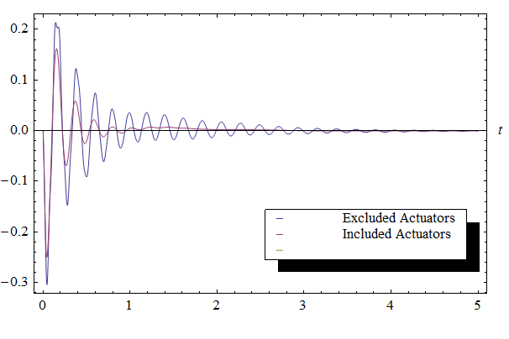

**Figure 4.2: The Tip Torsion Displacements**

Figure 4.3 and 4.4 are the first-order position *R* and Euler angle *θ* vector of the rigid body.

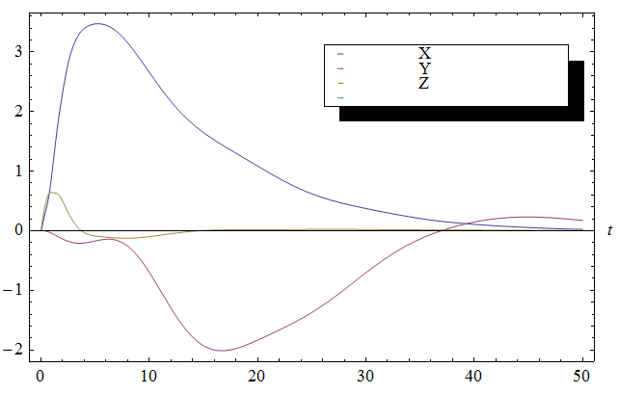

**Figure 4.3: The First Order Position Vector**

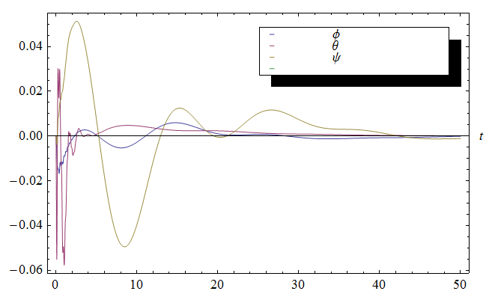

**Figure 4.4: The First Order Euler Angle Vector**

*4.5. Conclusion*

From [1], Tuzcu’s and Meirovitch’s intention successfully shows that the multiple piezoelectric materials horizontally attached along the components of a conventional aircraft acquire an ability of controlling the bending displacements of the components. In our study, if the piezo actuators are tilted at an angle to provide axial and shear strains to the systems, not only bending but also torsion are effectively controlled, which have been theoretically proved in the Equation (3.16) and the result in Figure (4.1) and (4.2.)

There are several studies which have used various approaches to eliminate the disturbances and damp the system. However, using the piezoelectric materials over the components of an aircraft as an actuating system is still a phenomenon in the aviation industry. [1] and this study drastically prove the feasibility of using them to control the aircraft’s vibrations. The piezo actuators seem to be good candidates to be considered as an additional control inputs complementing aircraft’s conventional control inputs.

APPENDIX

*A.1. Direction Cosines and Relating Eulerian Velocities*

$$C=\left[\begin{matrix}\cos{ψ}\cos{θ} & \sin{ψ}\cos{θ} & -\sin{θ} \\ \sin{ϕ}\sin{θ}\cos{ψ}-\cos{ϕ}\sin{ψ} & \sin{ψ}\sin{θ}\sin{ϕ}+\cos{ψ}\cos{ϕ} & \sin{ϕ}\cos{θ} \\ \cos{ψ}\sin{θ}\cos{ϕ}+\sin{ψ}\sin{ϕ} & \sin{ψ}\sin{θ}\cos{ϕ}-\cos{ψ}\sin{ϕ} & \cos{θ}\cos{ϕ}\end{matrix}\right]$$

$$E=\left[\begin{matrix}1 & 0 & -\sin{θ} \\ 0 & \cos{ϕ} & \sin{ϕ}\cos{θ} \\ 0 & -\sin{ϕ} & \cos{ϕ}\cos{θ}\end{matrix}\right]$$

*A.2. Mass Matrix*

$M_{11}=78.16$

$M_{13}=M_{13}=\left[\begin{matrix}0 & 0 \\ 0 & 0 \\ -5.40 & 3.0\end{matrix}\right]$

$M_{15}=M_{16}=\left[\begin{matrix}0 & 0 \\ 0 & 0 \\ 0 & 0\end{matrix}\right]$

$M_{23}=\left[\begin{matrix}-62.8 & 10.0 \\ 0 & 0 \\ 0 & 0\end{matrix}\right]$ and $M_{24}=-M_{23}$

$M_{25}=M_{26}=\left[\begin{matrix}0 & 0 \\ 1.02 & .04 \\ 0 & 0\end{matrix}\right]$

$M_{33}=M_{44}=\left[\begin{matrix}3.45 & 0 \\ 0 & 3.45\end{matrix}\right]$, $M_{35}=M_{46}=M_{56}=\left[\begin{matrix}0 & 0 \\ 0 & 0\end{matrix}\right]$

$M_{55}=M_{66}=\left[\begin{matrix}.8 & 0 \\ 0 & .8\end{matrix}\right]$

*A.3. Total Generalized Forces from the Actuators*

$Q_{pi}={\left[\begin{matrix}Q_{i1} & Q_{i2}\end{matrix}\right]}^{T}$

$Θ_{pi}={\left[\begin{matrix}Θ_{i1} & Θ_{i2}\end{matrix}\right]}^{T}, i=r,l$

where:

*Qi*1 = -0.000182514 VL[1]-0.000180903 VL[2]-0.000179292 VL[3]-0.000177681 VL[4]-0.00017607 VL[5]-0.000174459 VL[6]-0.000172848 VL[7]-0.000171238 VL[8]-0.000169628 VL[9]-0.000168017 VL[10]-0.000166408 VL[11]-0.000164798 VL[12]

*Qi*2 = 0.00107019 VL[1]+0.00103513 VL[2]+0.00100008 VL[3]+0.000965045 VL[4]+0.000930022 VL[5]+0.00089502 VL[6]+0.000860043 VL[7]+0.0008251 VL[8]+0.000790195 VL[9]+0.000755338 VL[10]+0.000720536 VL[11]+0.000685798 VL[12]

$Θ_{i1}$ = -0.000318775 VL[1]-0.000318669 VL[2]-0.000318532 VL[3]-0.000318365 VL[4]-0.000318167 VL[5]-0.000317938 VL[6]-0.000317679 VL[7]-0.000317389 VL[8]-0.000317068 VL[9]-0.000316717 VL[10]-0.000316335 VL[11]-0.000315923 VL[12]

$Θ_{i2}$ = -.000952287 VL[1]-0.000949433 VL[2]-0.000945756 VL[3]-0.000941258 VL[4]-0.000935943 VL[5]-0.000929817 VL[6]-0.000922885 VL[7]-0.000915151 VL[8]-0.000906624 VL[9]-0.000897311 VL[10]-0.000887219 VL[11]-0.000876358 VL[12]}

*A.4. Constant Coefficient Matrix* A*,* B *and* Bp *and Weighting Matrix R and Q*

$A=\left[\begin{matrix}0 & 0 & … & 0 & 0 & … & 0 & 0 \\ 0 & 0 & … & 0 & 0 & … & 0 & 0 \\ ⋮ & ⋮ & … & ⋮ & ⋮ & … & ⋮ & ⋮ \\ 0 & 0 & … & .016 & -.105 & … & -.067 & -.018 \\ 0 & 0 & … & 2.01 & -11.10 & … & -.001 & 0.003 \\ ⋮ & ⋮ & … & ⋮ & ⋮ & … & ⋮ & ⋮ \\ 0 & 0 & … & -.048 & .325 & … & -.005 & -.002 \\ 0 & 0 & … & -.144 & .975 & … & -3.68 & -.007 \\ 0 & 0 & … & -.048 & .325 & … & -.005 & -8.66\end{matrix}\right]$

$B=\left[\begin{matrix}0 & 0 & 0 & 0 \\ 0 & 0 & 0 & 0 \\ ⋮ & ⋮ & ⋮ & ⋮ \\ 0.013 & -.024 & -.228 & .019 \\ 0.0 & .093 & -.030 & -.800 \\ ⋮ & ⋮ & ⋮ & ⋮ \\ -.000 & 18.9 & 2.25 & -.059 \\ -.002 & -56.4 & 6.76 & -.177 \\ -0.00 & -18.8 & 2.25 & -.06\end{matrix}\right]$

$${ B}_{pi}={\left[\begin{matrix}0 & 0 & … & 9.87×{10}^{-7} & -.000016 & … & -3.03×{10}^{-6} & -.0012 & -.0036 \\ 0 & 0 & … & 9.69×{10}^{-7} & -.000015 & … & -2.98×{10}^{-6} & -.0012 & -.0035 \\ 0 & 0 & … & 9.48×{10}^{-7} & -.000014 & … & -2.92×{10}^{-6} & -.0012 & -.0034 \\ 0 & 0 & … & 9.24×{10}^{-7} & -.000013 & … & -2.84×{10}^{-6} & -.0012 & -.0033\end{matrix}\right]}^{T}$$

$R=\left[\begin{matrix}1 & 0 & 0 & 0 \\ 0 & {10}^{9} & 0 & 0 \\ 0 & 0 & {10}^{9} & 0 \\ 0 & 0 & 0 & {10}^{9}\end{matrix}\right]$

$Q=\left[\begin{matrix}{10}^{3} & 0 & 0 & 0 & 0 & 0 & 0 & 0 & 0 & 0 & 0 & 0 \\ 0 & {10}^{3} & 0 & 0 & 0 & 0 & 0 & 0 & 0 & 0 & 0 & 0 \\ 0 & 0 & {10}^{3} & 0 & 0 & 0 & 0 & 0 & 0 & 0 & 0 & 0 \\ 0 & 0 & 0 & {10}^{3} & 0 & 0 & 0 & 0 & 0 & 0 & 0 & 0 \\ 0 & 0 & 0 & 0 & {10}^{3} & 0 & 0 & 0 & 0 & 0 & 0 & 0 \\ 0 & 0 & 0 & 0 & 0 & {10}^{3} & 0 & 0 & 0 & 0 & 0 & 0 \\ 0 & 0 & 0 & 0 & 0 & 0 & {10}^{3} & 0 & 0 & 0 & 0 & 0 \\ 0 & 0 & 0 & 0 & 0 & 0 & 0 & 0 & 0 & 0 & 0 & 0 \\ 0 & 0 & 0 & 0 & 0 & 0 & 0 & 0 & 0 & 0 & 0 & 0 \\ 0 & 0 & 0 & 0 & 0 & 0 & 0 & 0 & 0 & 0 & 0 & 0 \\ 0 & 0 & 0 & 0 & 0 & 0 & 0 & 0 & 0 & 0 & 0 & 0 \\ 0 & 0 & 0 & 0 & 0 & 0 & 0 & 0 & 0 & 0 & 0 & 0\end{matrix}\right]$

BIBLIOGRAPHY

[1] *I. Tuzcu and L. Meirovitch: ”Control of Flying Flexible Aircraft Using Control Surfaces and Dispersed,”* Journal of Smart Materials and Structures, Vol. 15, pp.893-903, 2006.

[2] *C. Park and I. Chopra:”Modeling Piezoceramic Actuation of Beams in Torsion”* AIAA Journal, Vol.34, No.12, pp.2582-2589, 1996

[3] L. Edery-Azulay and H. Abramovich: “*Active Damping of Piezo-Composite Beams*,” Science Direct, Composite Structures, June 2005.

[4] Staley, D., Tsinovkin, Tuan Le, A., Morris, J. and Colemen, C.: *“Novel Solid State Air Pump for Forced Convection Electronics Cooling,”* IEEE Electronic Components and Technology Conference, 2008, pp 1332 – 1338, May 2008.

[5] I. Tuzcu, P. Marzocca and K. Awni: *“Nonlinear Dynamical Modeling of a High Altitude Long Endurance Unmanned Aerial Vehicle,”* 50th AIAA/ASME/ASCE/AHS/ASC Structures, Structural Dynamics, and Materials Conference, 2009.

[6] I. L. Meirovitch, *Elements of Vibration Analysis* (Second Ed.), McGraw-Hill Inc, 1986.

[7]J. E. Shigley and C. R. Mischke, *Mechanical Engineering Design (Fifth Ed.)*, McGraw Hill Inc, 1989.

[8] *L. Meirovitch and I. Tuzcu: “Unified Theory for the Dynamics and Control of Maneuvering Flexible Aircraft,” AIAA Journal, Vol. 42, No. 4, pp. 714-727, 2004.*

[9] *“Air Force Shoots Down Rogue UAV,” Baron’s Hobbies – Online Hobby Magazine.*

[10] “Piezoelectricity,” American Piezo – Piezo Theory.