ASML, THE QUIET FORCE BEHIND THE TECH REVOLUTION

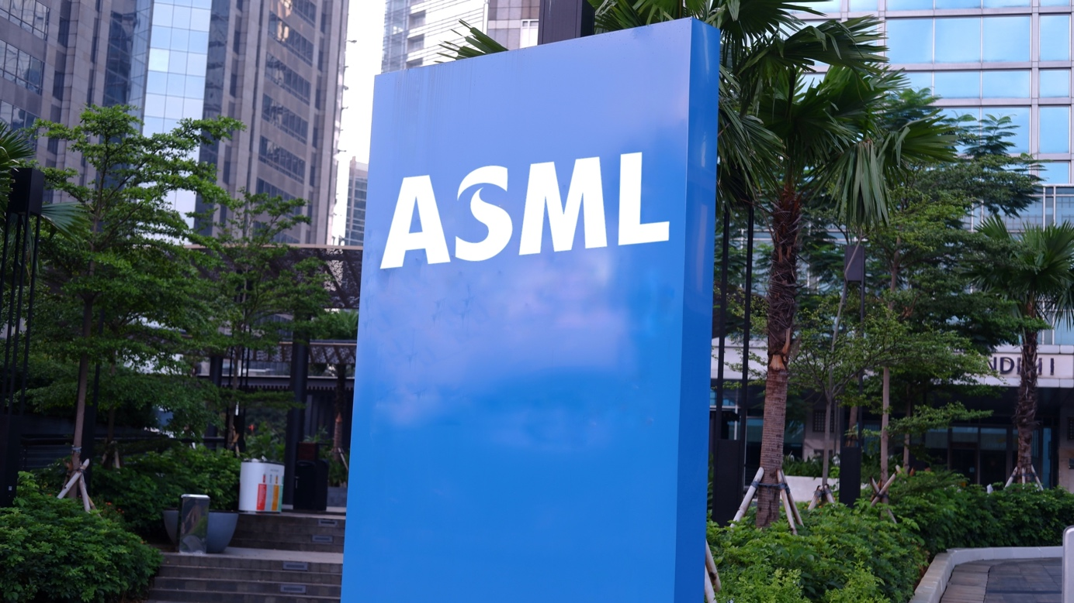

When you think about the tech giants shaping the future, names like Apple, Google, and Microsoft probably come to mind. But behind the scenes, there's a company you might not have heard of that's quietly making it all possible: ASML. This Dutch powerhouse plays a pivotal role in the semiconductor industry, enabling the very chips that power our digital lives. ASML recently took a bit of a tumble in the stock market, mostly due to some short-term challenges, but that just might be an opportunity in disguise. For those in the know, it could be the perfect time to get in on a company that's truly the backbone of the modern tech ecosystem.

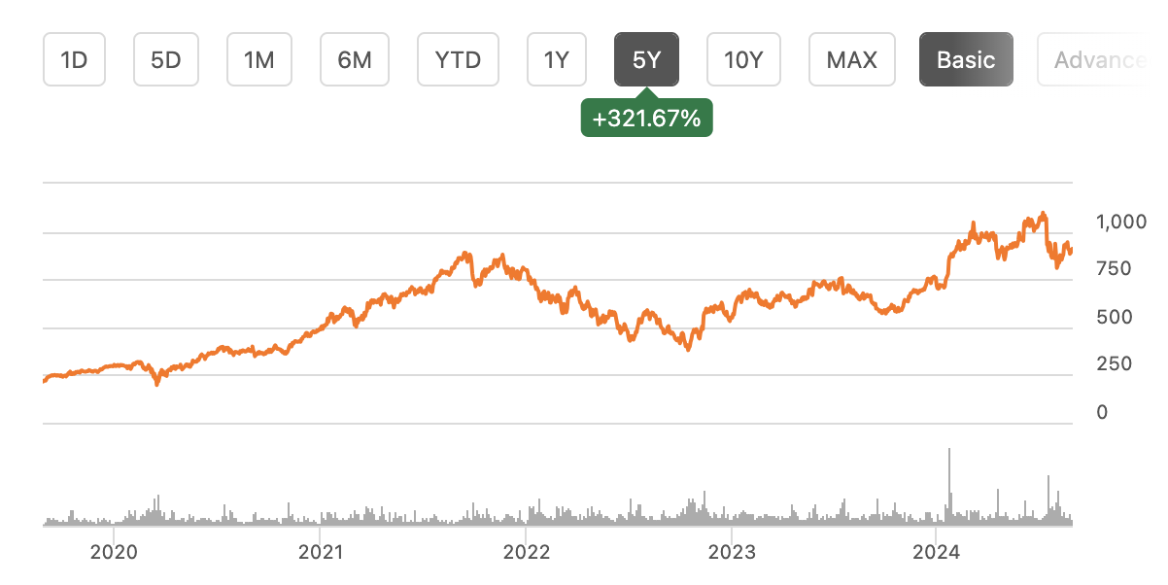

WHO EXACTLY IS ASML?

Founded in 1984 in the Netherlands, ASML started as a small division of Philips but quickly grew into the leading provider of photolithography machines—the crucial equipment used to manufacture semiconductors. These aren't your average machines; they're some of the most complex pieces of technology ever created, enabling the production of the tiny, intricate chips found in everything from smartphones to supercomputers.

ASML's technology is so advanced that it's often referred to as the "holy grail" of semiconductor manufacturing. Without ASML, the likes of Intel, TSMC, and Samsung wouldn't be able to produce the cutting-edge chips that drive innovation across the globe. The company's journey from a relatively unknown player to a dominant force in the semiconductor industry is nothing short of remarkable. It’s a tale of relentless innovation, deep collaboration, and a laser-sharp focus on staying ahead of the curve.

THE CORE TECH

At the heart of ASML's business lies photolithography, a process that uses light to print patterns onto silicon wafers. These patterns are then etched into the wafer to create the tiny transistors that make up a semiconductor chip. It's a bit like printing a picture onto a piece of paper, but instead of ink, you're using light, and instead of paper, you're working with ultra-pure silicon. The big deal? ASML's machines can create these patterns at an incredibly small scale—down to a few nanometers. This extreme precision is what allows modern chips to be so powerful and energy-efficient.

But it’s not just about being small—it’s about doing it with speed, accuracy, and consistency. ASML’s machines are engineered to operate at a level of precision that borders on the incredible.

ASML AND AI – A MATCH MADE IN SILICON



In the actual race for AI supremacy, semiconductors are the engine, and ASML is the key mechanic. AI demands immense computational power, and this power comes from the most advanced chips, which can be manufactured with ASML’s cutting-edge technology. ASML’s machines, especially the EUV (extreme ultraviolet) models, are crucial for producing the high-density, high-performance chips that AI algorithms thrive on. While TSMC dominates in semiconductor production, ASML’s role is indispensable. It holds a near-monopoly on the tools needed to make AI chips, ensuring that it remains a crucial player as AI continues to evolve. The collaboration between ASML and TSMC isn’t just about maintaining leadership; it’s about pushing the boundaries of what’s possible in AI.

The progress doesn’t stop there. ASML is already working on the next generation of its EUV technology—High-NA EUV—which promises even greater precision and efficiency. This will be vital for the next wave of AI development, enabling even more powerful and energy-efficient chips.

So why is ASML so important? Simply put, as we said, they have a near-monopoly on the technology that powers the semiconductor industry. While there are other companies that produce photolithography equipment, none seems to match the efficiency of ASML's machines. This dominance gives ASML an incredible amount of leverage in the tech world. In fact, their customers, including giants like Intel, Samsung, and TSMC, are highly dependent on its technology. This makes it not just a supplier, but a critical partner in the global tech ecosystem!

Beyond the sheer technical superiority, ASML's machines are also indispensable because of the ecosystem that has built up around them. The company offers extensive support, training, and services to its customers, ensuring that they can get the most out of their equipment.

A POWERHOUSE WITH STRONG FINANCIALS

Now, let's talk about what really interests us!

ASML isn't just a tech innovator; it's also a financial juggernaut. The company has seen consistent revenue growth driven by the strong demand for its cutting-edge equipment. In 2023, ASML reported revenues of over €21 billion, a testament to its dominant position in the market, despite the fact that 2024 is seen as a "transition year" with flat revenue growth, but ASML is preparing for a cyclical upturn in 2025.

One of the most impressive aspects of ASML's financials is its profitability. With gross margins consistently above 50% (see graph below, compared to two of its competitors; Applied Materials & KLA Corporation), ASML is generating significant profits, which it reinvests into research and development to stay with the top of the competition. And more, the company's strong balance sheet, with minimal debt and a healthy cash reserve, gives it the financial flexibility to continue innovating and expanding its business.

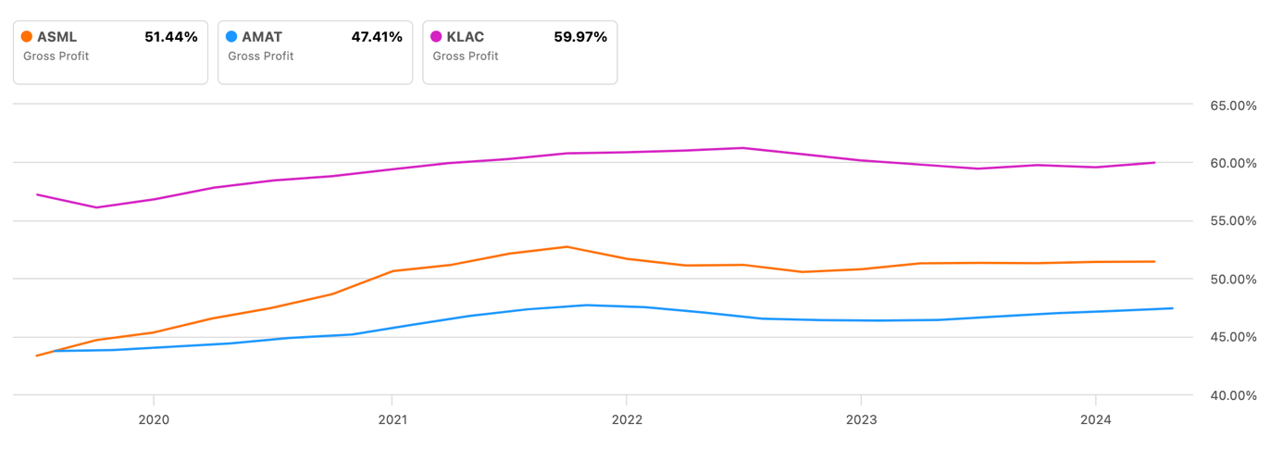
If we talk about valorization, ASML's higher P/E ratio is all about the confidence investors have in its future (see graph below). With its top-tier EUV technology, it’s like the boss of the chip-making world, holding a near-monopoly that leaves competitors in the dust. As demand for semiconductors skyrockets thanks to AI and other tech trends, ASML is in the perfect spot to cash in, so investors are happy to pay a bit more for a piece of this action, trusting it to stay ahead of the game and handle the ups and downs of the industry.

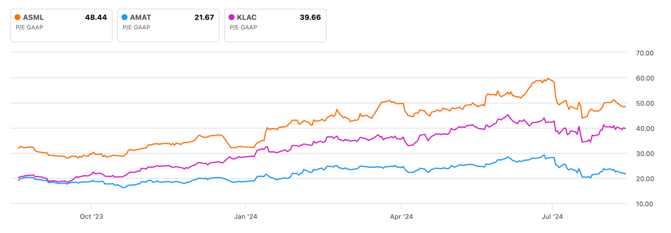

Investors have taken note, and ASML's stock price has reflected this strong financial performance. The company has become one of the most valuable tech firms in Europe, and its shares are a favorite among those looking to invest in the future of technology. This market's confidence is a direct result of its unwavering commitment to innovation and excellence.

CAN ANYONE CATCH UP?

Given ASML's dominance, you might wonder if there's any competition on the horizon. The short answer? Not really. While companies like Nikon and Canon also produce photolithography equipment, they're several generations behind ASML's technology. And when it comes to EUV, ASML is in a league of its own. That said, the semiconductor industry is incredibly dynamic, and no company can afford to rest on its laurels. ASML continues to invest heavily in research and development, ensuring that it stays ahead of the curve. The company is already working on the next generation of EUV machines, which promise to push the boundaries of what's possible even further.

Competition, however, isn’t just about technology—it’s about the ability to scale, innovate, and adapt to changing market conditions. ASML’s leadership is acutely aware of this and has made strategic moves to ensure that the company remains agile and responsive to industry trends. This forward-thinking approach is a key reason why the company has maintained its leadership position for so long.

Also, technology and geopolitics are increasingly intertwined, and ASML finds itself at the center of this intersection. The company's technology is so critical that it's become a key asset in the global tech race, particularly between the United States and China. The U.S. government has placed restrictions on the sale of ASML's EUV machines to Chinese companies, citing concerns about national security and technological supremacy. This has put ASML in a tricky position, as China represents a significant potential market. However, ASML has navigated these challenges by focusing on its existing customers and continuing to innovate!

These geopolitical dynamics add an extra layer of complexity to ASML's operations. The company must balance its business interests with the political realities of the world, a challenge that requires not just technical expertise but also diplomatic finesse.

WHAT’S NEXT FOR ASML?

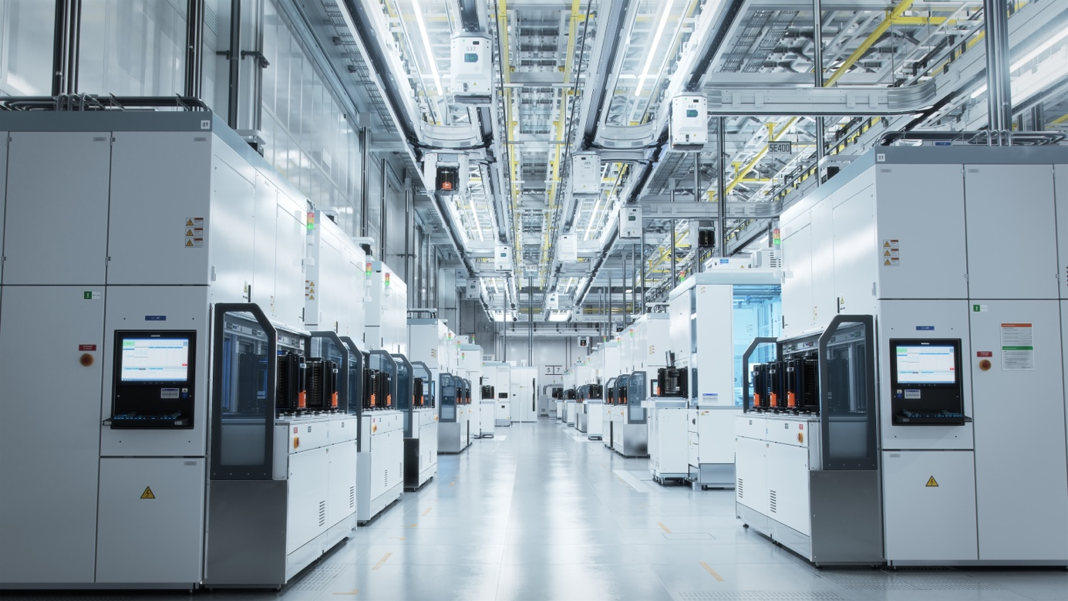

Looking ahead, ASML is in a prime spot to keep crushing it in the semiconductor game for years to come. With the demand for semiconductors set to skyrocket as AI and other tech keep growing, ASML's machines are poised to be right at the center of it all. The big focus? High-NA EUV—the next level of their already game-changing EUV tech, promising even more precision and efficiency. Plus, ASML isn't just sticking to chips; they're branching out into cool new areas like quantum computing and nanotechnology.

Sure, the road ahead won't be all smooth sailing. ASML will need to keep innovating, boosting its capabilities, and navigating some tricky geopolitical waters. But with their killer track record, there's every reason to believe ASML will keep leading the charge and shaping the future of semiconductors.

CONCLUSION

In the tech world, it's easy to get dazzled by big names like Apple and Google. But behind the scenes, ASML is the unsung hero making it all happen. This hidden giant of the semiconductor industry provides the cutting-edge technology that powers our digital lives.

Looking forward, its role is only going to get more crucial. With their top-tier tech, strong financials, and smart strategies, ASML is set to stay a major player on the global tech stage. So, the next time you pick up your smartphone or fire up your computer, take a second to appreciate the amazing tech behind it!

