Fertility Trends Across Generational Classifications in the US

Team Members: Isaac Martinez, Natalie Aviles, Vanessa Lee, Yan Kong, Devin Bankston, Jeremy Jackson

Project Description: Comparing fertility rates throughout generations. The fertility rate measures the number of births per 1,000 women of childbearing age (ages 15 to 44) occurring in a particular year; birth rates refer to this measure within particular age groups.
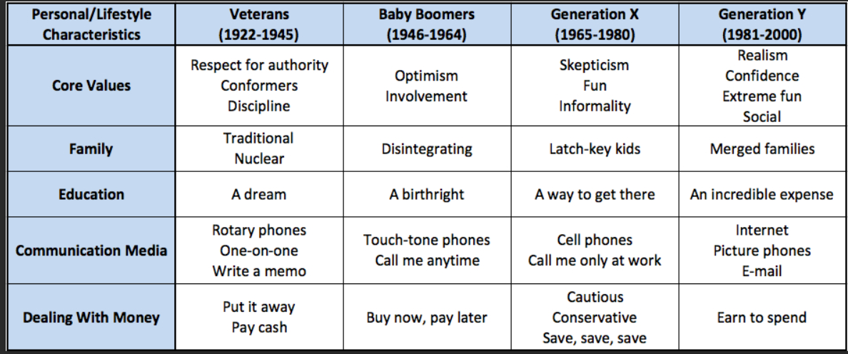

Education levels, household income, marital status, age, location, and race.

Data sets: Statista (https://www.statista.com/statistics/195943/birth-rate-in-the-united-states-since-1990/)
(https://www.statista.com/statistics/1033027/fertility-rate-us-1800-2020/)

CDC (https://data.cdc.gov/NCHS/NCHS-Birth-Rates-for-Females-by-Age-Group-United-S/yt7u-eiyg/data)
Data World (https://data.world/fivethirtyeight/marriage)
Data.gov (http://data.gov/)
Kaggle (https://www.kaggle.com/)

Division of Tasks:
Isaac- Education Level
Natalie – Age
Vanessa – Income
Yan – Marital Status
Jeremy – Location
Devin - Race

