Introduction to Human Biology Laboratory Workbook
George Mateja
2026-01-01
Table of contents

Preface
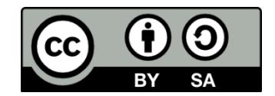
Introduction to Human Biology Laboratory Workbook; an Open Education Resource. First Edition © 2026 by George Mateja is licensed under CC BY-SA 4.0. To view a copy of this license, visit https://creativecommons.org/licenses/by-sa/4.0/
This manual includes original content by George Mateja, Professor of Biology at Community College of Baltimore County. Its creation also contains a variety of remixed and revised content from other resources. These sources are noted in the attributions section for each lab.

Table of Contents
 | Topics related to writing in lab
 | Front Matter 01: Scientific Writing, Citation, and Using Credible Sources
 | Front Matter 02: Prelab Preparation and Responsible Use of Ai
Week | Lab Topic
1 | Lab 01: Laboratory Safety and Measurement
2 | Lab 02: Use of the Microscope
3 | Lab 03: Molecules, Water, and pH; Bufferin Variation
4 | Lab 04: Chemical Composition of Cells - VM  (take home handout-coupled with lab 04)  Molecular Structure of Biological Molecules
5 | Lab 05: Diffusion and Osmosis
6 | Lab 06: Enzyme activity (Turnip Peroxidase)
7 | Lab 07: Practical 1
8 | Lab 08: Respiration and Yeast Fermentation
9 | Lab 09: Photosynthesis & Respiration
10 | Lab 10: Mitosis & Meiosis - VM
11 | Lab 11: Mendelian Genetics of Corn with Inherited Human Traits
12 | Lab 12: Mendelian Genetics Problems with Genetics Handout.
13 | Lab 13: (Break; floats depending on semester)
14 | Lab 14: Poster presentation & Practical Review
15 | Lab 15: Practical 2
16 | Finals week – No Labs

Scientific Writing, Citations, and Using Credible Sources

Student Pre-Lab Questions
- What makes a question scientific?
- Why must credible sources be used in biology?
- What is a primary scientific source?
- What is plagiarism?
- When must a source be cited?
- What is included in an in-text citation?
- Which section explains why a study was conducted?

Overview
Biology is a scientific discipline grounded in observation, experimentation, and evidence-based reasoning. Scientific knowledge does not exist in isolation; it builds upon the work of other researchers. As a result, scientists must evaluate credible sources, cite prior work properly, and communicate findings clearly and accurately.
In this course, you will learn how to:
- Ask scientific, testable questions
- Identify and evaluate credible biological sources
- Properly cite scientific literature
- Communicate findings using accepted formats of scientific writing
Together, these skills form the foundation of scientific literacy and integrity.

Learning Objectives
By the end of this chapter, students will be able to:
- Distinguish between scientific and non-scientific questions
- Identify credible sources appropriate for biological research
- Differentiate between primary, secondary, popular, and scholarly sources
- Evaluate source credibility using objective criteria (CRAAP test)
- Explain the importance of citation in scientific writing
- Define plagiarism and identify examples of academic dishonesty
- Apply proper in-text citation formats (APA or CSE style)
- Describe the structure and purpose of sections in a scientific paper
- Distinguish between Results and Discussion sections
- Use writing practices that improve clarity, accuracy, and credibility

Scientific Questions and the Role of Evidence
Science focuses on questions that can be tested through observation, measurement, and experimentation.

Scientific Questions
- Can be investigated empirically
- Rely on measurable data
- Are testable and repeatable
Examples:
- What temperature maximizes bacterial growth?
- Does a specific drug reduce disease symptoms?

Non-Scientific Questions
- Cannot be tested using scientific methods
- Often involve opinions, beliefs, or ethics
Examples:
- What is the best genre of music?
- Should cloning be allowed?
Only scientific questions can be addressed in laboratory investigations.

Using Credible Sources in Biology
Before conducting research, scientists review existing knowledge. Using credible sources ensures accuracy and reliability.

Types of Scientific Sources

Primary Sources
- Original research articles
- Present new data and experimental findings
- Peer-reviewed and written by experts

Secondary Sources
- Summarize or interpret primary research
- Examples: textbooks, review articles

Popular vs. Scholarly Sources
The following table compares popular and scholarly sources, highlighting key differences in audience, review process, and reliability in scientific research.

Table 1. Comparison of Popular and Scholarly Sources in Scientific Research
This table compares popular and scholarly sources across several characteristics. Popular sources are written for a general audience, are not peer-reviewed, contain few or no citations, use simplified language, and include examples such as blogs and magazines. Scholarly sources are written for an expert audience, are peer-reviewed, include extensive references, use technical language, and include examples such as scientific journals like Science and Nature.
Popular Sources | Scholarly Sources
General audience | Expert audience
Not peer-reviewed | Peer-reviewed
Few or no citations | Extensive references
Simplified language | Technical language
Examples: blogs, magazines | Examples: Science, Nature
Scientific writing relies primarily on scholarly sources.

Evaluating Credibility: The CRAAP Test
To assess sources, use the CRAAP criteria:
- Currency – Is the information recent?
- Reliability – Is it from a trusted organization or journal?
- Authority – Is the author qualified?
- Accuracy – Is it supported by evidence?
- Purpose – Is the content objective or biased?
Low-quality sources should not be used in scientific work.

Citing Sources and Avoiding Plagiarism

Why Citation Matters
Citations:
- Distinguish your ideas from others
- Credit original authors
- Allow verification of information
- Maintain academic integrity

What Is Plagiarism?
Plagiarism is presenting another person’s work as your own.

Examples:
- Copying text without citation
- Paraphrasing without credit
- Submitting someone else’s work

Avoiding Plagiarism
Plagiarism is the act of presenting another person’s work, ideas, words, or creative output as your own without giving proper credit to the original source. This can include copying text directly, paraphrasing someone else’s ideas without acknowledgment, or submitting work that was created by someone else, such as a classmate or an online source. Plagiarism is considered a serious academic and ethical violation because it misrepresents authorship, undermines intellectual honesty, and deprives the original creator of recognition for their work.
- Use your own words
- Cite all non-original ideas
- Keep accurate research notes
- Use quotes sparingly in science

Citation Styles in Science
Scientific disciplines use standardized formats such as:
- APA (Author–Year)
- CSE (Name–Year commonly used in biology)

In-Text Citation Example
- (Smith, 2020)

Reference List
- Includes only sources cited in the paper
- Organized alphabetically
Consistency in formatting is essential.

Writing for Science
Scientific writing emphasizes clarity, precision, and conciseness to ensure that ideas and findings are communicated effectively. Clarity means presenting information in a straightforward and understandable manner, avoiding ambiguity or unnecessary complexity. Precision involves using specific, accurate language and terminology so that the meaning is exact and scientifically correct. Conciseness requires eliminating unnecessary words or repetition, allowing the reader to quickly grasp the essential information without distraction. Together, these principles help make scientific communication efficient, credible, and accessible to other researchers.

Structure of a Scientific Paper
The structure of a scientific paper provides a standardized format that allows researchers to communicate findings clearly and logically. Each section has a specific purpose: the Introduction presents background and the research question, the Methods describe how the study was conducted, the Results report the data, and the Discussion interprets the findings. This organized approach helps readers quickly understand the study and evaluate its validity.

Title
- Concise and descriptive

Abstract
- Summary of purpose, methods, results, and conclusions
- Written last

Introduction
- Provides background and context
- States research question or hypothesis
- Explains importance of the study

Methods
- Describes how the study was conducted
- Allows replication
- Includes materials and procedures

Results
- Presents data and findings
- Includes figures and tables
- No interpretation

Discussion
- Interprets results
- Connects findings to existing research
- Explains significance and limitations

Literature Cited
- Lists all referenced sources

General Writing Practices
- Be concise and precise
- Use appropriate scientific terminology
- Prefer active voice when appropriate
- Use past tense for results, present tense for general knowledge
- Avoid ambiguity and unnecessary detail
- Treat “data” as plural
- Italicize scientific names (Homo sapiens)
- Revise and proofread carefully

Summary and Application to Laboratory Work
This chapter introduces the foundational skills required for success in biology, emphasizing the importance of scientific thinking, credible research, proper citation, and effective communication. Biology relies on evidence-based investigation, meaning that students must be able to ask testable scientific questions, evaluate reliable sources, and interpret data accurately. Understanding how to distinguish between scientific and non-scientific questions ensures that laboratory work remains focused on measurable and reproducible outcomes.
A key component of scientific work is the use of credible sources, particularly scholarly and peer-reviewed materials. Students learn to differentiate between primary and secondary sources and to evaluate credibility using criteria such as the CRAAP test. This ensures that conclusions are based on accurate, unbiased, and scientifically valid information.
Equally important is the ethical use of information. Proper citation practices allow students to give credit to original researchers, avoid plagiarism, and strengthen the credibility of their work. Using consistent citation formats such as APA or CSE helps maintain professional standards in scientific communication.
The chapter also introduces scientific writing, which prioritizes clarity, precision, and conciseness. Students learn the standard structure of a scientific paper—including Introduction, Methods, Results, and Discussion—and the purpose of each section. This structure ensures that experiments can be clearly understood, evaluated, and replicated.

Application to a Pre-Lab or Laboratory Report
In a pre-lab, students apply these skills by:
- Formulating testable scientific questions or hypotheses
- Researching background information using credible sources
- Properly citing references used to justify the experiment
In a laboratory report, students:
- Use the Introduction to explain the scientific question and support it with cited research
- Describe procedures clearly in the Methods to allow replication
- Present data objectively in the Results section
- Interpret findings in the Discussion, connecting results to scientific literature
- Include a properly formatted Literature Cited section
Overall, these skills ensure that laboratory work is not only accurate and ethical but also aligned with the standards of the scientific community.

Student Post-Lab Questions
- How do citations improve scientific credibility?
- What distinguishes scholarly from popular sources?
- Give one example of plagiarism and explain why it is incorrect.
- Why must Methods be replicable?
- Why is interpretation excluded from Results?
- How does Discussion differ from Results?
- How do credible sources strengthen scientific conclusions?

Appendix: Scientific Writing, Citations, and Credible Sources Terms
Term | Definition
Abstract | A brief summary of a scientific paper including purpose, methods, results, and conclusions.
Accuracy | The correctness of information, supported by evidence and reliable sources.
APA Style | A citation format that uses author and date for referencing sources.
Authority | The credibility and qualifications of an author or source.
Bias | A tendency to present information in a non-objective or unfair way.
Citation | A reference to a source used to give credit and allow verification.
Clarity | The quality of being easy to understand in writing.
Conciseness | Expressing ideas clearly using as few words as necessary.
CRAAP Test | A tool used to evaluate sources based on Currency, Reliability, Authority, Accuracy, and Purpose.
Credible Source | A reliable and trustworthy source of information supported by evidence and expertise.
CSE Style | A citation format commonly used in biology that emphasizes author and year.
Discussion | A section of a scientific paper that interprets results and explains their significance.
Empirical | Based on observation or experiment rather than theory alone.
Introduction | The section of a paper that provides background and states the research question or hypothesis.
Literature Cited | A list of all sources referenced in a scientific paper.
Methods | The section describing how an experiment was conducted.
Peer Review | The evaluation of scientific work by experts before publication.
Plagiarism | Using another person’s work or ideas without giving proper credit.
Precision | Using exact and accurate language in scientific writing.
Primary Source | An original research article presenting new data.
Purpose | The intended goal or objective of a source or study.
Reliability | The consistency and dependability of a source.
Results | The section that presents data without interpretation.
Scholarly Source | A peer-reviewed source written for a scientific audience.
Scientific Question | A question that can be tested through observation and experimentation.
Secondary Source | A source that summarizes or interprets primary research.
Significance | The importance or meaning of findings in a scientific context.
Source Evaluation | The process of determining the credibility of a source.
Testable | Able to be examined through scientific experiment or observation.

Attribution Note
This chapter is adapted and synthesized from openly licensed instructional materials on scientific writing, citation practices, and evaluating sources, including OpenStax Biology and university library resources. Adapted for introductory biology laboratory instruction.

Pre-Lab Preparation and Responsible Use of AI

Student Information (Required for Submission)
- Name: _______________________________________
- Date: ________________________________________
- Lab Section: __________________________________
- Lab Title: _____________________________________

Overview of Pre-Lab Preparation
Preparing for your laboratory session is an important part of your success in this course. Before attending lab, you are expected to carefully review all assigned materials, including the lab manual, background readings, and any additional instructions provided by your instructor.
Effective reading requires active engagement. This means you should take your time, avoid skimming, and review the material more than once if necessary to fully understand the concepts and procedures. Thoughtful preparation will help you:
- Work more efficiently during the lab
- Make accurate observations
- Better understand the purpose of the experiment
Important Note:
Not all instructors require a pre-lab assignment. Requirements may vary by faculty member, so it is your responsibility to check your course instructions or confirm expectations with your instructor before completing this work.

Responsible Use of Artificial Intelligence (AI)
This course recognizes that students may use AI tools (such as ChatGPT, Claude, or Copilot) to support learning. When used appropriately, AI can be helpful for:
- Generating ideas or study questions
- Clarifying difficult concepts
- Improving grammar and writing clarity
However, AI is not a replacement for your own thinking or scientific understanding.

Key Expectations
- AI is not a reliable scientific source
- AI responses may be incorrect, incomplete, or misleading
- You are responsible for verifying all information and completing your own work

AI Guidelines for This Lab

You are expected to:
- Use AI only as a support tool, not as a source of answers
- Verify all information using textbooks or approved scientific sources
- Write all responses in your own words
- Take full responsibility for the accuracy of your work

You are not allowed to:
- Copy or paste AI-generated content into your assignment
- Submit AI-generated answers as your own work
- Use AI instead of reading assigned lab materials
If you use AI to help organize ideas or revise writing, you may acknowledge its use according to your instructor’s guidelines. All scientific content must come from credible sources.

Grading
Each section of the pre-lab assignment is worth 5 points.

Pre-Lab Assignment Sections

Section 1: Essential Ideas of the Lab
Identify the main scientific concept or procedure you will study.
Your response should address:
(a) What is already known about this topic? Include:
- Key concepts and definitions
- Important discoveries or developments
- Any gaps or unanswered questions
(b) Why was this study performed?
- Explain the purpose of the lab using the title and introduction
Requirements:
- Write in your own words
- Use credible sources (e.g., textbooks, lab manual)
- Cite sources in APA format

Section 2: Lab Objectives
Describe what you will do during the lab.
Examples of objective actions:
- Observe
- Measure
- Analyze
- Determine
Requirements:
- Use action-based statements (e.g., “To observe…”)
- Focus on the procedures you will perform

Section 3: Purpose of the Lab
Explain how lab activities support your understanding of the scientific concept.
This section connects:
- What you are doing
- What you are learning
Requirement:
- Clearly explain this relationship in your own words

Section 4: Hypothesis
(Required for experimental labs only: Labs 2, 4, 6, 7, 8, and 9)
Develop a hypothesis (an educated prediction).
Steps:
- Identify the independent variable (what you change)
- Identify the dependent variable (what you measure)
- Predict the relationship between them
Format:
If [independent variable changes], then [dependent variable will respond], because of [scientific reasoning].
Requirements:
- Base your hypothesis on scientific knowledge
- Clearly explain your reasoning
- Cite any supporting information

Section 5: Questions
Write at least five thoughtful questions about the lab.
Your questions may focus on:
- Concepts you find confusing
- Steps in the procedure
- Expected results

Section 6: References Cited
List all sources in APA (7th edition) format.
CCBC APA Guide:
https://libraryguides.ccbcmd.edu/Citations/apa7
Requirements:
- Include all sources used
- Use proper in-text citations
- Provide a complete reference list

Pre-Lab Checklist (Before Submission)
✔ I carefully read all assigned materials
✔ I confirmed whether this pre-lab is required for my section
✔ I used AI appropriately (if applicable)
✔ I verified all information using reliable sources
✔ I wrote all responses in my own words
✔ I explained how the lab connects to the concept
✔ I included at least five questions
✔ I formatted all references in APA style

Final Note to Students
This pre-lab assignment is designed to help you prepare for the laboratory experience and improve your understanding of scientific concepts. Students who complete the pre-lab thoughtfully are typically more confident, efficient, and successful in the lab.
Remember: success in this course depends on preparation, critical thinking, and academic integrity. Responsible use of AI and independent learning are essential skills for both this class and future scientific work.

Appendix: Pre-Lab Preparation and Responsible Use of AI Terms
Term | Definition
Academic Integrity | Honest and ethical behavior in academic work.
Action Verb | A word that describes an action, used in lab objectives (e.g., observe, measure).
APA Format | A standardized citation style used to reference sources in scientific writing.
Artificial Intelligence (AI) | Computer systems that can generate text, analyze information, or assist with learning tasks.
Checklist | A list used to ensure all required steps or components are completed.
Citation | Giving credit to a source of information.
Concept | A main idea or principle studied in a lab or lesson.
Credible Source | A reliable and trustworthy source of scientific information.
Dependent Variable | The variable that is measured or observed in an experiment.
Experimental Design | The plan for conducting an experiment and testing a hypothesis.
Hypothesis | An educated prediction that can be tested through experimentation.
Independent Variable | The variable that is changed or manipulated in an experiment.
Lab Objective | A statement describing what students will do during a lab.
Paraphrasing | Rewriting information in your own words while retaining meaning.
Plagiarism | Using another person’s words or ideas without proper credit.
Pre-Lab Preparation | The process of reviewing material before conducting an experiment.
Procedure | Step-by-step instructions for completing a lab experiment.
Purpose of Lab | An explanation of how the lab connects to scientific concepts.
Reference List | A complete list of sources used in an assignment.
Responsible AI Use | Using AI tools ethically to support learning without replacing original work.
Scientific Reasoning | Using logic and evidence to explain scientific ideas.
Source Evaluation | The process of determining whether a source is reliable and accurate.
Study Question | A question used to guide understanding before or during a lab.
Support Tool | A resource used to assist learning without replacing student work.
Verification | The process of checking information for accuracy.
Writing Clarity | The ability to express ideas clearly and effectively.

1. Laboratory Safety and Measurement

1.1 Introduction: Laboratory Safety and Measurement
Welcome to your first biology lab! Before you begin conducting experiments, it is essential to learn how to work safely and accurately in a laboratory setting. This lab will introduce you to the basic skills and habits that scientists use every day.
In the first part of this lab, you will learn about laboratory safety. Even in an introductory biology lab, there are potential hazards such as chemicals, glassware, biological materials, and heat sources. Understanding how to recognize these risks—and how to respond to them—helps protecting you, your classmates, and your experiments. Following safety rules also ensure that your results are reliable and free from contamination. These safety practices are not only important in class but are also essential in real-world careers such as healthcare, research, and biotechnology.
In the second part of this lab, you will focus on scientific measurement, which is a key skill in all areas of science. You will learn how to use the metric (SI) system, the standard system used by scientists worldwide. You will practice measuring length, mass, and volume using common laboratory tools such as rulers, balances, graduated cylinders, and pipettes. You will also learn how to convert between units, record data correctly, and organize your results.
Finally, you will explore how scientists evaluate data by learning the difference between accuracy (how close a measurement is to the true value) and precision (how consistent repeated measurements are). You will also practice calculating percent error and displaying your data using graphs.
Together, these skills—working safely, measuring carefully, and recording data accurately—form the foundation for all future lab work. Mastering them now will help you succeed in this course and prepare you for more advanced scientific investigations.
Laboratory Safety and Measurement Objectives
By the end of this laboratory unit, students will be able to:
A. Laboratory Safety Knowledge
- Identify common laboratory hazards like chemical, biological, physical, and equipment.
- Explain the importance of laboratory safety in preventing injuries, ensuring valid results, and preparing for workplace environments.
- Describe proper laboratory attire and personal protective equipment (PPE) and explain how each protects against specific hazards.
B. Laboratory Safety Skills
- Demonstrate safe laboratory behaviors, including proper handling of materials, maintaining clean workspaces, and following instructions.
- Apply correct emergency procedures, including responding to chemical spills and eye or skin exposure.
- Properly dispose of laboratory waste, including glass, biological materials, and chemical substances.
C. Scientific Measurement Skills
- Identify and use standard SI (metric) units for length, mass, volume, and temperature.
- Perform accurate metric unit conversions using appropriate prefixes (kilo-, centi-, milli-, micro-).
- Use laboratory instruments correctly, including rulers, balances, graduated cylinders, and pipettes.
D. Data and Scientific Reasoning
- Record and report data accurately, including correct units, labels, and appropriate precision.
- Differentiate between accuracy and precision and evaluate measurements based on these concepts.
- Analyze measurement error and identify potential sources of error in laboratory procedures.
E. Professional and Scientific Practice
- Demonstrate responsibility and accountability in a laboratory setting by following safety guidelines and maintaining appropriate conduct.
- Explain how laboratory safety practices translate to real-world careers in healthcare, research, and biotechnology.

1.2 Introduction to Laboratory Safety
Purpose
Laboratory safety is essential for protecting yourself, your classmates, and your experiments. Even in introductory biology labs, hazards such as chemicals, glassware, biological materials, and heat sources are present.
Why This Matters (Lab and Workplace)
- Prevents injuries such as burns, cuts, and exposure to harmful materials
- Ensures accurate experimental results (no contamination or errors)
- Builds professional habits required in healthcare, research, and laboratory jobs
Example
If you contaminate a microbial sample by touching it without gloves, results become invalid and unusable. In a workplace lab, this could lead to incorrect diagnoses or product failure.

1.3 Pre-Lab Activity 1.1: Questions
Multiple Choice
- Why is lab safety important?
A. Saves time
B. Prevents injury and ensures accurate results
C. Reduces workload
D. Makes lab easier
- Which footwear is acceptable?
A. Sandals
B. Closed-toe shoes
C. Flip-flops
D. Open-toe shoes
- What is a common lab hazard?
A. Food
B. Chemicals
C. Chairs
D. Paper
Short Answer
- Why must hair be tied back in the lab?
- What could happen if you do not follow safety rules?
General Safety Review

1.4 Section 1.1: Common Laboratory Hazards
Introduction
Even basic biology labs contain hazards that can cause injury if proper precautions are not followed.
Types of Hazards
- Chemicals (toxins, irritants)
- Sharp objects (glassware, pipettes)
- Biological materials (specimens, fluids)
- Heat and electrical equipment
Examples
- Breaking a glass slide can cut your hand
- Hot plates can cause burns if touched incorrectly
- Preserved specimens may contain irritating chemicals

1.5 Section 1.2: Proper Clothing and Personal Preparation
Introduction
Clothing and preparation protect you before accidents occur.
Required Clothing
- Closed-toe, closed-heel shoes
- Long pants covering legs
- Shirt covering torso and shoulders
- Hair tied back
Not Allowed
- Sandals, flip-flops, open shoes
- Shorts or exposed legs
- Loose sleeves or dangling items
Examples
- A chemical spill on exposed skin can cause irritation or burns
- Loose hair may catch fire or fall into chemicals

1.6 Section 1.3
Introduction
PPE is your direct barrier against hazards.
Required PPE
- Safety goggles (ANSI-approved)
- Gloves (when handling biological or chemical materials)
- Lab coat (recommended)
Examples
- Goggles prevent chemicals from entering eyes
- Gloves prevent exposure to biological materials

1.7 Section 1.4: Safe Lab Behavior
Introduction
Safe behavior reduces accidents for everyone in the lab.
Rules
- No eating or drinking
- No running or horseplay
- Keep hands away from face
- Treat all materials as potentially hazardous
Examples
- Eating in the lab could expose you to chemicals
- Running could cause spills or broken glass

1.8 Section 1.5: Emergency Procedures
Introduction
Knowing what to do immediately can prevent severe injury.
Chemical Splash (Face with Goggles)
- Do NOT remove goggles
- Go to eyewash station immediately
- Flush for at least 15 minutes
- Notify instructor
Chemical Splash (Eyes)
- Use eyewash immediately
- Hold eyes open
- Flush for at least 15 minutes
Examples
- Rapid flushing can prevent permanent eye damage
- Delaying response increases injury severity

1.9 Section 1.6: Waste Disposal and Cleanup
Introduction
Proper disposal protects people and the environment.
Guidelines
- Dispose of biohazard materials properly
- Use broken glass containers
- Never leave spills unattended
- Clean lab benches before leaving
Example
Improperly discarded glass can injure custodial staff.

1.10 Section 1. 7: Hand Washing and Hygiene
Introduction
Hygiene prevents contamination and illness.
Key Rule
- Wash hands for at least 30 seconds before leaving lab
Example
Failure to wash hands may spread biological contaminants outside the lab.
Measurement and the Metric System
Learning Objectives
By the end of this lab, students will be able to:
- Identify the common International System of Units (SI) used in biology.
- Explain why the SI system is preferred over the imperial system in science.
- Perform conversions between metric units using the following prefixes: k-, d-, c-, m- and µ-.
- Perform measurements of length, mass, and volume using proper scientific equipment.
- Record and report experimental data using correct metric units.
- Distinguish between accuracy and precision in laboratory measurements.
- Record data on charts to include proper units and labels.
Prelab Activity 1.1:
Students should complete these questions before coming to the lab.
- What is the SI base unit for length, mass, and volume commonly used in biology?
- How many milliliters are in one liter?
- What metric prefix stands for one thousandth of a base unit?
- Why is the metric system easier to use than the imperial system in science?
- Which unit would be most appropriate for measuring the size of a cell, and why?
- What measuring device would you use to measure mass in a laboratory?
- Explain the difference between accuracy and precision.
Background:
Scientists use scientific methods to understand the natural world. An important aspect of the scientific process is collecting and analyzing data from observations and experiments. Two methods of measuring and recording data have been commonly used - the Imperial and the Metric System. The Imperial System uses units such as inches and pounds while the Metric System, a decimal-based system, uses units such as meters, liters, and grams. Because of its ease of use, the metric system is more widely used within the modern scientific community. The universal “language” of modern science is based on the metric system and learning to use it is the main purpose of this lab.
Part 1: Introduction to Metric System
Work conducted in science laboratories requires a functional understanding of the metric system, which serves as the standard system of measurement in scientific research. The metric system employs standardized, decimal-based units to measure length, mass, and volume, ensuring that measurements are precise, reproducible, and universally interpretable. Appropriate laboratory instruments are selected based on the quantity being measured; for example, balances are used to measure mass in grams, and graduated cylinders are used to measure liquid volume in milliliters.
The metric system is built upon a set of base units commonly used in biology. The meter (m) is the standard unit for measuring length; the liter (L) is used to measure volume, and the gram (g) is used to measure mass. Temperature in biological laboratories is typically measured in degrees Celsius (°C). All recorded measurements must include both a numerical value and the proper unit. For example, a measurement of 2 m indicates a length that is twice the base unit of length, the meter. Standard unit symbols and abbreviations are allowed and should be used consistently when recording data.
A primary advantage of the metric system is the ease with which units can be converted. Because the system is based on powers of ten, conversions involve multiplication or division by 10 or multiples of 10. For example, one decameter is equal to ten meters, and one kilometer is equal to one thousand meters. This base ten structure simplifies calculations, reduces the likelihood of errors, and makes the metric system especially well-suited for scientific measurements and laboratory applications.
Base Units of Measure
- Length: meter (m)
- Mass: gram g)
- Volume: liter (L)
- Time: seconds (s)
- Temperature: degree Celsius (ºC)
Table 1.1 Metric Prefixes
Prefix | Unit | Multiplier | Scientific Notation
Kilo- | k | 1,000 | 10³
Hecto- | h | 100 | 10²
Deca- | da | 10 | 10¹
One | base  (m, L, g) | 1 | 10
Deci- | d | 0.1 = 1/10 | 10⁻¹
Centi- | c | 0.01 = 1/100 | 10⁻²
Milli- | m | 0.001 = 1/1,000 | 10⁻³
Micro- | µ | 0.000001 = 1/1,000,000 | 10⁻⁶
Table 1.2 Mnemonics to help memorize the metric prefixes
Mnemonic | King | Henry | Does | Usually | Drink | Chocolate | Milk | Mondays
Prefix | Kilo- | Hecto- | Deca- | Base units | Deci- | Centi- | Milli- | Micro
unit | k | h | da | m, L, g | d | c | m | µ
In Metric conversions, when you are converting a smaller unit to a larger unit, you move the decimal point to the left for the proper number of steps. Keep in mind each time you move the decimal point you are dividing by 10. When you are converting from a larger unit to a smaller, you will move the decimal point to the right. This means each time you move the decimal point you are multiplying by 10.
Steps for Converting Metric Units
- Write down the number you are converting, for example (100 cm). Then enter the decimal point. It is always right after the ones place to the right of the number.
100 = 100.
- If you want to convert 100 cm to meters (m) you will now look at your chart and determine how many “steps” you must move the decimal to the right or left. From centimeter to meters, you must take 2 steps to the left. That means you must move your decimal two places to the left.
- 100. cm = 1.00 meters
Lab Activity .11: Metric Conversion Practice
Using the steps above, complete the following problems:
- 50 mm = ________ cm
- 50 cm = _________ km
- 700 mL = _________ L
- 30 m = __________ µm
- 3 dm = ____________ m
- 15 kg = ____________ cg
- 55 L = _____________ mL
- 52 mg = ____________ µg
Lab Activity 1.2: Measuring Using the Metric System
- Taking Linear Measurements with a Ruler
Figure 1.1: Metric ruler displays measurements alongside imperial units.
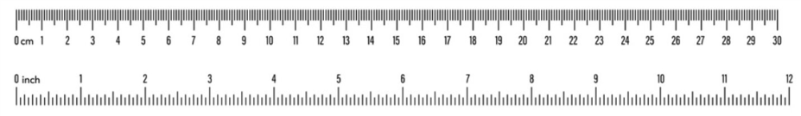
Image of a metric ruler displaying centimeter and millimeter markings, with numbered intervals and smaller subdivisions used to measure length accurately.
Figure 1. Example of a metric ruler. By Russetburbank - Own work, CC BY-SA 4.0.
The fundamental unit of length in the metric system is the meter (m). In this laboratory exercise, length measurements will be made using centimeter (cm) rulers. As illustrated on a meter stick or metric ruler, one meter is equal to 100 centimeters (cm). When examining a metric ruler, each centimeter is subdivided into smaller intervals. Between each numbered centimeter marking, there are ten equally spaced hatch marks, each being one millimeter (mm). Therefore, ten millimeters are equal to one centimeter. Familiarity with these scale divisions is essential for accurately measuring and recording length in biological laboratory experiments.
Materials
- Rulers
  - 4-5 objects of various sizes
Procedure
- Using a centimeter ruler, record the length, width, and height, in centimeters or mm, as directed, of each object provided to you by your instructor.
- Record your results in Table 3.
Results
Record the measurements in the Table 1.3 below:
Table 1.3 Linear Measurements and Unit Conversions
Object | Length (cm) | Width (cm) | Height (mm)
Black metal object
Storage bins
Test tube rack
Your Lab Bench
Glovebox
Lab Activity 1.3: Taking Mass Measurements with an Electronic Balance
Weight measurements in science are also expressed in metric units. The basic unit is the gram (g). The electronic balances you will be using today are gram balances. The model you will be using will accurately measure 0.01 grams. There are 1000 grams in a kilogram. One of the most common units used in labs is the milligram (mg). There are 1000 milligrams in a gram. If you need a very small amount of something, you measure it in micrograms (µg). There are 10⁶ µg in a gram. Some conversions are shown below:
1000 g = 1 kg
1 g = 1000 mg
1 g = 1,000,000 µg (10⁶ µg)
1 mg= 1000 µg (10³ µg)
Materials
- Gram balance
- Objects used in the earlier activity
Procedure
- Press the on button and wait for the balance to display zeros on screen.
- If the screen does not display zeros, press the “zero” or “tare” button.
- Once the machine displays zeros (0.00 g), place your object on the center of the platform.
- Wait for the scale to achieve a stable reading (numbers are not fluctuating).
- Record your mass in grams in Table 1.4 for each object starting from smallest to largest.
Results
Record your results in table 1.4 as grams (g) and then convert those masses to kg and mgs.
Table 1.4. Weight Measurements and Unit Conversions
Object | Mass (g) | Mass (kg) | Mass (mg)
Black metal object
Test tube
250 ml beaker
Weigh boat
your cell phone
Lab Activity 1.4: Volumetric Measurements
The metric unit for volume is the Liter (L). There are 1000 milliliters (mL) in one liter. Another common unit in volume is the microliter (µL). There are 10⁶ µL in one liter and 1000 µL in one milliliter. Some common conversions are shown below:
1 L = 1000 mL
1 L = 1,000,000 µL (10⁶ µL)
1 ml= 1000 µL (10³ µL)
You will need to become familiar with the diverse types of instrumentation and glassware that you will be using throughout this semester. Today, we will focus on glassware and devices that measure larger volumes of liquid. You will also decide when a particular device is appropriate to use, based on the volume that you are dispensing. The types of measuring devices are quite different if you want to measure and dispense a liter versus a milliliter!
Graduated Cylinder
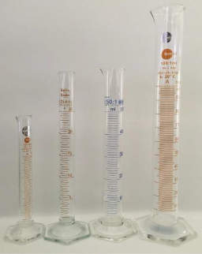
Image showing four graduated cylinders of different capacities (10 mL, 25 mL, 50 mL, and 100 mL), each with measurement markings and narrow cylindrical shapes used for measuring liquid volumes.
Figure 1.2. Several types of graduated cylinders: 10ml, 25ml, 50ml, and 100ml. Praphai Donphaimueang - Own work, 15 March 2016, CC BY-SA 4.0.
You will use this to dispense large volumes that are more than 10 mL. You will be using various size graduated cylinders, ranging from 10mL – 2000 mL (2L), in this lab. The volume of fluid in a graduated cylinder is measured by reading the bottom of the meniscus or the curved upper surface of the fluid in the graduated cylinder (red arrow)
Lab Activity 1.5: Serological Pipettes:
Figure 1.3. Examples of Serological Pipets, By Paweena.S - Own work, CC BY-SA 4.0. Image showing examples of serological pipettes, long transparent tubes with graduated markings, designed for measuring and transferring specific volumes of liquid using a pipette pump.
These pipettes accurately dispense volumes of 1mL to 10mL and can be used for volumes up to 50 mL. You will be using mostly 1mL and 10mL serological pipettes in this class.
Reading a Meniscus
When measuring liquid volume in a pipette or graduated cylinder, it is important to read the meniscus, the curved surface of the liquid. Most liquids (like water) form a concave meniscus, meaning the surface curves downward.
To obtain a correct measurement:
- Position your eyes level with the liquid surface to avoid parallax errors.
- Read the measurement at the lowest point of the meniscus (the bottom of the curve) for those liquids that form a concave meniscus. For liquids that form a convex meniscus (such as mercury), the measurement should be read at the top of the curve.
- Ensure the instrument is upright on a flat surface, and the liquid is still.
Careful alignment and consistent technique are essential for precise volume measurements.
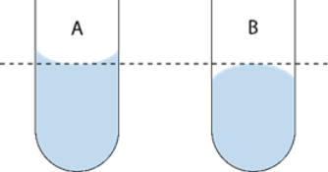
Figure 1.4: Demonstration on how to read a meniscus properly. By Reading_the_meniscus.png: User:Jleedevderivative work: Rehua (talk) - This file was derived from: Reading the meniscus.png: CC BY-SA 3.0, https://commons.wikimedia.org/w/index.php?curid=18062727
Materials
- 100 ml beaker
- Distilled H20
- 50 ml graduated cylinder
- Gram scale
- 1- and 10-ml serological pipettes
- 1 large and 1 small pipette pump
- 1mL microcentrifuge tubes
Procedure
Graduated Cylinder Measurements
- Obtain a 100 mL beaker. This is the container you will use to weigh your water. It is not what you will use to measure in this experiment.
- Place the beaker on the balance and tare it.
- The target amount of water you will be measuring using a graduated cylinder is 42 mL. This has been recorded in Table 5.
- Pour 42 mL of water into a 50 mL graduated cylinder. Be sure to read from the bottom of the meniscus.
- Pour the 42 mL from the graduated cylinder into the tared beaker.
- Determine the weight of the water and record as “Weight of Water.”
- Convert this weight to mL. Water has a density of 1g/mL, therefore the number of g= number of mL (e.g. 50 g = 50 mL). Record this number as “Actual Volume Dispensed.”
- Calculate the % error for each of your measurements as follows:
$$\text{Percentage Error}=\frac{|\text{Measured Value}−\text{True Value}|}{\text{True Value}}×100$$
- If you are not within an error range of +/- 5% then try again.
- Note: Percent error is always reported as an absolute value, so no negative sign is included. For example, a calculated value of −5% is reported as 5% error.
Lab Activity 1.6: Serological Pipette Measurements
- Dry the 100 mL beaker you used previously, with a dry paper towel. Tare it.
- Get a 10 mL serological pipette and its pipette pump. Insert the blunt end of the pipette into the pipette pump. Use the dial to draw 6.6 mL of deionized water into the pipet from a beaker filled with water.
- Dispense the water into the tared beaker, dialing the pump in the opposite direction. To get the last bit out of the pipet, quickly dial one way then the other.
- Determine the weight of the water in the beaker. If you accurately dispensed 6.6 mL; the weight difference should be close to 6.6 g. Record, it as “Weight of Water.”
- Convert the weight to mL and record as “Actual Volume Dispensed”
- Calculate the % error as described in the earlier section and record on Table 1.5.
- If you are not with in an error range of +/- 5% then try again
- Repeat steps 2-8 with a 1 ml serological pipette to dispense 0.6 ml of water into a tared microcentrifuge tube.
Results
Table 1.5 Comparison of Target, Actual Volumes and Percent Error Dispensed Using Different Measurement Devices
Device used | Attempt | Target volume dispensed (ml) | Weight of Water (g) | Actual Volume Dispensed (mL) | % Error
50 mL graduated cylinder | trial #1 | 42
50 mL graduated cylinder | trial#2 | 42
10 mL pipet | trial #1 | 6.6
10 mL pipet | trial #2 | 6.6
1 mL pipet | trial #1 | 0.6
1 mL pipet | trial #2 | 0.6
Lab Activity 1.7: Accuracy and Precision
When making measurements, both precision and accuracy are extremely important. Precision of a measurement refers to the closeness of repeated measurements or the reproducibility of the measurement. Precision can be affected by the measuring instrument. If a student uses a thermometer calibrated to the nearest degree to measure the temperature of a beaker of water and a second student uses a thermometer that is calibrated to the nearest ten degrees for the same exercise, the reproducibility or precision of measurements will be greater for the student using the thermometer calibrated to the nearest degree. The thermometer with the greatest number of calibrations (smallest increments) is the most precise, and thus the reproducibility is greater. Accuracy, described as how close a measurement is to its true value, however, is dependent upon both the precision of the measuring instrument and the technical skills of the individual taking the measurement. You will perform an experiment to determine which instrument is most accurate and precise for measuring 10ml of liquid.
Materials
- 100 ml beaker
- Distilled Water
- 50 ml graduated cylinder
- Gram scale
- 10 ml serological pipette
- Pipette pumps
Procedure
- Obtain a 100 mL beaker. Place the beaker on the scale and hit “tare.” This will cancel the weight of the beaker.
- Obtain a 50 mL beaker and use it to measure 10 mL of deionized water. Pour the measured 10 mL of water into the 100 mL beaker on the scale. Record the weight in grams in the Table below.
- Convert this weight to mL. Record this number as “Actual volume dispensed.”
- Empty the beaker on the scale and dry it well with a dry paper towel. Place it back on the scale and tare.
- Obtain a 50 mL graduated cylinder and measure 10 mL of deionized water. Pour the measured 10 mL of water into the 50 mL beaker on the scale. Record the weight (g) and volume (ml).
- Obtain a 10 mL serological pipet and measure 10 mL of deionized water. Pour the measured 10 mL of water into the 50 mL beaker on the scale. Record the weight (g) and volume (ml).
Results
Table 1.6: Volume, Weight, and Actual Volume Results:
Measuring Device | Volume Dispensed (ml) | Weight of Water (g) | Actual Volume Dispensed (ml)
100 ml beaker
50 ml graduated cylinder
10 ml serological pipet
Conclusion
Use your data and the questions below to write your conclusion below:
- For the volume measurements, which glassware used to measure 10 mL was the most precise? Why?
- Which measuring device was the least precise?
- For the glassware used to measure 10 mL, which instrument was the most accurate?
- Was the instrument that was most precise, the same one that is the most accurate? Why or why not?
Lab Activity 1.8: Graphing on an Excel Spreadsheet
- Open a blank MS Excel file. Save it using the File tab “Save as” choice. Name it,”Lab 1 Graph_your last name”. Make sure you save it in a location on the computer hard drive that you remember.
- Pick any cell on any column and type in Amount of Water (ml). On the next cell to the right type in
Weight (g).
- Under the Amount of water column type in the volumes of water, whose weights were measured during the experiment recorded on Table 1.6 (independent variable). Under the Weight column, type in the corresponding weights measured. (see figure on top right)
- Click on the Insert Tab on top of the page (see Figure 1.5)
- Select all the cells with text or numbers in them (Press Shift and select all the cells while holding the shift button). With the cells selected click on Recommended Charts in the menu items (See Figure 1.5)
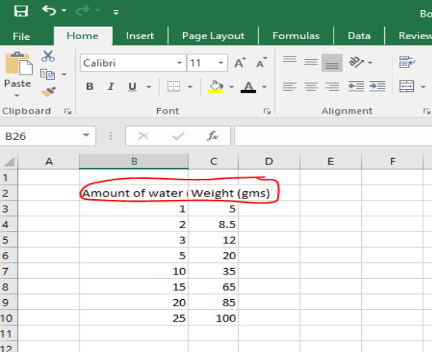
Figure 1.5: A screenshot showing data being entered into an Excel spreadsheet, with columns recording the volume and weight of water measured in a laboratory container.
- A small window opens with two tabs on the top. Click the first one on the tight that says All Charts and pick XY Scatter and hit OK
- The window will close, and a scatter plot graph will appear on the main Excel sheet (Fig. 1.7).
- Click inside the graph box and three small open shows up to the right of the graph box.
- Click on the green + sign and check on the boxes next to Axis, Chart title, Axis titles, and Gridlines. The rest of the boxes can stay unchecked.
- Rename the Axis tiles with Amount of Water (X-axis) and Weight (Y-axis). Rename the Chart tile to say, “Volume-Weight Relationship.”
- Save the file (Control + S).
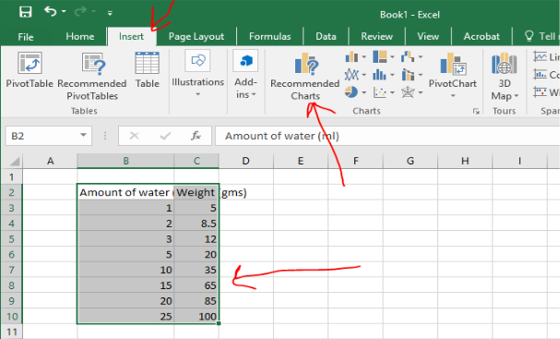”}
Figure 1.6: A screenshot showing multiple cells selected in an Excel spreadsheet, containing text and numbers. The top menu highlights the “Recommended Charts” choice, showing the step used to create a chart from the selected data.
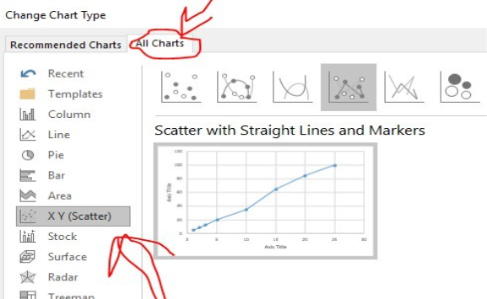
Figure 1.7: A screenshot of an Excel chart window showing two tabs at the top. The “All Charts” tab is selected, and the XY (Scatter) chart option is chosen, with an OK button highlighted to create the chart.
Post Lab Activity 1.1: Questions
Students must complete these questions after completion of the lab and give them to your instructor for review
Multiple choice
- What should you do if a chemical gets in your eyes?
A. Ignore it
B. Flush with water immediately
C. Leave lab
D. Tell a classmate
- Where should broken glass be disposed of?
A. Trash
B. Sink
C. Designated container
D. Floor
- Why should you not eat in the lab?
A. Messy
B. Contamination risk
C. Rules only
D. No reason
Short answer
- Describe one hazard you observed or learned about.
- How does PPE reduce risk in the lab?
- Which measuring device was most precise for measuring liquid volume, and why?
- Which device was the least precise for measuring 10 mL of liquid?
- Was the most precise instrument also the most accurate? Explain your answer using your data.
- Why is it important to read the bottom of the meniscus when measuring liquid volume?
- How does the base‑10 structure of the metric system reduce calculation errors?
- What source of error could affect mass or volume measurements in this lab?
- Explain why SI units are essential for communicating scientific data.
- Convert 250 mL to liters.
- A cell is 5 µm wide. How many meters is this?
- Explain one advantage of using Celsius in biology experiments.
- Which metric prefix would be most appropriate for measuring bacterial size, and why?
- Describe a potential laboratory error that could occur if imperial units were used instead of SI units.
- Describe one hazard you observed or learned about.
- How does PPE reduce risk in the lab?
Additional Student Resources
Metric Conversions and Scientific measures. From New York City College of Technology, CC BY NC SA.
https://openlab.citytech.cuny.edu/bio-oer/biology-basics/units-of-measure/.
Quantitative Skills.
This site has instructions on variables, graphing a line, slope activity, and creating a line of best fit. From New York City College of Technology, CC BY NC SA.
https://openlab.citytech.cuny.edu/bio-oer/biology-basics/quantitative-skills/.
Reporting Science
This is a description of how to write lab reports. From New York City College of Technology, CC BY NC SA.
https://openlab.citytech.cuny.edu/bio-oer/biology-basics/reporting-on-science/.

1.11 Appendix: Laboratory Safety and Measurement Terms
Term | Definition
Accuracy | How close a measured value is to the true or accepted value.
Balance | An instrument used to measure mass.
Base Units | Standard units in the metric system such as meter, gram, liter, and second.
Biological Hazard | Living organisms or biological materials that may cause harm.
Chemical Hazard | A harmful substance that can cause injury or damage.
Contamination | The introduction of unwanted substances can affect results.
Conversion | The process of changing a measurement from one unit to another.
Data Recording | The accurate documentation of observations and measurements is important.
Density | The mass of a substance per unit of volume is incorrect.
Dependent Variable | The variable that is measured or observed in an experiment.
Experimental Error | Deviation from the expected result due to limitations or mistakes.
Eyewash Station | A safety device used to flush the eyes in case of chemical exposure.
Graduated Cylinder | A piece of laboratory glassware used to accurately measure liquid volume.
Graphing | The visual representation of data for analysis is important.
Hazard | A potential source of harm such as chemicals, heat, or sharp objects.
Independent Variable | The variable that is changed or controlled in an experiment is correct.
Laboratory Procedure | Step-by-step instructions followed during an experiment.
Laboratory Safety | Practices are used to prevent accidents and ensure safe working conditions in a lab.
Length | The measurement of distance from one point to another is important.
Mass | The amount of matter in an object.
Meniscus | The curved surface of a liquid in a container used for accurate measurement.
Metric Prefix | A factor that indicates multiples or fractions of base units (e.g., kilo-, milli-, micro-).
Metric System (SI) | A decimal-based system of measurement used in science worldwide.
Percent Error | A calculation that describes how far a measured value is from the true value, expressed as a percentage.
Personal Protective Equipment (PPE) | Protective clothing and gear like goggles and gloves used to prevent injury.
Physical Hazard | Environmental factors such as heat, glass, or equipment that can cause injury.
Pipette | A tool used to measure and transfer small volumes of liquid accurately.
Precision | The consistency or repeatability of measurements is important.
Reproducibility | The ability to obtain consistent results across repeated trials is important.
Scatter Plot | A graph used to display relationships between two variables.
Scientific Measurement | The process of obtaining quantitative data using standardized methods.
Tare | The process of resetting a balance to zero before measuring.8
Temperature | A measure of the amount of heat energy in a substance.
Volume | The amount of space an object or substance occupies.
Waste Disposal | The proper handling and discarding of laboratory materials.

2. Use of the Microscope

2.1 Introduction: Use of the Microscope
In this lab, you will learn how to use one of the most important tools in biology: the compound light microscope. Microscopes allow scientists to observe objects that are too small to be seen with the naked eye, such as cells, tissues, and microorganisms. Learning how to effectively use a microscope is a fundamental skill that you will use throughout this course and in many scientific careers.
During this lab, you will become familiar with the parts of the microscope and how each part works together to produce a clear image. You will focus on specimens using different magnifications, starting with low power, and working your way up to higher magnifications. As you increase magnification, you will notice critical changes in what you see, including how much of the specimen is visible (field of view) and how much of it stays in focus (depth of field).
You will also learn how to prepare your own slides using a technique called a wet mount, which allows you to see living or freshly prepared specimens. In addition, you will practice making careful observations and recording what you see through drawings and notes—an essential part of scientific investigation.
Proper handling and care of the microscope will be emphasized throughout the lab. Using the microscope correctly not only protects delicate equipment but also ensures that your observations are accurate and reliable.
By the end of this lab, you will have the skills needed to confidently use a microscope to explore the microscopic world and better understand the structure of living organisms.

2.2 Objectives
By the end of this laboratory exercise, students will be able to:
- Correctly identify and use the scanning, low power, and high-power objective lenses of a compound light microscope.
- Define and compare field of view and depth at different magnifications.
- Demonstrate proper preparation of a wet mount using cultured organisms or pond water.
- Use fine focus to determine the relative vertical position of objects within a specimen.
- Observe and accurately document microscopic specimens at increasing magnifications.
- Explain how magnification affects image clarity, field of view, and depth of field.
- Apply proper microscope handling, cleaning, and storage procedures.

2.3 General Rules:
- Always carry the microscope using two hands. The easiest way to do this is to place one hand holding the arm while the other hand is supporting the base.
- Do not touch the objective lenses. The lenses should originally be set in the scan position and when stored, the microscope scanning lens should be set in place.
- If needed, the ocular and objective lenses must be cleaned with a special lens paper and lens cleaning solution.
- Report any malfunctions of the microscope to your instructor; do not try to repair the scope yourself.

2.4 Returning the Microscope to the Cabinet.
- Lower the stage.
- Rotate the turret so that the scanning (4x) lens is in position over the stage.
- Remove the lens from the stage and clean the lens before replacing it in its storage box.
- Secure the cord by wrapping it around the correct holder on the back of the microscope.
- Replace the dust cover.
- Carry the microscope back to the storage cabinet with two hands!

2.5 Prelab Activities

2.6 Introduction
These pre-laboratory activities are designed to familiarize students with the structure and function of the compound microscope. Students will identify key microscope components, match each part with its function, and apply their understanding to written responses. Completion of these activities prior to the lab session will help ensure proper microscope use and improve observational accuracy during laboratory work.

2.7 Prelab Activity 2.1. Terms to define:
- Arm
- Neck
- Body
- Base
- Ocular lens
- Objective lens
- Rotating nosepiece or Turret
- Course and Fine focus knobs
- Mechanical stage
- Iris diaphragm
- Condenser adjustment knob
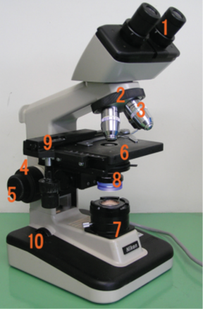
Enumerated diagram of a typical bright-field microscope showing major components, including the ocular lens, head, revolving nosepiece, objective lenses, stage, condenser, iris diaphragm, light source, coarse and fine focus knobs, arm, and base.
Figure 2.1 Components of a Typical Bright Field Microscope.

2.8 Prelab Activity 2.2
Identify the following parts and functions of the microscope above.
- _________________________
- _________________________
- _________________________
- _________________________
- _________________________
- _________________________
- ___________________________
- ___________________________
- ___________________________
- ___________________________

2.9 Prelab Activity 2.2
Match the microscope part with its definition.
Microscope Part
__________ Condenser
__________ Revolving Turret
__________ Mechanical stage
__________ Ocular lens
__________ Power switch
__________ Iris diaphragm
__________ Arm
__________ Depth of field
__________ Fine focus
__________ X-Y stage controls
__________ Light source
__________ Total magnification
__________ Head
__________ Base
__________ Objective lens
__________ Course focus
__________ Field of view

2.10 Definitions
- The light source at the bottom of the microscope, also known as the illuminator.
- Also known as the body- carries the oculars.
- The microscope supports.
- The part that connects the head and the base.
- The lens closest to the eye
- The major lenses closest to the specimen
- Also known as the nosepiece-holds the objective lenses
- Knob that makes large scales adjustments in the focus
- The knob that makes small adjustments in the mechanical stage.
- Set of lenses that collect and focus the light onto the specimen.
- Controls the amount of light reaching the specimen.
- Controls that move the slide vertically and horizontality on the stage
- Calculated by multiplying the ocular magnification by the objective magnification.
- The visible area one can see through the oculars.
- The measure of the thickness or the specimen in focus
- The switch used to turn the microscope on and off.
- The section in which the specimen is placed for viewing.

2.11 Prelab activity 2.3
Answer the following questions in a brief paragraph.
- What is the field of view, and how does it change as magnification increases?
- Define depth of field in microscopy.
- Which objective lens provides the greatest depth of field? Why?
- Why is it important to center a specimen before switching to a higher magnification?
- What is a wet mount, and what type of specimens are commonly observed using this technique?
- What is the purpose of using the fine adjustment knob instead of the coarse adjustment knob at high magnification?

2.12 Lab Activities

2.13 Introduction: Magnification and Microscope Use
This laboratory activity introduces students to the proper use of the compound light microscope, a fundamental tool in biological sciences. Students will learn to identify microscope components, understand how magnification is achieved, and develop skills in focusing on specimens at increasing levels of magnification. Emphasis will be placed on proper handling, accurate observation, and the relationship between magnification, field of view, and depth of field. Mastery of these techniques is essential for examining biological specimens and conducting accurate scientific observations.

2.14 Magnification
Student scopes used in our classes have four objective lenses (i.e., those that are closest to the specimen); scanning, low power, high power, and oil immersion. The set of lenses closest to the eye are the ocular lenses.
General Procedures
Microscope components

2.15 Lab Activity 2.1
- Carry the microscope with two hands and bring it to your lab bench
Clear your workspace for safe and comfortable use
- Collect slides:
  - Metric ruler
  - Letter “e”
  - Crossed colored threads
  - Prepared organism slides
- Clean ocular and objective lenses with lens paper
Set the nosepiece to the scanning (lowest power) lens
- Plug in the microscope
- Identify and label microscope parts
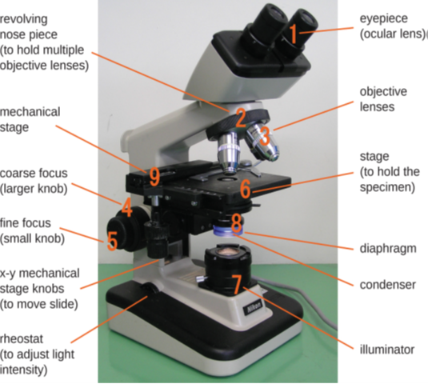
Labeled diagram of a bright-field microscope showing key components, including the ocular lenses, head, revolving nosepiece, objective lenses, stage, mechanical stage controls, condenser, iris diaphragm, light source, coarse and fine focus knobs, arm, and base.
Figure 2.2 Components of a Typical Bright Field Microscope, labelled.
Key: Components of a typical bright field microscope.
- Ocular lens
- Head
- Revolving nose piece (turret)
- Objective lens
- Arm
- Mechanical stage
- Stage clips
- Diaphragm
- Condenser
- Fine focus
- Course focus
- X-Y Mechanical stage knobs
- Light source (Illuminator)
- Rheostat
- Illuminator switch

2.16 Lab Activity 2.1
Record the magnifications of the lenses on your microscope in the table below.
Table 2.1. Ocular and Objective Lens Magnifications and Total Magnification
Lenses | Ocular Lens | Objective lens | Total Magnification
Scanning power: dry
Red lines
Low power: dry
Blue lines
High Power: dry
Yellow lines
Oil Immersion: oil
Black/white lines
To figure out the total magnification simply multiply the ocular lens magnification by the objective lens magnification. For example, if the Ocular lens magnification is 10X and the scanning lens magnification is 4X, then the total magnification will be 40X. Complete the table above.

2.17 Focusing on Specimens
For biology 110 labs you will only be focusing on a total magnification of 400x. You will have to use the oil immersion lenses (1000x) in your Microbiology (230) classes. For your first practical, you will have to focus clearly on a specimen at a total magnification of 400x. You will have two minutes to complete this task.
Focusing on a specimen may be broken down into a three-step process.
- Scanning Lens (4x):
- Begin focusing on a specimen using the Scanning lens. First, adjust the mechanical stage so that it is at its lowest position. You can do this by turning the course focus knobs away from your body.
- Turn on the light. And adjust the ocular lenses so that your field of view is a circle of light.
- Place and center the specimen on the mechanical stage.
- Look into the oculars and slowly raise the mechanical stage by turning the course focus knob towards your body. Stop when it comes to focus. You may adjust the focus using the fine focus knob that is needed.
- Center the specimen. Adjust the X-Y stage knobs so that your specimen is in the center of your field of view. This position will enable you to see the specimen when you adjust the lens to the next higher magnification. If the specimen is found to the side, then you may lose the specimen from your field of view when you adjust your objective lens to the next higher magnification.
- Low Power (10x)
  - Next, while looking into your objective lenses, turn the turret clockwise (to the right) to 10x power.
  - Adjust the focus. Do not use the course focus knob to adjust your focus. Only use the fine focus knob at this point. If you use the course focus knob, then you may adjust your focus too far out of focus and may have to start at the Scanning power again.
  - Center your specimen
- High Power (40X)
  - Finally, switch to the high-power lens (40X) by turning the lens to the right (clockwise). At this point only use the fine focus to adjust the focus.
  - If the color of light is too yellow, you may adjust the rheostat to change the color of light to a white light.
  - If the light is too dark, you may adjust the diaphragm.

2.18 Measuring and Calculating the Field of View
The field of view is the area of the specimen you can see through the ocular lenses. When you adjust your magnification, the diameter will decrease at higher magnifications. The image below, figure 2.3, is an example of a field of view.
How to find the field of view:
- Obtain a prepared slide with a ruler and place it on the stage.
- Adjust the ruler so that the edge of the ruler is visible as a series of tic marks/lines that lie across the diameter or the field of view as in the figure below.
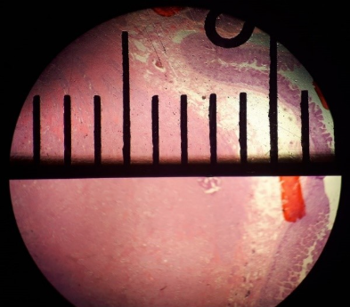
https://upload.wikimedia.org/wikipedia/commons/thumb/6/69/Field_of_view_diameter_in_microscopy.jpg/1024px-Field_of_view_diameter_in_microscopy.jpg
Microscope field of view showing a metric ruler aligned across the circular viewing area, with measurement markings used to determine the diameter of the field of view.
Figure 2.3. Field of view diameter being measured in a microscope with a metric ruler. Mikael Häggström, 29 January 2020. CC0.
Arrange the slide so that the horizontal line is aligned along the midline of the field as seen above. Align one of the vertical lines so that it is at the edge of your field of view, as you can see on the right side of the picture. The space between the leading edge of the horizontal lines is 1 mm in distance, see the yellow bar.
- Measure the distance of the field of view for the scanning lens (4X)
  - ________________ mm.
  - ________________ µm
- Measure the distance of the field of view for the low power lens (10x)
  - __________ mm
  - __________ µm
When you use high-power and oil-immersion lenses, you should not be able to measure the field of view directly. At this point, you will have to calculate the field of view. This calculation is a simple conversion using the formula below:
Conversion Formula:
(Diameter of the field; A) X (Total Magnification: A) = (Diameter of the field; B) X (Total Magnification: B)
In this case “A” stands for the known field information of the measured field of view of either the scanning or low-power magnification and “B” stands for the information of the new or unknown lens magnification (e.g., high-power or the oil immersion lenses)
- Figure out the distance of the field of view for the high-power objective lens (40X)
  - ________________ mm.
  - ________________ µm
- Determine the distance of the field of view for the oil-immersion objective lens (100X)
  - __________ mm
  - __________ µm
Focusing Exercise(s)
- Letter “e” exercise
  - Obtain a letter “e” slide and place it on the mechanical. Note the position of the “e.” Draw and label it on the page.
  - Center the “e” and look at it through the oculars. Draw this “e” and label it.
  - Describe the differences there are between the two ’e’s. Hint: look at and describe its position and orientation.
Field of View and Depth of Field of a Microscope
- When viewing a specimen through a microscope, the visible area appears circular and is referred to as the field of view. The diameter of this circle decreases as magnification increases.
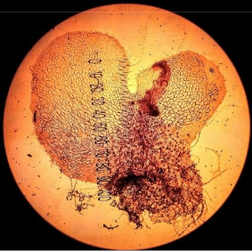
Circular microscope field of view displaying the prothallium of Polypodium vulgare at 4× magnification, showing a thin, flat, green plant structure centered within the viewing area.
Figure 2.4. Circular microscope field of view showing the prothallium (prothallus) of Polypodium vulgare. Taken with a light microscope on x4 magnification. Image: Viséan, 2019, CC BY-SA 4.0, https://commons.wikimedia.org
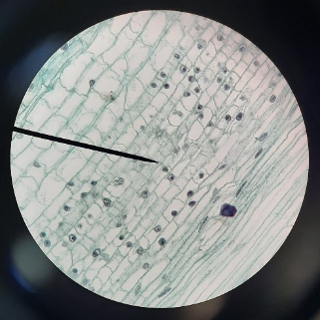
Circular microscope field of view displaying an unknown plant specimen, showing cellular or tissue structures within a round viewing area under magnification.
Figure 2.5. A view of an unknown plant under a microscope. Palmer-Harris, L. (2021, December 28).CC BY SA 4.0.
- The depth of field is the vertical distance (top to bottom) within the specimen that stays in focus at one time. As magnification increases, the depth of the field decreases. Therefore, the scanning objective lens provides the greatest depth of field, while the oil immersion objective lens has the shallowest depth of field.
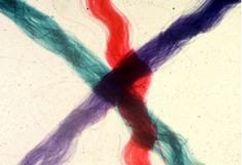
Microscopic view showing three overlapping yarn fibers at 40× magnification, with only portions of the fibers in sharp focus at a time, illustrating limited depth of field.
Figure 2.6. View showing three overlapping yarn fibers (40×). Image from Botweb, the University of Wisconsin, https://botweb.uwsp.edu/130y.htm.
- A prepared slide having three differently colored silk fibers or threads is commonly used to show depth of field. In this preparation, the threads are arranged to cross at a single point, with each thread positioned at a different vertical level. By focusing at 400x and adjusting the fine focus and seeing which thread comes into focus first, second, and last, the relative positions of the threads—top, middle, and bottom—can be figured out.

2.18.1 Depth of Field Using Crossed Threads
- Obtain a prepared slide containing three crossed threads.
- Place the slide on the microscope stage. Using the scanning objective lens, bring the threads into focus with the fine adjustment knob. Figure out which thread is positioned on the top, in the middle, and at the bottom of the slide.
- Switch to the 100× (low power) objective lens. Locate the top thread and then focus on the bottom thread. Compare the amount of fine focus adjustment needed at this magnification to that used with the scanning objective.
  - Did you need to move the adjustment knob more or less? __________________
- Change to the 400× (high power) objective lens. At this magnification, each thread may occupy most of the field of view.
  - Is the entire thickness of a thread in focus as it was under the scanning objective lens? __________
  - What does this observation say about the depth of field at high magnification? __________
- Using only the fine focus knob, figure out the relative vertical position of each colored thread.
  - Bottom thread: __________________
  - Middle thread: __________________
  - Top thread: __________________
Examining Tissues
Your instructor will guide you in observing a series of prepared organism slides to practice proper microscope technique. Examine each slide using total magnifications of 40×, 100×, and 400×.
Place particular emphasis on effective focusing and observation at 400× magnification, as this magnification will be used during the practical examination. Draw and label the organisms from the prepared slide

2.19 Prepared slide
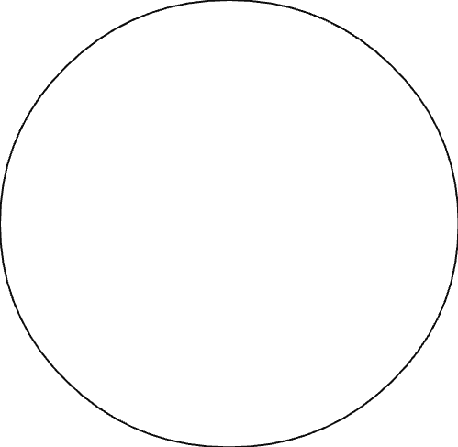
Identification of the organism: ____________________
Prepared slide
Identification of the organism: ____________________

2.20 Preparing a Wet Mount
You will have to prepare wet mount slides of fresh specimens on many occasions during this course. You will often need to apply a biological stain to a specimen to see the structures within cells. Such stains combine with cellular components. Selective use of available stains enables the observer to see desired components. It is also important when preparing wet mount slides to use the thinnest section of a specimen possible. You will use a scalpel or razor blade to section your specimens. A wet mount requires a layer of liquid to completely fill the space between the slide and coverslip, immersing the specimen and enabling the observer to clearly focus through the microscope.

2.21 Procedure:
- Wet mount of an Onion Skin
Watch the video on this link to see how to prepare wet mount of an onion skin and then follow the instructions below:
- Prepare the specimen
- Peel a small, rectangular piece of transparent epidermis (inner layer) from a sliced onion.
- Place the onion skin flat in the center of a clean glass slide.
- Stain
- Add one drop of methylene blue directly onto the onion skin.
- Let it sit for 1 to 2 minutes, so the stain penetrates the cells.
- Remove excess stain and rinse
- Gently touch a corner of a paper napkin to the slide edge (not the specimen) to wick away excess stain.
- Add one small drop of water to rinse the stained area, then wick away the rinse with the napkin.
- Repeat the rinse once, if needed, remove the excess each time.
- Mount with a coverslip
- Place one final small drop of water on the specimen.
- Hold the coverslip at a 45° angle and slowly lower it onto the drop to spread the liquid and avoid air bubbles.
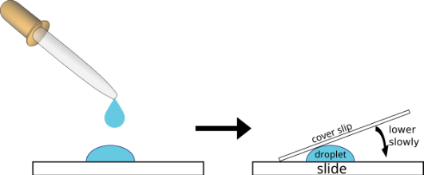
A student lowers a coverslip at a 45-degree angle onto a glass slide having a drop of liquid and a specimen, allowing the liquid to spread evenly and prevent air bubbles from forming beneath the coverslip.
Figure 2.7 Image of placing a coverslip on a glass slide when making a wet mount. Image courtesy of New York City College of Technology. BY CC NC SA 3.0.
- Clean slide edges
- Run the edge of a paper napkin around the coverslip to remove excess fluid.
- Wipe and dry the bottom of the slide so it is clean for viewing.
- Observe under the microscope
- Secure the slide on the stage. Start with the scanning objective lens (4X) to find tissue; center a clear area in the field of view.
- Switch to low power (10X), re-center and refocus, then move to high power (40X) for details (40X objective with a 10X eyepiece = 400X).
- Always center and refocus before increasing magnification. Draw or image what you see.
- Finish and dispose
- Rotate the scanning (4X) objective lens into place and lower the stage. Remove the slide and place it in the “Used Slides” container.
- Clean and store equipment per lab protocol and wash your hands.
Safety notes: avoid pressing the coverslip, handle methylene blue carefully, and follow your lab’s disposal procedures.
- Wet mount of human cheek cells
Watch the video on this link to see how to prepare wet mount of a cheek cell and then follow the instructions below:
- Wash your hands with soap and water.
- Watch the onionskin wet mount video first.
- Use a sterile cotton swab or the flat end of a clean toothpick to gently scrape the inside of your cheek (do not poke or scrape hard).
- Place a clean microscope slide on a flat surface and add one drop of water to the center.
- Rub the swab or toothpick tip gently through the drop for ~4 seconds to transfer cells. Discard the used swab/toothpick safely.
- Add one drop of methylene blue to the smear (at the edge of the drop to avoid bubbles).
- Carefully lower a cover slip at an angle over the drop to avoid trapping air bubbles.
- Blot any excess stain from the slide edge with absorbent paper.
- Place the slide on the microscope stage. Start with the scanning (4X) lens to locate the sample, then switch to a 40X objective (400X total with a 10X eyepiece) to observe stained cheek cells.
- When finished, dispose of the cover slip and slide per your lab’s biohazard or sharps protocol, and wash your hands.
Safety notes: wear gloves and eye protection if available; avoid swallowing stains; do not reuse contaminated toothpicks; follow institutional disposal rules.

2.22 II. Wet Mount Preparation of Cultured Organisms and Pond Water
View the instructional video in this link to review wet mount preparation techniques using cultured organisms. Then complete the following procedure.
- Gather materials: plastic pipette, clean slide, coverslip, and your sample (cultured organisms or pond water).
- Use the pipette to draw liquid from near the bottom of the container (where organisms collect).
- Put 1 or 2 drops of the sample in the center of the slide.
- Hold the coverslip at a 45° angle and slowly lower it onto the drop to avoid air bubbles.
- Blot excess liquid by touching a paper napkin to the coverslip edge; dry the underside of the slide.
- Place the slide on the stage. Start with the 4× (scanning) objective lens to find the specimen, center it, then move to 10× and 40×—recenter and refocus at each step.
- Record observations with a labeled drawing.
- Finish: return the 4× objective lens, lower the stage, remove the slide, and put it in the “Used Slides” container.
Safety: avoid contaminating the sample, do not a pipette by mouth, and follow lab disposal rules.

2.23 End-of-Lab Procedures
- Clean and return all prepared slides to their designated storage trays.
- Turn off and unplug the microscope; neatly wrap the power cord around the cord holder or base.
- Rotate the head to face inward toward the microscope body.
- Set the objective turret to the scanning (4×) objective lens.
- Lower the stage fully.
- Place the dust cover over the microscope (if available).
- Return the microscope to its assigned storage cabinet.
Troubleshooting Guide
- Image too dark
- Check power: ensure the microscope is plugged in and switched on; confirm the light is lit.
- Increase light: raise the rheostat (brightness control).
- Open the iris diaphragm and/or raise the condenser to let more light through.
- Fine-tune the rheostat until the image is bright and white.
- Unable to see a single image with both eyes
- Move your head slightly away from the eyepieces.
- Adjust interpupillary distance by sliding the oculars together or apart until one image appears.
- Stationary spot in the field of view
- The lens is likely to be dirty. Use only lens paper to gently clean the oculars and objective lenses.
- If needed, carefully remove the ocular to clean the inner surface.
- Do not use tissues, paper towels, or clothing (they can scratch lenses).
- Eyelashes or other near eye artifacts visible
- e too close to the eyepieces—move your head back a little.
- Nothing visible at high power
- Always focus on scanning (4×) and low (10×) first, center the specimen, then switch to high (40×).
- Make sure the specimen is centered before increasing magnification.
- Only part of the field is illuminated (half-moon)
- Ensure the objective clicks fully into place on the nosepiece.
- Adjust the condenser and its centering to align the light.
- Image stays blurry and will not focus
- Check the slide orientation (not upside down) and that it is secured in the stage clips.
- Recenter the specimen and refocus at lower magnification before switching up.
- Eye strain or headache from using the microscope
- Focus first with your dominant eye (e.g., right eye), then adjust the other ocular diopter.
- Set interpupillary distance correctly and reduce light intensity if it is too bright.
- Take short breaks to rest your eyes.
Quick maintenance/reminders
- Always start with the lowest magnification, center the specimen, then increase power.
- Use only lens paper for optics.
- If problems persist, notify the instructor or lab technician.

2.24 Student Post-Laboratory Policy
Students must complete all assigned post-laboratory questions, including both short-answer and multiple-choice items, following the completion of the laboratory exercise. These questions are designed to assess understanding of key concepts and proper application of laboratory techniques.
All responses must be completed prior to leaving the laboratory unless otherwise directed by the instructor. Students must present their completed work to the instructor for review and verification before departure.
Be advised that completion of the post-laboratory questions may be required for a grade at the discretion of the instructor. Failure to complete, submit, or obtain instructor for review of the assigned questions may result in a loss of credit or the assignment being considered incomplete.
It is the responsibility of each student to ensure compliance with all post-laboratory requirements and grading expectations as outlined by their instructor.

2.25 Student Post-Laboratory Questions
(To be completed after the laboratory to assess comprehension)
- How did the depth of field change as you increased magnification from 4× to 40×?
- In the crossed threads slide, how were you able to determine which thread was on top, middle, and bottom?
- Why was it more difficult to keep the entire specimen in focus at higher magnifications?
- Describe one structure you observed in the wet mount that was not visible at lower magnification.
- What mistakes could lead to a broken slide or damaged objective lens, and how can they be avoided?
- How does proper microscope care extend the life of the instrument and improve data quality?
Multiple choice questions
Directions: Choose the best answer for each question.
Basic Knowledge and Application
- Which part of the microscope is closest to the eye?
A. Objective lens
B. Condenser
C. Ocular lens
D. Stage
- What is the total magnification if the ocular lens is 10× and the objective lens is 40×?
A. 4×
B. 50×
C. 400×
D. 100×
- Which objective lens should always be used first when focusing on a specimen?
A. Oil immersion
B. High power
C. Low power
D. Scanning
- What is the function of the coarse focus knob?
A. Adjust light intensity
B. Make small adjustments to focus
C. Move the stage for large focusing adjustments
D. Change magnification
- Which part controls the amount of light reaching the specimen?
A. Condenser
B. Iris diaphragm
C. Objective lens
D. Mechanical stage
- What happens to the field of view as magnification increases?
A. It increases
B. It stays the same
C. It decreases
D. It becomes brighter
- Which structure holds the objective lenses and rotates to change magnification?
A. Arm
B. Base
C. Revolving nosepiece
D. Stage clips
- What is the correct way to carry a microscope?
A. With one hand on the base
B. With one hand on the arm
C. With two hands (arm and base)
D. By holding the eyepiece
- Which lens requires the use of immersion oil?
A. Scanning lens
B. Low power lens
C. High power lens
D. Oil immersion lens
- What is resolution?
A. The brightness of an image
B. The amount of light entering the microscope
C. The ability to distinguish two close points as separate
D. The total magnification

2.26 Higher-Order Thinking (Analysis & Application)
- A student switches directly from scanning (4×) to high power (40×) and cannot find the specimen. What is the most likely reason?
A. The light intensity is too high
B. The specimen was not centered before increasing magnification
C. The objective lens is broken
D. The eyepiece needs cleaning
- If an image is too dark, which combination of actions would best improve visibility?
A. Lower the stage and use coarse focus
B. Increase illumination and open the diaphragm
C. Switch to higher magnification
D. Close the diaphragm and turn off the light
- Why does depth of field decrease as magnification increases?
A. The lens becomes larger
B. More light passes through the specimen
C. A thinner section of the specimen can be kept in focus
D. The field of view increases
- Two students measure the same specimen. One gets consistent results that are slightly off from the true value, while the other gets varied results around the correct value. Which is true?
A. First student is accurate, second is precise
B. First student is precise, second is accurate
C. Both are equally accurate
D. Neither is precise
- If a specimen moves to the left when viewed under the microscope, what direction was the slide actually moved?
A. Left
B. Right
C. Up
D. Down
- A student uses the coarse focus knob while viewing a slide under high power and breaks the slide. What mistake did the student make?
A. Used the wrong lens
B. Turned the light off
C. Used coarse focus at high magnification
D. Did not center the specimen
- A biologist needs to observe small internal cell structures. Which combination of features is most important?
A. Low magnification and large field of view
B. High magnification and high resolution
C. Low resolution and high brightness
D. Large stage and low light
- Why is it important to center the specimen before switching to a higher magnification?
A. It improves light intensity
B. It prevents lens damage
C. The field of view becomes smaller at higher magnification
D. It increases resolution
- A student notices that only half of the field of view is illuminated. What is the most probable cause?
A. Dirty slide
B. Objective lens not fully clicked into place
C. Stage is too low
D. Specimen is too thick
- Why is starting with the scanning objective considered best practice?
A. It gives the highest resolution
B. It allows faster focusing with fine adjustment
C. It provides the widest field of view and reduces the risk of damage
D. It requires less light

2.27 Student resources:

2.28 Microscopy

2.29 The Light Microscope. A review of lab materials.
https://openlab.citytech.cuny.edu/bio-oer/biology-basics/microscopy/.

2.29.1 Learn the parts of the microscope (activity)
- Visit https://www.ncbionetwork.org/iet/microscope/
  - Click on “Explore”
  - Click on parts “?” to learn their name and function
Table 2.2. Chapter 2: Microscopy Glossary of Terms and Definitions
This table provides key terminology related to microscopy, along with concise definitions of each term. It serves as a reference for understanding the structure, function, and proper use of the microscope, as well as concepts such as magnification, and resolution.
Chapter 2: Microscopy Glossary
Terms | Definitions
binocular | a microscope having two eyepieces
brightfield microscope, | a compound microscope with two or more lenses that produce a dark image on a bright background.
coarse focusing knob | used for large-scale movements with 4⨯ and 10⨯ objective lenses
condenser lens | (located below the stage), which focuses all the light rays on the specimen to maximize illumination.
fine focusing knob | used for small-scale movements, especially with 40⨯ or 100⨯ objective lenses.
fixation | The process of attaching cells to a slide.
illuminator | provides light for the brightfield microscope
lens | a medium with a curved surface that refracts and focuses on light to produce an image.
magnification | the ability of a lens to enlarge the image of an object when compared to the real object
monocular microscope | a microscope having a single ocular lens
objective lenses | the lenses far end of the body tube
ocular lens | the eyepiece of a microscope
oil immersion lens, | a special lens designed to be used with immersion oils.
refraction | occurs when light waves change speed and direction as they pass from one medium to another.
resolution | The ability to tell that two separate points or objects are separate.
rotating nosepiece, also known as the revolving turret, | sits below the head of the microscope and locks the objective lens into position over the stage aperture by rotating in either direction.
stage | (a platform) of the microscope total magnification is the product of the ocular magnification times the objective
Total magnification | (ocular magnification × objective magnification)
wet mount | slide preparation in which the specimen is placed on the slide in a drop of liquid.
x-y mechanical stage knobs. | These knobs move the slide on the surface of the stage, but do not raise or lower the stage.
Citations
- Figure 2.1. Components of a typical bright field microscope. GCG(jawp). 2008. https://commons.wikimedia.org/wiki/File:Optical_microscope_nikon_alphaphot.jpg#/media/File:Optical_microscope_nikon_alphaphot.jpg.
- Figure 2.2 Components of a typical bright field microscope. Parker, Schneegurt, Tu, Lister, and Forster. OpenStax. Microbiology. Nov 1, 2016. Houston, Texas. https://openstax.org/books/microbiology/pages/1-introduction. https://openstax.org/books/microbiology/pages/2-3-instruments-of-microscopy
- Figure 2.3: Field of view diameter measured in a microscope with a metric ruler. Häggström, M. (2020, January 29). Field of view diameter being measured in a microscope with a metric ruler [Photograph]. Wikimedia Commons. https://commons.wikimedia.org/wiki/File:Field\_of\_view\_diameter\_in\_microscopy.jpg (CC0)
- Figure 2.4. Viséan. (n.d.). Circular microscope field of view showing the prothallium (prothallus) of Polypodium vulgare [Photograph]. Wikimedia Commons. https://commons.wikimedia.org/wiki/File:FileName.jpg (CC BY-SA 4.0)
- Figure 2.5. Palmer-Harris, L. (2021, December 28). View inside microscope [Photograph]. Wikimedia Commons. https://commons.wikimedia.org/wiki/File:View\_Inside\_Microscope.jpg. (Licensed under CC BY-SA 4.0)
- Figure 2.6. Fritzmann2002. (2017, September 1). A circular field of view showing two overlapping yarn fibers observed under a standard light microscope at 40× magnification [Photograph]. Wikimedia Commons. https://commons.wikimedia.org/wiki/File:Blue%2BRed\_String\_Under\_Microscope_(40x).jpg (CC BY-SA 4.0)

3. Molecules, Water, and pH

3.1 Pre-Lab Activity 3.1: Questions
Objectives
- Represent molecules using molecular models
- Write a molecular formula based on a structural formula
- Identify and demonstrate various properties of water that make it essential for life.
- Identify acids and bases and learn how to measure their pH
- Identify the role of buffers in living organisms
Multiple Choice (10)
- Which of the following is an inorganic compound?
A. Glucose
B. Protein
C. Water
D. Lipid
- Organic molecules always contain:
A. Nitrogen
B. Carbon and hydrogen
C. Oxygen only
D. Sulfur
- Carbon can form how many covalent bonds?
A. 2
B. 3
C. 4
D. 6
- A molecular formula shows:
A. Exact bonding structure
B. Atom arrangement
C. Types and numbers of atoms
D. Bond angles
- What type of bond involves shared electrons?
A. Ionic
B. Hydrogen
C. Covalent
D. Metallic
- Isomers are molecules that:
A. Have different formulas
B. Have same atoms but different arrangements
C. Are always inorganic
D. Are always identical
- Water is considered polar because:
A. It has equal charge distribution
B. It contains hydrogen bonds only
C. Electrons are shared evenly
D. Electrons are shared unevenly
- pH measures:
A. Oxygen levels
B. Hydrogen ion concentration
C. Temperature
D. Salt concentration
- A buffer functions to:
A. Increase pH rapidly
B. Neutralize all acids
C. Resist changes in pH
D. Eliminate hydrogen ions
Short Answer (10)
- Define an organic molecule.
- What is a covalent bond?
- What is the difference between a molecular and structural formula?
- What does the formula C₂H₆O tell you about a molecule?
- What is a functional group?
- Explain what an isomer is.
- Why is water considered an excellent solvent?
- Define cohesion and adhesion.
- What is surface tension?
- Why is pH important in living organisms?
Key Terms to Define
- Organic compound
- Inorganic compound
- Covalent bond
- Molecular formula
- Structural formula
- Abbreviated structural formula
- Isomer
- Polarity
- pH
- Acid
- Base
- Buffer

3.2 Introduction: Molecules, Water, and pH
Biology is the study of life, and understanding life begins with understanding the chemistry that makes it possible. In this first-semester biology lab, you will explore the fundamental chemical principles that underlie biological systems, preparing you for advanced work as a biology major or pre-med student. Through hands-on experiments and model-based activities, you will connect basic chemical concepts to real biological function.
Chemical compounds can be divided into two broad categories: inorganic and organic. Inorganic compounds, such as water, salts, acids, and bases, generally do not contain carbon–hydrogen (C–H) bonds and play essential roles in maintaining life processes. Organic molecules, on the other hand, are defined by the presence of carbon and C–H bonds. Carbon’s unique ability to form four covalent bonds allows it to create a wide variety of complex molecules, especially when combined with other key elements such as oxygen, nitrogen, phosphorus, and sulfur—elements that make up the vast majority of living matter.
In this lab, you will investigate how atoms form molecules through covalent bonding, where electrons are shared between atoms. You will learn how to represent molecules using molecular formulas, structural formulas, and abbreviated structural formulas, each providing different levels of detail. Using molecular model kits, you will build three-dimensional representations of molecules to better understand how atomic arrangement influences molecular shape and function. You will also explore isomers, which are molecules with the same molecular formula but different structures, demonstrating how small differences in arrangement can lead to significant biological differences.
A major focus of this lab is water, one of the most important inorganic molecules for life. Because of its polar structure, water exhibits unique properties such as cohesion, adhesion, high surface tension, and high specific heat. These properties allow water to act as a solvent, regulate temperature, and move through narrow spaces via capillary action—all essential for sustaining life. You will perform experiments to observe and measure these properties directly.
You will also examine acids, bases, and pH, which are critical for maintaining proper conditions in biological systems. The pH scale measures the concentration of hydrogen ions in a solution and determines whether a solution is acidic, neutral, or basic. Because the pH scale is logarithmic, even small changes represent significant shifts in chemical conditions. Living systems depend on tightly regulated pH levels—for example, human blood must remain within a narrow range to support proper enzyme and cellular function. To maintain this balance, organisms rely on buffers, which resist changes in pH when acids or bases are introduced.
By combining theory with experimentation, this lab will help you develop essential scientific skills, including observation, data collection, analysis, and critical thinking. These foundational concepts will support your future studies in biology, chemistry, and medicine, and provide insight into how chemical processes sustain life at every level.

3.3 Activity 1: Lab Experiment
Watch the video on the link here to understand the activity we will be performing.
Objectives:
By the end of this laboratory exercise, students should be able to:
- Describe how the addition of acids and bases affects the pH of a solution.
- Demonstrate proper use of a pH probe and computer interface to measure pH.
- Accurately collect, record, and organize experimental data.
- Construct and interpret graphs showing pH changes in response to added substances.
- Compare pH changes in plain water versus buffered solutions.
- Explain how buffers resist changes in pH when acids or bases are added.
- Analyze experimental results to identify patterns and draw conclusions.
- Relate the concept of buffering to biological systems and homeostasis.
Materials
- 1 laptop computer
- 1 computer interface
- 2 pH probes
- 2 microstirrers (rinse with deionized water before use)
- Stir plate setup (stir plate, rod, and clamp)
- 1 – 250 mL beaker (for rinsing probes)
- 2 – 50 mL beakers (rinse before each use)
- 1 – 100 mL graduated cylinder (rinse before use)
- ~125 mL tap water (for probe storage)
- 1 rinse bottle with distilled/deionized water
- 0.10 M HCl (acid) with dropper
- 0.10 M NaOH (base) with dropper
- 2 Bufferin tablets
General Setup
- Put on your safety goggles.
- Add 40 mL of distilled water to each of two 50 mL beakers.
- Label the beakers:
  - A (Acid)
  - B (Base)
- Place both beakers on stir plates.
Preparing the pH Probes
- Remove each pH probe from its storage container.
- Rinse the probe tip thoroughly:
  - Hold it over a 250 mL beaker
  - Use distilled water to rinse
Important:
- Do not let the probe dry out
- Keep it in tap water when not in use
- The tip is fragile glass—handle carefully
Computer Setup
- Set up the computer and interface (follow your instructor’s guide).
- Plug the probes into:
  - CH1
  - CH2
- Open the “Bio 110” folder on the desktop.
- Open “Acids Bases Template.”
You should see both probes listed on the screen. If not, check connections or try a different USB port.
Part 1: Testing Acids and Bases in Water
- Place the probes into the beakers:
  - CH1 probe → Beaker A (acid)
  - CH2 probe → Beaker B (base)
- Turn on the stir plates.
- Click “COLLECT” to begin recording pH.
- Wait until the pH readings stabilize.
- Click “KEEP,” enter 0 (no drops yet), and click OK.
Adding Acid and Base
- Add:
  - 5 drops of acid to Beaker A
  - 5 drops of base to Beaker B
- Wait for the readings to stabilize.
- Click “KEEP” and enter the total number of drops added.
- Repeat steps 6–8 until you reach 30 total drops.
- Click “STOP.”
- Save your data (Experiment → Store Latest Run).
- Record your results in Table 1.
Table 1: Water (No Buffer)
Total Drops Added | pH (Acid - Beaker A) | pH (Base - Beaker B)
0
5
10
15
20
25
30
Graph:
Graph the data you collected.
Title:
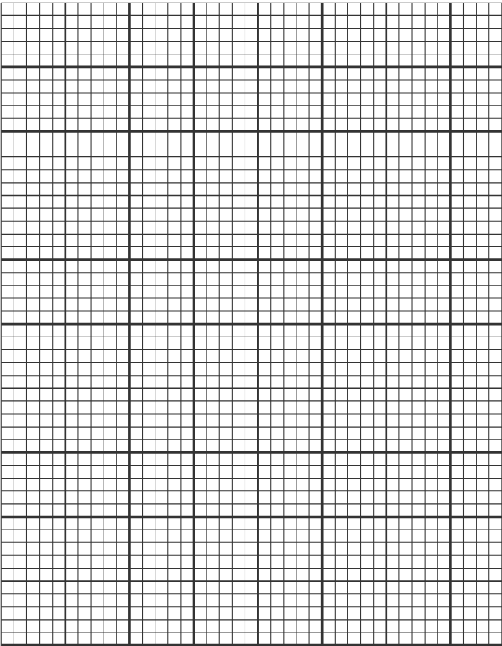
After Part 1
- Rinse probes and place them in tap water.
- Rinse both beakers thoroughly with deionized water.
Part 2: Testing Buffers (Bufferin)
- Add 40 mL of distilled water to two clean 50 mL beakers.
- Place one Bufferin tablet in each beaker and let it dissolve.
- Repeat the same procedure as in Part 1 (steps 1–13).
Table 2: Buffered Solution (Bufferin)
Total Drops Added | pH (Acid - Beaker A) | pH (Base - Beaker B)
0
5
10
15
20
25
30
Graph:
Graph the data you collected.
Title:
Clean-Up
- Disconnect the pH probes.
- Rinse them and return them to storage solution.
- Clean all glassware (especially the 50 mL beakers).

3.4 Activity 2: Demonstration of Capillary Action (Adhesion and Cohesion)
In this exercise, you will observe how water can move from one container to another without direct pouring. This activity demonstrates the properties of water such as cohesion and adhesion, which allow water to travel through materials like paper towels. Over time, you will record your observations to better understand how water moves through capillary action.
- Take two 250 ml beakers and put them side by side.
- Fill one with water. Keep the second empty.
- Take a piece of paper towel and fold it lengthwise in the middle a few times to get a thin strip. Fold it in the middle to make a V shape.
- Dip one end of the paper towel strip into the empty beaker and the other end into the beaker full of water. Allow this to sit until the end of the lab period. Check the beakers every 60 mins and make observations. Record your observations below.
Table 3 (Paper Towel Water Movement Observations):
A table for recording observations during an experiment where a paper towel connects two beakers, one with water and one empty. Students note changes over time, such as water movement and levels in each beaker, at regular intervals.
Elapsed Time  (in minutes) | Observations
0
60
120

3.5 Activity 3: Demonstration of Surface Tension (Adhesion and Cohesion)
In this exercise, you will investigate the property of surface tension in water. Surface tension is caused by hydrogen bonding between water molecules, creating a thin “skin” at the surface. By observing how a paperclip floats and how detergent affects this behavior, you will better understand how intermolecular forces influence the properties of water.
- Fill a culture dish halfway with water. Float a small paperclip on the surface of the water. This requires careful placement of the paperclips to avoid breaking the surface tension of the water.
- Use a dropper to carefully deposit a drop of water near the floating paperclips. Record your observations.
- Next, deposit several drops of liquid detergent near the floating paperclips. After applying the detergent, try to float another paperclip. The detergent disrupts the hydrogen bonds in water. Record your observations below.
Table 4 (Detergent and Surface Tension Observations):
A table for recording observations during an experiment where detergent is added to water with floating paperclips. Students note changes after the detergent disrupts hydrogen bonding, such as paperclips sinking and differences in surface tension.
Dropper contents | Did it cause the paperclip to sink? | Did this substance break the surface tension?
Water
Detergent

3.6 Activity 4: Building Models
In this activity, you will explore how molecules are represented using molecular, structural, and abbreviated structural formulas. A molecular formula, such as glycine (C₂H₅NO₂), shows the number and types of atoms present, while structural formulas display how those atoms are bonded. Abbreviated structural formulas simplify these representations by grouping atoms, making complex molecules easier to visualize.
You will use a molecular model kit to build three-dimensional representations of molecules, helping you understand how atoms connect through covalent bonds. As you construct models, you will also observe how the same molecular formula can form different structures, known as isomers. Additionally, you will examine how chemical reactions involve breaking and forming covalent bonds to create new products.
- Look at the four most common spheres and fill out which element they represent and how many bonds they can make in the table below.
Table 5 (Element Spheres and Bonding):
A table for identifying common elements shown as spheres in molecular models, with columns to list each element and the number of bonds it typically forms.
Sphere color | Element | # of bonds it forms
black
white
red
blue
- Build a molecular model for each molecule listed in the table below. Use the molecular formula to collect the correct spheres first, then put them together so that every hole is filled with a bond. Have your instructor verify your models Write the structural formula from the model you built in the table below. Hint: some of these molecules may include double or triple bonds
Table 6 (Molecular Model Building Activity):
A table for recording molecular model results, where students build each molecule using spheres and bonds, then write the corresponding structural formula based on the completed model.
Molecule | Molecular Formula | Structural Formula
Methane | CH₄
Ethane | C₂H₆
Ethene | C₂H₄
Methanol | CH₄O
Formaldehyde | CH₂O
Acetone (contains a carbonyl group at a ketone position between two methyl groups) | C₃H₆O
Glycine (a 2-carbon compound; contains an amino and a carboxyl group on each end) | C₂H₅NO₂
Several functional groups are commonly found in organic molecules. Using the table below, build a molecular model for each listed functional group. Then, record the corresponding structural formula for each model you construct. Refer to pages 47–49 of your textbook for guidance on the shapes and characteristic properties of these functional groups.
Table 7 (Functional Groups Molecular Models):
A table for recording common functional groups in organic molecules, where students build each group using molecular models and then write the corresponding structural formula, with dashes indicating bonds attached to a carbon atom.
Functional Group | Structural Formula | Characteristics
Amino (-NH2)
Carbonyl (-CO-)
Carboxyl (-COOH)
Hydroxyl (-OH)
Methyl (-CH4)
- Determine the molecular formula of each molecule using the abbreviated structural formula below. Ethanol is given as an example. You do not need to build these molecules. (remember to follow the rules of writing molecular formulas from the introduction)
Table 8 (Determining Molecular Formulas):
A table where students determine and record the molecular formulas of molecules based on given abbreviated structural formulas, with ethanol provided as an example.
Abbreviated structural formula | Molecular formula | Abbreviated structural formula | Molecular formula
CH₃-CH₂-OH | C₂H₆O | 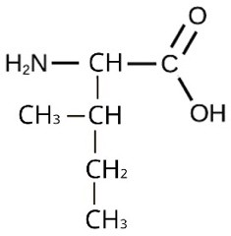
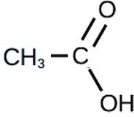 |  | 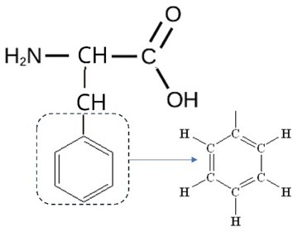
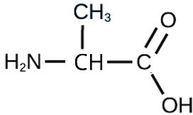 |  | 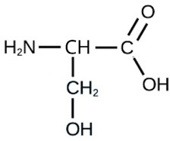
- Create two different models which both have the molecular formula C₂H₆O. Draw the structural formula of each in the table below.
Table 9 (Isomers of C₂H₆O):
A table where students draw and compare two different structural formulas for molecules with the same molecular formula (C₂H₆O), illustrating that the same formula can produce different structures (isomers).
Molecule | Molecular Formula | Structural formula
Ethanol (Start by making a hydroxyl group.
Dimethyl ether (Start by making two methyl groups)
Hint: from the name of this molecule, which functional group must this molecule have?
Chemical reactions involve the breaking and forming of bonds. In this exercise, you will use molecular models to simulate these processes by modeling the formation of urea from ammonia
The overall balanced equation for the formation of urea from ammonia is:
2 NH₃+CO₂→(NH₂)2CO+H₂O₂
Follow the steps below to construct each molecule, determine its structural formula, and identify whether it is a reactant or a product in the reaction.
- Build two ammonia (NH₃) molecules and one carbon dioxide (CO₂) molecule.
- Take one hydrogen (H) from each NH₃ and set them aside, these will be part of water.
- Take one oxygen (O), and two rods from the CO₂ model, combine these with the H from step b to make water.
- Combine the remaining molecules to construct Urea.
Table 10 (Reactants and Products—Modeling Reaction):
A table for recording molecular structures and identifying whether each is a reactant or product in a model activity. Students build ammonia and carbon dioxide molecules, rearrange atoms to form water, and combine remaining atoms to form urea, then record the structural formulas and classify each substance accordingly.
Molecule | Product or Reactant? | Structural formula
Ammonia
Carbon dioxide
Urea
Water

3.7 Post-Lab Activities
Post Lab Questions (20 Total)
- What evidence did you observe for capillary action?
- How did water move between the beakers and why?
- What property of water allows paperclips to float?
- What happened when detergent was added? Why?
- Describe how hydrogen bonding affects water properties.
- Compare cohesion and adhesion using your observations.
- Explain why surface tension decreases with detergent.
- How did adding water affect pH values?
- Why does dilution change pH?
- What role do buffers play in pH stability?
- Compare experimental vs simulated pH observations.
- What challenges did you encounter using molecular models?
- How did model building help your understanding?
- What differences did you observe between isomers?
- How do structural formulas improve understanding over molecular formulas?
- Describe one real-life application of surface tension.
- Why is water essential for life based on lab observations?
- How do chemical properties affect biological systems?
Check Your Understanding (Concept Questions)
- Why are carbon-based molecules so diverse?
- How does molecular shape impact function?
- Why is polarity critical for biological systems?
- What would happen if water had low surface tension?
- Why is hydrogen bonding essential in biology?
- Why must blood pH stay within a narrow range?
- How do buffers prevent drastic pH changes?
- What is the significance of isomers in biology?
- How do structure and function relate in molecules?
- Why are covalent bonds important in organic chemistry?

4. Chemical Composition of Cells

4.1 Pre-Lab Activity 4.1: Questions
Pre-Lab Questions (7 pts)
Complete these questions before coming to lab. They are designed to prepare you for the laboratory procedures and concepts
Multiple Choice (0.5 pt each)
1. Which of the following is a monosaccharide?
A. Sucrose
B. Lactose
C. Glucose
D. Starch
2. Benedict's reagent is used to detect the presence of:
A. Proteins
B. Lipids
C. Reducing sugars
D. Starch
3. Which reagent is used to detect proteins?
A. Iodine
B. Sudan III
C. Biuret
D. Benedict's
4. Which carbohydrate serves as the primary storage polysaccharide in plants?
A. Glycogen
B. Cellulose
C. Chitin
D. Starch
5. Which statement best describes a qualitative test?
A. It determines the exact concentration of a substance.
B. It measures molecular weight.
C. It indicates whether a substance is present or absent.
D. It determines the pH of a solution.
6. Which reagent is used to detect starch?
A. Iodine
B. Sudan III
C. Biuret
D. Benedict's
Short Answer (4 pts total)
6. Explain the structural difference between monosaccharides, disaccharides, and polysaccharides. (2 pts)
7. What is the purpose of including positive and negative controls in a laboratory experiment? (2 pts)

4.2 Learning Objectives
Upon completion of this laboratory exercise, students will be able to:
- Identify the four major classes of biological macromolecules found in living cells.
- Differentiate between monosaccharides, disaccharides, and polysaccharides based on their chemical structure and biological function.
- Describe the structure and function of proteins, amino acids, and lipids.
- Distinguish between saturated and unsaturated fatty acids.
- Explain the chemical principles behind qualitative tests used to detect carbohydrates, proteins, and lipids.
- Perform Benedict's, iodine, Biuret, and Sudan III tests safely and accurately.
- Interpret positive and negative test results using appropriate experimental controls.
- Differentiate between qualitative and quantitative laboratory analyses.
- Analyze experimental data to identify the major biological molecules present in unknown samples.

4.3 Introduction
All living organisms are composed of chemical compounds that perform essential functions needed for life. The majority of these compounds belong to four major classes of biological macromolecules:
- Carbohydrates
- Proteins
- Lipids
- Nucleic acids
In this laboratory exercise, you will examine three of these macromolecules—carbohydrates, proteins, and lipids—using chemical indicator tests. These tests allow scientists to identify specific types of molecules based on observable color changes or staining patterns. Although these laboratory tests do not determine the exact concentration of a substance, they provide valuable information about whether a particular biological molecule is present in a sample.

4.4 Carbohydrates
Carbohydrates are organic molecules composed primarily of carbon (C), hydrogen (H), and oxygen (O), generally in a ratio of approximately 1:2:1.
They serve several important biological functions including:
- Immediate energy source
- Energy storage
- Structural support
- Cell recognition
Carbohydrates are classified according to the number of sugar units they contain.

4.4.1 Monosaccharides
Monosaccharides are the simplest carbohydrates because they consist of a single sugar molecule.
Examples include:
- Glucose
- Fructose
- Galactose
Although glucose, galactose, and fructose all have the same chemical formula (C6H12O6), they differ structurally and chemically (and are isomers) because of the different arrangement of functional groups around the asymmetric carbon.
The chemical formula for glucose is C₆H₁₂O₆. In humans, glucose is an important source of energy. During cellular respiration, energy is released from glucose, and that energy helps make adenosine triphosphate (ATP).
Galactose (part of lactose, or milk sugar) and fructose (found in sucrose, in fruit) are other common monosaccharides.
Monosaccharides are considered reducing sugars, meaning they possess a free aldehyde or ketone group capable of reducing certain chemical reagents such as Benedict's reagent.
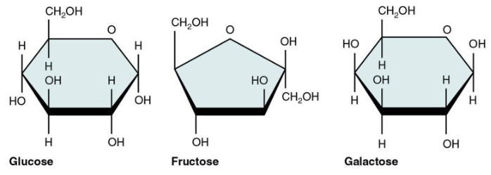
Image Source: https://pressbooks.bccampus.ca/kinsnew/chapter/2-5-organic-compounds-essential-to-human-functioning-anatomy-and-physiology-2/

4.4.2 Disaccharides
Disaccharides are formed when two monosaccharides join together through a dehydration synthesis reaction, creating a glycosidic bond.
Examples include:
Disaccharide | Composed of
Maltose | Glucose + Glucose
Lactose | Glucose + Galactose
Sucrose | Glucose + Fructose
Some disaccharides (maltose and lactose) are reducing sugars, whereas sucrose is considered a non-reducing sugar because its reactive groups are involved in the glycosidic bond.
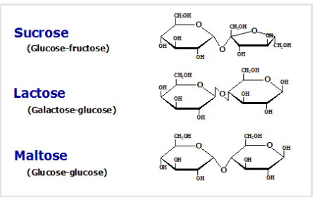
Image source: microbe notes Monosaccharides, Disaccharides, and Polysaccharides

4.4.3 Polysaccharides
Polysaccharides consist of hundreds or thousands of monosaccharides linked together.
Major examples include:

4.4.3.1 Starch
- Plant energy storage molecules
- Composed of glucose
- Digestible by humans

4.4.3.2 Glycogen
- Animal energy storage molecules
- Highly branched
- Stored in liver and muscle cells

4.4.3.3 Cellulose
- Structural component of plant cell walls
- Humans cannot digest cellulose because we lack cellulase
Unlike monosaccharides, polysaccharides are generally not reducing sugars.

4.5 Proteins
Proteins are large biological molecules composed of amino acids linked together by peptide bonds.
Proteins perform a tremendous variety of cellular functions including:
- Enzymes
- Structural support
- Transport
- Hormones
- Cell signaling
- Immune defense
- Muscle contraction
Protein function depends upon its unique three-dimensional structure.

4.5.1 Amino Acids
Amino acids are the building blocks of proteins.
Each amino acid contains:
- Amino group (-NH₂)
- Carboxyl group (-COOH)
- Hydrogen atom
- Variable R-group (side chain)
Twenty different amino acids are commonly used to construct proteins.
Differences in their side chains determine the chemical properties and function of proteins.

4.6 Lipids
Lipids are hydrophobic molecules composed primarily of carbon and hydrogen.
Unlike carbohydrates, lipids contain relatively little oxygen.
Major functions include:
- Long-term energy storage
- Cell membrane structure
- Hormone production
- Thermal insulation
- Cushioning organs
Common classes of lipids include:
- Fats
- Oils
- Phospholipids
- Steroids
- Waxes

4.6.1 Fatty Acids
Most fats consist of glycerol attached to three fatty acids forming triglycerides.
Fatty acids differ in the presence or absence of double bonds.

4.6.1.1 Saturated Fatty Acids
Saturated fatty acids contain only single carbon-carbon bonds.
Characteristics:
- Straight hydrocarbon chains
- Pack tightly together
- Usually solid at room temperature
Examples:
- Butter
- Lard
- Coconut oil
Excessive dietary intake is associated with increased cardiovascular disease risk.

4.6.1.2 Unsaturated Fatty Acids
Unsaturated fatty acids contain one or more carbon-carbon double bonds.
These double bonds introduce bends (kinks) into the fatty acid chain.
Characteristics:
- Do not pack tightly
- Usually liquid at room temperature
Examples:
- Olive oil
- Canola oil
- Fish oil
Unsaturated fats are generally considered healthier dietary fats.
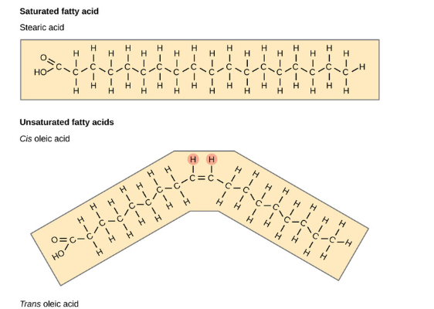
Image source 2.5.2: Lipid Molecules - Biology LibreTexts

4.7 Qualitative versus Quantitative Tests
Scientists use different laboratory methods depending on the information they need.

4.7.1 Qualitative Tests
Qualitative tests determine whether a substance is present or absent.
Results are based on observations such as:
- Color change
- Precipitate formation
- Layer formation
- Staining
Example:
Benedict's test indicates whether reducing sugars are present.
This laboratory uses qualitative testing.

4.7.2 Quantitative Tests
Quantitative tests determine how much of a substance is present.
Results are numerical and often require specialized equipment such as:
- Spectrophotometers
- Colorimeters
- Analytical balances
Examples include:
- Blood glucose measurements
- Protein concentration assays
- Cholesterol analysis

4.8 Experimental Controls
Controls are essential components of every scientific experiment because they ensure that results are reliable and meaningful.

4.8.1 Positive Control
A positive control contains a substance known to produce the expected positive result.
Example:
Glucose solution serves as the positive control for Benedict's test because glucose is reducing sugar.
A successful positive control confirms that:
- The reagent is functioning properly
- The procedure was performed correctly

4.8.2 Negative Control
Negative control lacks the substance being tested.
Distilled water is commonly used.
Negative control should produce no reaction.
It confirms that:
- Positive results are due to the sample rather than contamination or reagent error.

4.9 Laboratory Procedures: Chemical Composition of Cells
Safety Precautions
- Wear safety goggles, gloves, and a lab coat throughout the experiment.
- Handle all reagents carefully. Sudan III is flammable and can stain skin and clothing.
- Benedict's reagent and Biuret reagent contain copper compounds that should not be ingested.
- Use caution when working with hot water baths.
- Dispose of chemical waste as instructed by your instructor.
Wash your hands before leaving the laboratory.

4.9.1 Materials
Reagents
- Benedict's reagent
- Lugol's iodine solution
- Biuret reagent
- Sudan III solution
Equipment
- Test tubes
- Test tube rack
- Test tube holder
- Graduated pipettes or transfer pipettes
- Hot water bath (95–100°C)
- Beakers
- Permanent marker
- Paper towels

4.9.2 Part I. Chemical Indicator Tests - Benedict’s Test for Reducing Sugars
Principle
Benedict's reagent detects reducing sugars containing free aldehyde or ketone groups.
When heated, reducing sugars reduce copper (II) ions (Cu²⁺) to copper (I) oxide (Cu₂O), producing a colored precipitate.
Positive Results
Color | Approximate Sugar Amount
Green | Low
Yellow | Moderate
Orange | High
Brick-red | Very high
Negative Result - Blue
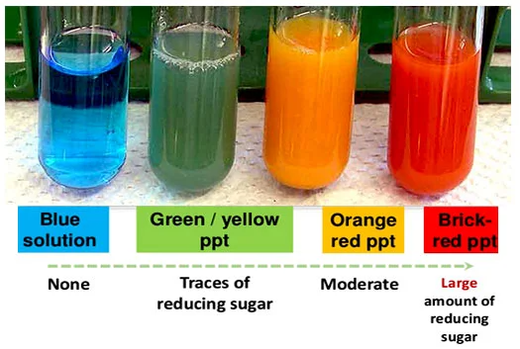
Image source: microbiology information.com Benedict's Test- Principle, Preparation, Procedure and Result Interpretation
Procedure
A. Label Six clean test tubes:
1. Positive Control (Glucose)
2. Negative Control (Water)
3. Onion
4. Potato
5. Grape juice
6. Unknown Sample
- Add 2 mL of each sample into the appropriately labeled tube.
- Add 1-2 mL of Benedict's reagent to each tube.
- Mix gently.
- Place the tubes in a beaker with water, place beaker on a hot plate and heat to boiling (95–100°C) for 3–5 minutes.
- Carefully remove the tubes using a test tube holder.
- Allow the tubes to cool for approximately 2 minutes.
- Record your results in the Table.
Table 1: Benedicts test for reducing sugars
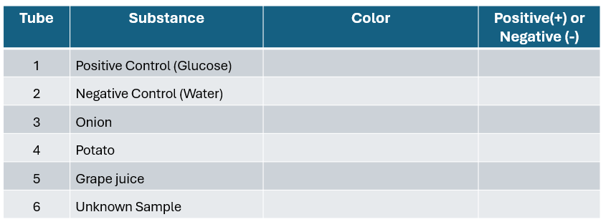

4.9.3 Part II. Iodine Test for Starch
Principle
Iodine molecules become trapped inside the helical structure of amylose, producing a dark blue-black color.
Procedure
- Label Five clean test tubes:
1. Positive Control (Starch)
2. Negative Control (Water)
3. Onion
4. Potato
5. Unknown Sample
- Add 2 mL of each sample.
- Add 2–3 drops of Lugol's iodine solution.
- Gently swirl the tube.
- Observe immediately.
- Record your results in the table.
Color | Interpretation
Yellow-Brown | Negative
Blue-Black | Positive for starch
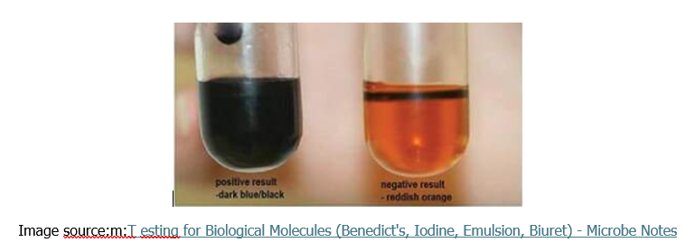
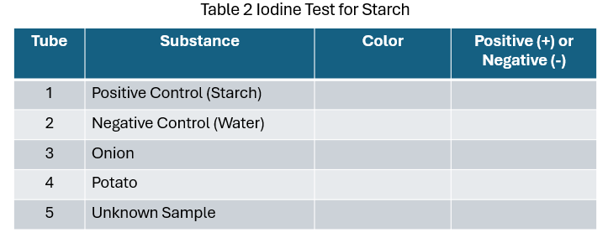

4.9.4 Part III. Biuret Test for Proteins
Principle
Copper ions in Biuret reagent react with peptide bonds in proteins under alkaline conditions to form a violet-colored complex.
Procedure
- Label Four clean test tubes:
1. Positive Control (Egg albumin)
2. Negative Control (Water)
3. Chicken broth
4. Milk
5. Unknown Sample
- Add 2 mL of each sample.
- Add 2 mL of Biuret reagent.
- Mix gently.
- Allow the tubes to stand for 2–3 minutes.
- Record results in table.
Biuret Test Results
Color | Interpretation
Blue | Negative
Violet/Purple | Positive for protein
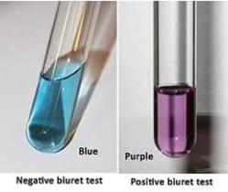
Image source:m:T esting for Biological Molecules (Benedict's, Iodine, Emulsion, Biuret) - Microbe Notes
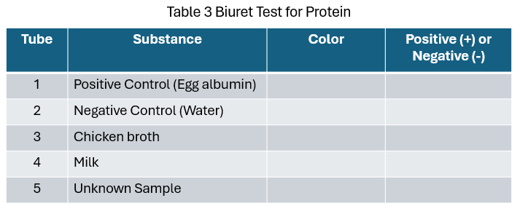

4.9.5 Part IV. Sudan III Test for Lipids
Principle
The Sudan III test is a qualitative test used to detect the presence of lipids (fats and oils). Sudan III is a fat-soluble dye that dissolves in lipids rather than water. When lipids are present on filter paper, the dye is retained in the lipid-containing area, producing a red to orange-red stained spot.
Materials
- Filter paper
- Pencil
- Forceps
- Cotton swabs
- Sudan III solution
- Distilled water (negative control)
- Vegetable oil (positive control)
- Test samples
- Petri dish or staining tray
- Wash bottle containing distilled water
Procedure
- Place a piece of filter paper in a clean Petri dish or on a clean surface.
- Using a pencil, draw and label circles (approximately 1–2 cm in diameter) for each sample.
- Add 1–2 drops of each sample into its designated circle using cotton swabs.
- Include:
1. Positive control (Vegetable oil)
2. Negative control (Distilled water)
3. Coconut milk (juice)
4. Whole milk
5. Skim milk
6. Italian dressing
6. Fat-free Italian dressing
7. Unknown
- Allow the samples to air dry completely (approximately 10–15 minutes).
- Pour enough Sudan III solution into a Petri dish to cover the filter paper.
- Place the dried filter paper into the Sudan III solution for 3–5 minutes.
- Remove the filter paper using forceps.
- Rinse gently with distilled water for about 30–60 seconds to remove excess stain.
- Use a blow dryer to dry filter paper briefly.
- Observe and record the color of each spot, record results in table.
Results
Observation | Interpretation
Bright orange-red or red stained spot remains | Positive for lipids
Little or no red/orange staining | Negative for lipids
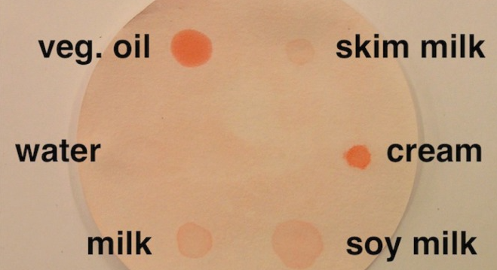
Image Source: A Biology Laboratory Exercise Using Macromolecule Assays to Distinguish Four Types of Milk - PMC
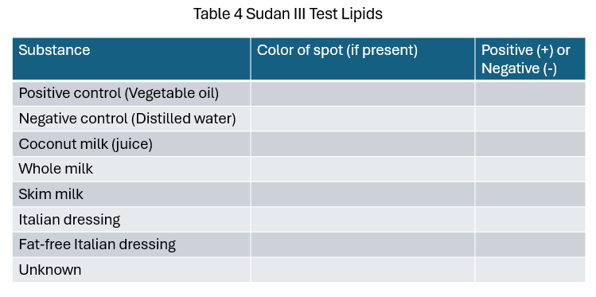

4.9.6 Unknown Solution Identification
After completing the previous experiments, you should have developed a working knowledge of qualitative tests used to identify the major classes of biological molecules, including simple sugars, starch, proteins, and lipids. In this exercise, you will apply those techniques to identify an unknown solution.
Each laboratory group will be assigned one unknown sample selected from a set of three possible solutions. Using the appropriate qualitative tests and comparing your results with the expected reactions of known substances, you will determine the identity of your assigned unknown. Be sure to record all observations carefully and use your test results as evidence to support your final identification.
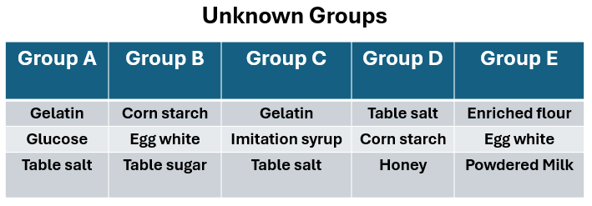
Assigned Unknown Group: ________________________________
Instructions
Complete Table 5 by recording the expected results for each qualitative test and indicating the type of biological molecule that each test detects (the first row has been completed as an example). Use the information and results from Table 7 to help you complete the table accurately.
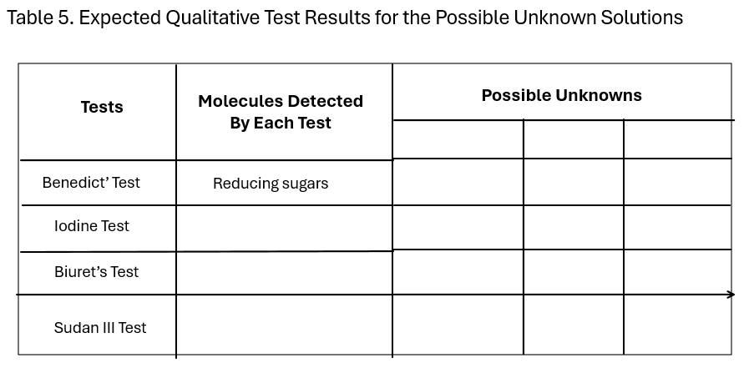
After completing Table 5, transfer your experimental results from Tables 1–4 into Table 6. Compare your observed results with the expected results listed in Table 5 for the possible unknown solutions. Use this comparison to determine the identity of your assigned unknown sample and record your conclusion in Table 6.
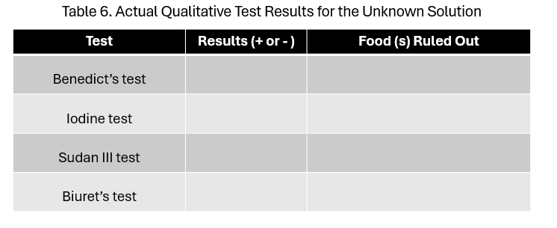
Identity of the Unknown Solution: _________________________
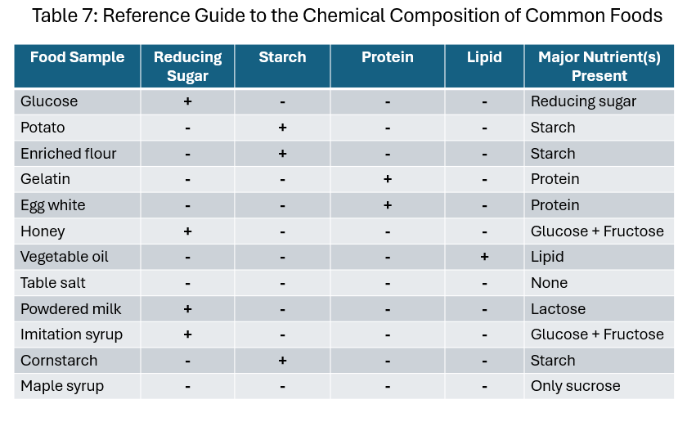
This reference table can be used by students to predict qualitative test results and compare them with their experimental observations during food composition analysis and unknown identification exercises.

4.9.7 Cleanup
- Dispose of all chemical waste in the designated waste containers.
- Thoroughly rinse test tubes with tap water followed by distilled water.
- Return all equipment to the designated area.
- Clean your workspace with a disinfectant if instructed.
- Remove gloves and wash your hands thoroughly before leaving the laboratory.

4.9.8 Scientific Significance
Chemical indicator tests provide a rapid method for identifying biological molecules in foods, biological samples, and laboratory specimens. These qualitative assays are widely used in biology, biochemistry, medicine, food science, microbiology, and environmental science. Understanding how these tests work reinforces the relationship between molecular structure and biological function while introducing students to the principles of experimental design, including the use of controls, observation, and data interpretation. This laboratory also emphasizes that while qualitative tests identify the presence of a molecule, quantitative methods are required to accurately measure its concentration in research and clinical settings.

4.10 Lab Worksheet: Pre-Lab and Post-Lab Questions
Pre-Lab Questions (7 pts)
Complete these questions before coming to lab. They are designed to prepare you for the laboratory procedures and concepts.
Multiple Choice (0.5 pt each)
1. Which of the following is a monosaccharide?
A. Sucrose
B. Lactose
C. Glucose
D. Starch
2. Benedict's reagent is used to detect the presence of:
A. Proteins
B. Lipids
C. Reducing sugars
D. Starch
3. Which carbohydrate serves as the primary storage polysaccharide in plants?
A. Glycogen
B. Cellulose
C. Chitin
D. Starch
4. Which statement best describes a qualitative test?
A. It determines the exact concentration of a substance.
B. It measures molecular weight.
C. It indicates whether a substance is present or absent.
D. It determines the pH of a solution.
Short Answer (5 pts total)
5. Explain the structural difference between monosaccharides, disaccharides, and polysaccharides. (2 pts)
6. What is the purpose of including positive and negative controls in a laboratory experiment? (2 pts)
Post-Lab Questions (15 pts)
These questions require you to analyze your results and apply the concepts learned during the laboratory exercise.
Part I: Data Interpretation (5 pts)
1. Unknown Sample Analysis (2 pts)
An unknown sample produced the following results:
Test | Result
Benedict's | Brick-red
Iodine | Negative
Biuret | Negative
Sudan III | Negative
a. Which biological molecule is present? ______________________
b. What evidence supports your conclusion? ___________________
2. Unknown Sample Analysis (3 pts)
Another unknown sample produced these results:
Test | Result
Benedict's | Negative
Iodine | Blue-black
Biuret | Negative
Sudan III | Negative
a. Identify the biological molecule present. ______________________
b. Explain why Benedict's test was negative while iodine was positive.
4. Case Study (3 pts)
A nutrition scientist analyzes two food samples.
- Sample A is positive for Sudan III but negative for Benedict's.
- Sample B is positive for Benedict's but negative for Sudan III.
Compare the composition of the two samples and explain which would provide immediate energy and which would serve as long-term energy storage.

5. Molecular Structure of Biological Molecules
Carbohydrates, Lipids, Proteins, Nucleic Acids, and Functional Groups
Estimated Time: 2.5–3 hours

5.1 Introduction: Molecular Structure of Biological Molecules
Living organisms are composed of many organic molecules, most of which can be grouped into four major biological classes: carbohydrates, lipids, proteins, and nucleic acids. These molecules are central to life because they store energy, provide structural support, regulate cellular processes, form membranes, catalyze reactions, and carry genetic information.
Many biological molecules are built from smaller units. For example, simple sugars called monosaccharides may exist as individual molecules or join to form disaccharides and polysaccharides. Amino acids link together to form polypeptides and proteins. Nucleotides form nucleic acids such as DNA and RNA. Lipids are more chemically diverse; some contain fatty acids and glycerol, while others, such as sterols, contain fused carbon rings.
In this laboratory, you will examine molecular models and structural formulas representing the four major classes of biological molecules. You will identify functional groups, compare molecular structures, and relate structure to biological functions. As you work, focus on how atoms, bonds, polarity, molecular shape, and subunit arrangement influence what each molecule does in living systems.
For a direct and concise review of this topic you con review the following review on the macromolecules: Macromolecules - Classes and Functions from the 2-Minute Classroom
Learning Objectives
By the end of this laboratory, students should be able to:
- Identify the four major classes of biological molecules.
- Recognize common subunits of carbohydrates, proteins, and nucleic acids.
- Compare monosaccharides, disaccharides, and polysaccharides.
- Distinguish among major lipid types, including fatty acids, triglycerides, phospholipids, and sterols.
- Identify the general structure of an amino acid and explain the importance of the R group.
- Describe the basic structure of nucleotides, DNA, and RNA.
- Identify common functional groups in biological molecules.
- Explain how molecular structure relates to biological functions.
Terms to Define Before Lab
Define the following terms before beginning the lab.
- Organic molecule
- Macromolecule
- Monomer
- Polymer
- Functional group
- Hydroxyl group
- Carboxyl group
- Amino group
- Phosphate group
- Monosaccharide
- Disaccharide
- Polysaccharide
- Glycosidic linkage
- Fatty acid
- Triglyceride
- Phospholipid
- Sterol
- Amino acid
- Peptide bond
- Nucleotide

5.2 Pre-Lab Activity 4.1: Questions
Pre-Lab Questions: Complete these questions before coming to the lab.
Multiple Choice
- Which element forms the backbone of most biological organic molecules?
A. Sodium
B. Carbon
C. Chlorine
D. Potassium
- Which class includes sugar and starches?
A. Lipids
B. Proteins
C. Carbohydrates
D. Nucleic acids
- Which molecule is a monosaccharide?
A. Glucose
B. Sucrose
C. Starch
D. Cellulose
- Amino acids are the monomers of:
A. Proteins
B. Lipids
C. Nucleic acids
D. Carbohydrates
- Nucleotides are the monomers of:
A. Proteins
B. Nucleic acids
C. Lipids
D. Polysaccharides
- Which molecule is a key component of cell membranes?
A. Phospholipid
B. Glucose
C. Amino acid
D. Cellulose
- Which lipid has a four-ring carbon structure?
A. Triglyceride
B. Sterol
C. Phospholipid
D. Fatty acid
- Which process breaks polymers by adding water?
A. Dehydration synthesis
B. Hydrolysis
C. Translation
D. Diffusion
- Which biological molecule stores hereditary information?
A. DNA
B. Triglyceride
C. Starch
D. Cholesterol
- Which functional group is commonly found in amino acids?
A. Amino group
B. Phosphate group only
C. Methyl group only
D. Sulfhydryl group only
Short Answer
- What are the four major classes of biological molecules?
- What is the difference between a monomer and a polymer?
- What is a functional group?
- Why is carbon especially important in biological molecules?
- What atoms are commonly found in carbohydrates?
- What is the difference between starch and cellulose?
- What is the difference between a saturated and unsaturated fatty acid?
- What does it mean for a molecule to be amphipathic?
- What are the three parts of a nucleotide?
- Why is molecular shape important in biology?
Materials
Each student or group should have:
- Lab handout
- Pencil or pen
- Colored pencils or highlighters
- Molecular model kit or instructor-provided molecular diagrams
- Textbook or approved course reference
- Ruler or straightedge
- Optional: digital molecular model viewer
Laboratory Procedure

5.3 Part I. Carbohydrates: Sugars and Polysaccharides
Suggested Time: 35–40 minutes
Carbohydrates are composed primarily of carbon, hydrogen, and oxygen. Many carbohydrates contain multiple hydroxyl groups, making them polar and often water-soluble. Carbohydrates may function as immediate energy sources, energy-storage molecules, or structural materials. This topic may be reviewed in “Carbohydrates,; biological molecules simplified #1”
A. Monosaccharides: Glucose
Glucose is a six-carbon monosaccharide with the molecular formula: C₆H₁₂O₆
Glucose may be represented in a linear or ring form. Ring forms are common in aqueous environments. Different ring arrangements of glucose can produce structural isomers, such as alpha-glucose and beta-glucose.
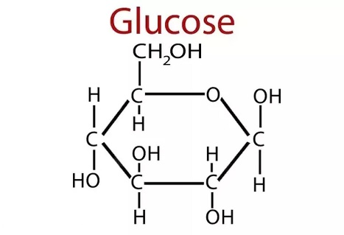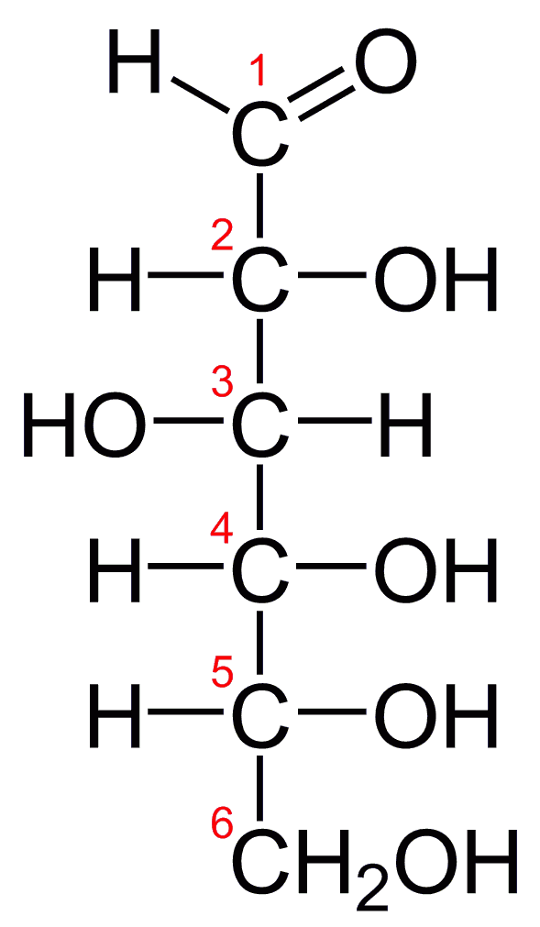
Figure 4.1a: a glucose molecule Figure 4.11b: a linear glucose molecule
Two diagrams of glucose are shown: Figure 4.1a presents glucose as a ring-shaped molecule, while Figure 4.1b shows it as a straight-chain molecule, illustrating its two common forms.
Figure 4.1a: Ring (cyclic) glucose molecule
A ring-shaped glucose molecule (C₆H₁₂O₆) is shown in its cyclic form, where the carbon chain has folded to form a six-membered ring. This occurs when the aldehyde group at carbon 1 reacts with the hydroxyl group on carbon 5. The ring consists of five carbon atoms and one oxygen atom, with hydroxyl (–OH) groups attached to the carbons. The position of the –OH group on carbon 1 distinguishes α- and β-glucose forms.
Figure 4.1b: Linear glucose molecule
A linear glucose molecule (C₆H₁₂O₆) is shown in its open-chain form, consisting of a six-carbon backbone with an aldehyde group (–CHO) at carbon 1 and hydroxyl (–OH) groups attached to the remaining carbons. This structure can cyclize in solution to form the ring structure shown in Figure 4.1a.
Credits: Figure 4.1a & 4.1b: From https://www.nutrientsreview.com/wp-content/uploads/2014/09/Glucose-formula.jpg
Guided Work
Examine a glucose model or refer to the structural diagrams above.
- Count the number of carbon atoms.
- Count the number of oxygen atoms.
- Identify the hydroxyl groups.
- Explain whether hydroxyl groups are polar or nonpolar.
- Compare alpha-glucose and beta-glucose. What structural differences do you observe?
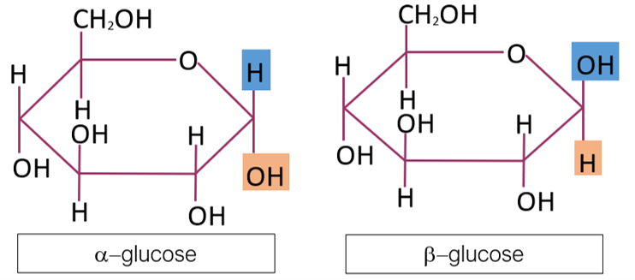
Carbohydrates - Karven Academy
Figure 4.2: glucose isomers: α-glucose and β-glucose (C₆H₁₂O₆)
Figure 4.2 (Glucose Isomers: α-glucose and β-glucose):
A diagram showing two ring-shaped glucose molecules labeled α-glucose and β-glucose (C₆H₁₂O₆). Both structures consist of six-membered rings made of carbon and oxygen atoms with attached hydroxyl (–OH) groups. The key difference is the orientation of the –OH group on carbon 1: in α-glucose it points downward, while in β-glucose it points upward. .
B. Disaccharides: Sucrose
Disaccharides form when two monosaccharides are joined by a glycosidic linkage. Sucrose is a common disaccharide composed of glucose and fructose.
During the formation of a disaccharide, water is removed. During breakdown of a disaccharide, water is added in a process called hydrolysis.
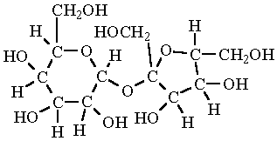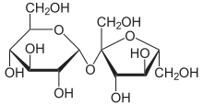
(4.3a) (4.3b)
Figure 4.3a & 4.3b (Sucrose molecule representations):
Two diagrams of a sucrose molecule are shown. The first (2a) is a detailed structural model displaying all atoms, including carbon, oxygen, and hydrogen, clearly illustrating the glucose and fructose units joined by a glycosidic bond. The second (2b) is a simplified skeletal diagram where carbon atoms and attached hydrogens are not shown; instead, lines are bonds and the overall structure, making the arrangement of the two sugar rings easier to see.
Figure 4.3 a & b: Sucrose molecules. Figure 2a contains all the hydrogens in the molecule. From https://www.chem.purdue.edu/jmol/molecules/sucrose.gif Figure 2b is the chemist’s shorthand version. From https://upload.wikimedia.org/wikipedia/commons/thumb/1/1a/Saccharose2.svg/440px-Saccharose2.svg.png
Guided Work
Examine a sucrose model.
- How many monosaccharide units are present?
- Which bond connects the two sugar units?
- What molecule is needed to break sucrose apart by hydrolysis?
- Is sucrose polar or nonpolar? Explain using functional groups.
C. Polysaccharides: Starch and Cellulose
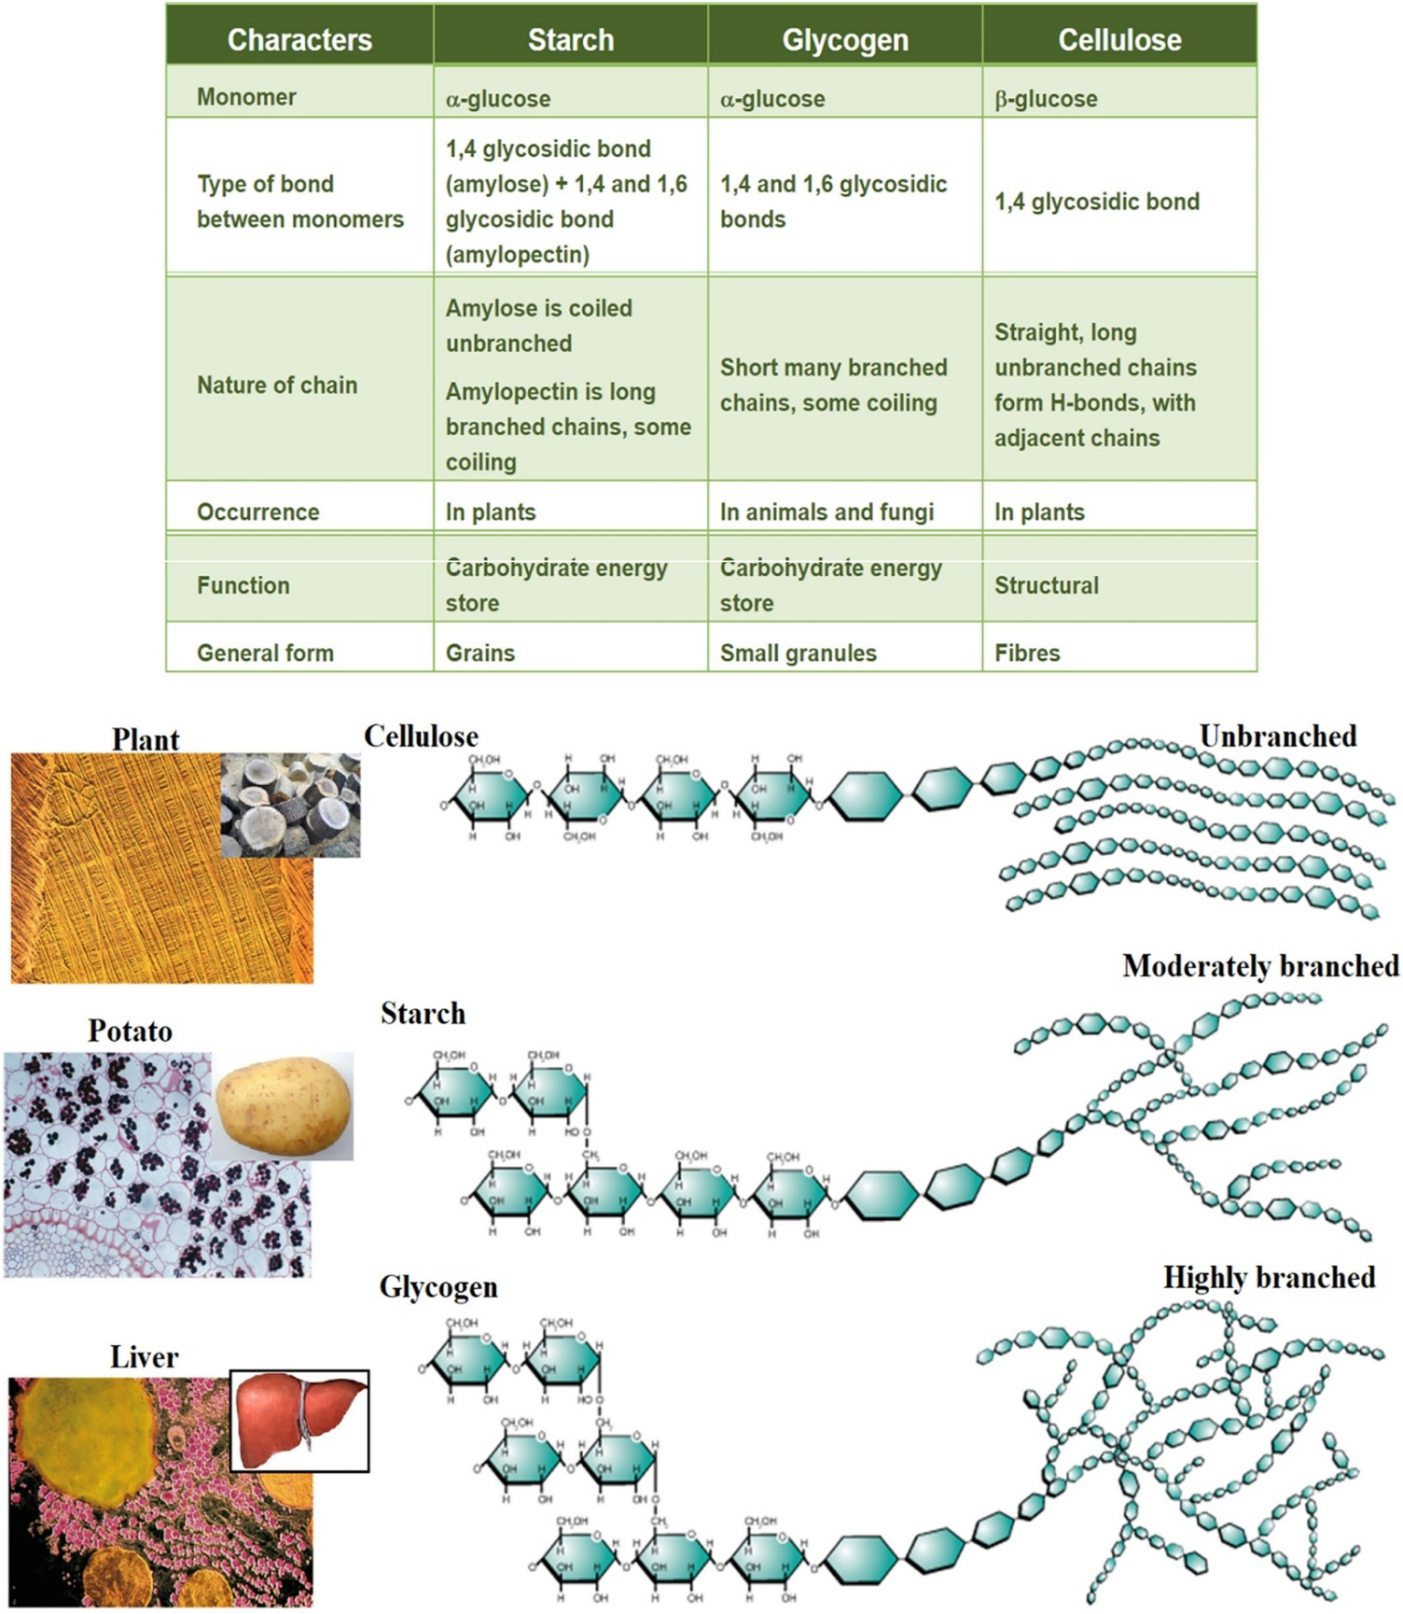
https://ars.els-cdn.com/content/image/1-s2.0-S0144861721010110-gr1_lrg.jpg
A diagram comparing two polysaccharides made of repeating glucose units. On one side, starch is shown as a coiled or branching chain of glucose molecules, illustrating its role in energy storage in plants. On the other side, cellulose is depicted as straight, parallel chains of glucose linked together, forming rigid fibers that provide structural support in plant cell walls. The difference in arrangement highlights starch as flexible and digestible, while cellulose appears tightly packed and stable
Figure 4.4: Naturally occurring polysaccharides. Polysaccharides are giant polymers of monosaccharides. Polysaccharides of glucose: starch: storage of glucose in plants; cellulose: very stable, good for structural components. From F. Seidi, M. Yazdi, M. Jouyandeh, S. Habibzadeh, M. Munir, H. Vahabi, B. Bagheri, N. Rabiee, P. Zarrintaj, M. Saeb, Crystalline polysaccharides: A review, Carbohydrate Polymers, Vol. 275, 2022, https://doi.org/10.1016/j.carbpol.2021.118624. (https://www.sciencedirect.com/science/article/pii/S0144861721010110)
.
Guided Work
Compare starch and cellulose models.
- Are the glucose chains branched or unbranched?
- How does the linkage between glucose units differ?
- Which molecule is better suited for energy storage?
- Which molecule is better suited for structural support?
- Why can two molecules made of glucose have different biological functions?

5.4 Part II. Lipids: Fatty Acids, Triglycerides, Phospholipids, and Sterols
Suggested Time: 40–45 minutes
Lipids are a diverse group of mostly hydrophobic molecules. Many contain long hydrocarbon regions, which make them poorly soluble in water. Lipids function in long-term energy storage, insulation, membrane structure, waterproofing, and chemical signaling. A brief introduction may be seen in the following video: “Lipids | Fats, Steroids, and Phospholipids | Biological Molecules Simplified #4”
A. Fatty Acids
Fatty acids contain a carboxyl group at one end and a hydrocarbon chain. A saturated fatty acid contains no carbon-carbon double bonds in its hydrocarbon chain. An unsaturated fatty acid contains one or more carbon-carbon double bonds, often producing bends in the chain.
Fatty acids:
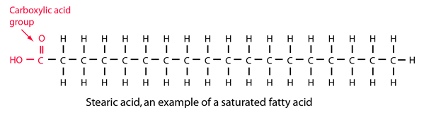
http://hyperphysics.phy-astr.gsu.edu/hbase/Organic/imgorg/stearic.png
Figure 4.5a: a saturated fatty acid
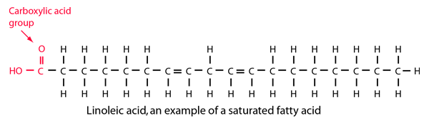
http://hyperphysics.phy-astr.gsu.edu/hbase/Organic/imgorg/linoleic.png
Figure 4.5b: an unsaturated fatty acid
Two diagrams compare fatty acids: one shows a saturated fatty acid with a straight carbon chain, and the other shows an unsaturated fatty acid with a bent chain due to a double bond.
Figure 4.5a and 4.5b: Comparison of Saturated and Unsaturated Fatty Acids
Guided Work
Examine saturated and unsaturated fatty acid models.
- Circle or identify the carboxyl group.
- Identify the hydrocarbon tail.
- Compare the shape of saturated and unsaturated fatty acids.
- Explain how double bonds affect molecular shape.

B. Triglycerides
A triglyceride contains one glycerol molecule joined to three fatty acids. Triglycerides are important for long-term energy storage molecules.
TRIGLYCERIDES
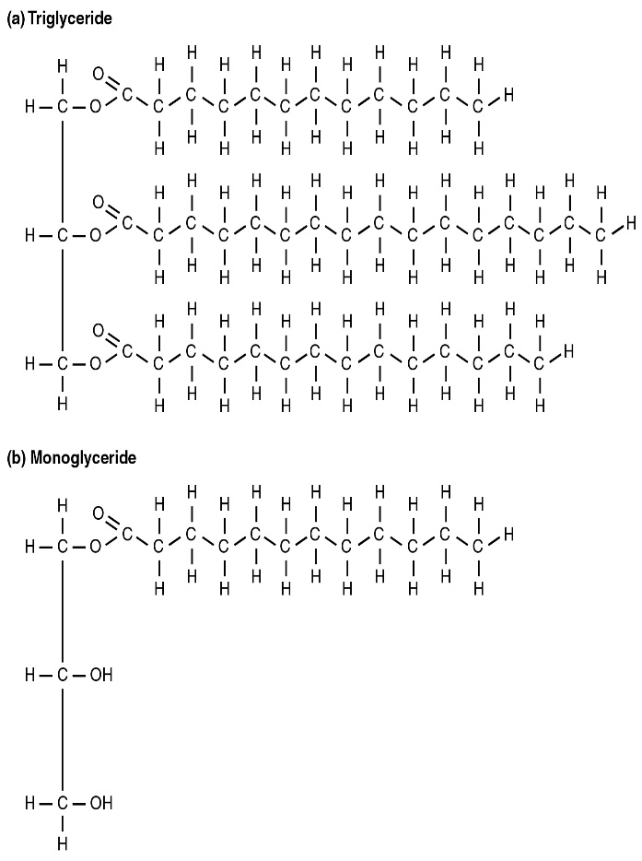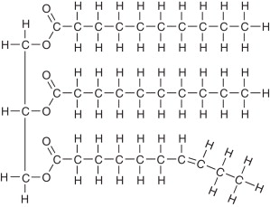
Figure 4.6a; a saturated fat Figure 4.6b an unsaturated fat
Two diagrams of fat molecules are shown: one stands for a saturated fat with straight fatty acid chains, and the other is an unsaturated fat with one or more bent chains due to double bonds.
Figure 4.6a and b. A saturated and unsaturated fat, respectively.
Credits: Figure 4.6 a: https://open.oregonstate.education/app/uploads/sites/48/2019/07/2511_A_Triglyceride_Molecule_a_Is_Broken_Down_Into_Monoglycerides_b.jpg. Figure 4.6b: A.H. Lichtenstein, 2013, Fats and Oils, Encyclopedia of Human Nutrition (Third Edition), Academic Press, Pages 201-208, https://doi.org/10.1016/B978-0-12-375083-9.00097-0. https://www.sciencedirect.com/science/article/pii/B9780123750839000970)
Guided Work
Examine a triglyceride model.
- Identify and draw a circle around the glycerol backbone.
- Identify and draw a box around the three fatty acid chains.
- Predict the products of triglyceride hydrolysis. Write the products below.
- Explain why triglycerides are mostly nonpolar.
- Compare saturated and unsaturated triglycerides. Explain the differences below.
C. Phospholipids
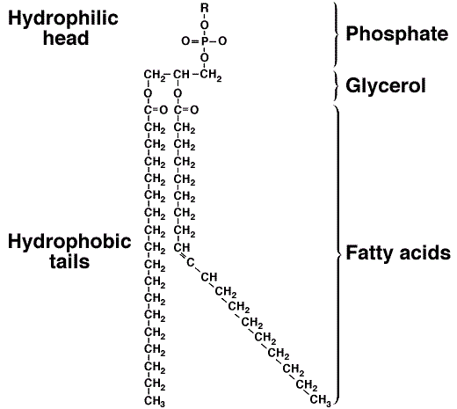
molecular structure of phospholipid Figure 2.
A diagram of a phospholipid molecule showing a polar head group and two nonpolar fatty acid tails. The head has a phosphate group, while the tails extend as long hydrocarbon chains, illustrating the molecule’s structure with a water-attracting (hydrophilic) head and water-repelling (hydrophobic) tails.
Figure 4.7; a phospholipid. From https://www.researchgate.net/profile/Ebrahim-Zahrabi/publication/297161568/figure/fig1/AS:336950331494401@1457346627123/molecular-structure-of-phospholipid-Figure-2.png
Phospholipids are major components of cell membranes. A phospholipid has a hydrophilic head region and hydrophobic fatty acid tails. Because it has both water-attracting and water-repelling regions, it is described as amphipathic.
Guided Work
Examine a phospholipid model.
- Identify the phosphate-containing head. Draw a circle around it.
- Identify the fatty acid tails.
- Explain why the molecule is amphipathic.
- Predict how phospholipids arrange themselves in water.
- Explain why phospholipids are well suited for membrane formation.
D. Sterols
Sterols are lipids with a characteristic four-ring carbon framework. Cholesterol is the major sterol in animal cells. It contributes to membrane structure and serves as a precursor for several important molecules, including steroid hormones and vitamin D.
Guided Work
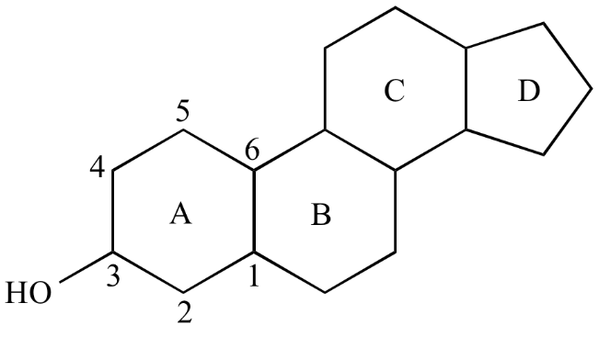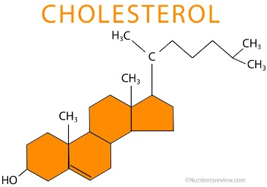
Figure 4.8a. a general sterol molecule model Figure 4.8b. cholesterol
Two diagrams of sterol molecules are shown: one illustrates a general sterol structure with four fused carbon rings, and the other shows cholesterol with a similar ring structure and a short hydrocarbon tail.
Credits: Figure 4.8a: From Steven A. Hardinger, “Illustrated Glossary of Organic Chemistry”, Department of Chemistry & Biochemistry, UCLA https://www.chem.ucla.edu/~harding/IGOC/S/sterol01.png. Figure 4.8b from https://www.nutrientsreview.com/wp-content/uploads/2014/12/Cholesterol-structure.jpg
Examine a cholesterol or sterol model.
- Count the number of fused rings. How many are there?
- Identify any polar functional group in the general sterol model?
- Is cholesterol mostly polar or mostly nonpolar?
- Where is cholesterol found in animal cells?
- Why is cholesterol biologically important?

5.5 Part III. Proteins: Amino Acids and Polypeptides
Suggested Time: 35–40 minutes PROTEINS: Pages 75-83
Proteins are polymers made of amino acid monomers. Each amino acid contains a central carbon attached to an amino group, a carboxyl group, a hydrogen atom, and an R group. The R group differs among amino acids and determines many of their chemical properties.
Amino acids are joined by peptide bonds to form polypeptides. The amino acid sequence influences how the protein folds, and the folded shape determines protein function. For a quick review please visit the following video: “Proteins, Biological Molecules simplified #2”
- Amino Acid Structure
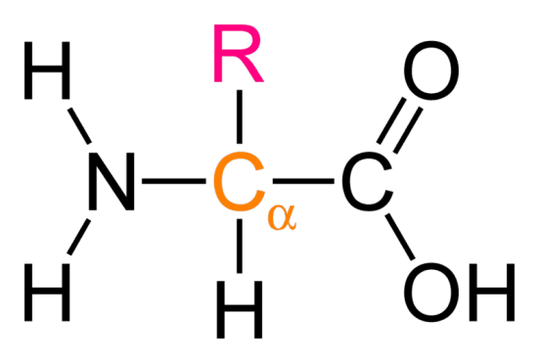
How are alpha amino acids different from beta amino acids? - Quora
Alt text:
A diagram of a general amino acid showing a central carbon atom bonded to an amino group (–NH₂), a carboxyl group (–COOH), a hydrogen atom, and a variable side chain (R group).
Figure 4.9 (Amino Acid): (obtained from Quora https://qph.fs.quoracdn.net/main-qimg-6e5fc1022752632bbe80515b295f4440)
Examine a general amino acid model.
- Find the amino group. Draw a ring around this structure.
- Locate the carboxyl group. Draw a box around this structure.
- Identify the central carbon.
- Find the R group.
- From your review of amino acids in your textbook, describe why the R group is significant.

B. Amino Acid Categories
Using an amino acid chart from figure 4.1 below, identify one example of each type:
Table 4.1. Examples of amino acids based on the R-group structural differences.
Category | Example Amino Acid
Nonpolar
Polar
Acidic
Basic
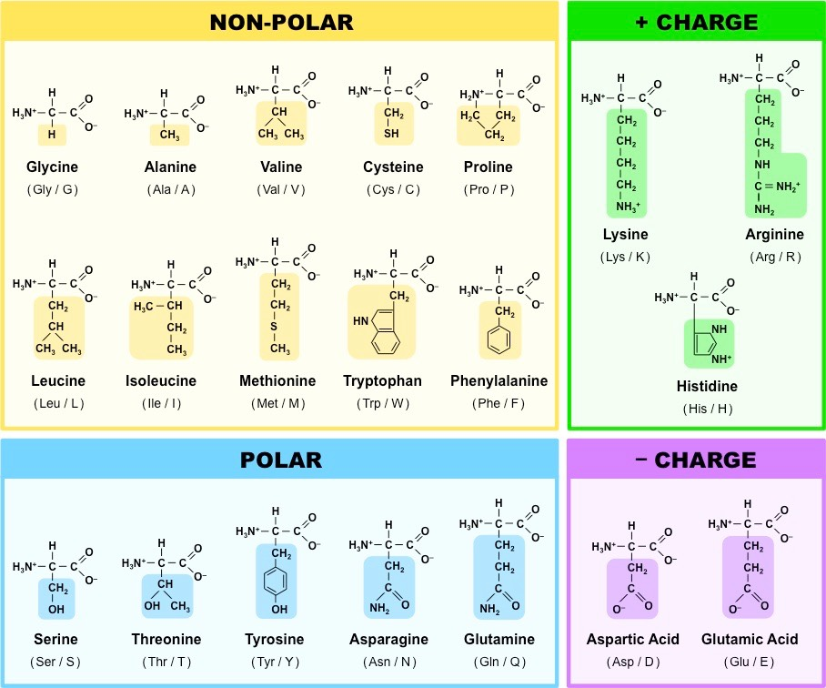
My Image 1
A chart displaying the 20 standard amino acids found in proteins, each shown with its chemical structure. The amino acids share a common backbone but differ in their side chains (R groups), which vary in size, shape, and chemical properties.
Figure 4.10: the 20 amino acids of proteins. From https://ib.bioninja.com.au/_Media/amino-acid-structures_med.jpeg
C. Polypeptides
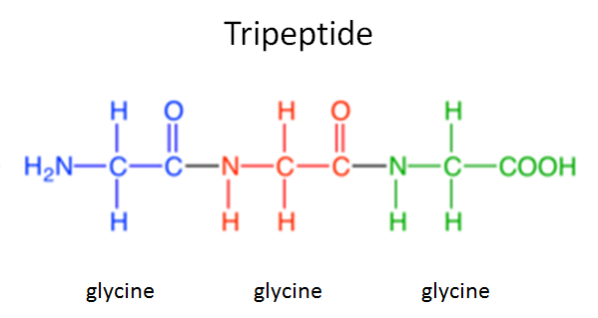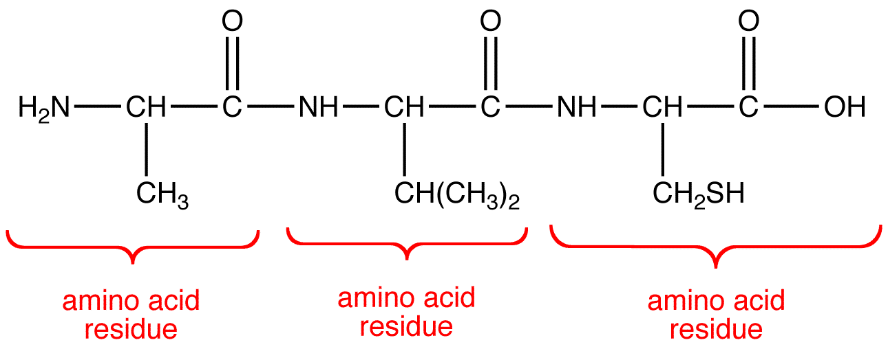
Figure 4.11a: diagram of polypeptide “a” Figure 4.11b: diagram of polypeptide “b”
Two diagrams of polypeptides are shown: one (4.11a) illustrates a chain of amino acids linked together by peptide bonds, and the other (4.11b) shows a similar chain in a slightly different arrangement, highlighting how amino acids connect to form protein structures. A credit line lists sources from Quora and Ochempal.
Credits: figure 4.11a: Quora; https://qph.cf2.quoracdn.net/main-qimg-aa8d4ec5c5e5c108bfec85724cbb89f3. Figure 4.11b by Gamini Gunawardena; http://www.ochempal.org/wp-content/images/O/oligopeptide.png.
Examine the short polypeptide model in the figures above.
- Count and write down the number of amino acids in figures 4.11a and 4.11b.
- Identify peptide bonds, circle these.
- Write the amino acid sequence for figures 4.11a and 4.11b using the abbreviations provided in figure 4.10.
- Label each amino acid as polar, nonpolar, acidic, or basic for both the molecules in 10a and 10b.
- Explain how changing one amino acid could affect protein shape or function.

5.6 Part IV. Nucleic Acids: Nucleotides, DNA, and RNA
Suggested Time: 35–40 minutes NUCLEIC ACIDS Pages 84-87, 260
Nucleic acids store and transmit genetic information. DNA and RNA are polymers made of nucleotide monomers. Each nucleotide contains a phosphate group, a five-carbon sugar, and a nitrogenous base.
DNA contains deoxyribose and the bases adenine, thymine, cytosine, and guanine. RNA contains ribose and the bases of adenine, uracil, cytosine, and guanine. A brief introduction to this topic may be found in “What are Nucleic Acids? Nucleic Acid Structure & Function”.
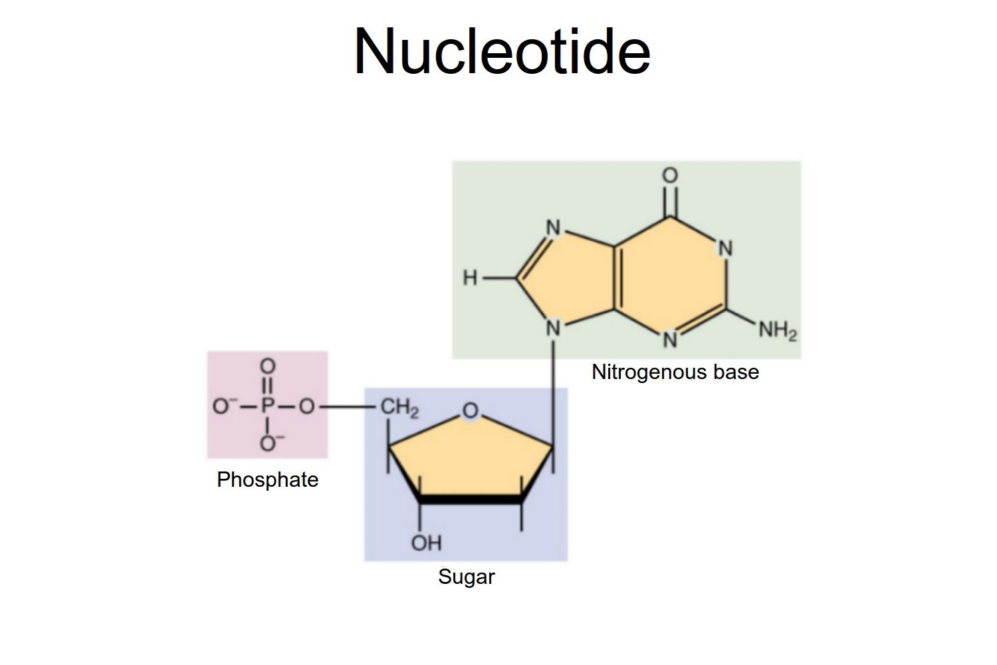
Nucleic Acids - Function, Examples, and Monomers
A diagram showing the structure of nucleotides, each composed of three parts: a phosphate group, a sugar, and a nitrogenous base.
Figure 4.12: Nucleotides (OpenStax/Wikimedia Commons/CC BY-SA 3.0)
A. Nucleotide Structure
Examine a nucleotide model of diagram.
- Identify the phosphate group.
- Identify the sugar.
- Identify the nitrogenous base.
- Explain how nucleotides are linked to a nucleic acid strand.
B. DNA Structure
DNA has a sugar-phosphate backbone and paired nitrogenous bases. The two strands are antiparallel, meaning they run in opposite directions.
Base-pairing rules:
- A pair with T
- C pairs with G
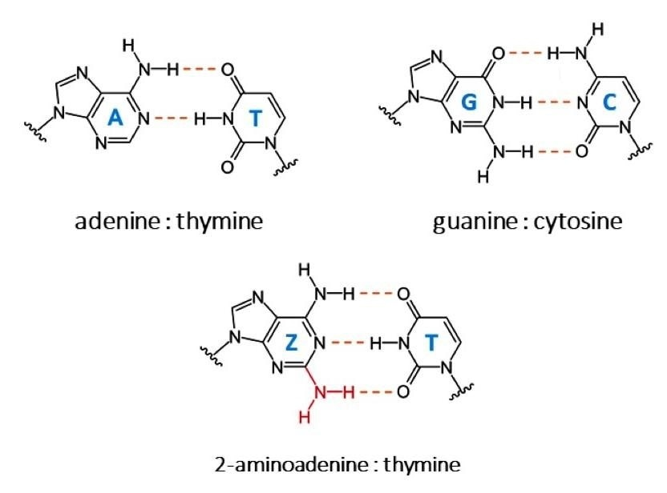
Researchers identify the biosynthesis mechanism of new DNA nucleobases
A diagram illustrating the bonding pattern between a purine and a pyrimidine base, showing how the two nitrogen-containing rings align and form complementary base pairs through hydrogen bonds. From Sleiman, D., et al. (2021) A third purine biosynthetic pathway encoded by amino adenine-based viral DNA genomes. Science. doi.org/10.1126/science.abe6494.
Fig. 4.13: bonding pattern of a puring end pyrimidine.

DNA
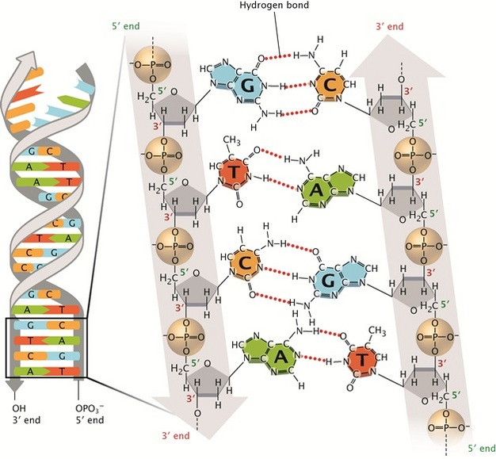
In a schematic illustration, a region of double-stranded, double helical DNA is shown at the left. The two sugar-phosphate backbones are represented as grey ribbons coiled into a double helical shape. Arrows at the end of the grey ribbons show how one strand is oriented in an antiparallel manner relative to the other strand. A cut-away at the bottom of the DNA molecule on the left shows a magnified view of the molecule at the right, with individual atoms, covalent bonds, and hydrogen bonds shown. The magnified region is four base pairs long.
A diagram of a DNA molecule showing the double helix structure with two strands twisted around each other, along with a close-up of a partial chemical strand highlighting the sequence of nucleotides and their bonding. Nature Education 1(1):100
Figure 4.14, a DNA molecule, and a partial DNA chemical strand. Credit: Pray, L. (2008). Discovery of DNA structure and function: Watson and Crick.
Guided Work
- Identify the sugar-phosphate backbone. Circle this.
- Identify paired bases. Draw a box around these.
- Distinguish purines from pyrimidines. Label the purines (Pu) and the pyrimidines (Pyr).
- Explain how pairing a purine with a pyrimidine helps keep the width of DNA consistent.
- Count the hydrogen bonds between A-T and C-G pairs. How many did you find between each pair?
C. RNA Compared with DNA
RNA differs from DNA in three major ways: RNA usually has ribose sugar, contains uracil instead of thymine, and is usually single-stranded.
RNA: Page 271
In figure 4.15, find the RNA nucleotide model labeled Uracil (U). The sugar in RNA is ribose, and the sugar in DNA (fig. 4.13) is deoxyribose.
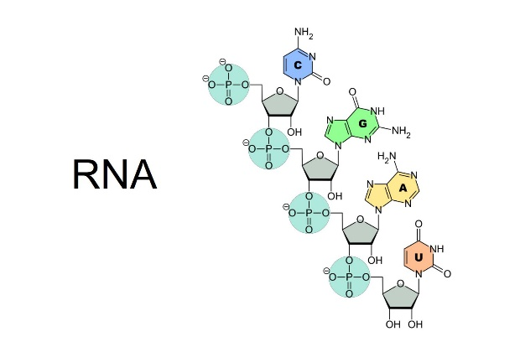
Nucleic Acids - Function, Examples, and Monomers
A diagram of an RNA strand showing a single chain of nucleotides, each made of a sugar, phosphate group, and nitrogenous base, illustrating the linear structure of RNA.
Figure 4.15 RNA strand from Online Education Resources, LLC © 2017; https://www.scienceprofonline.com/images/RNA-Nucleobases.jpg
Complete the comparison table.
Table 4.2. Comparison Table: DNA vs RNA
Feature | DNA | RNA
Sugar
Bases
Usual number of strands
Major function

5.7 Part V. Functional Groups in Biological Molecules
Suggested Time: 25–30 minutes FUNCTIONAL GROUPS: pgs. 62-63
Functional groups are specific groups of atoms that give molecules characteristic chemical properties. They influence polarity, acidity, charge, solubility, and reactivity. For a video on functional groups see the following video: “Functional Groups Explained so AP Bio Students can Understand!”
Complete the table.
Table 4.3. Functional Groups: Structure, Examples, and Biological Importance
Functional Group | General Structure | Example of Molecule/Class Where Found | Biological Importance
Hydroxyl
Carboxyl
Amino
Phosphate
Methyl

5.8 Part VI. Synthesis: Structure Determines Function
Suggested Time: 15–20 minutes
Choose one molecule from each class and explain how its structure supports its function.
Table 4.4. Examples of biological molecules’ features and function(s)
Biological Molecule | Structural Feature |  | Biological Function
Carbohydrate example
Lipid example
Protein example
Nucleic acid example
Final Reflection
In one well-developed paragraph, explain why structure is essential to biological function.

5.9 Post-Lab Questions
Multiple Choice
- Which molecule is a monosaccharide?
A. Glucose
B. Protein
C. Cholesterol
D. DNA
- Which molecule is a structural polysaccharide in plants?
A. Starch
B. Cellulose
C. Glycogen
D. Sucrose
- Which bond joins monosaccharides?
A. Peptide bond
B. Glycosidic linkage
C. Hydrogen bond
D. Ionic bond
- Which molecule is composed of glycerol and three fatty acids?
A. Phospholipid
B. Triglyceride
C. Sterol
D. Nucleotide
- A molecule with both hydrophilic and hydrophobic regions is:
A. Amphipathic
B. Saturated
C. Inorganic
D. Linear only
- Which lipid contains four fused carbon rings?
A. Fatty acid
B. Phospholipid
C. Sterol
D. Triglyceride
- Which part of an amino acid varies among the 20 common amino acids?
A. Amino group
B. Carboxyl group
C. R group
D. Central carbon only
- Which bond joins amino acids?
A. Glycosidic linkage
B. Peptide bond
C. Phosphodiester bond
D. Disulfide only
- Which molecule has deoxyribose?
A. RNA
B. DNA
C. Protein
D. Triglyceride
- In DNA, adenine pairs with:
A. Cytosine
B. Guanine
C. Thymine
D. Uracil
Short Answer
- Explain why glucose is considered a carbohydrate monomer.
- Compare starch and cellulose in structure and function.
- Why are hydroxyl groups hydrophilic?
- Explain the difference between saturated and unsaturated fatty acids
.
- Why are triglycerides useful for long-term energy storage?
- Explain why phospholipids form bilayers in water.
- Why is cholesterol an important molecule in animal cells?
- Describe the general structure of an amino acid.
- Explain how the R group influences amino acid properties.
- Compare DNA and RNA in terms of sugar, bases, strand numbers, and function.

5.10 Student Ancillaries
MolView
MolView is an easy-to-use chemical sketcher and viewer for small molecules. Explore the molecular world and get creative through this intuitive web app!
https://molview.com/.

5.11 Appendix: Molecular Structure of Biological Molecules
Term | Definition
Amino Acid | A molecule containing an amino group, carboxyl group, hydrogen, and variable R group; building blocks of proteins.
Amino Group | A functional group (-NH2) consisting of nitrogen bonded to hydrogen; found in amino acids.
Amphipathic | Having both hydrophilic (water-attracting) and hydrophobic (water-repelling) regions.
Carbohydrate | A biological molecule composed of carbon, hydrogen, and oxygen, used for energy and structure.
Carboxyl Group | A functional group (-COOH) that acts as an acid and is found in many organic molecules.
Disaccharide | A carbohydrate formed by two monosaccharides linked together by a glycosidic bond.
Fatty Acid | A lipid component consisting of a carboxyl group and a long hydrocarbon chain.
Functional Group | A specific group of atoms that gives a molecule its chemical properties.
Glycosidic Linkage | A covalent bond that joins two monosaccharides in a carbohydrate.
Hydrolysis | A chemical reaction that breaks bonds by adding water.
Hydroxyl Group | A functional group (-OH) that is polar and increases solubility in water.
Lipid | A group of hydrophobic biological molecules including fats, phospholipids, and sterols.
Macromolecule | A large biological molecule composed of many smaller subunits.
Monomer | A small molecular subunit that can join with others to form a polymer.
Monosaccharide | A single sugar molecule, such as glucose; the simplest form of carbohydrate.
Nucleic Acid | A macromolecule (DNA or RNA) that stores and transmits genetic information.
Nucleotide | The monomer of nucleic acids, consisting of a phosphate group, sugar, and nitrogenous base.
Peptide Bond | A covalent bond that links amino acids together in proteins.
Phosphate Group | A functional group (PO4) involved in energy transfer and found in nucleotides.
Phospholipid | A lipid with a hydrophilic head and hydrophobic tails that forms cell membranes.
Polymer | A large molecule made of repeating monomer units.
Polysaccharide | A carbohydrate composed of many linked monosaccharides.
Protein | A macromolecule made of amino acid chains that performs various cellular functions.
R Group | The variable side chain of an amino acid that determines its properties.
Saturated Fatty Acid | A fatty acid with no double bonds, resulting in a straight chain.
Sterol | A lipid with a four-ring carbon structure, such as cholesterol.
Triglyceride | A lipid composed of glycerol and three fatty acids, used for energy storage.
Unsaturated Fatty Acid | A fatty acid containing one or more double bonds causing bends in the chain.

6. Molecular Movement in the Cells and Across Cell Membranes

6.1 Pre-Lab Activity 5.1: Questions
Lab Objectives: Cell Membranes, Diffusion, and Osmosis
By the end of this lab, students will be able to:
- Describe the structure and function of the cell membrane.
- Explain the concepts of diffusion and osmosis.
- Distinguish between passive transport and active transport.
- Define hypertonic, hypotonic, and isotonic solutions.
- Predict the movement of water across a selectively permeable membrane.
- Perform an osmosis experiment using dialysis tubing.
- Measure and record changes in mass over time.
- Analyze data to determine the direction of water movement.
- Compare how plant and animal cells respond to different solutions.
- Explain the role of the cell wall in plant cell responses to osmosis.
Prelab Questions (15 total)
Multiple Choice (8)
- The cell membrane is best described as:
A. Completely permeable
B. Selectively permeable
C. Impermeable
D. Rigid
- Diffusion is the movement of molecules:
A. From low to high concentration
B. From high to low concentration
C. Using ATP
D. Against a gradient
- Osmosis specifically refers to the movement of:
A. Solutes
B. Proteins
C. Water
D. Ions
- A solution with higher solute concentration is:
A. Hypotonic
B. Isotonic
C. Hypertonic
D. Neutral
- In a hypotonic solution, a cell will:
A. Shrink
B. Remain unchanged
C. Gain water
D. Lose solutes only
- Which molecules cross membranes most easily?
A. Charged ions
B. Large proteins
C. Nonpolar molecules
D. Sugars
- Energy (ATP) is required for:
A. Diffusion
B. Osmosis
C. Active transport
D. Passive transport
- Equilibrium means:
A. No movement of molecules
B. Equal distribution of molecules
C. Maximum concentration
D. No solute present
Short Answer (7)
- Define diffusion in your own words.
- What is a selectively permeable membrane?
- What is the difference between solute and solvent?
- Predict what happens to a cell in a hypertonic solution.
- Why does water move during osmosis?
- What is Brownian motion?
- Why might plant and animal cells respond differently to osmotic changes?

6.2 Introduction: Molecular Movement in the Cells and Across Cell Membranes
All cells are enclosed by membranes which provide a semi-permeable barrier between the internal contents of the cell and its external environment. Cells must be able to regulate the movement of molecules or ions (i.e., amino acids, sugars, O₂) so that their concentrations do not disrupt cell metabolic processes. In addition to regulating what contents may enter or exit the cell, the cell membrane plays a role in a few other functions, including communication, binding, and adhering to adjacent cells. Properties of the cell membrane can be determined by exposing red blood cells to different solutions (i.e., different “environments”) and observing the appearance of cells under a microscope. The cell may, for example, lyse due to the influx of water. More specifically, we will be looking at how animal cells (red blood cells) and plant cells respond differently to distinct types of solutions.
Diffusion
Molecules can pass a cell membrane using different means of transport. One such means is passive transport; in which case the laws of thermodynamics dictate the flow of molecules. In passive transport, no added energy (ATP) is necessary for the movement of molecules as they move along their concentration gradient, passing from high to low concentration. There are several types of passive transport, including diffusion and osmosis.
Some, but not all, of the traffic across the membranes of cells occurs by diffusion. Diffusion is the movement of molecules from an area of greater to an area of lesser concentration. Molecules are in motion constantly due to their natural movement caused by thermal agitation (Brownian Motion), and they bounce off each other and disperse themselves in an area until equilibrium is reached. Equilibrium means that the molecules have an equal distribution across the medium. Keep in mind that each particle is exhibiting random motion— you cannot predict which way an individual particle will move—but you can predict the net movement of the collection of particles.
As biological membranes are selectively permeable, some substances can freely diffuse through the membrane more easily than others. This is due to the contrasting properties of the phospholipid bilayer that makes up the cell membrane, as it includes both polar and nonpolar regions. Moreover, substances that move through the membrane can do so at different rates. Hydrophobic or non-polar molecules, such as hydrocarbons, oxygen, and carbon dioxide, can dissolve in the membrane and cross it with ease due to the hydrophobic nature of the membrane. Conversely, most hydrophilic molecules, such as ions and polar molecules, cannot pass through the membrane.
Osmosis
Osmosis is a special case of passive transport that deals with the diffusion of water across a selectively permeable membrane. Osmosis depends upon the concentration of solutes in a solution. A solution is made up of a solvent, the substance that does the dissolving, and a solute, the substance that is being dissolved. In the case of osmosis, the solvent is water. A Solute is a substance, such as sugar or salt that is dissolved in the water.
In comparing two solutions of unequal solute concentration, the solution with a greater concentration of solutes is said to be hypertonic. The solution with the lesser solute concentration is hypotonic. These are relative terms that are only meaningful in a comparative sense. For example, tap water is hypertonic to distilled water, but hypotonic to seawater. In other words, tap water has a higher concentration of solutes than distilled water, but a lower concentration than seawater. Solutions of equal solute concentration are said to be isotonic.
If a cell is placed in an environment which is isotonic, an environment of equal solute concentration, then there is no concentration gradient. Without such a gradient, there will be no net flow of water across the membrane.
If a cell is placed in a hypotonic environment, then there is a lower solute concentration surrounding the cell than within the cell. Whenever the solute concentration is lower, the concentration of free water molecules is higher. Therefore, water will diffuse alongdown its concentration gradient from an area of higher concentration (outside the cell) to an area of lower concentration (inside the cell). The added pressure that develops because osmosis is occurring is called hydrostatic (or turgor) pressure. This pressure may increase the point of opposing the entry of more water by osmosis (in which case it is equal to osmotic pressure), or this pressure may cause the membrane to rupture before such a point is reached.
Conversely, a cell placed in a hypertonic environment is surrounded by solution which is higher in solutes, hence lower in free water molecules. In this case, the free water concentration is greater inside the cell than outside, so the water flows out of the cell.
Plant and animal cells will respond differently in hypertonic, hypotonic, and isotonic solutions. This is primarily due to the presence of a cell wall in plant cells, which is absent from animal cells. For example, an animal cell (such as a red blood cell) will lyse (burst open) in a hypotonic solution due to the movement of water molecules into the cell. A plant cell placed into a hypotonic solution is considered turgid, however, and will not lyse due to the presence of the cell wall.

6.3 Procedure
- Simple Diffusion in Agar
Agar is a semi-solid substance made of long chains of molecules arranged in a random pattern. Because of this structure, it has many small pores and fewer large ones. Smaller molecules can diffuse through agar more easily because they can pass through these pores, while larger molecules move more slowly and may become trapped. In this experiment, you will compare how different substances diffuse through agar.
- Materials: Obtain the following:
  - 2 agar plates
  - Ruler
    - Only a small portion is used to cut your holes in the agar so you may have to cut a whole straw in half
  - Drinking straw
  - Stains: three of the following
  - Methylene Blue
  - Neutral Red
  - Crystal Violet
  - Methyl Green
Procedure
- Turn the petri dish upside down. Using the marker, place dots on the bottom of the plate as shown in Figure x.x.
- Use a ruler to space the dots 1.5 cm apart
- Label one dot “B” (BaCl₂)
- Label the other “K” (K₂SO₄)
- Carefully open the petri dish and create small wells (holes) in the agar at each marked location:
- Use a straw, tube, or pipette tip to gently punch into the agar and twist the straw to cut the agar.
- Pinch the far end of the straw to apply slight suction (if possible) to remove the agar plug
- Make sure the wells are clean and properly formed
- Using a fine tip pipette, carefully add:
  - 10% BaCl₂ solution to the “B” well
  - 10% K₂SO₄ solution to the “K” well
Important: Do not overfill the wells.

- When the two substances diffuse toward each other, they will react to form:
  - BaSO₄ (a white precipitate)
  - KCl (is still in solution)
The white precipitate will appear as a fuzzy line between the wells.
- Measure the distance from each well to the white line (see Figure 6.1).
- Record your measurements in Table 6.1.
1.5 cm
K
B
Figure 6.1. Agar petri plate with holes cut for BaCl₂ and K₂SO₄ solutions
Table 6.1. Distance from the Edge of the Cell to the Precipitate for Barium Chloride and Sodium Sulfate.
Chemical | Distance from Edge of Well to Precipitate (in cm)
10% BaCl₂
10% K₂S04
- Interpretation
Based on your measurements:
Determine which ion traveled farther. Use this information to infer which ion is larger.
- Note: The reaction may take an hour or more, so be patient.
B Osmosis across non-living membranes (see Figure 6.2)
1. Obtain the following:
a. (6) 250-ml beakers. Label the beakers 1-6 with a wax pencil.
b. (3) 10-ml graduated cylinders.
Label the cylinders; DiWater, 20% and 40% with a wax pencil.
c. (6) ~8-cm lengths of string.
d. (6) 18-cm lengths of dialysis tubing.
**NOTE: Place cut tubing in a 250 ml beaker full of water. Do not remove the tubing from the water until you are ready to fill the tubes.
Table 6.2: Dialysis Tubing
Tube # | 10 ml of: | Lay filled tube in beaker numbers
1 & 6 | Deionized Water | 1 & 6
2 & 5 | 20% Sucrose | 2 & 5
3 & 4 | 40% Sucrose | 3 & 4
2. Fill the dialysis tubing with the solutions listed in Table 6.2 in the following way:
- Rub one end of the dialysis tubing strip between your fingers under the water until the tube opens
- Tie a knot in one end of the tube
- Measure 10 ml of liquid into the graduated cylinder
- Fill the dialysis tube.
- Gently press together at the tube's open end. Press out the air. Twist the tubing and tie it with string.
- Rinse each tube gently with tap water to remove any spilled sucrose.
- Gently blot the outside of the tube dry.
- Weigh the tube (to the nearest 0.1 gram) and record its initial mass (time 0) in Table 4.3
- Place the tube into the proper beaker.
***NOTE: Pour all liquids (water and sucrose) into the beakers at the same time!
- Fill the beakers as follows and make sure the dialysis tubing is submerged.
Table 6.3. List of Beakers with their Solutions
Beakers# | ~125-150 ml of the following:
1 | Deionized Water
2 | Deionized Water
3 | Deionized Water
4 | 20% Sucrose
5 | 40% Sucrose
6 | 40% Sucrose
- Immediately start timing for a precise 10-minute interval.
- Place a paper towel in front of each beaker and work on parts 12-16.
- After the 10-minute interval, remove all dialysis tubes from the beakers & place them on the corresponding paper towels.
- Gently blot the tubes dry, weigh them (to the nearest 0.1 g), and record their weights in data table 6.4.
- Return each tube to its corresponding paper towel.
- After all the tubes have been weighed, return each tube to its corresponding beaker, and immediately start timing for another 10-minute interval.
- Repeat for 10 more minutes, ending at 40 minutes.
- Take the tubes and beakers to the sink. Use scissors to puncture each tube and allow the fluid to drain. Place the more-or-less empty tubes in the trash can. Pour the fluid from the beakers into the sinks and rinse the beakers. Return the rinsed beakers to the proper location.
- By subtracting, find the initial differences between the sucrose concentration in the fluid in the bags and the sucrose concentration gradients. Write the concentration gradients in Figure 6.2.
- In Figure 6.2, draw an arrow indicating which way water will flow (into or out of the dialysis tube).
Beaker #1 Beaker #2 Beaker #3
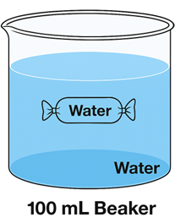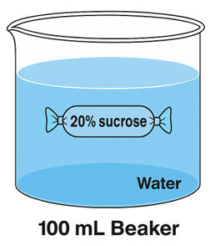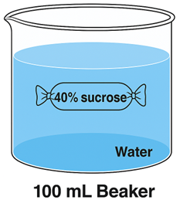
Tonicity: __________ Tonicity: __________ Tonicity: __________
Beaker #4 Beaker #5 Beaker #6
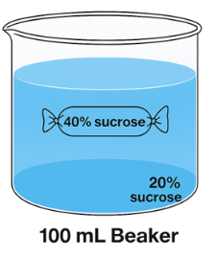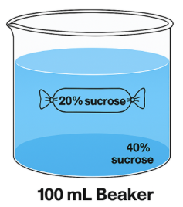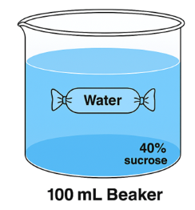
Tonicity: __________ Tonicity: __________ Tonicity: __________
Figure 6.2. Illustration of the Contents of Beakers and Dialysis Tubes (All tubes hold 10 ml of the specified solution as per Table 6.2).
14. Label the solution in the beakers above as hypertonic, hypotonic, or isotonic.
15. Which bag/ & beaker combinations have no concentration gradient? Label the 16. In which bag/beaker combination (or combinations) is the initial concentration gradient the greatest? What is the gradient?
17. In which bag/beaker combination (or combinations) is the initial concentration gradient the least without being equal? What is the gradient?
18. Record your data into Table 6.4
Table 6.4: Weights of Dialysis Tubes to the Nearest 0.1 g
Time | TUBE 1 | TUBE 2 | TUBE 3 | TUBE 4 | TUBE 5 | TUBE 6
0 MIN
10 MIN
20 MIN
30 MIN
40 MIN
18. Transfer the data from Table 6.4 onto Graph 6.3. Be sure to add an appropriate title to the graph and clearly label both axes.

Figure 6.3
C. Osmosis across the membranes of Elodea cells
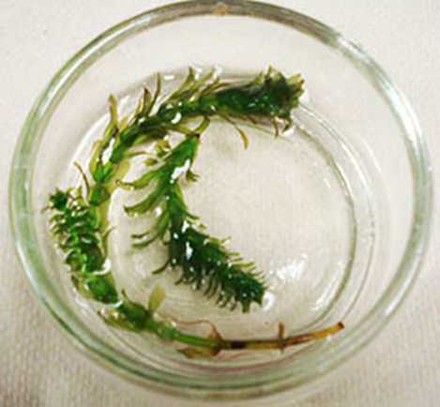
A small green aquatic plant (Elodea) submerged in clear water inside a shallow, transparent petri dish. The Elodea has thin stems with clusters of bright green leaves arranged along the length of each stem. The petri dish sits on a flat surface, and the water allows the delicate structure of the plant to be clearly visible.
Figure 6.4. Elodea in a petri dish.
- Put a drop of water on a clean slide. Add a single, young leaf from the tip of an Elodea plant. Cover the slide. Examine the slide microscopically. First, find the leaf under the shortest objective. Look at the center of the leaf and switch to the 10X objective.
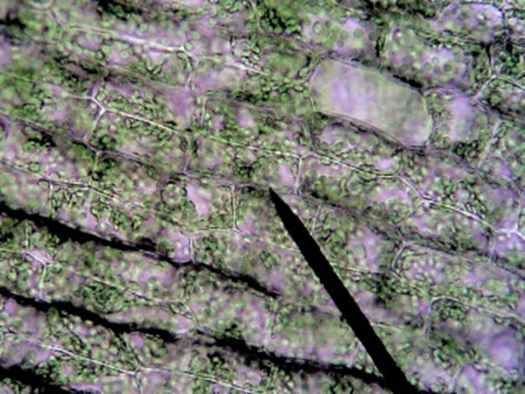
Microscopic view of Elodea at 10× magnification, showing green plant cells arranged in rectangular patterns along the leaf. The cells appear tightly packed, with visible cell walls and numerous small green chloroplasts distributed throughout each cell.
Figure 6.5: Elodea at 10x magnification
- Finally, switch the objectives to 40X. Try to find a cell where the chloroplasts move in a circle. The streaming motion of the cytoplasm carries the chloroplasts around a large, central vacuole. This vacuole is filled with water.
  - Draw a cell in the space below and label the plasma membrane and chloroplasts.
    - When a cell is exposed to an environment that has a greater concentration of solute than is in the cell, the cell loses water by osmosis. Place a drop of 10% NaCl solution just touching one side of the cover glass. Use a small piece of paper towel or lens paper to draw the original water out from the opposite side of the cover glass. This procedure will draw the salt solution under the cover glass and surround the leaf with salt water. Repeat the addition of a drop of NaCl and the removal of water from under the cover glass. Again, examine the cells of the Elodea leaf.
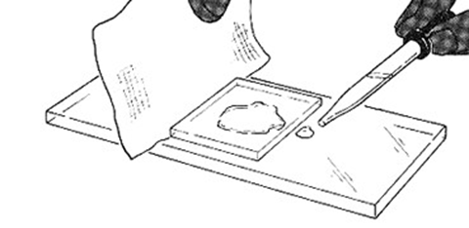
A figure showing how to expose Elodea leaf cells to a hypertonic solution: a drop of sodium chloride (NaCl) solution is placed at one edge of a microscope cover glass, while a paper towel draws out water from the opposite edge, pulling the salt solution underneath the cover glass and around the leaf. This process is repeated to fully bathe the cells in salt solution, causing them to lose water by osmosis before being viewed again under the microscope.
Figure 6.6. Illustration showing how to replace the water in a wet mount with a hypertonic solution. Image courtesy of Biologycorner.com, CC BY-NC-SA.
- Redraw the cell after NaCl has been added. Label the plasma membrane and chloroplasts.
- Can you see a space between the chloroplasts and the cell wall?
- What fills this space?
- Before you added the 10% NaCl solution, which would the central vacuole have, a solution with a greater total solute concentration than 10% NaCl or a solution with a lower total solute concentration than 10% NaCl?
- After adding 10% NaCl, what has happened to the volume of the cytoplasm and its central vacuole?
- What happens to the total solute concentration of the vacuole when 10% NaCl is added?
- Expose the leaf to a drop of distilled or deionized water (DiH₂O) by adding a drop of this water next to the cover glass and drawing the water out the opposite side of the cover glass. Repeat this procedure twice to replace all salt water with pure water. Observe the cells. Have the cells regained their original appearance?
  - Redraw the cell after NaCl has been added. Label the plasma membrane and chloroplasts.
  - Did the spaces between the chloroplasts and cell walls disappear?
As water flows into a plant cell, the cell wall stops the swelling , but an increased pressure develops. This pressure is referred to as turgor pressure.
D. Osmosis in bovine red blood cells (Optional)
- Prepare working solutions for the experiment. Note that this may already be done for you, in which case you can skip this step.
  - For the 0.15 M NaCl solution, take 7.5ml of the 0.3M stock solution and add 7.5ml of DiH₂O. This will make 15ml of 0.15M NaCl.
  - For the 0.07M NaCl solution, take 3.5ml of the 0.3M stock solution and add to
11.5ml of DiH₂O. This will make 15ml of 0.07M NaCl.
- You will also be using an undiluted 0.3M NaCl stock solution.
- Take a glass slide and label it 0.15 M.
- Using a transfer pipette, add 2 drops of the 0.15M NaCl solution (from Step 1) to the slide.
- Using a micropipette with a clean tip, add 5µl of bovine blood to the NaCl solution. Use the tip of the pipette to mix the blood and saline.
- Add a cover slip.
- View the red blood cells at 400x Total Magnification. Make note/ sketch their appearance in table 6.4 below. Measure 3 red blood cells and record their width in ocular units (ou) in table 6.5 below.
- Repeat steps 2-6 using a clean slide and 0.3M NaCl solution.
- Repeat steps 2-6 using a clean slide and 0.07M NaCl solution.
Table 6.5. Red Blood Cell Sketches and Observations
Sketch/ Observations | 0.3 M NaCl | 0.15M NaCl | 0.08M NaCl
Initial
5-minutes
Observations
Table 6.6. Red Blood Cell Measurements (Size in ocular units (ou))
Sketch/ Observations | 0.3 M NaCl | 0.15M NaCl | 0.08M NaCl
Initial | Cell 1:  Cell 2:  Cell 3:  Average: | Cell 1:  Cell 2:  Cell 3:  Average: | Cell 1:  Cell 2:  Cell 3:  Average:
5-minutes | Cell 1:  Cell 2:  Cell 3:  Average: | Cell 1:  Cell 2:  Cell 3:  Average: | Cell 1:  Cell 2:  Cell 3:  Average:
To calculate the size at each period, take the average of the 3 cells measured.
Observations:
- Based on the results from the plant cell and red blood cell experiments, how do these two distinct types of cells respond to different saline environments?
- Why do the differences you described above occur?
Terms: Parts of the Cell
- Cell membrane
- Cytoplasm (cytosol)
- Chromatin
- Chromosomes
- Nucleus
- Nuclear envelope
- Nucleolus
- Cytoskeleton
- Lysosome
- Centrioles
- Flagellum
- Microvilli
- Cilia
- Golgi apparatus
- Rough endoplasmic reticulum
- Smooth endoplasmic reticulum
- Ribosome
- Mitochondria
- Peroxisome
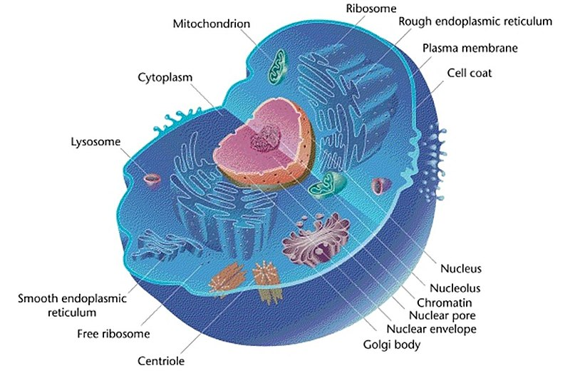
File:Eukaryotic Cell (animal).jpg
Figure 3.3 A Typical Animal Cell with Labeled Organelles.
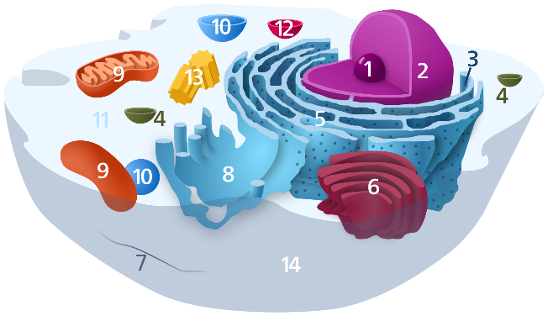
Figure 3.4 Diagram of the Cell.
Organelles in the cell above are labelled as follows:
- Nucleolus
- Nucleus
- Ribosome (dots as part of 5)
- Vesicle
- Rough endoplasmic reticulum
- Golgi apparatus (or Golgi body)
- Cytoskeleton
- Smooth endoplasmic reticulum
- Mitochondrion
- Vacuole
- Cytosol (fluid that contains organelles; with which, comprises cytoplasm)
- Lysosome
- Centrosome
- Cell membrane
Membrane Structure
Review the material related to the composition of a cell membrane. You should be able to answer the following questions.
- What are the primary macromolecules that make up the membrane?
- What are the functions of the following components:
  - Phospholipids
  - Cholesterol
  - Proteins
Lab Activity 3.1 continued
- Obtain tape and one of the models of the cell.
- Identify and label the cell organelles on the model.
- Complete the table below (Table 4.6)
- Once you are done, have another group to check your accuracy. Make corrections if needed.
- Then, have your Lab Instructor check your accuracy.
Identify the following structures and their function in the model below:
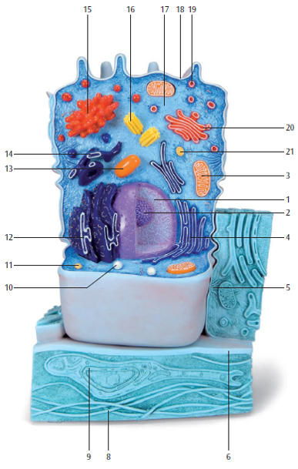
Classroom model of an animal cell.
Figure 3.6 Classroom Model of an Animal Cell: 3B Scientific
1
13
12
11
10
7
8
6
5
4
3
2
9
Figure 3.7 Classroom Model of a Plant Cell: 3B Scientific
Lab Activity 3.2
Using the information in table 3.2 review the cells structures and function(s) then complete the table below.
Table 4.6 Identify the Organelles and their Function.
Structure | Model Number |  | Organelle function
 | Animal | Plant
Plasma membrane
Cilia
Microvilli
Nucleolus
Nucleus
Nuclear envelope
Nuclear pore
Ribosome
Vesicle
Peroxisome
Lysosome
Golgi apparatus
Mitochondrion
Rough Endoplasmic Reticulum
Smooth Endoplasmic Reticulum
Centriole
Vacuole

6.4 Post-Lab Activities
Post Lab Questions (15 total)
Multiple Choice (8)
- If a dialysis tube gains mass, water movement was:
A. Out of the tube
B. Into the tube
C. Equal
D. Random
- A tube with 40% sucrose in water becomes lighter. The solution outside is:
A. Hypotonic
B. Hypertonic
C. Isotonic
D. Neutral
- The greatest mass change occurs when:
A. Solutions are equal
B. Gradient is largest
C. No solute is present
D. Time is short
- In plant cells, turgor pressure results from:
A. Water leaving the cell
B. Water entering the cell
C. Protein breakdown
D. Ion transport
- Red blood cells in hypotonic solution will:
A. Shrink
B. Burst (lyse)
C. Stay unchanged
D. Harden
- Plasmolysis occurs when a plant cell:
A. Gains water
B. Loses water
C. Divides
D. Expands
- Dialysis tubing models:
A. Nucleus
B. Cell membrane
C. Cytoplasm
D. Cell wall
- If no mass change occurs, the solutions are:
A. Hypertonic
B. Hypotonic
C. Isotonic
D. Active
Short Answer (7)
- Explain how concentration gradients affect your dialysis results.
- Describe how mass changed in one experimental setup and why.
- Why did some tubes show greater mass change than others?
- Explain the role of the cell wall in preventing plant cells from bursting.
- Identify a possible experimental error and how it would affect results.
- Using your data, explain how osmosis helps maintain homeostasis in cells.

6.5 Appendix: Key Terms and Definitions for the Osmosis and the Cell Lab
Term | Definition
Active Transport | The movement of substances across a cell membrane against their concentration gradient, requiring energy (ATP).
ATP (Adenosine Triphosphate) | The primary energy-carrying molecule used by cells to power processes such as active transport.
Brownian Motion | The random movement of particles in a fluid is caused by collisions with other fast-moving molecules.
Cell Membrane | A selectively permeable barrier composed of a phospholipid bilayer that regulates what enters and exits the cell.
Cell Wall | A rigid outer layer found in plant cells that provides structure and prevents over-expansion during water uptake.
Centrioles | Cylindrical structures involved in organizing microtubules and assisting in cell division in animal cells.
Chromatin | A complex of DNA and proteins (histones) that form chromosomes and help regulate gene expression.
Chromosomes | Threadlike structures made of DNA that carry genetic information, especially visible during cell division.
Cilia | Short, hair-like structures that move fluid or substances across the cell surface.
Concentration Gradient | The difference in the concentration of a substance between two areas.
Cytoplasm (cytosol) | The gel-like substance inside the cell where organelles are suspended and many metabolic reactions occur.
Cytoskeleton | A network of protein filaments that provides structural support, shape, and movement for the cell.
Dialysis Tubing | A semi-permeable membrane used in experiments to model how substances move across cell membranes.
Diffusion | The passive movement of molecules from an area of higher concentration to an area of lower concentration.
Equilibrium | A state in which molecules are evenly distributed, resulting in no net movement.
Flagellum | A long, whip-like structure that enables cell movement (e.g., sperm cell motility).
Golgi apparatus | An organelle that modifies, sorts, and packages proteins and lipids for transport.
Hypertonic Solution | A solution with a higher solute concentration than the cell, causing water to move out of the cell.
Hypotonic Solution | A solution with a lower solute concentration than the cell, causing water to move into the cell.
Isotonic Solution | A solution with equal solute concentration inside and outside the cell, resulting in no net water movement.
Lysosome | A membrane-bound organelle containing digestive enzymes that break down waste materials and cellular debris.
Mass Change | A measurable increase or decrease in mass used to determine water movement during osmosis experiments.
Microvilli | Small, finger-like projections that increase surface area for absorption, commonly found in intestinal cells.
Mitochondria | Organelles that generate energy (ATP) through cellular respiration; often called the cell’s 'powerhouse.'
Nucleus | A membrane-bound organelle that contains the cell’s DNA and controls cellular activities.
Nuclear envelope | A double membrane that surrounds the nucleus, containing pores that regulate material exchange.
Nucleolus | A dense region within the nucleus where ribosomal RNA (rRNA) is produced, and ribosome assembly begins.
Osmosis | The passive movement of water across a selectively permeable membrane from an area of lower solute concentration to higher solute concentration.
Passive Transport | The movement of substances across a membrane without the use of cellular energy, following the concentration gradient.
Peroxisome | An organelle containing enzymes that break down fatty acids and detoxify harmful substances using oxygen.
Phospholipid Bilayer | The double layer of phospholipids that forms the basic structure of the cell membrane, with hydrophilic heads and hydrophobic tails.
Red Blood Cells | Animal cells are often used in experiments to observe membrane behavior in different solutions.
Ribosome | A small organelle responsible for protein synthesis, found free in the cytosol or attached to rough ER.
Rough endoplasmic reticulum | A membrane network studded with ribosomes involved in protein synthesis and folding.
Selective Permeability | The property of a membrane that allows some substances to pass while restricting others.
Smooth endoplasmic reticulum | A membrane network without ribosomes involved in lipid synthesis and detoxification.
Solute | A substance that is dissolved in a solution.
Solvent | The substance (often water) that dissolves the solute to form a solution.
Transport Mechanism | Any process that allows substances to move across the cell membrane (e.g., diffusion, osmosis, active transport).
Turgor Pressure | The pressure exerted by water inside a plant cell against the cell wall, helping maintain structure.

7. Enzyme Activity: Turnip Peroxidase

7.1 Objectives
At the completion of this lab, students will be able to:
- Define the term enzyme and identify the class of macromolecules to which enzymes belong.
- Identify the substrate and products of the peroxidase-catalyzed reaction.
- Explain the role of guaiacol in this reaction.
- Use a colorimeter to detect product formation during an enzyme-mediated reaction.
- Determine the effects of the following conditions on the rate of an enzyme-catalyzed reaction:
  - Substrate concentration
  - Enzyme concentration
  - Temperature
  - PH
  - The inhibitor hydroxylamine
- Use Excel, or a suitable software program, to plot the following:
  - Raw data versus time
  - Reaction rate versus treatment (substrate concentration, enzyme concentration, temperature, pH, and presence of inhibitors)

7.2 Pre-Lab Activities
Reminder: Please complete your pre-lab assignment before coming to the lab. This work is intended to help you understand the experiment and be prepared to participate fully.
Your instructor may collect and grade the pre-lab at the beginning of the lab session, so be sure to have it finished and ready to submit the material.
Pre-Lab Activity 5.1: DefineTerms
- Enzyme
- Catalyst
- Substrate
- Active site
- Enzyme specificity
- Product
- Enzyme-catalyzed reaction
- Activation energy
- Peroxidase
- Hydrogen peroxide (H₂O₂)
- Guaiacol
- Tetraguaiacol
- Oxidation
- Reduction
- Reducing agent
- Oxidizing agent
- Absorbance
- Transmittance
- Colorimeter
- Wavelength (nm)
- Reaction rate
- Inhibitor
- Denaturation
- pH
- Temperature (effects on enzymes)
Pre-Lab Activity 5.2: Multiple Choice Questions
- Enzymes function primarily to:
A. Increase the temperature of reactions
B. Speed up chemical reactions
C. Provide energy for reactions
D. Change the final products
- Enzymes are classified as:
A. Lipids
B. Carbohydrates
C. Proteins
D. Nucleic acids
- The molecule an enzyme acts upon is called the:
A. Product
B. Substrate
C. Catalyst
D. Inhibitor
- In this experiment, guaiacol is used because it:
A. Slows the reaction
B. Produces a visible color change
C. Breaks down enzymes
D. Neutralizes pH
- As tetraguaiacol forms, the solution becomes:
A. Clear
B. Blue
C. Brown/orange
D. Green
- A colorimeter measures:
A. Temperature
B. Mass
C. Light absorption/transmission
D. pH
- Increasing enzyme concentration will generally:
A. Decrease reaction rate
B. Increase reaction rate
C. Have no effect
D. Stop the reaction
Pre-Lab Activity 5.3: Short Answer Questions
- Explain why enzymes are important for living organisms.
- What role does guaiacol play in the peroxidase reaction?
- Why is hydrogen peroxide necessary for this reaction?
- How does a colorimeter indirectly measure product formation?
- Predict what might happen to enzyme activity at extremely elevated temperatures.
- When calibrating and testing a sample, why should you wipe off the cuvette?
- What is the catalyst in this series of experiments?
- At what temperature do enzymes normally work in the body of a warm-blooded organism? Would your answer differ if the enzyme came from a plant or yeast? Give a specific example of your answer.
- From the literature, what temperatures and pH values are reported to be optimum for turnip peroxidase?
- Based on information you’ve gleaned from your text, the internet (e.g., the Khan Academy) or your classes, construct a set of separate hypotheses for each of the five experiments (enzyme concentration, substrate concentration, temperature effects, pH effects and inhibitor effects) that will describe how, and why, the different treatments will affect the rates of reaction of absorbance.
Hypothesis/Prediction Construction – Remember that this is set this up as an - if…. then… statement. For example: If heat is applied to particles in a balloon, then because of the heated air, it is based on an increase in the gas pressure as predicted by the gas laws. This example is meant to be very general; your job is to use your answer to question # 1 and make it into a more specific if-then statement based on your understanding prior to conduction the experiment

7.3 Introduction
As you have learned in the lecture part of this course, enzymes are protein molecules that catalyze various reactions in living organisms. They allow organisms to carry out complex chemical activities at relatively low temperatures and are highly specific for one or a group of related reactions. Enzymes bring substrates together in a manner that increases the likelihood that a reaction will occur. One of the unique features of enzyme-catalyzed reactions is that enzymes are not consumed during the process. That is, enzymes stay unchanged during the reaction and can be reused repeatedly.
Many factors can affect enzyme activity, and in this laboratory, we will study the effects of substrate concentration, enzyme concentration, temperature, pH, and inhibitors on enzyme activity (Pitkin, 1992).
In this series of experiments, you will use enzyme peroxidase isolated from turnips. Peroxidases catalyze the decomposition of hydrogen peroxide. In reactions catalyzed by peroxidase, reducing agents, such as guaiacol, donate electrons and hydrogen atoms, while hydrogen peroxide acts as the oxidizing agent. These reactions result in the formation of water and an oxidized organic compound, tetraguaiacol, as shown in the equation below:
4 H₂O₂ + 4 guaiacol → tetraguaiacol + 4 H₂O
Guaiacol acts as the hydrogen donor (i.e., it is the reducing agent). When guaiacol is oxidized, it changes from a colorless liquid to a dark orange-brown compound (tetraguaiacol). In this experiment, blue light (470 nm) will be passed through the solution, and a colorimeter will measure the amount of light transmitted. This measurement is based on the absorption of blue light by the brown-colored solution (Enzyme Activity Guided Inquiry Lab: Turnip Peroxidase, 2018).

7.4 Materials
- Gloves
- Goggles
- Bottle of distilled water
- Bottle of turnip extract
- Bottle of substrate mix
- Colorimeter/Spectrometer cuvettes
- Micropipette (100-1000µl)
- Box of tissue wipes.
- Cup for waste pipettes
- Cup for waste liquids.
- Pipettes: 1, 5, and/or 10ml
- Pipetters
  - Green: the 5 & 10 ml pipettes
  - Blue: the 1 ml pipettes

7.5 Methods
Lab Activity 5.1: Practice experiments
- Obtain and wear gloves and goggles
- Practice run #1: 5-minute data collection
  - Set the collection time. To set the collection time, you need to find the sampling time button, which looks like a clock on the upper right-hand side of the top bar. When you activate this program, you should set the collection duration for 300 seconds (5 min.) and collect each sample every 30 seconds (30 seconds/sample)
  - Add the following to the cuvette.
    - 2.2 ml of distilled water
    - 400 µl of turnip extract
  - Calibrate the sensor
    - Press the (<or>) button to select the 470 nm wavelength. You will not have to do this during the other runs.
    - Close the colorimeter lid. Press and hold the CAL button until the red light begins to flash.
      - The absorbance should read 0.001 or less. If the display is set for transmittance, then the reading should be approximately 100%.
      - When the light stops flashing, the system is calibrated.
  - Test the sample
    - Open the lid and add 400 µl of the substrate mix to the cuvette.
    - Close the lid at once and hit the collect button (The green button at the right of the top bar)
    - Record the data from your 5-minute experiment in table 5.6 of the Results Section.
- Practice run #2: 1 minute data collection
  - Set the collection time. To set the collection time, you need to find the sampling time button that looks like a clock on the upper right-hand side of the top bar. When you activate this program, you should set the collection duration for 60 seconds (1 min.) and collect each sample every 10 seconds (10 seconds/sample)
    - Add the following to the cuvette.
      - 2.2 ml of distilled water
      - 400 µl of turnip extract
  - Calibrate the sensor
    - Close the colorimeter lid. Press and hold the CAL button until the red light begins to flash.
      - The absorbance should read 0.001 or less.
      - When the light stops flashing, the system is calibrated.
    - Open the lid and add 400 µl of the substrate mix to the cuvette.
    - Close the lid immediately and hit the collect button (The green button at the right of the top bar)
    - Record the data from your 1-minute experiment in table 5.7 of the Results section below.

Lab Activity 5.2: Experimental data collections
- Enzyme concentration
Table 5.1: Enzyme Experimental Setup
Concentration | Distilled Water (ml) | Turnip Extract (µl) | Substrate Mix (µl) | Total  (ml)
0.5 x | 2.4 | 200 | 400 | 3.0
1.0 x | 2.2 | 400 | 400 | 3.0
2.0 x | 1.8 | 800 | 400 | 3.0
- From now on, you do not have to reset the time.
- Add the proper amount of distilled water and Turnip extract as is shown in the table above.
- Calibrate the spectrophotometer using the methods outlined previously
- Add the proper amount of substrate for the run you need to run.
- Close the lid immediately and hit the collect button (The green button at the right of the top bar)
- Record the data from your enzyme concentration experiment in table 3 of the Results section.
- Substrate Concentration
Table 5.2: Substrate Experimental Setup
Concentration | Distilled Water (ml) | Turnip Extract (µl) | Substrate Mix (µl) | Total  (ml)
0.5 x | 2.4 | 400 |  | 3.0
1.0 x | 2.2 | 400 |  | 3.0
2.0 x | 1.8 | 400 |  | 3.0
- Complete the chart above
- Setup each cuvette using the amounts shown in the chart above
- Close the lid immediately and hit the collect button (The green button at the right of the top bar)
- Record the data from your substrate concentration experiment in table 4 of the Results section.
- pH effects
Table 5.3: pH Experimental Setup
pH | Distilled Water (ml) | Turnip Extract (µl) | Buffered Water Substrate Mix (µl) | Total  (ml)
All pH solutions | 2.2 | 400 | 400 | 3.0
- Complete the chart above
- Setup each cuvette using the amounts showed in the chart above
- Close the lid immediately and hit the collect button (The green button at the right of the top bar)
- Record the data from your pH experiment in table 5 of the Results section.
- Temperature effects
Table 5.4: Temperature Effects Experimental Setup
Temperature description | Actual Water Temperature | Distilled Water (ml) | Turnip Extract (µl) | Buffered Substrate Mix (µl) | Total  (ml)
Ice water | ____ ºC | 2.2 | 400 | 400 | 3.0
Room Temperature | ____ ºC | 2.2 | 400 | 400 | 3.0
Body Temperature | ____ ºC | 2.2 | 400 | 400 | 3.0
Boiling water | ____ ºC | 2.2 | 400 | 400 | 3.0
- Complete the chart above
- Setup each cuvette using the amounts indicated in the chart above
- Close the lid immediately and hit the collect button (The green button at the right of the top bar)
- Record the data from your temperature effects experiment in table 6 of the Results section.
- Inhibitor
Table 5.5: Inhibitor Experimental Setup
Experiment | Distilled Water (ml) | Turnip Extract (µl) | substrate mix (µl) | Inhibitor (µl) | Total (ml)
Inhibitor | 1.8 | 400 | 400 | 400 | 3.0
No inhibitor | 2.2 | 400 | 400 | 0 | 3.0
- Setup each cuvette using the amounts indicated in the chart above
- Close the lid immediately and hit the collect button (The green button at the right of the top bar)
- Record the data from your inhibitor experiment in table 7 of the Results section.

7.6 Results
- Experimental data
Table 5.6.: Five-minute Practice Run
Time (in seconds) | Absorbance
0
30
60
90
120
180
210
240
270
300
Table 5.7: One-minute Practice Run
Time (in seconds) | Absorbance
0
10
20
30
40
50
60
Table 5.8: Enzyme Concentration Experimental Data
Enzyme Concentration
Time (in seconds) | 0.5 x | 1.0x | 2.0x
0
10
20
30
40
50
60
Table 5.9: Substrate Concentration Experimental Data
Substrate Concentration
Time (in seconds) | 0.5 x | 1.0x | 2.0x
0
10
20
30
40
50
60
Table 5.10: pH Experimental Data
Time (in seconds) | pH 2 | pH 5 | pH 7 | pH 8 | pH 10
0
10
20
30
40
50
60
Table 5.11: Temperature Effects Data
Time (in seconds) | Ice water  ________ ºC | Room Temp.  ________ ºC | Body Temp.  ________ ºC | Hot/Boiling Temp.  ________ ºC
0
10
20
30
40
50
60
Table 5.12: Inhibitor Experiment Data
Time (in seconds) | No Inhibitor | Inhibitor
0
10
20
30
40
50
60
Lab Activity 5.3: Data analysis
Create a set of graphs using the data generated from these experiments. The first set of graphs requires that you plot the absorbance data over time. The trend-line of this graph will enable you to determine the rate of reaction (slope) of the absorbance data.
The second plot requires you to plot the rate of reaction (slope) of the absorbance versus the treatment. Instructions to calculate and plot the data to complete each of the graphs described above are in the Appendix.
Reaction rate data
*Student Note: Graphs “a” through “d” should be created as scatterplots with the data points connected.
- Enzyme concentration experiment
Table 5.13: Enzyme Treatment vs. Enzyme Reaction Rate Data
Enzyme concentration | Reaction Rate
0.5 x
1.0 x
2.0 x
Describe the relationship between the enzyme concentration vs. the reaction rate trend that you plotted in your graphs.
- Substrate concentration experiment
Table 5.14: Substrate Treatment vs. Enzyme Reaction Rate Data
Substrate concentration | Reaction Rate
0.5x
1.0x
2.0x
Describe the relationship between the substrate concentration vs. the reaction rate trend that you plotted in your graphs.
- Effects of pH experiment
Table 5.15: pH Treatment vs. Enzyme Reaction Rate Data
pH | Reaction Rate
2
5
7
8
10
Describe the relationship between the pH vs. the reaction rate trend that you plotted in your graphs.
- Effects of temperature experiment
Table 5.16: Temperature Treatment vs. Enzyme Reaction Rate Data
Water Temperature ^{O}C | Reaction Rate
________ ºC
________ ºC
________ ºC
________ ºC
________ ºC
Describe the relationship between the substrate concentration vs. the reaction rate trend that you plotted in your graphs.
- Inhibitor experiment: *Note to the student, this graph is best plotted as a bar graph
Table 5.17: Inhibitor Treatment vs. Enzyme Reaction Rate Data
Inhibitor | Reaction Rate
Present
Absence
Describe the relationship between the presence or absence vs. the reaction rate trend that you plotted in your graphs.

7.7 Post-Lab Activities: Discussion Questions
After completing the lab, be sure to work through the post-lab questions. These are designed to help you analyze your results and better understand the concepts explored in the experiment.
You should review your answers with your lab instructor before the session ends. Some instructors may ask you to submit your post-lab work for a grade at the end of class, so plan your time accordingly.
From your results, explain the following:
Post-Lab Activity 5.1: Multiple Choice Questions
- If the enzyme becomes saturated with substrate, increasing substrate concentration will:
A. Increase rate indefinitely
B. Decrease rate
C. Have little to no effect
D. Destroy the enzyme
- A decrease in reaction rate at elevated temperature is most likely due to:
A. Increased substrate collisions
B. Denaturation of the enzyme
C. Increased pH
D. Increased absorbance
- If hydroxylamine inhibits peroxidase, it most likely:
A. Acts as a substrate
B. Blocks the active site or alters enzyme structure
C. Increases temperature
D. Changes color of guaiacol
- Which condition would decrease conductivity?
A. Optimal pH
B. High substrate concentration
C. Extreme pH
D. Moderate temperature
Post-Lab Activity 5.2: Short Answer / Analysis Questions
- Interpret your data: How did reaction rate change with increasing substrate concentration? Explain biologically.
- Compare the effects of temperature and pH on enzyme activity. Which had the greatest impact and why?
- Explain why enzyme activity decreases at molecular level with extreme pH values.
- Describe how the presence of an inhibitor affected your results. What type of inhibition might occur?
- Why is it important to measure reaction rate instead of just the final amount of product?
- If your data did not match expected trends, identify two sources of experimental error.
- Based on your results, describe the best conditions for peroxidase activity.
- How did changing the concentration of the enzyme affect the rate of decomposition of H₂O₂?
  - Did the trend you observed follow your hypothesis?
  - If you increased the concentration of enzyme to 8x, what do you think will happen to the rate of reaction? Predict what the rate would be for a concentration of 8x.
- How did the changes in temperature affect the reaction rate?
  - At what temperature was the greatest rate of enzyme activity? The least? Explain.
  - Did the result support or reject your hypotheses explain why?
  - Organisms that depend on external temperatures often show varying metabolic rates throughout the day. Analyze how fluctuations in environmental temperature influence enzyme behavior and metabolic processes in these organisms.
- Research and choose an enzyme related to genetic disorder. Write a summary of the enzyme effects and their influences on the body.
- Imagine you are working in an international research laboratory as a prominent research scientist. Knowing that each enzyme has a set of optimal conditions (pH, temperature). Describe how you will go about to find out the best conditions for a newly discovered enzyme.

7.8 Appendix: Enzyme Activity and Experimental Methods Terms
Term | Definition
Absorbance | A measure of how much light is absorbed by a solution; used to estimate concentration of a product.
Active Site | The region of an enzyme where the substrate binds and the reaction occurs.
Calibration | The process of adjusting an instrument to ensure accurate measurements.
Colorimeter | An instrument used to measure the absorbance of light by a solution.
Control | A standard for comparison in an experiment where variables are kept constant.
Cuvette | A small transparent container used to hold samples for spectrophotometer or colorimeter readings.
Data Collection | The process of gathering measurements during an experiment.
Denaturation | A change in protein structure that causes loss of function, often due to extreme temperature or pH.
Enzyme | A protein that speeds up chemical reactions in living systems without being consumed.
Enzyme Concentration | The amount of enzyme present, which can affect the rate of a reaction.
Experimental Variable | A factor that is changed or tested in an experiment (e.g., pH, temperature).
Graphing | The process of visually representing data to analyze trends.
Hydrogen Peroxide (H2O2) | A chemical compound that serves as the substrate for peroxidase in this experiment.
Inhibitor | A substance that decreases or stops enzyme activity.
Optimal Conditions | The specific conditions (temperature, pH, concentration) at which an enzyme works best.
pH | A measure of how acidic or basic a solution is.
Reaction Mixture | The combined solution of enzyme, substrate, and other components used in an experiment.
Reaction Rate | The speed at which reactants are converted into products.
Sampling Interval | The time between each data collection point during an experiment.
Slope | The rate of change in a graph, often used to determine reaction rate.
Spectrophotometer | An instrument used to measure how much light a sample absorbs at a specific wavelength.
Substrate | The molecule upon which an enzyme acts.
Substrate Concentration | The amount of substrate available in a reaction, affecting reaction rate.
Temperature | A measure of heat that can influence enzyme activity and reaction rates.
Transmittance | The amount of light that passes through a sample.
Turnip Peroxidase | An enzyme extracted from turnips that catalyzes the breakdown of hydrogen peroxide.
Wavelength | The distance between peaks of light waves, measured in nanometers, used in absorbance readings.

7.9 Acknowledgment of Use
Portions of this laboratory exercise were developed using and adapted from previously published educational resources. The authors gratefully acknowledge the contributions of the following works:
The Enzyme Activity Guided Inquiry Lab: Turnip Peroxidase (2018), developed by Flinn Scientific Inc., provided foundational concepts and methodological approaches that informed the design of this laboratory activity. This resource was retrieved from: https://www.flinnsci.com/api/library/Download/c72433f3c1c4436ebec63bd06bee4768
Conceptual and instructional elements were also informed by:
- Pitkin, R. (1992). Enzyme investigations for introductory courses, in Tested Studies for Laboratory Teaching, Vol. 13 (C. A. Goldman, Ed.), Proceedings of the 13th Workshop/Conference of the Association for Biology Laboratory Education (ABLE).
Additional material was adapted from:
- Kilbourne, J., & Montgomery, L. (2009). Laboratory investigations for BIOL 110 (pp. 59–75). Kendall Hunt Publishing Company. This material has been used with permission; further reproduction is subject to the original copyright.
These resources have been modified, reorganized, and integrated for instructional use in this laboratory manual. Any errors, omissions, or interpretations are the responsibility of the author.

8. Respiration and Yeast Fermentation

8.1 Introduction: Respiration and Yeast Fermentation
All living organisms need energy to survive. Plants and animals take energy from the environment and convert it into forms their cells can use. In plants, this begins with photosynthesis, where light energy from the sun is converted into chemical energy stored in glucose. This stored energy then becomes available to living cells through cellular respiration, a series of metabolic pathways that break down glucose and convert its energy into ATP, the usable form of energy for cellular work.
Sugars such as glucose are especially important because they have a large amount of energy stored in their chemical bonds. In organisms that use oxygen, cellular respiration is essentially the reverse of photosynthesis. In this process, glucose reacts with oxygen to produce carbon dioxide, water, and energy:
C₆H₁₂O₆ + 6O₂ → 6CO₂ + 6H₂O
During aerobic respiration, oxygen serves as the final electron acceptor in the electron transport chain, allowing cells to produce a large amount of ATP using energy carried by molecules such as NADH and FADH₂.
But when oxygen is unavailable, cells must use alternative pathways to keep producing energy. In these anaerobic conditions, cells rely on fermentation to regenerate NAD⁺ from NADH so that glycolysis can continue producing ATP. Fermentation uses organic molecules as final electron acceptors and does not require oxygen.
There are two common types of fermentation. Lactic acid fermentation occurs in animal muscle cells during intense exercise and in certain bacteria; it converts pyruvate into lactic acid while regenerating NAD⁺:
C₆H₁₂O₆ → Pyruvic acid + NADH ↔ lactic acid + NAD⁺
Alcohol fermentation, used by yeast, converts pyruvate into ethanol and carbon dioxide while also regenerating NAD⁺:
C₆H₁₂O₆ → Pyruvic acid → CO₂ + acetaldehyde → ethanol
Yeast are single-celled eukaryotic fungi that are widely used in industry to produce bread, beer, wine, and various chemicals. In this lab, you will investigate how yeast carry out alcohol fermentation and produce carbon dioxide (CO₂) while breaking down sugars for energy.
During cellular respiration, yeast metabolize sugars and release CO₂ as a byproduct. You will test three monosaccharides—glucose, fructose, and galactose—which all share the same chemical formula (C₆H₁₂O₆) but differ in structure as isomers.
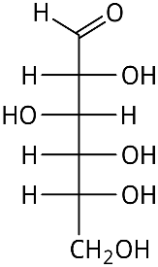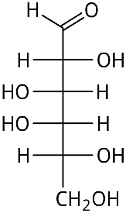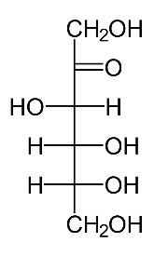
Glucose Galactose Fructose
You will also examine two disaccharides, lactose and sucrose, which have the same chemical formula (C₁₂H₂₂O₁₁) but different molecular arrangements.
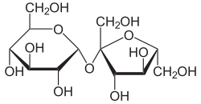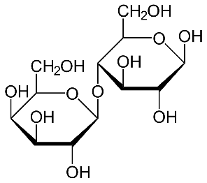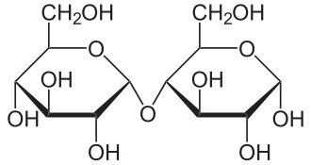
Sucrose Lactose Maltose
By comparing how yeast ferments these different sugars, you will see how molecular structure influences the rate and efficiency of fermentation. Overall, this experiment will help you understand how cells generate energy under anaerobic conditions through processes such as fermentation.

8.2 Materials
Substrate experiment
- China marker
- 7 - 50 ml beakers
- 7 – 15 ml plastic centrifuge tubes
- 7 screw caps for the centrifuge tubes
- 7- I gm parcels of yeast
- 20 ml of the following solutions of the following solutions
  - Water
  - Fructose
  - Glucose
  - Galactose
  - Sucrose
  - Maltose
  - Lactose
Temperature experiment
- 5 – 50 ml beakers
- 5 – 15 ml plastic centrifuge tubes
- 20 ml of Glucose of Glucose
- Thermometer
- Water Baths set up for
  - Ice bath; approximately 10ºC
  - Room temperature, approximately 22ºC
  - Body temp. Approx 30ºC
  - Warm, approximately 60ºC
  - Hot; approximately 90ºC

8.3 Procedures
- Effects of Substrate on Respiration
Procedure:
- Gather 6 beakers and 6 screw-cap test tubes. Label for each set: Water, Glucose, Fructose, Galactose, Lactose, Maltose, and Sucrose.
- Add 1 g of yeast to each beaker. Then add 20 mL of the matching solution to each labeled beaker. Mix thoroughly.
- Fill the corresponding test tube completely with the yeast mixture. Secure the cap, then carefully invert the tube into the beaker. (Extra liquid will remain in the beaker.)
- Leave the setup on your lab bench. As fermentation occurs, CO₂ gas will form, pushing liquid out of the tube and creating an air space.
- When the CO₂ reaches the first marked line on the test tube, begin recording the volume of gas every 5 minutes for 60 minutes. Record your data in the table.
- If the tube fills with CO₂ before 60 minutes, calculate the hourly rate using: (Total mL CO₂÷time in minutes) ×60.
- Record your data in table x.x, then plot the data on the accompanying graph.
Table 8.1 Amount of Gas Produced in a Variety of Solutions.
Time, in minutes | Water | Glucose | Fructose | Galactose | Sucrose | Lactose | Maltose
0
5
10
15
20
25
30
35
40
45
50
60
Total CO₂ in ml/hr.

Figure 8.1
- Effects of Temperature on Respiration
You will repeat the experiment to test how temperature affects the rate of respiration. Set up five more beakers and test tubes, but this time use only one sugar, glucose. This part of the lab will help you understand how temperature changes influence yeast respiration.
- Set up 5 new beakers and 5 test tubes. In this part, you will use glucose only as the sugar source.
- Add 20 mL of glucose solution to each beaker.
- Before adding yeast, place the beakers in their assigned water bath or incubator for at least 5 minutes, so the solution reaches the correct temperature.
- Once the solution has adjusted to the temperature, add 1 g of yeast to each beaker and mix well.
- Fill a test tube completely with the mixture, cap it, and invert it into the beaker. Then return the setup to the correct temperature environment.
- Allow at least 20 minutes for the water baths to reach the correct temperature before starting.
- Measure the amount of CO₂ produced every 5 minutes for 60 minutes and record your data in the results table.
- Record the data in table x.xx, then plot the data in the following graph.
Table 8.2 Amount of Gas Produced in \Varying Temperatures
Time, in minutes | Ice  ____ ºC | Room  ____ ºC | Body  ____ ºC | Warm  ____ ºC | Hot  ____ ºC
0
5
10
15
20
25
30
35
40
45
50
60
Total CO₂ in ml/hr.
9. Transfer the data from Table 8.2 onto Graph 8.2. Be sure to add a proper title to the graph and clearly label both axes.
Figure 8.2

8.4 Appendix: Respiration and Yeast Fermentation Terms
Term | Definition
Aerobic Respiration | The process of breaking down glucose using oxygen to produce ATP, carbon dioxide, and water.
Alcohol Fermentation | An anaerobic process that converts pyruvate into ethanol and CO2.
Anaerobic | A process that occurs without oxygen.
ATP | Adenosine triphosphate, the main energy currency of the cell.
Carbon Dioxide (CO2) | A gas produced as a byproduct of cellular respiration and fermentation.
Cellular Respiration | A series of metabolic reactions that convert glucose into ATP.
Electron Transport Chain | A series of proteins that transfer electrons and generate ATP during respiration.
Ethanol | Alcohol produced during yeast fermentation.
Fermentation | An anaerobic process that allows ATP production by regenerating NAD+ from NADH.
Fructose | A monosaccharide sugar that can be used by yeast for fermentation.
Galactose | A monosaccharide that must be converted before it can enter glycolysis.
Glucose | A primary sugar used by cells to produce energy.
Glycolysis | The first step of cellular respiration where glucose is broken into pyruvate.
Isomer | Molecules with the same chemical formula but different structures.
Lactic Acid Fermentation | An anaerobic process that converts pyruvate into lactic acid.
Lactose | A disaccharide composed of glucose and galactose.
Maltose | A disaccharide consisting of two glucose molecules.
Monosaccharide | A single sugar molecule such as glucose or fructose.
NAD+ | An electron carrier required for glycolysis to continue.
NADH | A reduced electron carrier that donates electrons in respiration.
Oxygen | A gas used as the final electron acceptor in aerobic respiration.
Pyruvate | A three-carbon molecule produced during glycolysis.
Reaction Rate | The speed at which a biochemical reaction occurs.
Respiration | The process by which cells harvest energy from glucose.
Substrate | A substance that is metabolized or acted upon in a reaction.
Sucrose | A disaccharide composed of glucose and fructose.
Temperature | A factor that affects enzyme activity and reaction rate.
Yeast | A unicellular fungus used as a model organism for fermentation.

9. Photosynthesis and Respiration
Plants play a critical role in the flow of energy through ecosystems by capturing sunlight and converting it into chemical energy through the process of photosynthesis. In this process, plants use light energy, along with carbon dioxide (CO₂) from the atmosphere and water (H₂O) from the soil, to synthesize glucose (C₆H₁₂O₆), a type of sugar that stores energy in its chemical bonds. Oxygen (O₂) is released as a byproduct. This process is summarized by the following equation:
6H₂O + 6CO₂ + light + energy→C₆H₁₂O₆ + 6O₂ + 6H2O + 6CO₂
The glucose produced during photosynthesis serves as an energy-rich molecule that plants can use later to fuel cellular activities. When energy is needed, plants (like all living organisms) break down glucose through the process of cellular respiration. During cellular respiration, glucose reacts with oxygen to produce carbon dioxide, water, and usable energy in the form of ATP (adenosine triphosphate). This process releases the stored energy from glucose and is described by the following equation:
C₆H₁₂O₆+6O₂ → 6H2O + 6CO + energy (ATP)
Cellular respiration occurs in the mitochondria of cells and is essential for powering cellular processes such as growth, movement, and biosynthesis. Photosynthesis stores energy; cellular respiration releases it, making these processes complementary and interdependent.
All organisms, including both plants and animals, rely on cellular respiration to obtain energy. The ATP produced is used to drive many biological reactions by converting ADP (adenosine diphosphate) and inorganic phosphate into ATP. Together, photosynthesis and cellular respiration form a cycle that connects the flow of energy and the cycling of carbon and oxygen in living systems.

9.1 Objectives
By the end of this lab, students will be able to:
- Describe the processes of photosynthesis and cellular respiration, including their balanced equations.
- Explain the relationship between photosynthesis and respiration in the cycling of energy and matter.
- Measure changes in oxygen (O₂) and carbon dioxide (CO₂) using gas sensors.
- Compare plant metabolic activity under light and dark conditions.
- Calculate and interpret the rates of photosynthesis and respiration using graphical data.
- Distinguish between gas production and consumption based on experimental observations.
- Relate experimental results to key biological concepts such as energy transfer and ATP production.
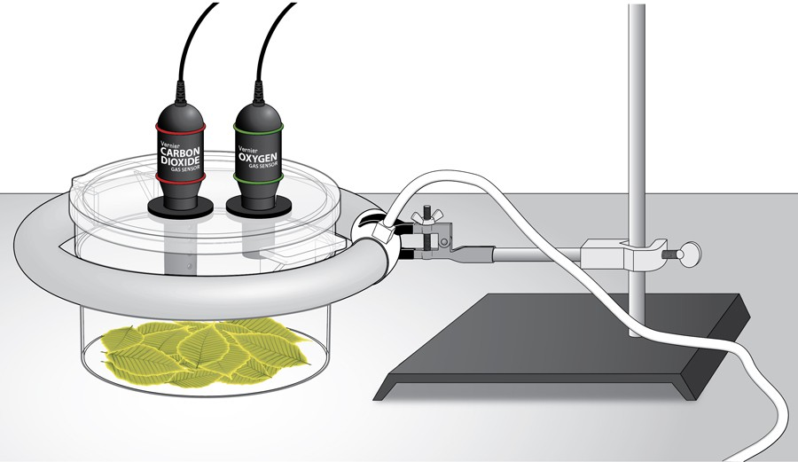
Figure 1: A diagram showing a respiration chamber containing plant leaves connected to carbon dioxide (CO₂) and oxygen (O₂) sensors, which are linked to a computer interface. The chamber is positioned within a circular fluorescent light ring for the light trial, allowing illumination from all sides, while the sensors measure gas changes during photosynthesis and respiration.

9.2 Pre-Lab Exercise
Terms to Define
- Photosynthesis
- Cellular respiration
- Chloroplast
- Mitochondrion
- Glucose
- ATP
- Light reactions
- Calvin cycle
- Oxidation
- Reduction
- Gas exchange
- Carbon dioxide (CO₂)
- Oxygen (O₂)
- Metabolic rate
- Enzyme
- Autotroph
- Stomata
- Aerobic respiration
- Anaerobic respiration
- Equilibrium
Multiple Choice (20 Questions)
- Photosynthesis occurs in the:
A. Nucleus
B. Mitochondria
C. Chloroplast
D. Ribosome
- Cellular respiration occurs in the:
A. Chloroplast
B. Mitochondria
C. Membrane
D. Nucleus
- Photosynthesis requires:
A. Oxygen
B. Carbon dioxide and light
C. ATP only
D. Nitrogen
- The product of photosynthesis is:
A. CO₂
B. Glucose
C. ATP only
D. Nitrogen
- Cellular respiration produces:
A. Oxygen
B. Glucose
C. ATP
D. Light
- Oxygen is:
A. Consumed in respiration
B. Produced in respiration
C. Not involved
D. Only in plants
- CO₂ in photosynthesis is:
A. Produced
B. Consumed
C. Not used
D. Neutral
- Glucose is:
A. Waste
B. Energy source
C. Gas
D. Enzyme
- ATP is:
A. Structural molecule
B. Energy carrier
C. Waste
D. Gas
- Light reactions occur in:
A. Cytoplasm
B. Thylakoid membrane
C. Nucleus
D. Ribosome
- Calvin cycle occurs in:
A. Thylakoid
B. Stroma
C. Membrane
D. Cytoplasm
- In darkness, plants:
A. Only photosynthesize
B. Only respire
C. Do both equally
D. Stop metabolism
- A positive CO₂ slope means:
A. CO₂ consumption
B. CO₂ production
C. No change
D. Error
- A negative O₂ slope means:
A. Oxygen production
B. Oxygen consumption
C. No change
D. Evaporation
- Plants in light:
A. Only respire
B. Both processes occur
C. Stop metabolism
D. Use only CO₂
- Photosynthesis stores energy as:
A. Heat
B. Glucose
C. Light
D. ATP only
- Respiration releases energy as:
A. Light
B. ATP
C. Heat only
D. Sugar
- CO₂ sensor measures:
A. Temperature
B. Gas concentration
C. Light
D. Pressure
- Gas exchange occurs through:
A. Roots
B. Stomata
C. Leaves only
D. Stem
- A higher slope means:
A. Slower rate
B. Faster rate
C. No change
D. Error
Short Answer (10 Questions)
- Write the equation for photosynthesis.
- Write the equation for cellular respiration.
- How are photosynthesis and respiration related?
- What is the role of chloroplasts?
- What is ATP and why is it important?
- Why do plants perform respiration?
- What happens in light reactions?
- What happens in the Calvin cycle?
- Why measure CO₂ and O₂?
- What do you expect in dark conditions?

9.3 Materials
- Computer and computer interface
- aluminum foil
- ring stand and utility clamp
- O₂ Gas Sensor
- CO₂ Gas Sensor
- biochamber
- 12-inch ring fluorescent lamp
- spinach leaves
Starting Point for Laboratory Procedure
If the equipment at your workstation has already been properly set up, you may begin the laboratory procedure at this point.
If the equipment has not been set up, you must first consult the addendum section provided at the conclusion of this laboratory document. Carefully follow the setup instructions outlined there. Upon completing the equipment setup, return to this point to begin the laboratory procedure.

9.3.1 Sensor Calibration
- CO2 Sensor
  - Wait 90 seconds, then place the tip of a stylus into the CAL slot of the CO2 Sensor (between the red bands)
  - Hold until the red-light blinks three times, then release. Note: If the light becomes steady, wait until it goes out, and then try again. The reading should be between .300-.500 ppt.

9.3.2 O₂ Sensor
- Select the Experiment Tab
- Select Calibrate from the drop-down menu
- Check the box for LabPro: 1 CH 2: Oxygen Gas '
1v. Click on the "Calibrate Now Box" in the Sensor Settings window box
- Enter 20.9 as Reading 1
- Click "Keep"
- Place the tip of a stylus into the CAL slot of the O2 Sensor (between the green bands)
  - Hold until the voltage reading in the right middle of the Sensor Settings box is close to O (0.01-0.09 V)
  - While holding the button in to maintain the near zero voltage reading. enter O for Reading 2.
    - Click "Keep"
    - Click "Done"
TEST PROCEDURE: Note for best results conduct the foil-wrapped test first

9.4 Foil-Wrapped Chamber (Dark Chamber) Test
- Assemble the lamp. Important: Do not turn the lamp on until instructed to do so.
- Wrap the BioChamber with aluminum foil so that no light will reach the leaves.
  - Wrap the outside of the chamber with foil.
  - Cover the lid with foil, poking the holes open to insert the sensors.
- Cover the bottom of the chamber with one layer of fresh turgid spinach leaves. Remove any stems that could interfere with an even lining of the bottom.
- Secure the lid on the chamber and insert the sensors into the holes.
- Wait five minutes for the sensors to equilibrate, then click to begin the 15-minute data collection.
- When data collection is complete, find the rate of respiration.
  - Click anywhere on the CO2 graph. Autoscale the data by clicking the Autoscale button on the toolbar.
  - Move the cursor to the point where the data values begin to increase. Hold down the left mouse button and drag the cursor to select the region of increasing CO2 gas concentration.
  - Click on the Linear Fit button to perform a linear regression. A box will appear with the formula for a best fit line.
  - Record the slope of the line, m, as the rate of respiration in Table 1.
  - Close the linear regression box.
  - Repeat Steps 5 a–e for the O2 graph, selecting the region of decreasing O2 concentration.
- Store your data by choosing Store Latest Run from the Experiment menu.
- When data collection has finished, change the column heading of the latest run by clicking on the column heading and typing "Dark Run" in the pop-up box
Plain chamber (light chamber) test
- Remove the aluminum foil from the respiration chamber and invert the chamber to remove the leaves and accumulated gases.
- Line the bottom of the chamber with fresh turgid spinach leaves.
- Secure the lid on the chamber and insert the sensors into the holes.
- Place the chamber inside the bulb and turn on the lamp.
- Repeat Steps 4 –6 to collect and analyze data.
- When data collection has finished, change the column heading of the latest run by clicking on the column heading and typing "Light Run" in the pop-up box

9.4.1 Determine the Rates of Photosynthesis/Respiration
- Click near the start of the CO2 graph. Move the mouse pointer to the point where the data values begin to increase or decrease. Hold down the left mouse button. Drag the pointer to the point where the data ceases to increase/ decrease and release the mouse button
- Click on the Linear Fit button, , (Analyze → Linear Fit) to perform a linear regression. Select both probes.
- A floating box will appear near each data line with the formulas for best fit
- Record the slope of the lines, m, from each box in Table 1 as the rate of photosynthesis/ respiration for each condition (move boxes if necessary)
- Click near the start of the 02 graph. Move the mouse pointer to the point where the data values begin to increase or decrease. Hold down the left mouse button. Drag the pointer to the point where the data ceases to increase/ decrease and release the mouse button

9.4.2 Determine the Rates of Photosynthesis/Respiration
Click near the start of the CO2 graph. Move the mouse pointer to the point where the data values begin to increase or decrease. Hold down the left mouse button. Drag the pointer to the point where the data ceases to increase/ decrease and release the mouse button
- Click on the Linear Fit button to perform a linear regression. Select both probes.
- A floating box will appear near each data line with the formulas for best fit
- Record the slope of the lines, m, from each box in Table 1 as the rate of photosynthesis/respiration for each condition (move boxes if necessary)
- Click near the start of the 0₂ graph. Move the mouse pointer to the point where the data values begin to increase or decrease. Hold down the left mouse button. Drag the pointer to the point where the data ceases to increase/decrease and release the mouse button
- Clean and dry the chamber.

9.5 Data
Table 9.1 Experimental Data showing Carbon Dioxide (CO₂) and Oxygen (O₂) Rates for Plant Leaves Under Two Conditions: Dark and Light
Table 1
Leaves | CO₂ rate of production/consumption (ppt/min) | O₂ rate of production/consumption (ppt/min)
In the dark
In the light
Describe the trends in the production or consumption of CO2 and O2 in the following conditions:
- Without light
- With Light.

9.6 Post-Lab Questions
Multiple Choice (15 Questions)
- In darkness, CO₂ levels:
A. Decrease
B. Increase
C. Stay same
D. Disappear
- In light, O₂ levels:
A. Decrease
B. Increase
C. Stay same
D. Disappear
- Photosynthesis rate is determined by:
A. Volume
B. Slope
C. Time only
D. Color
- Positive slope indicates:
A. Decrease
B. Increase
C. No change
D. Error
- Negative slope indicates:
A. Increase
B. Decrease
C. Stable
D. Error
- Plants in light produce:
A. CO₂ only
B. O₂
C. Nitrogen
D. Methane
- Respiration always:
A. Produces CO₂
B. Produces O₂
C. Stops in light
D. Uses nitrogen
- Data variation may result from:
A. Leaf size
B. Light
C. Temperature
D. All the above
- Faster respiration shows:
A. Steeper slope
B. Flat line
C. No gas exchange
D. Negative data
- Photosynthesis depends on:
A. Light
B. CO₂
C. Water
D. All the above
- Gas sensors measure:
A. Mass
B. Concentration
C. Volume
D. Energy
- Dark results show:
A. Photosynthesis
B. Respiration
C. Both equally
D. Neither
- Light results show:
A. Photosynthesis dominance
B. Respiration only
C. No reaction
D. Freezing
- Slower rate shows:
A. Steep slope
B. Flat slope
C. Vertical line
D. Curved line
- ATP is produced during:
A. Photosynthesis only
B. Respiration
C. Both
D. Neither
Short Answer (10 Questions).
All questions must be completed prior to leaving the laboratory. Upon completion, you must present your responses to the instructor for review and verification.
- What happened to CO₂ in dark vs light?
- What happened to O₂ in dark vs light?
- How do your graphs support respiration?
- How do your graphs support photosynthesis?
- Explain positive vs negative slopes.
- Why is light essential for photosynthesis?
- What factors affected your results?
- How would more leaves affect results?
- What errors could occur in this lab?
- How do these processes support life?

9.7 Potential Poster Topics
- Design and perform an experiment to test one of the factors that might influence the rate of oxygen production or consumption in Question 5.
- Compare the rates of photosynthesis and respiration among several types of plants.

9.8 Addendum: Setup Instructions
- Open and turn on the computer
- Attach one end of the AC adapter cord to the rear side of the Interface and plug the other end of the cord into the outlet
- Connect one end of the serial cable to the interface and the other end to a USB port on the laptop computer
- Open the LoggerPro program by double clicking on the desktop icon
- Set up the Sensors

9.8.1 CO2
- Ensure the switch is set to the Low (0-10,000 ppm) setting
2. Connect the CO2 Gas Sensor to Channel 1 (CH 1) on the left side of the Vernier computer interface. You should see a box with a reading in the lower left corner of the screen
- O2 Connect the O2 Gas Sensor to Channel 2 (CH 2) on the left side of the Vernier computer interface
- Prepare the computer for data collection:
  - Select the File tab
  - Select Open from the drop-down menu
  - Select Biology with Vernier
  - Select Experiment "31C Photo (CO2 and O2)" from the end of the list
  - Two graphs will appear. Move your cursor to the background of the CO2 graph and double click. The graph options box will appear. Under the axis options tab, for the "Y" axis, change the "Scaling:" setting from "manual" to "Autoscale" Click “Done”
  - Repeat "Y" axis scaling change for the O2 graph

9.9 Appendix: Photosynthesis and Respiration Terms
Term | Definition
Aerobic Respiration | The process of producing ATP using oxygen in the mitochondria.
Anaerobic Respiration | Energy production without oxygen, resulting in less ATP.
ATP | Adenosine triphosphate, the main energy-carrying molecule used by cells.
Autotroph | An organism that produces its own food using light or chemical energy.
Calvin Cycle | The stage of photosynthesis where carbon dioxide is used to produce glucose.
Carbon Dioxide (CO2) | A gas used in photosynthesis and released during respiration.
Cellular Respiration | The process that converts glucose into ATP, carbon dioxide, and water.
Chloroplast | The organelle in plant cells where photosynthesis occurs.
Enzyme | A protein that speeds up chemical reactions.
Equilibrium | A state where there is no net change in concentration or energy.
Gas Exchange | The movement of oxygen and carbon dioxide into and out of cells.
Glucose | A sugar molecule that stores energy produced during photosynthesis.
Light Reactions | The stage of photosynthesis that captures light energy and produces ATP and oxygen.
Metabolic Rate | The rate at which chemical reactions occur in an organism.
Mitochondrion | The organelle where cellular respiration occurs.
Oxidation | The loss of electrons during a chemical reaction.
Oxygen (O2) | A gas used in respiration and produced during photosynthesis.
Photosynthesis | The process plants use to convert light energy into chemical energy in glucose.
Reduction | The gain of electrons during a chemical reaction.
Stomata | Small openings in leaves that allow gas exchange.
Stroma | The fluid-filled space in chloroplasts where the Calvin cycle occurs.
Thylakoid | Membrane structures in chloroplasts where light reactions occur.
This laboratory exercise is adapted from Biology with Vernier: Experiment 31C – Photosynthesis and Respiration (November 1, 2022), with later modifications for instructional use.

10. Mitosis and Meiosis
Investigating Mitosis, Meiosis, and the Cellular Basis of Genetic Continuity and Variation

10.1 Learning Objectives
By the end of this laboratory, students will be able to:
- Identify and distinguish all major phases of mitosis and meiosis.
- Explain how chromosome behavior differs between mitosis and meiosis.
- Calculate the mitotic index from microscopic observations.
- Analyze how meiosis generates genetic variation through crossing over and independent assortment.
- Compare chromosome number and DNA content through the cell cycle.
- Interpret the biological significance of mitosis and meiosis in growth, repair, reproduction, and evolution. [oercommons.org], [lagccnsdoer.commons.gc.cuny.edu]

10.2 Background
Cell division is essential for growth, tissue repair, and reproduction. During mitosis, one diploid parent cell produces two genetically identical diploid daughter cells. During meiosis, a diploid germ cell undergoes two divisions to produce four genetically distinct haploid cells. Meiosis introduces genetic variation through crossing over and independent assortment. [oercommons.org], [lamc.edu]

10.3 Materials
Microscopy Station
- Compound light microscope
- Prepared onion root tip slides
- Prepared whitefish blastula slides
- Lens paper
Modeling Station
- Chromosome modeling kit (pipe cleaners, beads, or chromosome models)
- Colored pencils or markers
- Meiosis worksheet
Data Analysis Station
- Cell counting grid
- Calculator
- Graph paper or spreadsheet software

10.4 Safety Considerations
- Carry microscopes using both hands.
- Handle glass slides carefully.
- Keep workstations clean and dry.
- Wash hands before leaving the laboratory.

10.5 Pre-Lab Questions
- What is the difference between homologous chromosomes and sister chromatids?
- Define diploid and haploid.
- During which phase of the cell cycle is DNA replicated?
- Why is crossing over important?
- Why would chromosome number double every generation if meiosis did not occur?
During this activity you will work in pairs.

10.6 Part I: Microscopic Examination of Mitosis

10.6.1 Procedure
A. Onion Root Tip Observations
- Observe the prepared onion root tip slide under low power.
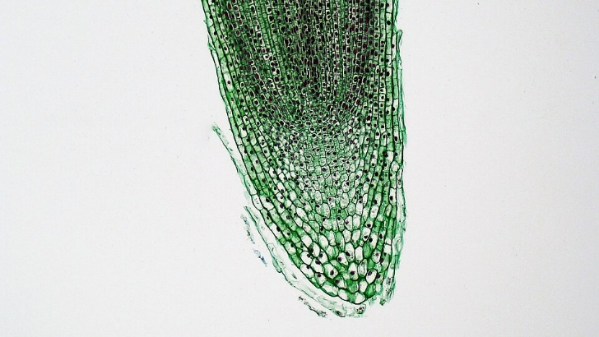
Micrograph of a longitudinal section of an onion root tip
Figure 10.1: Longitudinal section of an Allium (onion) root tip, 40× magnification. https://commons.wikimedia.org/wiki/File:Apical_Meristem_in_Allium_Root_Tip_(23581053848).jpg
- Locate the apical meristem region. This is within the zones of division.
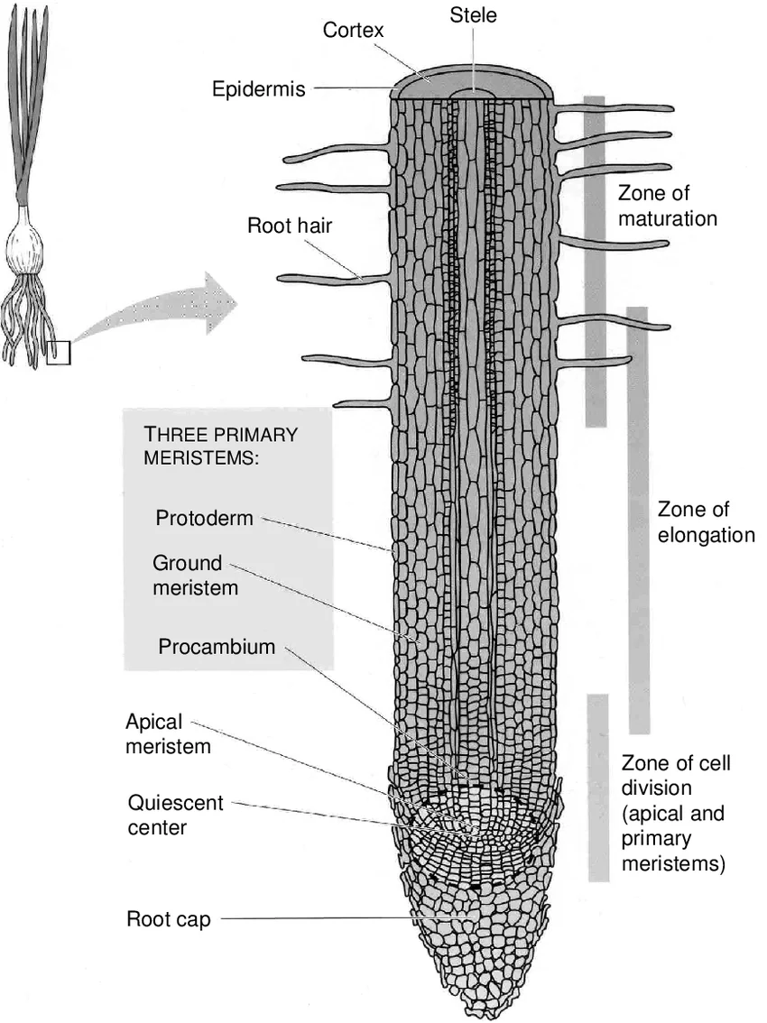
Diagram of an onion root tip labeling the root cap, apical meristem, and the zones of cell division, elongation, and maturation
Figure 10.2: Main tissues and regions of activity in an onion root tip. https://www.researchgate.net/figure/Main-tissues-and-regions-of-activity-in-an-onion-root-tip-source_fig1_279398426
- Switch to high power (400×).
- Identify cells in:
  - Interphase
  - Prophase
  - Metaphase
  - Anaphase
  - Telophase
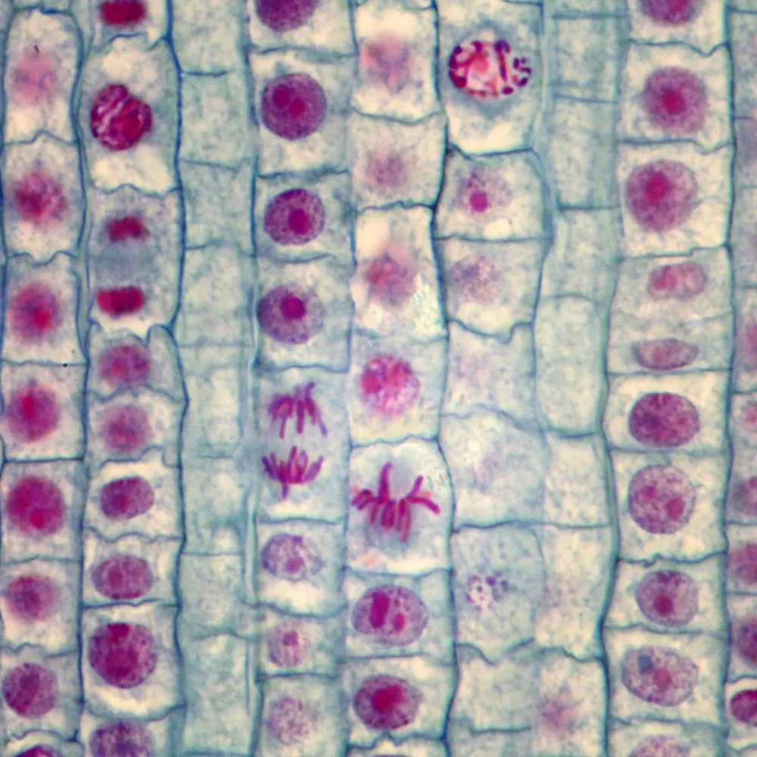
Micrograph of onion root tip cells in various stages of mitosis
Figure 10.3: Onion root tip cells in various stages of mitosis. https://www.carolina.com/mitosis-meiosis-microscope-slides/onion-mitosis-slide-ls-10-m-quadruple-stain/302408.pr
- Draw one representative cell from each stage.
- Interphase, Prophase, Metaphase, Anaphase, Telophase
- Record the distinguishing characteristics of each stage.
B. Onion Root Tip Analysis
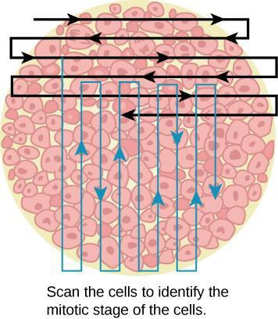
Field of view of cells with horizontal and vertical back-and-forth scanning paths drawn over it
Figure 10.4: Scan and count cells by using either a horizontal (black line) or vertical (blue line) back-and-forth scanning technique with your eyes.
- As you scan the field of view you need to count the number of cells in each stage. Scan different parts of the onion root in three different passes as noted above.
- Using the prepared slide, record the number of cells in each phase of the cell cycle. Use the method shown in Figure 10.4 to count the cells. Record your count in a data table like that shown in Table 10.1. Share your data with the class to create a group total count.
Data Table 10.1: Number of Cells Observed
Phase | Individual totals | Group Total | Percent (Individua
Interphase | 217 | 927 | 93.13%
Prophase | 9 | 49 | 3.86%
Metaphase | 1 | 19 | 0.43%
Anaphase | 0 | 10 | 0%
Telophase | 6 | 20 | 2.58%
Total | 233 | 1025 | 100%

10.6.2 Calculating Mitotic Index
$$\text{Mitotic Index}=\frac{\text{Cells in Mitosis}}{\text{Total Cells Counted}}×100$$
Where:
Cells in mitosis = Prophase + Metaphase + Anaphase + Telophase

10.6.3 Questions
- Which phase was most common?
- Based on the percentage of cells observed in each stage, which phase of the cell cycle lasts the longest?
- What does the most common phase suggest about cell cycle duration?
- Why are root tips ideal for studying mitosis?

10.7 Part II: Animal Cell Mitosis

10.7.1 Whitefish Blastula Observations
- Locate the whitefish eggs using the scanning lens (40×), then switch to the high power (400×) lens.
- Scan the prepared whitefish blastula slides as indicated in Figure 10.4.
- Locate cells undergoing mitosis.
- Draw one representative cell from each stage.
- Interphase, Prophase, Metaphase, Anaphase, Telophase
- Compare plant and animal mitotic cells.
Data Table 10.2: Comparison of Plant and Animal Mitotic Cells
Characteristic | Plant Cells | Animal Cells
Cell shape
Cell wall present?
Cytokinesis mechanism
Centrioles visible?

10.7.2 Analysis Questions
- How does cytokinesis differ in plants and animals?
- Why do rapidly growing embryos exhibit high mitotic activity?

10.8 Part III: Modeling Meiosis

10.8.1 Chromosome Model Activity
Review the stages of meiosis on the Purple Hubbard Models.
Starting Condition
Create a diploid cell (2n = 4) with:
- Pair 1: Red homologous chromosomes
- Pair 2: Blue homologous chromosomes
Each chromosome should consist of two sister chromatids.
Sketches Required
Students must draw all of the following stages:
- Prophase I
- Metaphase I
- Anaphase I
- Telophase I
- Prophase II
- Metaphase II
- Anaphase II
- Telophase II
- Final products
Clearly label:
- Homologous chromosomes
- Sister chromatids
- Chiasmata
- Centromeres

10.8.2 Meiosis I
Model:
- Prophase I
  - Synapsis
  - Crossing over
- Metaphase I
  - Homologous pairs line up
- Anaphase I
  - Homologs separate
- Telophase I
  - Two haploid cells produced
Meiosis I Diagrams
Interphase, Prophase I, Metaphase I, Anaphase I, Telophase I

10.8.3 Meiosis II
Model:
- Prophase II
- Metaphase II
- Anaphase II
- Telophase II
Meiosis II Diagrams
Prophase II, Metaphase II, Anaphase II, Telophase II
Result: four genetically unique haploid gametes.

10.9 Part IV: Independent Assortment Simulation

10.9.1 Procedure
Using the 2n = 4 model:
- Arrange homologous chromosome pairs randomly at metaphase I.
- Record resulting gamete combinations.
- Repeat 10 times.
Data Table 10.3: Gamete Combinations from Independent Assortment
Trial | Gamete Combination
1
2
3
4
5
6
7
8
9
10

10.9.2 Analysis
For a species with:
$$n=23$$
How many chromosome combinations can be produced by independent assortment alone?
Explain how crossing over further increases diversity.

10.10 Part V: Comparing Mitosis and Meiosis
Complete the table.
Data Table 10.4: Comparison of Mitosis and Meiosis
Characteristic | Mitosis | Meiosis
Number of divisions
Number of daughter cells
Chromosome number maintained?
Crossing over occurs?
Genetic variation produced?
Cell type produced
Biological purpose

10.11 Post-Lab Discussion Questions
- Why must DNA replication occur before both mitosis and meiosis?
- Explain why meiosis I is considered a reduction division.
- Which meiotic event contributes most to genetic diversity?
- How could errors during meiosis lead to aneuploidy?
- Why is mitosis essential for multicellular organisms?
- Predict the consequences if sister chromatids failed to separate during meiosis II.

11. Mendelian Genetics in Corn and Chi-Square Testing
Lab Objectives
The purpose of this lab is to help you understand how traits are inherited by:
- Identifying visible traits (phenotypes) in corn kernels
- Collecting and organizing data
- Using Punnett squares to predict genetic outcomes
- Calculating expected values based on Mendelian genetics
- Applying a chi-square (χ²) test to analyze data
- Interpreting results using degrees of freedom and critical values
- Drawing conclusions about whether traits follow Mendelian inheritance patterns

11.1 Pre-Lab Activity 11.1: Questions
A. Terms to Identify
Students should define the following:
- Phenotype
- Genotype
- Dominant
- Recessive
- Monohybrid cross
- Expected ratio
- Observed data
- Chi-square (χ²)
- Degrees of freedom (df)
- Significance level (p value)
B. Multiple Choice Questions (Pre-Lab)
- A monohybrid cross typically involves:
  - A. Two traits
  - B. One trait
  - C. Three traits
  - D. No traits
- In a 3:1 ratio, the “3” represents:
  - A. Recessive phenotype
  - B. Dominant phenotype
  - C. Genotypes only
  - D. Total offspring
- What does χ² measure?
  - A. Genetic mutation
  - B. Difference between observed and expected values
  - C. DNA sequence
  - D. Cell division
C. Short Answer Questions (Simple)
- What is the expected phenotypic ratio for a monohybrid cross?
- Why do scientists use expected values?
- What does a small difference between observed and expected values suggest?
- How is the total sample size used in calculating expected values?

11.2 Introduction: Corn Genetics
Genetics is the study of how traits are passed from parents to offspring. In this lab, you will explore these ideas using corn (Zea mays). Corn is a useful organism for studying genetics because each ear contains many kernels, and each kernel represents one offspring. These kernels clearly show visible traits, such as color (purple or yellow) and shape (round or wrinkled), making patterns of inheritance easier to observe.
Traits are controlled by genes, which are located on chromosomes. For each gene, organisms inherit two copies, called alleles—one from each parent. These alleles can be the same (homozygous) or different (heterozygous). The combination of alleles is called the genotype, while the physical appearance of the trait is the phenotype.
Some alleles are dominant, meaning they are expressed even if only one copy is present. Others are recessive, meaning they are only seen when two copies are present. For example, in corn, purple color is typically dominant over yellow, and round shape is dominant over wrinkled. Even if a recessive trait is not visible in one generation, it can reappear in later generations.
The principles you will use in this lab were first described by Gregor Mendel. His Law of Segregation states that allele pairs separate during the formation of gametes, so each gamete carries only one allele. His Law of Independent Assortment states that different genes are inherited independently, as long as they are on different chromosomes.
You will begin by using Punnett squares to predict the expected ratios of traits in offspring. In a monohybrid cross (one trait), the expected phenotypic ratio in the F2 generation is usually 3:1 (dominant to recessive). In a dihybrid cross (two traits), the expected ratio is typically 9:3:3:1.
However, real data rarely matches these ratios exactly. To test whether your results fit Mendelian predictions, you will use a chi-square (χ²) test. This statistical method helps determine whether differences between your observed data and expected values are due to random chance or suggest a different pattern of inheritance.
By the end of this lab, you will connect genetic theory to real data and develop skills in scientific reasoning, data analysis, and interpretation—important tools for all areas of biology.
The research question is: Does simple Mendelian inheritance explain the color and shape of corn seeds?
If the answer is yes, then you are assuming that:
- Each trait is controlled by two alleles that show complete dominance.
- Each trait is determined by a single gene.
- In the dihybrid cross, the genes for these traits are located on different chromosomes and assort independently.
- The data you collected are accurate, meaning the seeds were counted, and their traits were identified correctly.
Monohybrid cross
In this cross, the first-generation parents were homozygous for a single trait, e.g., either PP for purple (dominant) or pp for yellow (recessive). The offspring of this cross is the F1 generation, all of which are the same genotype.
Suppose you cross parental genotypes PP × p*p*. Use the Punnett squares below to determine the possible genotypes and phenotypes of the F1 and F2 generations.
F1 Generation
 | P | P
p* |  |  | Phenotype ratio:
p* |  |  | Genotype Ratio:
Next, cross two of the prodigies from the F1 generation above (Pp* x Pp*)
F2 Generation
 | P | p*
P |  |  | Phenotype ratio:
p* |  |  | Genotype Ratio:
Note: P refers to the dominant trait while p* refers to the recessive trait.
Chi-Square in Genetics
In genetics, Punnett squares are used to predict the expected ratios of traits in offspring. However, real experimental data rarely match these predictions exactly. Slight differences between expected and observed results are common due to chance, sampling variation, or experimental error.
The chi-square (χ²) test is a statistical method used to decide whether the differences between observed and expected results are significant, or simply due to random variation.
The chi-square test compares:
- What you observed in an experiment
- What you expected based on a genetic hypothesis
This allows you to evaluate whether your data fits the expected genetic model.
Key idea:
The chi-square test helps determine whether deviations from expected ratios are due to chance or show a different genetic outcome.
Chi-Square Formula
χ2=∑[(O−E)²] / E
Where:
- O = observed value
- E = expected value
- Σ = sum of all data points
Using Chi-Square in a Monohybrid Cross
Example: 3:1 Phenotypic Ratio
Step 1: State Hypothesis
The observed results follow a 3:1 ratio (dominant: recessive).
Step 2: Observed Data
- Tall = 78
- Short = 22
Total = 100
Step 3: Expected Values
- Tall = 75
- Short = 25
Step 4: Calculate Chi-Square
χ2=∑[(O−E)²] / E
χ2= [(78−75)²+(22−25)² ] = 9 + 9 = 0.12 + 0.36 = 0.48
75 25 25 25
Step 5: Degrees of Freedom
Degrees of freedom (df) represent the number of independent categories that can vary when calculating a chi-square value.
In genetics chi-square problems, degrees of freedom are calculated using the formula:
df=number of categories−1
Examples
- Monohybrid cross (2 categories: dominant and recessive):
df=2−1=1
- Dihybrid cross (4 categories: 9:3:3:1):
df=4−1=3
Why It Matters
The degrees of freedom determine which value you use from the chi-square table. This allows you to decide whether the difference between observed and expected results is significant.
Step 6: Interpretation
Compare χ² (0.48) to critical value (3.84 at p = 0.05, df = 1)
Since: 0.48<3.84
Why 3.84 is the Critical Value for a population of two observations
The number 3.84 comes from a chi-square distribution table and represents a cutoff point based on:
- Degrees of freedom (df = 1)
- Significance level (p = 0.05)
A graph of the Chi-squared distribution can be seen in figure 11.1.
This is the probability of rejecting the null hypothesis when it is true (a false positive).
A p-value of 0.05 means that there is a 5% chance that any difference between the observed and expected results is due to random chance. This sets out a cutoff point for deciding whether the result is significant.
For a chi-square test with 1 degree of freedom, this cutoff value (called the critical value) is 3.84.
So:
- If your χ² value is less than 3.84, the difference is due to chance (not significant).
- If your χ² value is greater than 3.84, the difference is unlikely due to chance (significant).
That 5% region is called the rejection region.
On the graph, our calculated Chi-squared value of 0.48 is far left of 3.84.
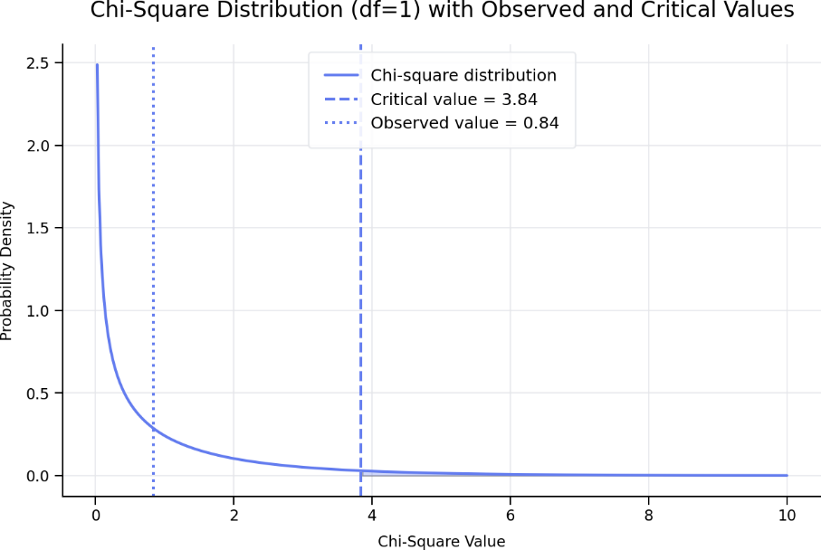
A graph with a line
A chi-square distribution curve with 1 degree of freedom is shown. The curve rises steeply on the left and gradually slopes downward to the right. A vertical line marks the critical value at 3.84 on the right side of the graph. The calculated chi-square value (0.48) is found far to the left of this line, in the high-probability region, showing that the result is not significant.
Figure 11.1. Chi-Square Distribution Plot (df = 1)
This means:
- Your result is in the high-probability region
- It is not unusual at all
- It fits what we expect by chance
Monohybrid experiment
Next, create a hypothesis regarding the distribution of seeds you expect to see based on the Punnett square for the F2 generation you completed above.
Expected Genotype and Phenotypes
Based on your information about the F2 progeny, complete the table below.
Table 11.1. Genotypic and Phenotypic Ratios
Genotype | ratio | Phenotype | ratio | Percentage expected
PP |  | Purple
Pp* |  | Yellow
p*p*
Working in groups of two, have one student read out the seed phenotypes while the other records the data in Table xxx. The kernels in this activity represent the F2 generation, as shown in the Punnett square completed earlier. Begin at one end of a row and count the number of seeds for each color, making sure not to count any seed more than once. Do not mark or remove the seeds from the cob. Use the provided rubber bands to divide the cob into sections to make counting easier. Record the number of purple seeds, yellow seeds, and the total number of seeds below.
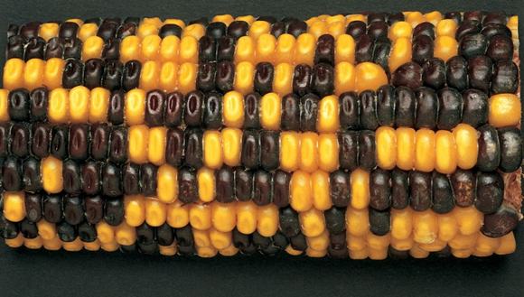
Photograph of a monohybrid ear of corn showing variation in a single trait, with kernels displaying two distinct phenotypes distributed across the cob.
Figure 11.2 Picture of a monohybrid ear of corn. Image source: Carolina Biological Supply (www.carolina.com).
Observed Data
Table 11.3 The number of purple (P) and yellow (p*) kernels.
 | Row
Phenotypes | 1 | 2 | 3 | 4 | 5 | 6 | 7 |  | Total
P
p*
 |  |  |  |  |  | Grand Total
Dominant Trait: ______
Recessive Trait: ______
Total Offspring: ______
Step 1: State the Hypothesis in a full sentence
Expected phenotypic ratio: ______________________
Step 2: Calculate Expected Values
Expected dominant: ______
Expected recessive: ______
Hint:
- Multiply total × 3/4 for dominant
- Multiply total × 1/4 for recessive
Monohybrid Chi Square testing
Using the data you generated from table11.3, you are now going to determine if the results obtained from an experiment or observation are consistent with the expected results. In this corn genetics study, we assume that purple seeds are dominant over yellow seeds. Based on this idea, we can predict the expected ratio of purple to yellow seeds in each F2 cob if Mendelian inheritance is occurring. You already calculated these expected ratios earlier using Punnett squares and genotype/phenotype predictions. Now, we will compare those expected results with the actual counts you observed. This comparison will help determine whether these traits follow Mendelian patterns. If your calculated Chi-square (χ²) value is higher than expected, it may indicate counting errors or that one or more of your assumptions may not be correct.
Steps to follow:
- Collect your data.
- Using the total number of seeds (grand total) counted on your F2 cob (regardless of color), calculate how many purple and yellow seeds you would expect based on the predicted phenotypic ratio from the Punnett square. Multiply the expected ratio by the total number of seeds recorded in Table xx.x. Record these values in the “Expected” column of Table xx.x.
- Subtract the expected value from the observed value for each phenotype and record the result in the “Deviation” column.
- Square each deviation and enter the values in the “D²” column.
- Divide each D² value by its corresponding expected value.
- Add all these values together. This total is your Chi-square (χ²) test statistic.
Table 11.4 Table of Chi-square Calculations
Phenotype | Observed (O) | Expected  (E) | Deviation (D)  D = (O-E) | D² | D²/E
Purple
Yellow
Total
Sum of all D2/E = c2
c2 =
The ratio predicted from your Punnett square will differ slightly from the ratio you observed when counting the corn kernels. If your calculated χ² value is greater than 3.84, the difference between observed and expected values is considered significant. If it is less than 3.84, the difference is not significant.
What degrees of freedom should be used for this analysis?
Is your χ² value greater than or less than 3.84?
Based on your chi-square results, how do your observed data compare to the predicted values?
Dihybrid chi-squared testing.
Using Chi-Square in a Dihybrid Cross
Example: 9:3:3:1 Ratio
Step 1: Observed Data
- Round Yellow = 190
- Round Green = 65
- Wrinkled Yellow = 40
- Wrinkled Green = 25
Total = 320
Step 2: Expected Values
- 9/16 × 320 = 180
- 3/16 × 320 = 60
- 3/16 × 320 = 60
- 1/16 × 320 = 20
Step 3: Calculate Chi-Square
χ2= (190−180)² +(65−60) ² +(40−60) ² +(25−20) ² = (0.56+0.42+6.67+1.25) = 8.90
180 60 60 20
Step 4: Degrees of Freedom
df = n - 1
df=4−1=3df = 4 - 1 = 3
Step 5: Interpretation
Critical value (df = 3, p = 0.05) = 7.81
Since: 8.90 > 7.81 (the Critical Value or cutoff point)
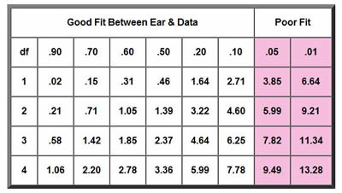
A table of chi-square critical values for right-tailed tests with degrees of freedom 1 through 4. Rows correspond to degrees of freedom (1, 2, 3, 4). Columns represent several significance levels ranging from 0.90 to 0.01. Values increase as either the degrees of freedom, or the level of significance becomes more stringent.
Figure 11.3. Chi square goodness fit table. Image from the biologycorner.com
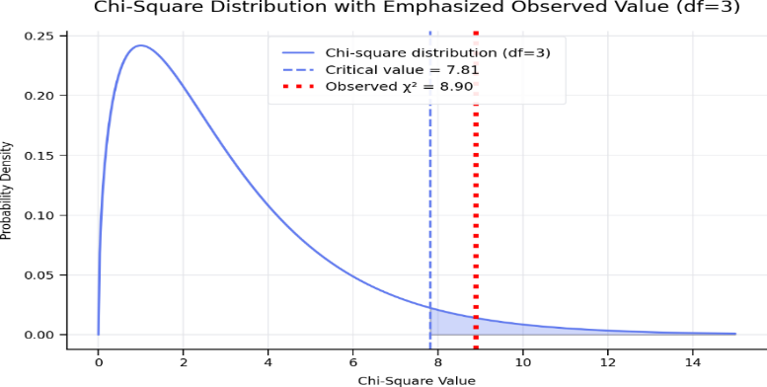
Static image
A chi-square distribution curve with 3 degrees of freedom is shown. The curve starts high on the left and gradually decreases to the right. A vertical line marks the critical value at 7.81, representing the cutoff for a significance level of p = 0.05. The calculated chi-square value is also positioned at 7.81, right at this cutoff line. This location indicates the result lies at the boundary of the 5% rejection region. Values beyond this line would fall outside the 95% confidence range, suggesting the results are significant, while values at or below the line are borderline or not significant.
Figure 11.4. Plot of chi-squared distribution and the calculated chi-squared value.
Conclusion:
The difference is significant. The observed data do not fit the expected 9:3:3:1 ratio.
Key Rule
- If χ² is less than the critical value
→ Differences are due to chance
→ Accept the hypothesis
- If χ² is greater than the critical value
→ Differences are significant
→ Reject the hypothesis
Important Points
- Real data rarely matches expected ratios exactly
- Larger sample sizes improve accuracy
- Experimental error may affect results
- Chi-square does not prove the hypothesis correct; it only tests if the data are consistent with it
Summary
- Punnett squares predict expected ratios
- Chi-square evaluates how well data match predictions
- Monohybrid crosses use fewer categories (df = 1)
- Dihybrid crosses involve more variation (df = 3)
- Corn kernel data provides real-world application of genetic principles
Part 2: Dihybrid Cross (9:3:3:1 Ratio)
Applying Chi-Square to Student Generated Corn Ear Data
Now you are going to create your own data to analyze inheritance patterns in corn ears, where each kernel stands for an offspring.
Common traits:
- Kernel color: Purple vs white
  - Purple is dominant
- Kernel texture: Round vs crinkled
  - Round is dominant
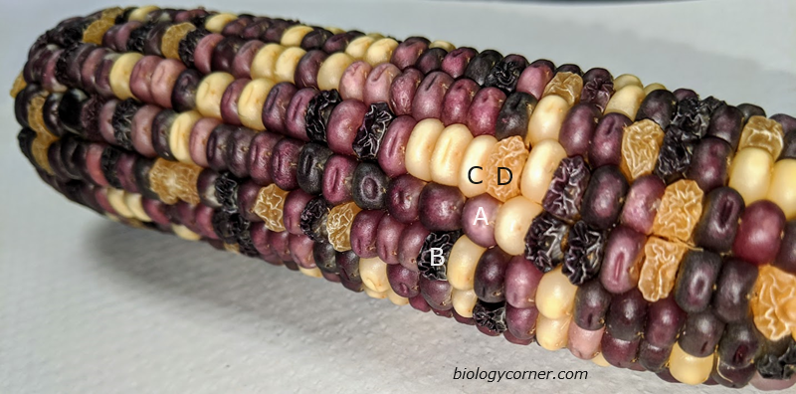
Photograph of an ear of corn showing four distinct kernel phenotypes arranged across the cob. The kernels vary in both color and texture. Category A shows purple, smooth kernels; Category B shows purple, shrunken kernels; Category C shows yellow, smooth kernels; and Category D shows yellow, shrunken kernels. The differences illustrate combinations of two traits: kernel color (purple vs. yellow) and kernel shape (smooth vs. shrunken). Biology corner.com, ND, CC SA By 4.0
Figure 11.5. Picture of a dihybrid ear of corn having two traits, kernel color, and texture. Image from the biologycorner.com
Dihybrid Corn Example
Students count:
- Purple round (PR)
- Purple wrinkled (Pr*)
- Yellow round (p*R)
- Yellow wrinkled (p*r*)
Expected ratio: 9:3:3:1
Process:
- Count total number of kernels from 7 rows
- Expect a 9:3:3:1 ratio
- Calculate expected values
- Perform chi-square test
Chi-squared calculations
Steps:
- Calculate expected values
- Compute χ²
- Compare to critical value
- Decide if inheritance follows Mendelian expectations
- Interpretation of Results
Chi-Square Worksheet (Guided Calculations)
Step 1: Data collected for the Chi-square calculations
Table 11.5. Data Collected from 7 Rows of Corn
 |  | Row
 |  | 1 | 2 | 3 | 4 | 5 | 6 | 7
Pheno t ypes | PR
 | Pr*
 | p*R
 | p*r*
Step 2: Calculate Chi-Square Components
Table11.6. Chi-square Calculation Data
Phenotype | Observed (O) | Expected  (E) | Deviation (D)  D = (O-E) | D² | D²/E
Purple round
Purple wrinkled
Yellow round
Yellow wrinkled
Total
Sum of all D2/E = c2
c2 =
Step 3: Calculate Chi-Square Value: χ² = Σ [(O – E) ²] / E} = ______
Step 4: Degrees of Freedom: df = categories − 1 = ______
Step 5: Interpretation
Compare your value to 7.81 (p = 0.05, df = 3)
Conclusion (circle one) and explain your reasoning.
- Accept hypothesis
- Reject hypothesis
Explain how it compares to the cutoff point
- Does your data support Mendelian inheritance? What does this mean biologically?
Discussion
Address the following:
- Why do observed values differ from expected?
- Was the difference significant?
- What sources of error may have affected results?
- How could the experiment be improved?

11.3 Post-Lab Activities
A. Multiple Choice Questions
- If χ² is greater than the critical value, you:
  - A. Accept the null hypothesis
  - B. Reject the null hypothesis
  - C. Ignore the data
  - D. Recount samples
- The critical value depends on:
  - A. Sample color
  - B. Degrees of freedom
  - C. Number of kernels only
  - D. Observed data
Short Answer Questions
- Why might the observed data differ slightly from expected ratios in real experiments?
- Explain what it means to “fail to reject the null hypothesis” in this lab.
- How would your conclusion change if χ² exceeded the critical value?
- What biological factors could cause large deviations from expected ratios?
- Why is chi-square analysis important in genetic studies?

Additional Learning Resources:
- Watch these videos to learn more about these critical, introductory concepts of corn genetics listed above.
- Chi Square Review
  - Don't FEAR Chi Square! A Guide for AP Bio
Don't FEAR Chi Square! A Guide for AP Bio Students, @sciencemusicvideos
A complete and student friendly discussion of how to solve a Chi Square problem
- https://youtu.be/HKDqlYSLt68?si=MPTSQYFcudMJvkZ_
Chi Square Test, The Organic Chemistry Tutor, (7 minutes)
This statistics video tutorial provides a basic introduction into the chi square test. It explains how to use the chi square distribution to perform a goodness of fit test to decide whether to accept or reject the null hypothesis.
- Corn Lab
  - https://youtu.be/D9956-GWOkA?si=AqsCbES_gWVWwFN2
By Sixth Form Biology, Chi Squared and the Corn Cobs (14 minutes)
A good step by step demonstration of the application of Chi Square in the corn lab.
- https://youtu.be/12Vcf4l_E6s?si=aigMtOuznSlPk3pk
By Christan Fry. bio 2 chi square corn lab (9 minutes)
A review of how a corn genetics lab could be approached and completed.
- https://youtu.be/OlKtfoy6V5w?si=uujzoMVOjtaD2o0o
By Elements of Biology, Lab_MaizeGenetics, (29 minutes)
A comprehensive explanation of corn biology and genetics and chi square testing.

11.4 Appendix: Corn Genetics and Chi-Square Testing Terms
Term | Definition
Allele | Different forms of a gene inherited from each parent.
Chi-Square (χ²) | A statistical test used to compare observed and expected data.
Critical Value | The cutoff value used to determine if results are statistically significant.
Degrees of Freedom (df) | The number of independent categories used in a chi-square test, calculated as categories minus one.
Dihybrid Cross | A genetic cross involving two traits.
Dominant | An allele that is expressed when present, even if only one copy exists.
Expected Ratio | The predicted proportion of phenotypes based on Mendelian genetics.
Genotype | The genetic makeup (allele combination) of an organism.
Heterozygous | Having two different alleles for a trait.
Homozygous | Having two identical alleles for a trait.
Hypothesis | A testable explanation or prediction about a scientific observation.
Law of Independent Assortment | Mendel’s principle that alleles of different genes are inherited independently.
Law of Segregation | Mendel’s principle that allele pairs separate during gamete formation.
Monohybrid Cross | A genetic cross involving a single trait.
Null Hypothesis | The assumption that observed differences are due to chance.
Observed Data | The actual results were collected during an experiment.
P-value | The probability that observed differences are due to chance.
Pedigree | A diagram used to track inheritance patterns in families.
Phenotype | The observable traits of an organism.
Punnett Square | A diagram used to predict genetic outcomes of crosses.
Ratio | A comparison of quantities, often used to describe genetic outcomes.
Recessive | An allele expressed only when two copies are present.
Significance Level | The threshold (commonly 0.05) used to determine statistical significance.
Test Statistic | A calculated value (like chi-square) used to evaluate a hypothesis.

12. Introduction to Mendelian Genetics

12.1 Introduction
Gregor Mendel is widely recognized as the father of modern genetics because his experiments provided the first clear explanation of how inherited characteristics are transmitted from one generation to the next. Mendel was born in 1822 and grew up on a farm, where he developed an early interest in plants. His later education in mathematics and science, especially at the University of Vienna, helped him apply quantitative reasoning to biological questions.
Between 1856 and 1865, Mendel conducted controlled breeding experiments using pea plants (Pisum sativum). He selected pea plants because they possessed easily observed traits, reproduced quickly, and could be artificially fertilized under controlled conditions. By tracking characteristics such as seed shape, seed color, flower color, and plant height across generations, he demonstrated that traits are inherited as discrete hereditary units rather than blending together. These findings became the conceptual basis for what are now called genes.
Mendel presented his results to the Natural History Society of Brno in 1865 and published them in 1866 in a paper titled Experiments in Plant Hybridization. Despite the importance of his conclusions, the work attracted little attention at the time. Historians and science references note that his paper circulated only narrowly and that many contemporary scientists did not appreciate the significance of his mathematical treatment of inheritance. Mendel’s work was not widely recognized until about 1900, when other scientists rediscovered similar inheritance patterns and connected them to his earlier publication.
The modern language of genetics emerged after Mendel, but the principles he discovered remain foundational. A gene is a unit of heredity, and a trait is a heritable characteristic influenced by one or more genes. Alternative versions of a gene are called alleles, and the specific physical position of a gene on a chromosome is its locus. Diploid organisms inherit two alleles for most genes, one from each parent. When both alleles are the same, the organism is homozygous for that gene; when the alleles differ, the organism is heterozygous.
The outward expression of a genetic characteristic is the phenotype, whereas the underlying allele combination is the genotype. In classical Mendelian inheritance, a dominant allele is expressed in the phenotype whenever it is present, while a recessive allele is expressed only when two recessive copies are inherited. However, not all inheritance patterns follow simple dominance. In incomplete dominance, the heterozygous phenotype is intermediate between the two homozygous phenotypes. In codominance, both alleles are fully expressed in the heterozygote. In sex-linked inheritance, the gene responsible for a trait is located on a sex chromosome, most often the X chromosome.
In this laboratory, students will first analyze a monohybrid cross, which follows the inheritance of a single trait. Monohybrid crosses are especially useful for examining complete dominance, incomplete dominance, codominance, and sex-linked traits. Students will then examine a dihybrid cross, which tracks two traits simultaneously and illustrates how genes may assort independently during gamete formation. Together, these exercises introduce the predictive framework of Mendelian genetics.
Objectives
Upon completion of this laboratory exercise, students should be able to:
- Describe the historical significance of Gregor Mendel’s work in establishing the foundations of modern genetics.
- Define essential genetic terms, including gene, trait, locus, allele, genotype, phenotype, homozygous, heterozygous, dominant, and recessive.
- Distinguish between monohybrid and dihybrid crosses and explain the biological questions each type of cross addresses.
- Predict genotypic and phenotypic ratios from monohybrid crosses involving complete dominance.
- Interpret inheritance patterns that deviate from simple dominance, including codominance, incomplete dominance, and sex-linked inheritance.
- Use Punnett square analysis to evaluate expected outcomes of genetic crosses.
- Relate observed inheritance patterns to Mendel’s principles of segregation and independent assortment.
Topics Covered in This Laboratory
- Monohybrid crosses with complete dominance
- Monohybrid crosses with codominance
- Monohybrid crosses with sex linkage
- Monohybrid crosses with incomplete dominance
- Dihybrid crosses

12.2 Pre-Lab Activity 12.1: Questions and Definitions
- Why is Gregor Mendel considered the founder of modern genetics?
- Why were pea plants especially useful for Mendel’s studies of inheritance?
- Define the terms gene, trait, allele, and locus in your own words.
- What is the difference between genotype and phenotype?
- What is the difference between a homozygous individual and a heterozygous individual?
- In a trait showing complete dominance, how does the phenotype of a heterozygote compare with that of a homozygous dominant individual?
- What is the difference between complete dominance, incomplete dominance, and codominance?
- What distinguishes a monohybrid cross from a dihybrid cross?
- Why are sex-linked traits often inherited differently from autosomal traits?
- If two heterozygous individuals are crossed for a single trait showing complete dominance, what genotypic and phenotypic ratios would you predict?

12.3 Monohybrid Cross Problems Using a Punnett Square
A monohybrid cross follows the inheritance of a single gene or trait. In a Punnett square, the possible gametes from one parent are written across the top, and the possible gametes from the other parent are written along the side. Each box inside the square represents one possible offspring genotype. This allows students to predict both genotypic ratios and phenotypic ratios for a cross.
For a trait that follows complete dominance, the dominant allele is expressed whenever it is present, while the recessive allele is expressed only when an individual has two recessive copies.
Problem 1: Worked Example: Homozygous Dominant × Homozygous Recessive
In pea plants, purple flowers (P) are dominant to white flowers (p*). Cross a homozygous dominant purple-flowered plant with a homozygous recessive white-flowered plant.
- Parent 1 genotype = PP
- Parent 2 genotype = p*p*
Step 1. Determine the gametes from each parent
Because each gamete receives only one allele for the gene, the PP parent can produce only P gametes, and the p*p* parent can produce only p* gametes. This follows Mendel’s principle of segregation.
- Gametes from PP: _____, _____
- Gametes from p*p*: _____, _____
Step 2. Set up the Punnett square
Fill in the outer boxes below

Step 3. Identify the offspring genotypes
All four boxes contain the genotype Pp*.
- Offspring genotypes: 100% Pp*
- Genotypic ratio: 0 PP : 4 Pp* : 0 p*p*
- Simplified genotypic ratio: 100% heterozygous
Step 4. Identify the offspring phenotypes
Because P is dominant, every offspring with genotype Pp* will have purple flowers. In complete dominance, a heterozygote shows the dominant phenotype.
- Offspring phenotypes: 100% purple flowers
- Phenotypic ratio: 4 purple : 0 white
Conclusion
A cross between a homozygous dominant parent and a homozygous recessive parent produces offspring that are:
- 100% heterozygous
- 100% dominant phenotype
This is a useful first example because every offspring has the same genotype and the same phenotype.
How to Solve Any Monohybrid Cross
You can use the following method for every problem:
- Write the genotypes of both parents.
- Determine the possible gametes from each parent. Each gamete carries only one allele for the trait.
- Draw a 2 × 2 Punnett square for a monohybrid cross.

- Place one allele from each parent in one of the outside boxes.
- Fill in the four internal boxes by combining one allele from each parent.
- Count the genotypes to determine the genotypic ratio.
- Use dominance rules to determine the phenotypic ratio.
Practice Problems for you to complete. Below are five additional monohybrid cross problems for you to solve.
Problem 1: Homozygous Dominant × Heterozygous
In pea plants, tall (T) is dominant to short (t*). Cross a homozygous dominant tall plant with a heterozygous tall plant.
- Parent 1 genotype = TT
- Parent 2 genotype = Tt*
You must determine:
- The gametes from each parent
- The Punnett square
- The offspring genotypes
- The genotypic ratio
- The phenotypic ratio
Problem 2: Heterozygous × Heterozygous
In pea plants, yellow seeds (Y) are dominant to green seeds (y*). Cross two heterozygous yellow-seeded plants.
- Parent 1 genotype = Yy*
- Parent 2 genotype = Yy*
You must determine:
- The Punnett square
- The genotypic ratio
- The phenotypic ratio
A heterozygote × heterozygote monohybrid cross is the classic cross that produces a 1:2:1 genotypic ratio and a 3:1 phenotypic ratio under complete dominance.
Problem 3: Heterozygous × Homozygous Recessive
In pea plants, round seeds (R) are dominant to wrinkled seeds (r*). Cross a heterozygous round-seeded plant with a homozygous recessive wrinkled-seeded plant.
- Parent 1 genotype = Rr*
- Parent 2 genotype = r*r*
Students should determine:
- The gametes from each parent
- The Punnett square
- The genotypic ratio
- The phenotypic ratio
Problem 4: Homozygous Recessive × Homozygous Recessive
In pea plants, green pods (g*) are recessive to yellow pods (G). Cross two homozygous recessive green-podded plants.
- Parent 1 genotype = g*g*
- Parent 2 genotype = g*g*
You must determine:
- The Punnett square
- The genotype of all offspring
- The phenotype of all offspring
Problem 5: Test Cross
In pea plants, purple flowers (P) are dominant to white flowers (p*). A purple-flowered plant has the genotype P_, meaning the second allele is unknown. To determine whether it is PP or Pp*, it is crossed with a white-flowered plant (p*p*).
Part A
Assume the unknown purple-flowered plant is PP.
- Cross: PP × p*p*
Part B
Assume the unknown purple-flowered plant is Pp*.
- Cross: Pp* × p*p*
Students should determine:
- The Punnett square for each cross
- The phenotypic ratio for each cross
- Which result would indicate that the unknown parent is heterozygous
A test cross uses a homozygous recessive parent to help reveal the genotype of an individual showing the dominant phenotype.
Problem 6.
In rabbits, black fur (B) is dominant to white fur (b*).
A black rabbit is crossed with a white rabbit, and half of the offspring are black and half are white.
Questions
- What must the genotype of the white rabbit be?
- What must the genotype of the black rabbit be?
- Draw the Punnett square that explains the results.
A recessive phenotype must always be homozygous recessive in a complete-dominance system.
Problem 7. Unknown Genotype (Test Cross)
In pea plants, purple flowers (P) are dominant to white flowers (p*).
A purple-flowered plant has the genotype P_, meaning its second allele is unknown. To determine its genotype, it is crossed with a white-flowered plant (p*p*).
Questions
- If the unknown purple-flowered plant is PP, what offspring are expected?
- If the unknown purple-flowered plant is Pp*, what offspring are expected?
- What result would prove that the unknown parent is heterozygous?
A test cross uses a homozygous recessive individual to identify the genotype of an organism showing the dominant phenotype.
Problem 8. Reverse Reasoning from Offspring Data
In a species of flowering plant, red flowers (R) are dominant to white flowers (r*).
Two red-flowered plants are crossed, and the offspring include 75% red-flowered plants and 25% white-flowered plants.
Questions
- What are the most likely genotypes of the two parents?
- Draw the Punnett square for the cross.
- Why are white-flowered offspring possible even though both parents are red?
Note: A 3:1 phenotypic ratio is the classic result of a heterozygote × heterozygote monohybrid cross when one allele is completely dominant over the other.
Problem 9. Predicting Probabilities
In dogs, short hair (H) is dominant to long hair (h*).
Two heterozygous short-haired dogs are crossed.
- Parent 1: Hh*
- Parent 2: Hh*
Questions
- What is the probability that an offspring will be long-haired?
- What is the probability that an offspring will be heterozygous?
- If this cross produces four puppies, how many would you expect to be short-haired?
Remember: Punnett squares predict expected proportions, not guaranteed outcomes for a small number of offspring.
Problem 10. Multi-Part Inference Problem
In corn plants, smooth kernels (S) are dominant to wrinkled kernels (s*).
A smooth-kernel plant is crossed with a wrinkled-kernel plant. Among the offspring, all are smooth.
Questions
- What is the genotype of the wrinkled-kernel plant?
- What are the two possible genotypes of the smooth-kernel parent before the cross is analyzed?
- Based on the fact that all offspring are smooth, what is the most likely genotype of the smooth-kernel parent?
- Draw the Punnett square that supports your answer.

12.4 Extensions of Monohybrid Crosses
Not all inherited traits follow the simple dominant–recessive pattern first described by Mendel in pea plants. Although Mendel’s work established the basic principles of segregation and inheritance, later studies demonstrated that some traits exhibit alternative inheritance patterns, including codominance, incomplete dominance, and sex-linked inheritance. These patterns can still be analyzed using the same general approach as a standard monohybrid cross, but the relationship between genotype and phenotype differs from that seen in complete dominance. [Experiment...gor Mendel], [en.wikipedia.org]
In the following sections, you will examine three important extensions of Mendelian inheritance. For each pattern, you should determine the parental genotypes, identify the possible gametes, construct a Punnett square, and then predict both the genotypic and phenotypic outcomes of the cross. Although the Punnett square method remains the same, interpretation of the offspring changes depending on the dominance relationship between the alleles or on whether the gene is carried on an autosome or a sex chromosome.

12.4.1 Monohybrid Crosses with Codominance
In codominance, both alleles in a heterozygous individual are fully and distinctly expressed in the phenotype; one allele does not mask the other. A classic biological example is the ABO blood group system, in which the Iᴬ and Iᴮ alleles are codominant and are both expressed in individuals with genotype IᴬIᴮ, producing blood type AB. Allele i, when it appears, is recessive and is masked by either I^{A} or I^{B}. In laboratory exercises, codominance is often illustrated with coat-color traits in animals, such as red and white coat alleles in cattle, where the heterozygote displays both red and white hairs.
Solved Example: Codominance
In cattle, red coat color (Cᴿ) and white coat color (Cᵂ) are codominant. A heterozygous animal with genotype CᴿCᵂ has a roan coat, meaning that both red and white hairs are visible. Cross two roan cattle.
Parental genotypes:
- Parent 1: CᴿCᵂ
- Parent 2: CᴿCᵂ
Possible gametes:
- Each parent produces Cᴿ and Cᵂ gametes.
 | Cᴿ | Cᵂ
Cᴿ | CᴿCᴿ | CᴿCᵂ
Cᵂ | CᴿCᵂ | CᵂCᵂ
Offspring genotypes:
- 1 CᴿCᴿ
- 2 CᴿCᵂ
- 1 CᵂCᵂ
Genotypic ratio: 1 : 2 : 1
Offspring phenotypes:
- CᴿCᴿ = red
- CᴿCᵂ = roan
- CᵂCᵂ = white
Phenotypic ratio: 1 red : 2 roan : 1 white
This example illustrates that, in codominance, the heterozygote has a phenotype in which both alleles are visibly expressed, rather than one allele masking the other or producing an intermediate blend.
Practice Questions: Codominance
Practice
- In cattle, red coat color (Cᴿ) and white coat color (Cᵂ) are codominant. Cross a red cow (CᴿCᴿ) with a white cow (CᵂCᵂ). Determine the expected genotypes and phenotypes of the offspring.
- Cross a roan cow (CᴿCᵂ) with a red cow (CᴿCᴿ). Determine the genotypic ratio and phenotypic ratio of the offspring.
- In a species of birds, black feathers (Fᴮ) and white feathers (Fᵂ) are codominant, and heterozygotes are speckled.
  - Cross two speckled birds. What fraction of the offspring will be black, speckled, and white?
- A roan bull is crossed with a white cow, producing 9 roan calves and 11 white calves.
  - What are the most likely parental genotypes, and
  - What phenotypic ratio would be expected from this cross?
- A red calf is produced from one roan parent.
  - What are the possible genotypes of the other parent?
  - Explain all possible crosses that could produce a red calf.
- Two animals with the same phenotype are crossed in a codominant system, and all three phenotypes appear among the offspring. What must the parental phenotype and genotype be?
- In a codominant system, why does a 1 : 2 : 1 phenotypic ratio occur in a heterozygote × heterozygote cross rather than the 3 : 1 phenotypic ratio seen in complete dominance?

12.4.2 Monohybrid Crosses with Sex Linkage
A sex-linked trait is determined by a gene located on a sex chromosome, most commonly the X chromosome. In humans and many other organisms, females typically have two X chromosomes (XX) and males have one X and one Y chromosome (XY). Because males have only one X chromosome, they possess only a single copy of most X-linked genes and will express a recessive X-linked allele whenever it is present. Females generally must inherit two recessive alleles to express a recessive X-linked trait. As a result, X-linked recessive conditions often occur more frequently in males than in females.
A common instructional example is red–green color blindness, which is usually treated as an X-linked recessive trait. In this notation, Xᴺ represents the normal-vision allele and Xⁿ represents the color-blind allele; the Y chromosome does not carry a corresponding allele for this trait.
Solved Example: Sex Linkage
Color blindness is X-linked recessive. Cross a carrier female with a normal male.
Parental genotypes:
- Female: XᴺXⁿ
- Male: XᴺY
Possible gametes: Write down the gametes in the spaces below
- Female gametes: ____, _____
- Male gametes: _____, ____
Complete the Punnett Square below.

———————– ———————– ———————–

Offspring genotypes and phenotypes:
- XᴺXᴺ = normal female
- XᴺXⁿ = carrier female
- XᴺY = normal male
- XⁿY = color-blind male
Predicted outcomes:
- Daughters: _____% normal, _____% carriers
- Sons: _____% normal, _____% color-blind
This cross demonstrates why X-linked recessive traits are commonly observed in males: a male needs only one recessive allele on his single X chromosome in order to express the phenotype.
Practice Questions: Sex Linkage
Simple Practice
- Color blindness is X-linked recessive. Cross a color-blind male (XⁿY) with a normal homozygous female (XᴺXᴺ). What are the genotypes and phenotypes of all offspring?

———————– ———————– ———————–
- Cross a carrier female (XᴺXⁿ) with a color-blind male (XⁿY). What fraction of daughters will be color-blind, and what fraction of sons will be color-blind?

———————– ———————– ———————–
- Hemophilia is an X-linked recessive trait. A carrier mother and a normal father have children. What is the probability that a son will have hemophilia? What is the probability that a daughter will be a carrier?

———————– ———————– ———————–
- A woman has normal vision, but her father was color-blind. She has children with a normal-vision man. What must the woman’s genotype be, and what is the probability that one of their sons will be color-blind? https://en.wikipedia.org/wiki/Experiments_on_Plant_Hybridization

———————– ———————– ———————–
- A normal-vision father and a normal-vision mother have a color-blind son. What must the mother’s genotype be? Could a daughter in this family be color-blind? Explain your answer.

———————– ———————– ———————–
- A color-blind female is crossed with a normal male. Determine the genotypes and phenotypes of all daughters and all sons. Explain how this cross differs from an autosomal recessive cross.

———————– ———————– ———————–
- Why is the notation for sex-linked crosses different from that used in autosomal monohybrid crosses? Relate your answer to the fact that the Y chromosome often lacks a corresponding allele for many X-linked genes.

12.4.3 Monohybrid Crosses with Incomplete Dominance
In incomplete dominance, neither allele is completely dominant over the other, and the heterozygote displays an intermediate phenotype between the two homozygotes. This pattern differs from codominance because the heterozygote does not show both traits distinctly; instead, it shows a phenotype that appears blended or intermediate. A classic example is snapdragon flower color, in which red-flowered plants and white-flowered plants produce pink-flowered heterozygous offspring.
A commonly used notation for this trait is:
- CᴿCᴿ = red
- CᵂCᵂ = white
- CᴿCᵂ = pink
Solved Example: Incomplete Dominance
In snapdragons, flower color shows incomplete dominance. Cross two pink flowers.
Parental genotypes:
- Parent 1: CᴿCᵂ
- Parent 2: CᴿCᵂ
Possible gametes:
- Each parent produces ______ and ______ gametes.
Complete the Punnett Square below.

———————– ———————– ———————–
Offspring genotypes:
- ____ CᴿCᴿ
- ____ CᴿCᵂ
- ____ CᵂCᵂ
Offspring phenotypes:
- CᴿCᴿ = red
- CᴿCᵂ = pink
- CᵂCᵂ = white
Genotypic ratio: 1 : 2 : 1
Phenotypic ratio: 1 red : 2 pink : 1 white
This example shows that in incomplete dominance the heterozygote has an intermediate phenotype, and therefore the phenotypic ratio matches the genotypic ratio in a heterozygote × heterozygote cross.
Practice Questions: Incomplete Dominance
- In snapdragons, cross a red flower (CᴿCᴿ) with a white flower (CᵂCᵂ). What genotype and phenotype will all offspring have?

———————– ———————– ———————–
- Cross a pink flower (CᴿCᵂ) with a white flower (CᵂCᵂ). Determine the expected offspring genotypes and phenotypes.

———————– ———————– ———————–
- In a species of fish, blue scales (BᴮBᴮ) and yellow scales (BʸBʸ) show incomplete dominance, and heterozygotes are green. Cross two green fish and determine the expected genotypic and phenotypic ratios.

———————– ———————– ———————–
- A pink snapdragon is crossed with a red snapdragon. What fraction of the offspring will be pink, and what fraction will be red?

———————– ———————– ———————–
- Two flowers produce offspring in the ratio 1 red : 2 pink : 1 white. What were the parental genotypes, and how does the ratio support your answer?

———————– ———————– ———————–
- A breeder crosses two flowers and observes 50% pink and 50% white offspring, with no red offspring. What were the parental genotypes? Draw the Punnett square to support your answer.

———————– ———————– ———————–
- Explain why incomplete dominance can appear similar to “blending inheritance” at first glance yet still follows predictable Mendelian segregation patterns.

12.4.4 Comparative Summary
These three types of monohybrid crosses illustrate that not all single-gene traits follow complete dominance. In codominance, both alleles are fully expressed in the heterozygote. In incomplete dominance, neither allele is fully dominant, and the heterozygote has an intermediate phenotype. In sex-linked inheritance, the pattern of transmission depends on whether the gene is located on a sex chromosome and whether the offspring is male or female. Despite these differences, each pattern can still be analyzed using the same stepwise process of identifying parental genotypes, determining gametes, constructing a Punnett square, and interpreting the resulting genotypic and phenotypic ratios., https://courses.lumenlearning.com/suny-oneonta-osbiology2e-1/chapter/characteristics-and-traits/

12.5 Dihybrid Crosses
A dihybrid cross is a genetic cross that examines the inheritance of two different traits (two genes) simultaneously. While a monohybrid cross follows one trait, a dihybrid cross allows us to observe how alleles of different genes are inherited together and whether they assort independently. This concept reflects Mendel’s principle of independent assortment, which states that alleles of different genes are distributed independently into gametes (provided the genes are not linked).
In a dihybrid cross, each parent contributes two alleles for each of two genes, and each gamete receives one allele from each gene. As a result, more combinations of gametes are possible compared to a monohybrid cross.
Using FOIL to Determine Gametes
To solve dihybrid crosses efficiently, students can use the FOIL method, a technique adapted from algebra:
- First
- Outer
- Inner
- Last
This method helps determine all possible gamete combinations from a heterozygous individual.
Example:
For a genotype AaBb, apply FOIL:
- First: A B → AB
- Outer: A b → Ab*
- Inner: a B → a*B
- Last: a b → a*b*
Thus, this individual produces four types of gametes:
- AB, Ab*, a*B, a*b*
Solved Example: Dihybrid Cross
Problem
In pea plants:
- Seed shape: Round (R) is dominant to wrinkled (r)
- Seed color: Yellow (Y) is dominant to green (y)
Cross two plants that are heterozygous for both traits:
- Parent 1: Rr*Yy*
- Parent 2: Rr*Yy*
Step 1: Determine gametes using FOIL
Each parent produces:
- RY, Ry*, r*Y, r*y*
Step 2: Set up a 4 × 4 Punnett square
Complete the following table.
 | RY | Ry* | r*Y | r*y*
RY
Ry*
r*Y
r*y*
Step 3: Determine phenotypes
- Round Yellow (R_Y_)
- Round Green (R_y*y*)
- Wrinkled Yellow (r*r*Y_)
- Wrinkled Green (r*r*y*y*)
Step 4: Count phenotypes
- Round Yellow = ______
- Round Green = ______
- Wrinkled Yellow = ______
- Wrinkled Green = ______
Final Answer
Phenotypic ratio: ______: ______: ______: ______
Conclusion
A dihybrid cross between two heterozygous individuals produces a 9:3:3:1 phenotypic ratio when the genes assort independently and follow complete dominance.
Practice Problems: Dihybrid Crosses
Simple Problem 1
In pea plants:
- Tall (T) is dominant to short (t*)
- Purple flowers (P) are dominant to white (p*)
Cross:
- Parent 1: Tt*Pp*
- Parent 2: Tt*Pp*
Questions:
- List all possible gametes using FOIL
- Construct the Punnett square
- Determine the phenotypic ratio

Simple Problem 2
In guinea pigs:
- Black fur (B) is dominant to brown (b*)
- Short hair (H) is dominant to long hair (h*)
Cross:
- Parent 1: Bb*Hh*
- Parent 2: b*b*h*h*
Questions:
- What gametes can each parent produce?
- What is the phenotypic ratio of offspring?
More Advanced Problems
Challenge Problem 1
In plants:
- Red flowers (R) are dominant to white (r*)
- Tall (T) is dominant to short (t*)
Cross a heterozygous plant (Rr*Tt*) with a plant that is homozygous recessive for both traits (r*r*t*t*).
Questions:
- What are the gametes produced by each parent? List the type you expect to see below
______, ______, ______, _______
- What phenotypic ratio would you expect?
______: ______: ______: ______
- Why is this type of cross called a test cross?
Challenge Problem 2
In mice:
- Gray fur (G) is dominant to white (g*)
- Normal tail (T) is dominant to short tail (t*)
Two mice are crossed, both with genotype Gg*Tt*.
Questions:
- What phenotypic ratio is expected?
______: ______: ______: ______
- What is the probability of producing a white mouse with a short tail?
- What fraction of offspring will be heterozygous for both traits?
Challenge Problem 3
In a dihybrid cross, the offspring phenotypes are observed in the ratio:
- 9 dominant for both traits
- 3 dominant for first trait, recessive for second
- 3 recessive for first trait, dominant for second
- 1 recessive for both traits
Questions:
- What were the genotypes of the parents?
- Explain why this ratio indicates independent assortment
- What would happen to this ratio if the genes were linked?
Challenge Problem 4
In corn:
- Smooth kernels (S) are dominant to wrinkled (s*)
- Yellow kernels (Y) are dominant to white (y*)
A smooth yellow plant is crossed with a wrinkled white plant and produces offspring in equal proportions of:
- Smooth yellow
- Smooth white
- Wrinkled yellow
- Wrinkled white
Questions:
- What must be the genotype of the smooth yellow parent?
- Explain how the data supports your answer
- Draw the appropriate Punnett square
Challenge Problem 5
A dihybrid cross is performed between two organisms. You observe that:
- 50% of offspring show both dominant traits
- 50% show both recessive traits
No mixed phenotypes appear.
Questions:
- What are the genotypes of the parents?
______, ______, ______, _______
- Why are only two phenotypes observed?
- How does this differ from the typical 9:3:3:1 ratio?
Summary
Dihybrid crosses extend the principles learned in monohybrid crosses by examining two traits simultaneously. The use of the FOIL method simplifies the process of determining gametes, and Punnett squares allow prediction of offspring outcomes. When both parents are heterozygous and genes assort independently, the expected phenotypic ratio is 9:3:3:1, but deviations from this ratio can reveal additional biological insights such as linkage or test crosses.

12.6 Key Terms / Glossary
Trait – A heritable characteristic or feature of an organism, such as flower color or seed shape.
Gene – A basic unit of heredity that contributes to a specific biological characteristic.
Locus – The specific location of a gene on a chromosome.
Allele – One of two or more alternative versions of a gene at a given locus.
Homozygous – Having two identical alleles for a gene.
Heterozygous – Having two different alleles for a gene.
Dominant – Refers to an allele that is expressed in the phenotype when present in a heterozygous individual.
Recessive – Refers to an allele whose effect is masked in a heterozygous individual and expressed only when two recessive alleles are present.
Phenotype – The observable physical or physiological characteristics of an organism.
Genotype – The allele combination or genetic constitution of an organism.
Monohybrid Cross – A genetic cross that tracks the inheritance of a single trait or gene.
Dihybrid Cross – A genetic cross that tracks the inheritance of two different traits or genes at the same time.
Complete Dominance – A pattern of inheritance in which the heterozygote has the same phenotype as the homozygous dominant individual.
Incomplete Dominance – A pattern of inheritance in which the heterozygous phenotype is intermediate between the two homozygous phenotypes.
Codominance – A pattern of inheritance in which both alleles are fully expressed in the heterozygous phenotype.
Sex-Linked Inheritance – Inheritance of traits determined by genes located on the sex chromosomes, commonly the X chromosome.

12.7 Post-Lab Analysis Questions
- Briefly explain how Mendel’s experiments with pea plants contributed to the development of modern genetics.
- In your own words, distinguish between a gene, an allele, and a trait.
- Why is it important to distinguish between phenotype and genotype when analyzing a genetic cross?
- In a monohybrid cross involving complete dominance, why can two organisms with the same phenotype have different genotypes?
- What genotypic ratio is expected when two heterozygous individuals are crossed for a trait with complete dominance?
- What phenotypic ratio is expected in the same cross?
- How does the phenotypic ratio in incomplete dominance differ from the phenotypic ratio in complete dominance for a heterozygote × heterozygote cross?
- How does codominance differ conceptually from incomplete dominance?
- Why do sex-linked traits often appear more frequently in one sex than in the other?
- What additional information can be learned from a dihybrid cross that cannot be learned from a monohybrid cross?
- Explain how a dihybrid cross can be used to illustrate the principle of independent assortment.
- If observed data from a cross do not exactly match expected ratios, what biological or experimental factors might explain the discrepancy?
- Which type of inheritance pattern in this lab did you find most conceptually challenging, and why?
- How does understanding patterns of inheritance help biologists interpret heredity in plants, animals, and humans?
Attribution Statement
This laboratory manual chapter incorporates and adapts content from a variety of educational and scholarly sources. The following materials were used in the development of this work:
Content related to fundamental principles of genetics, Mendelian inheritance, and Punnett square analysis was adapted from Biology 2e by OpenStax, which is licensed under a Creative Commons Attribution (CC BY 4.0) License. OpenStax resources are freely available at: https://openstax.org/details/books/biology-2e. The material has been edited, arranged, and framed to match the learning goals of this laboratory exercise.
Historical context and interpretation of Gregor Mendel’s work were informed by:
- Abbott, S., and Fairbanks, D. (2016), Perspectives: Experiments on Plant Hybrids by Gregor Mendel, Genetics 116:195–198.
- Mendel, G. (1865), Experiments in Plant Hybridization, English translations available at:
  - http://www.mendelweb.org/Mendel.html
  - http://www.esp.org/books/bateson/mendel/facsimile/contents/bateson-mendel-3-peas.pdf
Additional supporting material and explanatory context were drawn from:
- Introductory Biology (Copyright © will1278 and various authors), licensed under the Creative Commons Attribution 4.0 International License (CC BY 4.0).
- “Experiments on Plant Hybridization,” Wikipedia, available at https://en.wikipedia.org/wiki/Experiments_on_Plant_Hybridization.
- Andrei, A. (2013), “Experiments in Plant Hybridization (1866), by Johann Gregor Mendel,” Embryo Project Encyclopedia, ISSN 1940-5030, https://hdl.handle.net/10776/6240.
All third-party materials have been used in accordance with their respective licensing terms. This lab manual chapter represents a modified and integrated educational resource, and any errors or interpretations are the responsibility of the author.

12.8 Procedure Overview
Part I. Review of Mendelian Terminology and Genetic Notation
- Review the definitions of the terms provided in the glossary.
- Practice writing genotypes using standard letter notation for dominant and recessive alleles.
- Distinguish between genotype and phenotype for several sample organisms or traits.
Part II. Monohybrid Crosses with Complete Dominance
- Examine a genetic trait controlled by two alleles in which one allele is completely dominant to the other.
- Construct Punnett squares for parental crosses provided by the instructor or laboratory handout.
- Determine the expected genotypic and phenotypic ratios for the offspring.
- Compare predicted ratios with any observed class or sample data, if provided.
Part III. Monohybrid Crosses with Incomplete Dominance
- Analyze a trait in which the heterozygous phenotype is intermediate between the two homozygous phenotypes.
- Use Punnett square analysis to predict offspring genotypes and phenotypes.
- Record expected ratios and compare them with complete dominance outcomes.
Part IV. Monohybrid Crosses with Codominance
- Examine a trait in which both alleles are expressed in the heterozygous condition.
- Complete Punnett square analysis for the assigned codominant cross.
- Compare the resulting phenotypic ratios with those seen in complete and incomplete dominance.
Part V. Monohybrid Crosses with Sex Linkage
- Review the inheritance of a trait controlled by a gene located on the X chromosome.
- Use sex-linked notation to represent parental genotypes.
- Predict the expected phenotypic distribution among male and female offspring.
- Identify why reciprocal crosses may produce different results in sex-linked inheritance.
Part VI. Dihybrid Crosses
- Construct Punnett squares or use a forked-line method to analyze a cross involving two separately inherited traits.
- Determine the expected genotypic and phenotypic ratios.
- Evaluate how the results illustrate Mendel’s principle of independent assortment.
Part VII. Interpretation and Discussion
- Summarize the inheritance pattern observed in each type of cross.
- Compare different modes of inheritance and identify how they alter expected phenotypic ratios.
- Answer post-laboratory questions using both calculations and written explanations.

Quarto presentation
With Quarto, you can turn Quarto markdown (qmd) files into documents like articles or reports, websites such as blogs, and different kinds of presentations including sales pitches.
Like other digital deliverables created by Quarto, presentations can be rendered as HTML, viewed in a web browser, and saved as a PDF using the print dialog.
Before saving, we should make sure the Layout is set to Landscape.

A PDF presentation should have only one slide per page, but putting multiple slides on one page may be convenient if we want to read the slides instead of presenting them.

For best results, I suggest following the PDF export instructions in the RevealJS documentation: https://revealjs.com/pdf-export/.
PDF files are ubiquitous and it is good to know that you can generate one with nothing more than a web browser whenever necessary, but HTML files can do many things that PDF files simply cannot.
The example presentation below shows what is expected for the Research Presentation assignment. It covers chi-square (χ²) testing in genetics from Chapter 11 of the lab manual and models each part of the rubric:
- Scientific content and research quality: accurate explanations supported by academic sources, including a human genetics example
- Organization and structure: a clear introduction, body, and conclusion
- Visual aids: labeled figures and tables, readable slides, and citations on the slides and in a references slide
- Oral delivery: speaker notes on every slide (press S while viewing the HTML presentation to open the speaker view)
- Submission and accessibility: a working web link to both an HTML and a PDF version
The equations are written in LaTeX (e.g., $\chi^2$), and the R output and figures are embedded from a Jupyter notebook, chisq.ipynb, that was run locally before the presentation was published. Because the notebook’s output is saved in the notebook itself, the website can be built without installing R.
The HTML presentation is shown first, followed by the PDF version.
Instead of embedding your presentation in a webpage as shown above, you can view it in its own browser tab in HTML or PDF format.
To edit a presentation, you can modify the plain text of the associated qmd file in a text editor or work with a WYSIWYG version via the Visual Mode in RStudio, VSCode, Codespaces, or Positron.
When you want to update the presentation on your website, all you have to do is add, commit, and push your changes. It may take some time for your site to update after you push changes. You can see the status and logs of all of your website builds in the Actions tab of your repo on <www.github.com>.

