Laboratory Exercise 1: Laboratory Safety and Measurement

Overall Laboratory Unit Objectives

Introduction: Laboratory Safety and Measurement
Welcome to your first biology lab! Before you begin conducting experiments, it is essential to learn how to work safely and accurately in a laboratory setting. This lab will introduce you to the basic skills and habits that scientists use every day.

In the first part of this lab, you will learn about laboratory safety. Even in an introductory biology lab, there are potential hazards such as chemicals, glassware, biological materials, and heat sources. Understanding how to recognize these risks—and how to respond to them—helps protecting you, your classmates, and your experiments. Following safety rules also ensure that your results are reliable and free from contamination. These safety practices are not only important in class but are also essential in real-world careers such as healthcare, research, and biotechnology.

In the second part of this lab, you will focus on scientific measurement, which is a key skill in all areas of science. You will learn how to use the metric (SI) system, the standard system used by scientists worldwide. You will practice measuring length, mass, and volume using common laboratory tools such as rulers, balances, graduated cylinders, and pipettes. You will also learn how to convert between units, record data correctly, and organize your results.

Finally, you will explore how scientists evaluate data by learning the difference between accuracy (how close a measurement is to the true value) and precision (how consistent repeated measurements are). You will also practice calculating percent error and displaying your data using graphs.

Together, these skills—working safely, measuring carefully, and recording data accurately—form the foundation for all future lab work. Mastering them now will help you succeed in this course and prepare you for more advanced scientific investigations.

Laboratory Safety and Measurement Objectives
By the end of this laboratory unit, students will be able to:
A. Laboratory Safety Knowledge
- Identify common laboratory hazards like chemical, biological, physical, and equipment.
- Explain the importance of laboratory safety in preventing injuries, ensuring valid results, and preparing for workplace environments.
- Describe proper laboratory attire and personal protective equipment (PPE) and explain how each protects against specific hazards.

B. Laboratory Safety Skills
- Demonstrate safe laboratory behaviors, including proper handling of materials, maintaining clean workspaces, and following instructions.
- Apply correct emergency procedures, including responding to chemical spills and eye or skin exposure.
- Properly dispose of laboratory waste, including glass, biological materials, and chemical substances.

C. Scientific Measurement Skills
- Identify and use standard SI (metric) units for length, mass, volume, and temperature.
- Perform accurate metric unit conversions using appropriate prefixes (kilo-, centi-, milli-, micro-).
- Use laboratory instruments correctly, including rulers, balances, graduated cylinders, and pipettes.

D. Data and Scientific Reasoning
- Record and report data accurately, including correct units, labels, and appropriate precision.
- Differentiate between accuracy and precision and evaluate measurements based on these concepts.
- Analyze measurement error and identify potential sources of error in laboratory procedures.

E. Professional and Scientific Practice
- Demonstrate responsibility and accountability in a laboratory setting by following safety guidelines and maintaining appropriate conduct.
- Explain how laboratory safety practices translate to real-world careers in healthcare, research, and biotechnology.

Introduction to Laboratory Safety
Purpose
Laboratory safety is essential for protecting yourself, your classmates, and your experiments. Even in introductory biology labs, hazards such as chemicals, glassware, biological materials, and heat sources are present.
Why This Matters (Lab and Workplace)
- Prevents injuries such as burns, cuts, and exposure to harmful materials
- Ensures accurate experimental results (no contamination or errors)
- Builds professional habits required in healthcare, research, and laboratory jobs
Example
If you contaminate a microbial sample by touching it without gloves, results become invalid and unusable. In a workplace lab, this could lead to incorrect diagnoses or product failure.
Pre-Lab Activity 1.1: Questions
Multiple Choice
- Why is lab safety important?
A. Saves time
B. Prevents injury and ensures accurate results
C. Reduces workload
D. Makes lab easier
- Which footwear is acceptable?
A. Sandals
B. Closed-toe shoes
C. Flip-flops
D. Open-toe shoes
- What is a common lab hazard?
A. Food
B. Chemicals
C. Chairs
D. Paper
Short Answer
- Why must hair be tied back in the lab?

- What could happen if you do not follow safety rules?

General Safety Review
Section 1.1: Common Laboratory Hazards
Introduction
Even basic biology labs contain hazards that can cause injury if proper precautions are not followed.
Types of Hazards
- Chemicals (toxins, irritants)
- Sharp objects (glassware, pipettes)
- Biological materials (specimens, fluids)
- Heat and electrical equipment
Examples
- Breaking a glass slide can cut your hand
- Hot plates can cause burns if touched incorrectly
- Preserved specimens may contain irritating chemicals

Section 1.2: Proper Clothing and Personal Preparation
Introduction
Clothing and preparation protect you before accidents occur.
Required Clothing
- Closed-toe, closed-heel shoes
- Long pants covering legs
- Shirt covering torso and shoulders
- Hair tied back
Not Allowed
- Sandals, flip-flops, open shoes
- Shorts or exposed legs
- Loose sleeves or dangling items
Examples
- A chemical spill on exposed skin can cause irritation or burns
- Loose hair may catch fire or fall into chemicals

Section 1.3
Introduction
PPE is your direct barrier against hazards.
Required PPE
- Safety goggles (ANSI-approved)
- Gloves (when handling biological or chemical materials)
- Lab coat (recommended)
Examples
- Goggles prevent chemicals from entering eyes
- Gloves prevent exposure to biological materials

Section 1.4: Safe Lab Behavior
Introduction
Safe behavior reduces accidents for everyone in the lab.
Rules
- No eating or drinking
- No running or horseplay
- Keep hands away from face
- Treat all materials as potentially hazardous
Examples
- Eating in the lab could expose you to chemicals
- Running could cause spills or broken glass

Section 1.5: Emergency Procedures
Introduction
Knowing what to do immediately can prevent severe injury.
Chemical Splash (Face with Goggles)
- Do NOT remove goggles
- Go to eyewash station immediately
- Flush for at least 15 minutes
- Notify instructor
Chemical Splash (Eyes)
- Use eyewash immediately
- Hold eyes open
- Flush for at least 15 minutes
Examples
- Rapid flushing can prevent permanent eye damage
- Delaying response increases injury severity

Section 1.6: Waste Disposal and Cleanup
Introduction
Proper disposal protects people and the environment.
Guidelines
- Dispose of biohazard materials properly
- Use broken glass containers
- Never leave spills unattended
- Clean lab benches before leaving
Example
Improperly discarded glass can injure custodial staff.

Section 1. 7: Hand Washing and Hygiene
Introduction
Hygiene prevents contamination and illness.
Key Rule
- Wash hands for at least 30 seconds before leaving lab
Example
Failure to wash hands may spread biological contaminants outside the lab.

Measurement and the Metric System
Learning Objectives
By the end of this lab, students will be able to:
  - Identify the common International System of Units (SI) used in biology.
  - Explain why the SI system is preferred over the imperial system in science.
  - Perform conversions between metric units using the following prefixes: k-, d-, c-, m- and µ-.
  - Perform measurements of length, mass, and volume using proper scientific equipment.
  - Record and report experimental data using correct metric units.
  - Distinguish between accuracy and precision in laboratory measurements.
  - Record data on charts to include proper units and labels.

Prelab Activity 1.1:
Students should complete these questions before coming to the lab.
- What is the SI base unit for length, mass, and volume commonly used in biology?

- How many milliliters are in one liter?

- What metric prefix stands for one thousandth of a base unit?

- Why is the metric system easier to use than the imperial system in science?

- Which unit would be most appropriate for measuring the size of a cell, and why?

- What measuring device would you use to measure mass in a laboratory?

- Explain the difference between accuracy and precision.

Background:
Scientists use scientific methods to understand the natural world. An important aspect of the scientific process is collecting and analyzing data from observations and experiments. Two methods of measuring and recording data have been commonly used - the Imperial and the Metric System. The Imperial System uses units such as inches and pounds while the Metric System, a decimal-based system, uses units such as meters, liters, and grams. Because of its ease of use, the metric system is more widely used within the modern scientific community. The universal “language” of modern science is based on the metric system and learning to use it is the main purpose of this lab.

Part 1: Introduction to Metric System
Work conducted in science laboratories requires a functional understanding of the metric system, which serves as the standard system of measurement in scientific research. The metric system employs standardized, decimal-based units to measure length, mass, and volume, ensuring that measurements are precise, reproducible, and universally interpretable. Appropriate laboratory instruments are selected based on the quantity being measured; for example, balances are used to measure mass in grams, and graduated cylinders are used to measure liquid volume in milliliters.
The metric system is built upon a set of base units commonly used in biology. The meter (m) is the standard unit for measuring length; the liter (L) is used to measure volume, and the gram (g) is used to measure mass. Temperature in biological laboratories is typically measured in degrees Celsius (°C). All recorded measurements must include both a numerical value and the proper unit. For example, a measurement of 2 m indicates a length that is twice the base unit of length, the meter. Standard unit symbols and abbreviations are allowed and should be used consistently when recording data.
A primary advantage of the metric system is the ease with which units can be converted. Because the system is based on powers of ten, conversions involve multiplication or division by 10 or multiples of 10. For example, one decameter is equal to ten meters, and one kilometer is equal to one thousand meters. This base ten structure simplifies calculations, reduces the likelihood of errors, and makes the metric system especially well-suited for scientific measurements and laboratory applications.

Base Units of Measure
- Length: meter (m)
- Mass: gram g)
- Volume: liter (L)
- Time: seconds (s)
- Temperature: degree Celsius (ºC)

Table 1.1 Metric Prefixes

Prefix | Unit | Multiplier | Scientific Notation
Kilo- | k | 1,000 | 10³
Hecto- | h | 100 | 10²
Deca- | da | 10 | 10¹
One | base  (m, L, g) | 1 | 10
Deci- | d | 0.1 = 1/10 | 10−1
Centi- | c | 0.01 = 1/100 | 10−2
Milli- | m | 0.001 = 1/1,000 | 10−3
Micro- | µ | 0.000001 = 1/1,000,000 | 10−6

Table 1.2 Mnemonics to help memorize the metric prefixes

Mnemonic | King | Henry | Does | Usually | Drink | Chocolate | Milk | Mondays
Prefix | Kilo- | Hecto- | Deca- | Base units | Deci- | Centi- | Milli- | Micro
unit | k | h | da | m, L, g | d | c | m | µ

In Metric conversions, when you are converting a smaller unit to a larger unit, you move the decimal point to the left for the proper number of steps. Keep in mind each time you move the decimal point you are dividing by 10. When you are converting from a larger unit to a smaller, you will move the decimal point to the right. This means each time you move the decimal point you are multiplying by 10.
Steps for Converting Metric Units
- Write down the number you are converting, for example (100 cm). Then enter the decimal point. It is always right after the ones place to the right of the number.
100 = 100.
- If you want to convert 100 cm to meters (m) you will now look at your chart and determine how many “steps” you must move the decimal to the right or left. From centimeter to meters, you must take 2 steps to the left. That means you must move your decimal two places to the left.
- 100. cm = 1.00 meters

Lab Activity .11: Metric Conversion Practice
Using the steps above, complete the following problems:
- 50 mm = ________ cm
- 50 cm = _________ km
- 700 mL = _________ L
- 30 m = __________ µm
- 3 dm = ____________ m
- 15 kg = ____________ cg
- 55 L = _____________ mL
- 52 mg = ____________ µg
Lab Activity 1.2: Measuring Using the Metric System
- Taking Linear Measurements with a Ruler

Figure 1.1: Metric ruler displays measurements alongside imperial units.
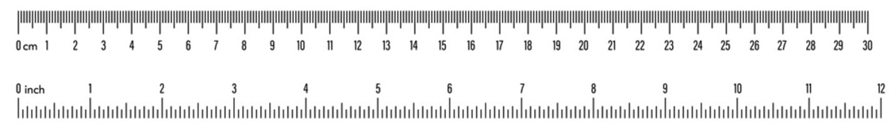
Image of a metric ruler displaying centimeter and millimeter markings, with numbered intervals and smaller subdivisions used to measure length accurately.
Figure 1. Example of a metric ruler. By Russetburbank - Own work, CC BY-SA 4.0.

The fundamental unit of length in the metric system is the meter (m). In this laboratory exercise, length measurements will be made using centimeter (cm) rulers. As illustrated on a meter stick or metric ruler, one meter is equal to 100 centimeters (cm). When examining a metric ruler, each centimeter is subdivided into smaller intervals. Between each numbered centimeter marking, there are ten equally spaced hatch marks, each being one millimeter (mm). Therefore, ten millimeters are equal to one centimeter. Familiarity with these scale divisions is essential for accurately measuring and recording length in biological laboratory experiments.
Materials
- Rulers
  - 4-5 objects of various sizes

Procedure
    - Using a centimeter ruler, record the length, width, and height, in centimeters or mm, as directed, of each object provided to you by your instructor.
    - Record your results in Table 3.

Results
Record the measurements in the Table 1.3 below:

Table 1.3 Linear Measurements and Unit Conversions

Object | Length (cm) | Width (cm) | Height (mm)
Black metal object
Storage bins
Test tube rack
Your Lab Bench
Glovebox

Lab Activity 1.3: Taking Mass Measurements with an Electronic Balance
Weight measurements in science are also expressed in metric units. The basic unit is the gram (g). The electronic balances you will be using today are gram balances. The model you will be using will accurately measure 0.01 grams. There are 1000 grams in a kilogram. One of the most common units used in labs is the milligram (mg). There are 1000 milligrams in a gram. If you need a very small amount of something, you measure it in micrograms (µg). There are 10⁶ µg in a gram. Some conversions are shown below:
1000 g = 1 kg
1 g = 1000 mg
1 g = 1,000,000 µg (10⁶ µg)
1 mg= 1000 µg (10³ µg)

Materials
- Gram balance
- Objects used in the earlier activity

Procedure
  - Press the on button and wait for the balance to display zeros on screen.
  - If the screen does not display zeros, press the “zero” or “tare” button.
  - Once the machine displays zeros (0.00 g), place your object on the center of the platform.
  - Wait for the scale to achieve a stable reading (numbers are not fluctuating).
  - Record your mass in grams in Table 1.4 for each object starting from smallest to largest.
Results
Record your results in table 1.4 as grams (g) and then convert those masses to kg and mgs.

Table 1.4. Weight Measurements and Unit Conversions
Object | Mass (g) | Mass (kg) | Mass (mg)
Black metal object
Test tube
250 ml beaker
Weigh boat
your cell phone

Lab Activity 1.4: Volumetric Measurements
The metric unit for volume is the Liter (L). There are 1000 milliliters (mL) in one liter. Another common unit in volume is the microliter (µL). There are 10⁶ µL in one liter and 1000 µL in one milliliter. Some common conversions are shown below:
1 L = 1000 mL
1 L = 1,000,000 µL (10⁶ µL)
1 ml= 1000 µL (10³ µL)
You will need to become familiar with the diverse types of instrumentation and glassware that you will be using throughout this semester. Today, we will focus on glassware and devices that measure larger volumes of liquid. You will also decide when a particular device is appropriate to use, based on the volume that you are dispensing. The types of measuring devices are quite different if you want to measure and dispense a liter versus a milliliter!

Graduated Cylinder
Image showing four graduated cylinders of different capacities (10 mL, 25 mL, 50 mL, and 100 mL), each with measurement markings and narrow cylindrical shapes used for measuring liquid volumes.
Figure 1.2. Several types of graduated cylinders: 10ml, 25ml, 50ml, and 100ml. Praphai Donphaimueang - Own work, 15 March 2016, CC BY-SA 4.0.
You will use this to dispense large volumes that are more than 10 mL. You will be using various size graduated cylinders, ranging from 10mL – 2000 mL (2L), in this lab. The volume of fluid in a graduated cylinder is measured by reading the bottom of the meniscus or the curved upper surface of the fluid in the graduated cylinder (red arrow)

Lab Activity 1.5: Serological Pipettes:

Figure 1.3. Examples of Serological Pipets, By Paweena.S - Own work, CC BY-SA 4.0. Image showing examples of serological pipettes, long transparent tubes with graduated markings, designed for measuring and transferring specific volumes of liquid using a pipette pump.
These pipettes accurately dispense volumes of 1mL to 10mL and can be used for volumes up to 50 mL. You will be using mostly 1mL and 10mL serological pipettes in this class.
Reading a Meniscus
When measuring liquid volume in a pipette or graduated cylinder, it is important to read the meniscus, the curved surface of the liquid. Most liquids (like water) form a concave meniscus, meaning the surface curves downward.

To obtain a correct measurement:
- Position your eyes level with the liquid surface to avoid parallax errors.
- Read the measurement at the lowest point of the meniscus (the bottom of the curve) for those liquids that form a concave meniscus. For liquids that form a convex meniscus (such as mercury), the measurement should be read at the top of the curve.
- Ensure the instrument is upright on a flat surface, and the liquid is still.
Careful alignment and consistent technique are essential for precise volume measurements.

Figure 1.4: Demonstration on how to read a meniscus properly. By Reading_the_meniscus.png: User:Jleedevderivative work: Rehua (talk) - This file was derived from: Reading the meniscus.png: CC BY-SA 3.0, https://commons.wikimedia.org/w/index.php?curid=18062727

Materials
- 100 ml beaker
- Distilled H20
- 50 ml graduated cylinder
- Gram scale
- 1- and 10-ml serological pipettes
- 1 large and 1 small pipette pump
- 1mL microcentrifuge tubes

Procedure
Graduated Cylinder Measurements
  - Obtain a 100 mL beaker. This is the container you will use to weigh your water. It is not what you will use to measure in this experiment.
  - Place the beaker on the balance and tare it.
  - The target amount of water you will be measuring using a graduated cylinder is 42 mL. This has been recorded in Table 5.
  - Pour 42 mL of water into a 50 mL graduated cylinder. Be sure to read from the bottom of the meniscus.
  - Pour the 42 mL from the graduated cylinder into the tared beaker.
  - Determine the weight of the water and record as “Weight of Water.”
  - Convert this weight to mL. Water has a density of 1g/mL, therefore the number of g= number of mL (e.g. 50 g = 50 mL). Record this number as “Actual Volume Dispensed.”

  - Calculate the % error for each of your measurements as follows:

Percentage Error = ∣ (Measured Value − True Value) ∣ × 100
True Value

  - If you are not within an error range of +/- 5% then try again.
  - Note: Percent error is always reported as an absolute value, so no negative sign is included. For example, a calculated value of −5% is reported as 5% error.

Lab Activity 1.6: Serological Pipette Measurements
- Dry the 100 mL beaker you used previously, with a dry paper towel. Tare it.
- Get a 10 mL serological pipette and its pipette pump. Insert the blunt end of the pipette into the pipette pump. Use the dial to draw 6.6 mL of deionized water into the pipet from a beaker filled with water.
- Dispense the water into the tared beaker, dialing the pump in the opposite direction. To get the last bit out of the pipet, quickly dial one way then the other.
- Determine the weight of the water in the beaker. If you accurately dispensed 6.6 mL; the weight difference should be close to 6.6 g. Record, it as “Weight of Water.”
- Convert the weight to mL and record as “Actual Volume Dispensed”
- Calculate the % error as described in the earlier section and record on Table 1.5.
- If you are not with in an error range of +/- 5% then try again
- Repeat steps 2-8 with a 1 ml serological pipette to dispense 0.6 ml of water into a tared microcentrifuge tube.
Results

Table 1.5 Comparison of Target, Actual Volumes and Percent Error Dispensed Using Different Measurement Devices

Device used | Attempt | Target volume dispensed (ml) | Weight of Water (g) | Actual Volume Dispensed (mL) | % Error
50 mL graduated cylinder | trial #1 | 42
50 mL graduated cylinder | trial#2 | 42
10 mL pipet | trial #1 | 6.6
10 mL pipet | trial #2 | 6.6
1 mL pipet | trial #1 | 0.6
1 mL pipet | trial #2 | 0.6

Lab Activity 1.7: Accuracy and Precision
When making measurements, both precision and accuracy are extremely important. Precision of a measurement refers to the closeness of repeated measurements or the reproducibility of the measurement. Precision can be affected by the measuring instrument. If a student uses a thermometer calibrated to the nearest degree to measure the temperature of a beaker of water and a second student uses a thermometer that is calibrated to the nearest ten degrees for the same exercise, the reproducibility or precision of measurements will be greater for the student using the thermometer calibrated to the nearest degree. The thermometer with the greatest number of calibrations (smallest increments) is the most precise, and thus the reproducibility is greater. Accuracy, described as how close a measurement is to its true value, however, is dependent upon both the precision of the measuring instrument and the technical skills of the individual taking the measurement. You will perform an experiment to determine which instrument is most accurate and precise for measuring 10ml of liquid.

Materials
- 100 ml beaker
- Distilled Water
- 50 ml graduated cylinder
- Gram scale
- 10 ml serological pipette
- Pipette pumps

Procedure
  - Obtain a 100 mL beaker. Place the beaker on the scale and hit “tare.” This will cancel the weight of the beaker.
  - Obtain a 50 mL beaker and use it to measure 10 mL of deionized water. Pour the measured 10 mL of water into the 100 mL beaker on the scale. Record the weight in grams in the Table below.
  - Convert this weight to mL. Record this number as “Actual volume dispensed.”
  - Empty the beaker on the scale and dry it well with a dry paper towel. Place it back on the scale and tare.
  - Obtain a 50 mL graduated cylinder and measure 10 mL of deionized water. Pour the measured 10 mL of water into the 50 mL beaker on the scale. Record the weight (g) and volume (ml).
  - Obtain a 10 mL serological pipet and measure 10 mL of deionized water. Pour the measured 10 mL of water into the 50 mL beaker on the scale. Record the weight (g) and volume (ml).

Results
Table 1.6: Volume, Weight, and Actual Volume Results:

Measuring Device | Volume Dispensed (ml) | Weight of Water (g) | Actual Volume Dispensed (ml)
100 ml beaker
50 ml graduated cylinder
10 ml serological pipet

Conclusion
Use your data and the questions below to write your conclusion below:
- For the volume measurements, which glassware used to measure 10 mL was the most precise? Why?

- Which measuring device was the least precise?

- For the glassware used to measure 10 mL, which instrument was the most accurate?

- Was the instrument that was most precise, the same one that is the most accurate? Why or why not?

Lab Activity 1.8: Graphing on an Excel Spreadsheet
- Open a blank MS Excel file. Save it using the File tab “Save as” choice. Name it, “Lab 1 Graph_your last name”. Make sure you save it in a location on the computer hard drive that you remember.
- Pick any cell on any column and type in Amount of Water (ml). On the next cell to the right type in
Weight (g).
- Under the Amount of water column type in the volumes of water, whose weights were measured during the experiment recorded on Table 1.6 (independent variable). Under the Weight column, type in the corresponding weights measured. (see figure on top right)
- Click on the Insert Tab on top of the page (see Figure 1.5)
- Select all the cells with text or numbers in them (Press Shift and select all the cells while holding the shift button). With the cells selected click on Recommended Charts in the menu items (See Figure 1.5)

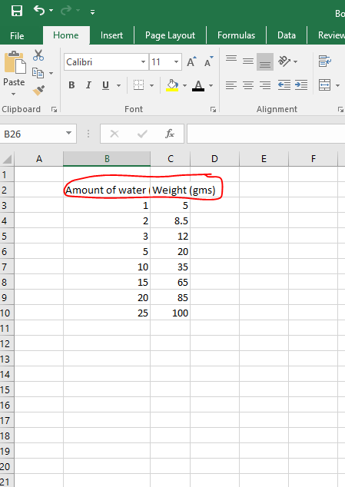

Figure 1.5: A screenshot showing data being entered into an Excel spreadsheet, with columns recording the volume and weight of water measured in a laboratory container.

- A small window opens with two tabs on the top. Click the first one on the tight that says All Charts and pick XY Scatter and hit OK
- The window will close, and a scatter plot graph will appear on the main Excel sheet (Fig. 1.7).
- Click inside the graph box and three small open shows up to the right of the graph box.
- Click on the green + sign and check on the boxes next to Axis, Chart title, Axis titles, and Gridlines. The rest of the boxes can stay unchecked.
- Rename the Axis tiles with Amount of Water (X-axis) and Weight (Y-axis). Rename the Chart tile to say,, “Volume-Weight Relationship.”
- Save the file (Control + S).

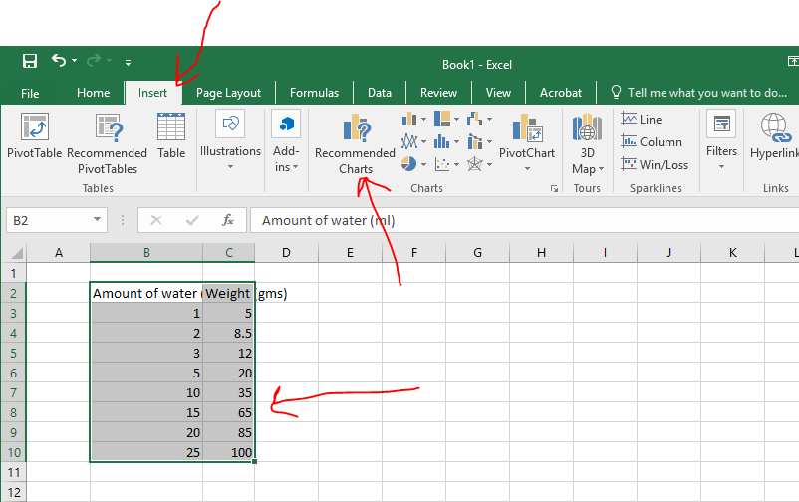

Figure 1.6: A screenshot showing multiple cells selected in an Excel spreadsheet, containing text and numbers. The top menu highlights the “Recommended Charts” choice, showing the step used to create a chart from the selected data.

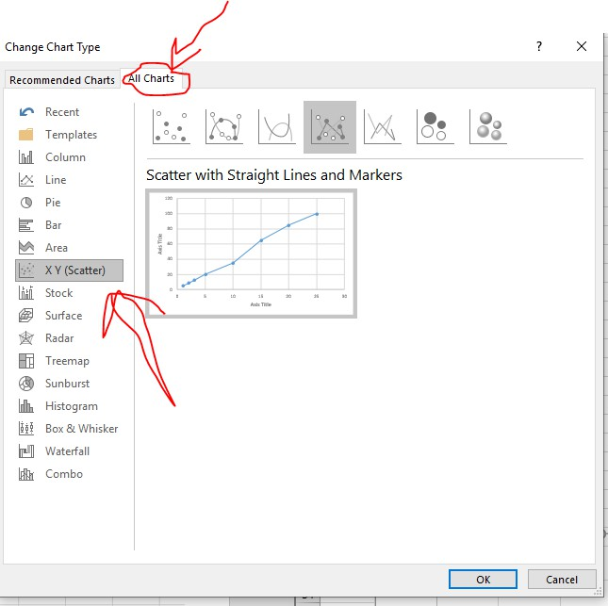
Figure 1.7: A screenshot of an Excel chart window showing two tabs at the top. The “All Charts” tab is selected, and the XY (Scatter) chart option is chosen, with an OK button highlighted to create the chart.
Post Lab Activity 1.1: Questions
Students must complete these questions after completion of the lab and give them to your instructor for review
Multiple choice
- What should you do if a chemical gets in your eyes?
A. Ignore it
B. Flush with water immediately
C. Leave lab
D. Tell a classmate
- Where should broken glass be disposed of?
A. Trash
B. Sink
C. Designated container
D. Floor
- Why should you not eat in the lab?
A. Messy
B. Contamination risk
C. Rules only
D. No reason
Short answer
- Describe one hazard you observed or learned about.

- How does PPE reduce risk in the lab?

- Which measuring device was most precise for measuring liquid volume, and why?

- Which device was the least precise for measuring 10 mL of liquid?

- Was the most precise instrument also the most accurate? Explain your answer using your data.

- Why is it important to read the bottom of the meniscus when measuring liquid volume?

- How does the base-10 structure of the metric system reduce calculation errors?

- What source of error could affect mass or volume measurements in this lab?

- Explain why SI units are essential for communicating scientific data.

- Convert 250 mL to liters.

- A cell is 5 µm wide. How many meters is this?

- Explain one advantage of using Celsius in biology experiments.

- Which metric prefix would be most appropriate for measuring bacterial size, and why?

- Describe a potential laboratory error that could occur if imperial units were used instead of SI units.

- Describe one hazard you observed or learned about.

- How does PPE reduce risk in the lab?

Additional Student Resources
Metric Conversions and Scientific measures. From New York City College of Technology, CC BY NC SA.
https://openlab.citytech.cuny.edu/bio-oer/biology-basics/units-of-measure/.

Quantitative Skills.
This site has instructions on variables, graphing a line, slope activity, and creating a line of best fit. From New York City College of Technology, CC BY NC SA.
https://openlab.citytech.cuny.edu/bio-oer/biology-basics/quantitative-skills/.

Reporting Science
This is a description of how to write lab reports. From New York City College of Technology, CC BY NC SA.
https://openlab.citytech.cuny.edu/bio-oer/biology-basics/reporting-on-science/.

Appendix: Laboratory Safety and Measurement Terms
Term | Definition
Accuracy | How close a measured value is to the true or accepted value.
Balance | An instrument used to measure mass.
Base Units | Standard units in the metric system such as meter, gram, liter, and second.
Biological Hazard | Living organisms or biological materials that may cause harm.
Chemical Hazard | A harmful substance that can cause injury or damage.
Contamination | The introduction of unwanted substances can affect results.
Conversion | The process of changing a measurement from one unit to another.
Data Recording | The accurate documentation of observations and measurements is important.
Density | The mass of a substance per unit of volume is incorrect.
Dependent Variable | The variable that is measured or observed in an experiment.
Experimental Error | Deviation from the expected result due to limitations or mistakes.
Eyewash Station | A safety device used to flush the eyes in case of chemical exposure.
Graduated Cylinder | A piece of laboratory glassware used to accurately measure liquid volume.
Graphing | The visual representation of data for analysis is important.
Hazard | A potential source of harm such as chemicals, heat, or sharp objects.
Independent Variable | The variable that is changed or controlled in an experiment is correct.
Laboratory Procedure | Step-by-step instructions followed during an experiment.
Laboratory Safety | Practices are used to prevent accidents and ensure safe working conditions in a lab.
Length | The measurement of distance from one point to another is important.
Mass | The amount of matter in an object.
Meniscus | The curved surface of a liquid in a container used for accurate measurement.
Metric Prefix | A factor that indicates multiples or fractions of base units (e.g., kilo-, milli-, micro-).
Metric System (SI) | A decimal-based system of measurement used in science worldwide.
Percent Error | A calculation that describes how far a measured value is from the true value, expressed as a percentage.
Personal Protective Equipment (PPE) | Protective clothing and gear like goggles and gloves used to prevent injury.
Physical Hazard | Environmental factors such as heat, glass, or equipment that can cause injury.
Pipette | A tool used to measure and transfer small volumes of liquid accurately.
Precision | The consistency or repeatability of measurements is important.
Reproducibility | The ability to obtain consistent results across repeated trials is important.
Scatter Plot | A graph used to display relationships between two variables.
Scientific Measurement | The process of obtaining quantitative data using standardized methods.
Tare | The process of resetting a balance to zero before measuring.8
Temperature | A measure of the amount of heat energy in a substance.
Volume | The amount of space an object or substance occupies.
Waste Disposal | The proper handling and discarding of laboratory materials.

Lab 1: Measurement and the Metric System
Instructor Prelab Ancillaries

Safety Pre-Lab Strategies
- Ask: “What could go wrong in a lab?”
- Show examples of proper vs improper clothing
- Display hazard scenarios for identification
- Check PPE compliance at start
- Correct unsafe behaviors at once
- Reinforce positive behaviors verbally

Preparation and Materials
- Ensure availability of:
    - Centimeter rulers or meter sticks
    - Electronic balances
    - Graduated cylinders (assorted sizes)
    - Serological pipettes and pipette pumps
    - Distilled water, beakers, microcentrifuge tubes, weigh boats
    - Confirm balances are calibrated and functional
Key Teaching Emphases
- Reinforce that all measurements require a number AND a unit
- Emphasize correct reading of rulers and menisci
- Review metric prefixes and powers of ten
- Introduce accuracy vs. precision early, with visual examples
Common Student Misconceptions
- Confusing mass and weight
- Reading the top instead of the bottom of the meniscus
- Misplacing decimal points during unit conversions
- Assuming precision guarantees accuracy
Instructor Post Lab Ancillaries
Safety Strategies
- Review common safety mistakes observed
- Ask students to reflect on one safety rule learned
- Use post-lab questions as a quiz or discussion
Assessment Indicators
- Correct use of metric units and prefixes
- Accurate conversions between metric units
- Appropriate selection of instruments for measurements
- Logical evaluation of accuracy and precision
- Proper data recording with units included
Discussion Prompts
- Why is water useful for evaluating volume accuracy using mass?
- How does improper instrument selection affect data quality?
- Why is consistency in units critical when comparing results between scientists?
Optional Follow-up Activities
- Metric conversion quiz
- Error analysis using student data
- Graph interpretation exercise (volume vs. mass of water)
- Small group discussion on real-world measurement errors

