Laboratory Exercise 2: Use of the Microscope

Introduction: Use of the Microscope
In this lab, you will learn how to use one of the most important tools in biology: the compound light microscope. Microscopes allow scientists to observe objects that are too small to be seen with the naked eye, such as cells, tissues, and microorganisms. Learning how to effectively use a microscope is a fundamental skill that you will use throughout this course and in many scientific careers.
During this lab, you will become familiar with the parts of the microscope and how each part works together to produce a clear image. You will focus on specimens using different magnifications, starting with low power, and working your way up to higher magnifications. As you increase magnification, you will notice critical changes in what you see, including how much of the specimen is visible (field of view) and how much of it stays in focus (depth of field).
You will also learn how to prepare your own slides using a technique called a wet mount, which allows you to see living or freshly prepared specimens. In addition, you will practice making careful observations and recording what you see through drawings and notes—an essential part of scientific investigation.
Proper handling and care of the microscope will be emphasized throughout the lab. Using the microscope correctly not only protects delicate equipment but also ensures that your observations are accurate and reliable.
By the end of this lab, you will have the skills needed to confidently use a microscope to explore the microscopic world and better understand the structure of living organisms.
Objectives
By the end of this laboratory exercise, students will be able to:
- Correctly identify and use the scanning, low power, and high-power objective lenses of a compound light microscope.
- Define and compare field of view and depth at different magnifications.
- Demonstrate proper preparation of a wet mount using cultured organisms or pond water.
- Use fine focus to determine the relative vertical position of objects within a specimen.
- Observe and accurately document microscopic specimens at increasing magnifications.
- Explain how magnification affects image clarity, field of view, and depth of field.
- Apply proper microscope handling, cleaning, and storage procedures.

General Rules:
- Always carry the microscope using two hands. The easiest way to do this is to place one hand holding the arm while the other hand is supporting the base.
- Do not touch the objective lenses. The lenses should originally be set in the scan position and when stored, the microscope scanning lens should be set in place.
- If needed, the ocular and objective lenses must be cleaned with a special lens paper and lens cleaning solution.
- Report any malfunctions of the microscope to your instructor; do not try to repair the scope yourself.

Returning the Microscope to the Cabinet.
- Lower the stage.
- Rotate the turret so that the scanning (4x) lens is in position over the stage.
- Remove the lens from the stage and clean the lens before replacing it in its storage box.
- Secure the cord by wrapping it around the correct holder on the back of the microscope.
- Replace the dust cover.
- Carry the microscope back to the storage cabinet with two hands!

Prelab Activities
Introduction
These pre-laboratory activities are designed to familiarize students with the structure and function of the compound microscope. Students will identify key microscope components, match each part with its function, and apply their understanding to written responses. Completion of these activities prior to the lab session will help ensure proper microscope use and improve observational accuracy during laboratory work.

Prelab Activity 2.1. Terms to define:

- Arm
- Neck
- Body
- Base
- Ocular lens
- Objective lens
- Rotating nosepiece or Turret
- Course and Fine focus knobs
- Mechanical stage
- Iris diaphragm
- Condenser adjustment knob

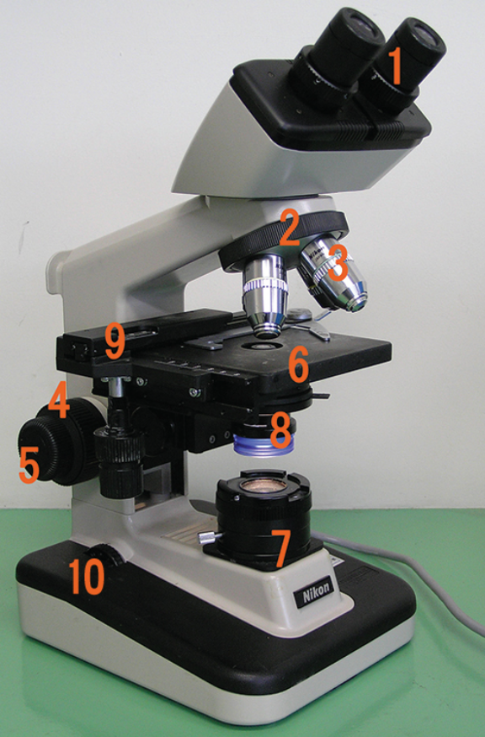
Enumerated diagram of a typical bright-field microscope showing major components, including the ocular lens, head, revolving nosepiece, objective lenses, stage, condenser, iris diaphragm, light source, coarse and fine focus knobs, arm, and base.
Figure 2.1 Components of a Typical Bright Field Microscope.

Prelab Activity 2.2
Identify the following parts and functions of the microscope above.

- _________________________
- _________________________
- _________________________
- _________________________
- _________________________
- _________________________
- ___________________________
- ___________________________
- ___________________________
- ___________________________
Prelab Activity 2.2
Match the microscope part with its definition.
Microscope Part
__________ Condenser
__________ Revolving Turret
__________ Mechanical stage
__________ Ocular lens
__________ Power switch
__________ Iris diaphragm
__________ Arm
__________ Depth of field
__________ Fine focus
__________ X-Y stage controls
__________ Light source
__________ Total magnification
__________ Head
__________ Base
__________ Objective lens
__________ Course focus
__________ Field of view
Definitions
- The light source at the bottom of the microscope, also known as the illuminator.
- Also known as the body- carries the oculars.
- The microscope supports.
- The part that connects the head and the base.
- The lens closest to the eye
- The major lenses closest to the specimen
- Also known as the nosepiece-holds the objective lenses
- Knob that makes large scales adjustments in the focus
- The knob that makes small adjustments in the mechanical stage.
- Set of lenses that collect and focus the light onto the specimen.
- Controls the amount of light reaching the specimen.
- Controls that move the slide vertically and horizontality on the stage
- Calculated by multiplying the ocular magnification by the objective magnification.
- The visible area one can see through the oculars.
- The measure of the thickness or the specimen in focus
- The switch used to turn the microscope on and off.
- The section in which the specimen is placed for viewing.

Prelab activity 2.3
Answer the following questions in a brief paragraph.
- What is the field of view, and how does it change as magnification increases?

- Define depth of field in microscopy.

- Which objective lens provides the greatest depth of field? Why?

- Why is it important to center a specimen before switching to a higher magnification?

- What is a wet mount, and what type of specimens are commonly observed using this technique?

- What is the purpose of using the fine adjustment knob instead of the coarse adjustment knob at high magnification?

Lab Activities
Introduction: Magnification and Microscope Use
This laboratory activity introduces students to the proper use of the compound light microscope, a fundamental tool in biological sciences. Students will learn to identify microscope components, understand how magnification is achieved, and develop skills in focusing on specimens at increasing levels of magnification. Emphasis will be placed on proper handling, accurate observation, and the relationship between magnification, field of view, and depth of field. Mastery of these techniques is essential for examining biological specimens and conducting accurate scientific observations.
Magnification
Student scopes used in our classes have four objective lenses (i.e., those that are closest to the specimen); scanning, low power, high power, and oil immersion. The set of lenses closest to the eye are the ocular lenses.

General Procedures
Microscope components
Lab Activity 2.1
- Carry the microscope with two hands and bring it to your lab bench
Clear your workspace for safe and comfortable use
- Collect slides:
  - Metric ruler
  - Letter “e”
  - Crossed colored threads
  - Prepared organism slides
- Clean ocular and objective lenses with lens paper
Set the nosepiece to the scanning (lowest power) lens
- Plug in the microscope
- Identify and label microscope parts

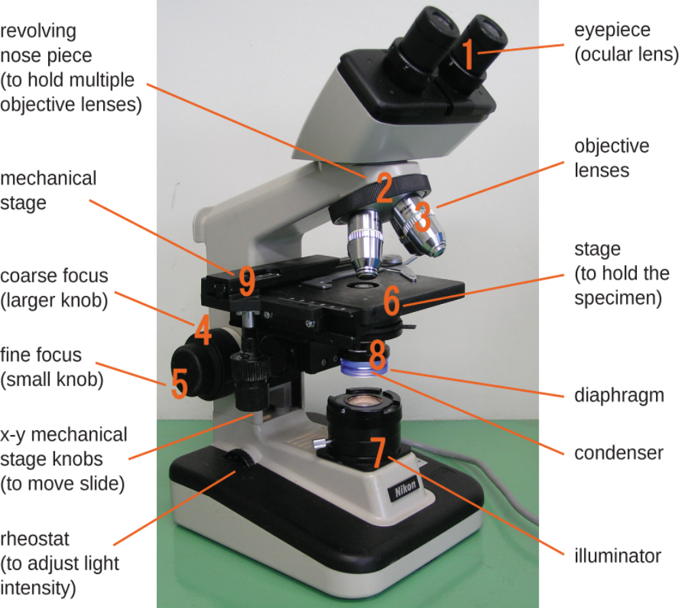
Labeled diagram of a bright-field microscope showing key components, including the ocular lenses, head, revolving nosepiece, objective lenses, stage, mechanical stage controls, condenser, iris diaphragm, light source, coarse and fine focus knobs, arm, and base.
Figure 2.2 Components of a Typical Bright Field Microscope, labelled.
Key: Components of a typical bright field microscope.

- Ocular lens
- Head
- Revolving nose piece (turret)
- Objective lens
- Arm
- Mechanical stage
- Stage clips
- Diaphragm
- Condenser
- Fine focus
- Course focus
- X-Y Mechanical stage knobs
- Light source (Illuminator)
- Rheostat
- Illuminator switch

Lab Activity 2.1
Record the magnifications of the lenses on your microscope in the table below.
Table 2.1. Ocular and Objective Lens Magnifications and Total Magnification
Lenses | Ocular Lens | Objective lens | Total Magnification
Scanning power: dry
Red lines
Low power: dry
Blue lines
High Power: dry
Yellow lines
Oil Immersion: oil
Black/white lines

To figure out the total magnification simply multiply the ocular lens magnification by the objective lens magnification. For example, if the Ocular lens magnification is 10X and the scanning lens magnification is 4X, then the total magnification will be 40X. Complete the table above.
Focusing on Specimens
For biology 110 labs you will only be focusing on a total magnification of 400x. You will have to use the oil immersion lenses (1000x) in your Microbiology (230) classes. For your first practical, you will have to focus clearly on a specimen at a total magnification of 400x. You will have two minutes to complete this task.
Focusing on a specimen may be broken down into a three-step process.
- Scanning Lens (4x):
- Begin focusing on a specimen using the Scanning lens. First, adjust the mechanical stage so that it is at its lowest position. You can do this by turning the course focus knobs away from your body.
- Turn on the light. And adjust the ocular lenses so that your field of view is a circle of light.
- Place and center the specimen on the mechanical stage.
- Look into the oculars and slowly raise the mechanical stage by turning the course focus knob towards your body. Stop when it comes to focus. You may adjust the focus using the fine focus knob that is needed.
- Center the specimen. Adjust the X-Y stage knobs so that your specimen is in the center of your field of view. This position will enable you to see the specimen when you adjust the lens to the next higher magnification. If the specimen is found to the side, then you may lose the specimen from your field of view when you adjust your objective lens to the next higher magnification.

- Low Power (10x)
  - Next, while looking into your objective lenses, turn the turret clockwise (to the right) to 10x power.
  - Adjust the focus. Do not use the course focus knob to adjust your focus. Only use the fine focus knob at this point. If you use the course focus knob, then you may adjust your focus too far out of focus and may have to start at the Scanning power again.
  - Center your specimen

- High Power (40X)
  - Finally, switch to the high-power lens (40X) by turning the lens to the right (clockwise). At this point only use the fine focus to adjust the focus.
  - If the color of light is too yellow, you may adjust the rheostat to change the color of light to a white light.
  - If the light is too dark, you may adjust the diaphragm.

Measuring and Calculating the Field of View
The field of view is the area of the specimen you can see through the ocular lenses. When you adjust your magnification, the diameter will decrease at higher magnifications. The image below, figure 2.3, is an example of a field of view.
How to find the field of view:
- Obtain a prepared slide with a ruler and place it on the stage.
- Adjust the ruler so that the edge of the ruler is visible as a series of tic marks/lines that lie across the diameter or the field of view as in the figure below.
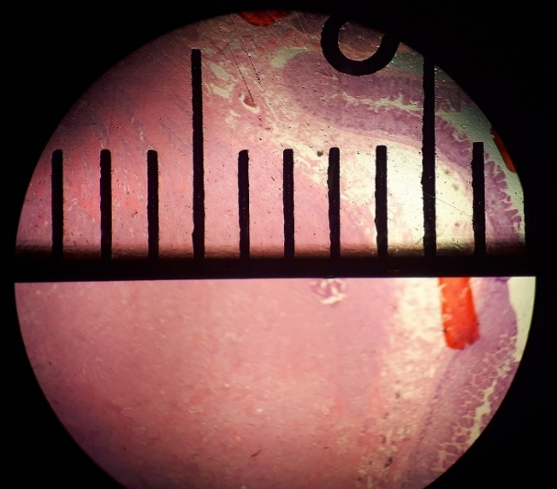
Microscope field of view showing a metric ruler aligned across the circular viewing area, with measurement markings used to determine the diameter of the field of view.
Figure 2.3. Field of view diameter being measured in a microscope with a metric ruler. Mikael Häggström, 29 January 2020. CC0.

Arrange the slide so that the horizontal line is aligned along the midline of the field as seen above. Align one of the vertical lines so that it is at the edge of your field of view, as you can see on the right side of the picture. The space between the leading edge of the horizontal lines is 1 mm in distance, see the yellow bar.
- Measure the distance of the field of view for the scanning lens (4X)
  - ________________ mm.
  - ________________ um
- Measure the distance of the field of view for the low power lens (10x)
  - __________ mm
  - __________ um
When you use high-power and oil-immersion lenses, you should not be able to measure the field of view directly. At this point, you will have to calculate the field of view. This calculation is a simple conversion using the formula below:
Conversion Formula:
(Diameter of the field; A) X (Total Magnification: A) = (Diameter of the field; B) X (Total Magnification: B)
In this case “A” stands for the known field information of the measured field of view of either the scanning or low-power magnification and “B” stands for the information of the new or unknown lens magnification (e.g., high-power or the oil immersion lenses)
- Figure out the distance of the field of view for the high-power objective lens (40X)
  - ________________ mm.
  - ________________ um
- Determine the distance of the field of view for the oil-immersion objective lens (100X)
  - __________ mm
  - __________ um
Focusing Exercise(s)
- Letter “e” exercise
  - Obtain a letter “e” slide and place it on the mechanical. Note the position of the “e.” Draw and label it on the page.
  - Center the “e” and look at it through the oculars. Draw this “e” and label it.
  - Describe the differences there are between the two ’e’s. Hint: look at and describe its position and orientation.

Field of View and Depth of Field of a Microscope
- When viewing a specimen through a microscope, the visible area appears circular and is referred to as the field of view. The diameter of this circle decreases as magnification increases.
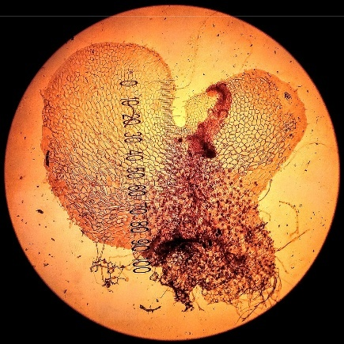
Circular microscope field of view displaying the prothallium of Polypodium vulgare at 4× magnification, showing a thin, flat, green plant structure centered within the viewing area.

Figure 2.4. Circular microscope field of view showing the prothallium (prothallus) of Polypodium vulgare. Taken with a light microscope on x4 magnification. Image: Viséan, 2019, CC BY-SA 4.0, https://commons.wikimedia.org/wiki/File:FileName.jpg
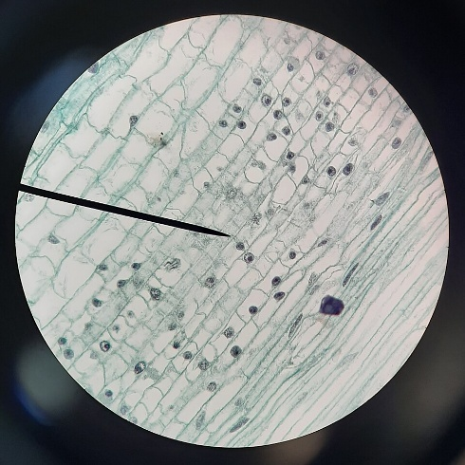
Circular microscope field of view displaying an unknown plant specimen, showing cellular or tissue structures within a round viewing area under magnification.
Figure 2.5. A view of an unknown plant under a microscope. Palmer-Harris, L. (2021, December 28).CC BY SA 4.0.
- The depth of field is the vertical distance (top to bottom) within the specimen that stays in focus at one time. As magnification increases, the depth of the field decreases. Therefore, the scanning objective lens provides the greatest depth of field, while the oil immersion objective lens has the shallowest depth of field.
Microscopic view showing three overlapping yarn fibers at 40× magnification, with only portions of the fibers in sharp focus at a time, illustrating limited depth of field.
Figure 2.6. View showing three overlapping yarn fibers (40×). Image from Botweb, the University of Wisconsin, https://botweb.uwsp.edu/130y.htm.
- A prepared slide having three differently colored silk fibers or threads is commonly used to show depth of field. In this preparation, the threads are arranged to cross at a single point, with each thread positioned at a different vertical level. By focusing at 400x and adjusting the fine focus and seeing which thread comes into focus first, second, and last, the relative positions of the threads—top, middle, and bottom—can be figured out.

Depth of Field Using Crossed Threads
- Obtain a prepared slide containing three crossed threads.
- Place the slide on the microscope stage. Using the scanning objective lens, bring the threads into focus with the fine adjustment knob. Figure out which thread is positioned on the top, in the middle, and at the bottom of the slide.
- Switch to the 100× (low power) objective lens. Locate the top thread and then focus on the bottom thread. Compare the amount of fine focus adjustment needed at this magnification to that used with the scanning objective.
  - Did you need to move the adjustment knob more or less? __________________
- Change to the 400× (high power) objective lens. At this magnification, each thread may occupy most of the field of view.
  - Is the entire thickness of a thread in focus as it was under the scanning objective lens? __________
  - What does this observation say about the depth of field at high magnification? __________

- Using only the fine focus knob, figure out the relative vertical position of each colored thread.
  - Bottom thread: __________________
  - Middle thread: __________________
  - Top thread: __________________
Examining Tissues
Your instructor will guide you in observing a series of prepared organism slides to practice proper microscope technique. Examine each slide using total magnifications of 40×, 100×, and 400×.
Place particular emphasis on effective focusing and observation at 400× magnification, as this magnification will be used during the practical examination. Draw and label the organisms from the prepared slide

Prepared slide

Identification of the organism: ____________________

Prepared slide

Identification of the organism: ____________________

Preparing a Wet Mount
You will have to prepare wet mount slides of fresh specimens on many occasions during this course. You will often need to apply a biological stain to a specimen to see the structures within cells. Such stains combine with cellular components. Selective use of available stains enables the observer to see desired components. It is also important when preparing wet mount slides to use the thinnest section of a specimen possible. You will use a scalpel or razor blade to section your specimens. A wet mount requires a layer of liquid to completely fill the space between the slide and coverslip, immersing the specimen and enabling the observer to clearly focus through the microscope.
Procedure:
- Wet mount of an Onion Skin
Watch the video on this link to see how to prepare wet mount of an onion skin and then follow the instructions below:
- Prepare the specimen
- Peel a small, rectangular piece of transparent epidermis (inner layer) from a sliced onion.
- Place the onion skin flat in the center of a clean glass slide.
- Stain
- Add one drop of methylene blue directly onto the onion skin.
- Let it sit for 1–2 minutes, so the stain penetrates the cells.
- Remove excess stain and rinse
- Gently touch a corner of a paper napkin to the slide edge (not the specimen) to wick away excess stain.
- Add one small drop of water to rinse the stained area, then wick away the rinse with the napkin.
- Repeat the rinse once, if needed, remove the excess each time.
- Mount with a coverslip
- Place one final small drop of water on the specimen.
- Hold the coverslip at a 45° angle and slowly lower it onto the drop to spread the liquid and avoid air bubbles.

A student lowers a coverslip at a 45-degree angle onto a glass slide having a drop of liquid and a specimen, allowing the liquid to spread evenly and prevent air bubbles from forming beneath the coverslip.
Figure 2.7 Image of placing a coverslip on a glass slide when making a wet mount. Image courtesy of New York City College of Technology. BY CC NC SA 3.0.

- Clean slide edges
- Run the edge of a paper napkin around the coverslip to remove excess fluid.
- Wipe and dry the bottom of the slide so it is clean for viewing.
- Observe under the microscope
- Secure the slide on the stage. Start with the scanning objective lens (4X) to find tissue; center a clear area in the field of view.
- Switch to low power (10X), re-center and refocus, then move to high power (40X) for details (40X objective with a 10X eyepiece = 400X).
- Always center and refocus before increasing magnification. Draw or image what you see.
- Finish and dispose
- Rotate the scanning (4X) objective lens into place and lower the stage. Remove the slide and place it in the “Used Slides” container.
- Clean and store equipment per lab protocol and wash your hands.
Safety notes: avoid pressing the coverslip, handle methylene blue carefully, and follow your lab’s disposal procedures.

- Wet mount of human cheek cells
Watch the video on this link to see how to prepare wet mount of a cheek cell and then follow the instructions below:
- Wash your hands with soap and water.
- Watch the onionskin wet mount video first.
- Use a sterile cotton swab or the flat end of a clean toothpick to gently scrape the inside of your cheek (do not poke or scrape hard).
- Place a clean microscope slide on a flat surface and add one drop of water to the center.
- Rub the swab or toothpick tip gently through the drop for ~4 seconds to transfer cells. Discard the used swab/toothpick safely.
- Add one drop of methylene blue to the smear (at the edge of the drop to avoid bubbles).
- Carefully lower a cover slip at an angle over the drop to avoid trapping air bubbles.
- Blot any excess stain from the slide edge with absorbent paper.
- Place the slide on the microscope stage. Start with the scanning (4X) lens to locate the sample, then switch to a 40X objective (400X total with a 10X eyepiece) to observe stained cheek cells.
- When finished, dispose of the cover slip and slide per your lab’s biohazard or sharps protocol, and wash your hands.
Safety notes: wear gloves and eye protection if available; avoid swallowing stains; do not reuse contaminated toothpicks; follow institutional disposal rules.

II. Wet Mount Preparation of Cultured Organisms and Pond Water

View the instructional video in this link to review wet mount preparation techniques using cultured organisms. Then complete the following procedure.
- Gather materials: plastic pipette, clean slide, coverslip, and your sample (cultured organisms or pond water).
- Use the pipette to draw liquid from near the bottom of the container (where organisms collect).
- Put 1–2 drops of the sample in the center of the slide.
- Hold the coverslip at a 45° angle and slowly lower it onto the drop to avoid air bubbles.
- Blot excess liquid by touching a paper napkin to the coverslip edge; dry the underside of the slide.
- Place the slide on the stage. Start with the 4× (scanning) objective lens to find the specimen, center it, then move to 10× and 40×—recenter and refocus at each step.
- Record observations with a labeled drawing.
- Finish: return the 4× objective lens, lower the stage, remove the slide, and put it in the “Used Slides” container.
Safety: avoid contaminating the sample, do not a pipette by mouth, and follow lab disposal rules.

End-of-Lab Procedures
- Clean and return all prepared slides to their designated storage trays.
- Turn off and unplug the microscope; neatly wrap the power cord around the cord holder or base.
- Rotate the head to face inward toward the microscope body.
- Set the objective turret to the scanning (4×) objective lens.
- Lower the stage fully.
- Place the dust cover over the microscope (if available).
- Return the microscope to its assigned storage cabinet.
Troubleshooting Guide
- Image too dark
- Check power: ensure the microscope is plugged in and switched on; confirm the light is lit.
- Increase light: raise the rheostat (brightness control).
- Open the iris diaphragm and/or raise the condenser to let more light through.
- Fine-tune the rheostat until the image is bright and white.
- Unable to see a single image with both eyes
- Move your head slightly away from the eyepieces.
- Adjust interpupillary distance by sliding the oculars together or apart until one image appears.
- Stationary spot in the field of view
- The lens is likely to be dirty. Use only lens paper to gently clean the oculars and objective lenses.
- If needed, carefully remove the ocular to clean the inner surface.
- Do not use tissues, paper towels, or clothing (they can scratch lenses).
- Eyelashes or other near eye artifacts visible
- e too close to the eyepieces—move your head back a little.
- Nothing visible at high power
- Always focus on scanning (4×) and low (10×) first, center the specimen, then switch to high (40×).
- Make sure the specimen is centered before increasing magnification.
- Only part of the field is illuminated (half-moon)
- Ensure the objective clicks fully into place on the nosepiece.
- Adjust the condenser and its centering to align the light.
- Image stays blurry and will not focus
- Check the slide orientation (not upside down) and that it is secured in the stage clips.
- Recenter the specimen and refocus at lower magnification before switching up.
- Eye strain or headache from using the microscope
- Focus first with your dominant eye (e.g., right eye), then adjust the other ocular diopter.
- Set interpupillary distance correctly and reduce light intensity if it is too bright.
- Take short breaks to rest your eyes.
Quick maintenance/reminders
- Always start with the lowest magnification, center the specimen, then increase power.
- Use only lens paper for optics.
- If problems persist, notify the instructor or lab technician.

Student Post-Laboratory Policy
Students must complete all assigned post-laboratory questions, including both short-answer and multiple-choice items, following the completion of the laboratory exercise. These questions are designed to assess understanding of key concepts and proper application of laboratory techniques.
All responses must be completed prior to leaving the laboratory unless otherwise directed by the instructor. Students must present their completed work to the instructor for review and verification before departure.
Be advised that completion of the post-laboratory questions may be required for a grade at the discretion of the instructor. Failure to complete, submit, or obtain instructor for review of the assigned questions may result in a loss of credit or the assignment being considered incomplete.
It is the responsibility of each student to ensure compliance with all post-laboratory requirements and grading expectations as outlined by their instructor.
Student Post-Laboratory Questions
(To be completed after the laboratory to assess comprehension)
- How did the depth of field change as you increased magnification from 4× to 40×?

- In the crossed threads slide, how were you able to determine which thread was on top, middle, and bottom?

- Why was it more difficult to keep the entire specimen in focus at higher magnifications?

- Describe one structure you observed in the wet mount that was not visible at lower magnification.

- What mistakes could lead to a broken slide or damaged objective lens, and how can they be avoided?

- How does proper microscope care extend the life of the instrument and improve data quality?

Multiple choice questions
Directions: Choose the best answer for each question.
Basic Knowledge and Application
- Which part of the microscope is closest to the eye?
A. Objective lens
B. Condenser
C. Ocular lens
D. Stage
- What is the total magnification if the ocular lens is 10× and the objective lens is 40×?
A. 4×
B. 50×
C. 400×
D. 100×
- Which objective lens should always be used first when focusing on a specimen?
A. Oil immersion
B. High power
C. Low power
D. Scanning
- What is the function of the coarse focus knob?
A. Adjust light intensity
B. Make small adjustments to focus
C. Move the stage for large focusing adjustments
D. Change magnification
- Which part controls the amount of light reaching the specimen?
A. Condenser
B. Iris diaphragm
C. Objective lens
D. Mechanical stage

- What happens to the field of view as magnification increases?
A. It increases
B. It stays the same
C. It decreases
D. It becomes brighter
- Which structure holds the objective lenses and rotates to change magnification?
A. Arm
B. Base
C. Revolving nosepiece
D. Stage clips
- What is the correct way to carry a microscope?
A. With one hand on the base
B. With one hand on the arm
C. With two hands (arm and base)
D. By holding the eyepiece
- Which lens requires the use of immersion oil?
A. Scanning lens
B. Low power lens
C. High power lens
D. Oil immersion lens
- What is resolution?
A. The brightness of an image
B. The amount of light entering the microscope
C. The ability to distinguish two close points as separate
D. The total magnification
Higher-Order Thinking (Analysis & Application)
            - A student switches directly from scanning (4×) to high power (40×) and cannot find the specimen. What is the most likely reason?
A. The light intensity is too high
B. The specimen was not centered before increasing magnification
C. The objective lens is broken
D. The eyepiece needs cleaning
            - If an image is too dark, which combination of actions would best improve visibility?
A. Lower the stage and use coarse focus
B. Increase illumination and open the diaphragm
C. Switch to higher magnification
D. Close the diaphragm and turn off the light
            - Why does depth of field decrease as magnification increases?
A. The lens becomes larger
B. More light passes through the specimen
C. A thinner section of the specimen can be kept in focus
D. The field of view increases
            - Two students measure the same specimen. One gets consistent results that are slightly off from the true value, while the other gets varied results around the correct value. Which is true?
A. First student is accurate, second is precise
B. First student is precise, second is accurate
C. Both are equally accurate
D. Neither is precise
            - If a specimen moves to the left when viewed under the microscope, what direction was the slide actually moved?
A. Left
B. Right
C. Up
D. Down

            - A student uses the coarse focus knob while viewing a slide under high power and breaks the slide. What mistake did the student make?
A. Used the wrong lens
B. Turned the light off
C. Used coarse focus at high magnification
D. Did not center the specimen
            - A biologist needs to observe small internal cell structures. Which combination of features is most important?
A. Low magnification and large field of view
B. High magnification and high resolution
C. Low resolution and high brightness
D. Large stage and low light
            - Why is it important to center the specimen before switching to a higher magnification?
A. It improves light intensity
B. It prevents lens damage
C. The field of view becomes smaller at higher magnification
D. It increases resolution
            - A student notices that only half of the field of view is illuminated. What is the most probable cause?
A. Dirty slide
B. Objective lens not fully clicked into place
C. Stage is too low
D. Specimen is too thick
            - Why is starting with the scanning objective considered best practice?
A. It gives the highest resolution
B. It allows faster focusing with fine adjustment
C. It provides the widest field of view and reduces the risk of damage
D. It requires less light

Student resources:

Microscopy

The Light Microscope. A review of lab materials.
https://openlab.citytech.cuny.edu/bio-oer/biology-basics/microscopy/.

Learn the parts of the microscope (activity)
  - Visit https://www.ncbionetwork.org/iet/microscope/
    - Click on “Explore”
    - Click on parts “?” to learn their name and function

Table 2.2. Chapter 2: Microscopy Glossary of Terms and Definitions
This table provides key terminology related to microscopy, along with concise definitions of each term. It serves as a reference for understanding the structure, function, and proper use of the microscope, as well as concepts such as magnification, and resolution.
Chapter 2: Microscopy Glossary
Terms | Definitions
binocular | a microscope having two eyepieces
brightfield microscope, | a compound microscope with two or more lenses that produce a dark image on a bright background.
coarse focusing knob | used for large-scale movements with 4⨯ and 10⨯ objective lenses
condenser lens | (located below the stage), which focuses all the light rays on the specimen to maximize illumination.
fine focusing knob | used for small-scale movements, especially with 40⨯ or 100⨯ objective lenses.
fixation | The process of attaching cells to a slide.
illuminator | provides light for the brightfield microscope
lens | a medium with a curved surface that refracts and focuses on light to produce an image.
magnification | the ability of a lens to enlarge the image of an object when compared to the real object
monocular microscope | a microscope having a single ocular lens
objective lenses | the lenses far end of the body tube
ocular lens | the eyepiece of a microscope
oil immersion lens, | a special lens designed to be used with immersion oils.
refraction | occurs when light waves change speed and direction as they pass from one medium to another.
resolution | The ability to tell that two separate points or objects are separate.
rotating nosepiece, also known as the revolving turret, | sits below the head of the microscope and locks the objective lens into position over the stage aperture by rotating in either direction.
stage | (a platform) of the microscope total magnification is the product of the ocular magnification times the objective
Total magnification | (ocular magnification × objective magnification)
wet mount | slide preparation in which the specimen is placed on the slide in a drop of liquid.
x-y mechanical stage knobs. | These knobs move the slide on the surface of the stage, but do not raise or lower the stage.

Instructor Prelab Ancillaries
(for preparation and facilitation)
- Prelab Checklist
  - Microscopes cleaned, functional, and properly adjusted
  - Prepared crossed threads slide available
  - Culture jars or pond water samples prepared
  - Pipettes, slides, coverslips, paper towels available
- Prelab Discussion Points
  - Review microscope parts and safety
  - Emphasize differences between coarse and fine focusing
  - Demonstrate proper wet mount technique (live or video)
  - Clarify expectations for drawings and observations
- Common Prelab Misconceptions to Address
  - Higher magnification always gives a “better” image
  - Coarse focus can be used safely at high power

Instructor Post Lab Ancillaries
(for assessment and reinforcement)
- Observation Rubric
  - Proper microscope setup and focusing
  - Correct identification of top/middle/bottom threads
  - Accurate drawings with labels and magnification noted
- Post Lab Discussion Prompts
  - Why depth of field decreases with magnification
  - Applications of wet mounts in clinical and environmental biology
  - Real-world consequences of improper microscope handling
- Formative Assessment Options
  - Short practical quiz using the 40× objective
  - Exit ticket: “One thing that surprised me about microscopy today”

Citations
- Figure 2.1. Components of a typical bright field microscope. GCG(jawp). 2008. https://commons.wikimedia.org/wiki/File:Optical_microscope_nikon_alphaphot.jpg#/media/File:Optical_microscope_nikon_alphaphot.jpg.
- Figure 2.2 Components of a typical bright field microscope. Parker, Schneegurt, Tu, Lister, and Forster. OpenStax. Microbiology. Nov 1, 2016. Houston, Texas. https://openstax.org/books/microbiology/pages/1-introduction. https://openstax.org/books/microbiology/pages/2-3-instruments-of-microscopy
- Figure 2.3: Field of view diameter measured in a microscope with a metric ruler. Häggström, M. (2020, January 29). Field of view diameter being measured in a microscope with a metric ruler [Photograph]. Wikimedia Commons. https://commons.wikimedia.org/wiki/File:Field\_of\_view\_diameter\_in\_microscopy.jpg (CC0)
- Figure 2.4. Viséan. (n.d.). Circular microscope field of view showing the prothallium (prothallus) of Polypodium vulgare [Photograph]. Wikimedia Commons. https://commons.wikimedia.org/wiki/File:FileName.jpg (CC BY-SA 4.0)
- Figure 2.5. Palmer-Harris, L. (2021, December 28). View inside microscope [Photograph]. Wikimedia Commons. https://commons.wikimedia.org/wiki/File:View\_Inside\_Microscope.jpg. (Licensed under CC BY-SA 4.0)
- Figure 2.6. Fritzmann2002. (2017, September 1). A circular field of view showing two overlapping yarn fibers observed under a standard light microscope at 40× magnification [Photograph]. Wikimedia Commons. https://commons.wikimedia.org/wiki/File:Blue%2BRed\_String\_Under\_Microscope_(40x).jpg (CC BY-SA 4.0)

