Laboratory Exercise 4: Molecular Structure of Biological Molecules
Carbohydrates, Lipids, Proteins, Nucleic Acids, and Functional Groups
Estimated Time: 2.5–3 hours
Introduction
Living organisms are composed of many organic molecules, most of which can be grouped into four major biological classes: carbohydrates, lipids, proteins, and nucleic acids. These molecules are central to life because they store energy, provide structural support, regulate cellular processes, form membranes, catalyze reactions, and carry genetic information.
Many biological molecules are built from smaller units. For example, simple sugars called monosaccharides may exist as individual molecules or join to form disaccharides and polysaccharides. Amino acids link together to form polypeptides and proteins. Nucleotides form nucleic acids such as DNA and RNA. Lipids are more chemically diverse; some contain fatty acids and glycerol, while others, such as sterols, contain fused carbon rings.
In this laboratory, you will examine molecular models and structural formulas representing the four major classes of biological molecules. You will identify functional groups, compare molecular structures, and relate structure to biological functions. As you work, focus on how atoms, bonds, polarity, molecular shape, and subunit arrangement influence what each molecule does in living systems.
For a direct and concise review of this topic you con review the following review on the macromolecules: Macromolecules - Classes and Functions from the 2-Minute Classroom
Learning Objectives
By the end of this laboratory, students should be able to:
- Identify the four major classes of biological molecules.
- Recognize common subunits of carbohydrates, proteins, and nucleic acids.
- Compare monosaccharides, disaccharides, and polysaccharides.
- Distinguish among major lipid types, including fatty acids, triglycerides, phospholipids, and sterols.
- Identify the general structure of an amino acid and explain the importance of the R group.
- Describe the basic structure of nucleotides, DNA, and RNA.
- Identify common functional groups in biological molecules.
- Explain how molecular structure relates to biological functions.
Terms to Define Before Lab
Define the following terms before beginning the lab.
- Organic molecule

- Macromolecule

- Monomer

- Polymer

- Functional group

- Hydroxyl group

- Carboxyl group

- Amino group

- Phosphate group

- Monosaccharide

- Disaccharide

- Polysaccharide

- Glycosidic linkage

- Fatty acid

- Triglyceride

- Phospholipid

- Sterol
- Amino acid

- Peptide bond

- Nucleotide

Pre-Lab Questions: Complete these questions before coming to the lab.
Multiple Choice
- Which element forms the backbone of most biological organic molecules?
A. Sodium
B. Carbon
C. Chlorine
D. Potassium

- Which class includes sugar and starches?
A. Lipids
B. Proteins
C. Carbohydrates
D. Nucleic acids
- Which molecule is a monosaccharide?
A. Glucose
B. Sucrose
C. Starch
D. Cellulose
- Amino acids are the monomers of:
A. Proteins
B. Lipids
C. Nucleic acids
D. Carbohydrates
- Nucleotides are the monomers of:
A. Proteins
B. Nucleic acids
C. Lipids
D. Polysaccharides
- Which molecule is a key component of cell membranes?
A. Phospholipid
B. Glucose
C. Amino acid
D. Cellulose
- Which lipid has a four-ring carbon structure?
A. Triglyceride
B. Sterol
C. Phospholipid
D. Fatty acid
- Which process breaks polymers by adding water?
A. Dehydration synthesis
B. Hydrolysis
C. Translation
D. Diffusion
- Which biological molecule stores hereditary information?
A. DNA
B. Triglyceride
C. Starch
D. Cholesterol
- Which functional group is commonly found in amino acids?
A. Amino group
B. Phosphate group only
C. Methyl group only
D. Sulfhydryl group only
Short Answer
- What are the four major classes of biological molecules?

- What is the difference between a monomer and a polymer?

- What is a functional group?

- Why is carbon especially important in biological molecules?

- What atoms are commonly found in carbohydrates?

- What is the difference between starch and cellulose?

- What is the difference between a saturated and unsaturated fatty acid?

- What does it mean for a molecule to be amphipathic?

- What are the three parts of a nucleotide?

- Why is molecular shape important in biology?

Materials
Each student or group should have:
- Lab handout
- Pencil or pen
- Colored pencils or highlighters
- Molecular model kit or instructor-provided molecular diagrams
- Textbook or approved course reference
- Ruler or straightedge
- Optional: digital molecular model viewer

Laboratory Procedure
Part I. Carbohydrates: Sugars and Polysaccharides
Suggested Time: 35–40 minutes
Carbohydrates are composed primarily of carbon, hydrogen, and oxygen. Many carbohydrates contain multiple hydroxyl groups, making them polar and often water-soluble. Carbohydrates may function as immediate energy sources, energy-storage molecules, or structural materials. This topic may be reviewed in “Carbohydrates,; biological molecules simplified #1”
A. Monosaccharides: Glucose
Glucose is a six-carbon monosaccharide with the molecular formula: C₆H₁₂O₆
Glucose may be represented in a linear or ring form. Ring forms are common in aqueous environments. Different ring arrangements of glucose can produce structural isomers, such as alpha-glucose and beta-glucose.
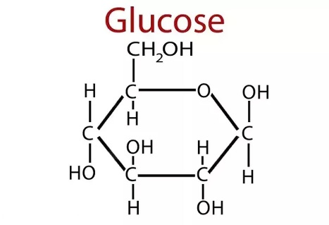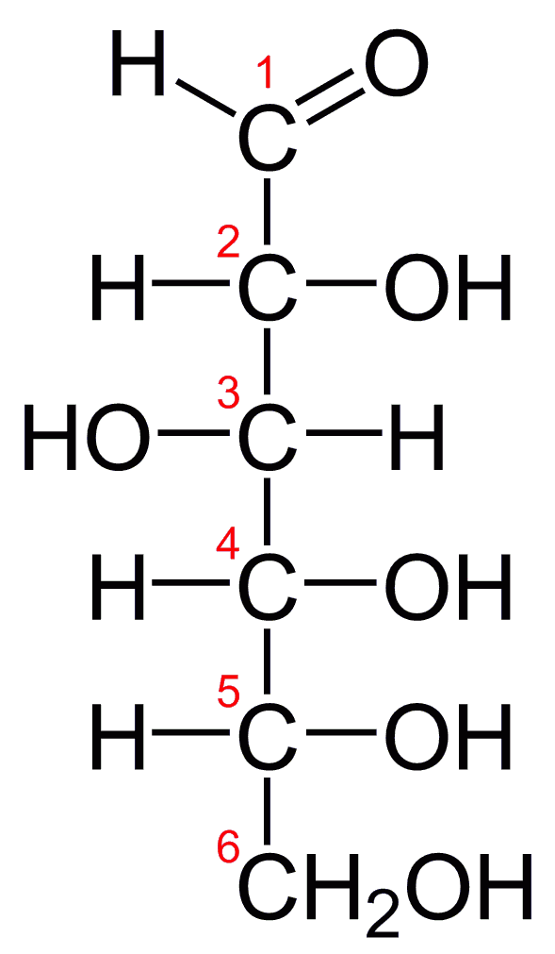
Figure 4.1a: a glucose molecule Figure 4.11b: a linear glucose molecule
Two diagrams of glucose are shown: Figure 4.1a presents glucose as a ring-shaped molecule, while Figure 4.1b shows it as a straight-chain molecule, illustrating its two common forms.
Figure 4.1a: Ring (cyclic) glucose molecule
A ring-shaped glucose molecule (C₆H₁₂O₆) is shown in its cyclic form, where the carbon chain has folded to form a six-membered ring. This occurs when the aldehyde group at carbon 1 reacts with the hydroxyl group on carbon 5. The ring consists of five carbon atoms and one oxygen atom, with hydroxyl (–OH) groups attached to the carbons. The position of the –OH group on carbon 1 distinguishes α- and β-glucose forms.
Figure 4.1b: Linear glucose molecule
A linear glucose molecule (C₆H₁₂O₆) is shown in its open-chain form, consisting of a six-carbon backbone with an aldehyde group (–CHO) at carbon 1 and hydroxyl (–OH) groups attached to the remaining carbons. This structure can cyclize in solution to form the ring structure shown in Figure 4.1a.
Credits: Figure 4.1a & 4.1b: From https://www.nutrientsreview.com/wp-content/uploads/2014/09/Glucose-formula.jpg
Guided Work
Examine a glucose model or refer to the structural diagrams above.
- Count the number of carbon atoms.

- Count the number of oxygen atoms.

- Identify the hydroxyl groups.

- Explain whether hydroxyl groups are polar or nonpolar.

- Compare alpha-glucose and beta-glucose. What structural differences do you observe?
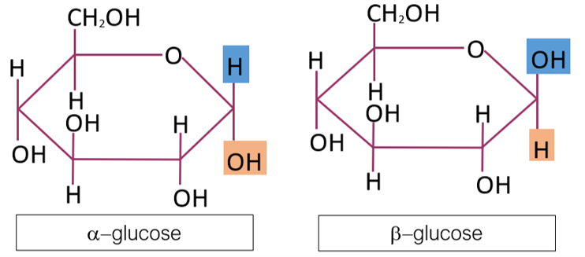
Figure 4.2: glucose isomers: α-glucose and β-glucose (C₆H₁₂O₆)
Figure 4.2 (Glucose Isomers: α-glucose and β-glucose):
A diagram showing two ring-shaped glucose molecules labeled α-glucose and β-glucose (C₆H₁₂O₆). Both structures consist of six-membered rings made of carbon and oxygen atoms with attached hydroxyl (–OH) groups. The key difference is the orientation of the –OH group on carbon 1: in α-glucose it points downward, while in β-glucose it points upward. .

B. Disaccharides: Sucrose
Disaccharides form when two monosaccharides are joined by a glycosidic linkage. Sucrose is a common disaccharide composed of glucose and fructose.
During the formation of a disaccharide, water is removed. During breakdown of a disaccharide, water is added in a process called hydrolysis.
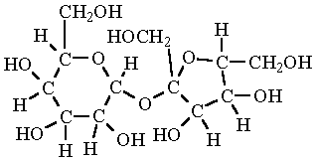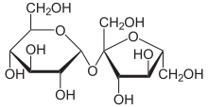
(4.3a) (4.3b)
Figure 4.3a & 4.3b (Sucrose molecule representations):
Two diagrams of a sucrose molecule are shown. The first (2a) is a detailed structural model displaying all atoms, including carbon, oxygen, and hydrogen, clearly illustrating the glucose and fructose units joined by a glycosidic bond. The second (2b) is a simplified skeletal diagram where carbon atoms and attached hydrogens are not shown; instead, lines are bonds and the overall structure, making the arrangement of the two sugar rings easier to see.
Figure 4.3 a & b: Sucrose molecules. Figure 2a contains all the hydrogens in the molecule. From https://www.chem.purdue.edu/jmol/molecules/sucrose.gif Figure 2b is the chemist’s shorthand version. From https://upload.wikimedia.org/wikipedia/commons/thumb/1/1a/Saccharose2.svg/440px-Saccharose2.svg.png

Guided Work
Examine a sucrose model.
- How many monosaccharide units are present?

- Which bond connects the two sugar units?

- What molecule is needed to break sucrose apart by hydrolysis?

- Is sucrose polar or nonpolar? Explain using functional groups.

C. Polysaccharides: Starch and Cellulose
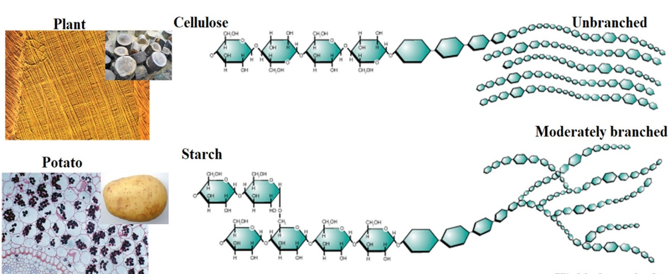
A diagram comparing two polysaccharides made of repeating glucose units. On one side, starch is shown as a coiled or branching chain of glucose molecules, illustrating its role in energy storage in plants. On the other side, cellulose is depicted as straight, parallel chains of glucose linked together, forming rigid fibers that provide structural support in plant cell walls. The difference in arrangement highlights starch as flexible and digestible, while cellulose appears tightly packed and stable
Figure 4.4: Naturally occurring polysaccharides. Polysaccharides are giant polymers of monosaccharides. Polysaccharides of glucose: starch: storage of glucose in plants; cellulose: very stable, good for structural components. From F. Seidi, M. Yazdi, M. Jouyandeh, S. Habibzadeh, M. Munir, H. Vahabi, B. Bagheri, N. Rabiee, P. Zarrintaj, M. Saeb, Crystalline polysaccharides: A review, Carbohydrate Polymers, Vol. 275, 2022, https://doi.org/10.1016/j.carbpol.2021.118624. (https://www.sciencedirect.com/science/article/pii/S0144861721010110)
.
Guided Work
Compare starch and cellulose models.
- Are the glucose chains branched or unbranched?
- How does the linkage between glucose units differ?
- Which molecule is better suited for energy storage?
- Which molecule is better suited for structural support?
- Why can two molecules made of glucose have different biological functions?

Part II. Lipids: Fatty Acids, Triglycerides, Phospholipids, and Sterols
Suggested Time: 40–45 minutes
Lipids are a diverse group of mostly hydrophobic molecules. Many contain long hydrocarbon regions, which make them poorly soluble in water. Lipids function in long-term energy storage, insulation, membrane structure, waterproofing, and chemical signaling. A brief introduction may be seen in the following video: “Lipids | Fats, Steroids, and Phospholipids | Biological Molecules Simplified #4”

A. Fatty Acids
Fatty acids contain a carboxyl group at one end and a hydrocarbon chain. A saturated fatty acid contains no carbon-carbon double bonds in its hydrocarbon chain. An unsaturated fatty acid contains one or more carbon-carbon double bonds, often producing bends in the chain.

Fatty acids:
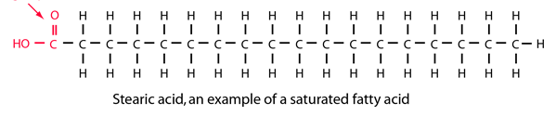
Figure 4.5a: a saturated fatty acid

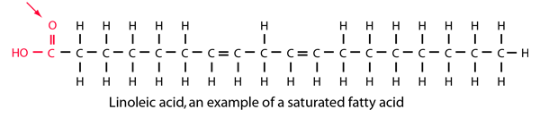
Figure 4.5b: an unsaturated fatty acid
Two diagrams compare fatty acids: one shows a saturated fatty acid with a straight carbon chain, and the other shows an unsaturated fatty acid with a bent chain due to a double bond.
Figure 4.5a and 4.5b: Comparison of Saturated and Unsaturated Fatty Acids
Guided Work
Examine saturated and unsaturated fatty acid models.
- Circle or identify the carboxyl group.
- Identify the hydrocarbon tail.
- Compare the shape of saturated and unsaturated fatty acids.
- Explain how double bonds affect molecular shape.

B. Triglycerides
A triglyceride contains one glycerol molecule joined to three fatty acids. Triglycerides are important for long-term energy storage molecules.
TRIGLYCERIDES
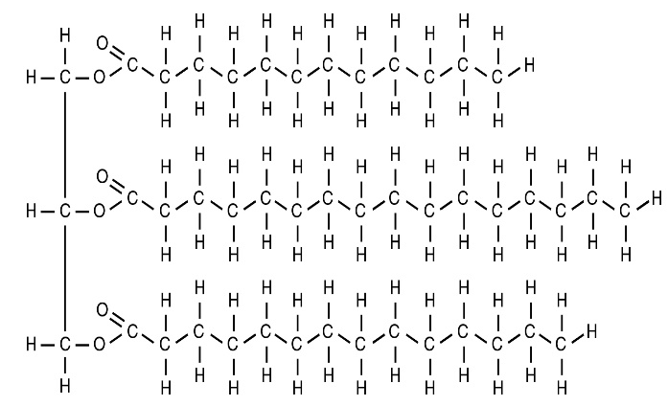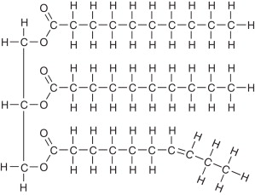
Figure 4.6a; a saturated fat Figure 4.6b an unsaturated fat
Two diagrams of fat molecules are shown: one stands for a saturated fat with straight fatty acid chains, and the other is an unsaturated fat with one or more bent chains due to double bonds.
Figure 4.6a and b. A saturated and unsaturated fat, respectively.
Credits: Figure 4.6 a: https://open.oregonstate.education/app/uploads/sites/48/2019/07/2511_A_Triglyceride_Molecule_a_Is_Broken_Down_Into_Monoglycerides_b.jpg. Figure 4.6b: A.H. Lichtenstein, 2013, Fats and Oils, Encyclopedia of Human Nutrition (Third Edition), Academic Press, Pages 201-208, https://doi.org/10.1016/B978-0-12-375083-9.00097-0. https://www.sciencedirect.com/science/article/pii/B9780123750839000970)

Guided Work
Examine a triglyceride model.
- Identify and draw a circle around the glycerol backbone.
- Identify and draw a box around the three fatty acid chains.
- Predict the products of triglyceride hydrolysis. Write the products below.
- Explain why triglycerides are mostly nonpolar.

- Compare saturated and unsaturated triglycerides. Explain the differences below.

C. Phospholipids
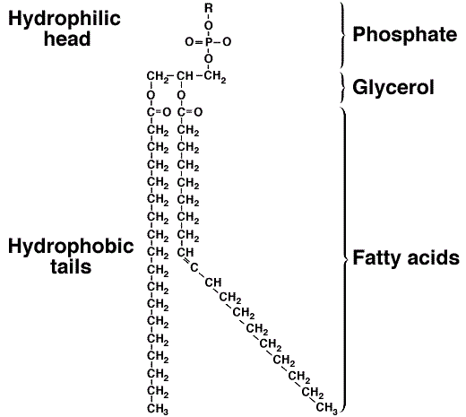
A diagram of a phospholipid molecule showing a polar head group and two nonpolar fatty acid tails. The head has a phosphate group, while the tails extend as long hydrocarbon chains, illustrating the molecule’s structure with a water-attracting (hydrophilic) head and water-repelling (hydrophobic) tails.
Figure 4.7; a phospholipid. From https://www.researchgate.net/profile/Ebrahim-Zahrabi/publication/297161568/figure/fig1/AS:336950331494401@1457346627123/molecular-structure-of-phospholipid-Figure-2.png

Phospholipids are major components of cell membranes. A phospholipid has a hydrophilic head region and hydrophobic fatty acid tails. Because it has both water-attracting and water-repelling regions, it is described as amphipathic.
Guided Work
Examine a phospholipid model.
- Identify the phosphate-containing head. Draw a circle around it.
- Identify the fatty acid tails.
- Explain why the molecule is amphipathic.

- Predict how phospholipids arrange themselves in water.

- Explain why phospholipids are well suited for membrane formation.

D. Sterols
Sterols are lipids with a characteristic four-ring carbon framework. Cholesterol is the major sterol in animal cells. It contributes to membrane structure and serves as a precursor for several important molecules, including steroid hormones and vitamin D.
Guided Work
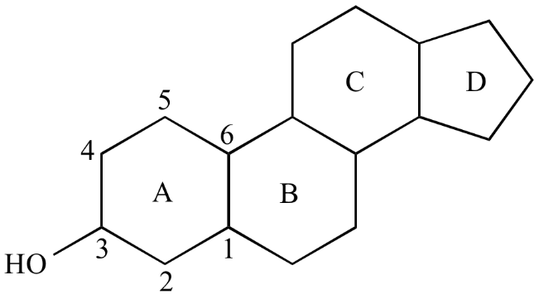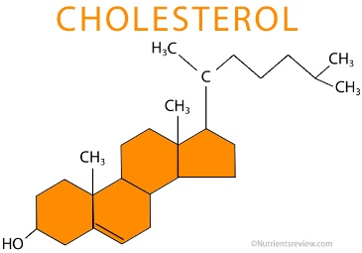
Figure 4.8a. a general sterol molecule model Figure 4.8b. cholesterol
Two diagrams of sterol molecules are shown: one illustrates a general sterol structure with four fused carbon rings, and the other shows cholesterol with a similar ring structure and a short hydrocarbon tail.
Credits: Figure 4.8a: From Steven A. Hardinger, “Illustrated Glossary of Organic Chemistry”, Department of Chemistry & Biochemistry, UCLA https://www.chem.ucla.edu/~harding/IGOC/S/sterol01.png. Figure 4.8b from https://www.nutrientsreview.com/wp-content/uploads/2014/12/Cholesterol-structure.jpg

Examine a cholesterol or sterol model.
- Count the number of fused rings. How many are there?

- Identify any polar functional group in the general sterol model?

- Is cholesterol mostly polar or mostly nonpolar?

- Where is cholesterol found in animal cells?

- Why is cholesterol biologically important?
Part III. Proteins: Amino Acids and Polypeptides
Suggested Time: 35–40 minutes PROTEINS: Pages 75-83
Proteins are polymers made of amino acid monomers. Each amino acid contains a central carbon attached to an amino group, a carboxyl group, a hydrogen atom, and an R group. The R group differs among amino acids and determines many of their chemical properties.
Amino acids are joined by peptide bonds to form polypeptides. The amino acid sequence influences how the protein folds, and the folded shape determines protein function. For a quick review please visit the following video: “Proteins, Biological Molecules simplified #2”

  - Amino Acid Structure
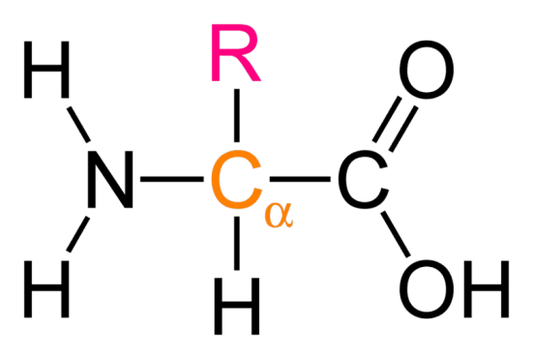
Alt text:
A diagram of a general amino acid showing a central carbon atom bonded to an amino group (–NH₂), a carboxyl group (–COOH), a hydrogen atom, and a variable side chain (R group).
Figure 4.9 (Amino Acid): (obtained from Quora https://qph.fs.quoracdn.net/main-qimg-6e5fc1022752632bbe80515b295f4440)

Examine a general amino acid model.
- Find the amino group. Draw a ring around this structure.

- Locate the carboxyl group. Draw a box around this structure.

- Identify the central carbon.

- Find the R group.

- From your review of amino acids in your textbook, describe why the R group is significant.

B. Amino Acid Categories
Using an amino acid chart from figure 4.1 below, identify one example of each type:
Table 4.1. Examples of amino acids based on the R-group structural differences.
Category | Example Amino Acid
Nonpolar
Polar
Acidic
Basic

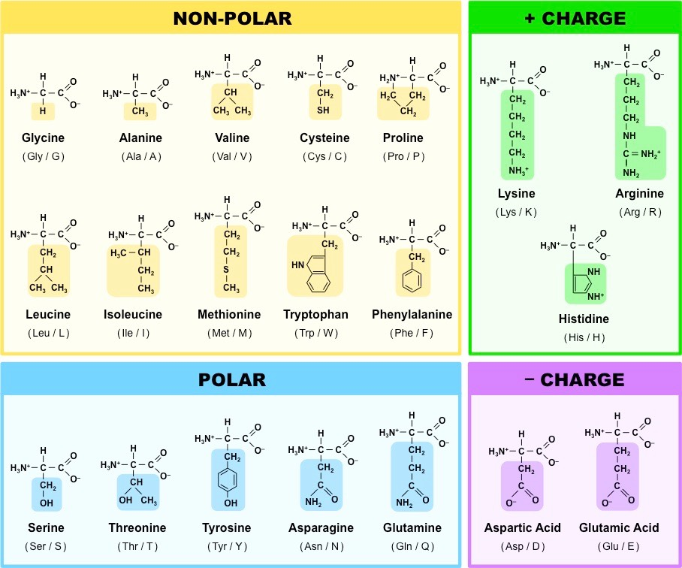
A chart displaying the 20 standard amino acids found in proteins, each shown with its chemical structure. The amino acids share a common backbone but differ in their side chains (R groups), which vary in size, shape, and chemical properties.
Figure 4.10: the 20 amino acids of proteins. From https://ib.bioninja.com.au/_Media/amino-acid-structures_med.jpeg

C. Polypeptides
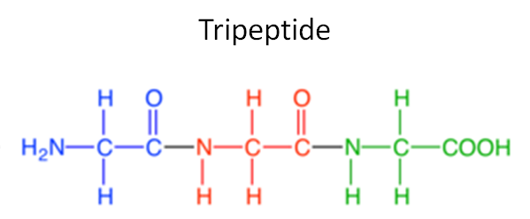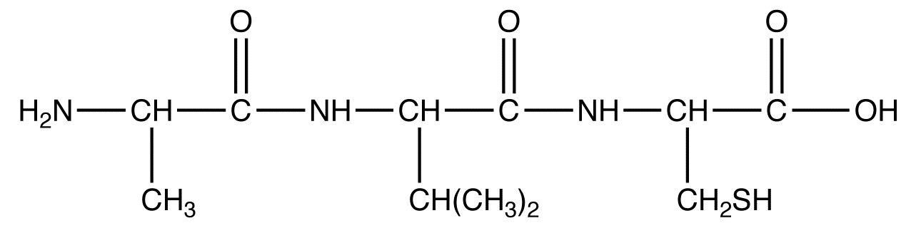

Figure 4.11a: diagram of polypeptide ”a” Figure 4.11b: diagram of polypeptide ”b”
Two diagrams of polypeptides are shown: one (4.11a) illustrates a chain of amino acids linked together by peptide bonds, and the other (4.11b) shows a similar chain in a slightly different arrangement, highlighting how amino acids connect to form protein structures. A credit line lists sources from Quora and Ochempal.
Credits: figure 4.11a: Quora; https://qph.cf2.quoracdn.net/main-qimg-aa8d4ec5c5e5c108bfec85724cbb89f3. Figure 4.11b by Gamini Gunawardena; http://www.ochempal.org/wp-content/images/O/oligopeptide.png.

Examine the short polypeptide model in the figures above.
- Count and write down the number of amino acids in figures 4.11a and 4.11b.

- Identify peptide bonds, circle these.

- Write the amino acid sequence for figures 4.11a and 4.11b using the abbreviations provided in figure 4.10.

- Label each amino acid as polar, nonpolar, acidic, or basic for both the molecules in 10a and 10b.

- Explain how changing one amino acid could affect protein shape or function.

Part IV. Nucleic Acids: Nucleotides, DNA, and RNA
Suggested Time: 35–40 minutes NUCLEIC ACIDS Pages 84-87, 260
Nucleic acids store and transmit genetic information. DNA and RNA are polymers made of nucleotide monomers. Each nucleotide contains a phosphate group, a five-carbon sugar, and a nitrogenous base.
DNA contains deoxyribose and the bases adenine, thymine, cytosine, and guanine. RNA contains ribose and the bases of adenine, uracil, cytosine, and guanine. A brief introduction to this topic may be found in “What are Nucleic Acids? Nucleic Acid Structure & Function“.
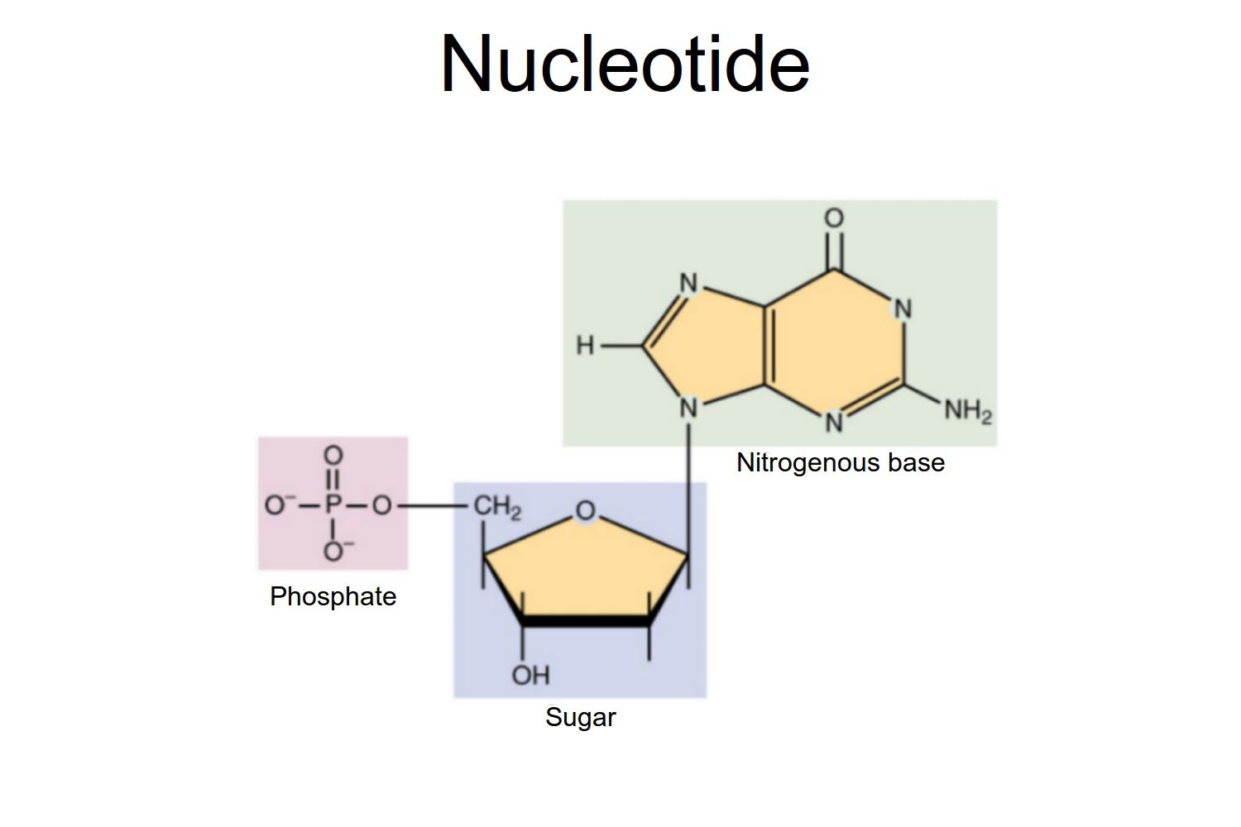
A diagram showing the structure of nucleotides, each composed of three parts: a phosphate group, a sugar, and a nitrogenous base.
Figure 4.12: Nucleotides (OpenStax/Wikimedia Commons/CC BY-SA 3.0)

A. Nucleotide Structure
Examine a nucleotide model of diagram.
- Identify the phosphate group.

- Identify the sugar.

- Identify the nitrogenous base.

- Explain how nucleotides are linked to a nucleic acid strand.
B. DNA Structure
DNA has a sugar-phosphate backbone and paired nitrogenous bases. The two strands are antiparallel, meaning they run in opposite directions.
Base-pairing rules:
- A pair with T
- C pairs with G
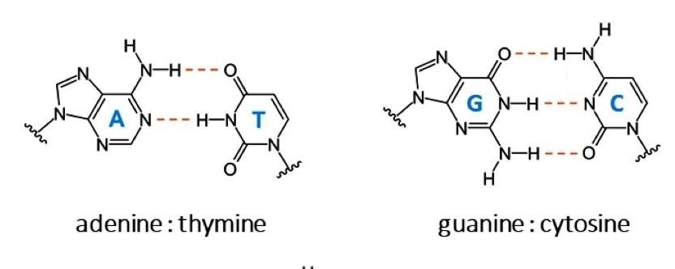
A diagram illustrating the bonding pattern between a purine and a pyrimidine base, showing how the two nitrogen-containing rings align and form complementary base pairs through hydrogen bonds. From Sleiman, D., et al. (2021) A third purine biosynthetic pathway encoded by amino adenine-based viral DNA genomes. Science. doi.org/10.1126/science.abe6494.
Fig. 4.13: bonding pattern of a puring end pyrimidine.

DNA
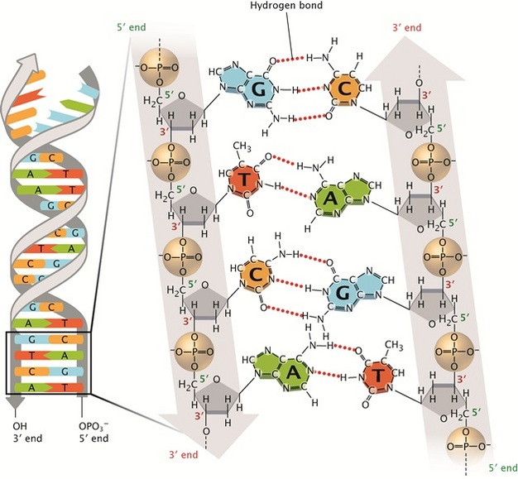
A diagram of a DNA molecule showing the double helix structure with two strands twisted around each other, along with a close-up of a partial chemical strand highlighting the sequence of nucleotides and their bonding. Nature Education 1(1):100
Figure 4.14, a DNA molecule, and a partial DNA chemical strand. Credit: Pray, L. (2008). Discovery of DNA structure and function: Watson and Crick.

Guided Work
- Identify the sugar-phosphate backbone. Circle this.

- Identify paired bases. Draw a box around these.

- Distinguish purines from pyrimidines. Label the purines (Pu) and the pyrimidines (Pyr).

- Explain how pairing a purine with a pyrimidine helps keep the width of DNA consistent.

- Count the hydrogen bonds between A-T and C-G pairs. How many did you find between each pair?

C. RNA Compared with DNA
RNA differs from DNA in three major ways: RNA usually has ribose sugar, contains uracil instead of thymine, and is usually single-stranded.
RNA: Page 271
In figure 4.15, find the RNA nucleotide model labeled Uracil (U). The sugar in RNA is ribose, and the sugar in DNA (fig. 4.13) is deoxyribose.
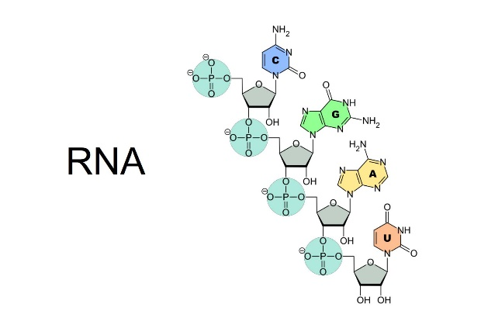
A diagram of an RNA strand showing a single chain of nucleotides, each made of a sugar, phosphate group, and nitrogenous base, illustrating the linear structure of RNA.
Figure 4.15 RNA strand from Online Education Resources, LLC © 2017; https://www.scienceprofonline.com/images/RNA-Nucleobases.jpg
Complete the comparison table.
Table 4.2. Comparison Table: DNA vs RNA
Feature | DNA | RNA
Sugar
Bases
Usual number of strands
Major function

Part V. Functional Groups in Biological Molecules
Suggested Time: 25–30 minutes FUNCTIONAL GROUPS: pgs. 62-63
Functional groups are specific groups of atoms that give molecules characteristic chemical properties. They influence polarity, acidity, charge, solubility, and reactivity. For a video on functional groups see the following video: “Functional Groups Explained so AP Bio Students can Understand!”

Complete the table.
Table 4.3. Functional Groups: Structure, Examples, and Biological Importance
Functional Group | General Structure | Example of Molecule/Class Where Found | Biological Importance
Hydroxyl
Carboxyl
Amino
Phosphate
Methyl

Part VI. Synthesis: Structure Determines Function
Suggested Time: 15–20 minutes
Choose one molecule from each class and explain how its structure supports its function.
Table 4.4. Examples of biological molecules’ features and function(s)
Biological Molecule | Structural Feature |  | Biological Function
Carbohydrate example
Lipid example
Protein example
Nucleic acid example

Final Reflection
In one well-developed paragraph, explain why structure is essential to biological function.

Post-Lab Questions
Multiple Choice
- Which molecule is a monosaccharide?
A. Glucose
B. Protein
C. Cholesterol
D. DNA
- Which molecule is a structural polysaccharide in plants?
A. Starch
B. Cellulose
C. Glycogen
D. Sucrose
- Which bond joins monosaccharides?
A. Peptide bond
B. Glycosidic linkage
C. Hydrogen bond
D. Ionic bond
- Which molecule is composed of glycerol and three fatty acids?
A. Phospholipid
B. Triglyceride
C. Sterol
D. Nucleotide
- A molecule with both hydrophilic and hydrophobic regions is:
A. Amphipathic
B. Saturated
C. Inorganic
D. Linear only
- Which lipid contains four fused carbon rings?
A. Fatty acid
B. Phospholipid
C. Sterol
D. Triglyceride
- Which part of an amino acid varies among the 20 common amino acids?
A. Amino group
B. Carboxyl group
C. R group
D. Central carbon only

- Which bond joins amino acids?
A. Glycosidic linkage
B. Peptide bond
C. Phosphodiester bond
D. Disulfide only
- Which molecule has deoxyribose?
A. RNA
B. DNA
C. Protein
D. Triglyceride
- In DNA, adenine pairs with:
A. Cytosine
B. Guanine
C. Thymine
D. Uracil
Short Answer
- Explain why glucose is considered a carbohydrate monomer.

- Compare starch and cellulose in structure and function.

- Why are hydroxyl groups hydrophilic?

- Explain the difference between saturated and unsaturated fatty acids
.
- Why are triglycerides useful for long-term energy storage?

- Explain why phospholipids form bilayers in water.

- Why is cholesterol an important molecule in animal cells?

- Describe the general structure of an amino acid.

- Explain how the R group influences amino acid properties.

- Compare DNA and RNA in terms of sugar, bases, strand numbers, and function.

Student Ancillaries
MolView
MolView is an easy-to-use chemical sketcher and viewer for small molecules. Explore the molecular world and get creative through this intuitive web app!
https://molview.com/.

Appendix: Molecular Structure of Biological Molecules
Term | Definition
Amino Acid | A molecule containing an amino group, carboxyl group, hydrogen, and variable R group; building blocks of proteins.
Amino Group | A functional group (-NH2) consisting of nitrogen bonded to hydrogen; found in amino acids.
Amphipathic | Having both hydrophilic (water-attracting) and hydrophobic (water-repelling) regions.
Carbohydrate | A biological molecule composed of carbon, hydrogen, and oxygen, used for energy and structure.
Carboxyl Group | A functional group (-COOH) that acts as an acid and is found in many organic molecules.
Disaccharide | A carbohydrate formed by two monosaccharides linked together by a glycosidic bond.
Fatty Acid | A lipid component consisting of a carboxyl group and a long hydrocarbon chain.
Functional Group | A specific group of atoms that gives a molecule its chemical properties.
Glycosidic Linkage | A covalent bond that joins two monosaccharides in a carbohydrate.
Hydrolysis | A chemical reaction that breaks bonds by adding water.
Hydroxyl Group | A functional group (-OH) that is polar and increases solubility in water.
Lipid | A group of hydrophobic biological molecules including fats, phospholipids, and sterols.
Macromolecule | A large biological molecule composed of many smaller subunits.
Monomer | A small molecular subunit that can join with others to form a polymer.
Monosaccharide | A single sugar molecule, such as glucose; the simplest form of carbohydrate.
Nucleic Acid | A macromolecule (DNA or RNA) that stores and transmits genetic information.
Nucleotide | The monomer of nucleic acids, consisting of a phosphate group, sugar, and nitrogenous base.
Peptide Bond | A covalent bond that links amino acids together in proteins.
Phosphate Group | A functional group (PO4) involved in energy transfer and found in nucleotides.
Phospholipid | A lipid with a hydrophilic head and hydrophobic tails that forms cell membranes.
Polymer | A large molecule made of repeating monomer units.
Polysaccharide | A carbohydrate composed of many linked monosaccharides.
Protein | A macromolecule made of amino acid chains that performs various cellular functions.
R Group | The variable side chain of an amino acid that determines its properties.
Saturated Fatty Acid | A fatty acid with no double bonds, resulting in a straight chain.
Sterol | A lipid with a four-ring carbon structure, such as cholesterol.
Triglyceride | A lipid composed of glycerol and three fatty acids, used for energy storage.
Unsaturated Fatty Acid | A fatty acid containing one or more double bonds causing bends in the chain.

Instructor Ancillaries

A. Instructor Overview
This lab is designed to help introductory biology students connect molecular structures with biological functions. It is based on the uploaded lab’s major activities: examining carbohydrates, lipids, proteins, nucleic acids, and functional groups through models and structural formulas.
The rewritten version avoids close copying by using new wording, reorganized sections, revised prompts, expanded conceptual framing, and original guided questions.

B. Suggested 2.5–3 Hour Schedule
Section | Suggested Time
Opening orientation and pre-lab review | 10–15 min
Part I: Carbohydrates | 35–40 min
Part II: Lipids | 40–45 min
Part III: Proteins | 35–40 min
Part IV: Nucleic acids | 35–40 min
Part V: Functional groups | 25–30 min
Part VI: Synthesis reflection | 15–20 min

C. Instructor Pre-Lab Materials
Recommended Pre-Lab Mini-Lecture
Briefly review:
- Carbon bonding and organic molecules
- Monomers, polymers, and macromolecules
- Dehydration synthesis and hydrolysis
- Functional groups and polarity
- Structure-function relationships
- Major features of carbohydrates, lipids, proteins, and nucleic acids
Suggested Demonstrations
- Show glucose in linear and ring form.
- Compare starch and cellulose models.
- Display saturated and unsaturated fatty acids.
- Build a triglyceride and phospholipid using model pieces.
- Compare an amino acid with a nucleotide.
- Show cholesterol and point out its four-ring structure.

D. Pre-Lab Answer Key
- B
- C
- A
- A
- B
- A
- B
- B
- A
- A
- Carbohydrates, lipids, proteins, and nucleic acids.
- A monomer is a smaller subunit; a polymer is a larger molecule made of linked monomers.
- A functional group is a specific group of atoms that gives a molecule particular chemical properties.
- Carbon forms four covalent bonds and can make chains, branches, and rings.
- Carbon, hydrogen, and oxygen.
- Starch stores energy in plants; cellulose provides structural support in plant cell walls. Their glucose linkages differ.
- Saturated fatty acids lack carbon-carbon double bonds; unsaturated fatty acids contain one or more.
- Amphipathic means having both hydrophilic and hydrophobic regions.
- Phosphate group, five-carbon sugar, and nitrogenous base.
- Molecular shape affects binding, solubility, reactivity, and biological function.

E. Instructor Post-Lab Materials
Recommended Post-Lab Discussion Prompts
- Why can starch and cellulose both be made of glucose but have distinct functions?
- How does the lipid structure explain membrane formation?
- Why are proteins more structurally diverse than carbohydrates?
- Why is nucleotide sequence important in DNA and RNA?
- How do functional groups affect biological molecule behavior?

Common Student Misconceptions
Misconception | Correction
All biological molecules are polymers. | Many are polymers, but many lipids are not true polymers.
All carbohydrates are simple sugars. | Carbohydrates include monosaccharides, disaccharides, and polysaccharides.
Cholesterol is only harmful. | Cholesterol is essential in animal membranes and is a precursor for important molecules.
DNA and RNA are made of amino acids. | DNA and RNA are made of nucleotides.
Protein function depends only on size. | Protein function depends strongly on amino acid sequence and three-dimensional shape.
Hydrophobic means “repelled by water” in a literal magnetic sense. | Hydrophobic molecules do not interact favorably with water because they are mostly nonpolar.

F. Post-Lab Answer Key
- A
- B
- B
- B
- A
- C
- C
- B
- B
- C
- Glucose is a monosaccharide, a single sugar unit that can be used to build larger carbohydrates.
- Starch is a plant energy-storage polysaccharide and may be branched or unbranched. Cellulose is a structural polysaccharide made of straight glucose chains that strengthen plant cell walls.
- Hydroxyl groups are polar because oxygen is more electronegative than hydrogen and carbon, allowing interactions with water.
- Saturated fatty acids have no carbon-carbon double bonds; unsaturated fatty acids have at least one, often creating bends.
- Triglycerides contain many energy-rich C-H bonds and are hydrophobic, allowing compact energy storage.
- Phospholipids form bilayers because hydrophilic heads face water while hydrophobic tails cluster away from water.
- Cholesterol helps regulate animal cell membrane fluidity and is a precursor for steroid hormones and other molecules.
- An amino acid has a central carbon bonded to an amino group, carboxyl group, hydrogen atom, and R group.
- The R group determines whether an amino acid is polar, nonpolar, acidic, or basic, influencing protein folding and function.
- DNA contains deoxyribose, A/T/C/G bases, is usually double-stranded, and stores genetic information. RNA contains ribose, A/U/C/G bases, is usually single-stranded, and functions in gene expression.

G. Optional Grading Rubric
Category | Excellent | Satisfactory | Needs Improvement
Pre-lab preparation | Complete and accurate | Mostly complete | Incomplete
Model interpretation | Correctly identifies structures | Minor errors | Frequent confusion
Vocabulary use | Accurate and clear | Mostly accurate | Major misuse of terms
Structure-function reasoning | Detailed and well supported | Basic but correct | Limited or unclear
Participation | Actively engaged | Participates when prompted | Minimal engagement

H. Suggested Instructor Closing Summary
Today’s lab emphasized that biological molecules are not just names or formulas. Their functions arise from their structures. Carbohydrates can store energy or provide structural support; lipids form membranes and store energy; proteins perform diverse cellular tasks, and nucleic acids store and transmit information. Across all four groups, functional groups, polarity, bonding patterns, and three-dimensional shapes help determine biological function.

