Lab 06: Molecular Movement in the Cells and Across Cell Membranes

Lab Objectives: Cell Membranes, Diffusion, and Osmosis
By the end of this lab, students will be able to:
- Describe the structure and function of the cell membrane.
- Explain the concepts of diffusion and osmosis.
- Distinguish between passive transport and active transport.
- Define hypertonic, hypotonic, and isotonic solutions.
- Predict the movement of water across a selectively permeable membrane.
- Perform an osmosis experiment using dialysis tubing.
- Measure and record changes in mass over time.
- Analyze data to determine the direction of water movement.
- Compare how plant and animal cells respond to different solutions.
- Explain the role of the cell wall in plant cell responses to osmosis.

Prelab Questions (15 total)
Multiple Choice (8)
- The cell membrane is best described as:
A. Completely permeable
B. Selectively permeable
C. Impermeable
D. Rigid
- Diffusion is the movement of molecules:
A. From low to high concentration
B. From high to low concentration
C. Using ATP
D. Against a gradient
- Osmosis specifically refers to the movement of:
A. Solutes
B. Proteins
C. Water
D. Ions
- A solution with higher solute concentration is:
A. Hypotonic
B. Isotonic
C. Hypertonic
D. Neutral

- In a hypotonic solution, a cell will:
A. Shrink
B. Remain unchanged
C. Gain water
D. Lose solutes only

- Which molecules cross membranes most easily?
A. Charged ions
B. Large proteins
C. Nonpolar molecules
D. Sugars
- Energy (ATP) is required for:
A. Diffusion
B. Osmosis
C. Active transport
D. Passive transport
- Equilibrium means:
A. No movement of molecules
B. Equal distribution of molecules
C. Maximum concentration
D. No solute present
Short Answer (7)
- Define diffusion in your own words.

- What is a selectively permeable membrane?

- What is the difference between solute and solvent?

- Predict what happens to a cell in a hypertonic solution.

- Why does water move during osmosis?

- What is Brownian motion?

- Why might plant and animal cells respond differently to osmotic changes?

INTRODUCTION

All cells are enclosed by membranes which provide a semi-permeable barrier between the internal contents of the cell and its external environment. Cells must be able to regulate the movement of molecules or ions (i.e., amino acids, sugars, O₂) so that their concentrations do not disrupt cell metabolic processes. In addition to regulating what contents may enter or exit the cell, the cell membrane plays a role in a few other functions, including communication, binding, and adhering to adjacent cells. Properties of the cell membrane can be determined by exposing red blood cells to different solutions (i.e., different “environments”) and observing the appearance of cells under a microscope. The cell may, for example, lyse due to the influx of water. More specifically, we will be looking at how animal cells (red blood cells) and plant cells respond differently to distinct types of solutions.

Diffusion
Molecules can pass a cell membrane using different means of transport. One such means is passive transport; in which case the laws of thermodynamics dictate the flow of molecules. In passive transport, no added energy (ATP) is necessary for the movement of molecules as they move along their concentration gradient, passing from high to low concentration. There are several types of passive transport, including diffusion and osmosis.

Some, but not all, of the traffic across the membranes of cells occurs by diffusion. Diffusion is the movement of molecules from an area of greater to an area of lesser concentration. Molecules are in motion constantly due to their natural movement caused by thermal agitation (Brownian Motion), and they bounce off each other and disperse themselves in an area until equilibrium is reached. Equilibrium means that the molecules have an equal distribution across the medium. Keep in mind that each particle is exhibiting random motion— you cannot predict which way an individual particle will move—but you can predict the net movement of the collection of particles.

As biological membranes are selectively permeable, some substances can freely diffuse through the membrane more easily than others. This is due to the contrasting properties of the phospholipid bilayer that makes up the cell membrane, as it includes both polar and nonpolar regions. Moreover, substances that move through the membrane can do so at different rates. Hydrophobic or non-polar molecules, such as hydrocarbons, oxygen, and carbon dioxide, can dissolve in the membrane and cross it with ease due to the hydrophobic nature of the membrane. Conversely, most hydrophilic molecules, such as ions and polar molecules, cannot pass through the membrane.

Osmosis

Osmosis is a special case of passive transport that deals with the diffusion of water across a selectively permeable membrane. Osmosis depends upon the concentration of solutes in a solution. A solution is made up of a solvent, the substance that does the dissolving, and a solute, the substance that is being dissolved. In the case of osmosis, the solvent is water. A Solute is a substance, such as sugar or salt that is dissolved in the water.

In comparing two solutions of unequal solute concentration, the solution with a greater concentration of solutes is said to be hypertonic. The solution with the lesser solute concentration is hypotonic. These are relative terms that are only meaningful in a comparative sense. For example, tap water is hypertonic to distilled water, but hypotonic to seawater. In other words, tap water has a higher concentration of solutes than distilled water, but a lower concentration than seawater. Solutions of equal solute concentration are said to be isotonic.

If a cell is placed in an environment which is isotonic, an environment of equal solute concentration, then there is no concentration gradient. Without such a gradient, there will be no net flow of water across the membrane.

If a cell is placed in a hypotonic environment, then there is a lower solute concentration surrounding the cell than within the cell. Whenever the solute concentration is lower, the concentration of free water molecules is higher. Therefore, water will diffuse alongdown its concentration gradient from an area of higher concentration (outside the cell) to an area of lower concentration (inside the cell). The added pressure that develops because osmosis is occurring is called hydrostatic (or turgor) pressure. This pressure may increase the point of opposing the entry of more water by osmosis (in which case it is equal to osmotic pressure), or this pressure may cause the membrane to rupture before such a point is reached.

Conversely, a cell placed in a hypertonic environment is surrounded by solution which is higher in solutes, hence lower in free water molecules. In this case, the free water concentration is greater inside the cell than outside, so the water flows out of the cell.

Plant and animal cells will respond differently in hypertonic, hypotonic, and isotonic solutions. This is primarily due to the presence of a cell wall in plant cells, which is absent from animal cells. For example, an animal cell (such as a red blood cell) will lyse (burst open) in a hypotonic solution due to the movement of water molecules into the cell. A plant cell placed into a hypotonic solution is considered turgid, however, and will not lyse due to the presence of the cell wall.

PROCEDURE
  - Simple Diffusion in Agar
Agar is a semi-solid substance made of long chains of molecules arranged in a random pattern. Because of this structure, it has many small pores and fewer large ones. Smaller molecules can diffuse through agar more easily because they can pass through these pores, while larger molecules move more slowly and may become trapped. In this experiment, you will compare how different substances diffuse through agar.
    - Materials: Obtain the following:
              - 2 agar plates
              - Ruler
                - Only a small portion is used to cut your holes in the agar so you may have to cut a whole straw in half
              - Drinking straw
              - Stains: three of the following
        - Methylene Blue
        - Neutral Red
        - Crystal Violet
        - Methyl Green
Procedure
  - Turn the petri dish upside down. Using the marker, place dots on the bottom of the plate as shown in Figure x.x.
  - Use a ruler to space the dots 1.5 cm apart
  - Label one dot “B” (BaCl₂)
  - Label the other “K” (K₂SO₄)
  - Carefully open the petri dish and create small wells (holes) in the agar at each marked location:
  - Use a straw, tube, or pipette tip to gently punch into the agar and twist the straw to cut the agar.
  - Pinch the far end of the straw to apply slight suction (if possible) to remove the agar plug
  - Make sure the wells are clean and properly formed
  - Using a fine tip pipette, carefully add:
      - 10% BaCl₂ solution to the “B” well
      - 10% K₂SO₄ solution to the “K” well
Important: Do not overfill the wells.

  - When the two substances diffuse toward each other, they will react to form:
      - BaSO₄ (a white precipitate)
      - KCl (is still in solution)
The white precipitate will appear as a fuzzy line between the wells.
  - Measure the distance from each well to the white line (see Figure 6.1).
  - Record your measurements in Table 6.1.
1.5 cm
K
B
Figure 6.1. Agar petri plate with holes cut for BaCl₂ and K₂SO₄ solutions
Table 6.1. Distance from the Edge of the Cell to the Precipitate for Barium Chloride and Sodium Sulfate.
Chemical | Distance from Edge of Well to Precipitate (in cm)
10% BaCl₂
10% K₂S04

    - Interpretation
Based on your measurements:
Determine which ion traveled farther. Use this information to infer which ion is larger.
    - Note: The reaction may take an hour or more, so be patient.

B Osmosis across non-living membranes (see Figure 6.2)
1. Obtain the following:
a. (6) 250-ml beakers. Label the beakers 1-6 with a wax pencil.
b. (3) 10-ml graduated cylinders.
Label the cylinders; DiWater, 20% and 40% with a wax pencil.
c. (6) ~8-cm lengths of string.
d. (6) 18-cm lengths of dialysis tubing.

**NOTE: Place cut tubing in a 250 ml beaker full of water. Do not remove the tubing from the water until you are ready to fill the tubes.

Table 6.2: Dialysis Tubing

Tube # | 10 ml of: | Lay filled tube in beaker numbers
1 & 6 | Deionized Water | 1 & 6
2 & 5 | 20% Sucrose | 2 & 5
3 & 4 | 40% Sucrose | 3 & 4

2. Fill the dialysis tubing with the solutions listed in Table 6.2 in the following way:
- Rub one end of the dialysis tubing strip between your fingers under the water until the tube opens
- Tie a knot in one end of the tube
- Measure 10 ml of liquid into the graduated cylinder
- Fill the dialysis tube.
- Gently press together at the tube's open end. Press out the air. Twist the tubing and tie it with string.
- Rinse each tube gently with tap water to remove any spilled sucrose.
- Gently blot the outside of the tube dry.
- Weigh the tube (to the nearest 0.1 gram) and record its initial mass (time 0) in Table 4.3
- Place the tube into the proper beaker.

***NOTE: Pour all liquids (water and sucrose) into the beakers at the same time!

  - Fill the beakers as follows and make sure the dialysis tubing is submerged.

Table 6.3. List of Beakers with their Solutions
Beakers# | ~125-150 ml of the following:
1 | Deionized Water
2 | Deionized Water
3 | Deionized Water
4 | 20% Sucrose
5 | 40% Sucrose
6 | 40% Sucrose

  - Immediately start timing for a precise 10-minute interval.

  - Place a paper towel in front of each beaker and work on parts 12-16.

  - After the 10-minute interval, remove all dialysis tubes from the beakers & place them on the corresponding paper towels.

  - Gently blot the tubes dry, weigh them (to the nearest 0.1 g), and record their weights in data table 6.4.

  - Return each tube to its corresponding paper towel.

  - After all the tubes have been weighed, return each tube to its corresponding beaker, and immediately start timing for another 10-minute interval.

  - Repeat for 10 more minutes, ending at 40 minutes.

  - Take the tubes and beakers to the sink. Use scissors to puncture each tube and allow the fluid to drain. Place the more-or-less empty tubes in the trash can. Pour the fluid from the beakers into the sinks and rinse the beakers. Return the rinsed beakers to the proper location.

  - By subtracting, find the initial differences between the sucrose concentration in the fluid in the bags and the sucrose concentration gradients. Write the concentration gradients in Figure 6.2.

  - In Figure 6.2, draw an arrow indicating which way water will flow (into or out of the dialysis tube).

Beaker #1 Beaker #2 Beaker #3
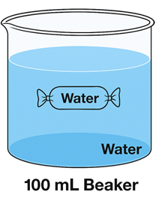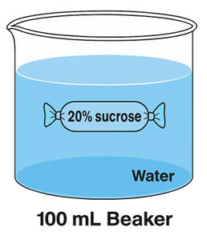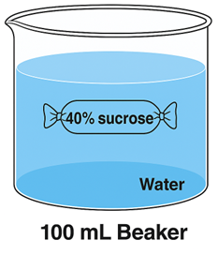

Tonicity: __________ Tonicity: __________ Tonicity: __________

Beaker #4 Beaker #5 Beaker #6
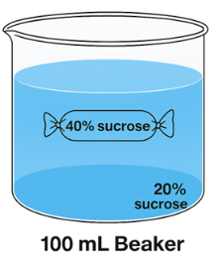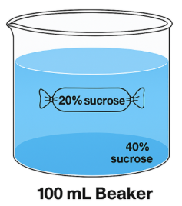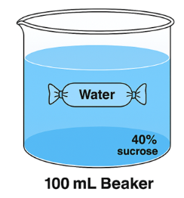

Tonicity: __________ Tonicity: __________ Tonicity: __________
Figure 6.2. Illustration of the Contents of Beakers and Dialysis Tubes (All tubes hold 10 ml of the specified solution as per Table 6.2).

14. Label the solution in the beakers above as hypertonic, hypotonic, or isotonic.

15. Which bag/ & beaker combinations have no concentration gradient? Label the 16. In which bag/beaker combination (or combinations) is the initial concentration gradient the greatest? What is the gradient?

17. In which bag/beaker combination (or combinations) is the initial concentration gradient the least without being equal? What is the gradient?

18. Record your data into Table 6.4

Table 6.4: Weights of Dialysis Tubes to the Nearest 0.1 g

Time | TUBE 1 | TUBE 2 | TUBE 3 | TUBE 4 | TUBE 5 | TUBE 6
0 MIN
10 MIN
20 MIN
30 MIN
40 MIN

18. Transfer the data from Table 6.4 onto Graph 6.3. Be sure to add an appropriate title to the graph and clearly label both axes.



Figure 6.3

C. Osmosis across the membranes of Elodea cells

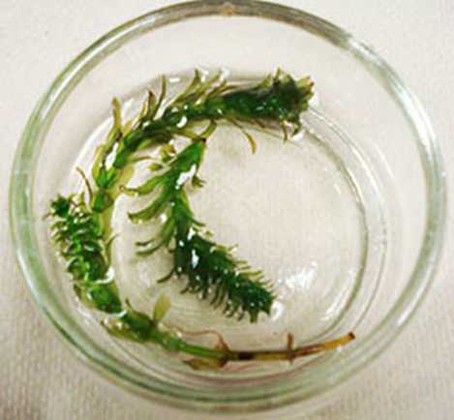

A small green aquatic plant (Elodea) submerged in clear water inside a shallow, transparent petri dish. The Elodea has thin stems with clusters of bright green leaves arranged along the length of each stem. The petri dish sits on a flat surface, and the water allows the delicate structure of the plant to be clearly visible.

Figure 6.4. Elodea in a petri dish.

- Put a drop of water on a clean slide. Add a single, young leaf from the tip of an Elodea plant. Cover the slide. Examine the slide microscopically. First, find the leaf under the shortest objective. Look at the center of the leaf and switch to the 10X objective.

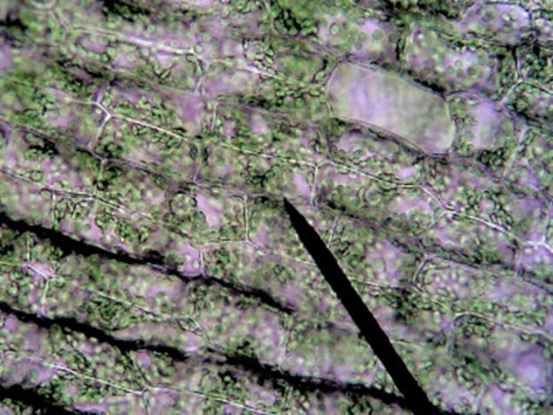

Microscopic view of Elodea at 10× magnification, showing green plant cells arranged in rectangular patterns along the leaf. The cells appear tightly packed, with visible cell walls and numerous small green chloroplasts distributed throughout each cell.

Figure 6.5: Elodea at 10x magnification

- Finally, switch the objectives to 40X. Try to find a cell where the chloroplasts move in a circle. The streaming motion of the cytoplasm carries the chloroplasts around a large, central vacuole. This vacuole is filled with water.

  - Draw a cell in the space below and label the plasma membrane and chloroplasts.

    - When a cell is exposed to an environment that has a greater concentration of solute than is in the cell, the cell loses water by osmosis. Place a drop of 10% NaCl solution just touching one side of the cover glass. Use a small piece of paper towel or lens paper to draw the original water out from the opposite side of the cover glass. This procedure will draw the salt solution under the cover glass and surround the leaf with salt water. Repeat the addition of a drop of NaCl and the removal of water from under the cover glass. Again, examine the cells of the Elodea leaf.

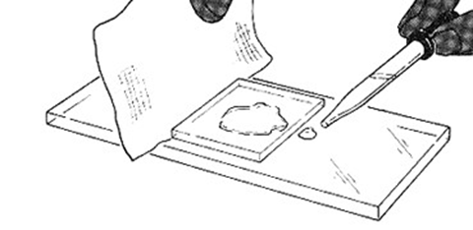
A figure showing how to expose Elodea leaf cells to a hypertonic solution: a drop of sodium chloride (NaCl) solution is placed at one edge of a microscope cover glass, while a paper towel draws out water from the opposite edge, pulling the salt solution underneath the cover glass and around the leaf. This process is repeated to fully bathe the cells in salt solution, causing them to lose water by osmosis before being viewed again under the microscope.

Figure 6.6. Illustration showing how to replace the water in a wet mount with a hypertonic solution. Image courtesy of Biologycorner.com, CC BY-NC-SA.

      - Redraw the cell after NaCl has been added. Label the plasma membrane and chloroplasts.

      - Can you see a space between the chloroplasts and the cell wall?

      - What fills this space?

      - Before you added the 10% NaCl solution, which would the central vacuole have, a solution with a greater total solute concentration than 10% NaCl or a solution with a lower total solute concentration than 10% NaCl?

      - After adding 10% NaCl, what has happened to the volume of the cytoplasm and its central vacuole?

      - What happens to the total solute concentration of the vacuole when 10% NaCl is added?

    - Expose the leaf to a drop of distilled or deionized water (DiH₂O) by adding a drop of this water next to the cover glass and drawing the water out the opposite side of the cover glass. Repeat this procedure twice to replace all salt water with pure water. Observe the cells. Have the cells regained their original appearance?

      - Redraw the cell after NaCl has been added. Label the plasma membrane and chloroplasts.

      - Did the spaces between the chloroplasts and cell walls disappear?

As water flows into a plant cell, the cell wall stops the swelling , but an increased pressure develops. This pressure is referred to as turgor pressure.

D. Osmosis in bovine red blood cells (Optional)
    - Prepare working solutions for the experiment. Note that this may already be done for you, in which case you can skip this step.
      - For the 0.15 M NaCl solution, take 7.5ml of the 0.3M stock solution and add 7.5ml of DiH₂O. This will make 15ml of 0.15M NaCl.
      - For the 0.07M NaCl solution, take 3.5ml of the 0.3M stock solution and add to
11.5ml of DiH₂O. This will make 15ml of 0.07M NaCl.
      - You will also be using an undiluted 0.3M NaCl stock solution.
    - Take a glass slide and label it 0.15 M.
    - Using a transfer pipette, add 2 drops of the 0.15M NaCl solution (from Step 1) to the slide.
    - Using a micropipette with a clean tip, add 5ul of bovine blood to the NaCl solution. Use the tip of the pipette to mix the blood and saline.
    - Add a cover slip.
    - View the red blood cells at 400x Total Magnification. Make note/ sketch their appearance in table 6.4 below. Measure 3 red blood cells and record their width in ocular units (ou) in table 6.5 below.
    - Repeat steps 2-6 using a clean slide and 0.3M NaCl solution.
    - Repeat steps 2-6 using a clean slide and 0.07M NaCl solution.

Table 6.5. Red Blood Cell Sketches and Observations

Sketch/ Observations | 0.3 M NaCl | 0.15M NaCl | 0.08M NaCl
Initial
5-minutes

Observations

Table 6.6. Red Blood Cell Measurements (Size in ocular units (ou))

Sketch/ Observations | 0.3 M NaCl | 0.15M NaCl | 0.08M NaCl
Initial | Cell 1:  Cell 2:  Cell 3:  Average: | Cell 1:  Cell 2:  Cell 3:  Average: | Cell 1:  Cell 2:  Cell 3:  Average:
5-minutes | Cell 1:  Cell 2:  Cell 3:  Average: | Cell 1:  Cell 2:  Cell 3:  Average: | Cell 1:  Cell 2:  Cell 3:  Average:

To calculate the size at each period, take the average of the 3 cells measured.

Observations:
- Based on the results from the plant cell and red blood cell experiments, how do these two distinct types of cells respond to different saline environments?

- Why do the differences you described above occur?

Terms: Parts of the Cell

- Cell membrane
- Cytoplasm (cytosol)
- Chromatin
- Chromosomes
- Nucleus
- Nuclear envelope
- Nucleolus
- Cytoskeleton
- Lysosome
- Centrioles
- Flagellum
- Microvilli
- Cilia
- Golgi apparatus
- Rough endoplasmic reticulum
- Smooth endoplasmic reticulum
- Ribosome
- Mitochondria
- Peroxisome

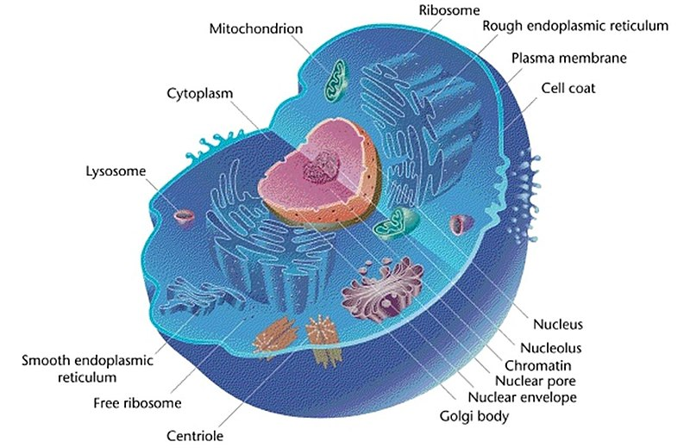
Figure 3.3 A Typical Animal Cell with Labeled Organelles.

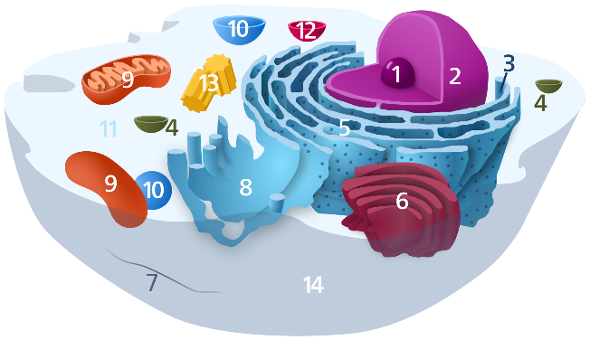
Figure 3.4 Diagram of the Cell.
Organelles in the cell above are labelled as follows:

- Nucleolus
- Nucleus
- Ribosome (dots as part of 5)
- Vesicle
- Rough endoplasmic reticulum
- Golgi apparatus (or Golgi body)
- Cytoskeleton
- Smooth endoplasmic reticulum
- Mitochondrion
- Vacuole
- Cytosol (fluid that contains organelles; with which, comprises cytoplasm)
- Lysosome
- Centrosome
- Cell membrane

Membrane Structure
Review the material related to the composition of a cell membrane. You should be able to answer the following questions.
- What are the primary macromolecules that make up the membrane?
- What are the functions of the following components:
    - Phospholipids

    - Cholesterol

    - Proteins

Lab Activity 3.1 continued
- Obtain tape and one of the models of the cell.
- Identify and label the cell organelles on the model.
- Complete the table below (Table 4.6)
- Once you are done, have another group to check your accuracy. Make corrections if needed.
- Then, have your Lab Instructor check your accuracy.

Identify the following structures and their function in the model below:

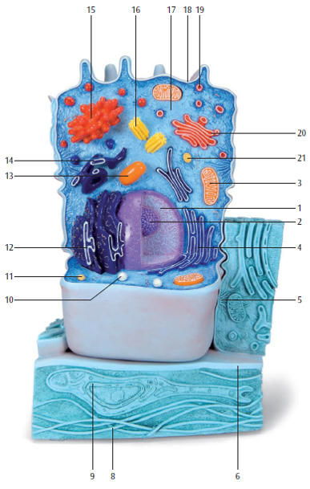
Figure 3.6 Classroom Model of an Animal Cell: 3B Scientific

1

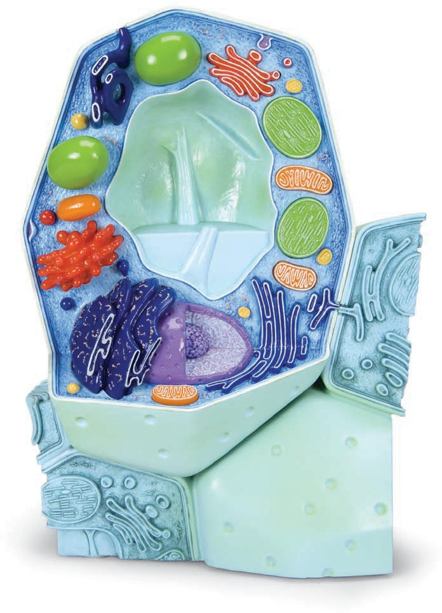
13
12
11
10
7
8
6
5
4
3
2
9

Figure 3.7 Classroom Model of a Plant Cell: 3B Scientific
Lab Activity 3.2
Using the information in table 3.2 review the cells structures and function(s) then complete the table below.
Table 4.6 Identify the Organelles and their Function.
Structure | Model Number |  | Organelle function
 | Animal | Plant
Plasma membrane
Cilia
Microvilli
Nucleolus
Nucleus
Nuclear envelope
Nuclear pore
Ribosome
Vesicle
Peroxisome
Lysosome
Golgi apparatus
Mitochondrion
Rough Endoplasmic Reticulum
Smooth Endoplasmic Reticulum
Centriole
Vacuole
Post Lab Questions (15 total)
Multiple Choice (8)
- If a dialysis tube gains mass, water movement was:
A. Out of the tube
B. Into the tube
C. Equal
D. Random
- A tube with 40% sucrose in water becomes lighter. The solution outside is:
A. Hypotonic
B. Hypertonic
C. Isotonic
D. Neutral
- The greatest mass change occurs when:
A. Solutions are equal
B. Gradient is largest
C. No solute is present
D. Time is short
- In plant cells, turgor pressure results from:
A. Water leaving the cell
B. Water entering the cell
C. Protein breakdown
D. Ion transport
- Red blood cells in hypotonic solution will:
A. Shrink
B. Burst (lyse)
C. Stay unchanged
D. Harden
- Plasmolysis occurs when a plant cell:
A. Gains water
B. Loses water
C. Divides
D. Expands
- Dialysis tubing models:
A. Nucleus
B. Cell membrane
C. Cytoplasm
D. Cell wall
- If no mass change occurs, the solutions are:
A. Hypertonic
B. Hypotonic
C. Isotonic
D. Active

Short Answer (7)
- Explain how concentration gradients affect your dialysis results.

- Describe how mass changed in one experimental setup and why.

- Why did some tubes show greater mass change than others?

- Explain the role of the cell wall in preventing plant cells from bursting.

- Identify a possible experimental error and how it would affect results.

- Using your data, explain how osmosis helps maintain homeostasis in cells.

Appendix: Key Terms and Definitions for the Osmosis and the Cell Lab
Term | Definition
Active Transport | The movement of substances across a cell membrane against their concentration gradient, requiring energy (ATP).
ATP (Adenosine Triphosphate) | The primary energy-carrying molecule used by cells to power processes such as active transport.
Brownian Motion | The random movement of particles in a fluid is caused by collisions with other fast-moving molecules.
Cell Membrane | A selectively permeable barrier composed of a phospholipid bilayer that regulates what enters and exits the cell.
Cell Wall | A rigid outer layer found in plant cells that provides structure and prevents over-expansion during water uptake.
Centrioles | Cylindrical structures involved in organizing microtubules and assisting in cell division in animal cells.
Chromatin | A complex of DNA and proteins (histones) that form chromosomes and help regulate gene expression.
Chromosomes | Threadlike structures made of DNA that carry genetic information, especially visible during cell division.
Cilia | Short, hair-like structures that move fluid or substances across the cell surface.
Concentration Gradient | The difference in the concentration of a substance between two areas.
Cytoplasm (cytosol) | The gel-like substance inside the cell where organelles are suspended and many metabolic reactions occur.
Cytoskeleton | A network of protein filaments that provides structural support, shape, and movement for the cell.
Dialysis Tubing | A semi-permeable membrane used in experiments to model how substances move across cell membranes.
Diffusion | The passive movement of molecules from an area of higher concentration to an area of lower concentration.
Equilibrium | A state in which molecules are evenly distributed, resulting in no net movement.
Flagellum | A long, whip-like structure that enables cell movement (e.g., sperm cell motility).
Golgi apparatus | An organelle that modifies, sorts, and packages proteins and lipids for transport.
Hypertonic Solution | A solution with a higher solute concentration than the cell, causing water to move out of the cell.
Hypotonic Solution | A solution with a lower solute concentration than the cell, causing water to move into the cell.
Isotonic Solution | A solution with equal solute concentration inside and outside the cell, resulting in no net water movement.
Lysosome | A membrane-bound organelle containing digestive enzymes that break down waste materials and cellular debris.
Mass Change | A measurable increase or decrease in mass used to determine water movement during osmosis experiments.
Microvilli | Small, finger-like projections that increase surface area for absorption, commonly found in intestinal cells.
Mitochondria | Organelles that generate energy (ATP) through cellular respiration; often called the cell’s 'powerhouse.'
Nucleus | A membrane-bound organelle that contains the cell’s DNA and controls cellular activities.
Nuclear envelope | A double membrane that surrounds the nucleus, containing pores that regulate material exchange.
Nucleolus | A dense region within the nucleus where ribosomal RNA (rRNA) is produced, and ribosome assembly begins.
Osmosis | The passive movement of water across a selectively permeable membrane from an area of lower solute concentration to higher solute concentration.
Passive Transport | The movement of substances across a membrane without the use of cellular energy, following the concentration gradient.
Peroxisome | An organelle containing enzymes that break down fatty acids and detoxify harmful substances using oxygen.
Phospholipid Bilayer | The double layer of phospholipids that forms the basic structure of the cell membrane, with hydrophilic heads and hydrophobic tails.
Red Blood Cells | Animal cells are often used in experiments to observe membrane behavior in different solutions.
Ribosome | A small organelle responsible for protein synthesis, found free in the cytosol or attached to rough ER.
Rough endoplasmic reticulum | A membrane network studded with ribosomes involved in protein synthesis and folding.
Selective Permeability | The property of a membrane that allows some substances to pass while restricting others.
Smooth endoplasmic reticulum | A membrane network without ribosomes involved in lipid synthesis and detoxification.
Solute | A substance that is dissolved in a solution.
Solvent | The substance (often water) that dissolves the solute to form a solution.
Transport Mechanism | Any process that allows substances to move across the cell membrane (e.g., diffusion, osmosis, active transport).
Turgor Pressure | The pressure exerted by water inside a plant cell against the cell wall, helping maintain structure.
Instructor Ancillaries

Answer Key (Short Answer Overview)
Prelab
- Diffusion = movement from high to low concentration
- Selectively permeable = allows some substances through
- Solvent dissolves solute
- Hypertonic = cell loses water
- Osmosis driven by water concentration differences
- Brownian motion = random particle movement
- Plant cells have cell walls; animal cells do not

Post Lab
- Mass increase = water entered
- Larger gradients → larger changes
- Plant cells become plasmolyzed; RBCs shrink
- Cell wall prevents bursting (turgor pressure)
- Errors include leaks, incorrect measurements, timing issues
- Osmosis maintains internal balance

Expected Results Summary
Setup | Expected Result
Hypotonic environment | Tube gains mass
Hypertonic environment | Tube loses mass
Isotonic environment | Little/no change

Common Student Misconceptions
- Diffusion requires energy
- Osmosis is solute movement (it is water movement)
- Equilibrium means no movement (movement still occurs)
- Plant cells burst like animal cells (they do not)

Teaching Tips
- Emphasize relative terms (hypertonic vs hypotonic)
- Use visual diagrams of water movement
- Reinforce with real-life examples (IV fluids, dehydration)
- Have students explain why, not just what happened

Discussion Prompts
- Why is an isotonic saline used in medicine?
- What happens during dehydration at the cellular level?
- How would results change with longer time intervals?

Assessment Ideas
- Graph mass vs. time
- Compare expected vs actual results
- Short reflection on osmosis in living organisms

Quick Instructor Summary
Students should understand:
- Diffusion and osmosis are passive processes
- Water moves based on concentration gradients
- Cell structure (wall vs membrane) affects response
- Osmosis is essential for cellular balance

