Lab 09: Photosynthesis and Respiration
Plants play a critical role in the flow of energy through ecosystems by capturing sunlight and converting it into chemical energy through the process of photosynthesis. In this process, plants use light energy, along with carbon dioxide (CO₂) from the atmosphere and water (H₂O) from the soil, to synthesize glucose (C₆H₁₂O₆), a type of sugar that stores energy in its chemical bonds. Oxygen (O₂) is released as a byproduct. This process is summarized by the following equation:
6H₂O + 6CO₂ + light + energy→C₆H₁₂O₆ + 6O₂ + 6H2O + 6CO₂
The glucose produced during photosynthesis serves as an energy-rich molecule that plants can use later to fuel cellular activities. When energy is needed, plants (like all living organisms) break down glucose through the process of cellular respiration. During cellular respiration, glucose reacts with oxygen to produce carbon dioxide, water, and usable energy in the form of ATP (adenosine triphosphate). This process releases the stored energy from glucose and is described by the following equation:
C₆H₁₂O₆+6O₂ → 6H2O + 6CO + energy (ATP)
Cellular respiration occurs in the mitochondria of cells and is essential for powering cellular processes such as growth, movement, and biosynthesis. Photosynthesis stores energy; cellular respiration releases it, making these processes complementary and interdependent.
All organisms, including both plants and animals, rely on cellular respiration to obtain energy. The ATP produced is used to drive many biological reactions by converting ADP (adenosine diphosphate) and inorganic phosphate into ATP. Together, photosynthesis and cellular respiration form a cycle that connects the flow of energy and the cycling of carbon and oxygen in living systems.

OBJECTIVES
By the end of this lab, students will be able to:
- Describe the processes of photosynthesis and cellular respiration, including their balanced equations.
- Explain the relationship between photosynthesis and respiration in the cycling of energy and matter.
- Measure changes in oxygen (O₂) and carbon dioxide (CO₂) using gas sensors.
- Compare plant metabolic activity under light and dark conditions.
- Calculate and interpret the rates of photosynthesis and respiration using graphical data.
- Distinguish between gas production and consumption based on experimental observations.
- Relate experimental results to key biological concepts such as energy transfer and ATP production.

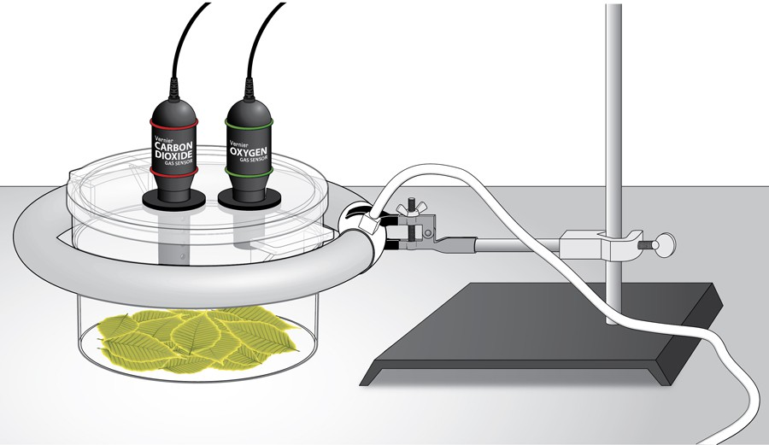

Figure 1: A diagram showing a respiration chamber containing plant leaves connected to carbon dioxide (CO₂) and oxygen (O₂) sensors, which are linked to a computer interface. The chamber is positioned within a circular fluorescent light ring for the light trial, allowing illumination from all sides, while the sensors measure gas changes during photosynthesis and respiration.

PRE-LAB EXERCISE
Terms to Define
- Photosynthesis
- Cellular respiration
- Chloroplast
- Mitochondrion
- Glucose
- ATP
- Light reactions
- Calvin cycle
- Oxidation
- Reduction
- Gas exchange
- Carbon dioxide (CO₂)
- Oxygen (O₂)
- Metabolic rate
- Enzyme
- Autotroph
- Stomata
- Aerobic respiration
- Anaerobic respiration
- Equilibrium

Multiple Choice (20 Questions)
- Photosynthesis occurs in the:
A. Nucleus
B. Mitochondria
C. Chloroplast
D. Ribosome
- Cellular respiration occurs in the:
A. Chloroplast
B. Mitochondria
C. Membrane
D. Nucleus
- Photosynthesis requires:
A. Oxygen
B. Carbon dioxide and light
C. ATP only
D. Nitrogen
- The product of photosynthesis is:
A. CO₂
B. Glucose
C. ATP only
D. Nitrogen
- Cellular respiration produces:
A. Oxygen
B. Glucose
C. ATP
D. Light
- Oxygen is:
A. Consumed in respiration
B. Produced in respiration
C. Not involved
D. Only in plants
- CO₂ in photosynthesis is:
A. Produced
B. Consumed
C. Not used
D. Neutral
- Glucose is:
A. Waste
B. Energy source
C. Gas
D. Enzyme

- ATP is:
A. Structural molecule
B. Energy carrier
C. Waste
D. Gas
- Light reactions occur in:
A. Cytoplasm
B. Thylakoid membrane
C. Nucleus
D. Ribosome
- Calvin cycle occurs in:
A. Thylakoid
B. Stroma
C. Membrane
D. Cytoplasm
- In darkness, plants:
A. Only photosynthesize
B. Only respire
C. Do both equally
D. Stop metabolism
- A positive CO₂ slope means:
A. CO₂ consumption
B. CO₂ production
C. No change
D. Error
- A negative O₂ slope means:
A. Oxygen production
B. Oxygen consumption
C. No change
D. Evaporation
- Plants in light:
A. Only respire
B. Both processes occur
C. Stop metabolism
D. Use only CO₂

- Photosynthesis stores energy as:
A. Heat
B. Glucose
C. Light
D. ATP only
- Respiration releases energy as:
A. Light
B. ATP
C. Heat only
D. Sugar
- CO₂ sensor measures:
A. Temperature
B. Gas concentration
C. Light
D. Pressure
- Gas exchange occurs through:
A. Roots
B. Stomata
C. Leaves only
D. Stem
- A higher slope means:
A. Slower rate
B. Faster rate
C. No change
D. Error
Short Answer (10 Questions)
- Write the equation for photosynthesis.

- Write the equation for cellular respiration.

- How are photosynthesis and respiration related?

- What is the role of chloroplasts?

- What is ATP and why is it important?

- Why do plants perform respiration?

- What happens in light reactions?

- What happens in the Calvin cycle?

- Why measure CO₂ and O₂?

- What do you expect in dark conditions?

MATERIALS
- Computer and computer interface
- aluminum foil
- ring stand and utility clamp
- O₂ Gas Sensor
- CO₂ Gas Sensor
- biochamber
- 12-inch ring fluorescent lamp
- spinach leaves

Starting Point for Laboratory Procedure

If the equipment at your workstation has already been properly set up, you may begin the laboratory procedure at this point.

If the equipment has not been set up, you must first consult the addendum section provided at the conclusion of this laboratory document. Carefully follow the setup instructions outlined there. Upon completing the equipment setup, return to this point to begin the laboratory procedure.

Sensor Calibration
- CO2 Sensor
  - Wait 90 seconds, then place the tip of a stylus into the CAL slot of the CO2 Sensor (between the red bands)
  - Hold until the red-light blinks three times, then release. Note: If the light becomes steady, wait until it goes out, and then try again. The reading should be between .300-.500 ppt.

O₂ Sensor
  - Select the Experiment Tab
  - Select Calibrate from the drop-down menu
- Check the box for LabPro: 1 CH 2: Oxygen Gas '
1v. Click on the "Calibrate Now Box" in the Sensor Settings window box
  - Enter 20.9 as Reading 1
  - Click "Keep"
  - Place the tip of a stylus into the CAL slot of the O2 Sensor (between the green bands)
    - Hold until the voltage reading in the right middle of the Sensor Settings box is close to O (0.01-0.09 V)
    - While holding the button in to maintain the near zero voltage reading. enter O for Reading 2.
      - Click "Keep"
      - Click "Done"
TEST PROCEDURE: Note for best results conduct the foil-wrapped test first

Foil-wrapped chamber (dark chamber) test
- Assemble the lamp. Important: Do not turn the lamp on until instructed to do so.
- Wrap the BioChamber with aluminum foil so that no light will reach the leaves.
  - Wrap the outside of the chamber with foil.
  - Cover the lid with foil, poking the holes open to insert the sensors.
- Cover the bottom of the chamber with one layer of fresh turgid spinach leaves. Remove any stems that could interfere with an even lining of the bottom.
- Secure the lid on the chamber and insert the sensors into the holes.
- Wait five minutes for the sensors to equilibrate, then click to begin the 15-minute data collection.
- When data collection is complete, find the rate of respiration.
  - Click anywhere on the CO2 graph. Autoscale the data by clicking the Autoscale button on the toolbar.
  - Move the cursor to the point where the data values begin to increase. Hold down the left mouse button and drag the cursor to select the region of increasing CO2 gas concentration.
  - Click on the Linear Fit button to perform a linear regression. A box will appear with the formula for a best fit line.
  - Record the slope of the line, m, as the rate of respiration in Table 1.
  - Close the linear regression box.
  - Repeat Steps 5 a–e for the O2 graph, selecting the region of decreasing O2 concentration.
- Store your data by choosing Store Latest Run from the Experiment menu.
- When data collection has finished, change the column heading of the latest run by clicking on the column heading and typing "Dark Run" in the pop-up box

Plain chamber (light chamber) test
- Remove the aluminum foil from the respiration chamber and invert the chamber to remove the leaves and accumulated gases.
- Line the bottom of the chamber with fresh turgid spinach leaves.
- Secure the lid on the chamber and insert the sensors into the holes.
- Place the chamber inside the bulb and turn on the lamp.
- Repeat Steps 4 –6 to collect and analyze data.
- When data collection has finished, change the column heading of the latest run by clicking on the column heading and typing "Light Run" in the pop-up box

Determine the rates of photosynthesis/Respiration:

- Click near the start of the CO2 graph. Move the mouse pointer to the point where the data values begin to increase or decrease. Hold down the left mouse button. Drag the pointer to the point where the data ceases to increase/ decrease and release the mouse button
- Click on the Linear Fit button, , (Analyze → Linear Fit) to perform a linear regression. Select both probes.
- A floating box will appear near each data line with the formulas for best fit
- Record the slope of the lines, m, from each box in Table 1 as the rate of photosynthesis/ respiration for each condition (move boxes if necessary)
- Click near the start of the 02 graph. Move the mouse pointer to the point where the data values begin to increase or decrease. Hold down the left mouse button. Drag the pointer to the point where the data ceases to increase/ decrease and release the mouse button

Determine the rates of photosynthesis/respiration:
Click near the start of the CO2 graph. Move the mouse pointer to the point where the data values begin to increase or decrease. Hold down the left mouse button. Drag the pointer to the point where the data ceases to increase/ decrease and release the mouse button
- Click on the Linear Fit  button to perform a linear regression. Select both probes.
- A floating box will appear near each data line with the formulas for best fit
- Record the slope of the lines, m, from each box in Table 1 as the rate of photosynthesis/respiration for each condition (move boxes if necessary)
- Click near the start of the 0₂ graph. Move the mouse pointer to the point where the data values begin to increase or decrease. Hold down the left mouse button. Drag the pointer to the point where the data ceases to increase/decrease and release the mouse button
- Clean and dry the chamber.

DATA

Table 9.1 Experimental Data showing Carbon Dioxide (CO₂) and Oxygen (O₂) Rates for Plant Leaves Under Two Conditions: Dark and Light

Table 1
Leaves | CO₂ rate of production/consumption (ppt/min) | O₂ rate of production/consumption (ppt/min)
In the dark
In the light

Describe the trends in the production or consumption of CO2 and O2 in the following conditions:

- Without light

- With Light.

QUESTIONS
POST-LAB QUESTIONS
Multiple Choice (15 Questions)
- In darkness, CO₂ levels:
A. Decrease
B. Increase
C. Stay same
D. Disappear
- In light, O₂ levels:
A. Decrease
B. Increase
C. Stay same
D. Disappear
- Photosynthesis rate is determined by:
A. Volume
B. Slope
C. Time only
D. Color
- Positive slope indicates:
A. Decrease
B. Increase
C. No change
D. Error
- Negative slope indicates:
A. Increase
B. Decrease
C. Stable
D. Error
- Plants in light produce:
A. CO₂ only
B. O₂
C. Nitrogen
D. Methane

- Respiration always:
A. Produces CO₂
B. Produces O₂
C. Stops in light
D. Uses nitrogen
- Data variation may result from:
A. Leaf size
B. Light
C. Temperature
D. All the above
- Faster respiration shows:
A. Steeper slope
B. Flat line
C. No gas exchange
D. Negative data
- Photosynthesis depends on:
A. Light
B. CO₂
C. Water
D. All the above
- Gas sensors measure:
A. Mass
B. Concentration
C. Volume
D. Energy
- Dark results show:
A. Photosynthesis
B. Respiration
C. Both equally
D. Neither
- Light results show:
A. Photosynthesis dominance
B. Respiration only
C. No reaction
D. Freezing

- Slower rate shows:
A. Steep slope
B. Flat slope
C. Vertical line
D. Curved line
- ATP is produced during:
A. Photosynthesis only
B. Respiration
C. Both
D. Neither
Short Answer (10 Questions).
All questions must be completed prior to leaving the laboratory. Upon completion, you must present your responses to the instructor for review and verification.
- What happened to CO₂ in dark vs light?
- What happened to O₂ in dark vs light?
- How do your graphs support respiration?
- How do your graphs support photosynthesis?
- Explain positive vs negative slopes.
- Why is light essential for photosynthesis?
- What factors affected your results?
- How would more leaves affect results?
- What errors could occur in this lab?
- How do these processes support life?

Potential Poster Topics
- Design and perform an experiment to test one of the factors that might influence the rate of oxygen production or consumption in Question 5.

- Compare the rates of photosynthesis and respiration among several types of plants.

Addendum: Setup Instructions
- Open and turn on the computer
- Attach one end of the AC adapter cord to the rear side of the Interface and plug the other end of the cord into the outlet
- Connect one end of the serial cable to the interface and the other end to a USB port on the laptop computer
- Open the LoggerPro program by double clicking on the desktop icon
- Set up the Sensors

CO2
    - Ensure the switch is set to the Low (0-10,000 ppm) setting
2. Connect the CO2 Gas Sensor to Channel 1 (CH 1) on the left side of the Vernier computer interface. You should see a box with a reading in the lower left corner of the screen
  - O2 Connect the O2 Gas Sensor to Channel 2 (CH 2) on the left side of the Vernier computer interface
- Prepare the computer for data collection:
  - Select the File tab
  - Select Open from the drop-down menu
  - Select Biology with Vernier
  - Select Experiment "31C Photo (CO2 and O2)" from the end of the list
  - Two graphs will appear. Move your cursor to the background of the CO2 graph and double click. The graph options box will appear. Under the axis options tab, for the "Y" axis, change the "Scaling:" setting from "manual" to "Autoscale" Click “Done”
  - Repeat "Y" axis scaling change for the O2 graph

Appendix: Photosynthesis and Respiration Terms
Term | Definition
Aerobic Respiration | The process of producing ATP using oxygen in the mitochondria.
Anaerobic Respiration | Energy production without oxygen, resulting in less ATP.
ATP | Adenosine triphosphate, the main energy-carrying molecule used by cells.
Autotroph | An organism that produces its own food using light or chemical energy.
Calvin Cycle | The stage of photosynthesis where carbon dioxide is used to produce glucose.
Carbon Dioxide (CO2) | A gas used in photosynthesis and released during respiration.
Cellular Respiration | The process that converts glucose into ATP, carbon dioxide, and water.
Chloroplast | The organelle in plant cells where photosynthesis occurs.
Enzyme | A protein that speeds up chemical reactions.
Equilibrium | A state where there is no net change in concentration or energy.
Gas Exchange | The movement of oxygen and carbon dioxide into and out of cells.
Glucose | A sugar molecule that stores energy produced during photosynthesis.
Light Reactions | The stage of photosynthesis that captures light energy and produces ATP and oxygen.
Metabolic Rate | The rate at which chemical reactions occur in an organism.
Mitochondrion | The organelle where cellular respiration occurs.
Oxidation | The loss of electrons during a chemical reaction.
Oxygen (O2) | A gas used in respiration and produced during photosynthesis.
Photosynthesis | The process plants use to convert light energy into chemical energy in glucose.
Reduction | The gain of electrons during a chemical reaction.
Stomata | Small openings in leaves that allow gas exchange.
Stroma | The fluid-filled space in chloroplasts where the Calvin cycle occurs.
Thylakoid | Membrane structures in chloroplasts where light reactions occur.

INSTRUCTOR ANCILLARIES
Pre-Lab Support
- Provide a brief lecture (15 min):
  - Photosynthesis overview
  - Respiration overview
  - Energy flow (ATP)
- Use visuals:
  - Diagrams of chloroplast & mitochondria
  - Reaction equations
- Assign pre-lab quiz
- Emphasize light vs dark predictions

During Lab
- Demonstrate:
  - Chamber setup
  - Sensor handling and calibration

- Monitor:
  - Proper leaf placement
  - Data collection accuracy
- Ask guiding questions:
  - “What trend do you expect?”
  - “Why is CO₂ increasing/decreasing?”

Post-Lab Support
- Compare class data
- Discuss:
  - Differences between groups
  - Unexpected results
- Reinforce:
  - Interpretation of slopes
  - Graph analysis

Assessment Suggestions
- Pre-lab quiz
- Lab data sheet grading
- Graph analysis assignment
- Post-lab reflection

Common Student Challenges
- Misinterpreting graph slopes
- Confusing respiration vs photosynthesis
- Mishandling sensors
- Not understanding light vs dark effects

Teaching Tips for Adjuncts
- Emphasize: “Plants always respire”
- Use: real-life connections (human respiration vs plants)
- Reinforce: graphs = rates (slope = change over time)
- Encourage: prediction → observation → explanation

Lab Timeline (Approx. 2–2.5 hours)
Pre-Lab (Before Class or First 15 min)
- 0–10 min: Pre-lab quiz / review key concepts
- 10–15 min: Instructor overview (photosynthesis vs respiration, sensors, graphs)

Lab Activities
Part 1: Setup & Calibration (20–25 min)
- Computer + software setup
- Sensor connection and calibration
- Chamber preparation

Part 2: Dark (Respiration) Trial (20 min)
- Setup foil-wrapped chamber
- 5 min equilibration
- 15 min data collection

Part 3: Data Analysis (10 min)
- Graph interpretation
- Slope calculation (CO₂ + O₂)

Part 4: Light (Photosynthesis) Trial (20 min)
- Remove foil, add light
- 15 min data collection

Part 5: Data Analysis (10–15 min)
- Calculate rates
- Compare light vs dark

Wrap-Up (15–20 min)
- Group discussion
- Begin post-lab questions
- Clean up

Lab Report Template
Title
Photosynthesis and Respiration in Spinach Leaves

Name / Date / Section

Objectives
(Use provided lab objectives)

Introduction (1–2 paragraphs)
- Describe photosynthesis and respiration
- Include balanced equations
- State purpose of experiment

Materials
(List key materials used)

Methods (Brief Summary)
- Describe dark and light trials
- Include sensor use

Results
Table 1:
Condition | CO₂ Rate | O₂ Rate
Dark
Light

Graphs
- Insert CO₂ and O₂ graphs
- Label “Light” and “Dark”

Calculations
- Show slope values (rates)
Discussion (2–3 paragraphs)
- Compare light vs dark results
- Explain biological meaning
- Identify errors
- Discuss environmental factors

Conclusion (1 paragraph)
- Summarize key findings
- State whether objectives were met

Post-Lab Questions
(Answer all assigned questions)
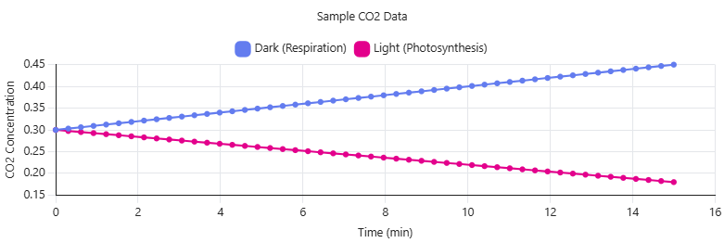
Alt Text:
Graph showing carbon dioxide (CO₂) concentration over time under two conditions. In the dark (respiration), CO₂ levels increase steadily, indicated by a positive slope, demonstrating CO₂ production. In the light (photosynthesis), CO₂ levels decrease over time, indicated by a negative slope, demonstrating CO₂ consumption.
Figure 9.1 Sample CO₂ Graph
How to Interpret
- Dark (Respiration):
  - CO₂ increases over time
  - Positive slope → CO₂ is being produced
- Light (Photosynthesis):
  - CO₂ decreases over time
  - Negative slope → CO₂ is being consumed

Alt Text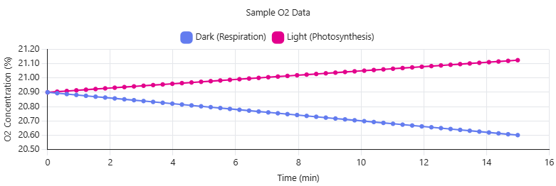:
Line graph of oxygen (O₂) levels over time showing two conditions: in darkness, O₂ decreases (negative slope, respiration), and in light, O₂ increases (positive slope, photosynthesis).
Figure 9.2 Sample O₂ Graph
How to Interpret
- Dark (Respiration):
  - O₂ decreases over time
  - Negative slope → oxygen is being used
- Light (Photosynthesis):
  - O₂ increases over time
  - Positive slope → oxygen is produced

Key Teaching Points
- Slope = Rate
  - Steeper slope → faster process
- Sign matters:
  - Positive CO₂ → respiration
  - Negative CO₂ → photosynthesis
- Plants ALWAYS respire
  - Light just adds photosynthesis

How Students Should Use These
- Compare their graphs to these patterns
- Identify whether their slopes match expected trends
- Use slopes to calculate metabolic rates

This laboratory exercise is adapted from Biology with Vernier: Experiment 31C – Photosynthesis and Respiration (November 1, 2022), with later modifications for instructional use.

