Laboratory Exercise 12: Introduction to Corn Genetics and Chi Square Testing
Lab Objectives
The purpose of this lab is to help you understand how traits are inherited by:
- Identifying visible traits (phenotypes) in corn kernels
- Collecting and organizing data
- Using Punnett squares to predict genetic outcomes
- Calculating expected values based on Mendelian genetics
- Applying a chi-square (χ²) test to analyze data
- Interpreting results using degrees of freedom and critical values
- Drawing conclusions about whether traits follow Mendelian inheritance patterns

Pre-Lab Exercises
A. Terms to Identify
Students should define the following:
- Phenotype
- Genotype
- Dominant
- Recessive
- Monohybrid cross
- Expected ratio
- Observed data
- Chi-square (χ²)
- Degrees of freedom (df)
- Significance level (p value)

B. Multiple Choice Questions (Pre-Lab)
- A monohybrid cross typically involves:
  - A. Two traits
  - B. One trait
  - C. Three traits
  - D. No traits

- In a 3:1 ratio, the “3” represents:
  - A. Recessive phenotype
  - B. Dominant phenotype
  - C. Genotypes only
  - D. Total offspring

- What does χ² measure?
  - A. Genetic mutation
  - B. Difference between observed and expected values
  - C. DNA sequence
  - D. Cell division

C. Short Answer Questions (Simple)
- What is the expected phenotypic ratio for a monohybrid cross?

- Why do scientists use expected values?

- What does a small difference between observed and expected values suggest?

- How is the total sample size used in calculating expected values?

Introduction to Corn Genetics
Genetics is the study of how traits are passed from parents to offspring. In this lab, you will explore these ideas using corn (Zea mays). Corn is a useful organism for studying genetics because each ear contains many kernels, and each kernel represents one offspring. These kernels clearly show visible traits, such as color (purple or yellow) and shape (round or wrinkled), making patterns of inheritance easier to observe.
Traits are controlled by genes, which are located on chromosomes. For each gene, organisms inherit two copies, called alleles—one from each parent. These alleles can be the same (homozygous) or different (heterozygous). The combination of alleles is called the genotype, while the physical appearance of the trait is the phenotype.
Some alleles are dominant, meaning they are expressed even if only one copy is present. Others are recessive, meaning they are only seen when two copies are present. For example, in corn, purple color is typically dominant over yellow, and round shape is dominant over wrinkled. Even if a recessive trait is not visible in one generation, it can reappear in later generations.
The principles you will use in this lab were first described by Gregor Mendel. His Law of Segregation states that allele pairs separate during the formation of gametes, so each gamete carries only one allele. His Law of Independent Assortment states that different genes are inherited independently, as long as they are on different chromosomes.
You will begin by using Punnett squares to predict the expected ratios of traits in offspring. In a monohybrid cross (one trait), the expected phenotypic ratio in the F2 generation is usually 3:1 (dominant to recessive). In a dihybrid cross (two traits), the expected ratio is typically 9:3:3:1.
However, real data rarely matches these ratios exactly. To test whether your results fit Mendelian predictions, you will use a chi-square (χ²) test. This statistical method helps determine whether differences between your observed data and expected values are due to random chance or suggest a different pattern of inheritance.
By the end of this lab, you will connect genetic theory to real data and develop skills in scientific reasoning, data analysis, and interpretation—important tools for all areas of biology.
The research question is: Does simple Mendelian inheritance explain the color and shape of corn seeds?
If the answer is yes, then you are assuming that:
- Each trait is controlled by two alleles that show complete dominance.
- Each trait is determined by a single gene.
- In the dihybrid cross, the genes for these traits are located on different chromosomes and assort independently.
- The data you collected are accurate, meaning the seeds were counted, and their traits were identified correctly.

Monohybrid cross
In this cross, the first-generation parents were homozygous for a single trait, e.g., either PP for purple (dominant) or pp for yellow (recessive). The offspring of this cross is the F1 generation, all of which are the same genotype.
Suppose you cross parental genotypes PP × p*p*. Use the Punnett squares below to determine the possible genotypes and phenotypes of the F1 and F2 generations.
F1 Generation
 | P | P
p* |  |  | Phenotype ratio:
p* |  |  | Genotype Ratio:

Next, cross two of the prodigies from the F1 generation above (Pp* x Pp*)
F2 Generation
 | P | p*
P |  |  | Phenotype ratio:
p* |  |  | Genotype Ratio:

Note: P refers to the dominant trait while p* refers to the recessive trait.
Chi-Square in Genetics
In genetics, Punnett squares are used to predict the expected ratios of traits in offspring. However, real experimental data rarely match these predictions exactly. Slight differences between expected and observed results are common due to chance, sampling variation, or experimental error.
The chi-square (χ²) test is a statistical method used to decide whether the differences between observed and expected results are significant, or simply due to random variation.

The chi-square test compares:
- What you observed in an experiment
- What you expected based on a genetic hypothesis
This allows you to evaluate whether your data fits the expected genetic model.
Key idea:
The chi-square test helps determine whether deviations from expected ratios are due to chance or show a different genetic outcome.
Chi-Square Formula
χ2=∑[(O−E)²] / E
Where:
- O = observed value
- E = expected value
- Σ = sum of all data points

Using Chi-Square in a Monohybrid Cross
Example: 3:1 Phenotypic Ratio
Step 1: State Hypothesis
The observed results follow a 3:1 ratio (dominant: recessive).
Step 2: Observed Data
- Tall = 78
- Short = 22
Total = 100
Step 3: Expected Values
- Tall = 75
- Short = 25

Step 4: Calculate Chi-Square
χ2=∑[(O−E)²] / E
χ2= [(78−75)²+(22−25)² ] = 9 + 9 = 0.12 + 0.36 = 0.48
75 25 25 25

Step 5: Degrees of Freedom
Degrees of freedom (df) represent the number of independent categories that can vary when calculating a chi-square value.
In genetics chi-square problems, degrees of freedom are calculated using the formula:
df=number of categories−1
Examples
- Monohybrid cross (2 categories: dominant and recessive):
df=2−1=1
- Dihybrid cross (4 categories: 9:3:3:1):
df=4−1=3
Why It Matters
The degrees of freedom determine which value you use from the chi-square table. This allows you to decide whether the difference between observed and expected results is significant.

Step 6: Interpretation
Compare χ² (0.48) to critical value (3.84 at p = 0.05, df = 1)
Since: 0.48<3.84
Why 3.84 is the Critical Value for a population of two observations
The number 3.84 comes from a chi-square distribution table and represents a cutoff point based on:
- Degrees of freedom (df = 1)
- Significance level (p = 0.05)
A graph of the Chi-squared distribution can be seen in figure 11.1.
This is the probability of rejecting the null hypothesis when it is true (a false positive).
A p-value of 0.05 means that there is a 5% chance that any difference between the observed and expected results is due to random chance. This sets out a cutoff point for deciding whether the result is significant.
For a chi-square test with 1 degree of freedom, this cutoff value (called the critical value) is 3.84.
So:
- If your χ² value is less than 3.84, the difference is due to chance (not significant).
- If your χ² value is greater than 3.84, the difference is unlikely due to chance (significant).
That 5% region is called the rejection region.
On the graph, our calculated Chi-squared value of 0.48 is far left of 3.84.

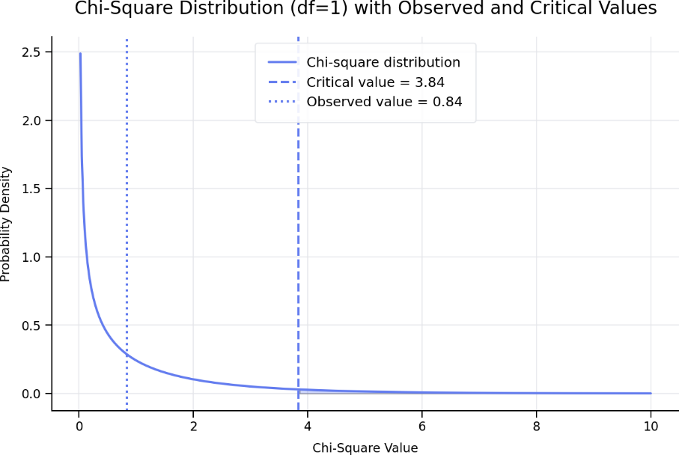
A chi-square distribution curve with 1 degree of freedom is shown. The curve rises steeply on the left and gradually slopes downward to the right. A vertical line marks the critical value at 3.84 on the right side of the graph. The calculated chi-square value (0.48) is found far to the left of this line, in the high-probability region, showing that the result is not significant.
Figure 11.1. Chi-Square Distribution Plot (df = 1)
This means:
- Your result is in the high-probability region
- It is not unusual at all
- It fits what we expect by chance

Monohybrid experiment
Next, create a hypothesis regarding the distribution of seeds you expect to see based on the Punnett square for the F2 generation you completed above.
Expected Genotype and Phenotypes
Based on your information about the F2 progeny, complete the table below.
Table 11.1. Genotypic and Phenotypic Ratios
Genotype | ratio | Phenotype | ratio | Percentage expected
PP |  | Purple
Pp* |  | Yellow
p*p*

Working in groups of two, have one student read out the seed phenotypes while the other records the data in Table xxx. The kernels in this activity represent the F2 generation, as shown in the Punnett square completed earlier. Begin at one end of a row and count the number of seeds for each color, making sure not to count any seed more than once. Do not mark or remove the seeds from the cob. Use the provided rubber bands to divide the cob into sections to make counting easier. Record the number of purple seeds, yellow seeds, and the total number of seeds below.

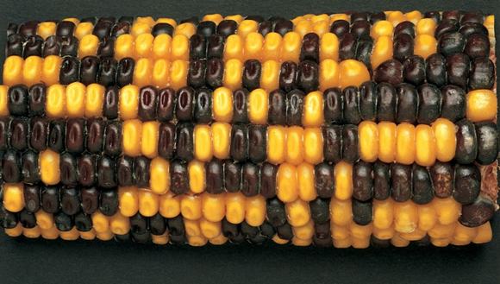

Photograph of a monohybrid ear of corn showing variation in a single trait, with kernels displaying two distinct phenotypes distributed across the cob.

Figure 11.2 Picture of a monohybrid ear of corn. Image source: Carolina Biological Supply (www.carolina.com).
Observed Data
Table 11.3 The number of purple (P) and yellow (p*) kernels.

 | Row
Phenotypes | 1 | 2 | 3 | 4 | 5 | 6 | 7 |  | Total
P
p*
 |  |  |  |  |  | Grand Total
Dominant Trait: ______
Recessive Trait: ______
Total Offspring: ______

Step 1: State the Hypothesis in a full sentence

Expected phenotypic ratio: ______________________

Step 2: Calculate Expected Values
Expected dominant: ______

Expected recessive: ______
Hint:
- Multiply total × 3/4 for dominant
- Multiply total × 1/4 for recessive

Monohybrid Chi Square testing
Using the data you generated from table11.3, you are now going to determine if the results obtained from an experiment or observation are consistent with the expected results. In this corn genetics study, we assume that purple seeds are dominant over yellow seeds. Based on this idea, we can predict the expected ratio of purple to yellow seeds in each F2 cob if Mendelian inheritance is occurring. You already calculated these expected ratios earlier using Punnett squares and genotype/phenotype predictions. Now, we will compare those expected results with the actual counts you observed. This comparison will help determine whether these traits follow Mendelian patterns. If your calculated Chi-square (χ²) value is higher than expected, it may indicate counting errors or that one or more of your assumptions may not be correct.

Steps to follow:
- Collect your data.
- Using the total number of seeds (grand total) counted on your F2 cob (regardless of color), calculate how many purple and yellow seeds you would expect based on the predicted phenotypic ratio from the Punnett square. Multiply the expected ratio by the total number of seeds recorded in Table xx.x. Record these values in the “Expected” column of Table xx.x.
- Subtract the expected value from the observed value for each phenotype and record the result in the “Deviation” column.
- Square each deviation and enter the values in the “D²” column.
- Divide each D² value by its corresponding expected value.
- Add all these values together. This total is your Chi-square (χ²) test statistic.
Table 11.4 Table of Chi-square Calculations
Phenotype | Observed (O) | Expected  (E) | Deviation (D)  D = (O-E) | D² | D²/E
Purple

Yellow

Total

Sum of all D2/E = c2

c2 =

The ratio predicted from your Punnett square will differ slightly from the ratio you observed when counting the corn kernels. If your calculated χ² value is greater than 3.84, the difference between observed and expected values is considered significant. If it is less than 3.84, the difference is not significant.
What degrees of freedom should be used for this analysis?
Is your χ² value greater than or less than 3.84?

Based on your chi-square results, how do your observed data compare to the predicted values?

Dihybrid chi-squared testing.
Using Chi-Square in a Dihybrid Cross
Example: 9:3:3:1 Ratio
Step 1: Observed Data
- Round Yellow = 190
- Round Green = 65
- Wrinkled Yellow = 40
- Wrinkled Green = 25
Total = 320
Step 2: Expected Values
- 9/16 × 320 = 180
- 3/16 × 320 = 60
- 3/16 × 320 = 60
- 1/16 × 320 = 20

Step 3: Calculate Chi-Square
χ2= (190−180)² +(65−60) ² +(40−60) ² +(25−20) ² = (0.56+0.42+6.67+1.25) = 8.90
180 60 60 20

Step 4: Degrees of Freedom
df = n - 1
df=4−1=3df = 4 - 1 = 3
Step 5: Interpretation
Critical value (df = 3, p = 0.05) = 7.81
Since: 8.90 > 7.81 (the Critical Value or cutoff point)

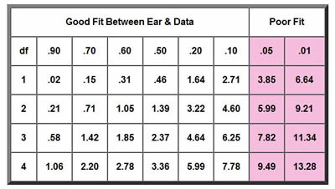
A table of chi-square critical values for right-tailed tests with degrees of freedom 1 through 4. Rows correspond to degrees of freedom (1, 2, 3, 4). Columns represent several significance levels ranging from 0.90 to 0.01. Values increase as either the degrees of freedom, or the level of significance becomes more stringent.
Figure 11.3. Chi square goodness fit table. Image from the biologycorner.com
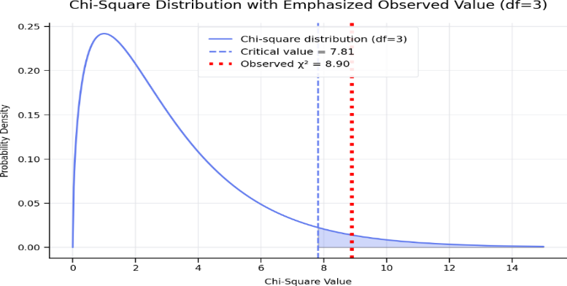
A chi-square distribution curve with 3 degrees of freedom is shown. The curve starts high on the left and gradually decreases to the right. A vertical line marks the critical value at 7.81, representing the cutoff for a significance level of p = 0.05. The calculated chi-square value is also positioned at 7.81, right at this cutoff line. This location indicates the result lies at the boundary of the 5% rejection region. Values beyond this line would fall outside the 95% confidence range, suggesting the results are significant, while values at or below the line are borderline or not significant.
Figure 11.4. Plot of chi-squared distribution and the calculated chi-squared value.
Conclusion:
The difference is significant. The observed data do not fit the expected 9:3:3:1 ratio.

Key Rule
- If χ² is less than the critical value
→ Differences are due to chance
→ Accept the hypothesis
- If χ² is greater than the critical value
→ Differences are significant
→ Reject the hypothesis
Important Points
- Real data rarely matches expected ratios exactly
- Larger sample sizes improve accuracy
- Experimental error may affect results
- Chi-square does not prove the hypothesis correct; it only tests if the data are consistent with it

Summary
- Punnett squares predict expected ratios
- Chi-square evaluates how well data match predictions
- Monohybrid crosses use fewer categories (df = 1)
- Dihybrid crosses involve more variation (df = 3)
- Corn kernel data provides real-world application of genetic principles

Part 2: Dihybrid Cross (9:3:3:1 Ratio)
Applying Chi-Square to Student Generated Corn Ear Data
Now you are going to create your own data to analyze inheritance patterns in corn ears, where each kernel stands for an offspring.
Common traits:
- Kernel color: Purple vs white
  - Purple is dominant
- Kernel texture: Round vs crinkled
  - Round is dominant

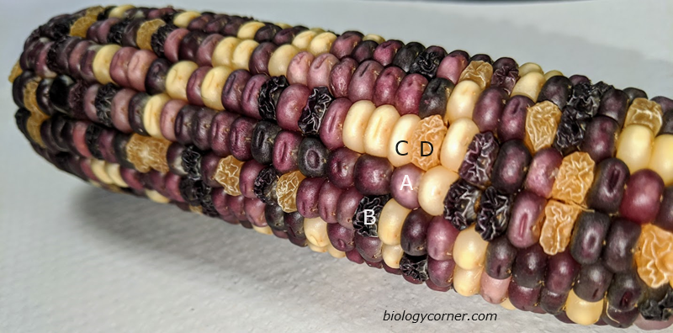
Photograph of an ear of corn showing four distinct kernel phenotypes arranged across the cob. The kernels vary in both color and texture. Category A shows purple, smooth kernels; Category B shows purple, shrunken kernels; Category C shows yellow, smooth kernels; and Category D shows yellow, shrunken kernels. The differences illustrate combinations of two traits: kernel color (purple vs. yellow) and kernel shape (smooth vs. shrunken). Biology corner.com, ND, CC SA By 4.0

Figure 11.5. Picture of a dihybrid ear of corn having two traits, kernel color, and texture. Image from the biologycorner.com
Dihybrid Corn Example
Students count:
- Purple round (PR)
- Purple wrinkled (Pr*)
- Yellow round (p*R)
- Yellow wrinkled (p*r*)
Expected ratio: 9:3:3:1
Process:
- Count total number of kernels from 7 rows
- Expect a 9:3:3:1 ratio
- Calculate expected values
- Perform chi-square test

Chi-squared calculations
Steps:
- Calculate expected values
- Compute χ²
- Compare to critical value
- Decide if inheritance follows Mendelian expectations
- Interpretation of Results

Chi-Square Worksheet (Guided Calculations)
Step 1: Data collected for the Chi-square calculations
Table 11.5. Data Collected from 7 Rows of Corn
 |  | Row
 |  | 1 | 2 | 3 | 4 | 5 | 6 | 7
Pheno t ypes | PR
Pheno t ypes | Pr*
Pheno t ypes | p*R
Pheno t ypes | p*r*

Step 2: Calculate Chi-Square Components
Table11.6. Chi-square Calculation Data
Phenotype | Observed (O) | Expected  (E) | Deviation (D)  D = (O-E) | D² | D²/E
Purple round

Purple wrinkled
Yellow round

Yellow wrinkled
Total

Sum of all D2/E = c2

c2 =

Step 3: Calculate Chi-Square Value: χ² = Σ [(O – E) ²] / E} = ______

Step 4: Degrees of Freedom: df = categories − 1 = ______

Step 5: Interpretation
Compare your value to 7.81 (p = 0.05, df = 3)
Conclusion (circle one) and explain your reasoning.
- Accept hypothesis
- Reject hypothesis
Explain how it compares to the cutoff point

- Does your data support Mendelian inheritance? What does this mean biologically?

Discussion
Address the following:
- Why do observed values differ from expected?

- Was the difference significant?

- What sources of error may have affected results?

- How could the experiment be improved?

Post-Lab Exercises
A. Multiple Choice Questions
- If χ² is greater than the critical value, you:
  - A. Accept the null hypothesis
  - B. Reject the null hypothesis
  - C. Ignore the data
  - D. Recount samples
- The critical value depends on:
  - A. Sample color
  - B. Degrees of freedom
  - C. Number of kernels only
  - D. Observed data

Short Answer Questions
- Why might the observed data differ slightly from expected ratios in real experiments?

- Explain what it means to “fail to reject the null hypothesis” in this lab.

- How would your conclusion change if χ² exceeded the critical value?

- What biological factors could cause large deviations from expected ratios?

- Why is chi-square analysis important in genetic studies?

Additional Learning Resources:
- Watch these videos to learn more about these critical, introductory concepts of corn genetics listed above.

- Chi Square Review
  - Don't FEAR Chi Square! A Guide for AP Bio
Don't FEAR Chi Square! A Guide for AP Bio Students, @sciencemusicvideos
A complete and student friendly discussion of how to solve a Chi Square problem
  - https://youtu.be/HKDqlYSLt68?si=MPTSQYFcudMJvkZ_
Chi Square Test, The Organic Chemistry Tutor, (7 minutes)
This statistics video tutorial provides a basic introduction into the chi square test. It explains how to use the chi square distribution to perform a goodness of fit test to decide whether to accept or reject the null hypothesis.

- Corn Lab
  - https://youtu.be/D9956-GWOkA?si=AqsCbES_gWVWwFN2
By Sixth Form Biology, Chi Squared and the Corn Cobs (14 minutes)
A good step by step demonstration of the application of Chi Square in the corn lab.

  - https://youtu.be/12Vcf4l_E6s?si=aigMtOuznSlPk3pk
By Christan Fry. bio 2 chi square corn lab (9 minutes)
A review of how a corn genetics lab could be approached and completed.

  - https://youtu.be/OlKtfoy6V5w?si=uujzoMVOjtaD2o0o
By Elements of Biology, Lab_MaizeGenetics, (29 minutes)
A comprehensive explanation of corn biology and genetics and chi square testing.

Appendix: Corn Genetics and Chi-Square Testing Terms
Term | Definition
Allele | Different forms of a gene inherited from each parent.
Chi-Square (χ²) | A statistical test used to compare observed and expected data.
Critical Value | The cutoff value used to determine if results are statistically significant.
Degrees of Freedom (df) | The number of independent categories used in a chi-square test, calculated as categories minus one.
Dihybrid Cross | A genetic cross involving two traits.
Dominant | An allele that is expressed when present, even if only one copy exists.
Expected Ratio | The predicted proportion of phenotypes based on Mendelian genetics.
Genotype | The genetic makeup (allele combination) of an organism.
Heterozygous | Having two different alleles for a trait.
Homozygous | Having two identical alleles for a trait.
Hypothesis | A testable explanation or prediction about a scientific observation.
Law of Independent Assortment | Mendel’s principle that alleles of different genes are inherited independently.
Law of Segregation | Mendel’s principle that allele pairs separate during gamete formation.
Monohybrid Cross | A genetic cross involving a single trait.
Null Hypothesis | The assumption that observed differences are due to chance.
Observed Data | The actual results were collected during an experiment.
P-value | The probability that observed differences are due to chance.
Pedigree | A diagram used to track inheritance patterns in families.
Phenotype | The observable traits of an organism.
Punnett Square | A diagram used to predict genetic outcomes of crosses.
Ratio | A comparison of quantities, often used to describe genetic outcomes.
Recessive | An allele expressed only when two copies are present.
Significance Level | The threshold (commonly 0.05) used to determine statistical significance.
Test Statistic | A calculated value (like chi-square) used to evaluate a hypothesis.

Instructor Ancillaries
Pre-Lab Support
- Mini-lecture topics:
  - Mendelian inheritance (dominant vs recessive)
  - Monohybrid crosses and Punnett squares
  - Introduction to chi-square testing
- Guided practice:
  - Walk students through a simple 3:1 ratio example
  - Model how to calculate expected values
- Common misconceptions to address:
  - Students may think data must exactly match 3:1
  - Confusion between genotype vs phenotypes
During Lab
- Encourage accurate counting and recording
- Check student tables for organization
- Prompt students to explain why they are doing each step
Post-Lab Support
- Discussion prompts:
  - “What does your χ² value tell you about inheritance?”
  - “Was your result expected or surprising?”
- Data analysis guidance:
  - Help interpret χ² results (not just calculate them)
  - Reinforce meaning of p = 0.05

- Extension ideas:
  - Compare results across groups
  - Discuss experimental error sources
  - Introduce dihybrid crosses as a next step
Assessment Suggestions
- Grade on:
  - Accuracy of data table
  - Correct χ² calculation
  - Quality of interpretation
  - Ability to explain conclusions in writing

Instructor Notes (Optional)
This structure:
- Guides students through quantitative reasoning
- Reinforces hypothesis testing
- Aligns with introductory lab report expectations
- Builds skills needed for advanced biology courses

