# Python pre-processing:

from csv import reader

import csv

import datetime

import re

outf = open('C:\\Documents\\HAMSCIData\\WSPR data\\WSPR2022v3-control\\Mar30.csv','at', newline='')

write=csv.writer(outf)

indir = 'C:\\Documents\\HAMSCIData\\WSPR data\\WSPR2022v3-control\\'

infile = indir+"2022-03-30_WSPR.csv"

legal_gridsquares = ["CN","CM","DN","DL","DM","EN","EM","EL","FN","FM","FL"]

print(infile)

with open(infile,'r') as WSPRfile:

WSPRcsv = reader(WSPRfile)

for row in WSPRcsv:

Tgrid = row[2][0:4]

Rgrid = row[7][0:4]

Tgridpre = Tgrid[0:2]

Rgridpre = Rgrid[0:2]

if Tgridpre in legal_gridsquares:

if Rgridpre in legal_gridsquares:

row.append(Tgrid)

row.append(Rgrid)

row=list(filter(None,row))

write.writerow(row)

WSPRfile.close()

outf.close()

print("Done")

# Using R to analyze data

Mar30fn <- "C:\\Documents\\HAMSCIData\\WSPR data\\WSPR2022v3-control\\Mar30.csv"

Mar30 <- read.csv(Mar30fn)

names(May30) <- c("Datetime", "Tcall", "Tgrid", "Tlat", "Tlang", "Tgridsrc", "Rcall", "Rgrid", "Rlat", "Rlon", "Rgridsrc", "Freq", "SNR", "Mode","x1","dist","x3","x4","TG04","RG04")

#

# So, if we merge dataframes by date, we know the origin

#

Mar30$DT <- "Mar30"

#

# Create columns for hours and hours/tenth of hour:

#

Mar30$HR <- as.numeric(substring(Mar30$Datetime, nchar(Mar30$Datetime)-7, nchar(Mar30$Datetime)-6))

Mar30$MIN <- as.numeric(substring(Mar30$Datetime, nchar(Mar30$Datetime)-4, nchar(Mar30$Datetime)-3))

Mar30$HRtenth <- Mar30$HR + (Mar30$MIN/60)

## Which metric is best for reflecting propagation changes

#

# Create data frames to analyze all data for date

#

# First, do SNR by hour and by hour/tenth

#

Mar30SNRbyHR <- aggregate(Mar30$SNR, list(Mar30$HR), FUN = mean)

names(Mar30distbyHR) <- c("Hour", "Dist")

Mar30SNRbyHRtenth <- aggregate(Mar30$SNR, list(Mar30$HRtenth), FUN = mean)

names(Mar30distbyHRtenth) <- c("Hour", "Dist")

#

# SNR vs. Time

#

ggplot(Mar30SNRbyHR , aes(x = Hour, y = AvgSNR) ) +geom_line() + ggtitle("March 30 2022 – Average SNR by hour on 40 meters") + geom_vline(xintercept=c(17.35,17.77), color='red')

ggplot(Mar30SNRbyHRtenth , aes(x = Hour, y = AvgSNR) ) +geom_line() + ggtitle("March 30 2022 - Average SNR by Six minute intervals on 40 meters ") + geom_vline(xintercept=c(17.35,17.77), color='red')

#

# Distance vs. time

#

ggplot(Mar30distbyHRtenth , aes(x = Hour, y = Dist)) +geom_line() + ggtitle("March 30 2022 - Average Distance by Six minute intervals on 40 meters ") + geom_vline(xintercept=c(17.35,17.77), color='red')

ggplot(Mar30distbyHR , aes(x = Hour, y = Dist)) +geom_line() + ggtitle("March 30 2022 - Average Distance by Hour on 40 meters ") + geom_vline(xintercept=c(17.35,17.77), color='red')

#

# Number of observations by time

#

Mar30COUNTbyHR <- aggregate(Mar30$HR, list(Mar30$HR), FUN = length)

names(Mar30COUNTbyHR) <- c("Hour", "Reports")

ggplot(Mar30COUNTbyHR , aes(x = Hour, y = Reports) ) +geom_line()+ggtitle("March 30 2022 - Nbr Observations by hour on 40 meters") + geom_vline(xintercept=c(17.35,17.77), color='red')

Mar30COUNTbyHRtenth <- aggregate(Mar30$HRtenth, list(Mar30$HRtenth), FUN = length)

names(Mar30COUNTbyHRtenth) <- c("Hour", "Reports")

ggplot(Mar30COUNTbyHRtenth , aes(x = Hour, y = Reports) ) +geom_line()+ggtitle("March 30 2022 - Nbr Observations by Six minute intervals on 40 meters") + geom_vline(xintercept=c(17.35,17.77), color='red')

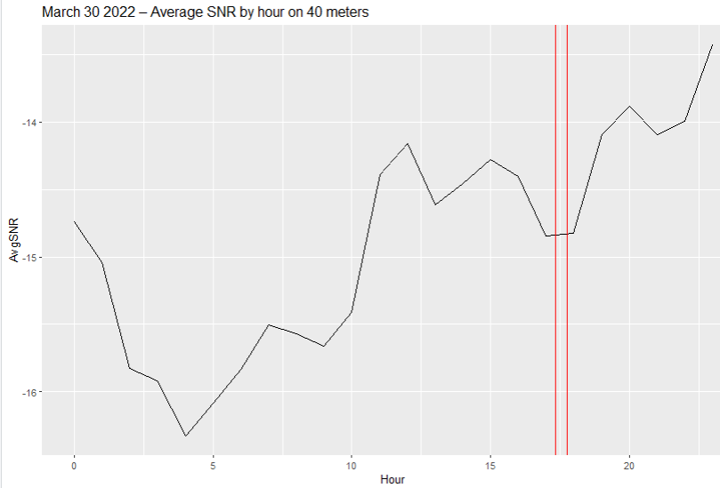

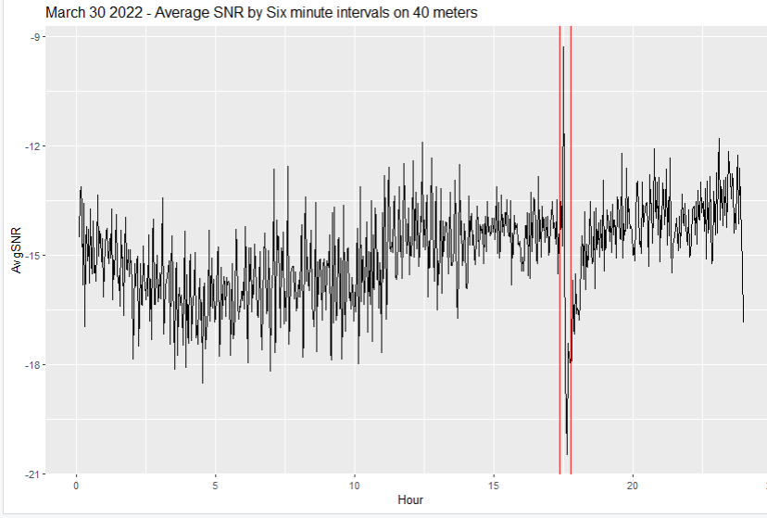

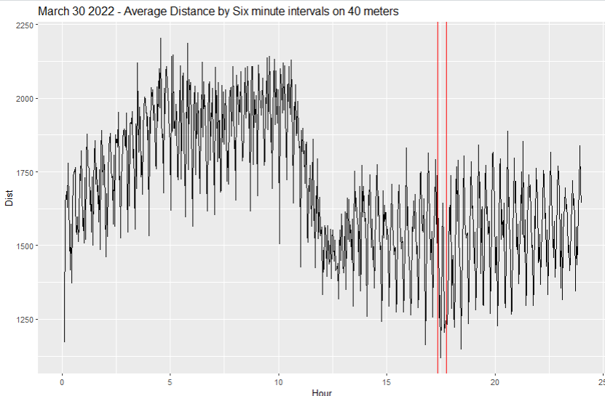

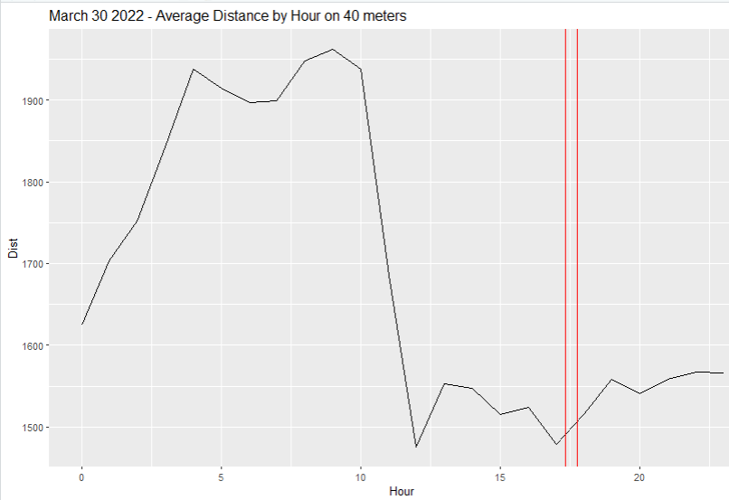

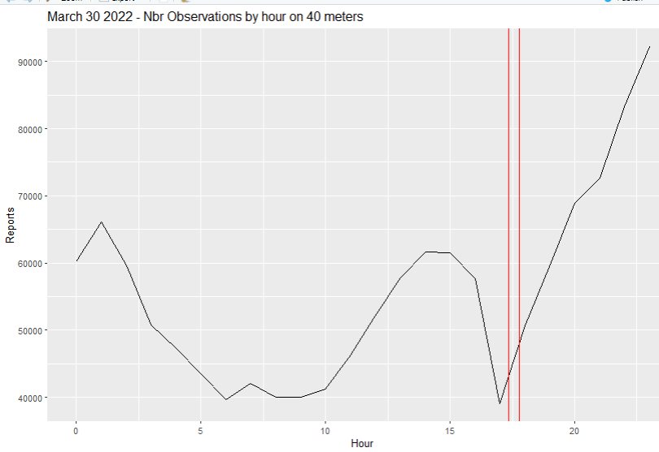

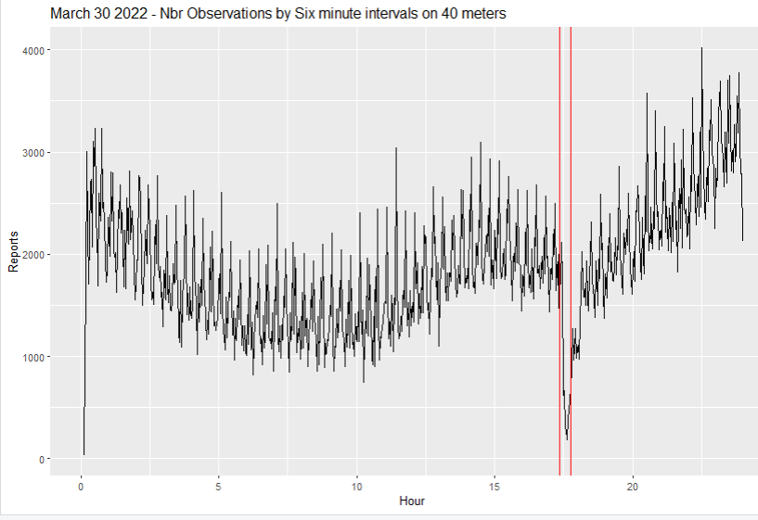

Conclusion – Average SNR by six minute intervals is the best candidate

as it shows the most pronounced impact during the flare duration. Averages by hour diminish the measured impact and tend to shift the time of most impact as the average trails the latest observation.

# Split by distance range

Ranges:

|  |  |  |  |
| --- | --- | --- | --- |
| **Miles** | **Possible propagation** | **File suffix** | **rows** |
| 0-1 | assumed a mistake | --- | --- |
| 0 – 40 | Ground wave, line-of-sight | LT40 | 16,479 |
| 40 – 500 | NVIS | LT500 | 141,315 |
| 500 – 1500 | E layer | LT1500 | 557,420 |
| 1500 – 3000 | F Layer | LT3000 | 417,528 |
| 3000 – max | Multi hop, other | LTmax | 197,890 |

references:

https://www.arrl.org/files/file/Technology/tis/info/pdf/8312011.pdf

https://www.arrl.org/files/file/Technology/pdf/119962.pdf

https://en.wikipedia.org/wiki/F2_propagation

https://en.wikipedia.org/wiki/Ionosphere#layers_anchor (E layer)

https://johnsonfrancis.org/techworld/what-are-ground-wave-sky-wave-skip-distance-and-skip-zone/ “In general, the maximum skip distance for E layer is around 2500 km while that for F2 layer is 5000 km”

https://r5.ieee.org/ctx-lm/wp-content/uploads/sites/50/INTRODUCTION-TO-SOLAR-WEATHER-ASTRO.pdf NVIS, F2 max range

# Line of Sight

Mar30LT40 <- Mar30[Mar30$dist >1 & Mar30$dist <40,]

# NVIS 40 to 500 miles

Mar30LT500 <- Mar30[Mar30$dist >40 & Mar30$dist < 500,]

# E-layer 500 to 1500 miles

Mar30LT1500 <- Mar30[Mar30$dist >500 & Mar30$dist < 1500,]

# F-layer over 1500 miles

Mar30LT3000 <- Mar30[Mar30$dist > 1500 & Mar30$dist < 3000,]

# All else – multi hop. etc

Mar30LTmax <- Mar30[Mar30$dist > 3000,]

# Summarize by SNR / tenth hour

Mar30LT40byHRtenth <- aggregate(Mar30LT40$SNR, list(Mar30LT40$HRtenth), FUN = mean)

names(Mar30LT40byHRtenth) <- c("Hour", "AvgSNR")

Mar30LT500byHRtenth <- aggregate(Mar30LT500$SNR, list(Mar30LT500$HRtenth), FUN = mean)

names(Mar30LT500byHRtenth) <- c("Hour", "AvgSNR")

Mar30LT1500byHRtenth <- aggregate(Mar30LT1500$SNR, list(Mar30LT1500$HRtenth), FUN = mean)

names(Mar30LT1500byHRtenth) <- c("Hour", "AvgSNR")

Mar30LT3000byHRtenth <- aggregate(Mar30LT3000$SNR, list(Mar30LT3000$HRtenth), FUN = mean)

names(Mar30LT3000byHRtenth) <- c("Hour", "AvgSNR")

Mar30LTmaxbyHRtenth <- aggregate(Mar30LTmax$SNR, list(Mar30LTmax$HRtenth), FUN = mean)

names(Mar30LTmaxbyHRtenth) <- c("Hour", "AvgSNR")

ggplot(Mar30LT40byHRtenth , aes(x = Hour, y = AvgSNR) ) +geom_line() + ggtitle("March 30 2022 - Average SNR by Six minute intervals on 40 meters - LT 40 miles") + geom_vline(xintercept=c(17.35,17.77), color='red')

ggplot(Mar30LT500byHRtenth , aes(x = Hour, y = AvgSNR) ) +geom_line() + ggtitle("March 30 2022 - Average SNR by Six minute intervals on 40 meters - 40 - 500 miles") + geom_vline(xintercept=c(17.35,17.77), color='red')

ggplot(Mar30LT1500byHRtenth , aes(x = Hour, y = AvgSNR) ) +geom_line() + ggtitle("March 30 2022 - Average SNR by Six minute intervals on 40 meters - 500 - 1500 miles") + geom_vline(xintercept=c(17.35,17.77), color='red')

ggplot(Mar30LT3000byHRtenth , aes(x = Hour, y = AvgSNR) ) +geom_line() + ggtitle("March 30 2022 - Average SNR by Six minute intervals on 40 meters - 1500 - 3000 miles") + geom_vline(xintercept=c(17.35,17.77), color='red')

ggplot(Mar30LTmaxbyHRtenth , aes(x = Hour, y = AvgSNR) ) +geom_line() + ggtitle("March 30 2022 - Average SNR by Six minute intervals on 40 meters - GT 3000 miles") + geom_vline(xintercept=c(17.35,17.77), color='red')

# Plots

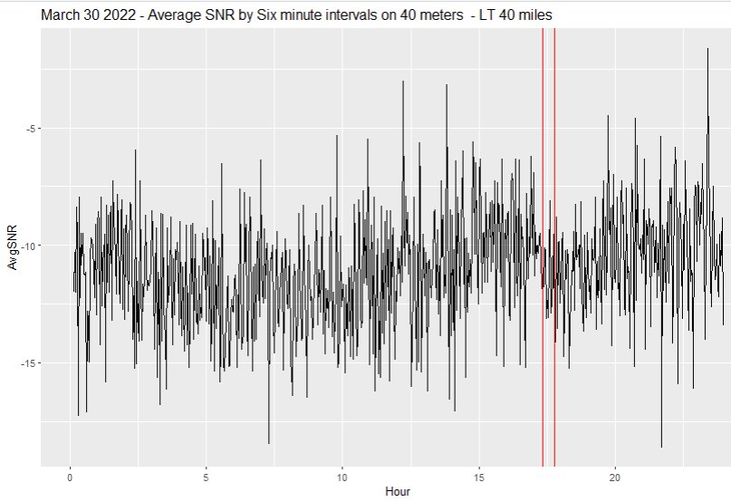

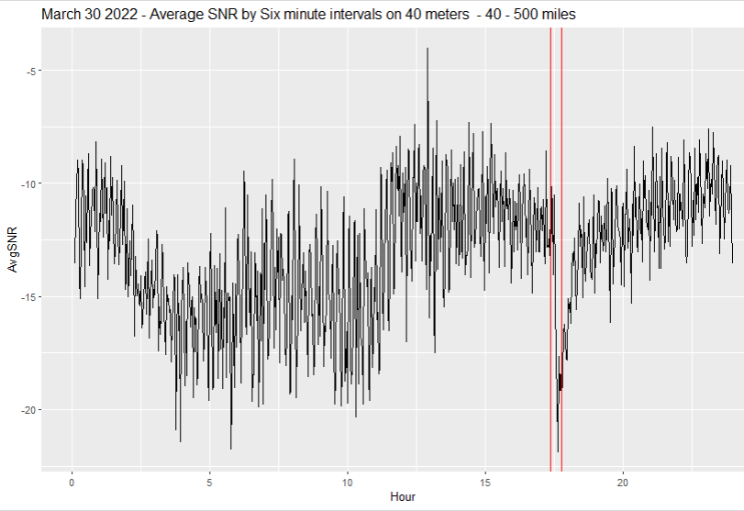

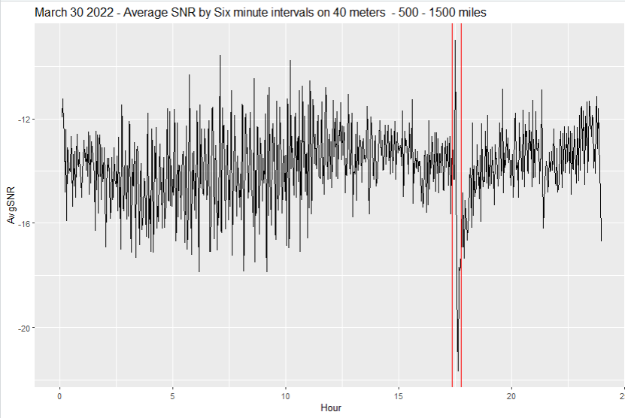

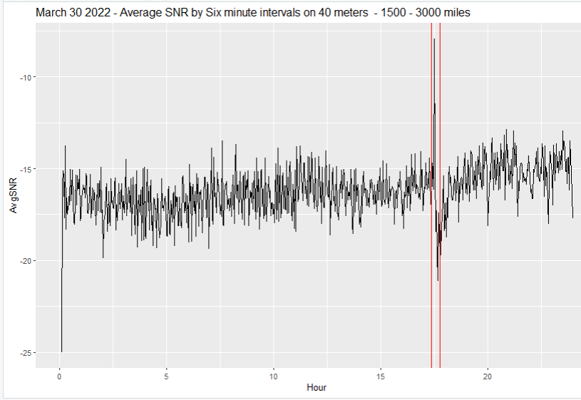

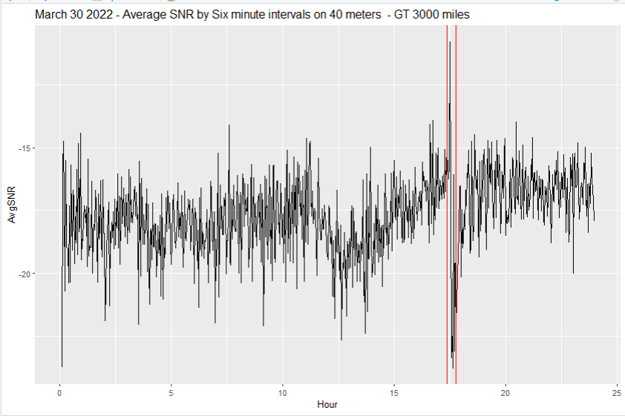

# More analysis:

Let’s zoom in on what happens right around the Flare