**CMSC203**

**Assignment 0 Part 3– Eclipse Installations**

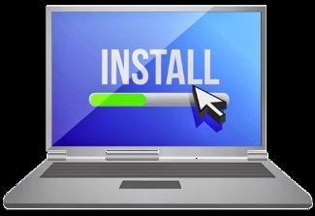

**Install and Test IDE Eclipse**

The purpose of this assignment is to prepare you with software(Eclipse) you need in order to be able to set the environment on your computer to successfully start working on your assignments. It is crucial that you complete this assignment to save you time in order to focus on the course work and projects.

**Objectives**

* Install Eclipse IDE ([www.eclipse.rog](http://www.eclipse.rog))
* Create a new Project in Eclipse

**Part 1 – Install Java Development Kit (JDK/SDK)**

**Step 1 Download –the Latest Eclipse IDE**

Eclipse is an Integrated Development Environment (IDE) that lets you write java code (program) and run and test your code. Follow the following steps to download Eclipse.

**1)** Open <https://www.eclipse.org/downloads/> and select “Download Packages” to download the latest Eclipse IDE 2021-12

**2)** Choose Eclipse IDE for Java Developers and select and click the operating system direct links:

* for Windows: Windows x86_64
* for Mac OS : macOS [x86_64](https://www.eclipse.org/downloads/download.php?file=/technology/epp/downloads/release/2021-12/R/eclipse-java-2021-12-R-macosx-cocoa-x86_64.dmg) | [AArch64](https://www.eclipse.org/downloads/download.php?file=/technology/epp/downloads/release/2021-12/R/eclipse-java-2021-12-R-macosx-cocoa-aarch64.dmg)

**3)** Click download

**

**5)** Click the box to “Use this as the default and do not ask again” and click “Launch”

**Note**: By doing so, you set your work directory as workspace within your local disk

(For Example: C:\Users\Sethatevy\eclipse-workspace)

**Now, you have successfully downloaded the Eclipse IDE!**

**6)** Take a screen shot of your screen showing you have been able to successfully start Eclipse and paste it to the same word document from part3.

**Step 2 – Create a new java Project**

**To create a simple first Java Project, follow these steps:**

**1) Click on File -> New -> Java project.**

[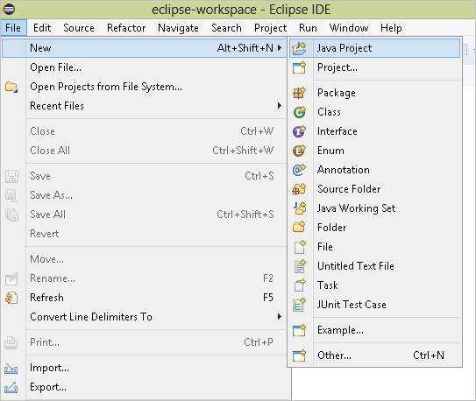](https://cdn.softwaretestinghelp.com/wp-content/qa/uploads/2018/09/1.Click-on-file-new-Java-project.png)

**2)** The following window will open:

Give a name to your project in the highlighted text field. Name your project as “MyFirstProject” and leave the rest of the fields as default and click **Finish**. Make sure uncheck Module checkbox.

You will see the following structure created in your project explorer.

[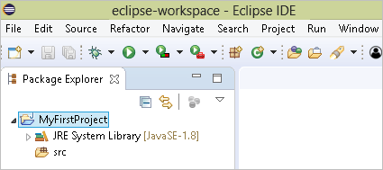](https://cdn.softwaretestinghelp.com/wp-content/qa/uploads/2018/09/4.structure-created-in-your-project-explorer.png)

Here you can see two sub-items under your project name. The JRE system library is the default Java library that Eclipse adds to your project. This library provides Java support and without this, you cannot proceed with creating a Java project. The other folder is the “src” folder or the source folder. Your project structure will get created inside this.

**3)** Right click on the MyFirstProject then select New ->Class.

Type the name of the program as **MyFirstClass** as follows and click on Finish button.

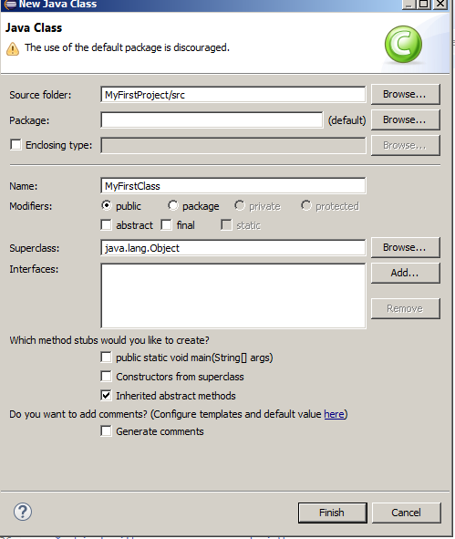

4) Type the following program and save it.

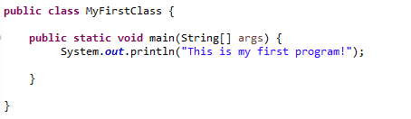

5) Take a screen shot of your screen and paste it to the same word document from part1.

**Deliverables**

1. Upload the word document containing the screen shots from Step 1 and 2 to Blackboard.
2. Upload the word document containing the screen shots from Step 1 and 2 to your account GitHub.