**CMSC203**

**Assignment 0 Part 4 – Setup Junit Test**



**Setup Junit Test**

The purpose of this Assignment is to prepare you with the tools and software you need in order to be able to set the environment on your computer to successfully start working on your assignments. It is crucial that you complete this Assignment to save you time to focus on the course work and projects.

* Add JUnit to Eclipse Java Project

**Objectives**

* Create java project, compile and run using Eclipse
* Create JUnit Test and execute JUnit Test Example

**Step – Setup JUnit**

Sources:

<https://www.tutorialspoint.com/junit/junit_basic_usage.htm>

Eclipse supports both JUnit 4 and JUnit 5 (JUnit Jupiter). You don’t have to download JUnit JAR files as Eclipse is shipped with JUnit library.

**Read the provided “JUnitBasics.pptx” slides before Creating New Java Project.**

1. Create New Java Project JUnitTestProject

This project will have two files, MessageUtil and MessageUtilTest, with the instructions to create them provided.

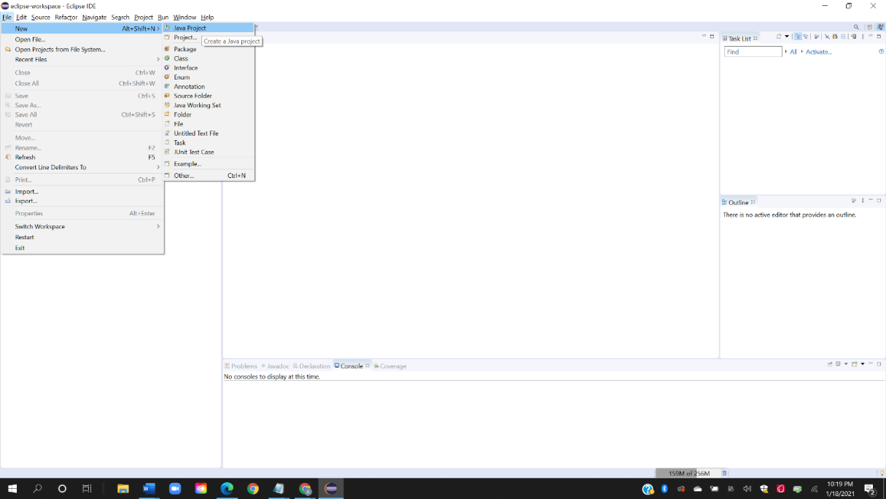

1. Create a java class to be tested MessageUtil.java

/*

* This class prints the given message on console.

*/

public class MessageUtil {

private String message;

//Constructor

//@param message to be printed

public MessageUtil(String message){

this.message = message;

}

// prints the message

public String printMessage(){

System.out.println(message);

return message;

}

}

1. Create a Test Case class based on MessageUtil class. Right click MessageUtil class and select Junit Test Case. Eclipse will create for you a class MessageUtilTest. Then

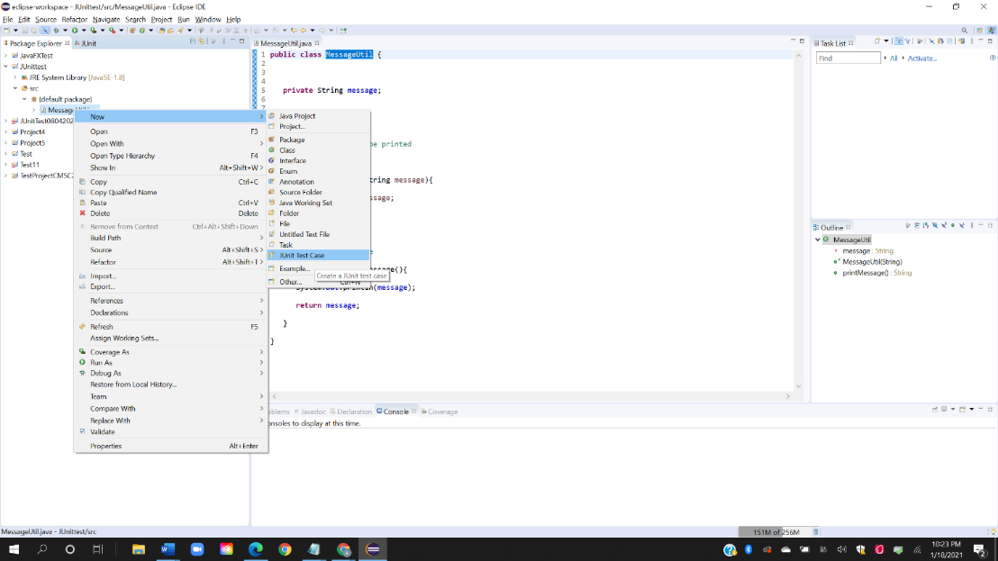

* Add a test method testPrintMessage () to your test class.
* Add an Annotation @Test to method testPrintMessage ().
* Implement the test condition and check the condition using assert Equals API of JUnit.

import org.junit.Test;

import static org.junit.Assert.assertEquals;

public class MessageUtilTest {

String message = "Hello World";

MessageUtil messageUtil = new MessageUtil(message);

@Test

public void testPrintMessage() {

assertEquals(message,messageUtil.printMessage());

}

}

1. Add Junit Library to the Project

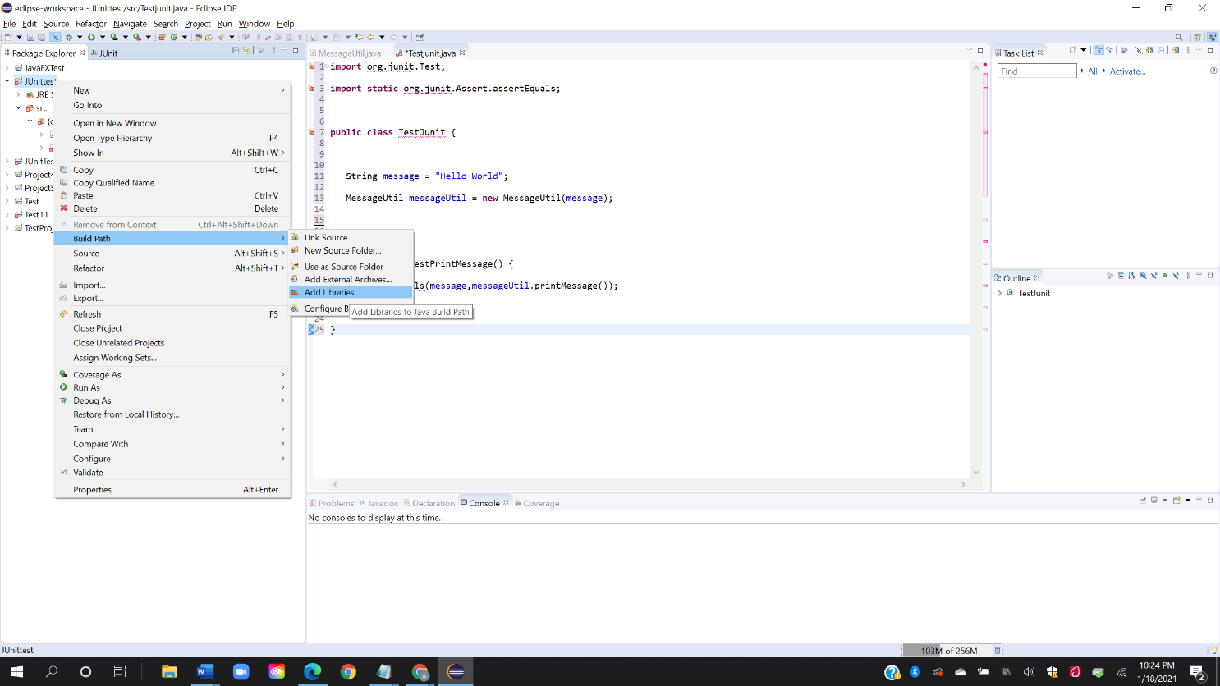

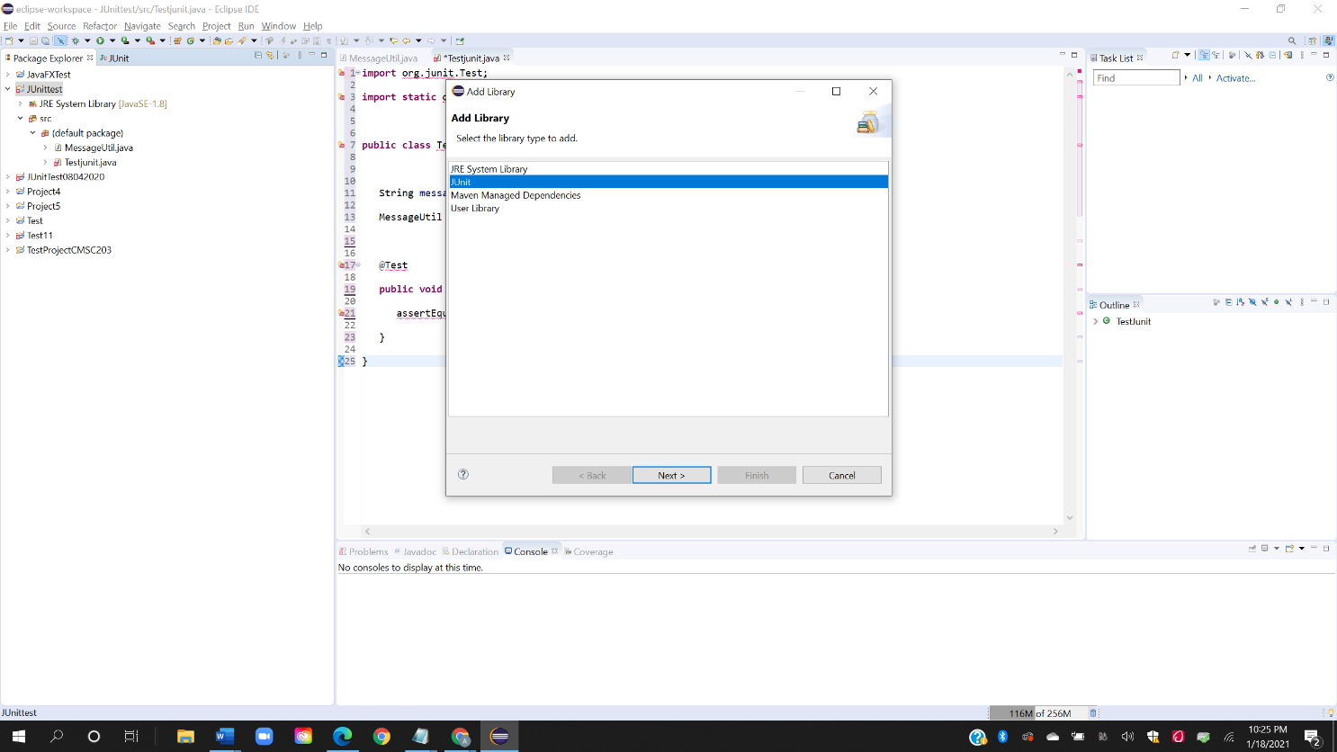

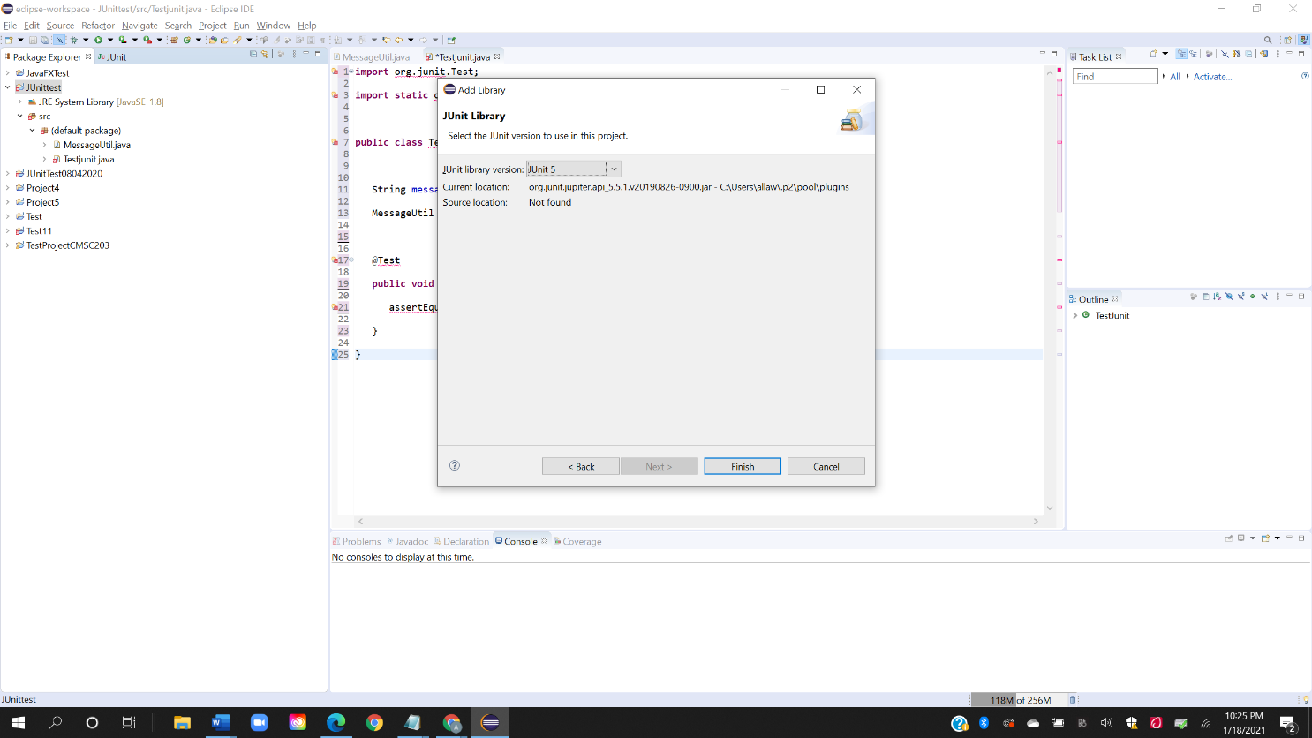

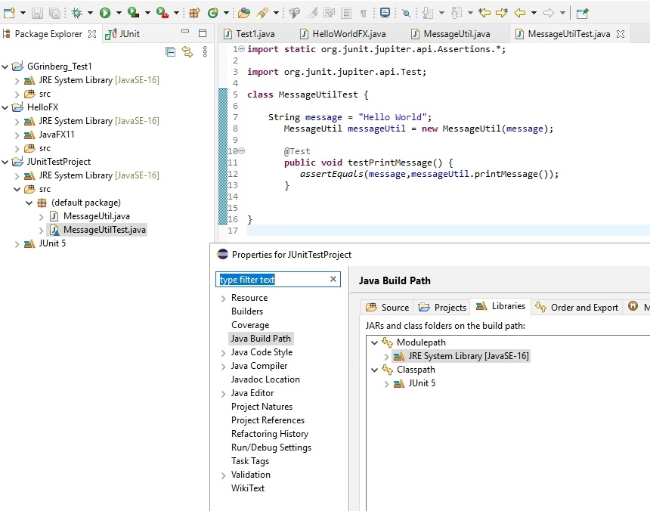

1. **How to Run JUnit Test**

To run the test, do right-click on the TestJunit class on the left navigation menu and select Run As > JUnit Test)

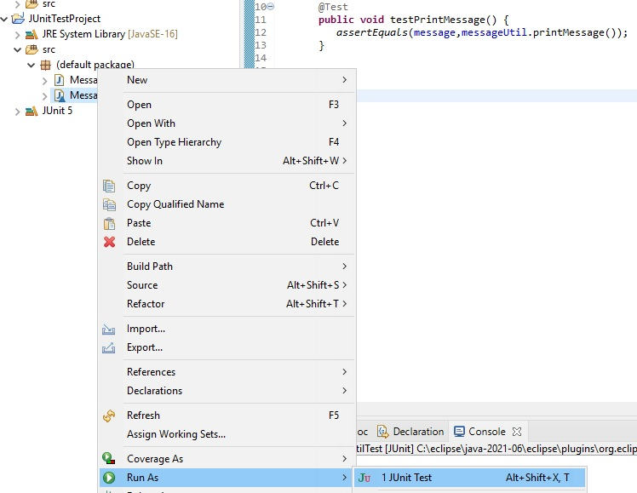

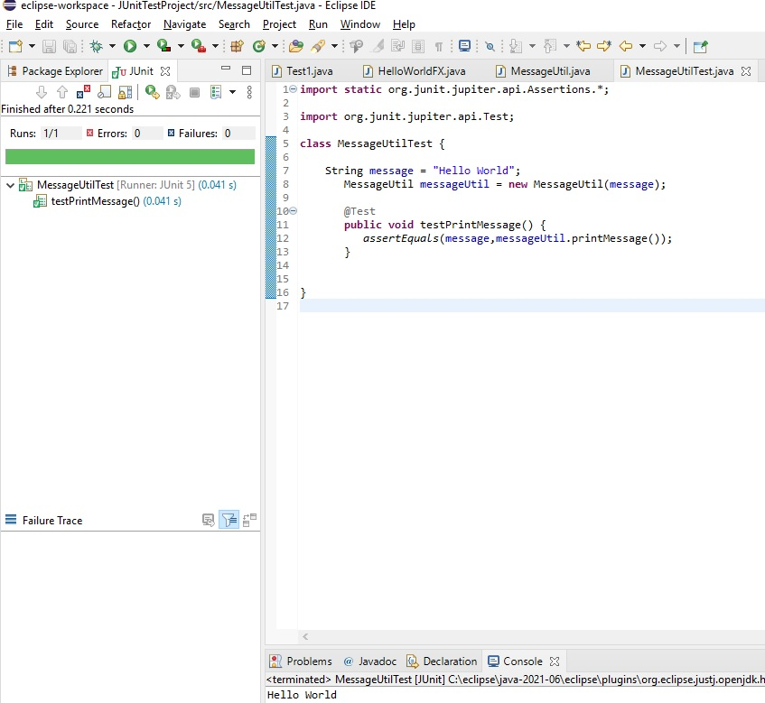

**Deliverables**

Upload the word document containing the screen shots from Step Setup JUnit to Blackboard Assignment 0.

**Submit:**

Screenshots showing:

Eclipse showing JUnit Test example working

* 1. Project screenshot
  2. Running example screenshot

**References**

How to Download and Install JUnit in Eclipse. (n.d.). Retrieved from <https://www.guru99.com/download-installation-junit.html>

<https://www.codejava.net/testing/junit-tutorial-for-beginner-with-eclipse>