http-backend

The backend is a server that uses SSE Server Side Events
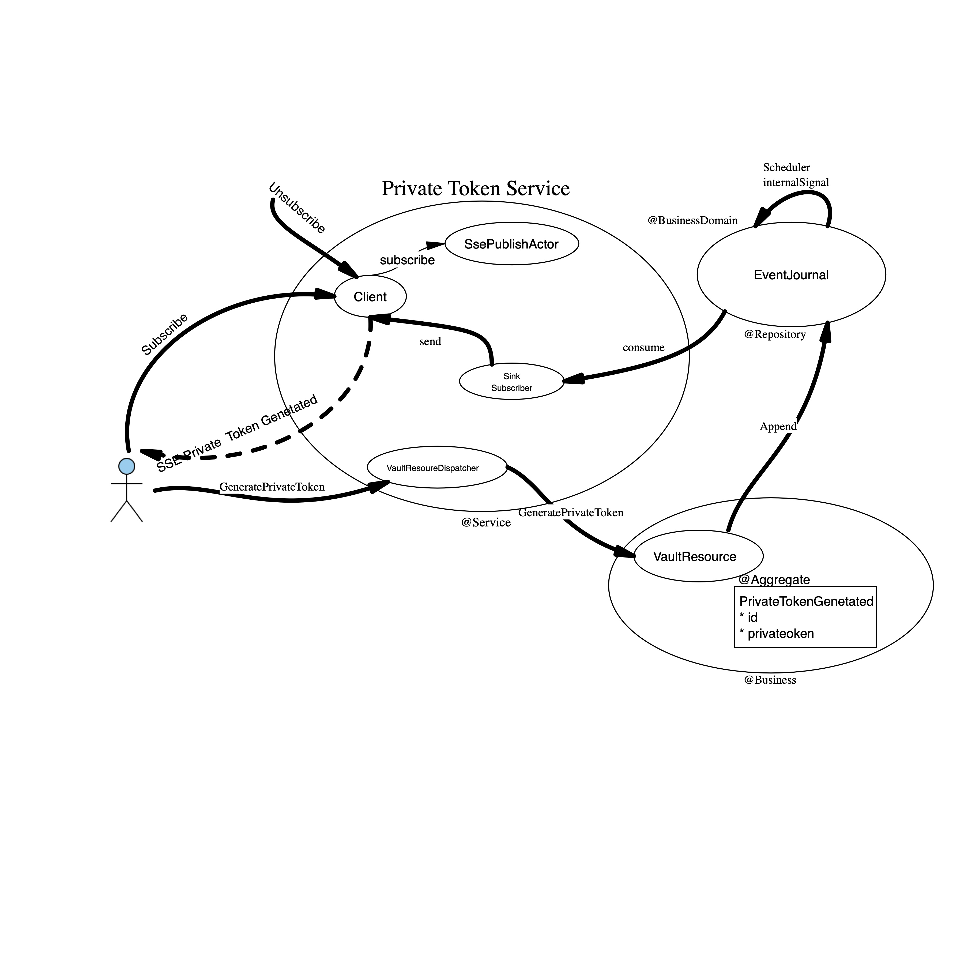

Client subscribe to vaultstream
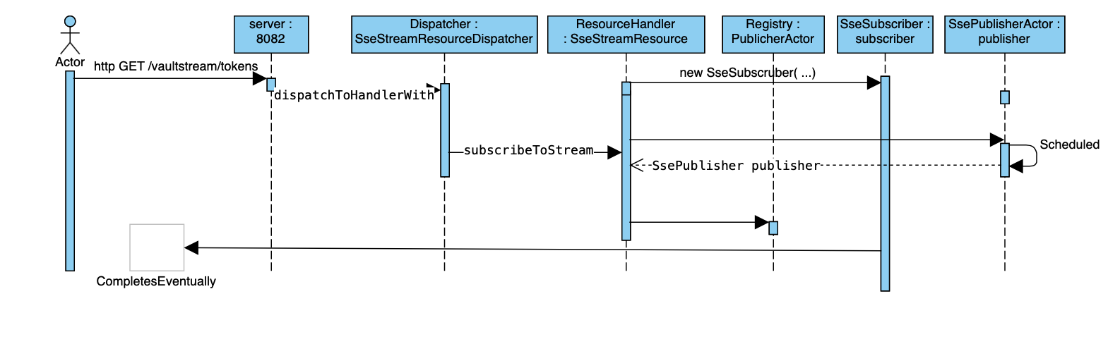
Figure: Server side diagram for how backend builds up incommng listening to vaultstream/tokens.
This takes place when http-frontend starts up.

streamName is mapped in vlingo-http.properties
in key sse.stream.name.tokens – here text after last dot is the streamName

GeneratePrivateToken
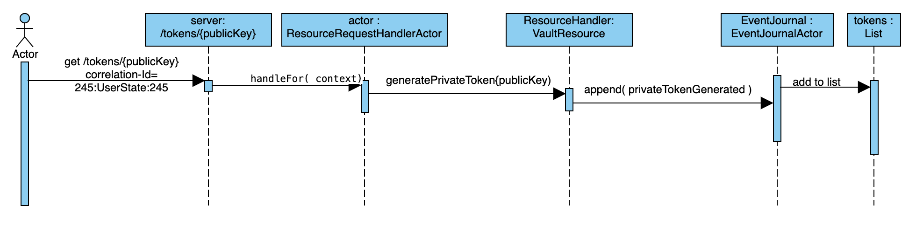
Figure: a private token is generated from backend server by REST call to /tokens/{publicKey}
The correlation-Id must be set to something that the vaultstream subscribing client/request can correlate to.

Define server
To define the http web server (class Server) this sample uses two components from vlingo-http plugin. A vault component and a sse component.

This is basic what happens when server is declared.

- A factory for TokenSseFeedActor is declated and stored in static factory
- server reads property file called http-server.properties
- Load web resources
  - Load vault
  - Load sse

A precondition to the server is that TokenSseFeedActor’s factory must be declared because that ActorInstanceRegistry works together with properties in http-server.properties.

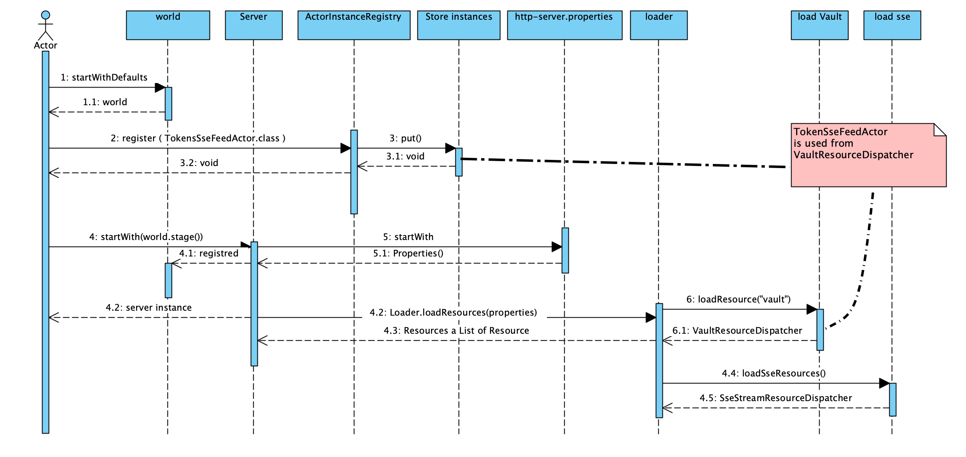
Sequence diagram how Server is configured and how http-server.properties is configured to to add two resources to the server.

