http-backend

The backend is a server that uses SSE Server Side Events

To define the http web server (class Server) this sample uses two components from vlingo-http plugin. A vault component and a sse component.

This is basic what happens when server is declared.

- A factory for TokenSseFeedActor is declated and stored in static factory
- server reads property file called http-server.properties
- Load web resources
  - Load vault
  - Load sse

A precondition to the server is that TokenSseFeedActor’s factory must be declared because that ActorInstanceRegistry works together with properties in http-server.properties.

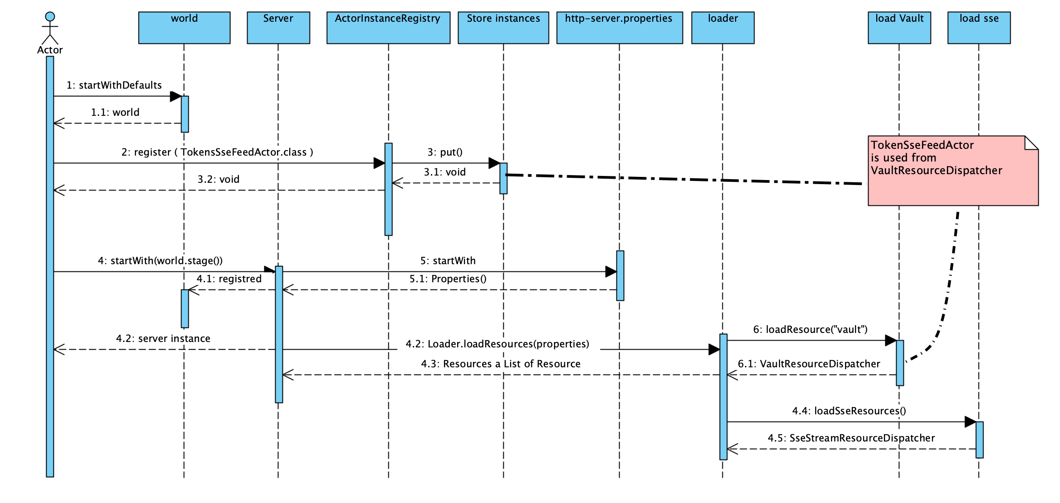
Vlingo is designed with basics programming patterns
- Components are immutable
- Components are added with using a fluent configuration.
- World contains stages that contains actors.
- World is NOT immutable – actors are born and actors are retired and taken out.
- World can be terminated – and a new world can be started. This helps testing here each test in a test case can have it’s own world.

These patterns are in progress and some older code does not 100% live up to all this.

Improvements
In general nothing should be ”hidden”
Fluent Building World

