ERROR: “Cannot locate database”
This document details the reason why you might get the “Cannot locate database” error when launching the OxBox software.
Before you read through the document, please note that one of the most common reasons why the error occurs is because someone has moved the database; so first of all, please check that nothing has been moved. (If you want to move the database to a different location, you need to re-install the network server and network client installations.) If you are sure that this hasn’t happened, then please read the fixes below to assess which one is appropriate to your problem.

Fix 1

When you have tried to install it as a Standalone
If you have installed the software using a standalone method and the error has occurred, then please go to the link below and download our Standalone Installation guide, and refer to the instructions in there. You will most likely need to use Installation Method 2 outlined in the guide, but please read through the whole document first.

http://fdslive.oup.com/www.oup.com/oxed/techsupport/help/oxbox-standalone-install.doc?region=uk

Fix 2

When you have installed the Network client from the disc
Before installing the Network client, please ensure that you have installed the database on the server.
When you are installing the client from the disc, often a simple error can occur if the wrong folder is linked to the client. Therefore, please make sure you have followed these network client instructions :
- Run the setup.exe on the client workstation and click Install.
- Accept the licence agreement and click Next.
- The destination of the install defaults to C:\Program files\Oxbox\ (recommended).
- Click Next, then click Install and when ready, Finish.
This should launch a choice of installation mode. Please select Network Client, and then select Browse and navigate to wherever your database has been put on the network. (See examples below.)
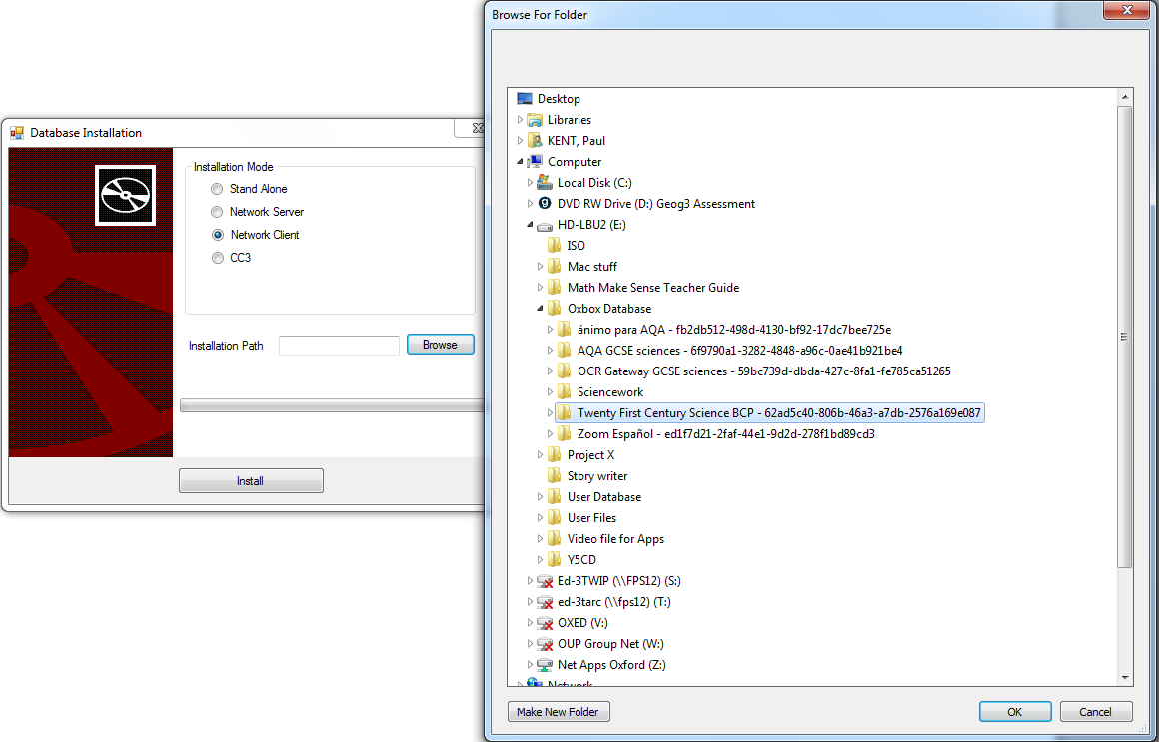
Installation mode menu, and example of the database folder for your product

During the installation of the Network server, the OxBox will create a share for you. Please navigate your network for the share, and select the folder which has the name of your product plus a unique number after it – for example, Twenty First Century Science BCP - 62ad5c40-806b-46a3-a7db-2576a169e087.
Once you have selected the correct folder please click OK, then Install and when ready, Finish.

Fix 3

When you have installed the network client from .msi
When rolling out the .msi for the network client installations, make sure you link the client to the database correctly. Please read the .msi installation instructions below.
There is an MSI file on the disc that you can use: it’s named ouptools.msi (Windows server). When you roll it out across the network it will create the client application on the client machines, but without the link to the database. The link to the database needs to be entered into a file called fusecore.config. Here’s how to do it:
Select one of the fusecore.config files from a client install. The most likely place to find the file is in the default location, C:/Program/OxBox/<name of product>. Open the file in Notepad. You will now see some simple XML code. (See example below.) All you need to do is:
- delete the “.”(the full stop) or the existing path from between the two <path> tags;
- between the two <path> tags, type (or paste) the correct path to the database on the server. This can be a UNC path or a direct path.

Example of the XML code in a fusecore.config file:

<?xml version="1.0" encoding="UTF-8"?>
<configuration>
<fusecore>
<path>E:\Oxbox Database\Twenty First Century Science BCP - 62ad5c40-806b-46a3-
a7db-2576a169e087</path>
<encryption>true</encryption>
</fusecore>
</configuration>

Save the file and test it out on a client machine.
If everything works, then use a batch command to upload the new FuseCore.config to all of the client machines that has had Network client tools installed onto them.

Fix 4

General Network Install: Permissions
You can also get the “Cannot locate database” error if you haven’t correctly set the permissions on the Database folder.
Please ensure that you have allowed users to read, write and modify the database on the server. When installing the OxBox the software should create the share for you, but you might still have to check that the permissions have been correctly set.

