User Guide

For version 0.5, January 2011


Download the latest version from jnetmap.sourceforge.net

Table of Contents
Introduction 2
Quick Start 2
Opening and saving files 3
Passwords 3
Editing a map 3
Undo & Redo 3
Using the mouse 3
Using tools 4
Properties 6
Plugins 8
Context Menu 8
Notifications 8
Sidebar 9
Preferences 10
Contact 11
Submit a bug 11
Request a feature 11
Write me directly: 11

Introduction
jNetMap helps you to keep an eye on you network. You can draw a graphical representation of your network, and jNetMap will periodically check if the devices are still up and or a service is still running. You can also set up E-mail notifications or let jNetMap execute a script when a device goes down or comes up again. Additionally, you may attach notes to a device, initiate an RDP/VNC/SSH connection to a device and much more.
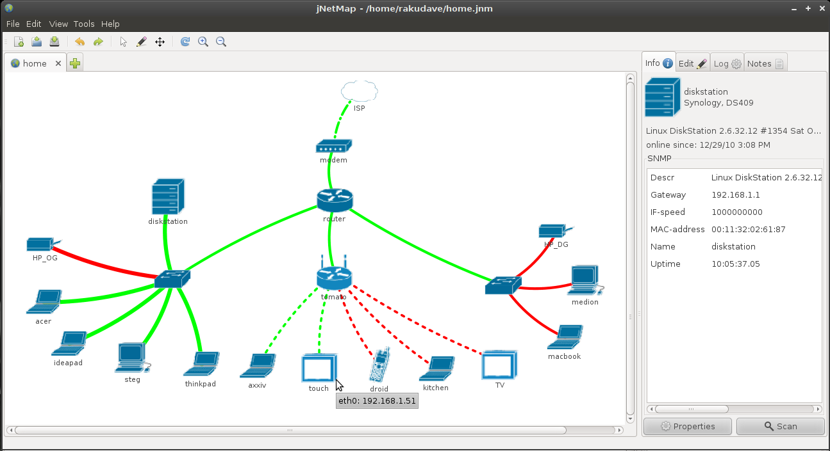

Quick Start
- Create a new file (Menu: File > New).
- Scan your network for devices (Menu: Tools > Network Scanner).
- The Network Scanner will automatically use the IP-Range of your first active network-connection. Change IP/Subnet if necessary.
(Hint: Use CIDR-Notation in the first field and hit enter).
- Click “Scan”, wait for a moment, then click “Add”.
- jNetMap will magically find the best ping-method, name and other settings for the devices and add them to the map.
- Drag the devices to an appropriate position on the map.
- Done

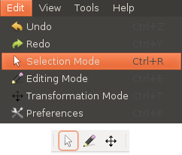
Opening and saving files
jNetMap can save and open network-files (.jnm). The File-Menu works as one would expect and you will be prompted to save your map when you quit.

Passwords
You might want to keep the internal structure of your network a secret. For that purpose you may encrypt the entire map with a password. You will find a password-field in the open- and save-dialogs. I would recommend you encrypt every map you create, especially if you use Mail-Notifiers, because otherwise your account-details will be stored in plain-text.

Editing a map

Undo & Redo
In case of a mishap, use the Edit-Menu, the Toolbar or Ctrl+Z & Ctrl+Y to undo/redo an action.

Using the mouse
The mouse can operate in three modes. To change the mode, go to the Edit-Menu and select a new mode. Alternatively you can use the buttons in the Toolbar.

Selection Mode

On a device
- Left-Click: Selects the device. Relevant information will appear in the Sidebar.
- Left-Drag: Moves the device.
- Right-Click: Opens the context menu in order to delete the device, change its properties or connect to the device with plugins.

On a connection
- Left-Click: Selects the connection.
- Right-Click: Opens the context menu in order to delete the connection, change its properties.

Outside
- Left-Drag: Select all devices within the rectangle
- Right-Click: Opens the context menu in order to add a new device.

Editing Mode
- Left-Click: Adds a new device, opens its properties window.
- Left-Drag: Creates a new connection between two devices.

Transforming Mode
- Left-Drag: Moves the display.
- Shift+Left-Drag: Rotates the display.
- Ctrl+Left-Drag: Shears the display.

All Modes
- ScrollWheel: Zoom in / Zoom out.

Using tools

Network Scanner
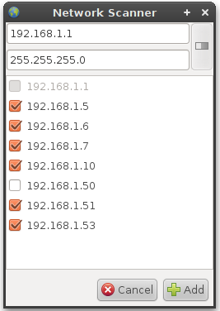
Discovers alive hosts on a given subnet using a variate of techniques (In the following order: Java Ping, Native Ping, Port Scans on commonly open Ports: 22,135,139,445,80,161*,21,53). The Network Scanner will automatically fill in IP-Address of the first active network connection on the computer. You may of course change this. Note that this first field accepts CIDR-Notation and will automatically fill in the subnet mask field if it is empty. You can also force this by pressing enter.
Now you can press the “Scan”-button. If you scan a large network (bigger than /24) you might want to get a coffee or something, it might take a while even tough the Scanner is Multi-Threaded. All responding machines will appear in the list where you may uncheck them if you don't want to add them to the map. If an address is already on the map it will be grayed out.
Finally, press the “Add”-button to add the devices to the map. jNetMap will try to get as much information from those new devices as possible, such as the hostname or even the MAC-Address and interface-speed, provided that SNMP is running on said device. Note that all new devices will be added at [0,0] on the map, so you will want to drag them to an appropriate location or apply an automatic layout (in planning).

* if a custom SNMP-Port was defined, it will be used instead.

Port Scanner
This tool is best used when setting up a new device that should check a TCP-Port to determine if the device is up so you can see what ports are open, but it can also be used in stand-alone mode or from the information-panel in the sidebar. You can select the range of ports that should be scanned, then hit “Scan”. I've been told that Windows-Machines are very slow at this for some reason, so if you are using Windows, please be patient or try adjusting the “portscan.timeout” value in the properties file (results will be less accurate when using lower values).
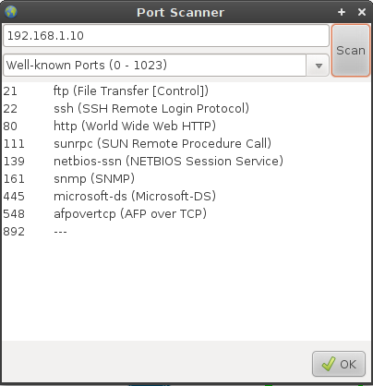

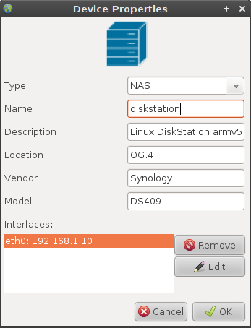
Properties

Device
Here you can set the type, name, description, location, vendor and model of the device. Most of these values have a purely informational character, except for the type: All Switches/Hubs will default to “transparent” mode when adding connections to them, i.e. they will not have an address; all other types need an address by default (You can change this in the “Interface/Connection Properties”). You can also edit and remove the network interfaces using the list in the lower half of the dialog.

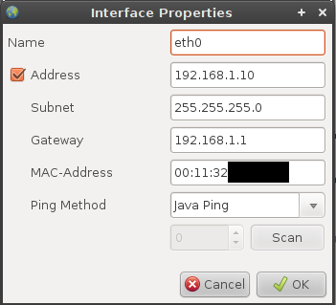
Interface
Here you can set the (internal) name of the network interface as well as the address and the ping-method.
Some interfaces do not have an address, such as switches and hubs. You can change this by checking/unchecking “Address”.

Ping Modes
Ping Modes describe the way jNetMap will determine whether the device is up or not.

Java Ping
This is the default way Java tries to see if an address is reachable. However, it has certain problems, especially on Windows (no ICMP-Pings). There's a good article on bordet.blogspot.com about it if you're interested.

System Ping
This implementation will execute the ping-command of your OS and look at the result. This should guarantee that real ICMP-Pings are sent. It is slightly slower than the default but a good alternative, especially on Windows.

TCP Port
This mode will try to establish a connection to a port (running service) of a device. This is useful if you intend to monitor a web-server or a system that blocks pings (firewall). If you are not sure what ports are open on that device, you can use the “Scan”-button to launch the “Port Scanner”-Tool. After completing a scan, simply select a port from the list, press ok an the selected port will automatically be entered into the “TCP Port” settings.

Connection
The left and right side of the connection properties represents the properties of the two interfaces attached to the connection, which you are already familiar with. In the center of this dialog you can change the type of the connection (Ethernet, Serial etc.) and the speed of the connection in Mb/s. Both values influence the way the connection is drawn on the map (i.e. faster speed = thicker line).
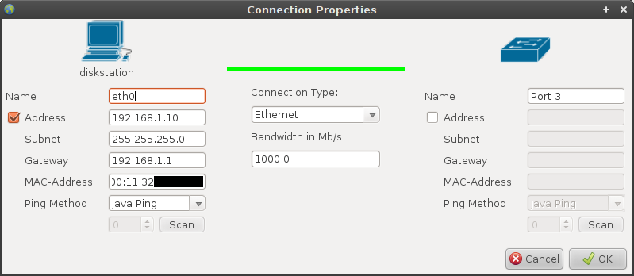

Map
The map properties currently contain the update interval and notification (see “plugins” below). jNetMap will check the status of all devices and addresses on the map every <update intervall>.

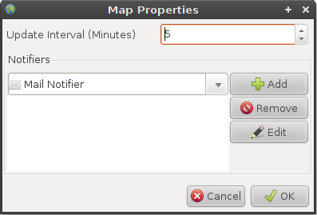

Plugins
Plugins extend the functionality of jNetMap version >= 0.5.
You can download plugins from jnetmap.sourceforge.net
To install a plugin, go to Edit > Preferences > Plugins > Install. You can remove the plugin again on that same page. Note that it is recommended to restart jNetMap after installing/removing a plugin.

Context Menu
These Plugins are available through the context menu of a device. They are usually used to connect to a device using RCP, SSH etc…
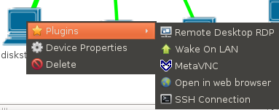

Notifications
These plugins will be called by jNetMap whenever a device of an interface changes its state, e.g. does down. You can add these plugins to a map in the maps properties (File > Properties).
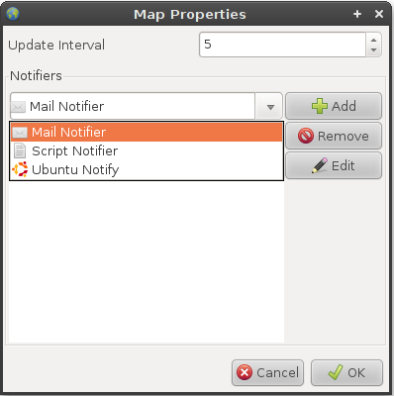
These plugins will then notify you of that change, provided that the event wasn't filtered. The filter is especially useful if don't want to be notified about about every change on the map. You can the following options:
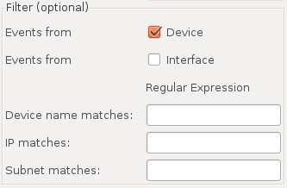
- Receive device events (default)
- Receive interface events (turning both off will essentially disable the notifier)
- Use regular expressions, only matching events will be passed (empty fields will match everything):
  - Device name
  - Address
  - Subnet Mask

Sidebar
The sidebar will display contextual information. The Info-Panel and the Notes are always shown, but you can add more, such as the LogPanel (displays logging information) or the NotePanel (stores notes about individual devices).

Preferences
To edit your preferences, go to Edit > Preferences or press Ctrl+P. The dialog itself is pretty self-explanatory, the left side displays different topics in the form of a tree and the right side the corresponding panel.
Note that there are usually more settings than are represented graphically, so if you're brave, you can edit the preference-file (in the .jNetMap folder in you home directory) in a text-editor. Just be careful, things might go wrong if the preferences-file contains “weird” stuff. However, the preference file is self-recovering, so if there's a crash after you've edited the file, you can simply delete it and it will restore itself.
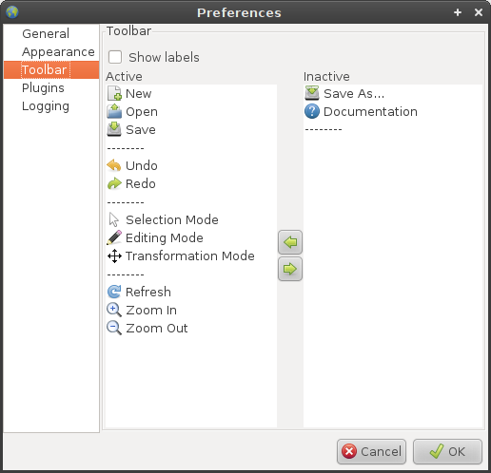

Contact

Submit a bug

Request a feature

Write me directly:
public@rakudave.ch
Contact language: English or German

