基本信息
- 分类：vllm
- 任务名称：Qwen3-VL-8B-Instruct
- 任务类别：资料验证和部署测试
- 镜像：quay.io/ascend/vllm-ascend:v0.18.0
- 权重链接：https://modelscope.cn/models/Qwen/Qwen3-VL-8B-Instruct
- 配套信息：Ascend HDK 25.5.0.B078
- 卡数（Atlas 800I A2）：1
- 内存：1T
- 硬盘：300G

任务概述
部署Qwen3-VL-8B-Instruct推理服务

在线服务
vllm serve /workspace/shared_assets/QuenchingAction/Infer/Model/models/Qwen3-VL-8B-Instruct --dtype bfloat16 --max-model-len 16384 --max-num-batched-tokens 16384

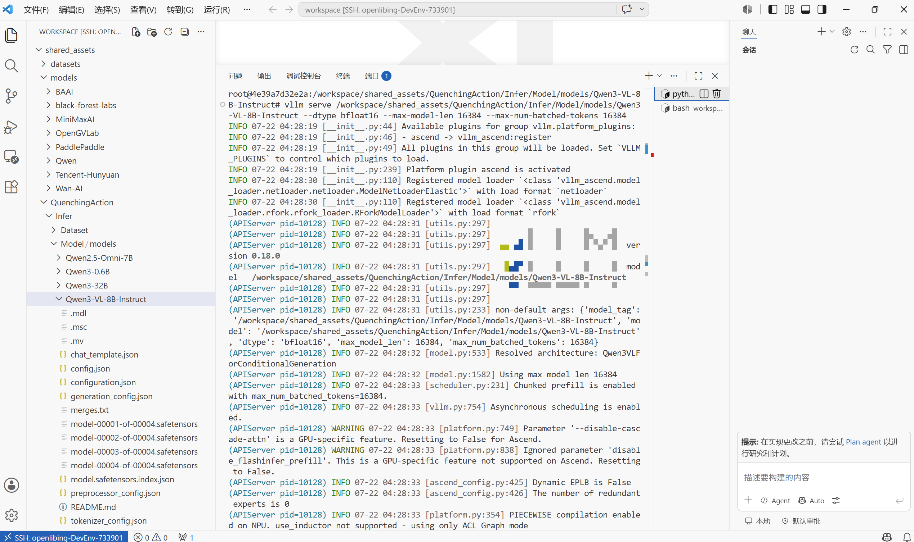
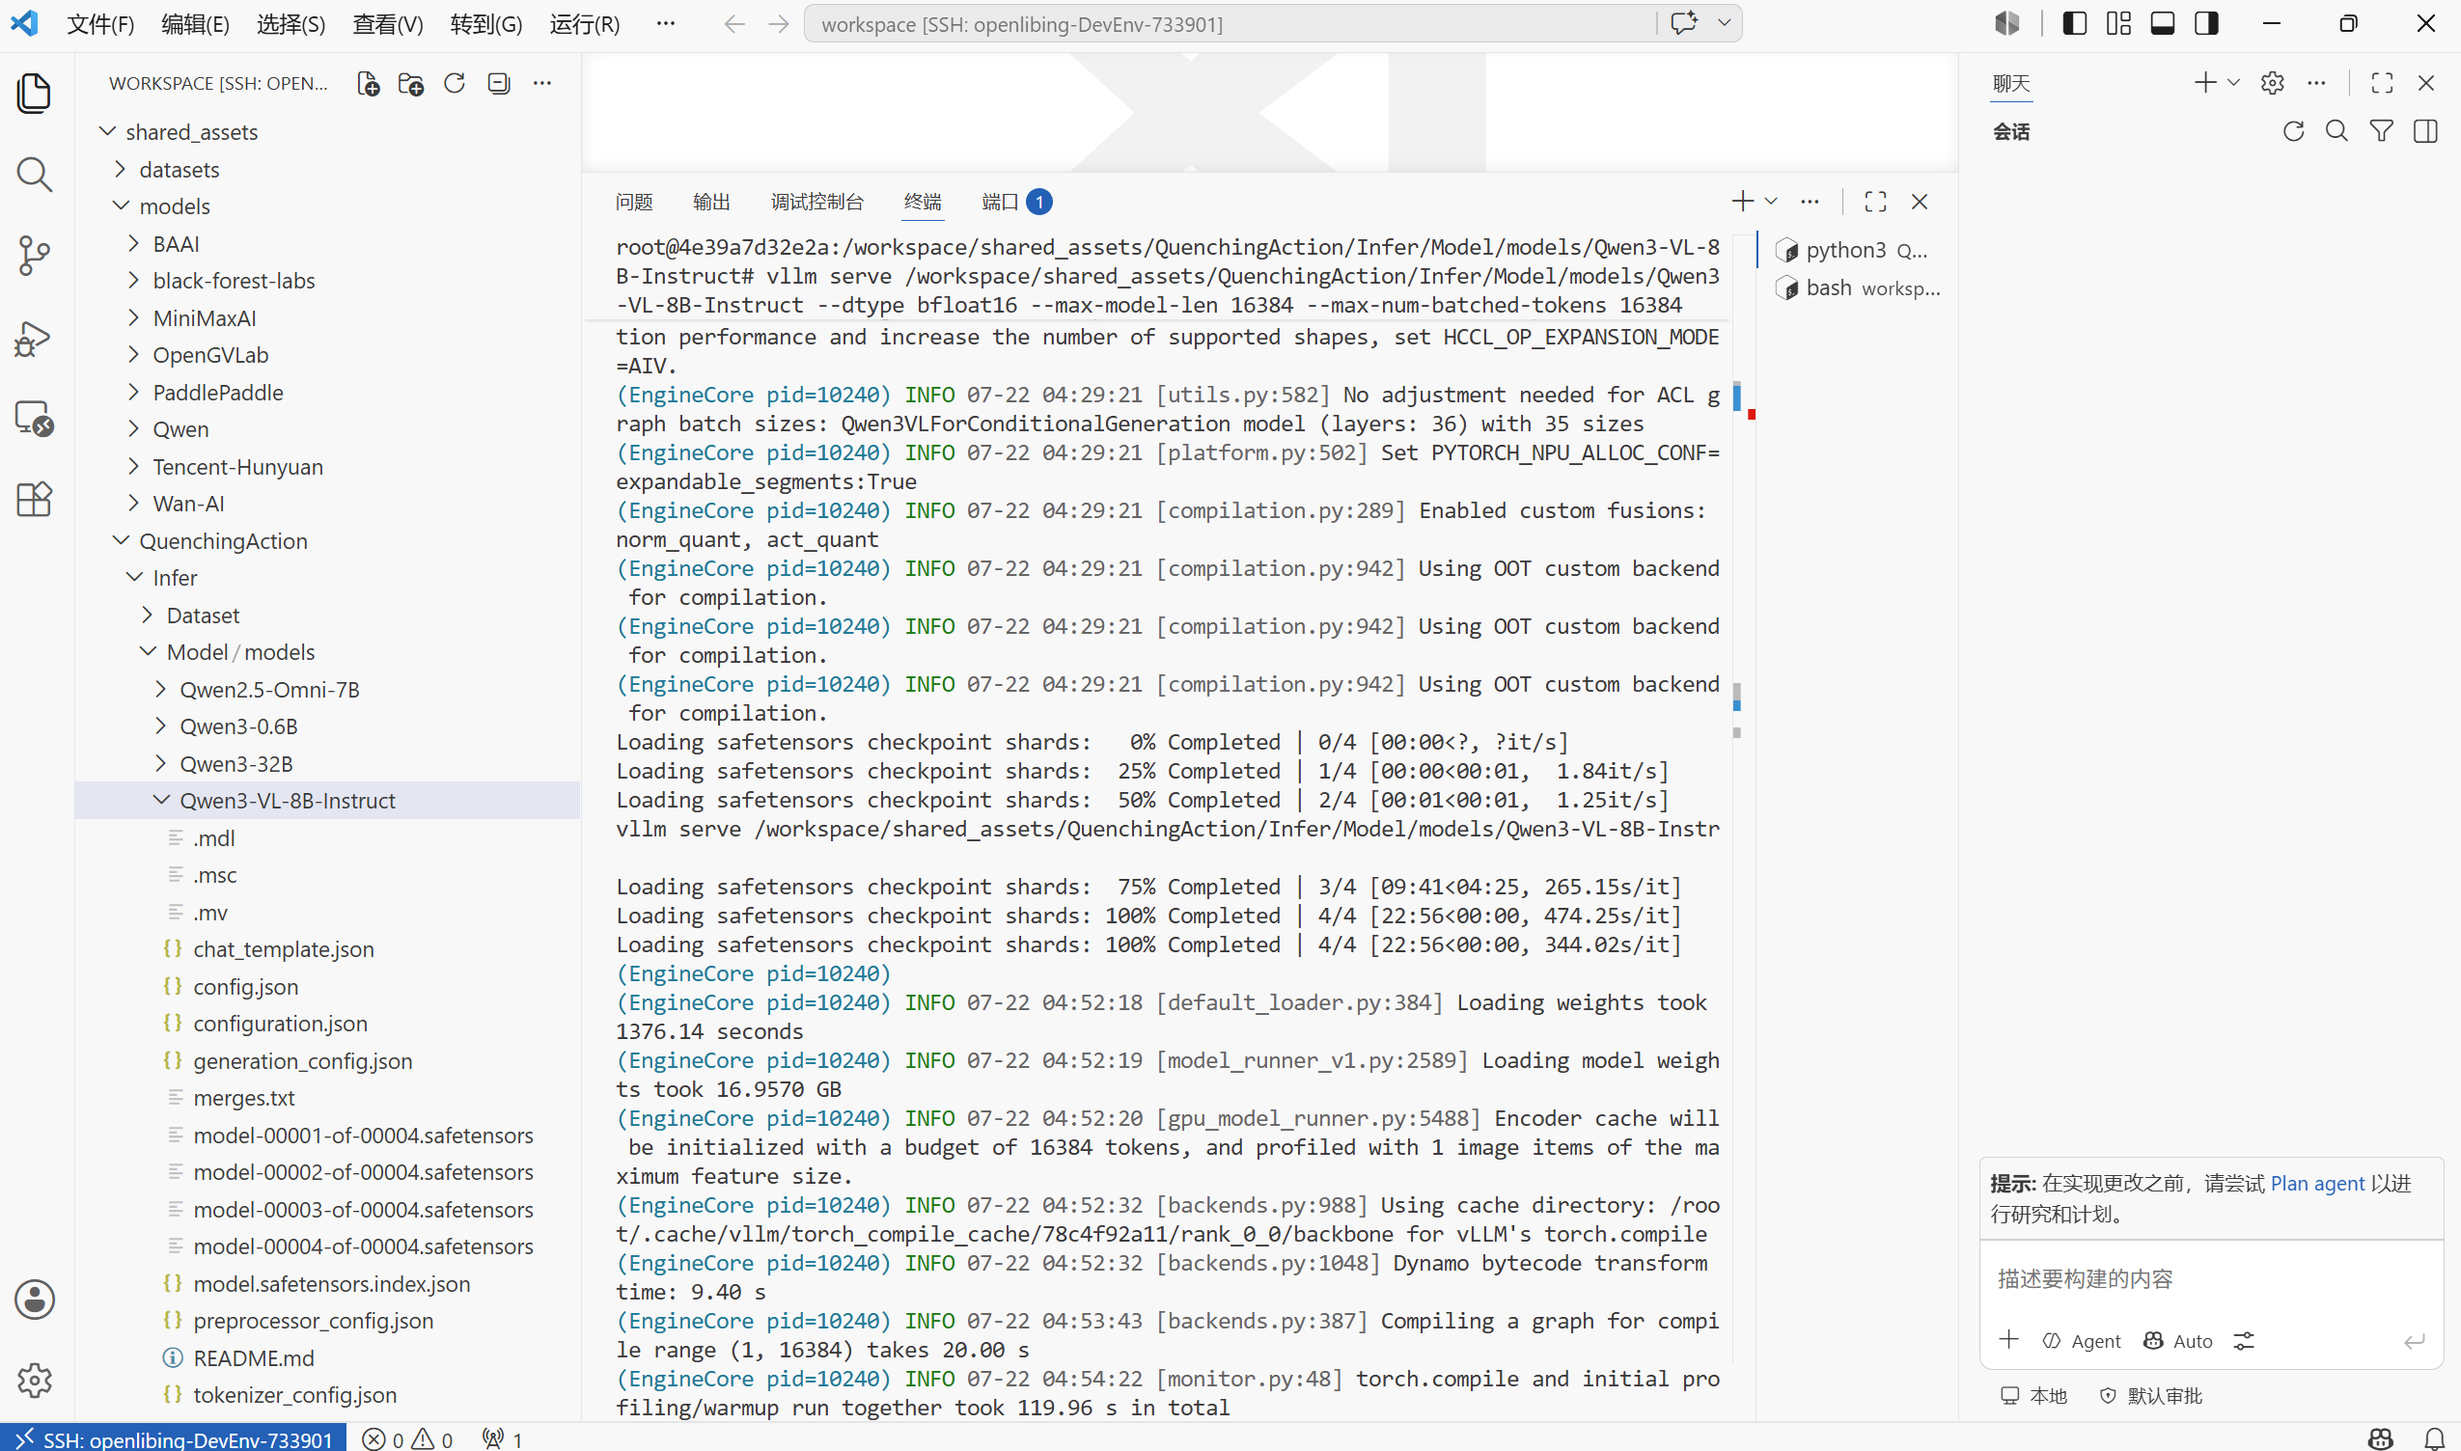
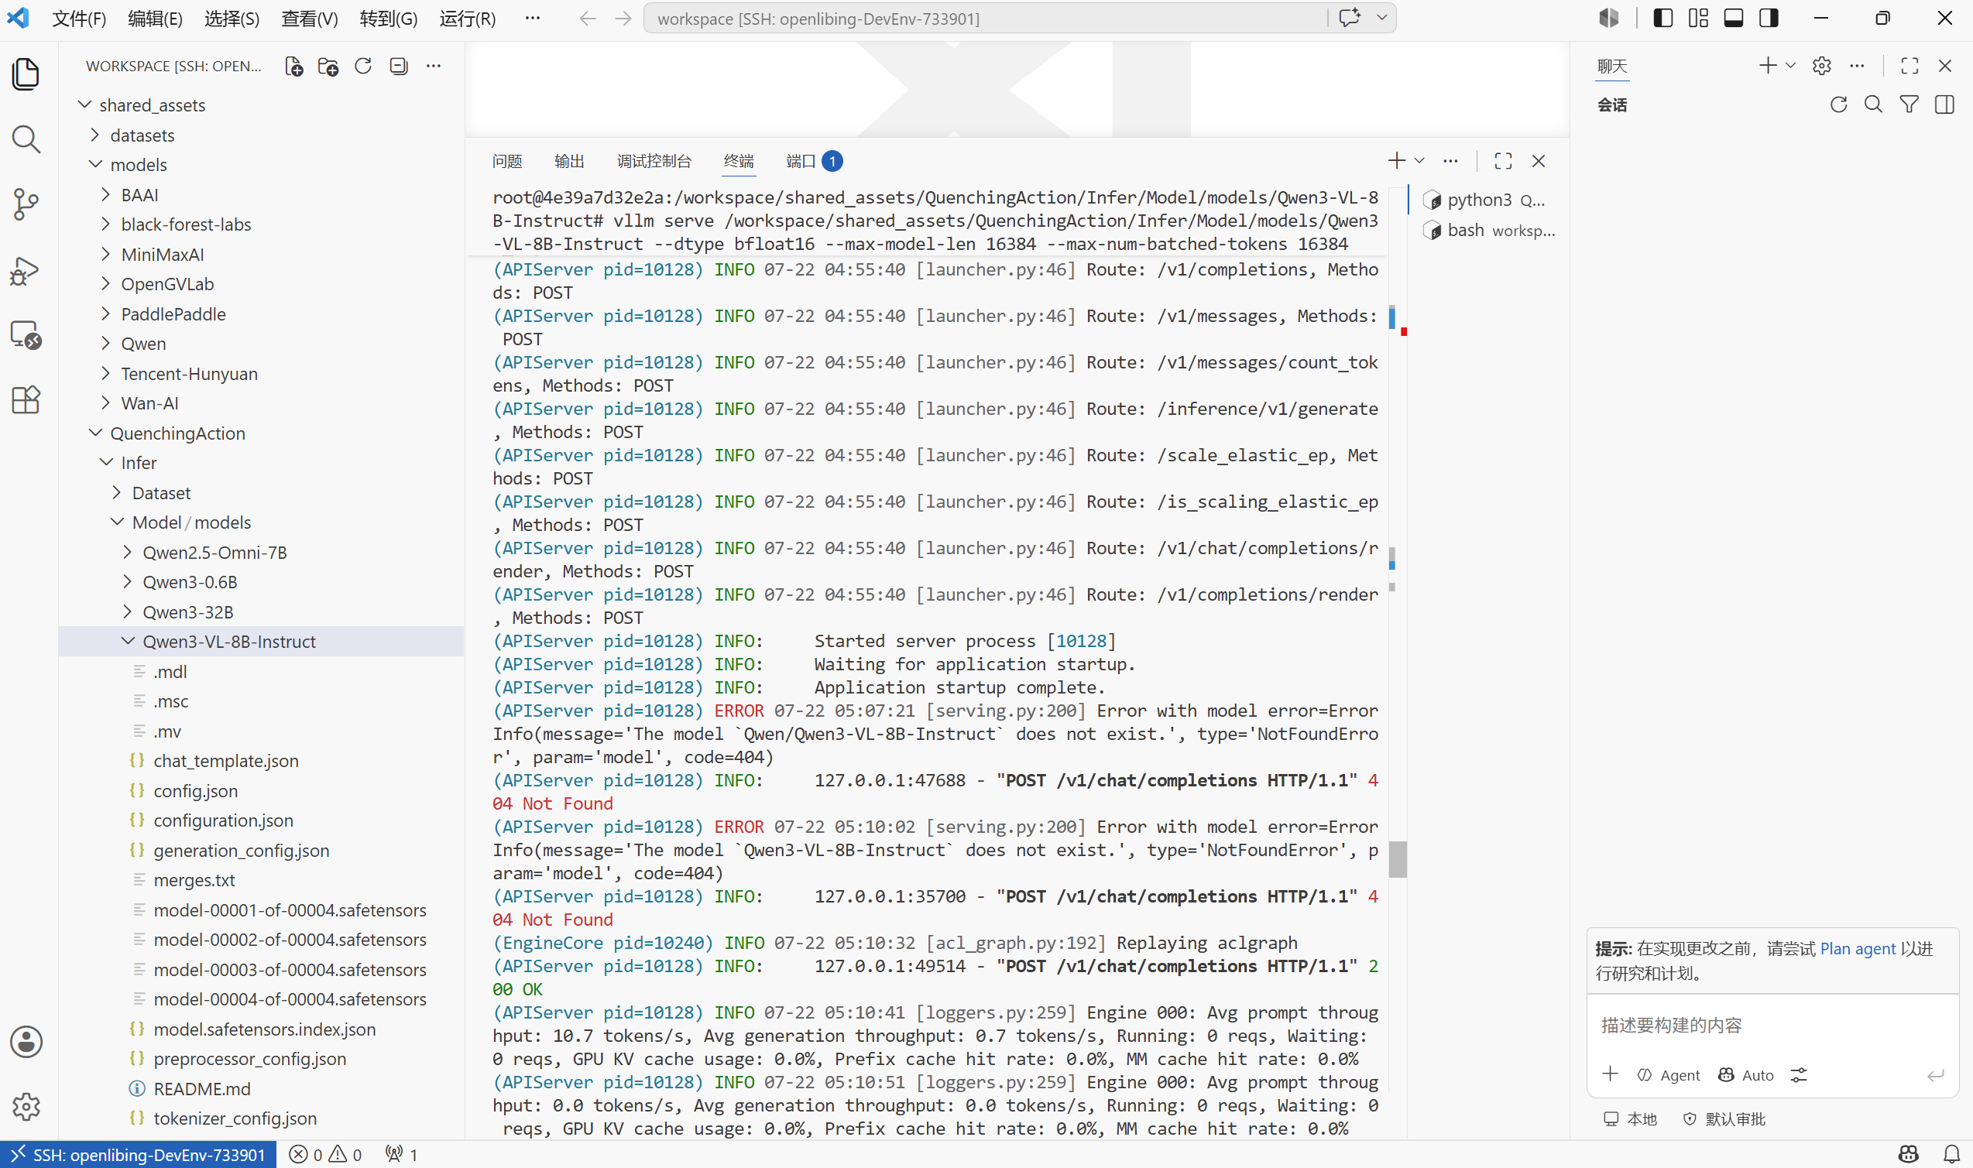

服务器启动后，输入提示词查询模型：
curl http://localhost:8000/v1/chat/completions \
-H "Content-Type: application/json" \
-d '{
"model": "/workspace/shared_assets/QuenchingAction/Infer/Model/models/Qwen3-VL-8B-Instruct",
"messages": [
{"role": "system", "content": "You are a helpful assistant."},
{"role": "user", "content": [
{"type": "image_url", "image_url": {"url": "https://modelscope.oss-cn-beijing.aliyuncs.com/resource/qwen.png"}},
{"type": "text", "text": "What is the text in the illustration?"}
]}
]
}'
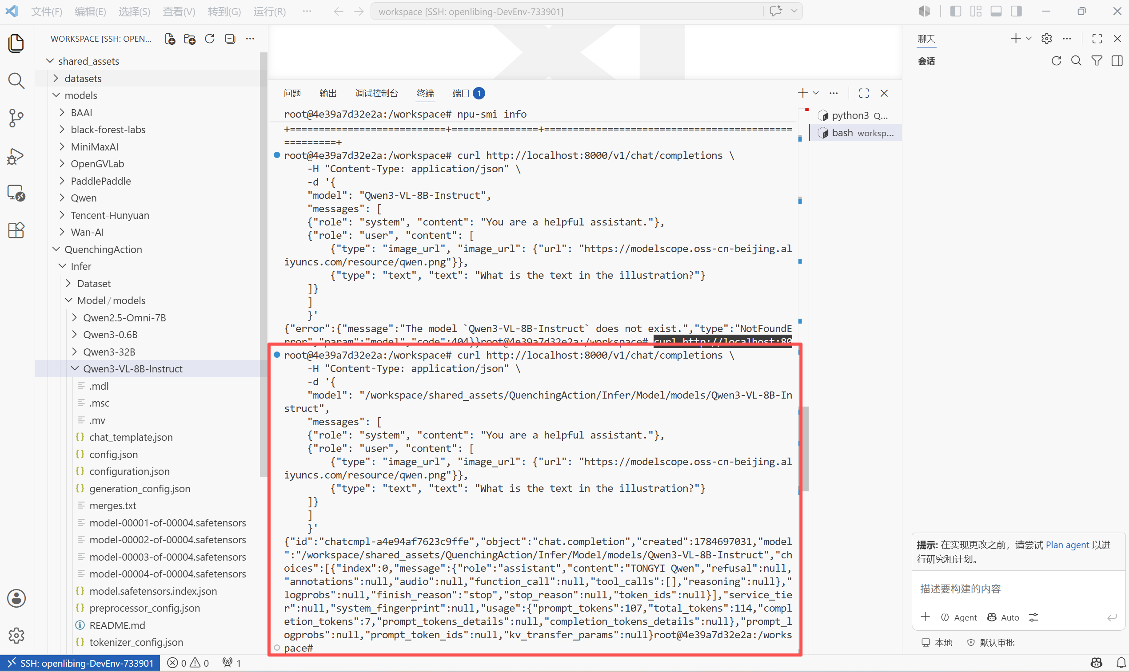

使用vLL BenchMark测试性能
vllm bench serve --model /workspace/shared_assets/QuenchingAction/Infer/Model/models/Qwen3-VL-8B-Instruct --dataset-name random --random-input 200 --num-prompts 200 --request-rate 1 --save-result --result-dir ./
