测试报告
查询npu状态
npu-smi info

下载模型，先把模型复制到本地
拉起服务
vllm serve /workspace/Qwen3-VL-8B-Instruct \
--dtype bfloat16 \
--max-model-len 16384 \
--max-num-batched-tokens 16384

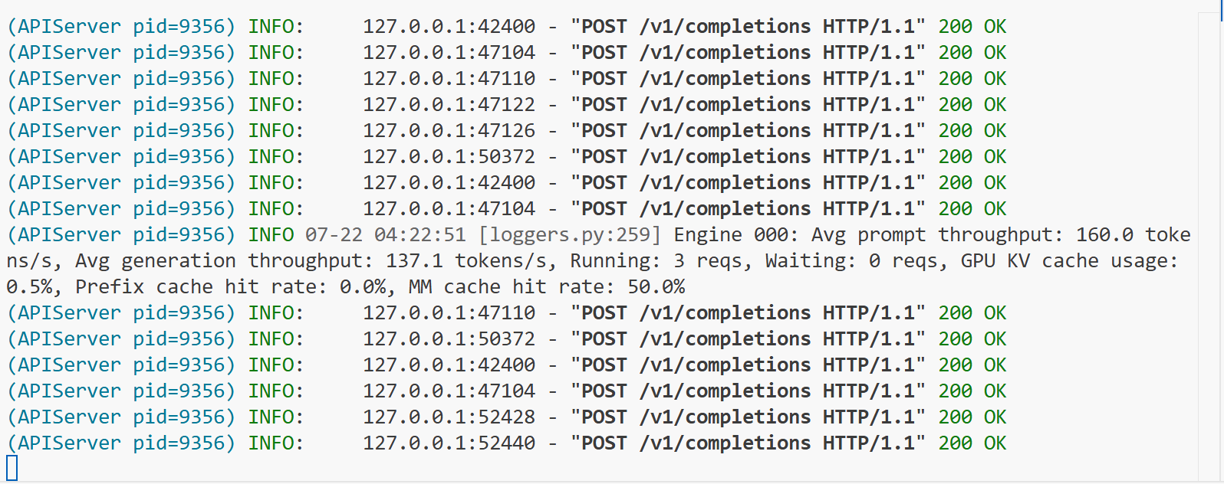

测试命令
vllm bench serve --model /workspace/Qwen3-VL-8B-Instruct --dataset-name
random --random-input 200 --num-prompts 200 --request-rate 1 --save-result --result-dir ./

测试结果
============ Serving Benchmark Result ============
Successful requests: 200
Failed requests: 0
Request rate configured (RPS): 1.00
Benchmark duration (s): 204.03
Total input tokens: 40000
Total generated tokens: 25600
Request throughput (req/s): 0.98
Output token throughput (tok/s): 125.47
Peak output token throughput (tok/s): 308.00
Peak concurrent requests: 13.00
Total token throughput (tok/s): 321.52
---------------Time to First Token----------------
Mean TTFT (ms): 105.51
Median TTFT (ms): 104.29
P99 TTFT (ms): 191.07
-----Time per Output Token (excl. 1st token)------
Mean TPOT (ms): 32.49
Median TPOT (ms): 32.35
P99 TPOT (ms): 34.18
---------------Inter-token Latency----------------
Mean ITL (ms): 32.49
Median ITL (ms): 32.14
P99 ITL (ms): 45.61
==================================================
sys:1: DeprecationWarning: builtin type swigvarlink has no __module__ attribute

