淬火行动

1. vLLM-Ascend拉起模型

1.1 执行拉起服务
Plain Text
vllm serve /workspace/shared_assets/models/Qwen/Qwen3-32B-W4A4 --served-model-name "qwen3-32b-w4a4" --max-model-len 4096 --quantization ascend
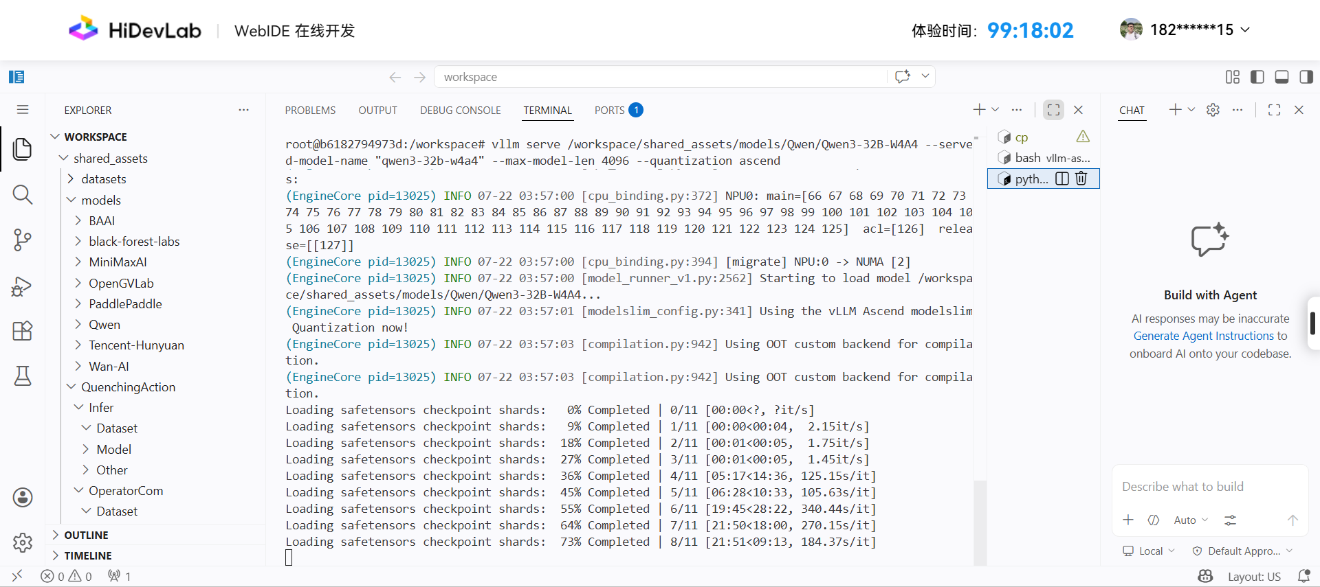
服务启动成功
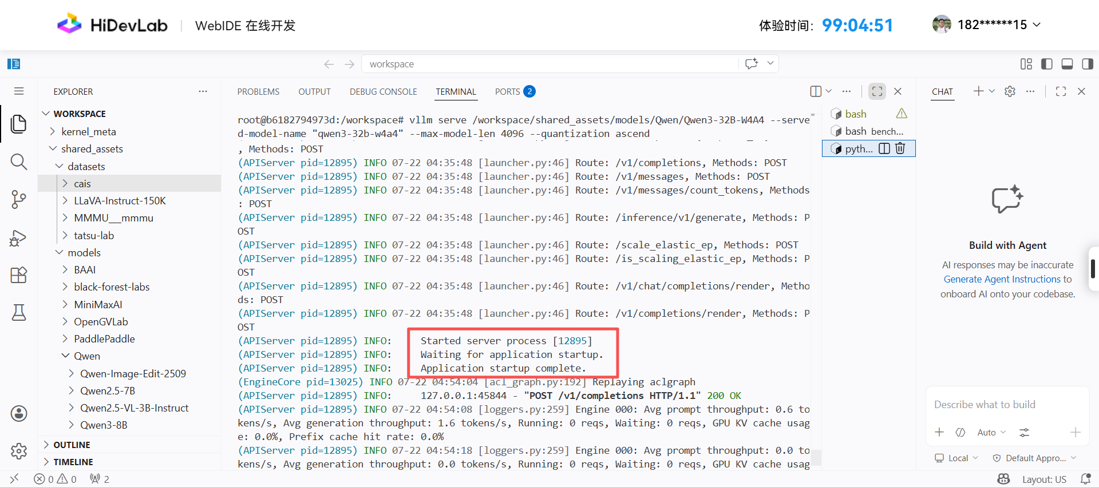

1.2 验证模型是否可用
C++
curl http://localhost:8000/v1/completions \
-H "Content-Type: application/json" \
-d '{
"model": "qwen3-32b-w4a4",
"prompt": "介绍自己",
"max_completion_tokens": 128,
"top_p": 0.95,
"top_k": 40,
"temperature": 0
}'
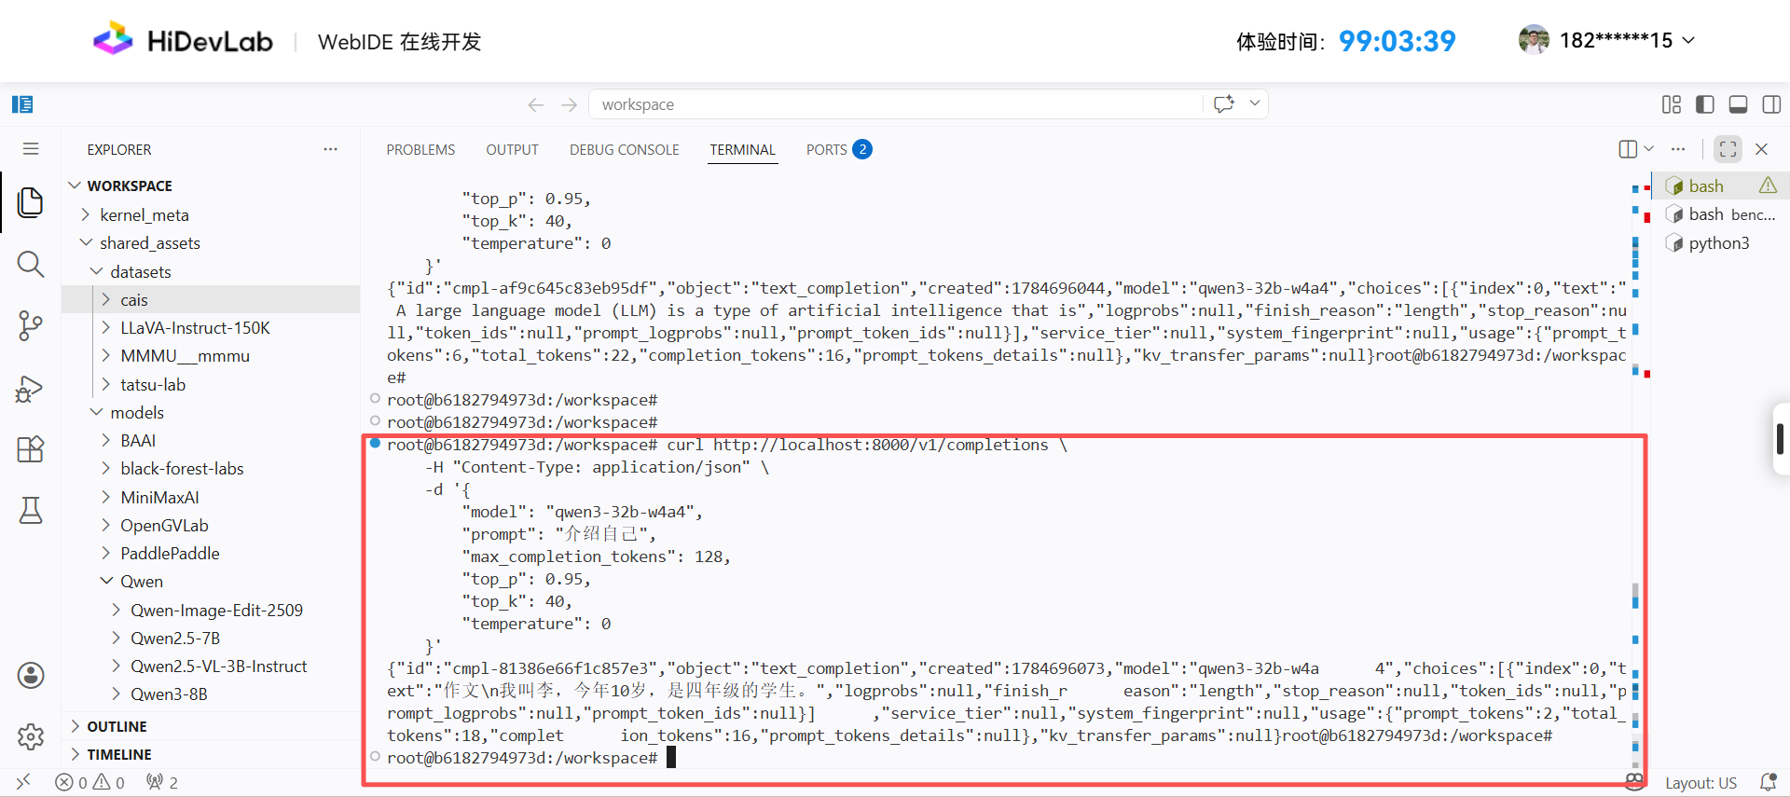

1.3 查看显卡使用情况
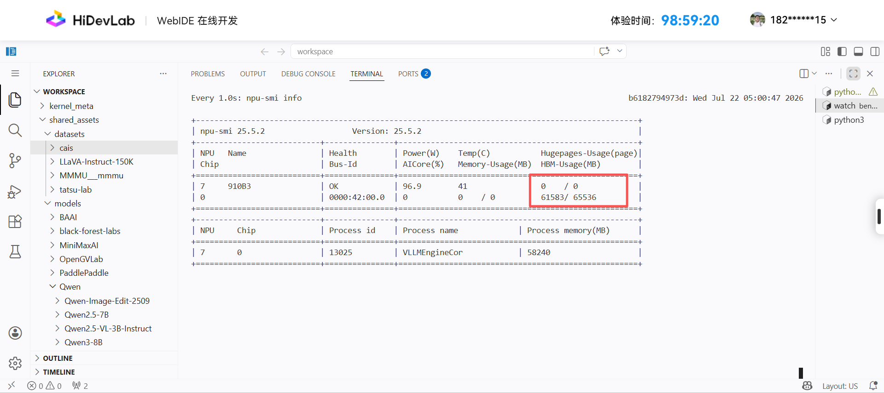

2. 性能基准测试

2.1 执行命令
Plain Text
vllm bench serve \
--model /workspace/shared_assets/models/Qwen/Qwen3-32B-W4A4 \
--dataset-name random \
--random-input 1024 \
--num-prompts 200 \
--request-rate 1 \
--save-result \
--result-dir ./ \
--host localhost \
--port 8000 \
--endpoint /v1/completions \
--backend openai \
--served-model-name qwen3-32b-w4a4 \
--temperature 0

2.2 执行结果
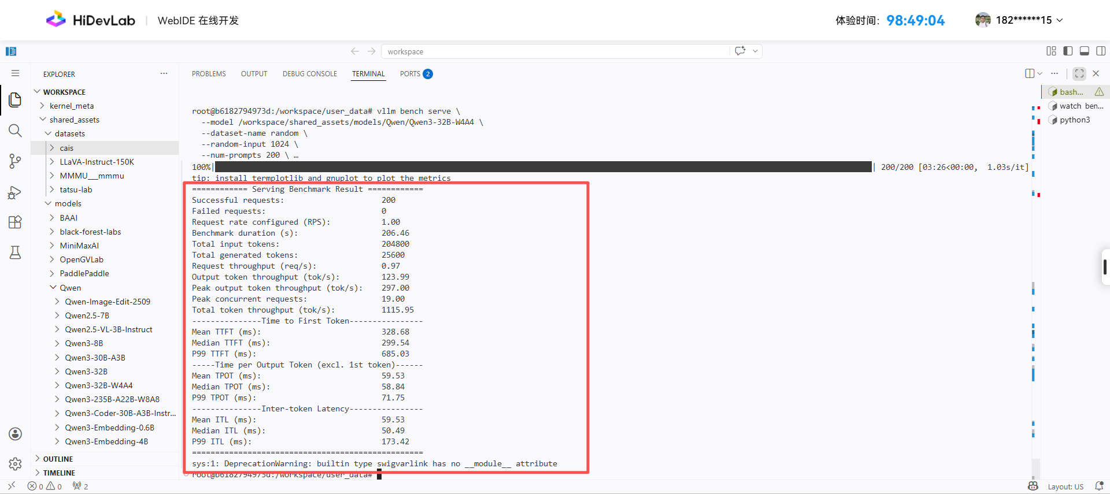
过程日志
SQL
root@b6182794973d:/workspace/user_data# vllm bench serve \
--model /workspace/shared_assets/models/Qwen/Qwen3-32B-W4A4 \
--dataset-name random \
--random-input 1024 \
--num-prompts 200 \
--request-rate 1 \
--save-result \
--result-dir ./ \
--host localhost \
--port 8000 \
--endpoint /v1/completions \
--backend openai \
--served-model-name qwen3-32b-w4a4 \
--temperature 0
INFO 07-22 05:05:08 [__init__.py:44] Available plugins for group vllm.platform_plugins:
INFO 07-22 05:05:08 [__init__.py:46] - ascend -> vllm_ascend:register
INFO 07-22 05:05:08 [__init__.py:49] All plugins in this group will be loaded. Set `VLLM_PLUGINS` to control which plugins to load.
INFO 07-22 05:05:08 [__init__.py:239] Platform plugin ascend is activated
INFO 07-22 05:05:16 [__init__.py:110] Registered model loader `<class 'vllm_ascend.model_loader.netloader.netloader.ModelNetLoaderElastic'>` with load format `netloader`
INFO 07-22 05:05:16 [__init__.py:110] Registered model loader `<class 'vllm_ascend.model_loader.rfork.rfork_loader.RForkModelLoader'>` with load format `rfork`
Namespace(subparser='bench', bench_type='serve', dispatch_function=<function BenchmarkServingSubcommand.cmd at 0xffff0d7a2b60>, trust_remote_code=False, seed=0, num_prompts=200, dataset_name='random', no_stream=False, dataset_path=None, no_oversample=False, skip_chat_template=False, enable_multimodal_chat=False, disable_shuffle=False, custom_output_len=256, spec_bench_output_len=256, spec_bench_category=None, sonnet_input_len=550, sonnet_output_len=150, sonnet_prefix_len=200, sharegpt_output_len=None, blazedit_min_distance=0.0, blazedit_max_distance=1.0, asr_max_audio_len_sec=inf, asr_min_audio_len_sec=0.0, random_input_len=1024, random_output_len=128, random_range_ratio=0.0, random_prefix_len=0, random_batch_size=1, no_reranker=False, random_mm_base_items_per_request=1, random_mm_num_mm_items_range_ratio=0.0, random_mm_limit_mm_per_prompt={'image': 255, 'video': 1}, random_mm_bucket_config={(256, 256, 1): 0.5, (720, 1280, 1): 0.5, (720, 1280, 16): 0.0}, hf_subset=None, hf_split=None, hf_name=None, hf_output_len=None, prefix_repetition_prefix_len=256, prefix_repetition_suffix_len=256, prefix_repetition_num_prefixes=10, prefix_repetition_output_len=128, label=None, backend='openai', base_url=None, host='localhost', port=8000, endpoint='/v1/completions', header=None, max_concurrency=None, model='/workspace/shared_assets/models/Qwen/Qwen3-32B-W4A4', input_len=None, output_len=None, tokenizer=None, tokenizer_mode='auto', use_beam_search=False, logprobs=None, request_rate=1.0, burstiness=1.0, disable_tqdm=False, num_warmups=0, profile=False, save_result=True, save_detailed=False, append_result=False, metadata=None, result_dir='./', result_filename=None, ignore_eos=False, percentile_metrics=None, metric_percentiles='99', goodput=None, request_id_prefix='bench-c3352b46-', top_p=None, top_k=None, min_p=None, temperature=0.0, frequency_penalty=None, presence_penalty=None, repetition_penalty=None, served_model_name='qwen3-32b-w4a4', lora_modules=None, ramp_up_strategy=None, ramp_up_start_rps=None, ramp_up_end_rps=None, ready_check_timeout_sec=0, extra_body=None, skip_tokenizer_init=False, insecure=False, plot_timeline=False, timeline_itl_thresholds=[25.0, 50.0], plot_dataset_stats=False)
INFO 07-22 05:05:17 [datasets.py:631] Sampling input_len from [1024, 1024] and output_len from [128, 128]
Starting initial single prompt test run...
Skipping endpoint ready check.
Starting main benchmark run...
Traffic request rate: 1.0
Burstiness factor: 1.0 (Poisson process)
Maximum request concurrency: None
100%|██████████████████████████████████████████████████████████████████████████████████████████████████████████████████████████████████████████████| 200/200 [03:26<00:00, 1.03s/it]
tip: install termplotlib and gnuplot to plot the metrics
============ Serving Benchmark Result ============
Successful requests: 200
Failed requests: 0
Request rate configured (RPS): 1.00
Benchmark duration (s): 206.46
Total input tokens: 204800
Total generated tokens: 25600
Request throughput (req/s): 0.97
Output token throughput (tok/s): 123.99
Peak output token throughput (tok/s): 297.00
Peak concurrent requests: 19.00
Total token throughput (tok/s): 1115.95
---------------Time to First Token----------------
Mean TTFT (ms): 328.68
Median TTFT (ms): 299.54
P99 TTFT (ms): 685.03
-----Time per Output Token (excl. 1st token)------
Mean TPOT (ms): 59.53
Median TPOT (ms): 58.84
P99 TPOT (ms): 71.75
---------------Inter-token Latency----------------
Mean ITL (ms): 59.53
Median ITL (ms): 50.49
P99 ITL (ms): 173.42
==================================================
sys:1: DeprecationWarning: builtin type swigvarlink has no __module__ attribute
root@b6182794973d:/workspace/user_data#

3. 遇到问题
执行性能测试命令报错
Plain Text
vllm bench serve --model /workspace/shared_assets/models/Qwen/Qwen3-32B-W4A4 --dataset-name random --random-input 1024 --num-prompts 200 --request-rate 1 --save-result --result-dir ./
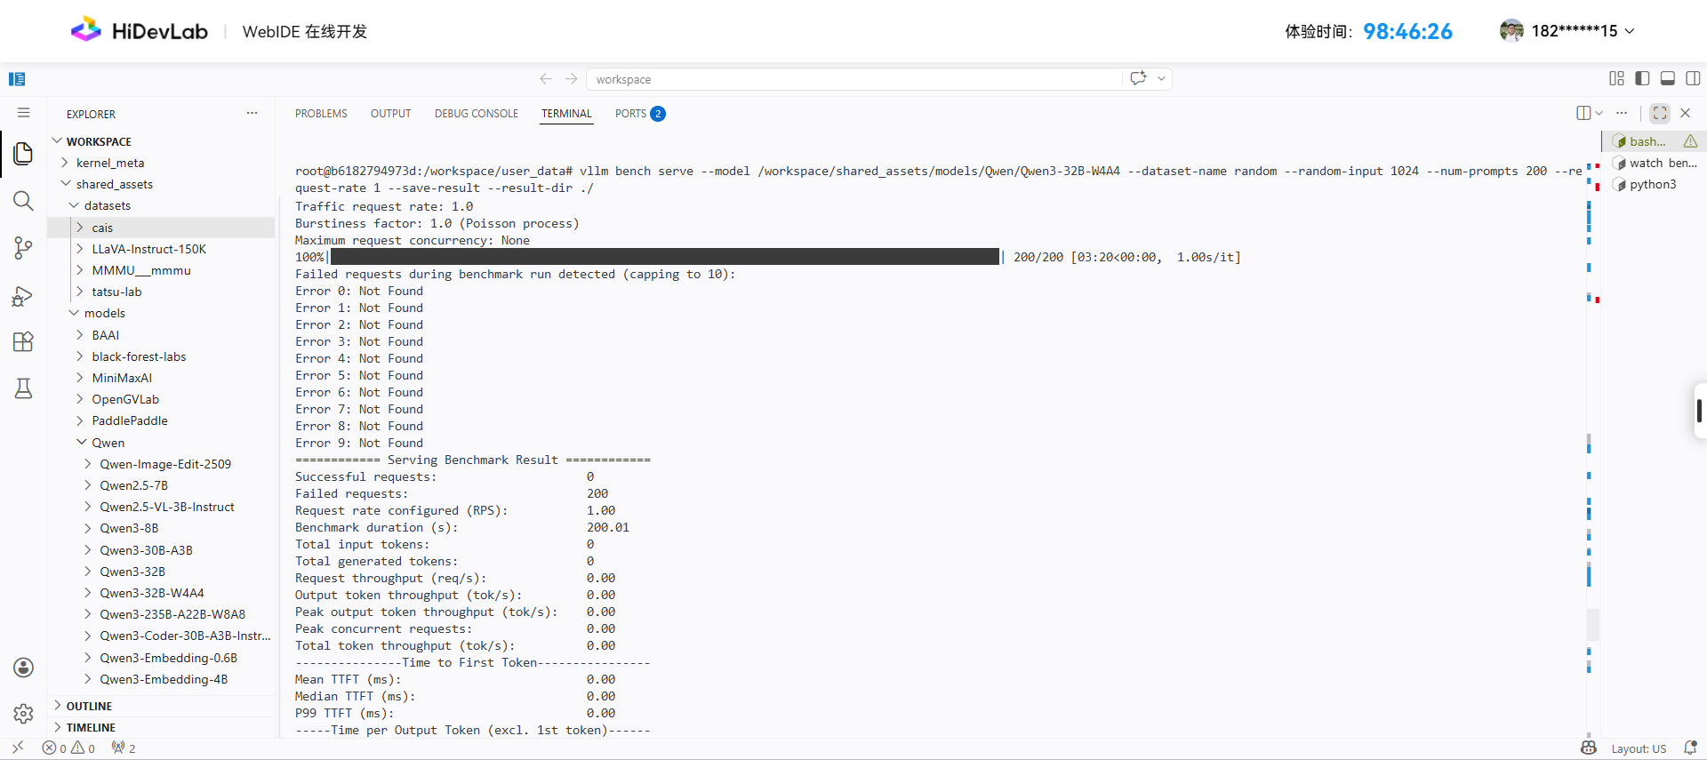
原因：
Plain Text
缺少 --served-model-name 参数
访问地址不对：应使用localhost
修改后命令
SQL
vllm bench serve \
--model /workspace/shared_assets/models/Qwen/Qwen3-32B-W4A4 \
--dataset-name random \
--random-input 1024 \
--num-prompts 200 \
--request-rate 1 \
--save-result \
--result-dir ./ \
--host localhost \
--port 8000 \
--endpoint /v1/completions \
--backend openai \
--served-model-name qwen3-32b-w4a4 \
--temperature 0

