任务背景
本 Issue 由 vLLM-Ascend 众测任务书自动生成，用于跟踪单个众测任务的执行、交付和问题闭环。

基本信息
- 分类：vllm
- 任务名称：hjh2-Qwen3-VL-8B-Instruct
- 任务类别：资料验证和部署测试
- 镜像：quay.io/ascend/vllm-ascend:v0.18.0
- 权重链接：https://modelscope.cn/models/Qwen/Qwen3-VL-8B-Instruct
- 配套信息：Ascend HDK 25.5.0.B078
- 卡数（Atlas 800I A2）：1
- 内存：1T
- 硬盘：300G

测试报告
目标部署Qwen3-VL-8B-Instruct推理服务

包含部署脚本、使用权重、vLLM Benchmark命令、输入输出、性能截图、资料使用感受、全程问题记录
主要实验步骤：
- 连接webIDE
- 使用vllm serve部署在线模型
注意修改本地模型地址，如果不修改模型从Huggingface下载，时间较长
vllm serve shared_assets/models/Qwen/Qwen3-VL-8B-Instruct --dtype bfloat16 --max-model-len 16384 --max-num-batched-tokens 16384
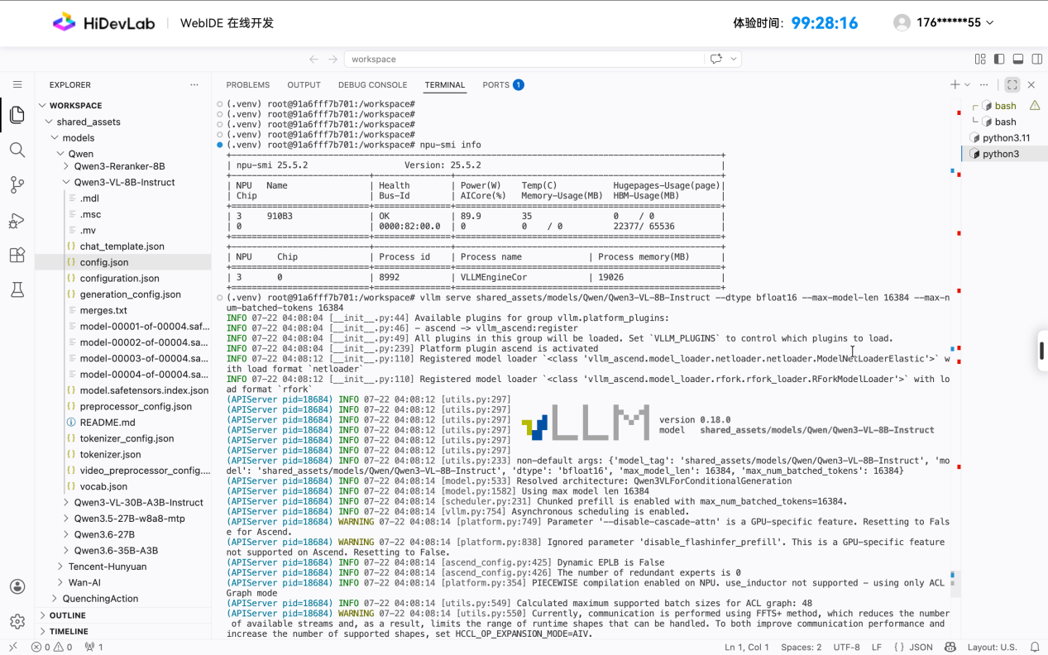
测试模型是否正常
curl http://localhost:8000/v1/chat/completions -H "Content-Type: application/json" -d '{
"model": "shared_assets/models/Qwen/Qwen3-VL-8B-Instruct",
"messages": [
{"role": "system", "content": "You are a helpful assistant."},
{"role": "user", "content": [
{"type": "image_url", "image_url": {"url": "https://modelscope.oss-cn-beijing.aliyuncs.com/resource/qwen.png"}},
{"type": "text", "text": "What is the text in the illustration?"}
]}
]
}'

模型请求体
{
"model": "shared_assets/models/Qwen/Qwen3-VL-8B-Instruct",
"messages": [
{"role": "system", "content": "You are a helpful assistant."},
{"role": "user", "content": [
{"type": "image_url", "image_url": {"url": "https://modelscope.oss-cn-beijing.aliyuncs.com/resource/qwen.png"}},
{"type": "text", "text": "What is the text in the illustration?"}
]}
]
}

3、安装lm_eval

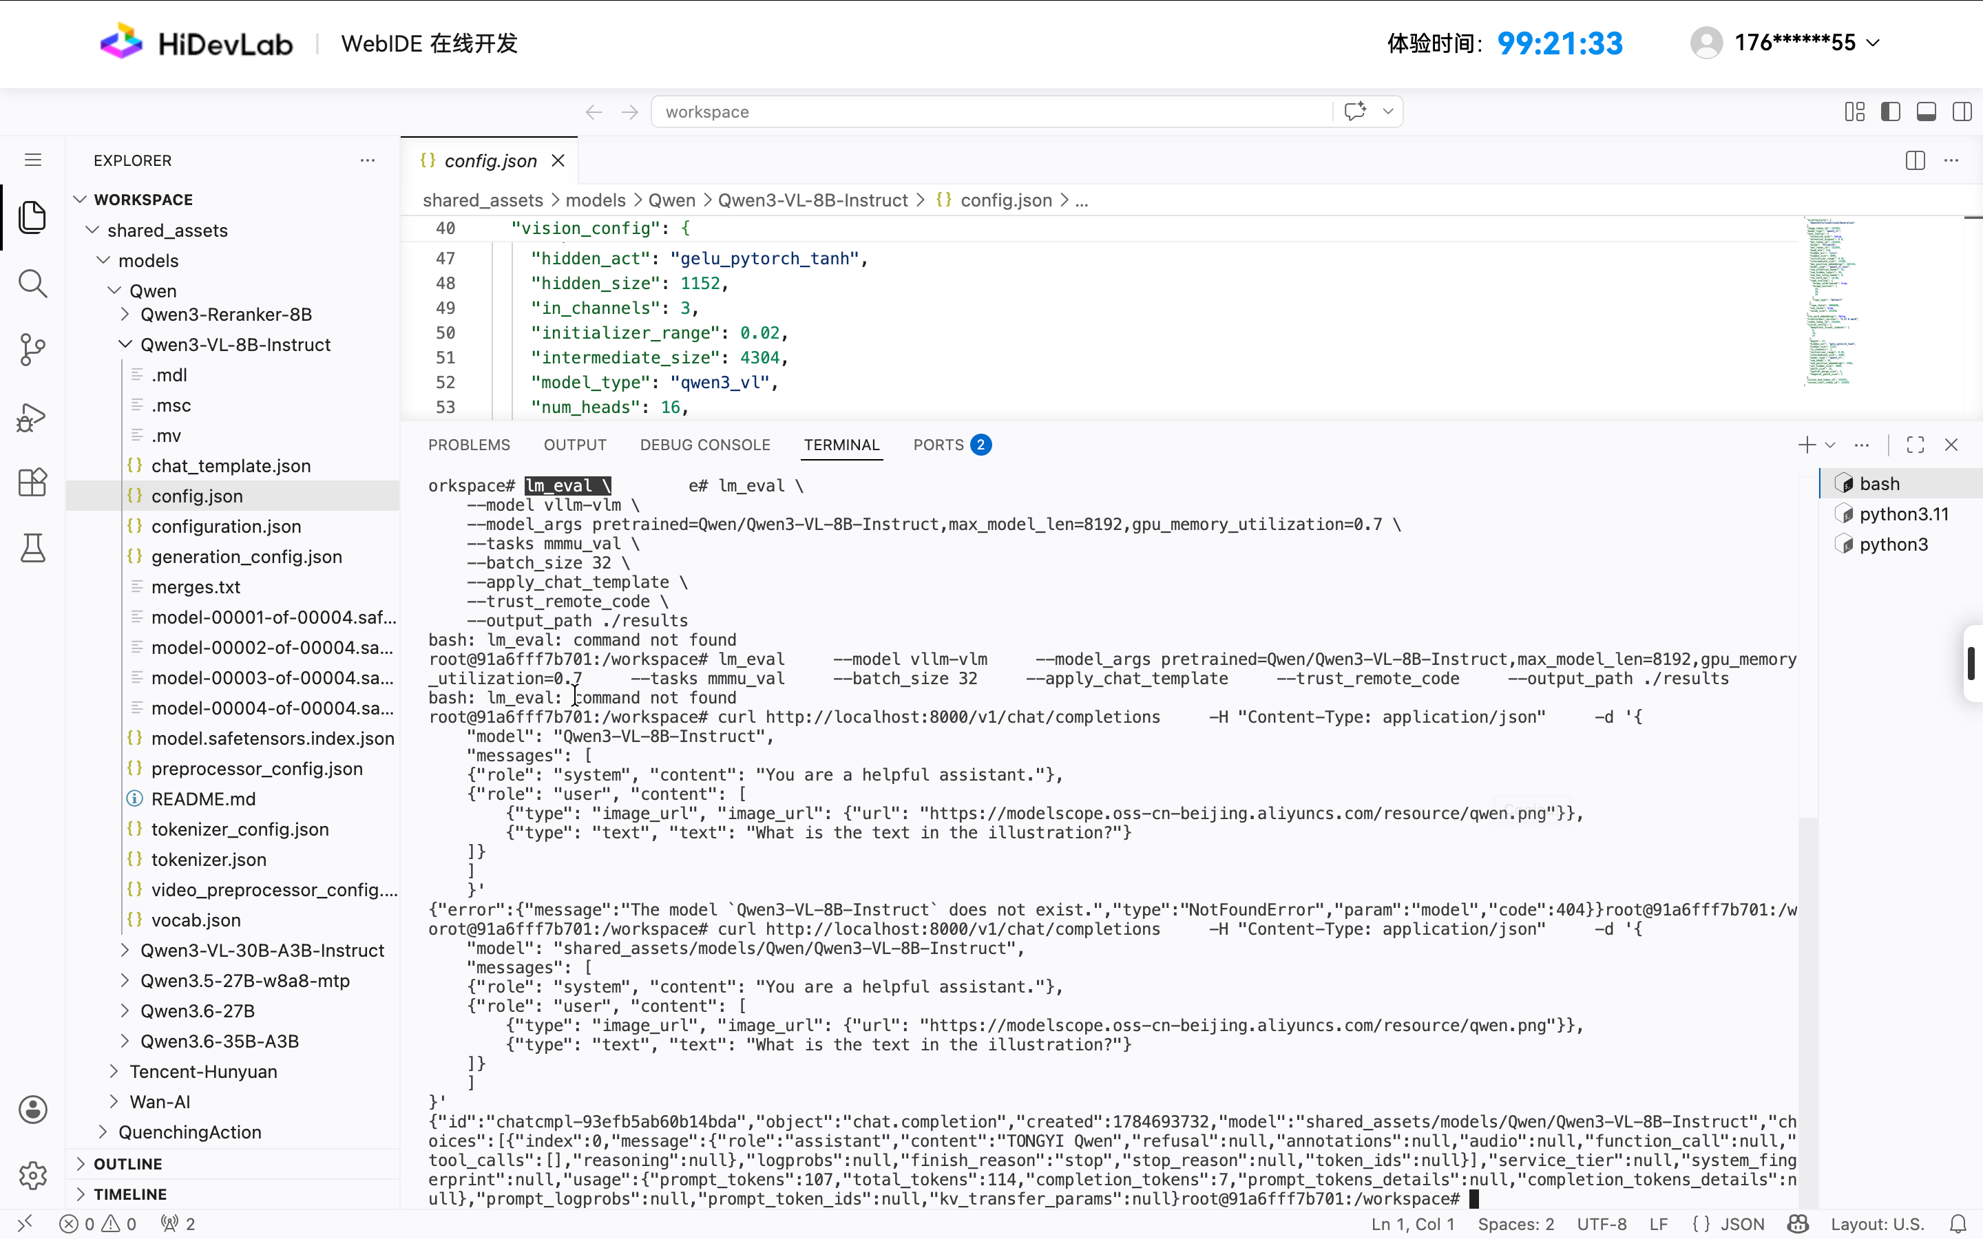

使用lm_eval测试精度

lm_eval \
--model vllm-vlm \
--model_args pretrained=shared_assets/models/Qwen/Qwen3-VL-8B-Instruct,max_model_len=8192,gpu_memory_utilization=0.7 \
--tasks mmmu_val \
--batch_size 32 \
--apply_chat_template \
--trust_remote_code \
--output_path ./results

遇到
lm_eval \
--model vllm-vlm \
--model_args pretrained=shared_assets/models/Qwen/Qwen3-VL-8B-Instruct,max_model_len=8192,gpu_memory_utilization=0.7 \
--tasks mmmu_val \
--batch_size 32 \
--apply_chat_template \
--trust_remote_code \
--output_path ./results
2026-07-22:05:03:35 INFO [config.evaluate_config:307] Using default fewshot_as_multiturn=True.
^CTraceback (most recent call last):
File "/usr/local/python3.11.14/bin/lm_eval", line 6, in <module>
sys.exit(cli_evaluate())
^^^^^^^^^^^^^^
File "/usr/local/python3.11.14/lib/python3.11/site-packages/lm_eval/__main__.py", line 10, in cli_evaluate
parser.execute(args)
File "/usr/local/python3.11.14/lib/python3.11/site-packages/lm_eval/_cli/harness.py", line 60, in execute
args.func(args)
File "/usr/local/python3.11.14/lib/python3.11/site-packages/lm_eval/_cli/run.py", line 355, in _execute
cfg = EvaluatorConfig.from_cli(args)
^^^^^^^^^^^^^^^^^^^^^^^^^^^^^^
File "/usr/local/python3.11.14/lib/python3.11/site-packages/lm_eval/config/evaluate_config.py", line 225, in from_cli
instance._configure()
File "/usr/local/python3.11.14/lib/python3.11/site-packages/lm_eval/config/evaluate_config.py", line 276, in _configure
self._validate_arguments()._process_arguments()._set_trust_remote_code()
File "/usr/local/python3.11.14/lib/python3.11/site-packages/lm_eval/config/evaluate_config.py", line 426, in _set_trust_remote_code
import datasets
File "/usr/local/python3.11.14/lib/python3.11/site-packages/datasets/__init__.py", line 17, in <module>
from .arrow_dataset import Column, Dataset
File "/usr/local/python3.11.14/lib/python3.11/site-packages/datasets/arrow_dataset.py", line 58, in <module>
import pandas as pd
File "/usr/local/python3.11.14/lib/python3.11/site-packages/pandas/__init__.py", line 46, in <module>
from pandas.core.api import (
File "/usr/local/python3.11.14/lib/python3.11/site-packages/pandas/core/api.py", line 27, in <module>
from pandas.core.arrays import Categorical
File "/usr/local/python3.11.14/lib/python3.11/site-packages/pandas/core/arrays/__init__.py", line 1, in <module>
from pandas.core.arrays.arrow import ArrowExtensionArray
File "/usr/local/python3.11.14/lib/python3.11/site-packages/pandas/core/arrays/arrow/__init__.py", line 5, in <module>
from pandas.core.arrays.arrow.array import ArrowExtensionArray
File "/usr/local/python3.11.14/lib/python3.11/site-packages/pandas/core/arrays/arrow/array.py", line 73, in <module>
from pandas.core.arrays._arrow_string_mixins import ArrowStringArrayMixin
File "/usr/local/python3.11.14/lib/python3.11/site-packages/pandas/core/arrays/_arrow_string_mixins.py", line 31, in <module>
class ArrowStringArrayMixin:
KeyboardInterrupt
source /workspace/.venv/bin/activate

root@91a6fff7b701:/workspace# source /workspace/.venv/bin/activate

使用source命令激活环境source /workspace/.venv/bin/activate

启动后日志
source /workspace/.venv/bin/activate
(.venv) root@91a6fff7b701:/workspace# lm_eval --model vllm-vlm --model_args pretrained=shared_assets/models/Qwen/Qwen3-VL-8B-Instruct,max_model_len=8192,gpu_memory_utilization=0.7 --tasks mmmu_val --batch_size 32 --apply_chat_template --trust_remote_code --output_path ./results
2026-07-22:05:04:34 INFO [config.evaluate_config:307] Using default fewshot_as_multiturn=True.
2026-07-22:05:04:48 INFO [_cli.run:388] Selected Tasks: ['mmmu_val']
2026-07-22:05:04:54 INFO [evaluator:214] Setting random seed to 0 | Setting numpy seed to 1234 | Setting torch manual seed to 1234 | Setting fewshot manual seed to 1234
2026-07-22:05:04:54 INFO [evaluator:239] Initializing vllm-vlm model, with arguments: {'pretrained': 'shared_assets/models/Qwen/Qwen3-VL-8B-Instruct', 'max_model_len': 8192, 'gpu_memory_utilization': 0.7, 'trust_remote_code': True}
INFO 07-22 05:04:56 [__init__.py:44] Available plugins for group vllm.platform_plugins:
INFO 07-22 05:04:56 [__init__.py:46] - ascend -> vllm_ascend:register
INFO 07-22 05:04:56 [__init__.py:49] All plugins in this group will be loaded. Set `VLLM_PLUGINS` to control which plugins to load.
INFO 07-22 05:04:56 [__init__.py:239] Platform plugin ascend is activated
INFO 07-22 05:05:01 [__init__.py:110] Registered model loader `<class 'vllm_ascend.model_loader.netloader.netloader.ModelNetLoaderElastic'>` with load format `netloader`
INFO 07-22 05:05:01 [__init__.py:110] Registered model loader `<class 'vllm_ascend.model_loader.rfork.rfork_loader.RForkModelLoader'>` with load format `rfork`
INFO 07-22 05:05:01 [utils.py:233] non-default args: {'trust_remote_code': True, 'seed': 1234, 'max_model_len': 8192, 'gpu_memory_utilization': 0.7, 'disable_log_stats': True, 'model': 'shared_assets/models/Qwen/Qwen3-VL-8B-Instruct'}
INFO 07-22 05:05:02 [model.py:533] Resolved architecture: Qwen3VLForConditionalGeneration
INFO 07-22 05:05:02 [model.py:1582] Using max model len 8192
INFO 07-22 05:05:02 [scheduler.py:231] Chunked prefill is enabled with max_num_batched_tokens=8192.
INFO 07-22 05:05:02 [vllm.py:754] Asynchronous scheduling is enabled.
WARNING 07-22 05:05:02 [platform.py:749] Parameter '--disable-cascade-attn' is a GPU-specific feature. Resetting to False for Ascend.
WARNING 07-22 05:05:02 [platform.py:838] Ignored parameter 'disable_flashinfer_prefill'. This is a GPU-specific feature not supported on Ascend. Resetting to False.
INFO 07-22 05:05:02 [ascend_config.py:425] Dynamic EPLB is False
INFO 07-22 05:05:02 [ascend_config.py:426] The number of redundant experts is 0
INFO 07-22 05:05:02 [platform.py:354] PIECEWISE compilation enabled on NPU. use_inductor not supported - using only ACL Graph mode
INFO 07-22 05:05:02 [utils.py:549] Calculated maximum supported batch sizes for ACL graph: 48
WARNING 07-22 05:05:02 [utils.py:550] Currently, communication is performed using FFTS+ method, which reduces the number of available streams and, as a result, limits the range of runtime shapes that can be handled. To both improve communication performance and increase the number of supported shapes, set HCCL_OP_EXPANSION_MODE=AIV.
INFO 07-22 05:05:02 [utils.py:582] No adjustment needed for ACL graph batch sizes: Qwen3VLForConditionalGeneration model (layers: 36) with 35 sizes
INFO 07-22 05:05:02 [utils.py:1114] Block size is set to 128 if prefix cache or chunked prefill is enabled.
INFO 07-22 05:05:02 [platform.py:502] Set PYTORCH_NPU_ALLOC_CONF=expandable_segments:True
INFO 07-22 05:05:02 [compilation.py:289] Enabled custom fusions: norm_quant, act_quant
(EngineCore pid=30907) INFO 07-22 05:05:08 [core.py:103] Initializing a V1 LLM engine (v0.18.0) with config: model='shared_assets/models/Qwen/Qwen3-VL-8B-Instruct', speculative_config=None, tokenizer='shared_assets/models/Qwen/Qwen3-VL-8B-Instruct', skip_tokenizer_init=False, tokenizer_mode=auto, revision=None, tokenizer_revision=None, trust_remote_code=True, dtype=torch.bfloat16, max_seq_len=8192, download_dir=None, load_format=auto, tensor_parallel_size=1, pipeline_parallel_size=1, data_parallel_size=1, decode_context_parallel_size=1, dcp_comm_backend=ag_rs, disable_custom_all_reduce=True, quantization=None, enforce_eager=False, enable_return_routed_experts=False, kv_cache_dtype=auto, device_config=npu, structured_outputs_config=StructuredOutputsConfig(backend='auto', disable_any_whitespace=False, disable_additional_properties=False, reasoning_parser='', reasoning_parser_plugin='', enable_in_reasoning=False), observability_config=ObservabilityConfig(show_hidden_metrics_for_version=None, otlp_traces_endpoint=None, collect_detailed_traces=None, kv_cache_metrics=False, kv_cache_metrics_sample=0.01, cudagraph_metrics=False, enable_layerwise_nvtx_tracing=False, enable_mfu_metrics=False, enable_mm_processor_stats=False, enable_logging_iteration_details=False), seed=1234, served_model_name=shared_assets/models/Qwen/Qwen3-VL-8B-Instruct, enable_prefix_caching=True, enable_chunked_prefill=True, pooler_config=None, compilation_config={'mode': <CompilationMode.VLLM_COMPILE: 3>, 'debug_dump_path': None, 'cache_dir': '', 'compile_cache_save_format': 'binary', 'backend': 'vllm_ascend.compilation.compiler_interface.AscendCompiler', 'custom_ops': ['all'], 'splitting_ops': ['vllm::unified_attention', 'vllm::unified_attention_with_output', 'vllm::unified_mla_attention', 'vllm::unified_mla_attention_with_output', 'vllm::mamba_mixer2', 'vllm::mamba_mixer', 'vllm::short_conv', 'vllm::linear_attention', 'vllm::plamo2_mamba_mixer', 'vllm::gdn_attention_core', 'vllm::olmo_hybrid_gdn_full_forward', 'vllm::kda_attention', 'vllm::sparse_attn_indexer', 'vllm::rocm_aiter_sparse_attn_indexer', 'vllm::unified_kv_cache_update', 'vllm::unified_mla_kv_cache_update', 'vllm::mla_forward'], 'compile_mm_encoder': False, 'compile_sizes': [], 'compile_ranges_endpoints': [8192], 'inductor_compile_config': {'enable_auto_functionalized_v2': False, 'combo_kernels': True, 'benchmark_combo_kernel': True}, 'inductor_passes': {}, 'cudagraph_mode': <CUDAGraphMode.PIECEWISE: 1>, 'cudagraph_num_of_warmups': 1, 'cudagraph_capture_sizes': [1, 2, 4, 8, 16, 24, 32, 40, 48, 56, 64, 72, 80, 88, 96, 104, 112, 120, 128, 136, 144, 152, 160, 168, 176, 184, 192, 200, 208, 216, 224, 232, 240, 248, 256], 'cudagraph_copy_inputs': False, 'cudagraph_specialize_lora': True, 'use_inductor_graph_partition': False, 'pass_config': {'fuse_norm_quant': True, 'fuse_act_quant': True, 'fuse_attn_quant': False, 'enable_sp': False, 'fuse_gemm_comms': False, 'fuse_allreduce_rms': False}, 'max_cudagraph_capture_size': 256, 'dynamic_shapes_config': {'type': <DynamicShapesType.BACKED: 'backed'>, 'evaluate_guards': False, 'assume_32_bit_indexing': False}, 'local_cache_dir': None, 'fast_moe_cold_start': True, 'static_all_moe_layers': []}
(EngineCore pid=30907) WARNING 07-22 05:05:09 [warnings.py:110] /vllm-workspace/vllm-ascend/vllm_ascend/patch/worker/patch_weight_utils.py:80: DeprecationWarning: pkg_resources is deprecated as an API. See https://setuptools.pypa.io/en/latest/pkg_resources.html
(EngineCore pid=30907) INFO 07-22 05:05:13 [parallel_state.py:1395] world_size=1 rank=0 local_rank=0 distributed_init_method=tcp://172.17.0.5:53305 backend=hccl
[Gloo] Rank 0 is connected to 0 peer ranks. Expected number of connected peer ranks is : 0
[Gloo] Rank 0 is connected to 0 peer ranks. Expected number of connected peer ranks is : 0
[Gloo] Rank 0 is connected to 0 peer ranks. Expected number of connected peer ranks is : 0
[Gloo] Rank 0 is connected to 0 peer ranks. Expected number of connected peer ranks is : 0
[Gloo] Rank 0 is connected to 0 peer ranks. Expected number of connected peer ranks is : 0
[Gloo] Rank 0 is connected to 0 peer ranks. Expected number of connected peer ranks is : 0
(EngineCore pid=30907) INFO 07-22 05:05:13 [parallel_state.py:1717] rank 0 in world size 1 is assigned as DP rank 0, PP rank 0, PCP rank 0, TP rank 0, EP rank N/A, EPLB rank N/A
[Gloo] Rank 0 is connected to 0 peer ranks. Expected number of connected peer ranks is : 0
(EngineCore pid=30907) INFO 07-22 05:05:14 [cpu_binding.py:320] [cpu_bind_mode] mode=topo_affinity rank=0 visible_npus=[0]
(EngineCore pid=30907) INFO 07-22 05:05:14 [cpu_binding.py:367] The CPU allocation plan is as follows:
(EngineCore pid=30907) INFO 07-22 05:05:14 [cpu_binding.py:372] NPU0: main=[130 131 132 133 134 135 136 137 138 139 140 141 142 143 144 145 146 147 148 149 150 151 152 153 154 155 156 157 158 159 160 161 162 163 164 165 166 167 168 169 170 171 172 173 174 175 176 177 178 179 180 181 182 183 184 185 186 187 188 189] acl=[190] release=[[191]]
(EngineCore pid=30907) INFO 07-22 05:05:14 [cpu_binding.py:394] [migrate] NPU:0 -> NUMA [4]
(EngineCore pid=30907) INFO 07-22 05:05:14 [model_runner_v1.py:2562] Starting to load model shared_assets/models/Qwen/Qwen3-VL-8B-Instruct...
(EngineCore pid=30907) INFO 07-22 05:05:15 [interface.py:275] Using default backend AttentionBackendEnum.TORCH_SDPA for vit attention
(EngineCore pid=30907) INFO 07-22 05:05:15 [mm_encoder_attention.py:230] Using AttentionBackendEnum.TORCH_SDPA for MMEncoderAttention.
(EngineCore pid=30907) INFO 07-22 05:05:16 [platform.py:354] PIECEWISE compilation enabled on NPU. use_inductor not supported - using only ACL Graph mode
(EngineCore pid=30907) INFO 07-22 05:05:16 [utils.py:549] Calculated maximum supported batch sizes for ACL graph: 48
(EngineCore pid=30907) WARNING 07-22 05:05:16 [utils.py:550] Currently, communication is performed using FFTS+ method, which reduces the number of available streams and, as a result, limits the range of runtime shapes that can be handled. To both improve communication performance and increase the number of supported shapes, set HCCL_OP_EXPANSION_MODE=AIV.
(EngineCore pid=30907) INFO 07-22 05:05:16 [utils.py:582] No adjustment needed for ACL graph batch sizes: Qwen3VLForConditionalGeneration model (layers: 36) with 35 sizes
(EngineCore pid=30907) INFO 07-22 05:05:16 [platform.py:502] Set PYTORCH_NPU_ALLOC_CONF=expandable_segments:True
(EngineCore pid=30907) INFO 07-22 05:05:17 [compilation.py:942] Using OOT custom backend for compilation.
(EngineCore pid=30907) INFO 07-22 05:05:17 [compilation.py:942] Using OOT custom backend for compilation.
(EngineCore pid=30907) INFO 07-22 05:05:17 [compilation.py:942] Using OOT custom backend for compilation.
Loading safetensors checkpoint shards: 0% Completed | 0/4 [00:00<?, ?it/s]
Loading safetensors checkpoint shards: 25% Completed | 1/4 [00:00<00:01, 1.74it/s]
Loading safetensors checkpoint shards: 50% Completed | 2/4 [00:01<00:01, 1.32it/s]
Loading safetensors checkpoint shards: 75% Completed | 3/4 [00:02<00:00, 1.09it/s]
Loading safetensors checkpoint shards: 100% Completed | 4/4 [00:03<00:00, 1.12it/s]
Loading safetensors checkpoint shards: 100% Completed | 4/4 [00:03<00:00, 1.17it/s]
(EngineCore pid=30907)
(EngineCore pid=30907) INFO 07-22 05:05:21 [default_loader.py:384] Loading weights took 3.52 seconds
(EngineCore pid=30907) INFO 07-22 05:05:22 [model_runner_v1.py:2589] Loading model weights took 16.7695 GB
(EngineCore pid=30907) INFO 07-22 05:05:23 [gpu_model_runner.py:5488] Encoder cache will be initialized with a budget of 16384 tokens, and profiled with 1 image items of the maximum feature size.

lm_eval \
--model vllm-vlm \
--model_args pretrained=shared_assets/models/Qwen/Qwen3-VL-8B-Instruct,max_model_len=8192,gpu_memory_utilization=0.7 \
--tasks shared_assets/datasets/MMMU___mmmu \
--batch_size 32 \
--apply_chat_template \
--trust_remote_code \
--output_path ./results
lm_eval \
--model vllm-vlm \
--model_args pretrained=shared_assets/models/Qwen/Qwen3-VL-8B-Instruct,max_model_len=8192,gpu_memory_utilization=0.7 \
--tasks shared_assets/datasets/MMMU___mmmu \
--batch_size 32 \
--apply_chat_template \
--trust_remote_code \
--output_path ./results
2026-07-22:05:12:22 INFO [config.evaluate_config:307] Using default fewshot_as_multiturn=True.
2026-07-22:05:12:36 INFO [_cli.run:388] Selected Tasks: []
2026-07-22:05:12:43 INFO [evaluator:214] Setting random seed to 0 | Setting numpy seed to 1234 | Setting torch manual seed to 1234 | Setting fewshot manual seed to 1234
Traceback (most recent call last):
File "/usr/local/python3.11.14/bin/lm_eval", line 6, in <module>
sys.exit(cli_evaluate())
^^^^^^^^^^^^^^
File "/usr/local/python3.11.14/lib/python3.11/site-packages/lm_eval/__main__.py", line 10, in cli_evaluate
parser.execute(args)
File "/usr/local/python3.11.14/lib/python3.11/site-packages/lm_eval/_cli/harness.py", line 60, in execute
args.func(args)
File "/usr/local/python3.11.14/lib/python3.11/site-packages/lm_eval/_cli/run.py", line 391, in _execute
results = simple_evaluate(
^^^^^^^^^^^^^^^^
File "/usr/local/python3.11.14/lib/python3.11/site-packages/lm_eval/utils.py", line 575, in _wrapper
return fn(*args, **kwargs)
^^^^^^^^^^^^^^^^^^^
File "/usr/local/python3.11.14/lib/python3.11/site-packages/lm_eval/evaluator.py", line 219, in simple_evaluate
raise ValueError(
ValueError: No tasks specified, or no tasks found. Please verify the task names.
[ERROR] 2026-07-22-05:12:43 (PID:32743, Device:-1, RankID:-1) ERR99999 UNKNOWN applicaiton exception
(.venv) root@91a6fff7b701:/workspace#

4、使用vllm bench验证性能
vllm bench serve --model shared_assets/models/Qwen/Qwen3-VL-8B-Instruct --dataset-name random --random-input 200 --num-prompts 200 --request-rate 1 --save-result --result-dir ./

