vLLM-Ascend部署Qwen2.5-Omni-7b模型过程报告

- 先确认驱动信息和本地vllm环境
npu-smi info
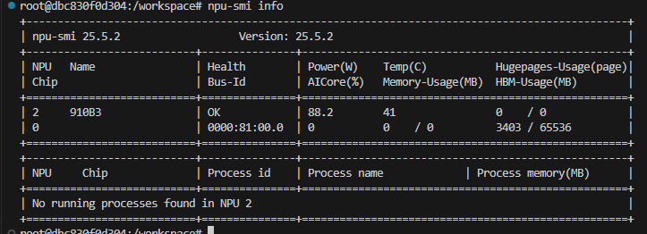
vllm -v
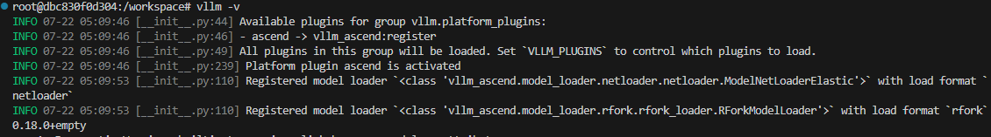
- 确认本地模型路径
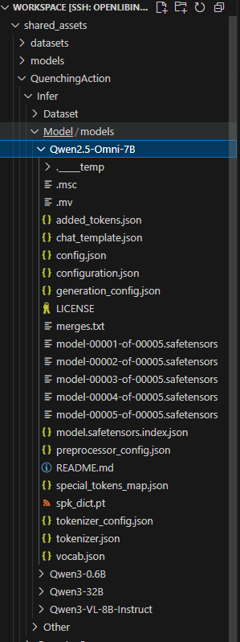
- vllm拉起模型

export VLLM_USE_MODELSCOPE=True
export MODEL_PATH="/workspace/shared_assets/QuenchingAction/Infer/Model/models/Qwen2.5-Omni-7B"
export LOCAL_MEDIA_PATH=/root/.cache/vllm/assets/vllm_public_assets/

vllm serve "${MODEL_PATH}" \
--host 0.0.0.0 \
--port 8000 \
--served-model-name Qwen-Omni \
--allowed-local-media-path ${LOCAL_MEDIA_PATH} \
--trust-remote-code \
--compilation-config '{"cudagraph_mode": "FULL_DECODE_ONLY"}' \
--no-enable-prefix-caching
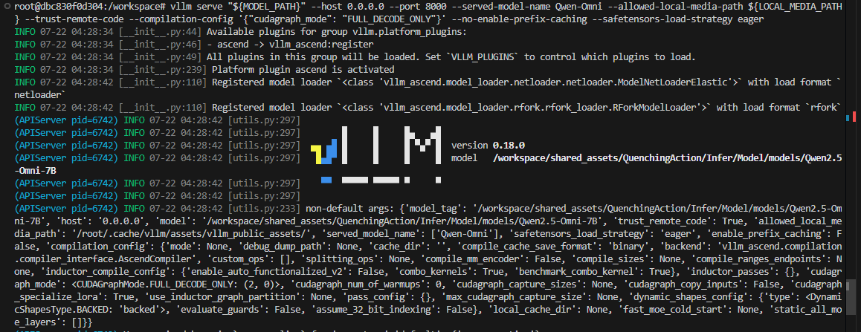
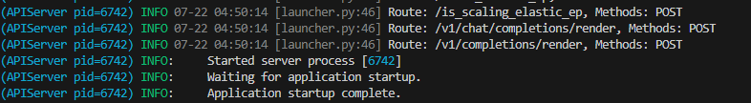
- 发送post请求对话，看推理是否正常
curl http://0.0.0.0:8000/v1/chat/completions -H "Content-Type: application/json" \
-d '{"model": "Qwen-Omni", "stream":false, "messages": [{"role": "user", "content": "你好，介绍下你自己"}]}'
- 运行模型性能测试
vllm bench serve \
--backend vllm \
--model shared_assets/QuenchingAction/Infer/Model/models/Qwen2.5-Omni-7B \
--served-model-name Qwen-Omni \
--port 8000 \
--dataset-name random \
--random-input 3500 \
--random-output 1500 \
--max-concurrency 20 \
--num-prompts 80 \
--save-result \
--result-dir user_data/benchmark_results/
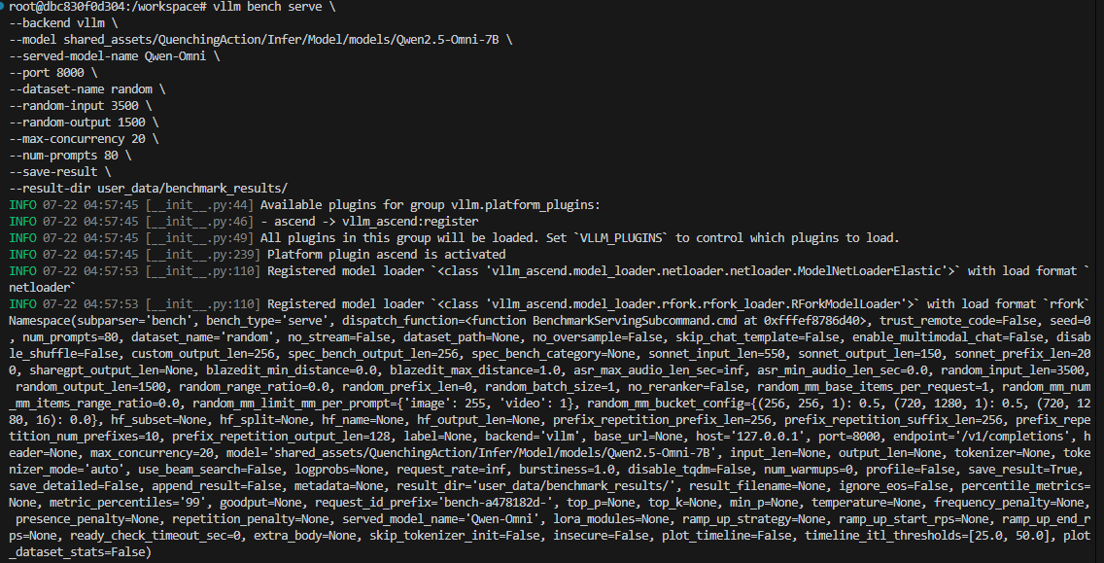
- 查看性能测试结果
