- 部署
命令：
vllm serve /workspace/shared_assets/models/Qwen/Qwen3-VL-8B-Instruct \
--dtype bfloat16 \
--max-model-len 16384 \
--max-num-batched-tokens 16384
截图：
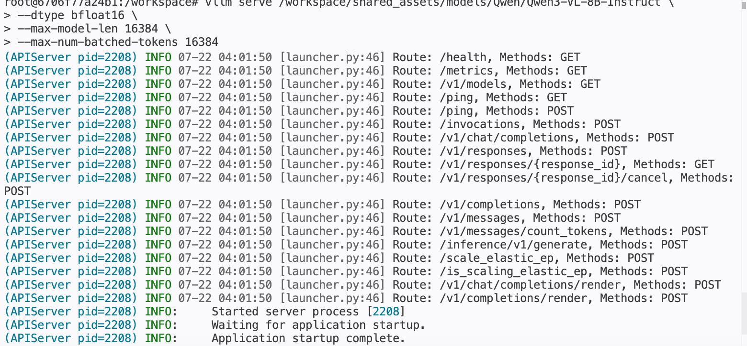

调用模型
命令：
curl http://localhost:8000/v1/chat/completions \
-H "Content-Type: application/json" \
-d '{
"model": "/workspace/shared_assets/models/Qwen/Qwen3-VL-8B-Instruct",
"messages": [
{"role": "system", "content": "You are a helpful assistant."},
{"role": "user", "content": [
{"type": "image_url", "image_url": {"url": "https://modelscope.oss-cn-beijing.aliyuncs.com/resource/qwen.png"}},
{"type": "text", "text": "What is the text in the illustration?"}
]}
]
}'
截图：
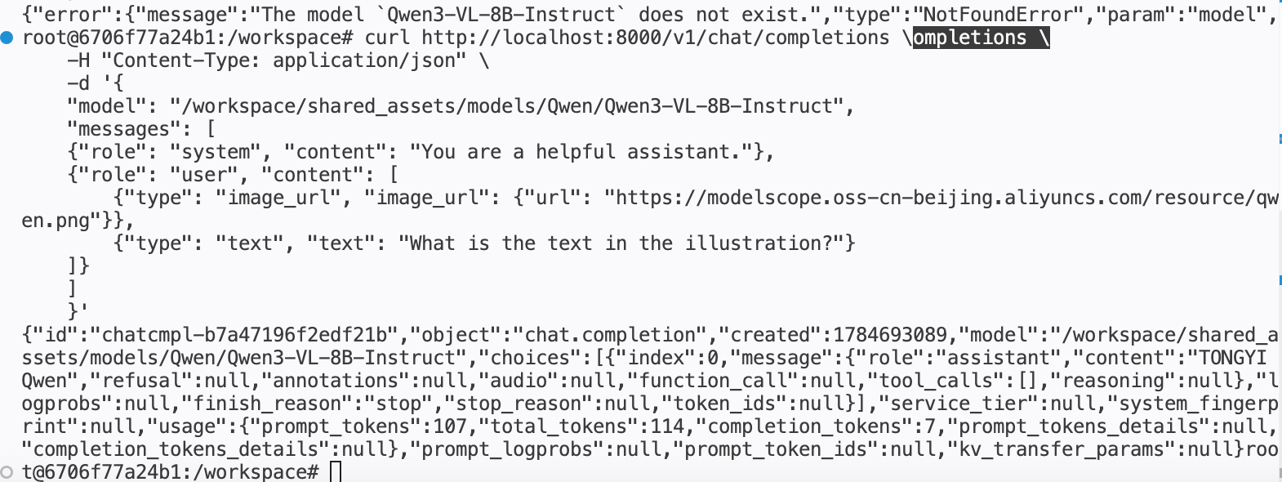
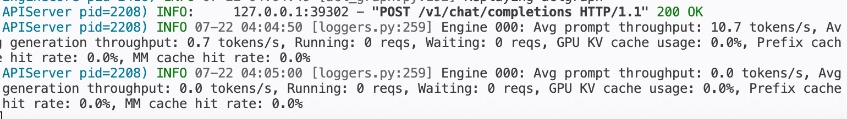

- vLLM Benchmark
命令：
vllm bench serve --model /workspace/shared_assets/models/Qwen/Qwen3-VL-8B-Instruct --dataset-name random --random-input 200 --num-prompts 200 --request-rate 1 --save-result --result-dir ./
