**Technical Report: How to Build a Life-Logging Camera**

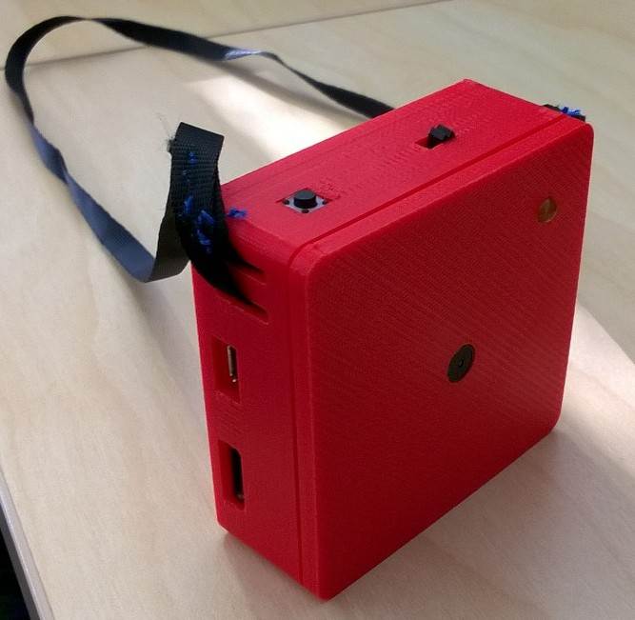

**Lanyard**

**LED**

**Micro-B USB cable slot**

**Micro SD card slot**

**Mini JPEG camera**

**Delete button**

**On/Off switch**

We built a wearable and programmable camera with the following **components** packed together in a 3d printed plastic box of size 65*65*22 mm.

1. Adafruit Real time clock – DS1307 breakout kit
2. Arduino nano v3.0 micro-controller
3. Adafruit Micro SD breakout board
4. Adafruit Mini JPEG Camera
5. Adafruit PowerBoost 500C
6. Resistors (12k, 24k, 1000k)
7. LiPoly battery 2000mAh
8. Micro-B USB cable
9. Micro SD card
10. Push Button
11. Slide button
12. Veroboard
13. Lanyard
14. Wires
15. LED

Following **tools** are needed for building the camera unit.

***Hardware:***

1. Soldering Machine

2. Heat gun

3. Glue gun

4. Cutter

5. Foreceps

6. 3d printer

***Software:***

1. Arduino
2. OpenSCAD

With the help of these tools, we solder the components together (as per the diagram below) glue them and fit in the 3d printed plastic box.

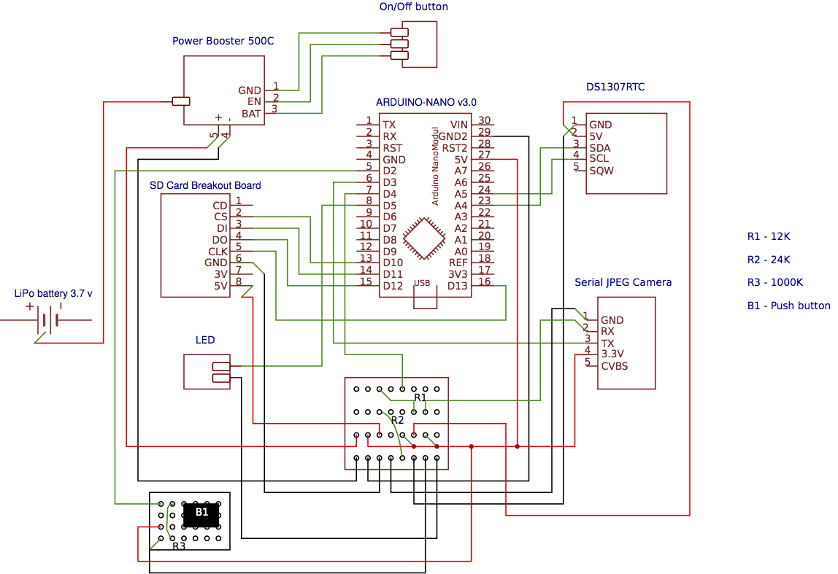

A user can wear the camera around their neck and move around. The LED flashes when the wearable camera is switched on. It takes automatic pictures of size 640*480 pixels and stores them in the micro SD card. The software program running on the arduino microcontroller creates different directories for each day, each storing pictures taken on that particular day. Photos are stored with the naming convention: <*hour_minutes_seconds>* and are taken randomly with a gap of at-least 5 minutes*.* Some more features of the life-logging camera are:

1. On/Off sliding button: to switch the camera on/off.
2. Push button: to delete photos taken in last 5 minutes.

A file named “del_log.txt “ records the photos that have been deleted.

1. *“Random flashes in between”* mode: Switch on the camera with push button in pressed state. The flash blinks randomly with a gap of at-least 15 minutes. 2 consecutive flashes occur with each of 0.5 seconds duration.

A file named “fla_log.txt” records the start and end flash time, throughout the time that camera is on.

1. *“No random flashes in between”* mode:  Switch on the camera. No flashes thereafter.
2. When connected to power, the camera will always be on. The on/off button would not work in that scenario.
3. The LED will lit up permanently and the camera won’t work, if there is no memory card.
4. The wearable camera runs on a 2000 m Ah LiPo battery. It can effectively work for entire day and then needs to be charged overnight through the micro USB slot provided.

The source code and 3D file for the camera case can be found at: https://github.com/vllstudy16/vllstudy16

**Basic Debugging:**

1. Make the hardware connections as per the diagram. They should be strong and well soldered. Make sure that no connection is broken or accidentally touching other connection.

2. If the LED doesn’t glow, it is possible that it’s connected the wrong way. Just exchange the wire connections.