Seeking groups of students
to wear a camera for a week!
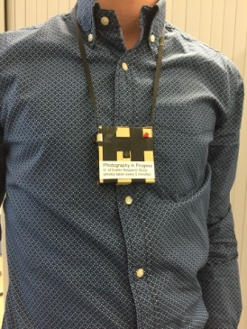
Researchers are seeking groups of between 3-6 students who know each other (e.g. live in a flat together, or are in the same class or society) to wear life-logging cameras one week (Monday to Friday) during term.
A life-logging camera (pictured above) is a light wearable camera that automatically takes photographs every 5 minutes.
You will each be compensated £7 a day (up to £35), and can enter a prize draw for an iPad Mini.
Please contact <redacted> for more information.
This study has received ethical approval (2015/933). If you have any complaints or enquiries about the ethical nature of this study please contact the head of Psychology Ethics Research Committee, <<redacted>>

