Internet of Things (IoT)

# What is IoT?

IoT is no more a buzz word. It’s emerged in daily life since a decade . You can see presence of IoT in any sector you name – Agriculture, Manufacturing, Automobile, Life Science, HealthCare, Supply Chain , Inventory Management , Environment management and list is never-ending . Even from your Kitchen table to high end luxury vehicles , you see use of IoT.

The **Internet of Things (IoT)** refers to a network of physical devices, vehicles, appliances, and other objects embedded with sensors, software, and network connectivity. (“What is the Internet of Things (IoT)? | IBM”) These smart devices can collect and share data, creating an interconnected ecosystem. Let’s delve into the details:

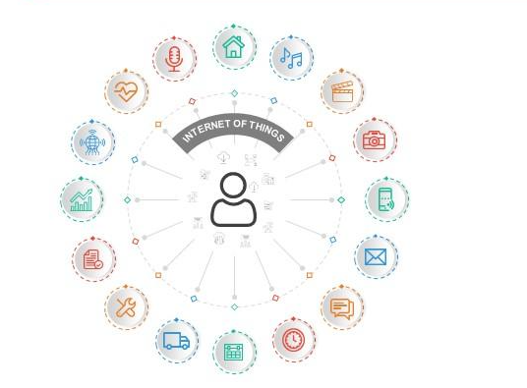

# **Definition and Scope**:

*The Internet* can be described as the communication network that connects individuals to information , while *The Internet of Things (IoT)* is an interconnected system of distinctively address able physical items with various degrees of processing, sensing, and actuation capabilities that share the capability to interoperate and communicate through the Internet as their joint platform. (“International Journal of Engineering Applied Sciences ... - ResearchGate”)

It may be a system of interrelated Computing devices, mechanical and digital machines given unique identifiers and therefore the ability to transfer data over a network without requiring human-to-human or human-to-computer interaction.

# How IoT Works?

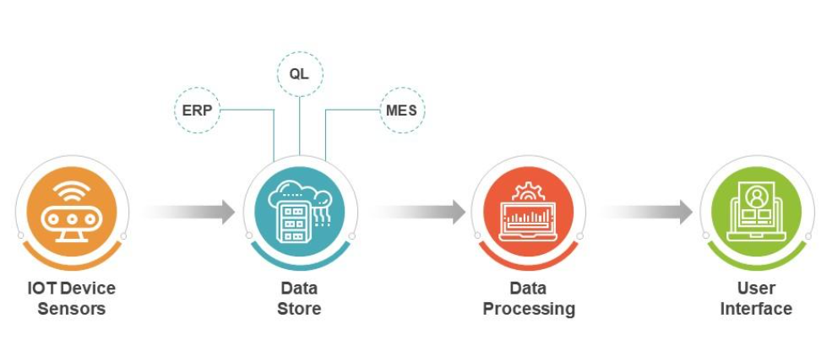

Here we understand , why it is called Internet of Thing (IoT) . Simple … as each device is connected and communicating over Internet without human interventions. IoT works  by connecting devices to the internet through a variety of technologies, such as Wi-Fi, Bluetooth, and cellular networks. Once devices are connected to the internet, they can send and receive data. This data can be used to track the devices, monitor their performance, and control their behavior*. SENSORS , NETWORKS and SOFTWARE*  are the pillars .

**Sensors**: Sensors are devices that collect data from the physical world. They can measure things like temperature, humidity, light, motion, and sound.

**Networks**: Networks connect the sensors to the internet. They can be wired or wireless networks.

**Software**: Software is used to collect, store, and analyze the data collected by the sensors. It can also be used to control the devices.

## Feature of IoT :

Data is the Fuel for IoT .

Smart devices collect and transmit information, which is then analyzed and used to improve performance, user experience, and even sales strategies. As IoT continues to expand, the amount of data collected and analyzed will grow exponentially, enabling increasingly personalized and connected experiences.

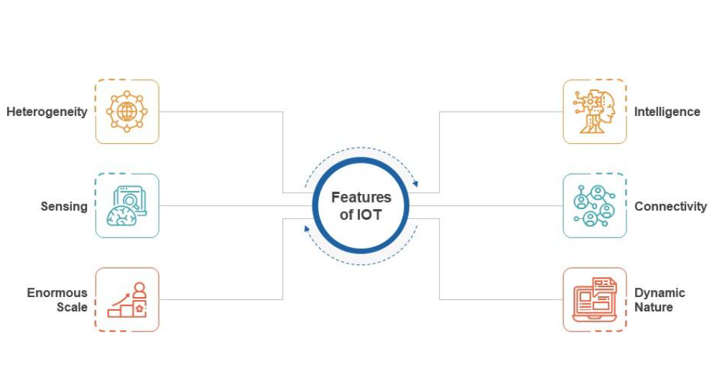

This information is used to streamline, manipulate, and measure these entities interact . Example: Your smartwatch tells the heart health , Step Count, Reminds you for sipping Water. More complex example- Engine Noise can be analyzed to predict the problem and suggest solution .

Your service provider and the product manufacturer can then use those insights to achieve a variety of objectives – from improving the device’s performance, and your experience of using it, to identifying how or when they should be selling you extra services or products.

Different Layers of IoT:

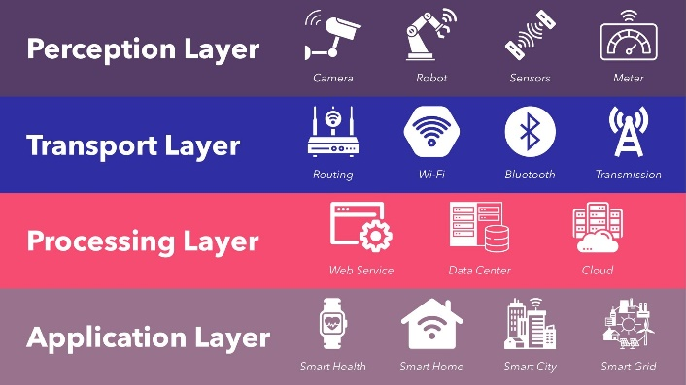

IoT architecture can comprise up to seven layers, which are known as the

1. Perception Layer :

The **perception** layer of an IoT system architecture, also known as the device layer, consists of multiple elements – sensors, cameras, actuators, and similar devices that gather data and perform tasks.

1. Transport Layer:

The **transport** layer of an IoT system architecture transmits data from multiple devices (e.g., on-site sensors, cameras, actuators) to an on-premises or cloud data center.

As a first step, IoT gateways must convert the incoming input from analog to digital format. Next, the gateway may employ any one of a range of data transfer protocols (DTPs) to transmit the data to an on-premises or cloud data center.

Following factors decide how the transport layer be built, What DTP will be used in IoT networks , what should be the data center ( on-prem or cloud)

* Amount and type of data to be sent.
* Desired speed and interval of transmission
* Reliability of network connection
* Power consumption during data transmission
* Data and network security
* Communication among edge devices
* Volume of Data

1. Edge Layer :

As IoT networks grow in scale, latency becomes one of the main performance challenges, as numerous devices connecting to a hub end up congesting the network. By enabling data processing and analysis as close to the source as possible, edge computing addresses these problems – which is handled through the edge layer of an IoT system architecture. These edge devices are additionally programmed to manage and handle the damage control when there is anomaly in

data transferring and processing.

1. Processing Layer :

The processing layer within an IoT system architecture is responsible for analyzing input data to generate new insights, useful predictions, and timely warnings.

Also known as middleware layer, typically leverages many connected computers simultaneously , in the form of cloud computing to deliver efficient compute, storage, networking and security performance . 3 stages these middleware works on to process.

* *Data accumulation* : identifies and assigns different data types to appropriate storage.

Example:

* + Unstructured Data , like audio-video streams and images which requires more storage are saved to data lakes .
  + Structured Data , like logs , documents, files , telemetries are stored in Data warehouse.
* *Data Abstraction:* aggregates data from multiple sources, as well as ensuring that data is converted into a format that can be “read” by the software of the application layer.
* *Data Analysis:* employs machine learning (ML) or deep learning algorithms, which are specialized in detecting patterns within large and seemingly random data sets.

1. Application Layer:

Application Layer involves decoding promising patterns in data and compiling then into summaries to human readable output formats, such as – graphs , tables .

1. Business Layer:

Patterns decoded at the application level can be used to design business insights, project future trends, and drive operational decisions that improve the efficiency, safety, cost-effectiveness, customer experience, and other important aspects of business functionality . This is how – industries come across innovative product features, E-Commerce comes up with predictive suggestion for shopping list. Many more.

1. Security Layer:

Most important requirement , or rather a key challenge in IoT system architecture is Security . They can be-

* Device Security: involves the actual IoT devices and protecting these endpoints from malware and hijacks.
* Cloud Security: with most IoT data being processed in the cloud, cloud security is crucial to prevent data leaks.
* Connection Security: focused on securing data transmitted across networks, primarily with encryption. The transport layer security (TLS) protocol is considered the benchmark for IoT connection security.
* Information Security : Data security due to
  + Weak authentication and authorization
  + Lack of encryption
  + Vulnerabilities in firmware and software
  + Insecure communications
  + Difficulty in patching and updating devices.

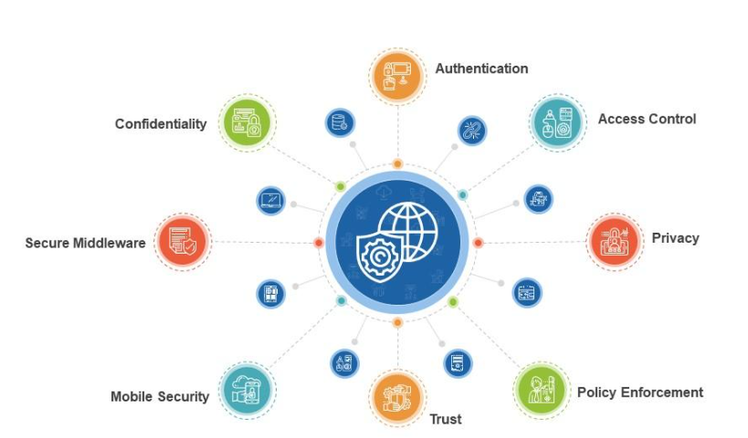

Here are some interesting articles , if you want to embark your journey on learning IoT.

<https://www.techaheadcorp.com/blog/iot-embedded-system-tutorial-for-beginners/>

<https://www.linkedin.com/pulse/10-tips-learn-iot-beginners-technology-industry-anttroboticsltd/>

<https://community.ptc.com/t5/IoT-Tips/Getting-Started-on-the-ThingWorx-Platform-Learning-Path/ta-p/810746>

<https://community.ptc.com/t5/IoT-Tips/ThingWorx-Learning-Paths/ta-p/841623>

<https://github.com/vlmadala/IoT-Roadmap-With-ThingWorx>