Chris Weaver  
WEB335 | Week 4

db.users.find()

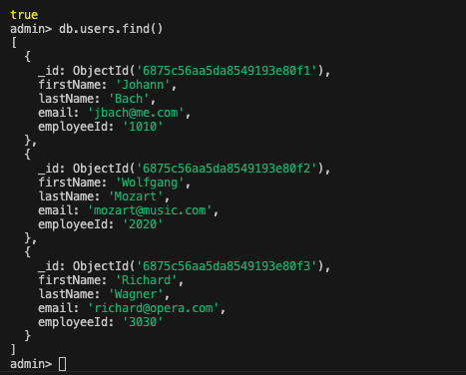

db.users.find({ email: "jbach@me.com" })

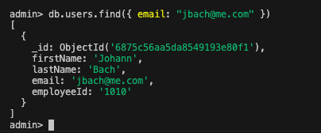

db.users.find({ lastName: "Mozart" })

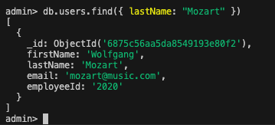

db.users.find({ firstName: "Richard" })

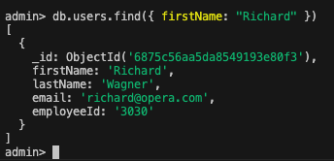

db.users.find({ employeeId: "1010" })

