Chris Weaver  
WEB335 | Week 5  
Assignment 5.2 Projections

// a. Add a new user to the user's collection

db.users.insertOne({

firstName: "Ludwig",

lastName: "Beethoven",

email: "beethoven@music.com",

employeeId: 1011

})



// Prove user was added successfully

db.users.find({ email: "beethoven@music.com" })

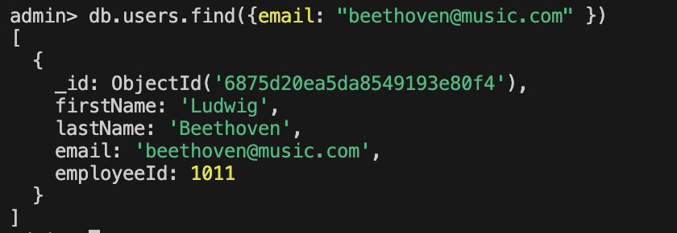

// b. Update Mozart's email address

db.users.updateOne(

{ lastName: "Mozart" },

{ $set: { email: "mozart@me.com" } }

)

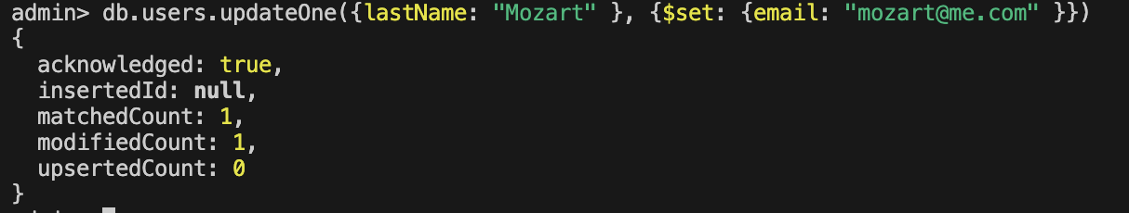

// Prove document was updated

db.users.find({ lastName: "Mozart" })

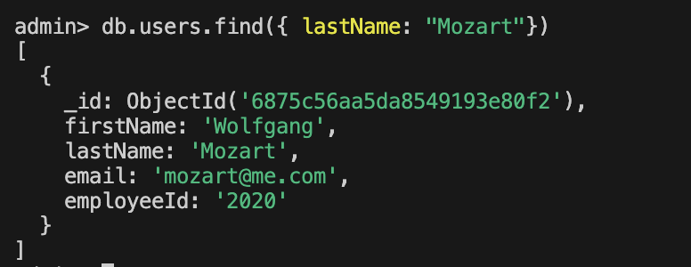

// c. Display all users with projections for first name, last name, and email

db.users.find(

{},

{ firstName: 1, lastName: 1, email: 1, _id: 0 }

)

