Chris Weaver  
WEB335 | Week 6  
Aggregate Queries

// Display all students in the collection

db.students.find()

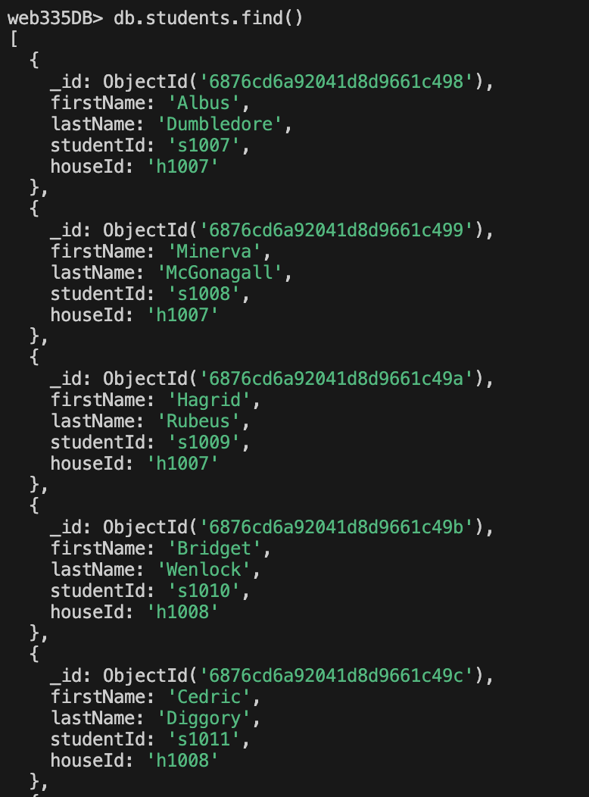 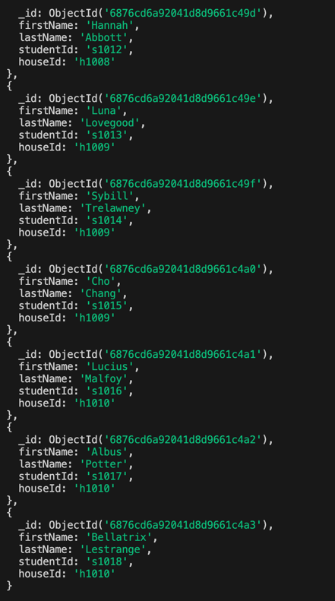

// b. Add a new student to the students collection

db.students.insertOne({

firstName: "Chiefferi",

lastName: "McDaniels",

studentId: "s10334",

houseId: "h1009"

})



// Confirm the new student was added successfully

db.students.find({ studentId: "s10334" })

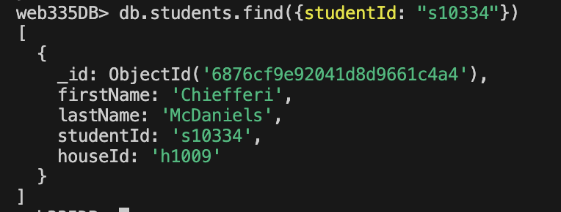

// c. Update Chiefferi McDaniels's houseId to Gryffindor

db.students.updateOne(

{ studentId: "s10334" },

{ $set: { houseId: "h1007" } }

)

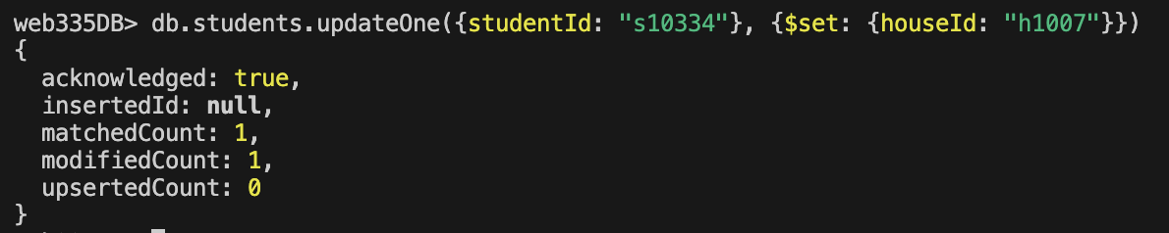

// Confirm the student’s house was updated

db.students.find({ studentId: "s10334" })

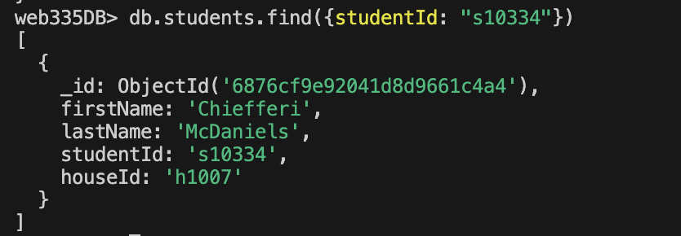

// d. Delete the student Chiefferi McDaniels

db.students.deleteOne({ studentId: "s10334" })

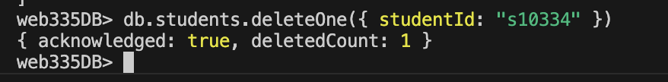

// Confirm the student was removed

db.students.find({ studentId: "s10334" })

// e. Display all students by house

db.houses.find().forEach(house => {

print("House:", house.founder)

db.students.find({ houseId: house.houseId }).forEach(student => printjson(student))

})

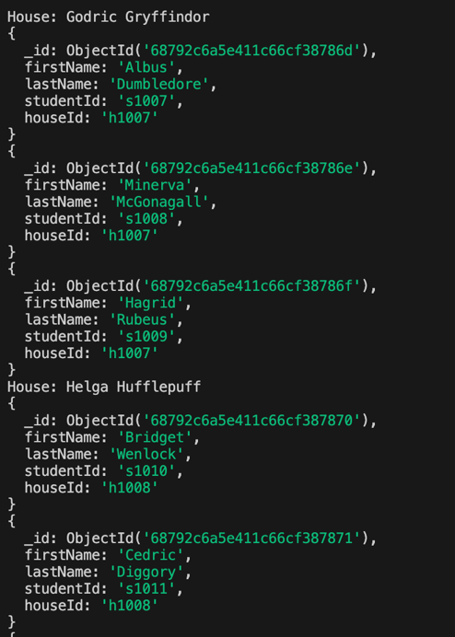 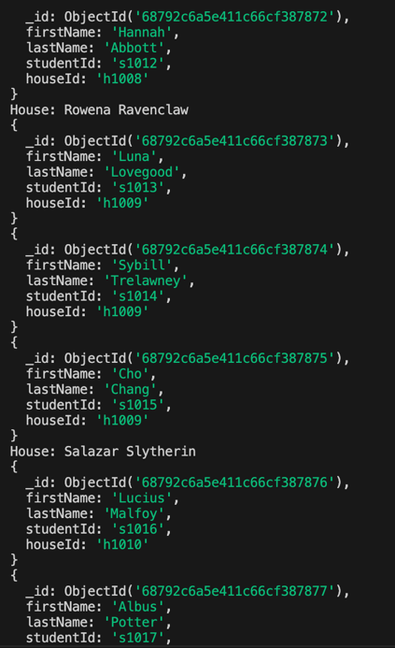

// f. Display all students in house Gryffindor

gryffindorHouse = db.houses.findOne({ founder: "Godric Gryffindor" })print("Gryffindor Students:");db.students.find({ houseId: gryffindorHouse.houseId }).forEach(student => printjson(student))

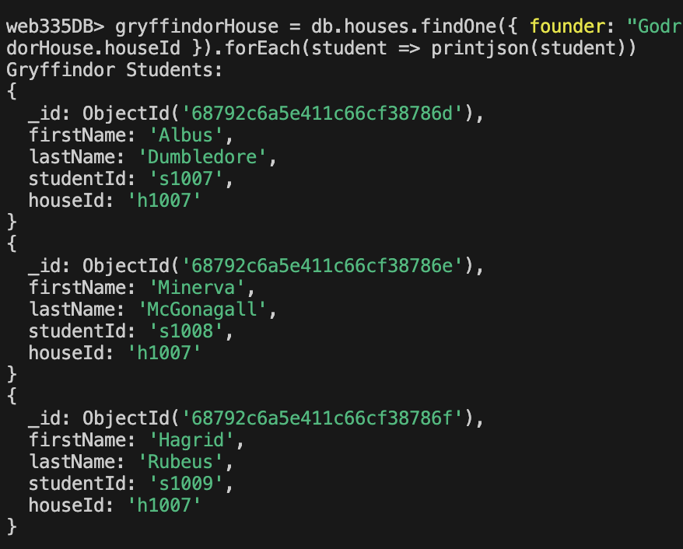

// g. Display all students in the house with an Eagle mascot

eagleHouse = db.houses.findOne({ mascot: "Eagle" })

print("House with Eagle Mascot:", eagleHouse.founder)

db.students.find({ houseId: eagleHouse.houseId }).forEach(student => printjson(student))

