Chris Weaver

WEB335

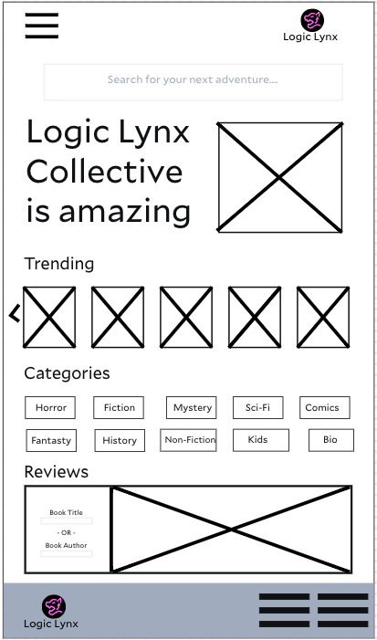 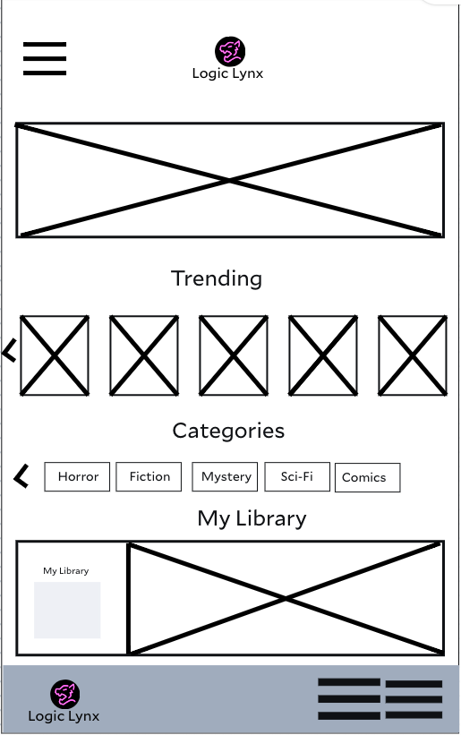

The WhatABook app is built to feel familiar and easy right from the start. We’ve stuck with classic elements—menus, search bars, icons—so users don’t have to relearn how to use an app. The homepage layout gives center stage to featured books, categories, and picks tailored to the reader, much like popular bookstore apps. We’ve focused on making tasks like browsing, searching, wishlisting, and buying as smooth as possible, with big, obvious buttons right where you expect them. And on top of that, it’s designed with accessibility in mind: clear fonts, smart color choices, and straightforward icons make it easy to use for everyone, including folks with visual or cognitive challenges.