Chris Weaver  
WEB420  
June 2, 2025

Spotify API Design

Operations:

1. Add a new album\*\* (`createAlbum`)

2. View all albums\*\* (`findAllAlbums`)

3. Viiew a specific album by ID\*\* (`findAlbumById`)

Flowchart Overview

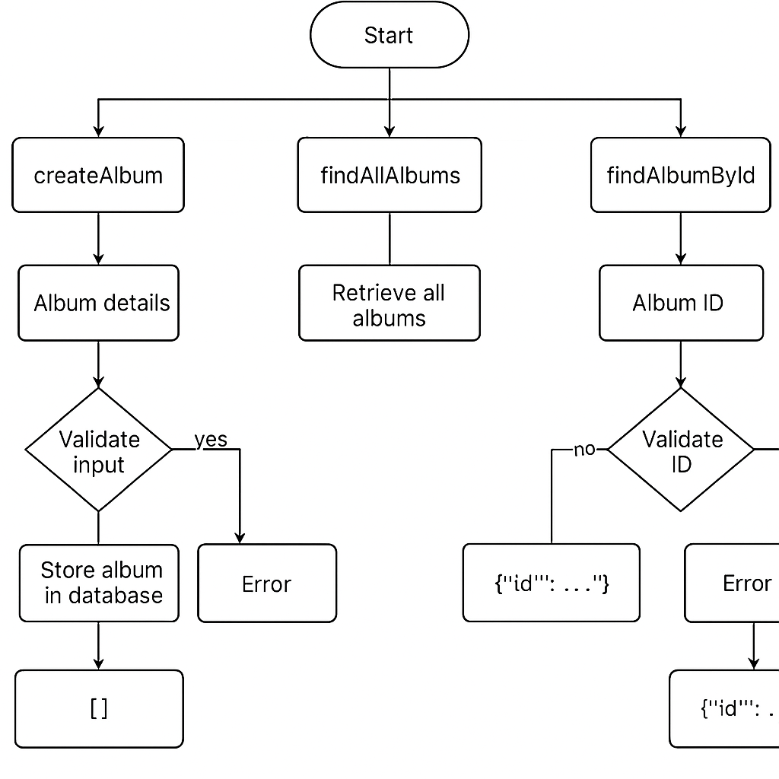

Flowchart Steps

1. createAlbum

- Input: Album details (title, artist, genre, release year, track list)

- Process:

- Validate input data

- Store album details in the database

- Return success response or error

2. findAllAlbums

- Input:Request without specific parameters

- Process:

- Retrieve all albums from the database

- Format data for response

- Return a list of albums

- Output: JSON array of album objects

3. findAlbumById

- Input: Album ID

- Process:

- Validate ID

- Search for the album in the database

- Return found album or error if not found

Brief Report:

This API is built to be straightforward and flexible, making it easy to add, retrieve, and manage albums without hassle. Each endpoint follows a clean, logical structure, ensuring smooth interactions and predictable responses. By sticking to RESTful naming conventions, developers can quickly understand how to use the API without extra learning curves. As it grows, there’s plenty of room for improvements—things like filtering albums by artist, searching for specific tracks within an album, or even letting users rate albums to help surface popular picks. Whether for personal music collections or a larger catalog, this setup is designed to adapt and scale over time.