Personal Portfolio Website Plan

# Your Name:

Chris Weaver

# Ideas for your website

Determine how you will use the portfolio website to showcase your skills and abilities.

Idea 1:

Timeline Design that starts with college associate degree, Goodi Digital to the present.

Idea 2:

Sport themed portfolio that highlights skills by the athletic meter and other sport like TV themed sports stuff.

Idea 3:

Case Study design

Idea 4:

Blacx and white monochrome theme. Displaying

Idea 5:

Visual darts or gameboard with background elements being corn hole boards.

# Website Plan

|  |  |  |
| --- | --- | --- |
| Topic | Questions | Answers |
| Purpose of Website | What is the purpose and goal of the website? | To display my resume and experience with tools learned in this class |
| Target Audience | Describe the target audience (age, gender, demographics) | Age: 19 – 55  Gender: M / F  Location: Anywhere  Occupation: Business Owner / Professor / Tech Enthusiats |
| Graphics | What graphics will you use on the website? | * Leafs (Shot by Me) * Under a Bridge pic (Shot by Me) * Wedding Recap Video * Barbershop Recap Video |
| Color | What colors will you use within the site to enhance the purpose and brand? | Background : Gray  Tile Backgrounds : White  Font : Navy |
| Accessibility | How will the website accommodate people with disabilities? | Captions on Pictures and |
| Project Timeline | Identify the project timeline (for this section outline your plan of attack to complete the project within the next five weeks; i.e., identify weekly tasks). | Phase One: Build Project Folder / Begin HTML & CSS for landing and 404  Week Two : Build out HTML & CSS for About / Resume  Week Three : Build out HTML & CSS for Project / Contact pages / Finalize desi  Week Four : Build Test pages  Week Five : Finalize design / prepare for turn in |

# Wireframe

Sketch the wireframe for your landing page below.

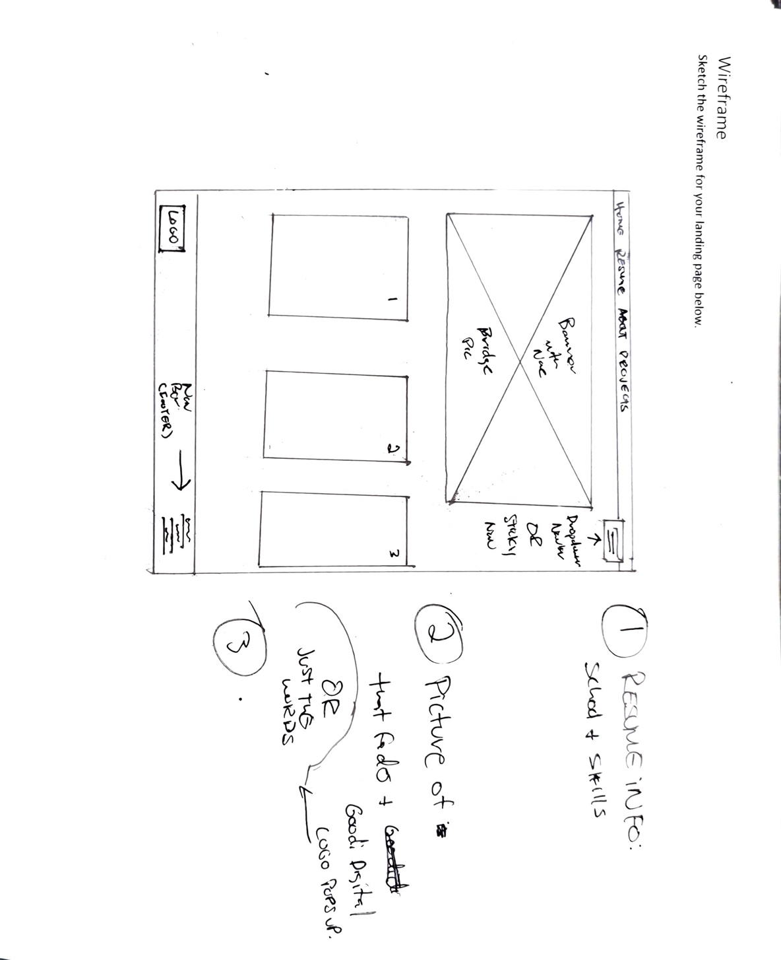

# Wireframe

Sketch the wireframe for the resume page below.

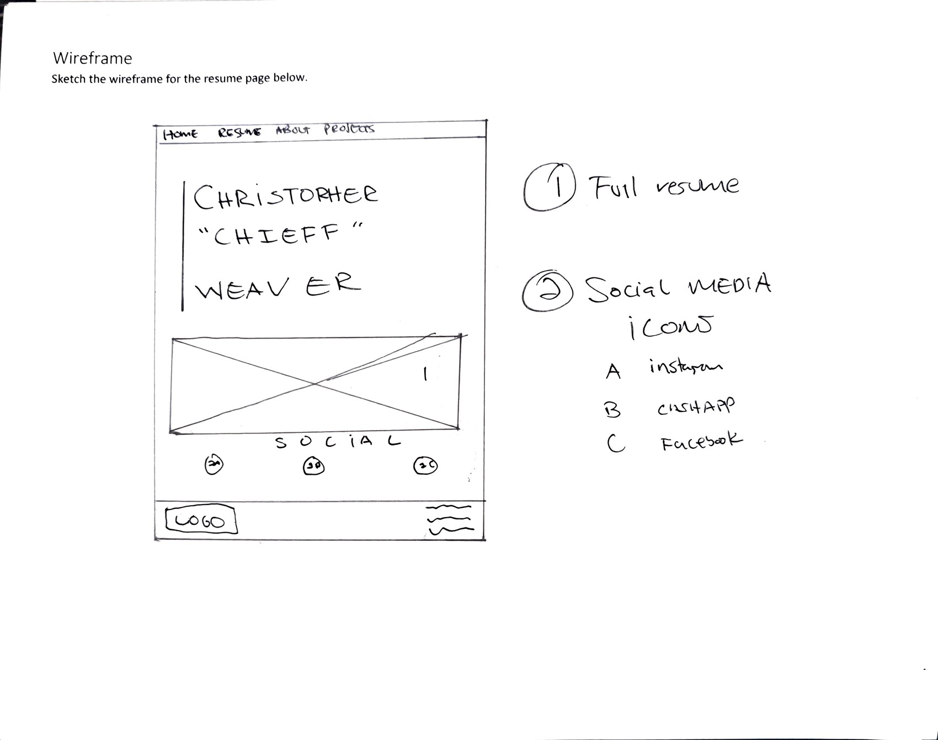

# Wireframe

Sketch the wireframe for the about page below.

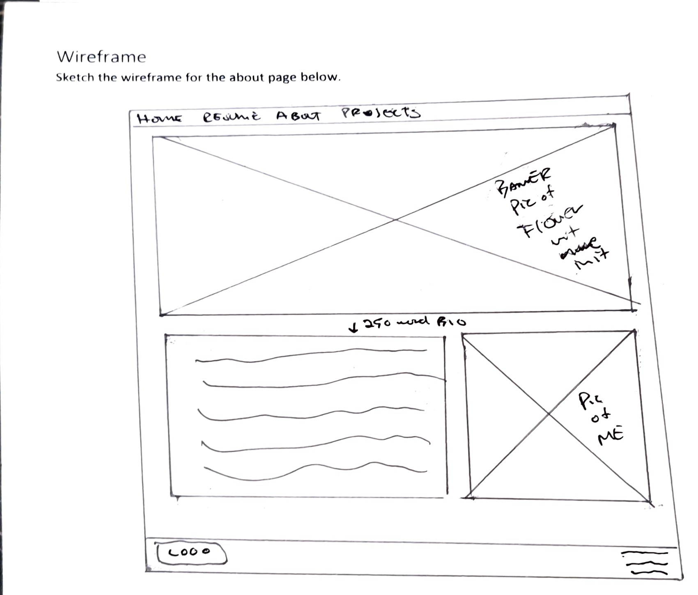

# Wireframe

Sketch the wireframe for the projects page below.

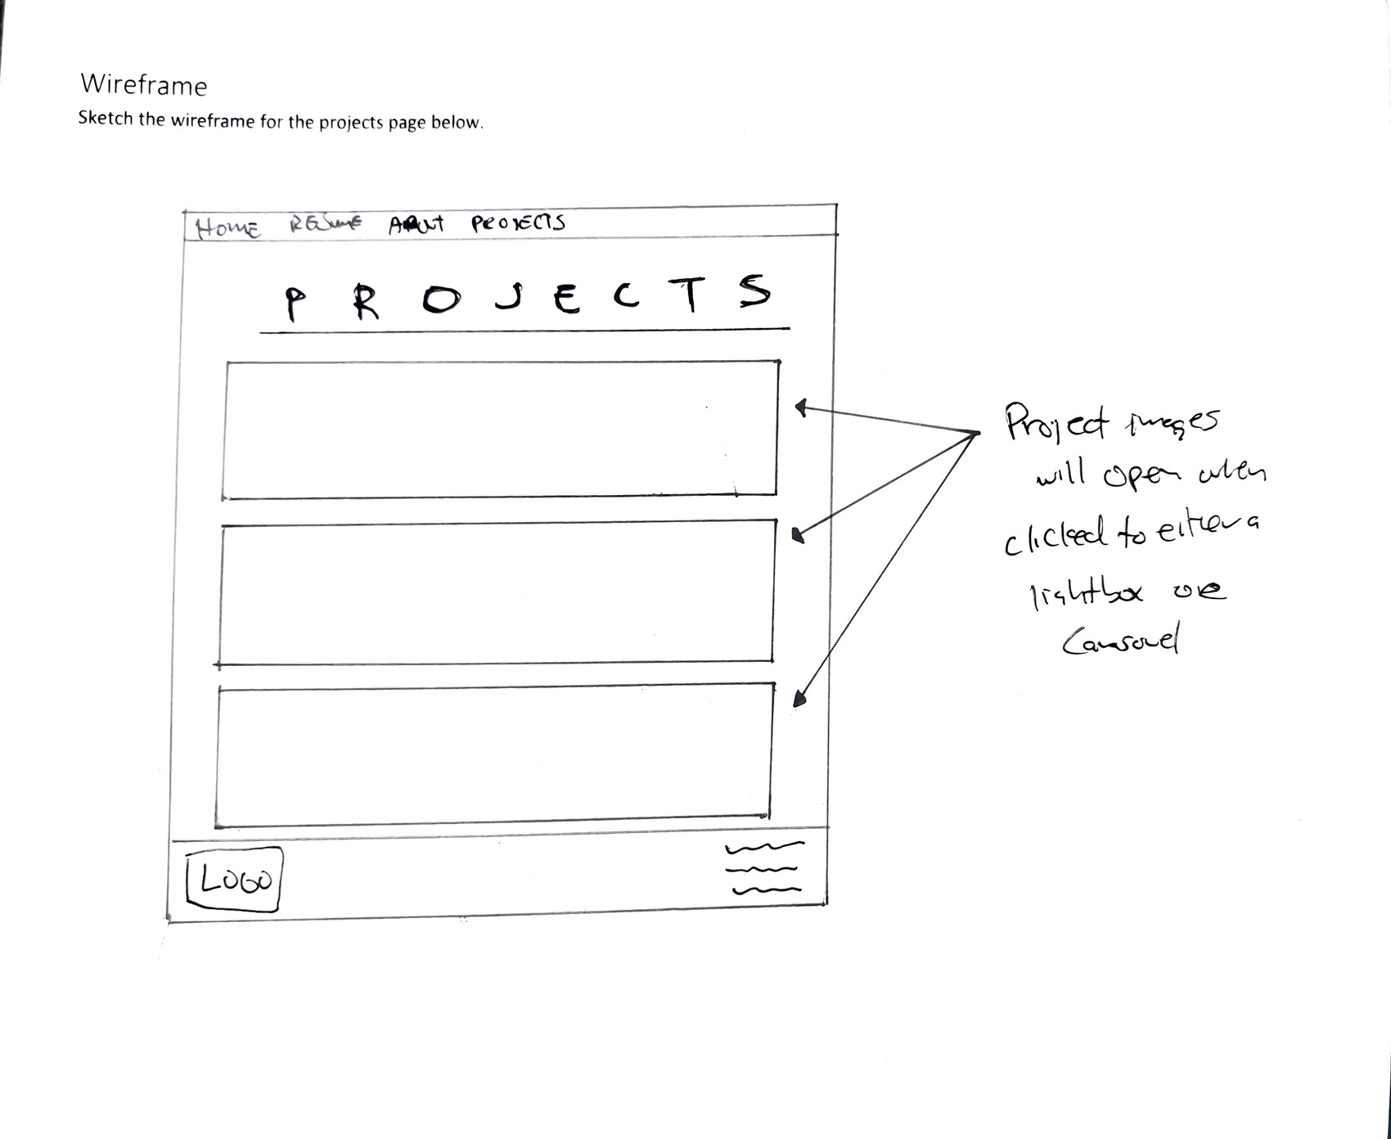

# Wireframe

Sketch the wireframe for the optional 404 page below.

# 

# Site map

Create a site map for the website below.

