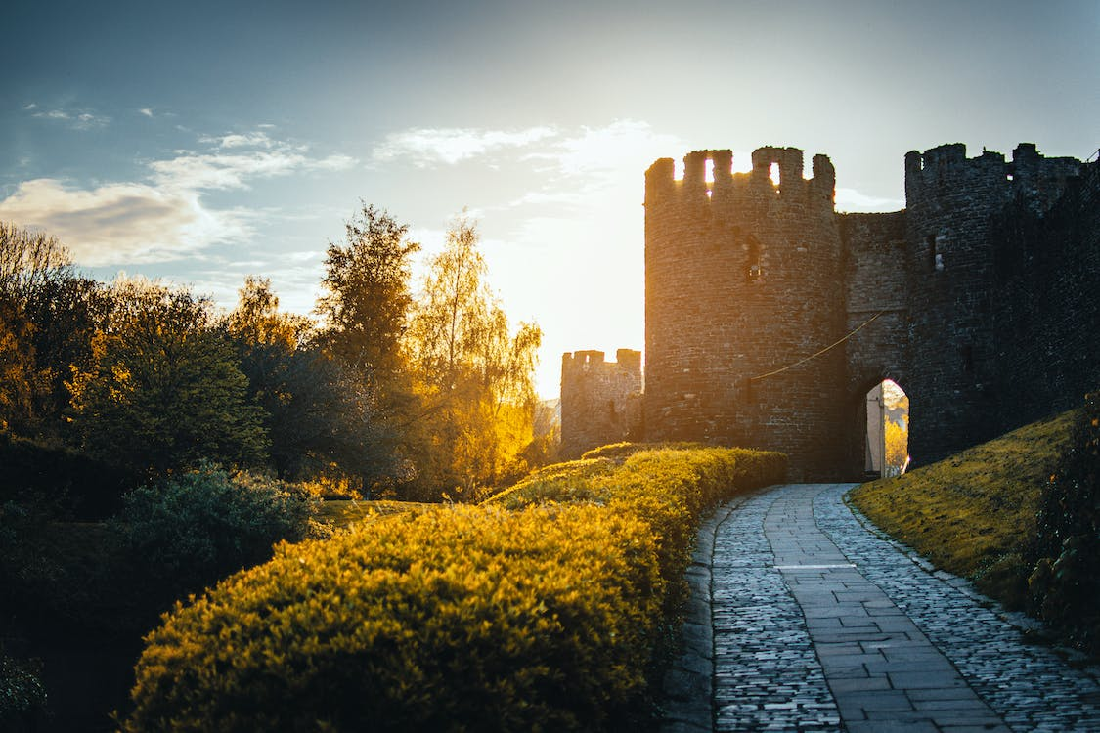

I am choosing this image of what appears to be a castle gate that I found online. I do like castles both in the real world as well as the fantasy setting such as video games and movies etc. The actual castle part I can represent as cylinders for the towers and rectangles for the connecting parts as well as the crenelations. Most of the ground can be represented as a plane and so could the walkway. The clouds as well as the sky could also be separate planes. I will try to use rectangles for the hedges lining the walkway. For the trees, I can get use cones to give the illusion that they are trees. I realize this image will be a bit of a challenge but at the least I think a very abstract representation of the image will look very nice as well as be sufficient practice with OpenGLs capabilities. There is also good opportunity to practice with lighting since there is a pronounced sun setting in the background which affects the rest of the elements greatly.