**This Homework Must Be Uploaded onto CANVAS to Receive Credit.**

**Deadline: Shown in Syllabus**

**Name: ____Solution___________________**

**Homework 02HWB Summary One-Page Cover Sheet**

**Problem 11:4 and SP02B-A Summary of Results**

|  |  |  |  |
| --- | --- | --- | --- |
| **Result** | **Prob. 11-4** | **SP02B_A** | **Comment on Reasons for Any Differences** |
| Initial Port Diameter,  2*Rpi (in)* |  |  |  |
| Web Thickness,  *w (in)* |  |  |  |
| Mid-web O/F ratio |  |  |  |
| Grain Length,  *L (in)* |  |  |  |
| Motor Diameter,  *D (in)* |  |  |  |
| Initial Thrust,  *F*, (lb*f)* |  |  |  |

**Graph of Thrust as a Function of time from SP02B-A**

**Copy of the “Reflect” Section of Your Literature Review (Paper Author Name)**

* **Omit Problem 11:5; Omit Problem 11.6**
* Complete Problem 11.4. Special Instructions on Problem 11.4

1. Use the average regression rate method to solve as outlined in the problem.
$$w=\frac{r_{i}^{}+r_{f}^{}}{2}t_{b}^{}$$

2. Assume a characteristic velocity efficiency of 1.0
3. Compute the fuel grain length based on the mid web port diameter and the optimum O/F ratio

* Special Problems

***SP-02B-A***

* Repeat Problem 11.4, by modifying the time-dependent forms of the lumped parameter hybrid rocket ballistic equations for the multi-port design as shown in lecture 02-B-1

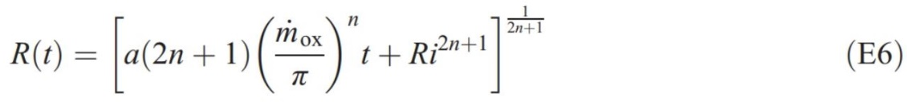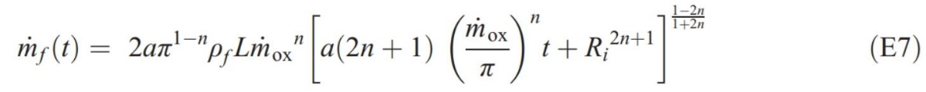

To find:

1. the total web distance burned,
2. the fuel grain length assuming the O/F ratio that occurs at the mid web radius,
3. the overall motor diameter,
4. the percentage difference of the web distance and grain length of this method to the average burn rate method from problem 11.4
5. provide 5 plots
   * Mixture ratio and oxidizer flux as a function of time on one graph
   * Characteristic Velocity as a function of O/F ratio data an point out motor start and stop points
   * Total fuel mass flow rate, total oxidizer mass flow rate and total propellant flow rate as a function of time
   * Chamber Pressure as a function of time assuming the motor design with the calculated oxidizer flow rate and a throat area of 300 in2 and employing the *c*\* thermochemical data provided in the table below
   * Vacuum thrust as a function of time assuming a constant *c*fv of 1.70 or using the thrust coefficient subroutine provided (Make a copy of this one on the front summary page)

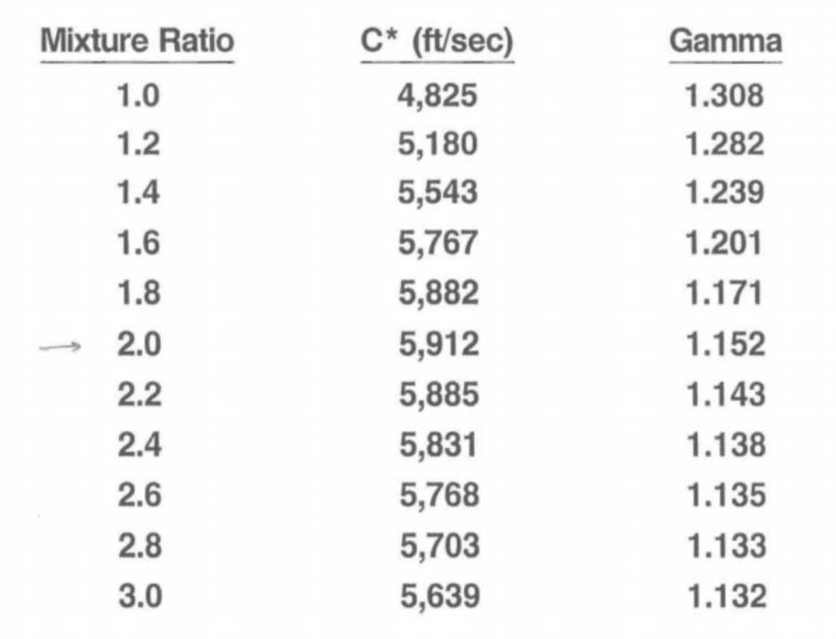

Recommend a 3rd order polynomial fit on these data for use in calculations

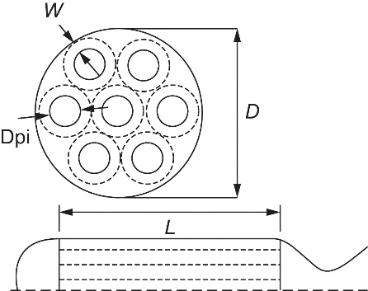

***SP02B-B (Use Annotated Bibliography Template shown below):***

Read paper one of the cited papers below that you have not already read. (Uploaded on 02BHW CANVAS site) and complete the attached Annotated Bibliography using the attached template. *(Note instructions are inserted as comments in the right-hand margin. Use REVIEW=🡺> All Markup to view)*

1. LaSarge, P.A., Ford, S.I., and Frederick, R.A., “Conceptual Design of Hybrid Rocket Powered Upper Stage (HRPUS) Demonstrator,” AIAA Paper 96-2841, July 1996.
2. Greiner, B.E. and Frederick, R.A., Jr., “Experimental Investigation of Hybrid Rocket Instability,” AIAA Paper 94-2878, 30th SAE/ASME/ASEE Joint Propulsion Conference, Indianapolis, IN, June 27–29, 1994
3. Whitehead, J.J. and Fredrick, R.A., Jr., “Predicting Hybrid Propellant Regression Rate Using Response Surfaces,” *AIAA Journal of Propulsion and Power*, Vol. 25, No. 3, 2009, pp. 815-818.
4. Frederick, R.A and Greiner, B.E., “Laboratory-Scale Hybrid Rocket Motor Uncertainty Analysis,” *AIAA Journal of Propulsion and Power*, Vol. 12, No. 3, 6, pp.605-611, 1996.
5. Frederick, R.A., Jr., Whitehead, J., Knox, R., and Moser, M.D., “Regression Rates Study of Mixed Hybrid Propellants,” *AIAA Journal of Propulsion and Power*, Vol. 23, No. 1, (2007), pp. 175–180, 2007.
6. McFarlane, J.S., “Design and Testing of AMROCS 250,000 pound Thrust Hybrid Motor,” AIAA Paper 1993-2551, 1993.

Remember to upload you entire assignment in one file (including the Annotated Bibliography). If you work by hand and do not have a scanner, there are phone aps that you can use to take picture and pdf the pictures into one file. We just need to be able to clearly see all the requested homework in one file.

**General Instructions**

* Uploading Assignment: The entire homework assignment must be uploaded in the CANVAS dropbox in one file. Use the filename *xxHW_Lastname_revxx.doc* when uploading to CANVAS. Your homework must be written neatly or typed. If you want to write it out, you can scan it or take pictures of it with your phone. I must be able to read the uploaded file. Submitting all solutions in one file is required.
* Uploading spreadsheets or other programs: If you use spreadsheets or other programs, put in screenshots of your graphs or pertinent tables into your homework file submission. You do not have to upload your spreadsheets, videos, or programs unless specifically requested in the assignment sheet. When using computer programs, be sure to document in your homework submission the basic equations and example calculations with units showing how the program works.
* Re-submitting homework: If you submit your package and then resubmit an update before the deadline, the newest submission will be graded.

**Required Homework Format (See Example at end of this Syllabus)**

In the solution of problems, you are required to:

1. **Name:** Provide name of the student.
2. **Given**: State briefly and concisely (in your own words) the information provided.
3. **Find:** State the information that you have to find.
4. **Schematic**: Draw a schematic representation of the system and control volume if applicable.
5. **Assumptions:** List the simplifying assumptions that are appropriate to the problem and implied by the equations used.
6. **Basic Equations**: Outline the basic equations needed to do the analysis. Use the proper symbol from the book where applicable.
7. **Analysis:** Manipulate the basic equations to the point where it is appropriate to substitute numerical values. Substitute numerical values (using a consistent set of units) to obtain a numerical answer. Include appropriate units in calculations. If multiple repetitive calculations are done on a spreadsheet for example, show at least one example calculation in detail, including all units. The significant figures in the answer should be consistent with the given data. Check the answer and the assumptions made in effecting the solution to make sure they are reasonable.
8. **Answer**. Label the answer(s) with a box and an arrow from the right-hand margin.
9. **Comment**: Write a comment at the end of the homework that reflects on the limitations of the solution, the reasonableness of the solution, or something that you learned by doing the problem.

***All nine formatting elements must be specifically shown in Each HW to receive full credit unless otherwise specified.***

* Grading Rubric**:** The homework-grading rubric is shown on CANVAS. The completeness of the entire homework package is also a component of the homewor

**Two-Page Annotated Bibliography Template**

**Summarize**

|  |  |
| --- | --- |
| **Reference Document Examined:** | List the complete citation of the reference here. Use the [AIAA Journal reference format](https://www.aiaa.org/publications/journals/reference-style-and-format?SSO=Y). |
| **Reviewer:** | Your Name |
| **Source of Document:** | List the source of the document (online, company, particular library, particular website, and any copyright information. |
| **Date of Review:** | Put in the date of your review |
| **Electronic File Name:** | **Put in the name of the electronic file** |

**Summary of Paper:**

Type in your one-page summary, single space, here. This paragraph or set of paragraphs should at least complete the first page. You may include one picture (not to exceed ½ pages) in the summary.

**B. Assess**:

**Important Facts from Document:**

1. List five important facts you learned from the reference document you examined. Put them in the form of complete sentences.

**Key Figure from Document:**

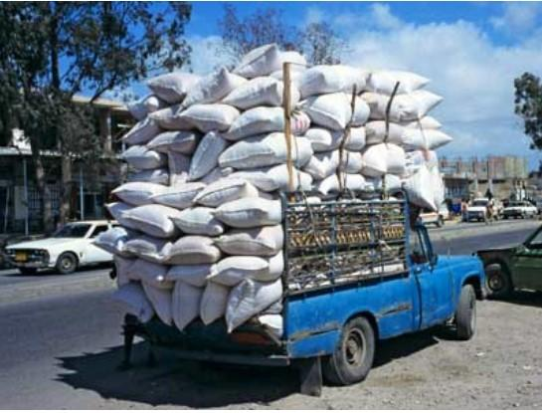

Put in one key figure from the paper with a caption

**Important Relationships among Parameters Described in the Paper:**

1. List 2 important relationships among parameters that are described in the paper
2. For example, when the pressure in the chamber goes up, the specific impulse increases;
3. For example, when a supplier goes out of business, the rocket community must turn to commercial industries that have a larger market to sustain the products.

**C. Reflect**

“Once you've summarized and assessed a source, you need to ask how it fits into your research. Was this source helpful to you? How can you use this source in a research project? Has it changed how you think about your topic?” Write this in your own words

**General Instructions**

* Uploading Assignment: The entire homework assignment must be uploaded in the CANVAS dropbox in one file. Use the filename *xxHW_Lastname_revxx.doc* when uploading to CANVAS. Your homework must be written neatly or typed. If you want to write it out, you can scan it or take pictures of it with your phone (tinyscan for phones works). I must be able to read the uploaded file. Submitting all solutions in one file is required.
* Uploading spreadsheets or other programs: If you use spreadsheets or other programs, put in screenshots of your graphs or pertinent tables into your homework file submission. You do not have to upload your spreadsheets, videos, or programs unless specifically requested in the assignment sheet. When using computer programs, be sure to document in your homework submission the basic equations and example calculations with units showing how the program works.
* Re-submitting homework: If you submit your package and then resubmit an update before the deadline, the newest submission will be graded.
* Grading Rubric**:** The homework grading rubric is shown on CANVAS. The completeness of the entire homework package is also a component of the homework grade.

**Required Homework Format (See Example at end of this Syllabus)**

In the solution of problems, you are required to:

1. **Name:** Provide name of the student.
2. **Given**: State briefly and concisely (in your own words) the information provided.
3. **Find:** State the information that you have to find.
4. **Schematic**: Draw a schematic representation of the system and control volume if applicable.
5. **Assumptions:** List the simplifying assumptions that are appropriate to the problem and implied by the equations used.
6. **Basic Equations**: Outline the basic equations needed to do the analysis. Use the proper symbol from the book where applicable.
7. **Analysis:** Manipulate the basic equations to the point where it is appropriate to substitute numerical values. Substitute numerical values (using a consistent set of units) to obtain a numerical answer. Include appropriate units in calculations. If multiple repetitive calculations are done on a spreadsheet for example, show at least one example calculation in detail, including all units. The significant figures in the answer should be consistent with the given data. Check the answer and the assumptions made in effecting the solution to make sure they are reasonable.
8. **Answer**. Label the answer(s) with a box and an arrow from the right-hand margin.
9. **Comment**: Write a comment at the end of the homework that reflects on the limitations of the solution, the reasonableness of the solution, or something that you learned by doing the problem.

***All nine formatting elements must be specifically shown in Each HW to receive full credit unless otherwise specified.***

**Assigned Problems:**

* Textbook Problems