**This Homework Must Be Uploaded onto CANVAS to Receive Credit.**

**Deadline: Shown in Syllabus**

**Name: _______________________**

Problems Assigned in the Syllabus from the Textbook

Textbook 6.4 and 6.7

Special Problem 04A

Run CEQUEL for Liquid Oxygen and Liquid Hydrogen under the following conditions

* *O/F* = 7.934
* *Pc* = 50 ATM
* Equilibrium Flow
* Nozzle Area Ratios of 0, 1, 2, 5, 10, and 20

Identify properties predicted by the code that could serve as input into heat transfer equations relevant to the chamber and nozzle. Plot the values of these parameters as a function of the nozzle area ratio. Comment on differences chamber temperature predicted with liquid propellants with that of gaseous propellants (Calculated in Assignment 03HW-B) and the basic reason for the difference.

Special Problem 04B

Bartz, D.R., “Turbulent boundary layer heat transfer from fast accelerating flow of rocket exhaust gases and heated air.” NASA CR-62615, December 1, 1963

* Read Chapter I , IV and V f this seminal report by Bartz on heat transfer in nozzles.
* Complete 2-Page Annotate Bibliography on your findings.

Special Problem 04C

**1.Name:** Dr. J. R. Osborn

**2. Given:** Average water temperature *Tl* = 100 *F*, Thermal conductivity of water *κ* = 1.07x10-4 *Btu/s-ft2-F/ft*, gas temperature = 4500 *F*, Specific gravity of water = 1, Viscosity of water *μ* = 2.5x10-5 *lbf-s/ft2*, Specific heat of water = 1.3 *Btu/lb-F*, Cooling passage dimensions = *in*, Water flow through passage = 0.585 *lb/s*, Thickness of inner wall *tw* = *in*, Heat absorbed *q* = 1.3 *Btu/in2-s (*also examine *1.0 Btu/in2)* , Thermal conductivity of wall material *κw* = 26 *Btu/hr-ft2-F/ft*

**3. Find:** Rework the solution provided by Dr. Osborn and check to see if the following items check out: a) Film coefficient of the coolant, b) Wall temperature on coolant side, c) Wall temperature on gas side, and d) Compare heat transfer coefficient equation given in this solution with the one in the textbook book just noting any differences in the form of the two equations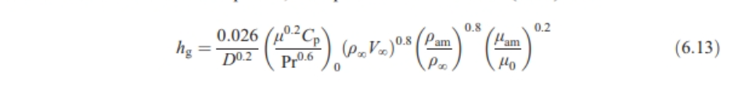.

**4. Assumptions:** No losses

**5. Schematic:**

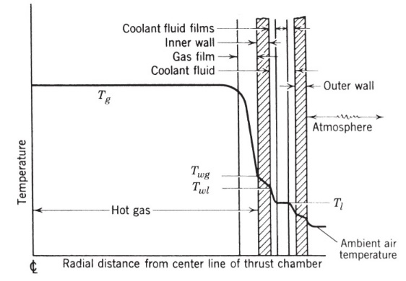

**6. Basic Equations:**

**7. Analysis:**

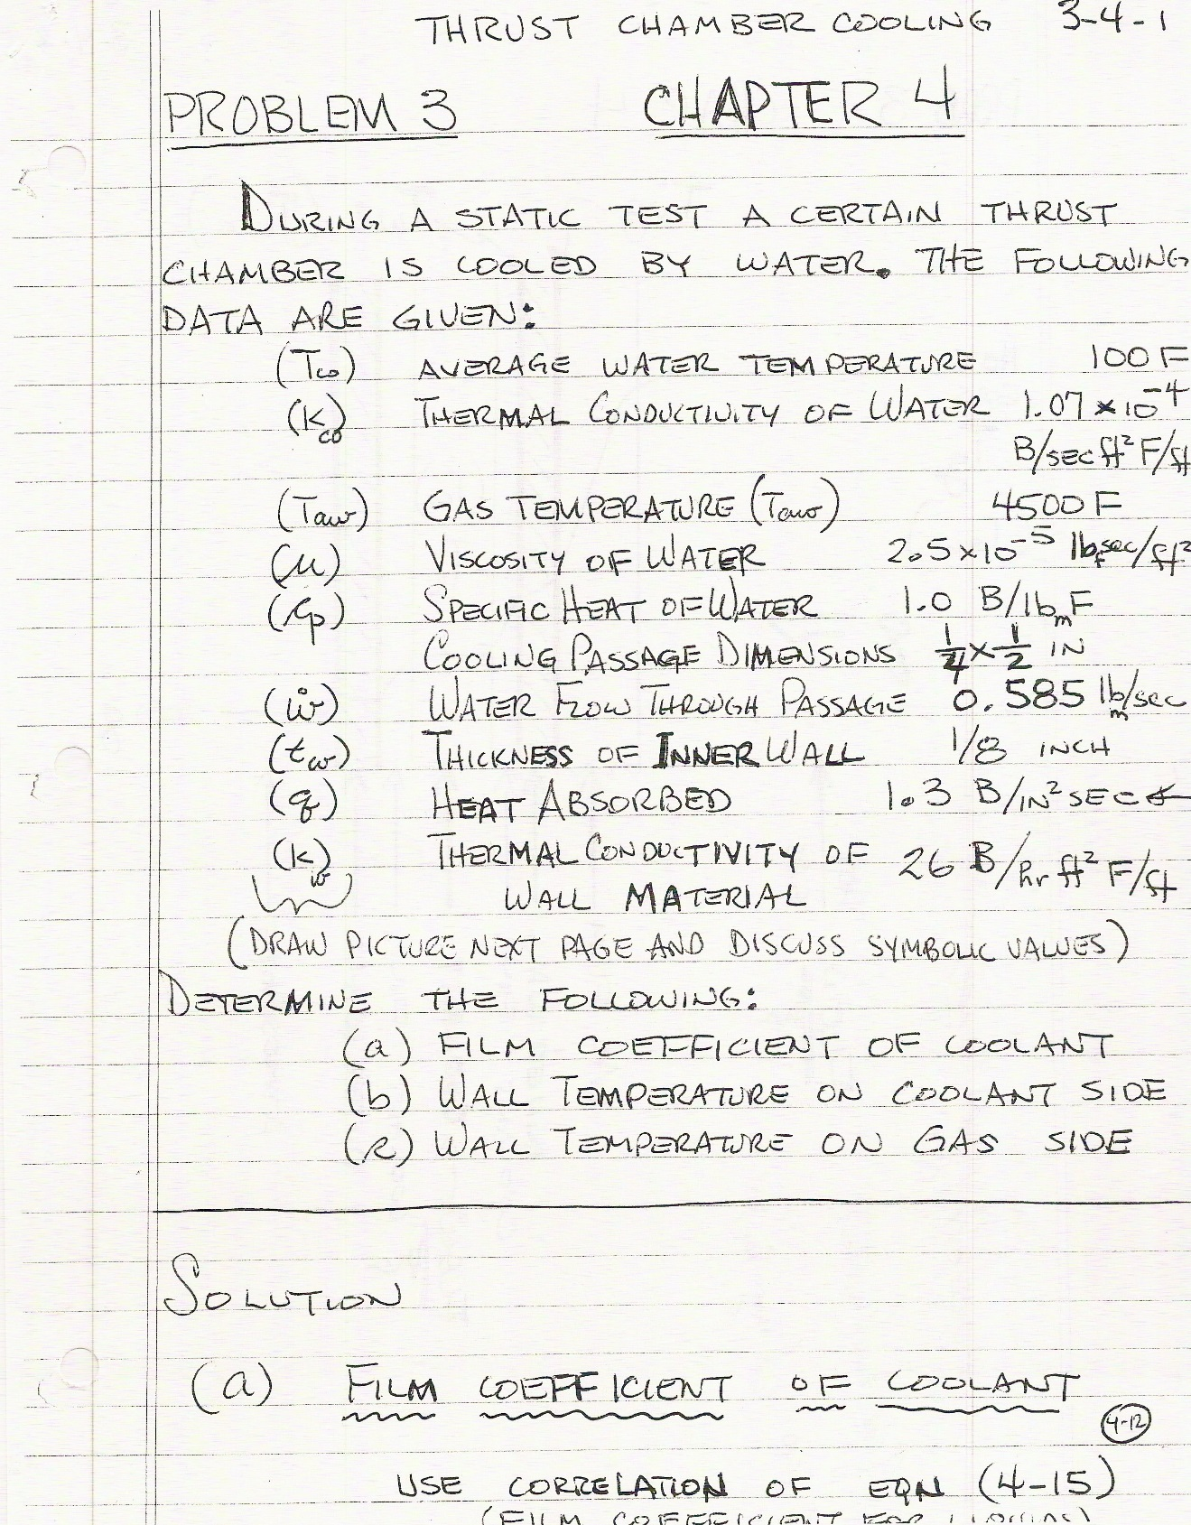

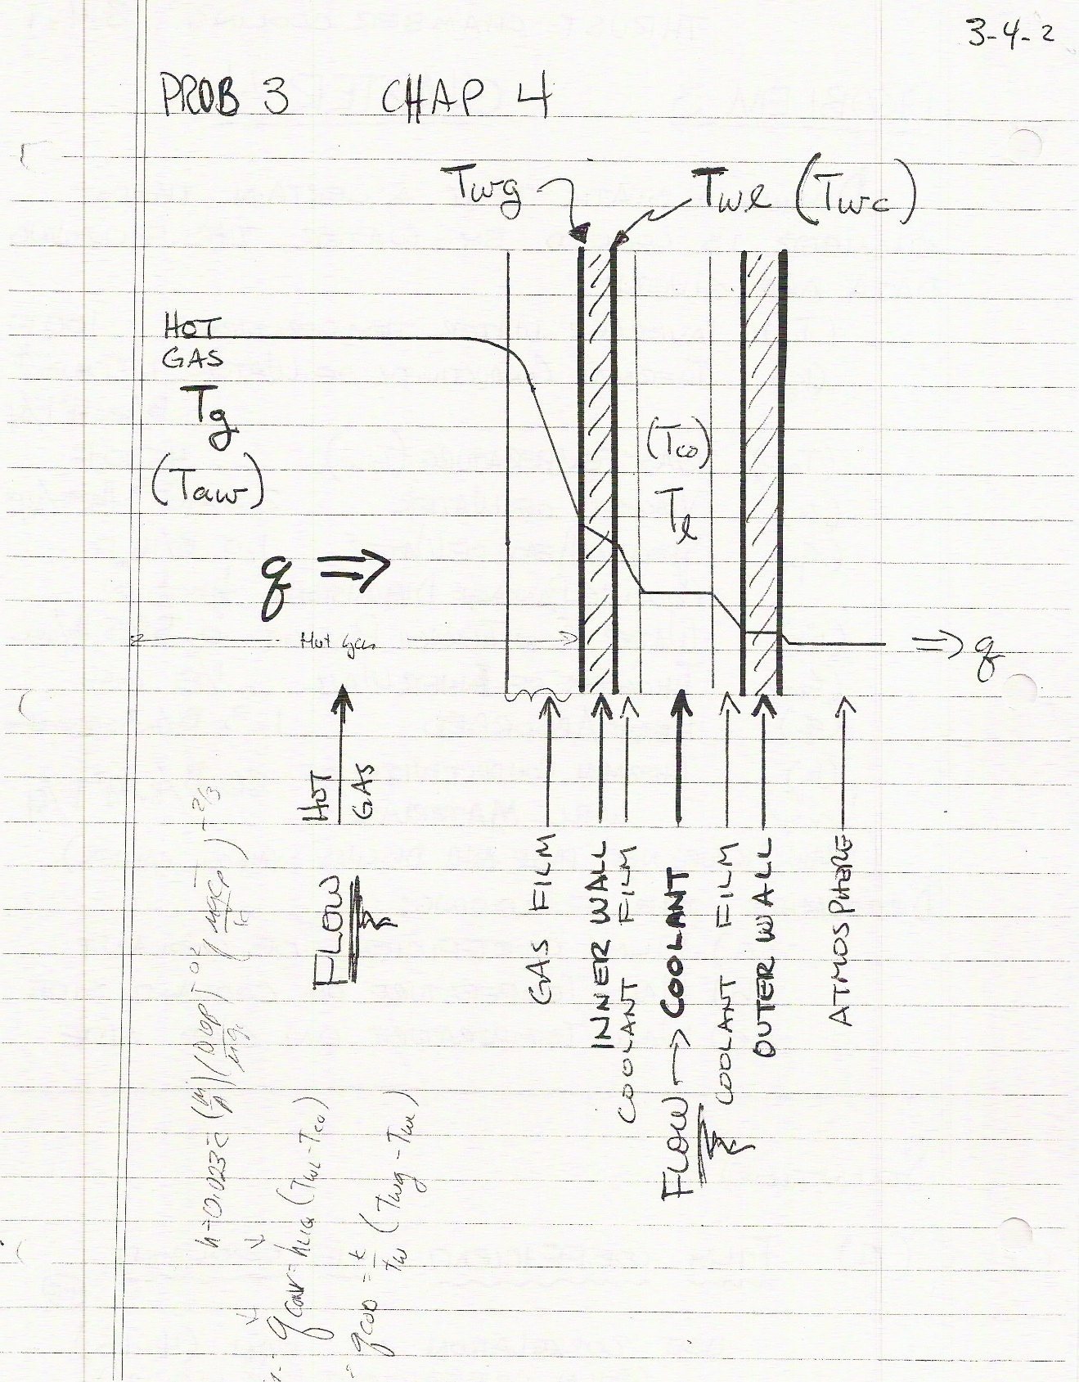

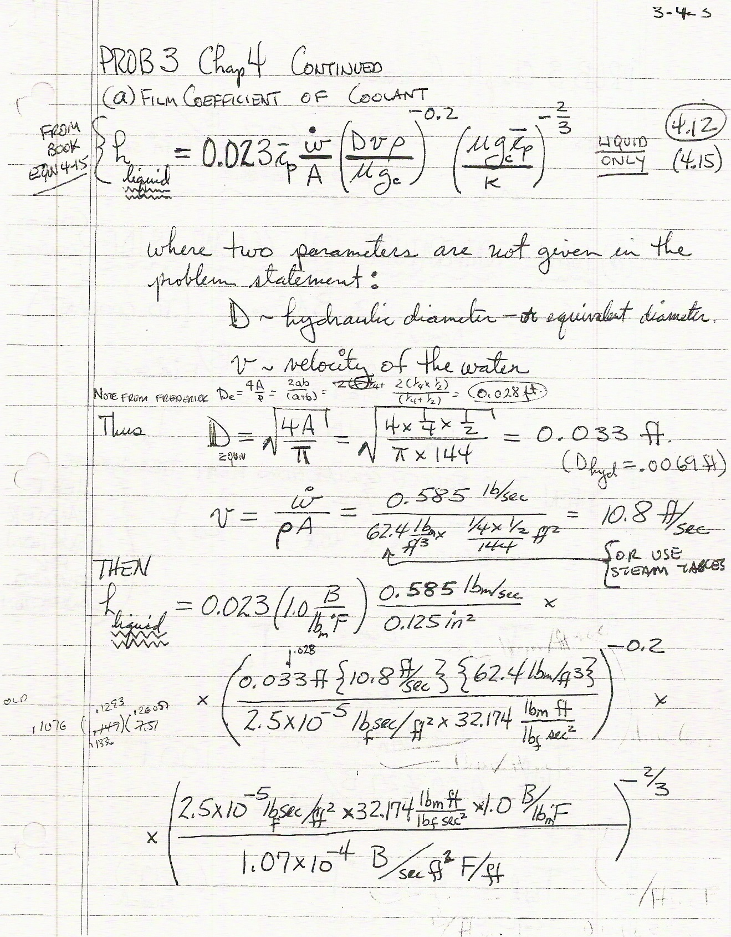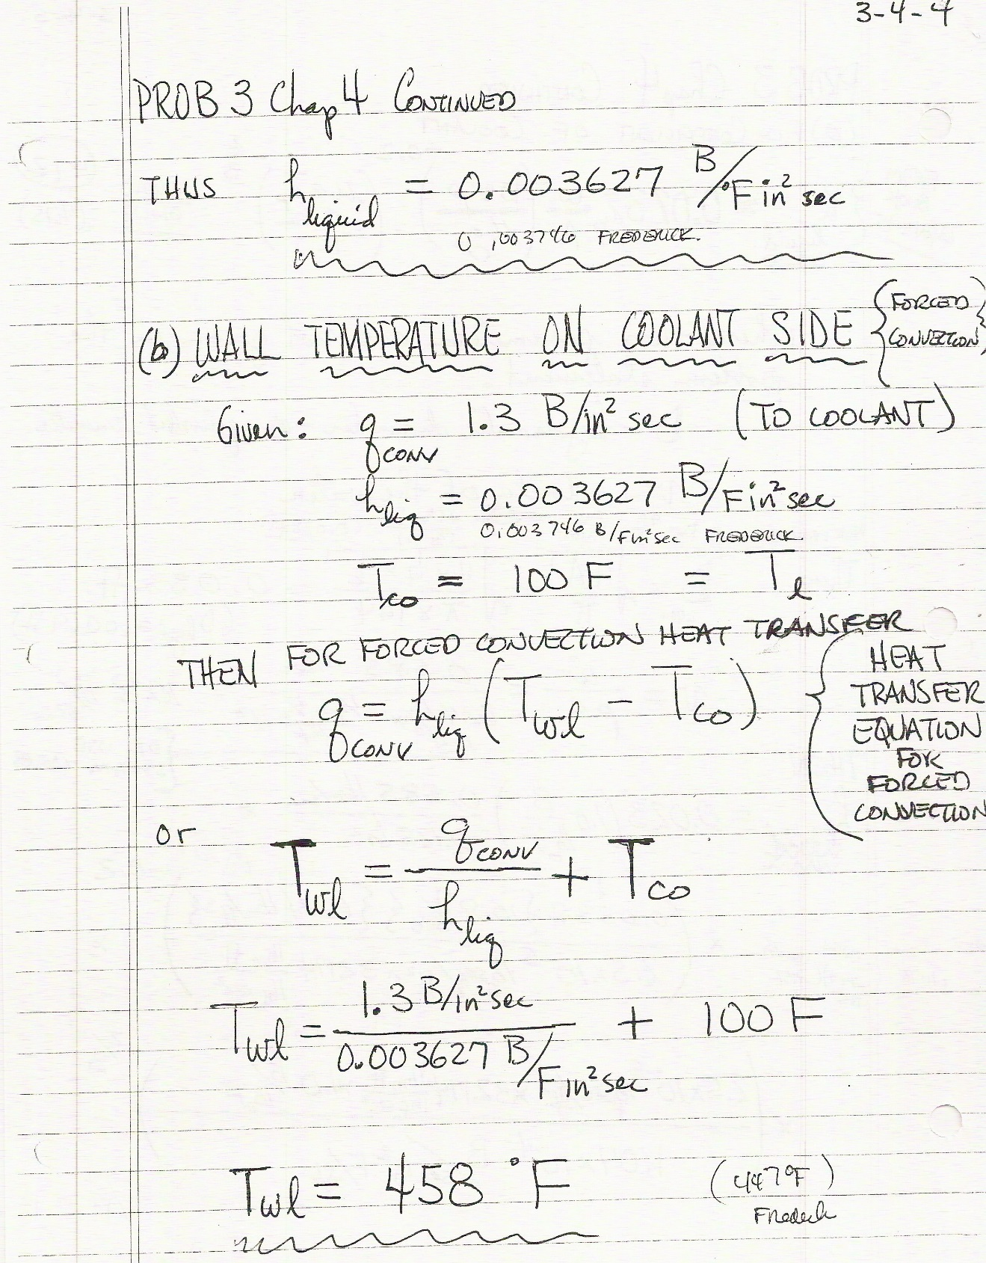

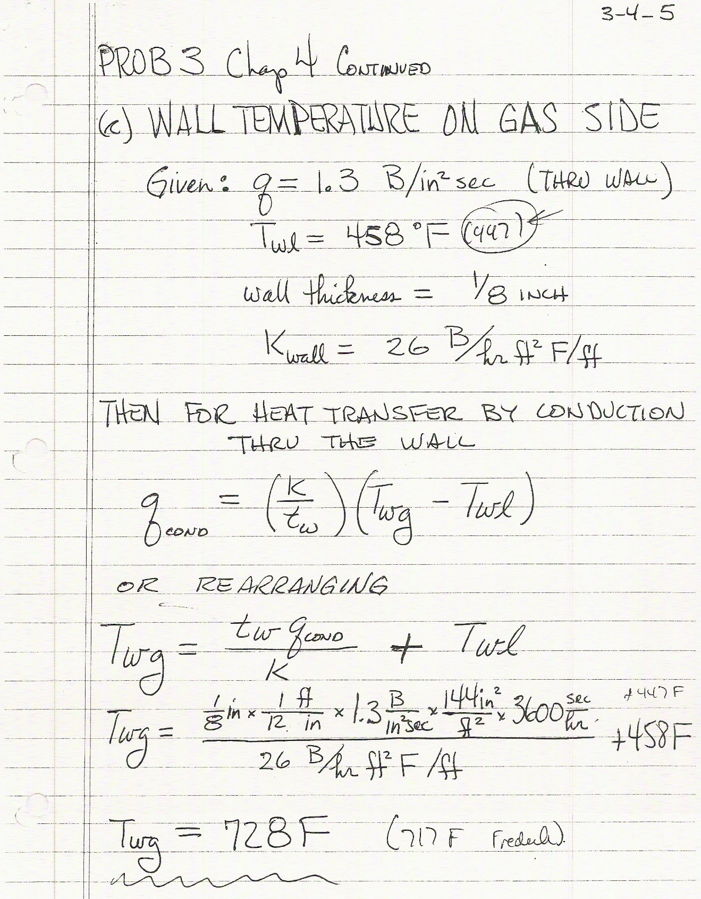

**General Instructions**

* Uploading Assignment: The entire homework assignment must be uploaded in the CANVAS dropbox in one file. Use the filename *xxHW_Lastname_revxx.doc* when uploading to CANVAS. Your homework must be written neatly or typed. If you want to write it out, you can scan it or take pictures of it with your phone (tinyscan for phones works). I must be able to read the uploaded file. Submitting all solutions in one file is required.
* Uploading spreadsheets or other programs: If you use spreadsheets or other programs, put in screenshots of your graphs or pertinent tables into your homework file submission. You do not have to upload your spreadsheets, videos, or programs unless specifically requested in the assignment sheet. When using computer programs, be sure to document in your homework submission the basic equations and example calculations with units showing how the program works.
* Re-submitting homework: If you submit your package and then resubmit an update before the deadline, the newest submission will be graded.
* Grading Rubric**:** The homework grading rubric is shown on CANVAS. The completeness of the entire homework package is also a component of the homework grade.

**Required Homework Format (See Example at end of this Syllabus)**

In the solution of problems, you are required to:

1. **Name:** Provide name of the student.
2. **Given**: State briefly and concisely (in your own words) the information provided.
3. **Find:** State the information that you have to find.
4. **Schematic**: Draw a schematic representation of the system and control volume if applicable.
5. **Assumptions:** List the simplifying assumptions that are appropriate to the problem and implied by the equations used.
6. **Basic Equations**: Outline the basic equations needed to do the analysis. Use the proper symbol from the book where applicable.
7. **Analysis:** Manipulate the basic equations to the point where it is appropriate to substitute numerical values. Substitute numerical values (using a consistent set of units) to obtain a numerical answer. Include appropriate units in calculations. If multiple repetitive calculations are done on a spreadsheet for example, show at least one example calculation in detail, including all units. The significant figures in the answer should be consistent with the given data. Check the answer and the assumptions made in effecting the solution to make sure they are reasonable.
8. **Answer**. Label the answer(s) with a box and an arrow from the right-hand margin.
9. **Comment**: Write a comment at the end of the homework that reflects on the limitations of the solution, the reasonableness of the solution, or something that you learned by doing the problem.

***All nine formatting elements must be specifically shown in Each HW to receive full credit unless otherwise specified.***

**Assigned Problems:**

* Textbook Problems

**Two-Page Annotated Bibliography Template**

**Summarize**

|  |  |
| --- | --- |
| **Reference Document Examined:** | List the complete citation of the reference here. Use the [AIAA Journal reference format](https://www.aiaa.org/publications/journals/reference-style-and-format?SSO=Y). |
| **Reviewer:** | Your Name |
| **Source of Document:** | List the source of the document (online, company, particular library, particular website, and any copyright information. |
| **Date of Review:** | Put in the date of your review |
| **Electronic File Name:** | **Put in the name of the electronic file** |

**Summary of Paper:**

Type in your one-page summary, single space, here. This paragraph or set of paragraphs should at least complete the first page. You may include one picture (not to exceed ½ pages) in the summary.

**B. Assess**:

**Important Facts from Document:**

1. List five important facts you learned from the reference document you examined. Put them in the form of complete sentences.

**Key Figure from Document:**

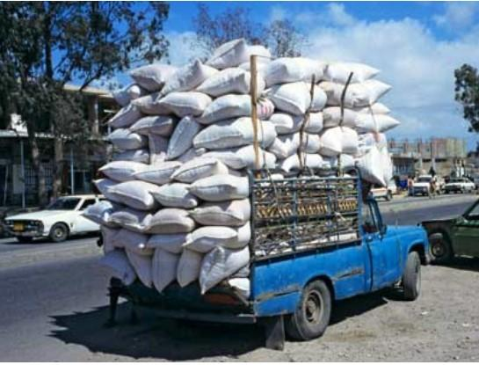

Put in one key figure from the paper with a caption

**Important Relationships among Parameters Described in the Paper:**

1. List 2 important relationships among parameters that are described in the paper
2. For example, when the pressure in the chamber goes up, the specific impulse increases;
3. For example, when a supplier goes out of business, the rocket community must turn to commercial industries that have a larger market to sustain the products.

**C. Reflect**

“Once you've summarized and assessed a source, you need to ask how it fits into your research. Was this source helpful to you? How can you use this source in a research project? Has it changed how you think about your topic?” Write this in your own words.