**PR08-A – PROJECT PLAN [Lastname]**

The goal of this assignment is confirm a communication plan with your project partner and make a preliminary outline as to how you will approach completing the project assignments together

**(10 Points) TEAM NAME: Discus a Name for Your Team and Put it Here**

**(10 points) Member 1 Interview [lastname of Member 2**]

Interview your teammate, discuss the following questions, and document answers here.

1. What is your name?
2. What as your first car? What color was it?
3. What I the primary way I can contact you for project items?
4. What is a preferred way to get in touch for urgent project matters?
5. Do you prefer to work ahead or wait until the last minute?
6. How would you like to see this project go?
7. Are there any schedule conflicts/factors that you foresee that we will need to consider?

**(10 points) Member 2 Interview [lastname of Member 1]**

1. What is your name?
2. What as your first car? What color was it?
3. What I the primary way I can Contact you for project items?
4. What is a preferred way to get in touch for urgent project matters?
5. Do you prefer to work ahead or wait until the last minute?
6. How would you like to see this project go?
7. Are there any schedule conflicts/factors that you foresee that we will need to consider?

**(20 Points) Review the Schedule Below [lastname]**

Review the revised course schedule below with your project partner. Then give your current answers to the questions that follow.

|  |  |  |  |  |  |  |  |
| --- | --- | --- | --- | --- | --- | --- | --- |
| New Dates | Assignment | Scope |  |  |  |  |  |
| 3/30 | PR - A | Project Plan, Nomenclature Table, , Two Papers , [10 point Bonus CF Plot with CEQUEL] |  |  |  |  |  |
| 4/6 | PR - B | Mission B - Ramjet Thrust Stand Predictions, Symbolic Equations, Five Papers Total |  |  |  |  |  |
| 4/13 | PR - C | Mission B1 - Baeline Flight, Alternative Propellant Thermochemistry, 8 papers Total |  |  |  |  |  |
| 4/20 | PR - D | Missions C's - Alternative Propellant Comparisons, Draft Final Report, 10 Papers Total |  |  |  |  |  |

* What is our team’s preferred way of working together in real time (Zoom, phone, in-person)
* What is your preferred days/times to interact on
  + PR08 A – List Date(s) and Proposed Times and Methods
  + PR08 B – List Date(s) and Proposed Times and Methods
  + PR08 C – List Date(s) and Proposed Times and Methods
  + PR08 D – List Date(s) and Proposed Times and Methods
  + Preparation of Final Exam– List Date(s) and Proposed Times and Methods. How do you plan to integrate the work of two people into one word document?
* Would you both like to develop the program and to check each other’s work?

**(10 Points) Briefly describe any other there planning items or agreements that you have made that are not already on at this time (put at least three) [lastname]**



Partner 1 Signature___________________

Partner 2 Signature ___________________

Both team members must sign the document electronically to verify they are in agreement with the plan

**(20 Points) Make a complete Nomenclature List Based on the Guidelines and Assumptions Document and Equations Presented in Class. All Symbols should be in Italics**

**List of Symbols (should be around 60 – 70 symbols)**

**Symbol Description, Units**

*A* burn rate constant

*ax,b* acceleration of vehicle at burnout, *ft/s2*

*a*x,Ivehicle acceleration*, ft/s2*

*a*a,Isound speed of air*, ft/s*

*A*1 inlet area, *in2*

*A5,i* nozzle throat area, *in2*

*A6* nozzle exit area, *in2*

*A*b,Ipropellant burn area, *in2*

*A*missile cross-sectional area of the missile, *ft2*

*A*p,Ipropellant bore port area (*πR*12), *in2*

*A*t,Inozzle throat area, *in2*

*A*t,0initial nozzle throat area, *in2*

*A*t,bfinal nozzle throat area*, in2*

*c\** characteristic exhaust velocity, *ft/s*

*cact\** actual characteristic exhaust velocity, *ft/s*

*Add here*

***Greek Letters***

*αpressure coefficient in burning rate, (-)*

*βtemperature coefficient in burning rate, (-)*

*εi nozzle expansion area ratio Ae/At, (-)*

*γa specific heat ratio of air, (-)*

*γp specific heat ratio of propellant, (-)*

*characteristic exhaust velocity efficiency, (-)*

*ρ density, lbm/ft3*

*ρb propellant density, lbm/ft3*

***Subscripts***

*i a counter that goes with time*

*ο initial conditions*

*0 stagnation flow conditions*

*a ambient*

*1 diffuser inlet*

*2 diffuser outlet*

*3 air injector inlet*

*4 combustor outlet*

*5 combustor throat*

*6 nozzle exit*

**[10 Points] Annotated Bibliography #01 [Lastname]**

**Two-Page Annotated Bibliography (#01)**

* 1. **Summarize**

|  |  |
| --- | --- |
| **Reference Document Examined:** | List the complete citation of the reference here. Use the [AIAA Journal reference format](https://www.aiaa.org/publications/journals/reference-style-and-format?SSO=Y). |
| **Reviewer:** | Your Name |
| **Source of Document:** | List the source of the document (online, company, particular library, particular website, and any copyright information. |
| **Date of Review:** | Put in the date of your review |
| **Electronic File Name:** | **Put in the name of the electronic file** |

**Summary of Paper:**

Type in summary, single space, here. This paragraph or set of paragraphs should at least complete the first page. You may include one figure (not to exceed ½ page) in the summary.

**B. Assess**:

**Important Facts from Document:**

1. List five important facts you learned from the reference document you examined. Put them in the form of complete sentences.

**Key Figure from Document:**

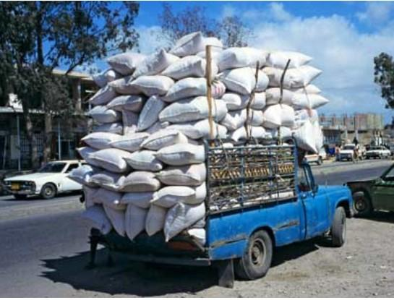

Put in one key figure from the paper.

**Important Relationships among Parameters Described in the Paper:**

1. List 2 important relationships among parameters that are described in the paper
2. For example, when the pressure in the chamber goes up, the specific impulse increases;
3. When a supplier goes out of business, the rocket community must turn to commercial industries that have a larger market to sustain the products.

**C. Reflect**

“Once you've summarized and assessed a source, you need to ask how it fits into your research. Was this source helpful to you? How can you use this source in a research project? Has it changed how you think about your topic?” Write this in your own words.

**[10 Points] Annotated Bibliography #02 [Lastname]**

**Two-Page Annotated Bibliography (#02)**

* 1. **Summarize**

|  |  |
| --- | --- |
| **Reference Document Examined:** | List the complete citation of the reference here. Use the [AIAA Journal reference format](https://www.aiaa.org/publications/journals/reference-style-and-format?SSO=Y). |
| **Reviewer:** | Your Name |
| **Source of Document:** | List the source of the document (online, company, particular library, particular website, and any copyright information. |
| **Date of Review:** | Put in the date of your review |
| **Electronic File Name:** | **Put in the name of the electronic file** |

**Summary of Paper:**

Type in summary, single space, here. This paragraph or set of paragraphs should at least complete the first page. You may include one figure (not to exceed ½ page) in the summary.

**B. Assess**:

**Important Facts from Document:**

1. List five important facts you learned from the reference document you examined. Put them in the form of complete sentences.

**Key Figure from Document:**



Put in one key figure from the paper.

**Important Relationships among Parameters Described in the Paper:**

1. List 2 important relationships among parameters that are described in the paper
2. For example, when the pressure in the chamber goes up, the specific impulse increases;
3. When a supplier goes out of business, the rocket community must turn to commercial industries that have a larger market to sustain the products.

**C. Reflect**

“Once you've summarized and assessed a source, you need to ask how it fits into your research. Was this source helpful to you? How can you use this source in a research project?

**BONUS A (20 points) [Lastname]**

* Use your thrust coefficient computer program to reproduce the following graph but use a gamma of 1.29, and for the Pc/Pa values shown. The x-axis should be a log scale. The y-axis should have the same range

.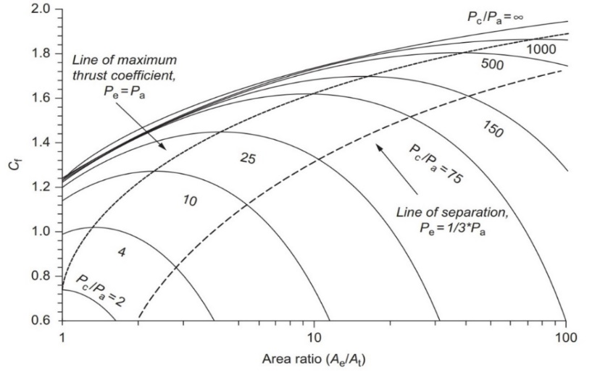

* Run CEQUEL for all the curves and add to the same plot for comparison. Use the same pressure ratios and Propellant B burning with 500K air at an OF ratio of 10.0. Assume *Pa*  is 3.8 psi.

|  |
| --- |
| Put a screenshot of your Thrust Coefficient graph here  It should have the simple * *= 1.29 calculations in blue, and the CCEQUEL Calculations in red lines |
| What are your calculated *CF*, ** = 3.0 , and Pc/Pa = 3 *CF,* = ____, *CF,CEQUEL*= _______ |