**PROJECT TITLE ESTIMATION OF BUSINESS EXPENSES**

**TEAM LEAD :V.LAKSHMI PRASANNA**

**TEAMMATE : V.TIRUMALA PRASAD**

**TEAMMATE: V.PAVANI**

Our project shows the fascinating realm of business expenses and provides a visual exploration of the various expenditures incurred by different businesses. It showcases the distribution of expenses, identifies key cost drivers, and highlights areas of potential optimization or concern. The visual representations allow for intuitive analysis, facilitating a deeper understanding of expenditure patterns and their implications for business performance. Decision-makers, financial analysts, and stakeholders can gain valuable insights into the financial health of businesses, identify areas of inefficiency or opportunity, and make informed decisions to optimize resources and drive growth. To Extract the Insights from the data and put the data in the form of visualizations, Dashboards and Story we employed Tableau tool.

**Technical Architecture:**

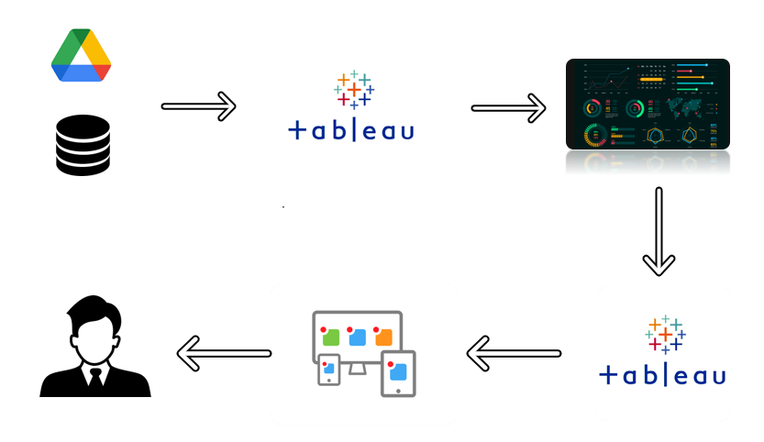

**Project Flow**

To accomplish this, we have to complete all the activities listed below,

* Define Problem / Problem Understanding
  + Specify the business problem
  + Business requirements
  + Literature Survey
  + Social or Business Impact.
* Data Collection & Extraction
  + Collect the dataset
  + Connect Dataset with Tableau
* Data Preparation
* Prepare the Data for Visualization
* Data Visualizations
  + No of Unique Visualizations
* Dashboard
  + Responsive and Design of Dashboard
* Story
  + No of Scenes of Story
* Performance Testing
  + Amount of Data Rendered to DB
  + No of Calculation Fields
  + No of Visualizations/ Graphs
* Web Integration
  + Dashboard and Story embed with UI With Flask
* Project Demonstration & Documentation
  + Record explanation Video for project end to end solution
  + Project Documentation-Step by step project development procedure
* **Milestone 1: Define Problem / Problem Understanding**
* **Activity 1: Business requirements**
* The primary business requirements for this report are to visualize and analyze business expenses, provide industry-specific insights, identify cost drivers, highlight outliers, and offer interactive functionality. Stakeholders need a visual representation of expenses to compare and analyze spending patterns across different businesses and industries. The report should facilitate the identification of key cost drivers, enabling stakeholders to understand the primary factors contributing to expenses. Additionally, it should flag any outliers or anomalies for further investigation.
* **Activity 3: Literature Survey**
* Cost drivers were a significant focus in the literature survey, with researchers extensively investigating the factors influencing business expenses. Studies highlighted labour costs, material costs, overhead expenses, and marketing expenditures as key drivers. Accurately identifying and tracking these drivers was emphasized as essential for effective expense management and control.
* The role of technology in expense analysis emerged as a significant theme. Researchers underscored the utilization of advanced data analytics tools and techniques, including data visualization platforms like Tableau, to enhance expense analysis and reporting.
* These technologies enable businesses to gain deeper insights into their spending patterns, identify trends, and make data-driven decisions for cost optimization.
* Overall, the literature survey revealed a rich body of knowledge on business expenses, covering cost analysis methodologies, cost drivers, benchmarking approaches, and the role of technology. These insights serve as a foundation for our subsequent analysis and visualization of expenses in this report.

* **Activity 4: Social or Business Impact.**
* Social Impact: The analysis of business expenses and financial management has a significant social impact. It contributes to economic stability by optimizing costs and fostering long-term sustainability. Effective expense management creates job opportunities and supports the workforce. It allows for better resource allocation, enabling businesses to invest in innovation and community engagement. Responsible expense management aligns with societal expectations and promotes social responsibility. Non-profit organizations benefit from expense analysis, enabling them to maximize their impact. Overall, analysing and managing expenses positively influences economic growth, employment, stakeholder well-being, and social responsibility.
* Business Impact: Analysing business expenses has a profound impact on various aspects of business operations. It helps optimize costs, improve profitability, and ensure financial stability. Expense analysis enables businesses to allocate resources effectively, make informed decisions, and create realistic budgets and forecasts. It enhances competitiveness, attracts investors, and mitigates financial risks. By understanding and managing expenses, companies can drive growth, maintain a strong financial position, and make strategic business decisions with confidence.

**Milestone 2: Data Collection & Extraction**

* Data collection is the process of gathering and measuring information on variables of interest, in an established systematic fashion that enables one to answer stated research questions, test hypotheses, evaluate outcomes and generate insights from the data.
* **Activity 1: Downloading the dataset**
* Please follow link to download:
* <https://drive.google.com/drive/folders/1CCxjo561-uTwp260h-YbAj9jurbEcXcB?usp=drive_link>
* **Activity 1.1: Understand the data**
* Data consists of 33 rows which correspond to 33 different business types and 29 columns that correspond to different operating expenses.
* **Column Description of the Dataset:**
* naics_code : Unique code given to each business type
* Business_types : Different Business Types present (33)
* operating_expenses : Total Operating expenses
* annual_payroll : Total yearly payment
* employer_cost : Amount spent on employees
* employer_costs_health_insurance : Amount spent on health insurance for employees
* employer_costs_contribution_plans : Amount spent on retirement plans for employees
* employer_costs_pension_plans : Amount spent on p
* pension plans for employees
* employer_costs_benefits : Amount spent to provide various benefits to the employees
* contract_labor_costs : Amount spent on contract labourers
* expensed_equipment_amount : Amount spent on equipment
* packaging_materials_and_containers: Amount spent on packaging
* parts_and_supplies_not_for_resale: Amount spent on necessary parts and supplies not for sale
* purchases_of_software: Amount spent to purchase software
* data_processing_and_computer_services: Amount spent to computer services
* commission_expense_amount : Amount spent on commissions given to employees based on their performance
* communication_services: Amount spent on transmission and reception of data.
* repairs_and_maintenance_of_equipment : Amount spent on repairs and maintenance
* maintenance_of_buildings_offices: Amount spent on maintenance of buildings
* rental_payment_for_machinery: Amount spent on leasing machinery
* rental_payments_for_buildings_offices: Amount spent on leasing buildings for offices
* electricity: Amount spent on electricity
* water_sewer_and_other_utility: Amount spent on water sewer treatment
* transportation_shipping_warehousing: Amount spent on transport, shipping and warehousing.
* advertising_and_promotional_services: Amount spent on advertising
* professional_and_technical_services: Amount spent on technical services
* depreciation_and_amortization: Amount of depreciation
* taxes_and_license: Amount spent on taxes and licenses

**Milestone 3: Data Preparation**

**Activity 1: Prepare the Data for Visualization**

Preparing the data for visualization involves cleaning the data to remove irrelevant or missing data, transforming the data into a format that can be easily visualized, exploring the data to identify patterns and trends, filtering the data to focus on specific subsets of data, preparing the data for visualization software, and ensuring the data is accurate and complete. This process helps to make the data easily understandable and ready for creating visualizations to gain insights into the performance and efficiency.

**Milestone 4: Data Visualization**

Data visualization is the process of creating graphical representations of data to help people understand and explore the information. The goal of data visualization is to make complex data sets more accessible, intuitive, and easier to interpret. By using visual elements such as charts, graphs, and maps, data visualizations can help people quickly identify patterns, trends, and outliers in the data.

**Activity 1: No of Unique Visualizations**

The number of unique visualizations that can be created with a given dataset. Some common types of visualizations that can be used to analyse the performance and efficiency of banks include bar charts, line charts, heat maps, scatter plots, pie charts, Maps etc.

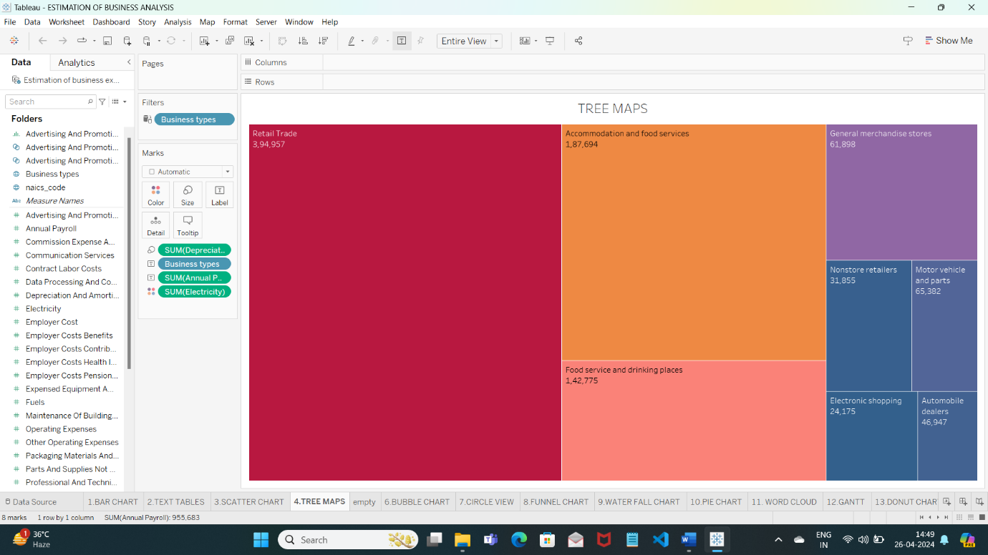

The above visualisation shows the Annual payroll , Deprecetion and Amortion , Electricity

expenses of various business types . Here in this visualisation we have used filter option to

filter few business types . Here we filtered top 8 visualisations by field option.

Here we can observe that Retail Trade has the highest annual payroll among all the 8 business

types . Accomodation is the second highest and Automobiles dealers has the lowest annual

payroll . This dashboard also shows Deprecetion and Amortion ,electricity expenses of various

8 business types.

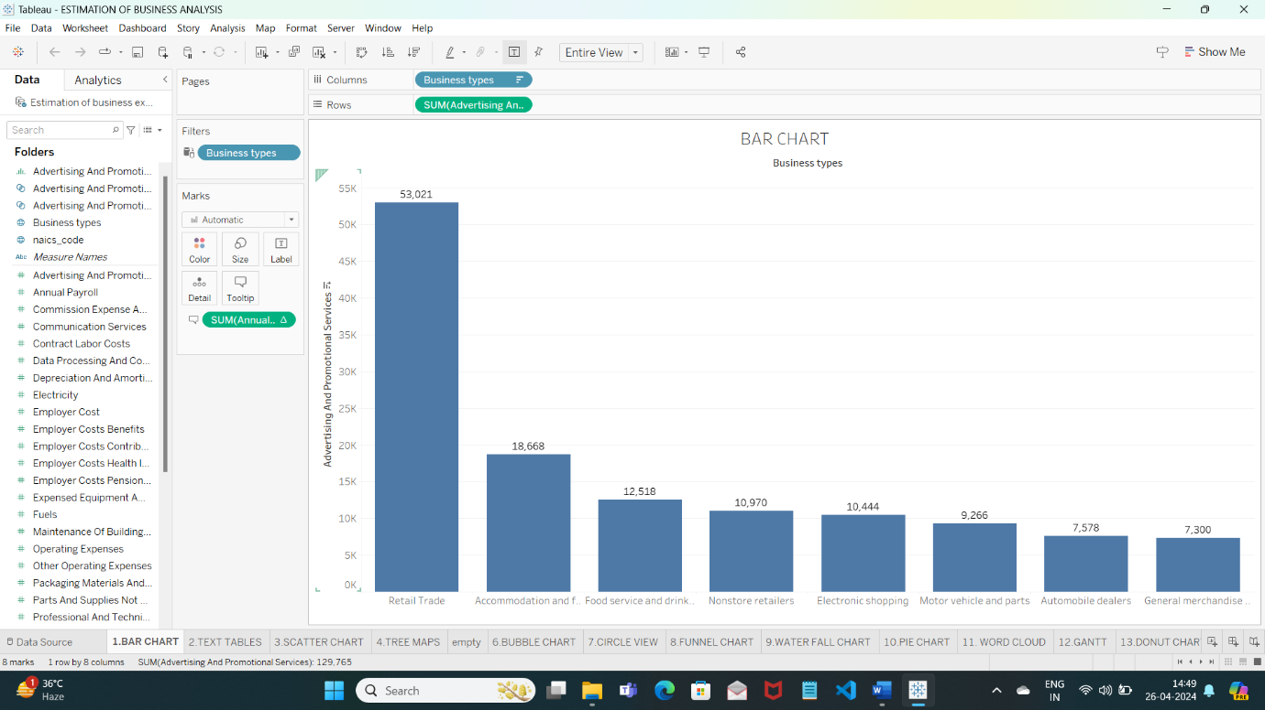

The above visualisation we created is a bar chart . Through this visualisation we analzed Annual payroll of various business types . we used filter for this visualisation . we filtered by top 10 business types with referrence to annual payroll. This visualisation also shows the advertising and promotional services of top 10 business types . Here we can say that Retail trade has the highest among all the 10.

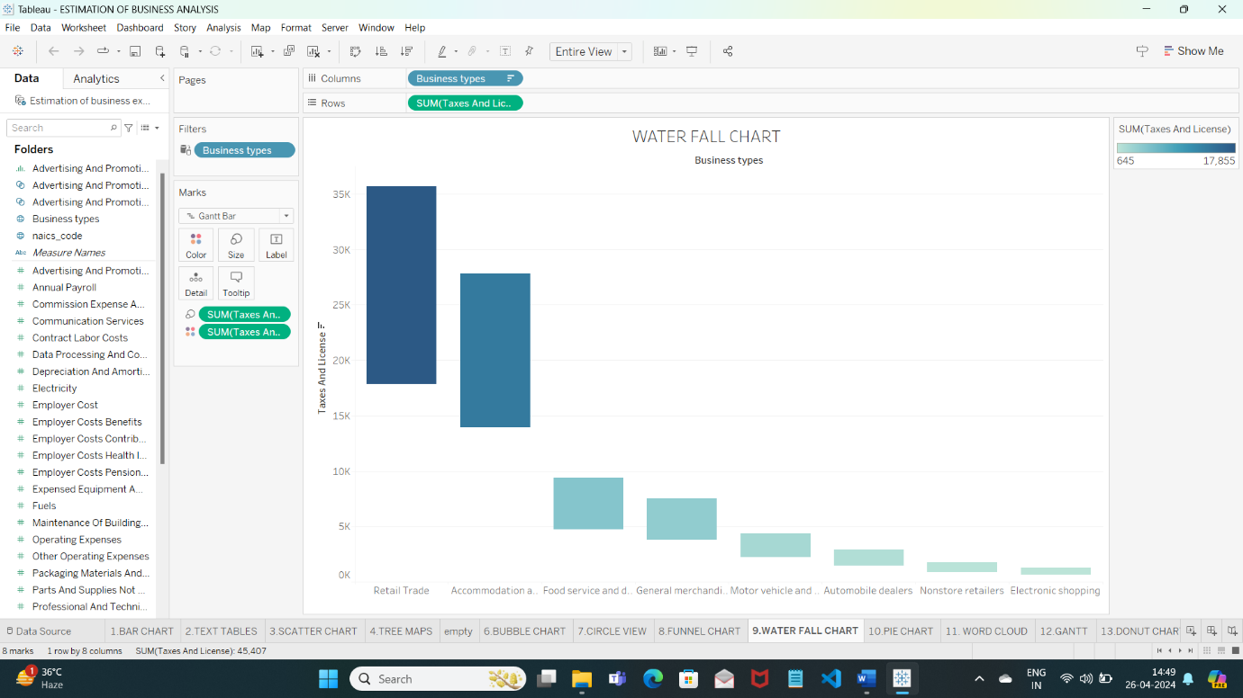

The above visualisation we have created is water chart .

Here we have analyzed the taxes and license of various business types. We have used filter in the above visualisation to filter few business types among all the other businesses . By above visualisation we analyzed that the Retail trade has the highest taxes and lincense expenses . Accomodation and food services are the second highest in expenses. Electronic shopping has the lowest expense among all 10 top businesses.

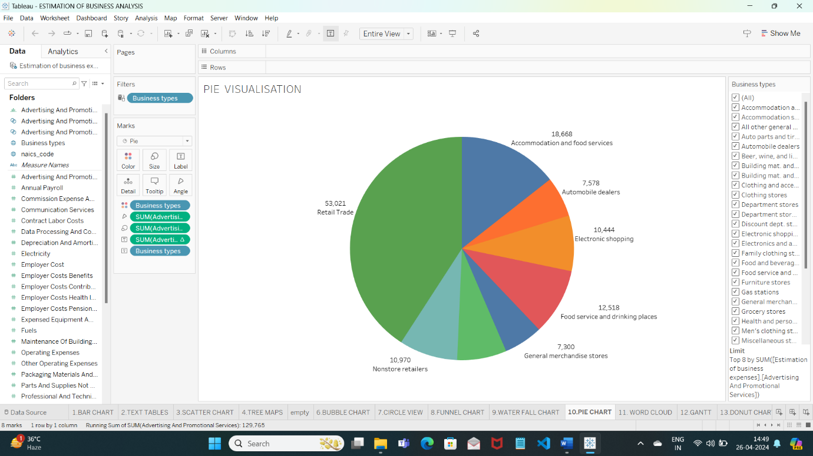

The above created visualisation is pie chart. We created to analyze the various business types on their expenses on advertising and promotional services . we used filter in this visualisation .Retail has the highest expenses on advertising and promotional services with 53,021 and automobile dealers are the least among the all with 7,578 on advertising and promotional services .

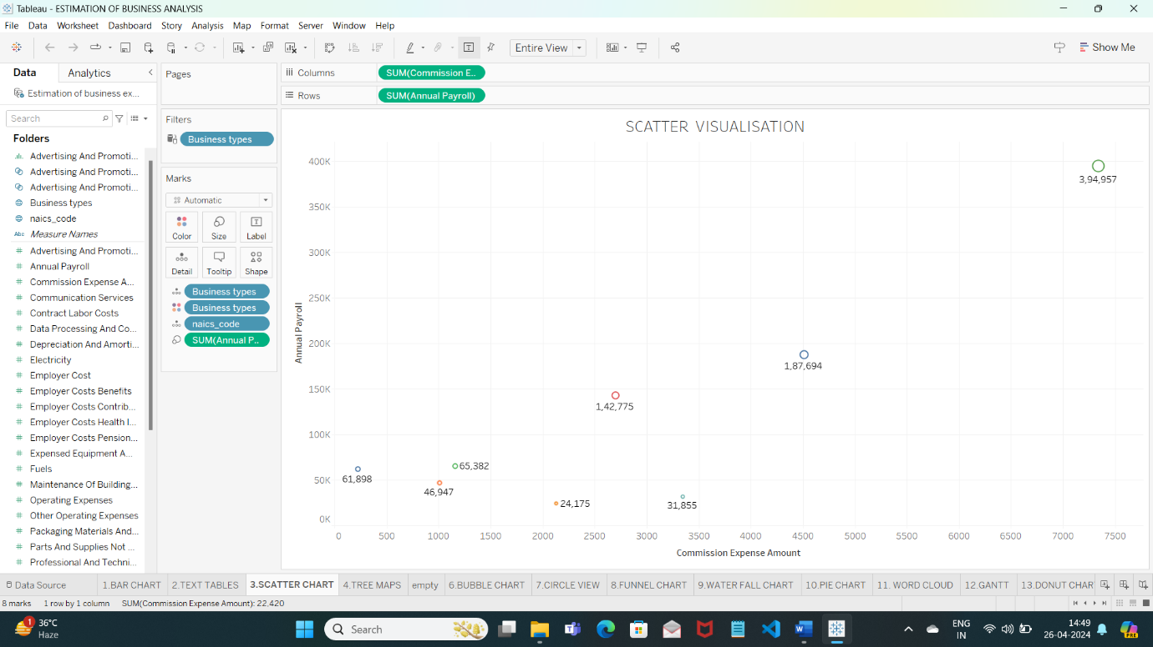

The above visualisation we have created is a scatter chart . we used nacis code and annual payroll to analyze various visualisations .we analyzed annual payroll and commission expenses amount in this visualisation. We used commission expense in the column and annual payroll in the row .

**Milestone 5: Dashboard**

A dashboard is a graphical user interface (GUI) that displays information and data in an organized, easy-to-read format. Dashboards are often used to provide real-time monitoring and analysis of data and are typically designed for a specific purpose or use case. Dashboards can be used in a variety of settings, such as business, finance, manufacturing, healthcare, and many other industries. They can be used to track key performance indicators (KPIs), monitor performance metrics, and display data in the form of charts, graphs, and tables.

**Activity 1: Responsive and Design of dashboard**

Once you have created views on different sheets in Tableau, you can pull them into a dashboard.

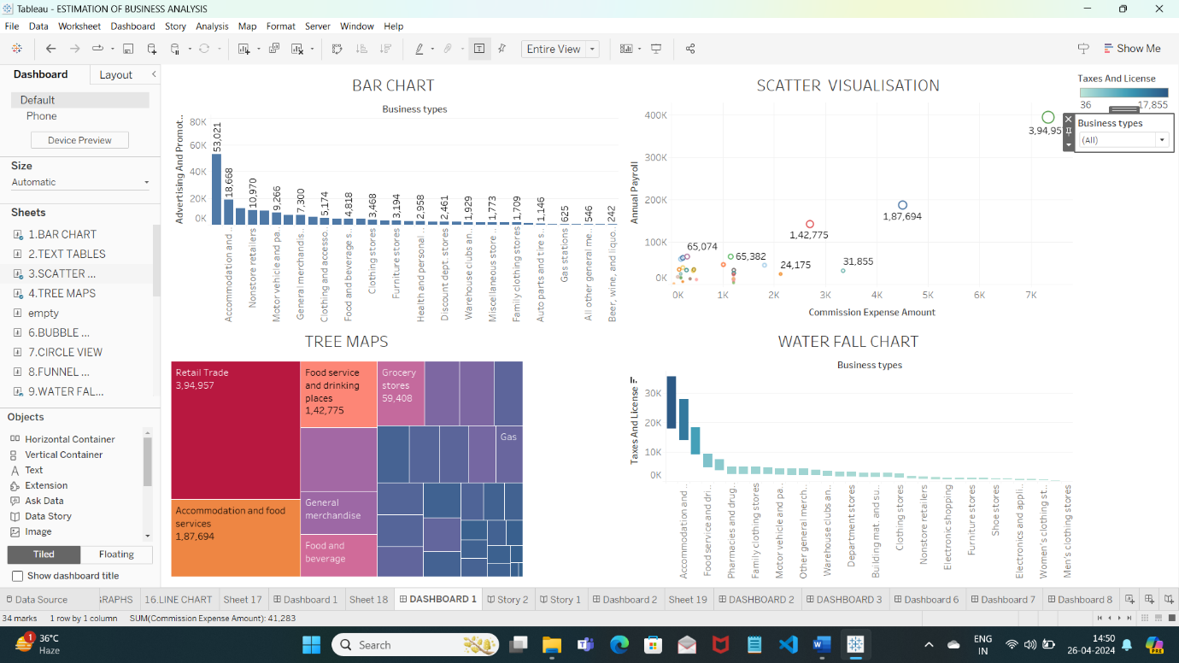

Here in the above dashboard we displayed four visualisations .first visualisation bar chart shows the advertising and promotional expenses of various business types . second visualisation is a scatter chart showing annual payroll and commission expenses amount . Third visualisation Tree maps depicts the electricity expenses of various business types .Forth visualisation depicts the taxes and license of various businesses.

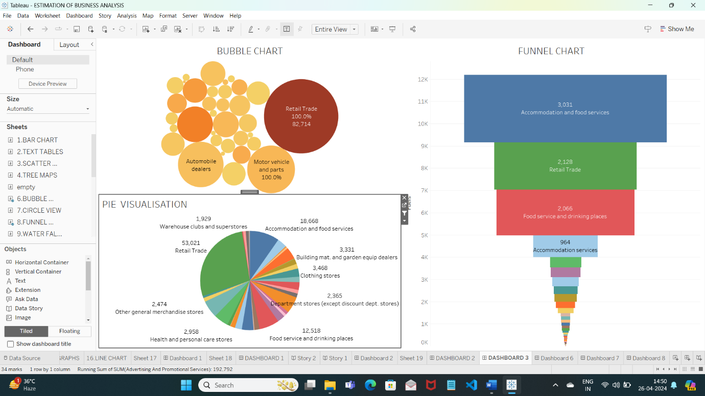

The above dashboard consists of three visualisations. The first visualisation bubble chart depicts the annual payroll of various business .Retail trade has the highest . second visualisation pie chart depicts the advertising and promotional services of various business types. Third visualisation funnel chart depicts the taxes and license of various businesses types . Accomodation and food services has the highest .

**Milestone 6: Story**

A data story is a way of presenting data and analysis in a narrative format, intending to make the information more engaging and easier to understand. A data story typically includes a clear introduction that sets the stage and explains the context for the data, a body that presents the data and analysis logically and systematically, and a conclusion that summarizes the key findings and highlights their implications. Data stories can be told using a variety of mediums, such as reports, presentations, interactive visualizations, and videos

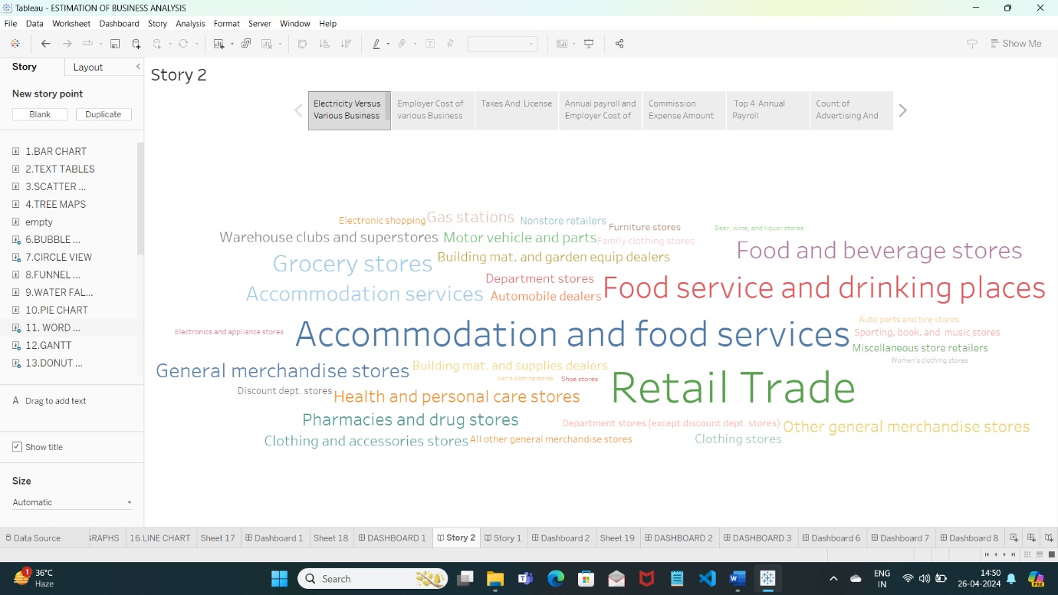

The above story we have created showcases seven scenes . Each scene has a visualisation displays the analysis of various expenses of various business types . The above story depicts the electricity expenses of various business types , employer cost of various businesses, taxes and license .

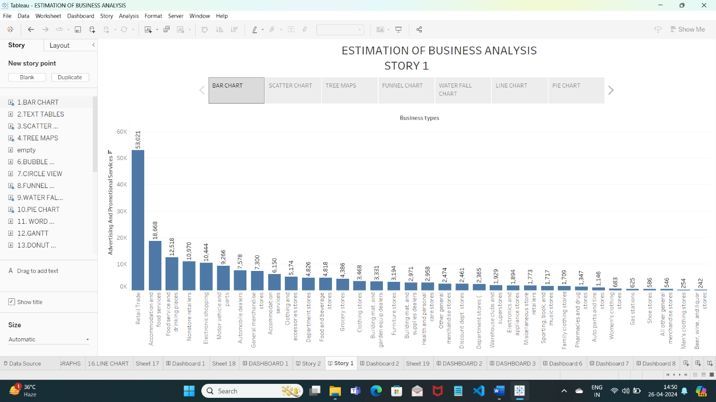

The above created story has seven scenes . Usually stories are created to give complete understanding of the data . The above story in the seven scenes gives us a brief understanding of advertising and promotional services , electricity expenses , employer cost , taxes and license , depreciation and amortion and data preprocessing and commission of various business types.

**Milestone 7: Performance Testing**

**Activity 1: Amount of Data Rendered to Tableau**

* The amount of data that is rendered to a Tableau depends on the size of the dataset

**Activity 2: Number of calculation fields**

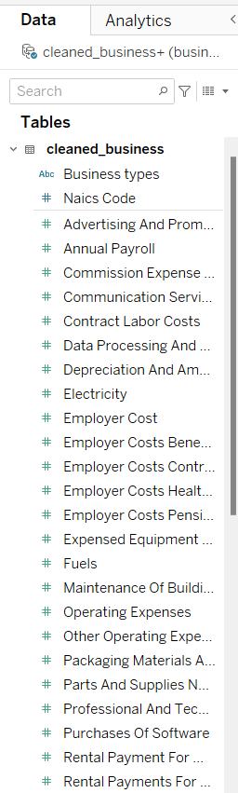

**Milestone 8: Publishing**

Publishing helps us to track and monitor key performance metrics and to communicate results and progress. help a publisher stay informed, make better decisions, and communicate their performance to others.

**Publishing dashboard and reports to tableau public**

# Milestone 9: Project Demonstration & Documentation

Below mentioned deliverables to be submitted along with other deliverables.

## Activity 1: Record explanation Video for project end to end solution

[VEDIO DEMONSTRATION 3.mp4](https://1drv.ms/v/c/c581feaca697e599/EXLarrel17tIkoYYQBTTjJIBTzq3UBubVrDzbk_56FsyGg?e=WUckah)