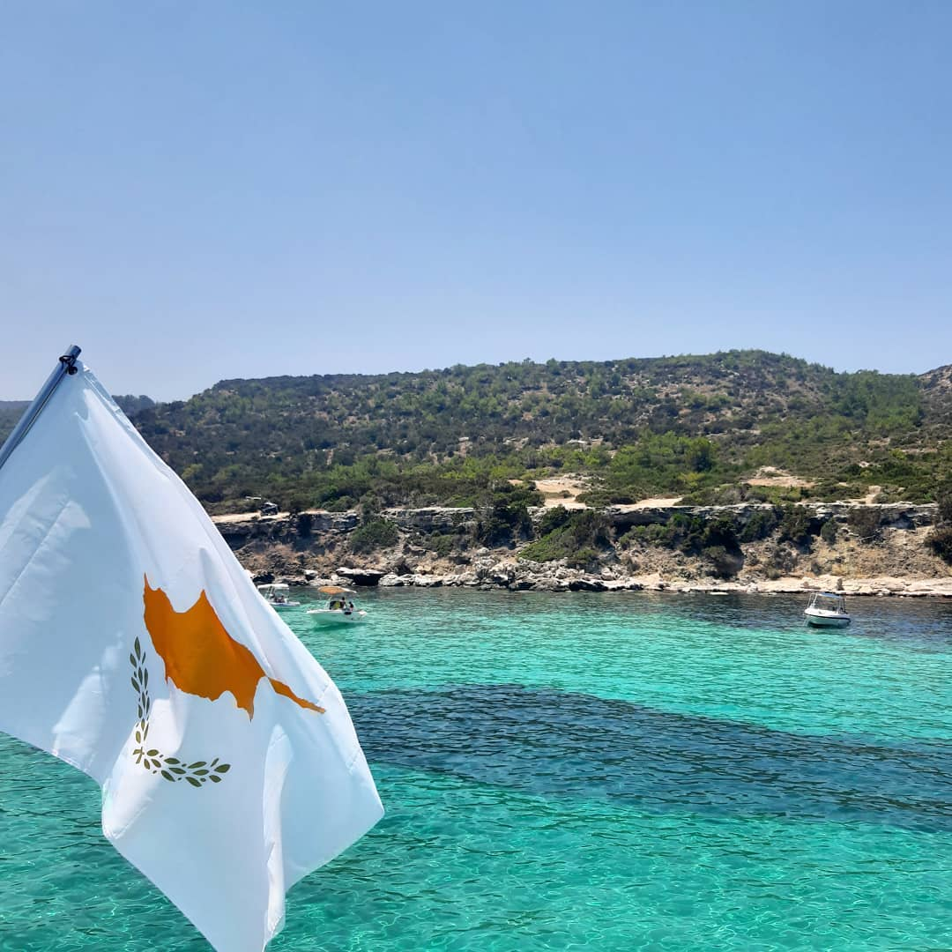

We look forward to hosting

**VLSI-SoC 2026**

in Cyprus!