Regular expressions language overview

Introduction
Regular expressions language, the language which greatly simplifies text manipulation, is one of the most used domain specific languages today. Almost any developer has used it at least once. Some languages, like Perl and Python have built in support for it; some like Java use it through libraries. Java, the language which we use to implement MPS, does not have language level support for regular expressions, so it was natural for us to implement DSL for them, so we will be able to use a DSL instead of a regular expression library. This language is a good example of a MPS language. Having read this introduction, you will be able to understand how to create and use languages in MPS.

Examples
This document uses many examples. You can find them in a regular expression language project (%MPS_HOME%/platform/regexp) under a jetbrains.mps.regexp.examples solution:
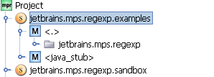

Language overview
Let’s take a look at a simple regular expression application. Suppose we want to get a user name and domain name from an email address. Here is a code which prints a user name and a domain name by analyzing an email address with a regular expression (you can find this example in an EmailExample class):
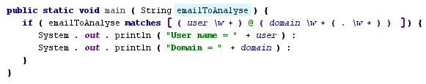

The regular expression that is used in this match regexp statement does the following. First it reads one or more word characters (\w+) and saves it in a “user” variable. After that it reads a “@” character. Than we read a list of words which are separated by a “.” character and save it in a domain variable (\w+(.\w+)). If match is found, this program prints user and domain to System.out.

Here is a syntax tree for this example regular expression:
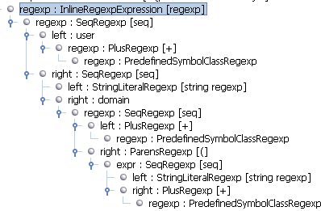

Language structure

When we create language in MPS, we usually start with defining its abstract syntax. Abstract syntax in MPS is called language structure. To do this we use structure language. Structure language is XML Schema counterpart from XML language, or DDL counterpart from SQL. Let’s take a look at the regular expressions language structure.

Overview
The MPS regular expressions language contains a few different parts:
- Regular expressions: concepts which are used to specify regular expressions. They include concepts for string literals, symbol classes, “or” and “sequence” regular expressions.
- BaseLanguage (BaseLanguage is a Java-like language, used internally by MPS as a target language for generators) integration: this part includes concepts which are used to embed regular expressions related code into BaseLanguage. For example, it includes MatchStatement, ReplaceStatement and SplitStatement.
- Regular expressions library support. When we work with regular expressions, we want to reuse them, and we created special concepts for this task.

Regular expressions
All the regular expressions concepts in our language are placed into “Regexp” folder in its structure model:
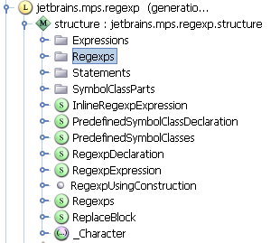
Let’s consider them in detail. We have one base concept for all of them: Regexp:
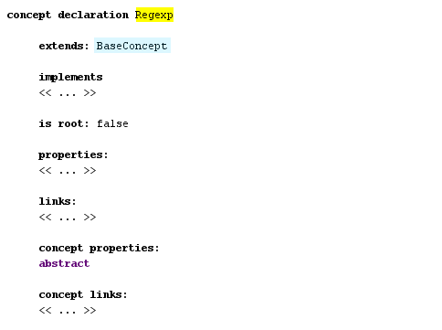

It is derived from BaseConcept concept. All the MPS concepts are derived from it. This concept also has the abstract concept property which means that it is created to form concepts hierarchy, not to be used in language to define regular expressions. It is similar to abstract modifier in Java classes.
Let’s consider the concepts which are derived from it. You can see them in hierarchy view. You can show this view if you press control + H on the concept declaration. For the Regexp concept we will see this:

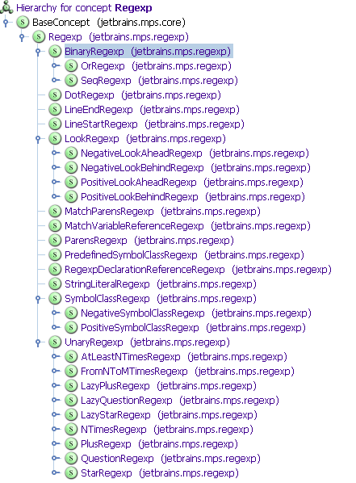
StringRegexp represent an arbitrary string which can be matched against text (you can find all the examples of regular expression, which we consider in this section in Regexps root node):
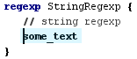
Let’s take a look at its concept declaration (you can quickly navigate to a concept declaration by pressing control + shift + s, if you select an instance of a concept in an editor):
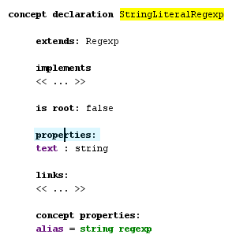
In its declaration we see a property text with a string type, which is used to store text, which will be shown in the editor. Also this concept declares a concept property “alias”. Concept properties differ from simple properties. Simple properties correspond to java instance fields, and concept properties correspond to java static fields. A value of a concept property alias will be shown in completion menu, when we press control + space:
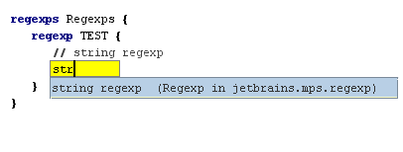
Binary regular expressions are created to represent regular expressions which combine two different regular expressions into one. BinaryRegexp concept is declared as abstract and has two concrete sub concepts: OrRegexp and SeqRegexp. Here are examples of them:
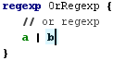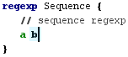

Here its concept declaration:
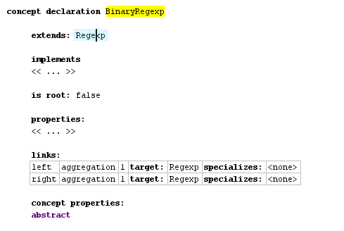
It defines two links: one to store a left part, and one to store a right part. The word aggregation means, that regular expression under this link will be a part of a declared concept instance, i.e. if we look at syntax tree, we will see a child regular expression under a parent BinaryRegexp:
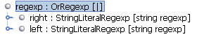
Dot regexp represents a regexp which matches any character. LineEndRegexp matches only at the end of a line. LineStartRegexp matches only at the start of a line. ParensRegexp are used to group other regular expressions in order to make an enclosing regular expression more readable.
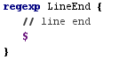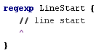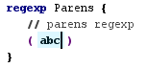
There are a lot of sets of symbols which are often used, but they are quite verbose to enter. So we have character classes that make it possible to enter [A-Z] instead of (A|B|C…Z). We have two kinds of them: negative and positive. Both of them extend abstract SymbolClassRegexp:
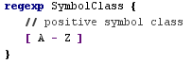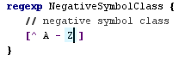
Many of these character classes used in several places, so they can be referenced in a simpler way with PredefinedSymbolClassRegexp. Instead of [A-Z] we can write \w:
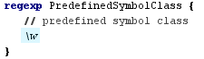
This concept is declared in this way:
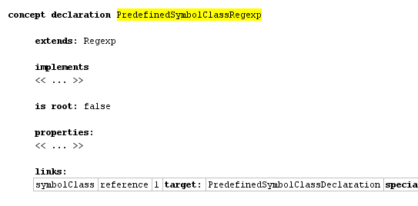
Here we have symbolClass link declaration, which has a reference stereotype (aggregation, which we mentioned above, is also a link stereotype). Reference stereotype means, that an instance of this concept won’t contain the referenced node as a child. Instead the referenced node can be stored in any place in a model.
Also we have a lot of different UnaryRegexps which are derived from an abstract concept UnaryRegexp. They include +, * and other regexp operations:
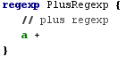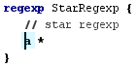

When we work with a text it is often useful to remember some match, and reference it later. To facilitate this task we have MatchParensRegexp which remembers a string which it matches and MatchVariableReferenceRegexp which reference a string which was matched before. The following code matches a pair of the same xml tags with a text inside it:
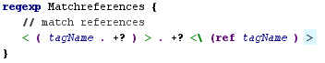

BaseLanguage integration
Regular expressions have a little use if they can’t be integrated in BaseLanguage code. So in regular expressions language we have special concepts which make it possible to write regular expression related constructs in a program which is written in BaseLanguage.
If you want to add new constructs to BaseLanguage you usually extend either Expression or Statement concept from BaseLanguage. Expression concept represents expressions like 1+2, a == b. Statement concept represents control structures like if(…) { }, while(…) { }. In the regular expressions language we create both new expressions and statements.
Let’s first take a look at the statements and than at the expressions:

MatchRegexpStatement is used when you want to check whether a specified string matches a regular expression (you can find the examples for this section in BaseLanguageIntegration class in jetbrains.mps.regexp.examples model):
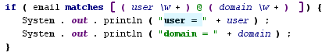
We have an interesting feature here: you can reference named matches in the block of MatchRegexpStatement. These match variables work in other statements which are defined in regular expressions language.

FindMatchStatement check if a specified string contains a match for a specified regular expression. It is similar to MatchRegexpStatement.
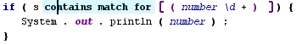

ForEachMatchStatement allows you to iterate over all matches of a specified regular expression in a specified string:
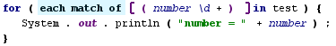

When we work with a string, we often want to replace all matches of a regular expression with a specified text. In regular expressions language you can do this with ReplaceWithRegexpExpression:
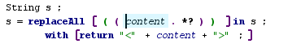

It is also often practical to split a string with some regular expression. For example to extract parts of a string which are separated by one or more whitespace symbols we can write this SplitExpression:
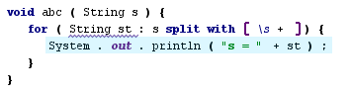

When we reference a match in a block, MatchVariableReference concept is used. It is also derived from Expression concept.

Library support

When we work with regular expressions, we want to use some of them in many places. To define these reusable regular expressions we have a special concept Regexps. In contain zero or more named regular expressions:
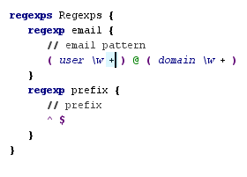

Accessory models
In many languages we have the following problem: we have a lot of very similar entities, which can be used in any model that is written with this language (like predefined symbol class regular expression). We can create a concept for every such an entity. But MPS has a better solution: you can create a special model which is called an accessory model, and declare all these entities in it with your language.
We have the PredefinedSymbolClass concept which is used to declare a symbol class. Also we have the PredefinedSymbolClasses container concept, which contains these symbol classes. If you look in the accessory model of the regular expressions language, you will see this:
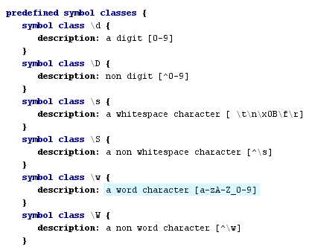

Editor
After defining concept structure we usually create an editor for it. To accomplish this task we use the editor language. It is quite a straightforward to use, so let’s consider the most common constructs of it.
All the editor related code is placed in an editor model. You can find it under a language node in a project tree:
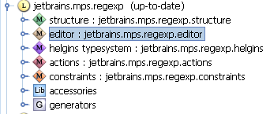
Here is an editor of StringLiteralRegexp:
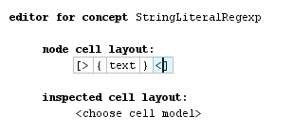
It contains a horizontal collection, the container which you might use to group other constructs inside it, and {text} which is used to include an editor for an instance property.
Here is an editor for MatchVariableReferenceRegexp:
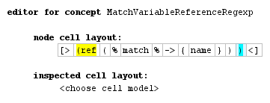
It also consists of a horizontal collection, but this time we have a richer set of constructs inside it. “(ref” and “)” are constants, which always contain the same text. “%match%->{name}” is used to reference the property “name” of match link’s target.
Here is an editor for Regexps:
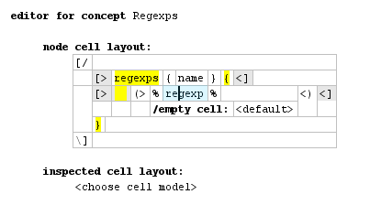
It contains a vertical collection with nested horizontal collections. Also it contains “(> %regexp% <)” construct. It is used to include editors for all the nodes in the role “regexp”.

Scopes
After declaring references in structure, we have default substitute menus for them. These default menus include all the nodes of a reference type in current model and all its imported models. Sometimes it works, but sometimes we have to narrow a scope of these menus (For example, if you have a lot of match variable named “name” in different parts of a model, it's a good idea to follow the Java scoping rules for these variables). To handle this task we have constraints language’s scopes.
Scopes are placed in a constraints model under a language node:
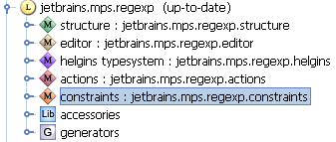
Let’s consider a scope for MatchVariableReference:
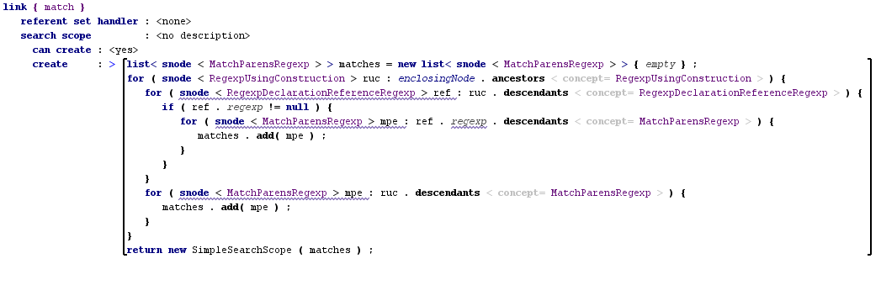

Scope consist of a referent set handler, a scope condition (labeled can create), and a scope constructor. Usually only a scope constructor is specified. Scope constructor has to return an object which implements the ISearchScope interface. Usually an instance of the class SimpleSearchScope is returned, it has a constructor which takes a list of nodes: i.e. we return a list of nodes which are visible in a specified place.

Actions
Default editors in MPS aren’t very easy to use. To improve this default behavior different constructs from the actions language and the editor language can be used.
When we enter code in a text based language we usually it from left to right. We might start from 2 than enter 2+ and finally we might have 2+2. It is also possible to enter code in MPS in this way with the aid of mechanism which is called right transform.
To define right transform action you have to create right transform actions root in actions model, and add right transform actions to it. Let’s consider a right transforms action from the regular expressions language which transforms one regular expression to the unary regular expression, i.e. it transforms “a” into “a+”, “a*” etc (like constraints, editor and structure, you can find an actions model under a language node in a project tree):
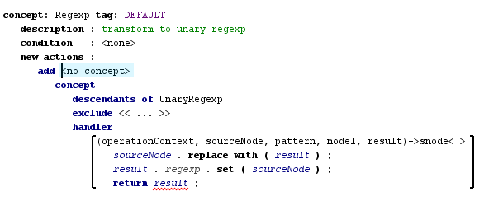
Each right transform has an applicable concept, the type of concept this action can be applied to, and it also has a condition and the most important part: right transform menu. There are different types of right transform menus. The menu on the picture above adds a one menu item for each non abstract UnaryRegexp sub concept. The handler of this menu part transforms an expression into a unary expression.

Type System
Many languages have a type system. It allows you to check a model against it, and can be used to improve editing experience and simplify generator. For example, if we know the type of a particular expression, we will be able to calculate which methods can be applied to it. MPS has a special language for type systems, which is called HELGINS. In languages with a very simple structure it is possible to live without it, but when we have a complex language or want to integrate with BaseLanguage, we have to create a type system, at least for BaseLanguage integration concepts.
In HELGINS types are represented as MPS nodes, so if you have a sublanguage for types, like BaseLanguage does, you can use it for type checking.
Let’s consider a couple of rules from the regular expressions language.
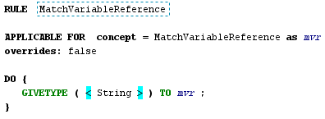
In this code we set a type String (String here is an instance of ClassifierType from BaseLanguage, which is used in method parameter types, local variables and other places). To do so we use GIVETYPE statement.
Let’s take a look at more complex rule:
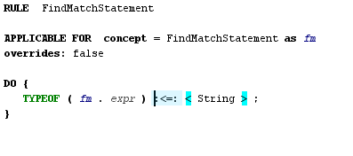
In this rule we require that expression that we match against a regular expression in FindMatchStatement is a subtype of String type. We do this by specifying a type equation. The sign “:<=:” means subtype, expression TYPEOF means a type of expression in parenthesis.
To calculate types HELGINS uses sophisticated algorithm. It saves you a lot of time: you don’t have to worry about in which order types are calculated, all you have to do is to specify type equations in typing rules, and HELGINS will solve them for you.
Of course, the rules in our language are very simple, and if you want to know more about HELGINS you have to take a look at rules in languages like BaseLanguage or the smodel language.

Generator
Almost any language which is created with MPS has a generator. Generators in MPS convert code in a high level language into a code in a lower level language. The key component of a generator is its mapping configuration. It tells us what to do with a language. Let’s consider a mapping configuration of the regular expressions language:
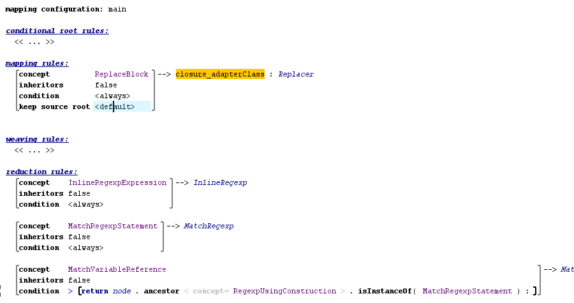

It contains one mapping rule and several reduction rules. Each rule has an applicable concept, for each instance of this concept, the rule will be applied. Mapping rules create a new root node on each application. Reduction rules replace a node which it is applied to with a new node. Each rule has an associated template, it used to create output node. Let’s take a look at an instance of such a template:
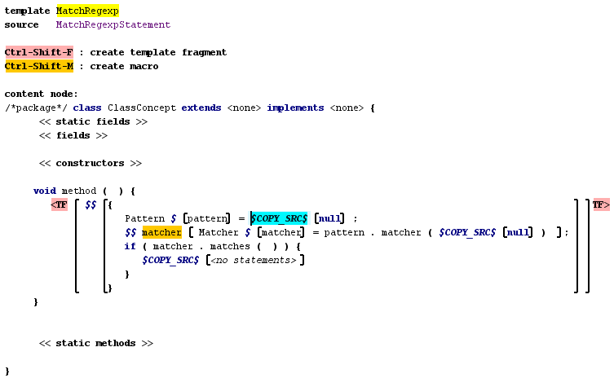

Templates contain MPS code with macros and template fragments.
The code which is outside of template fragment is not used during generation, and used only to create a context for a code inside a template fragment. For example, if we know that our code will be placed inside a method with a parameter named node, we might create a method with such a parameter around template fragment. During generation MPS will understand your intention, and this variable will be automatically resolved.
Macros are used to specify variable parts of code. For example, variable matcher on a picture above has a property macro on it. This property macro generates a unique name for this variable, so we will be able to use nested match blocks. MPS has different kinds of macros: different kinds of node macros, property macros, reference macros. All of these concepts are declared in the jetbrains.mps.TLBase language.

Further reading
We have taken a look at regular expressions language. It uses many MPS language development features, but of course not all of them. The best way to learn how to use MPS is to look at other language, like the base language and bootstrap languages. There are several tools in MPS which can be used to understand how MPS works.
One of them is find usages. You can invoke it by choosing Find Usages from the editor popup menu, or by pressing alt + F7 on a node in an editor.
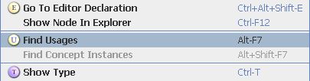

The second one is find concept instances. When you come across a concept, and don't know how to use it, the best way to make it clear is to find its instances, and try understanding what these instances do.
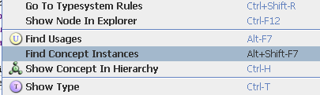

MPS distribution also contains documentation in %MPS_HOME%/help folder. Some of it is out of date, some quite incomplete, but it can be used to learn MPS.

