STM32F103 Software SPI Driver
Detailed Design, API Flows, Sequence Diagrams and UML

Implementation basis: hal_soft_spi.c
Target: STM32F103xB | Bare-metal GPIO bit-banging | GCC

Primary goal - A developer should be able to understand the SoftSPI architecture, timing rules, API responsibilities and implementation flow without first reading every line of source code.

Document Control
Item | Value
Document | STM32F103 Software SPI Driver Design
Source basis | hal_soft_spi.c supplied in the project
Target MCU | STM32F103xB
Driver type | Software SPI / GPIO bit-banging
Scope | Initialization, chip select, one-byte transfer, transmit, receive, full-duplex transfer, helpers, timing and test guidance
Language | English

Contents
- 1. Purpose and Scope
- 2. Driver Architecture
- 3. SPI Timing Model and Four Modes
- 4. Data Model and Responsibilities
- 5. Private Helper Functions
- 6. SoftSPI_Init()
- 7. SoftSPI_ChipSelect()
- 8. SoftSPI_TransmitReceiveByte() - Core Transfer
- 9. SoftSPI_Transmit()
- 10. SoftSPI_Receive()
- 11. SoftSPI_TransmitReceive()
- 12. End-to-End Transaction Sequence
- 13. State and Error Behavior
- 14. Development Guidelines
- 15. Verification and Test Plan
- 16. Quick Developer Checklist

1. Purpose and Scope
This document describes the design of the STM32F103 Software SPI driver implemented by GPIO bit-banging. It focuses on how each API works, how APIs call each other, how CPOL/CPHA create the four SPI modes, and how a developer can extend or debug the driver safely.

1.1 Design objectives
- Keep the hardware dependency small: only GPIO register access and a software delay are required.
- Implement one reusable byte-transfer core and build buffer APIs on top of it.
- Support CPOL, CPHA, MSB-first/LSB-first and configurable software delay.
- Keep CS control explicit so application or device drivers define transaction boundaries.
- Make the transfer flow visible and predictable for debugging with a logic analyzer.

1.2 In-scope APIs
API | Role
SoftSPI_Init() | Configure GPIO directions and default bus levels.
SoftSPI_ChipSelect() | Drive active-low CS/NSS.
SoftSPI_TransmitReceiveByte() | Core one-byte full-duplex bit-banging engine.
SoftSPI_Transmit() | Transmit a buffer; received bytes are discarded.
SoftSPI_Receive() | Receive a buffer by transmitting dummy 0xFF.
SoftSPI_TransmitReceive() | Exchange TX and RX buffers full-duplex.
Important - The driver does not automatically assert/deassert CS around transfers. The caller owns the transaction boundary unless a higher-level device driver wraps it.

2. Driver Architecture
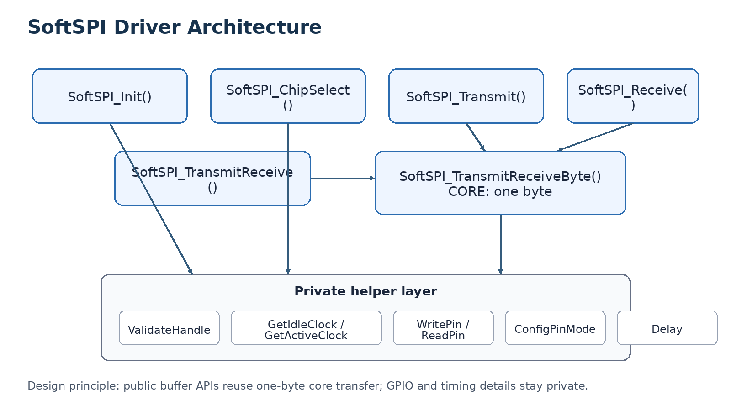
Figure 1. Public APIs reuse a common one-byte transfer core and private GPIO/timing helpers.

2.1 Layering
Layer | Responsibility | Examples
Application / Device driver | Select slave, issue protocol command, interpret returned data. | Flash, sensor, display driver
SoftSPI public API | Initialize, control CS and move bytes/buffers. | Transmit, Receive, TxRx
Byte core | Convert one byte into eight bit periods according to mode. | SoftSPI_TransmitReceiveByte
Private helpers | GPIO access, pin configuration, mode validation and timing. | WritePin, ReadPin, Delay

2.2 Call hierarchy
SoftSPI_Transmit()
-> SoftSPI_TransmitReceiveByte() [repeat Size times, discard RX]
SoftSPI_Receive()
-> SoftSPI_TransmitReceiveByte(0xFF) [repeat Size times, keep RX]
SoftSPI_TransmitReceive()
-> SoftSPI_TransmitReceiveByte(pTxData[i]) [repeat Size times, keep RX]

3. SPI Timing Model and Four Modes
The implementation does not need four separate transfer functions. CPOL defines the idle/active clock levels; CPHA defines which clock edge samples MISO. Their combination produces SPI Modes 0 to 3.
Mode | CPOL | CPHA | SCK idle | Sample edge | Change edge
0 | 0 | 0 | LOW | Rising | Falling
1 | 0 | 1 | LOW | Falling | Rising
2 | 1 | 0 | HIGH | Falling | Rising
3 | 1 | 1 | HIGH | Rising | Falling
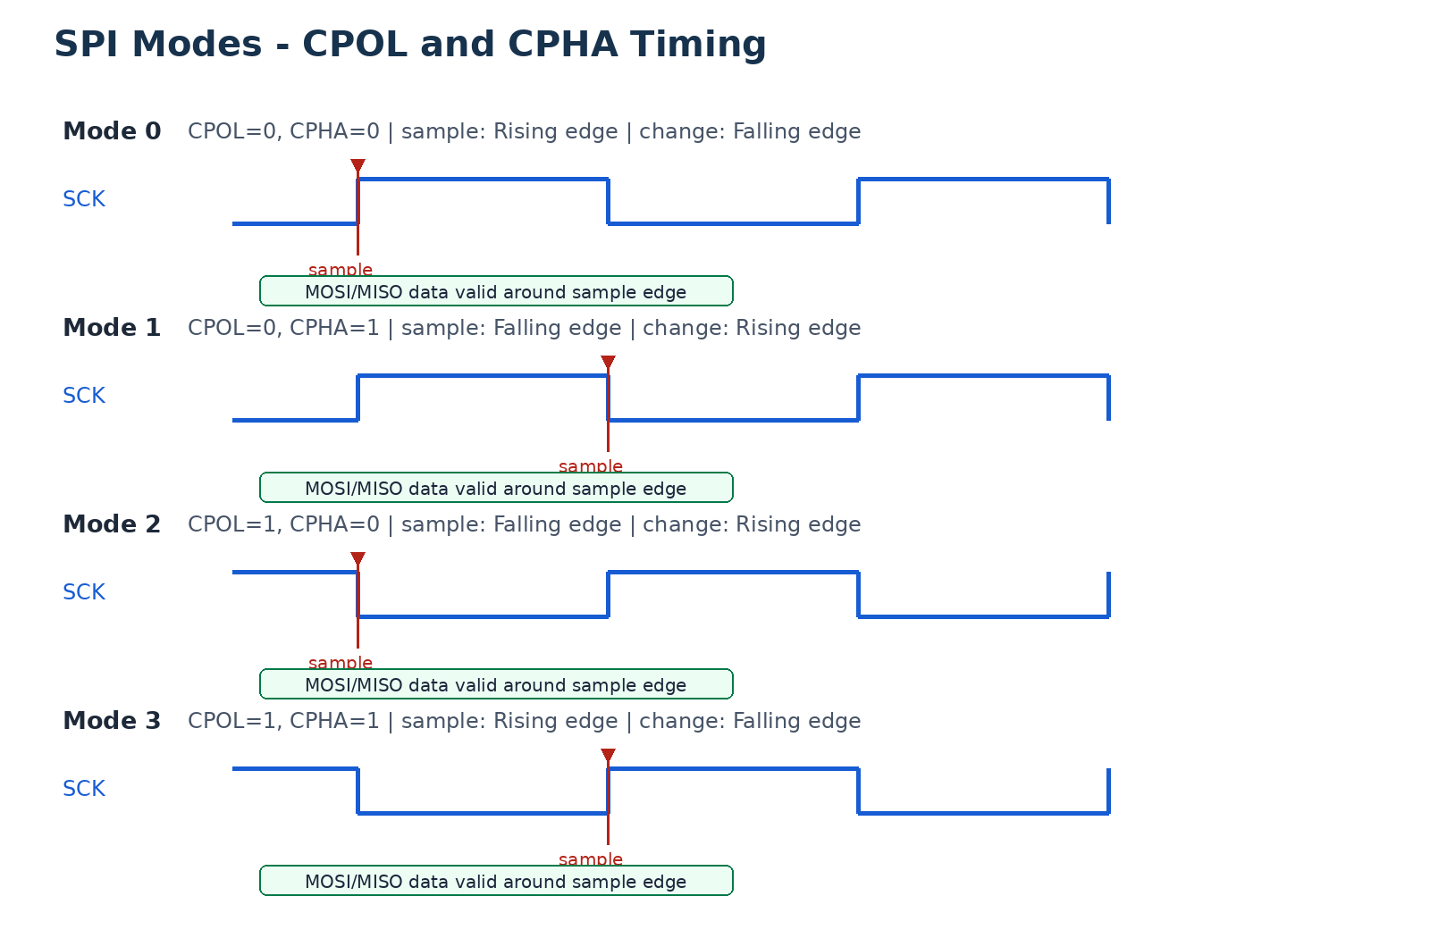
Figure 2. CPOL chooses idle polarity; CPHA chooses first-edge or second-edge sampling.
Naming note - In the current implementation, SOFT_SPI_CPHA_1EDGE represents CPHA = 0 behavior: data is sampled on the first (leading) edge. The else branch represents CPHA = 1 behavior.

4. Data Model and Responsibilities
The source uses a SoftSPI handle that contains initialization data and runtime state. The following fields are directly observed through member access in the implementation.
Observed field | Responsibility
Init.Pins.SckPort / SckPin | SCK GPIO location.
Init.Pins.MosiPort / MosiPin | MOSI GPIO location.
Init.Pins.MisoPort / MisoPin | MISO GPIO location.
Init.Pins.CsPort / CsPin | Active-low chip-select GPIO location.
Init.CPOL | Clock idle polarity.
Init.CPHA | Sampling phase.
Init.FirstBit | MSB-first or LSB-first bit order.
Init.DelayUs | Software delay count used between clock transitions.
State | Runtime READY/BUSY state.

4.1 UML-style relationship
+---------------------------+
| SoftSPI_HandleTypeDef |
+---------------------------+
| Init |----> Pins + CPOL + CPHA + FirstBit + DelayUs
| State |
+---------------------------+
|
+---- used by all public APIs
+---- passed to private helpers
This is a design view of relationships observed in the implementation; it is not a replacement for the exact type declarations in the project header.

5. Private Helper Functions
Helper | Input -> Output | Purpose
SoftSPI_Delay | count -> none | Generate approximate timing using NOP loop.
SoftSPI_WritePin | GPIO + pin + state -> none | Drive GPIO HIGH with BSRR or LOW with BRR.
SoftSPI_ReadPin | GPIO + pin -> 0/1 | Read MISO from IDR.
SoftSPI_ConfigPinMode | GPIO + pin + 4-bit mode -> none | Select CRL/CRH and program the pin MODE/CNF nibble.
SoftSPI_ValidateHandle | handle -> STD_OK/STD_ERROR | Reject null handle, invalid ports/pins or unsupported SPI options.
SoftSPI_GetIdleClock | handle -> 0/1 | Return SCK idle level from CPOL.
SoftSPI_GetActiveClock | handle -> 0/1 | Return the opposite SCK level for active phase.

5.1 GPIO configuration rule
Pin 0..7 -> CRL
Pin 8..15 -> CRH
pinPosition = Pin (CRL)
pinPosition = Pin - 8 (CRH)
bitOffset = pinPosition * 4
clear old 4-bit MODE/CNF -> write new 4-bit MODE/CNF

5.2 Timing limitation
Current behavior - SoftSPI_Delay() uses a NOP loop. The DelayUs field behaves as a delay loop count unless the implementation is calibrated for CPU clock and compiler optimization. Do not assume exact microseconds without measurement.

6. SoftSPI_Init()
Initializes GPIO modes and places the SPI bus in a deterministic idle state.
HALx_StatusTypeDef SoftSPI_Init(SoftSPI_HandleTypeDef *hspi)
Item | Design
Precondition | GPIO peripheral clocks must already be enabled by the RCC/clock driver.
SCK / MOSI / CS | General-purpose output push-pull, maximum 10 MHz in the current code.
MISO | Floating input.
CS idle | HIGH because CS is active LOW.
SCK idle | Derived from CPOL.
MOSI idle | LOW.
Success state | SOFT_SPI_STATE_READY.
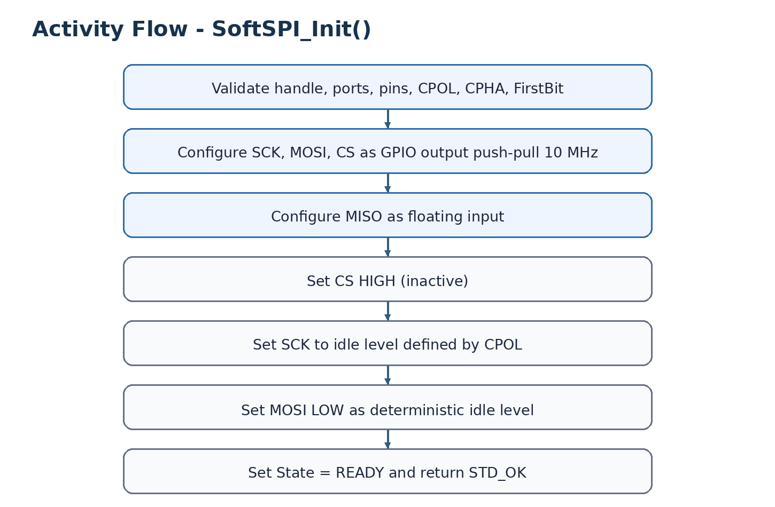
Figure 3. Initialization activity flow.

6.1 Developer interpretation
Initialization only prepares the GPIO-based SPI engine. It does not select a slave and does not transmit data. The first real transaction should assert CS explicitly before a transfer API is called.

7. SoftSPI_ChipSelect()
Controls the active-low CS/NSS signal. This API defines whether the target slave is selected or released.
HALx_StatusTypeDef SoftSPI_ChipSelect(SoftSPI_HandleTypeDef *hspi, FunctionalState NewState)
NewState | GPIO action | Meaning
ENABLE | CS = LOW | Select slave / begin transaction.
DISABLE | CS = HIGH | Release slave / end transaction.
SoftSPI_ChipSelect(&hspi, ENABLE);
/* call transmit / receive / txrx */
SoftSPI_ChipSelect(&hspi, DISABLE);
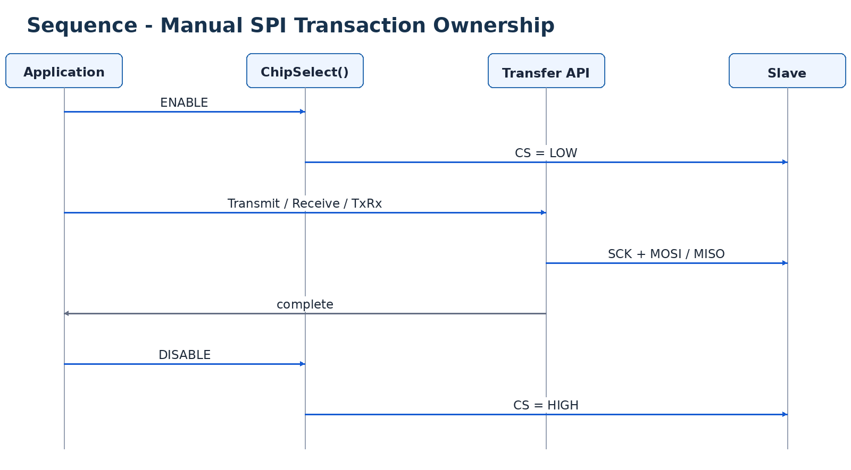
Figure 4. CS ownership is explicit and belongs to the caller or higher-level device driver.
Transaction rule - For most SPI slaves, keep CS LOW for the complete command/address/data transaction. Do not toggle CS between bytes unless the slave protocol requires it.

8. SoftSPI_TransmitReceiveByte() - Core Transfer
This is the core bit-banging engine. It exchanges exactly one byte by generating eight SCK cycles and handling one MOSI/MISO bit per cycle.
uint8_t SoftSPI_TransmitReceiveByte(SoftSPI_HandleTypeDef *hspi, uint8_t txData)
Item | Design
Input | One TX byte plus SoftSPI configuration.
Output | One RX byte sampled from MISO.
Clock count | 8 complete SCK cycles.
Bit order | MSB-first: 7 -> 0; LSB-first: 0 -> 7.
CPOL role | Defines sckIdle and sckActive.
CPHA role | Chooses first-edge or second-edge sampling.
State | BUSY at transfer start, READY when byte is complete.

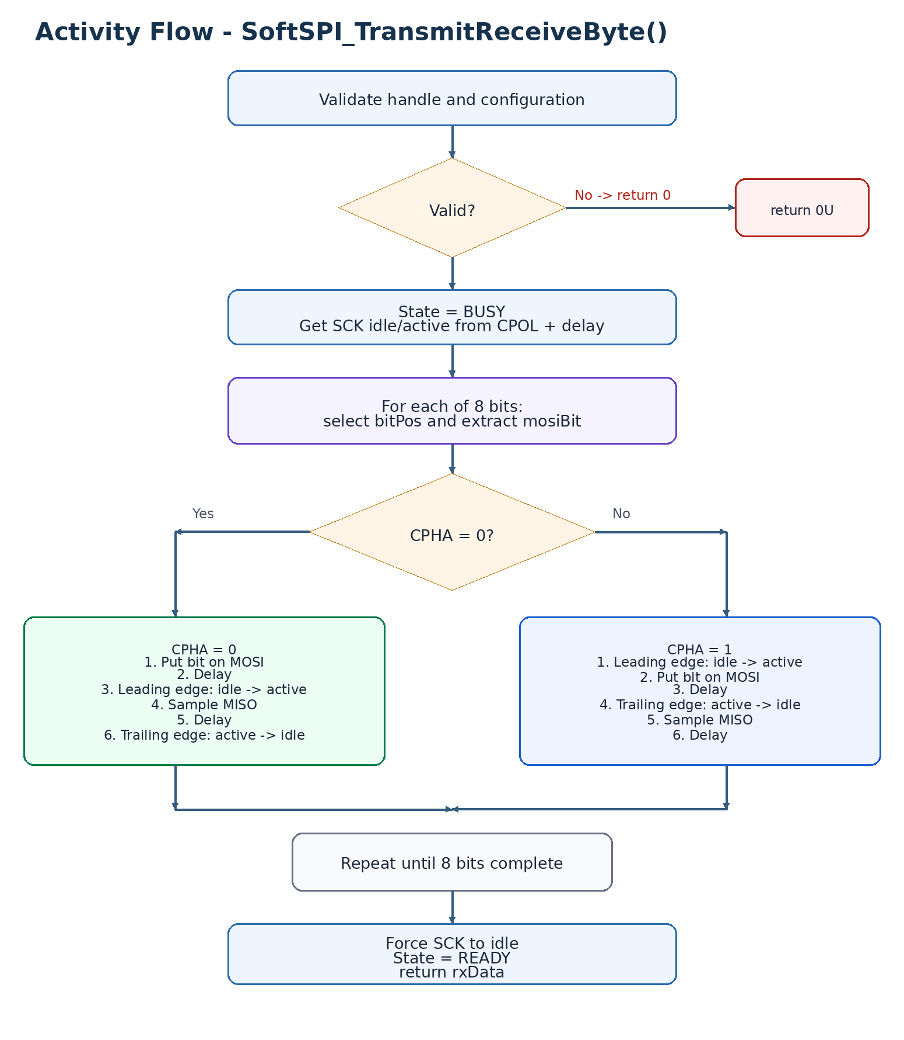
Figure 5. Core activity flow for a single byte.

8.1 Bit extraction and reconstruction
bitPos = MSB-first ? (7 - i) : i;
mosiBit = (txData >> bitPos) & 0x01;
if (MISO is HIGH)
rxData |= (1U << bitPos);
The transmit and receive bit positions are aligned. The same bitPos selects the MOSI bit and places the sampled MISO bit into the returned byte.

8.2 CPHA = 0 flow
MOSI setup
-> delay
-> leading edge (idle -> active)
-> sample MISO
-> delay
-> trailing edge (active -> idle)

8.3 CPHA = 1 flow
leading edge (idle -> active)
-> MOSI setup
-> delay
-> trailing edge (active -> idle)
-> sample MISO
-> delay
Why this one function matters - Transmit(), Receive() and TransmitReceive() do not reimplement CPOL/CPHA timing. They reuse this byte core, reducing duplicated timing logic and keeping all four SPI modes consistent.

9. SoftSPI_Transmit()
Transmits a buffer. Because SPI is full-duplex, a byte is still sampled from MISO for every transmitted byte, but the wrapper deliberately discards that returned value.
HALx_StatusTypeDef SoftSPI_Transmit(SoftSPI_HandleTypeDef *hspi, const uint8_t *pData, uint16_t Size)
for (i = 0; i < Size; i++)
{
(void)SoftSPI_TransmitReceiveByte(hspi, pData[i]);
}
The explicit (void) cast documents that the one-byte core returns RX data but this API intentionally does not use it.
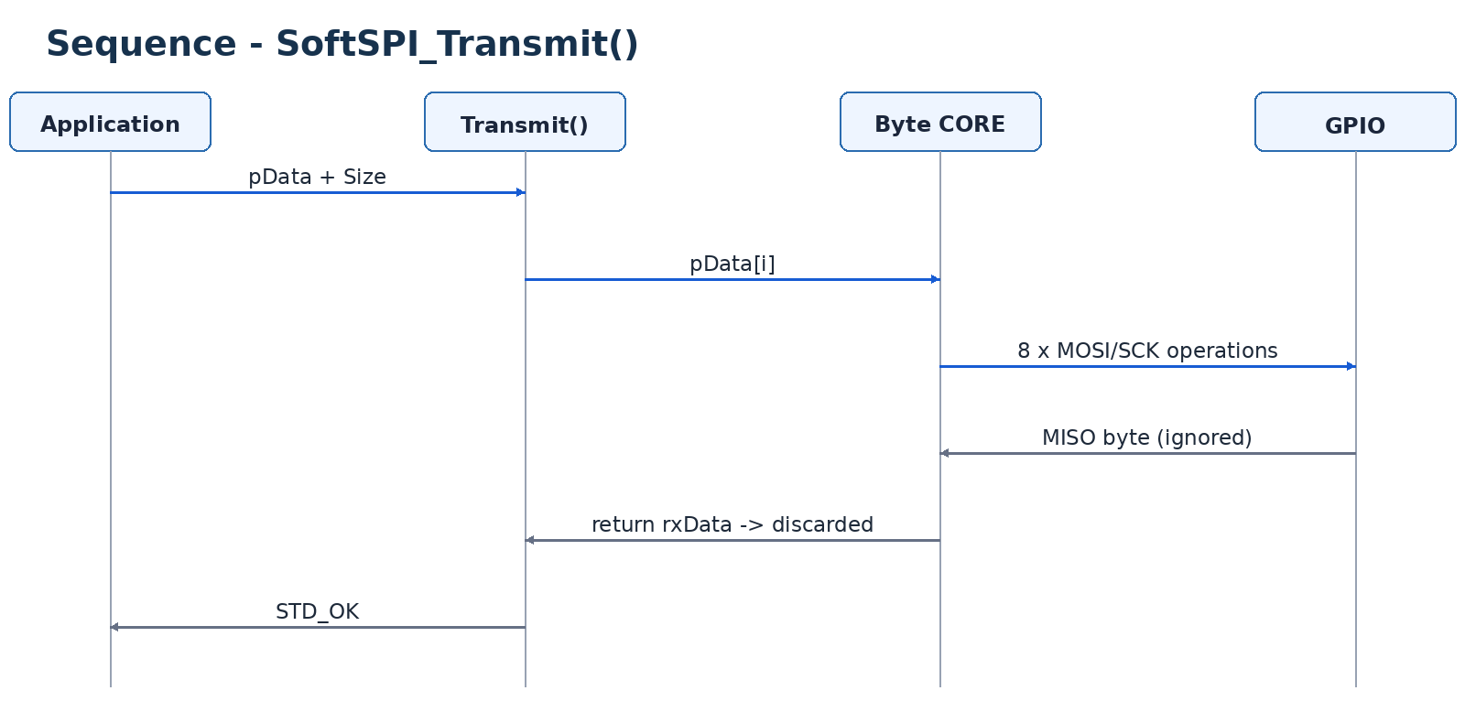
Figure 6. Transmit sequence: the RX byte exists internally but is discarded by the wrapper.
Clock calculation - Transmitting N bytes generates N x 8 SCK cycles. Example: Size = 4 produces 32 SCK cycles.

10. SoftSPI_Receive()
Receives a buffer. An SPI master must generate clock pulses to make the slave shift data onto MISO, so the wrapper transmits a dummy byte for every byte it wants to receive.
HALx_StatusTypeDef SoftSPI_Receive(SoftSPI_HandleTypeDef *hspi, uint8_t *pData, uint16_t Size)
for (i = 0; i < Size; i++)
{
pData[i] = SoftSPI_TransmitReceiveByte(hspi, 0xFFU);
}
0xFF is transmitted on MOSI. The function return value is the byte sampled from MISO and is stored into pData[i]. Therefore pData[i] is not automatically 0xFF.
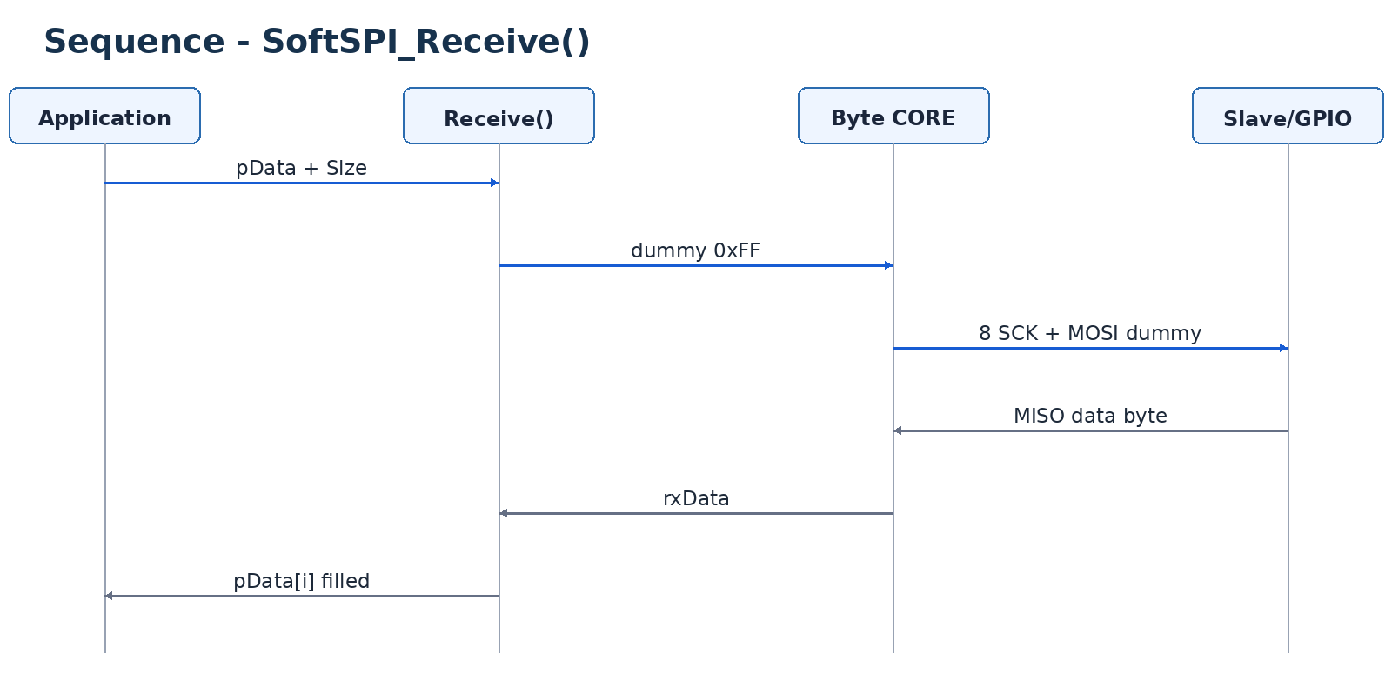
Figure 7. Receive sequence: dummy TX creates the clocks; returned MISO data fills the RX buffer.

10.1 Why dummy 0xFF?
SPI has no independent receive clock. The master must clock the bus. The current implementation chooses 0xFF so MOSI remains HIGH for the dummy bits instead of being forced LOW. A device-specific protocol may require a different dummy pattern; that requirement belongs to the slave datasheet.

11. SoftSPI_TransmitReceive()
Performs a full-duplex buffer exchange. Every transmitted byte is paired with one received byte.
HALx_StatusTypeDef SoftSPI_TransmitReceive(SoftSPI_HandleTypeDef *hspi, const uint8_t *pTxData, uint8_t *pRxData, uint16_t Size)
for (i = 0; i < Size; i++)
{
pRxData[i] = SoftSPI_TransmitReceiveByte(hspi, pTxData[i]);
}
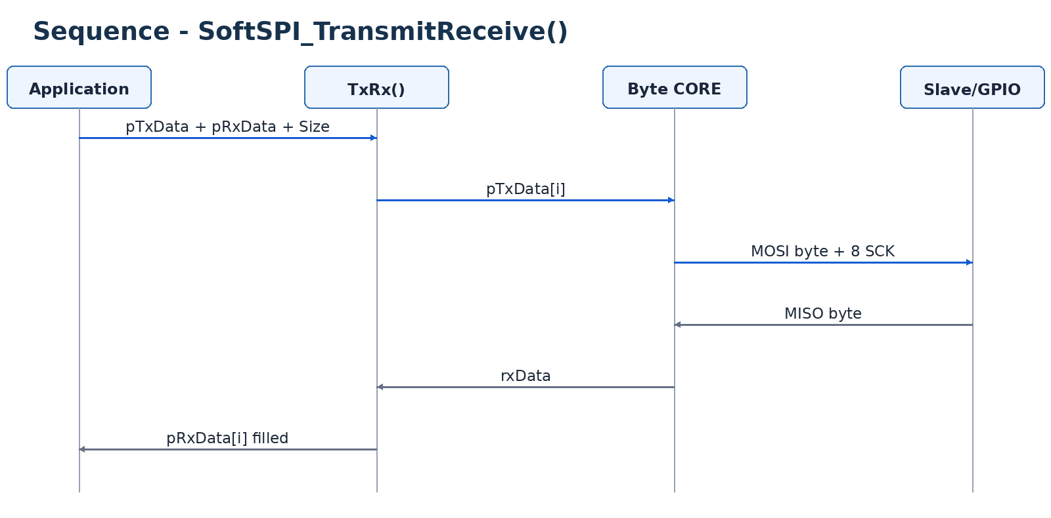
Figure 8. Full-duplex buffer sequence: each TX byte produces one RX byte.
This wrapper is the clearest expression of native SPI behavior: data moves in both directions during the same clock cycles.
Relationship - SoftSPI_TransmitReceiveByte() = one-byte core. SoftSPI_TransmitReceive() = buffer API that calls the core Size times.

12. End-to-End Transaction Sequence
A complete SPI transaction normally includes explicit chip selection, one or more transfer calls, and chip release.
/* 1. Select slave */
SoftSPI_ChipSelect(&hspi, ENABLE);
/* 2. Exchange command/data */
SoftSPI_Transmit(&hspi, tx, txSize);
SoftSPI_Receive(&hspi, rx, rxSize);
/* 3. Release slave */
SoftSPI_ChipSelect(&hspi, DISABLE);

12.1 Conceptual sequence
Application
|
+--> CS LOW
|
+--> Transfer API
| |
| +--> Byte CORE (byte 0)
| +--> Byte CORE (byte 1)
| +--> ...
|
+--> CS HIGH
|
+--> Parse returned protocol data
Separation of concerns - SoftSPI moves bits and bytes. A flash/sensor/display driver decides the command format, address bytes, dummy cycles and CS transaction boundaries required by that specific device.

13. State and Error Behavior
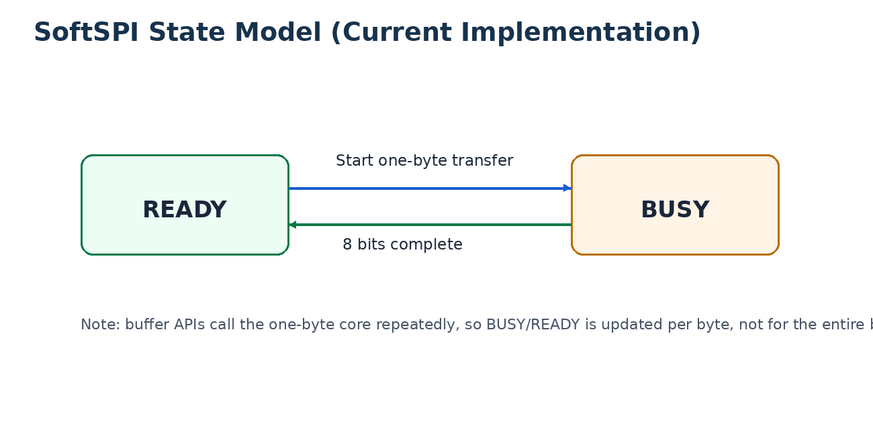
Figure 9. Runtime state currently changes around each one-byte core transfer.
Condition | Current behavior
Invalid handle/configuration in public APIs | Return STD_ERROR where the API has a status return.
Invalid handle/configuration in byte core | Return 0U.
Null data buffer | Buffer APIs return STD_ERROR.
Size == 0 | Buffer APIs return STD_ERROR.
Successful buffer transfer | Return STD_OK.
Byte transfer start/end | State changes BUSY -> READY.

13.1 Design limitations to understand before extension
- The byte core returns 0U on validation failure, which is indistinguishable from a valid received byte 0x00. A future interface may return status separately from RX data.
- Buffer wrappers do not hold State = BUSY for the whole buffer; the core toggles BUSY/READY per byte.
- There is no timeout because this implementation directly toggles GPIO and does not wait for hardware status flags.
- There is no automatic locking or interrupt protection; concurrent access to one handle should be prevented by the application if needed.

14. Development Guidelines

14.1 Recommended implementation order
- Implement and verify GPIO write/read helpers.
- Implement CRL/CRH pin configuration and initialize SCK/MOSI/MISO/CS.
- Implement CPOL helpers and verify SCK idle level for CPOL 0 and 1.
- Implement one-byte transfer for CPHA 0, then CPHA 1.
- Verify Mode 0..3 with a logic analyzer.
- Build Transmit(), Receive() and TransmitReceive() as thin wrappers around the byte core.
- Add a device driver above SoftSPI; keep device-specific protocol rules out of SoftSPI.

14.2 Do not duplicate timing logic
If a new high-level API needs to move bytes, prefer reusing SoftSPI_TransmitReceiveByte() or an equivalent shared transfer primitive. Duplicating edge-generation logic in multiple APIs makes CPOL/CPHA fixes harder and creates inconsistent modes.

14.3 Performance notes
- GPIO function-call overhead and NOP delay determine the practical SCK frequency.
- Compiler optimization can change NOP-loop timing.
- BSRR/BRR writes are appropriate for deterministic single-pin set/reset on STM32F1.
- For high throughput or precise timing, hardware SPI should be preferred over bit-banging.

15. Verification and Test Plan
Test ID | Test | Expected result
SFT-INIT-01 | Initialize CPOL=0 | CS HIGH, SCK LOW, MOSI LOW, State READY.
SFT-INIT-02 | Initialize CPOL=1 | CS HIGH, SCK HIGH, MOSI LOW, State READY.
SFT-CS-01 | ChipSelect ENABLE/DISABLE | CS toggles LOW/HIGH.
SFT-M0-01 | Mode 0 one-byte transfer | Sample on rising edge; SCK idle LOW.
SFT-M1-01 | Mode 1 one-byte transfer | Sample on falling edge; SCK idle LOW.
SFT-M2-01 | Mode 2 one-byte transfer | Sample on falling edge; SCK idle HIGH.
SFT-M3-01 | Mode 3 one-byte transfer | Sample on rising edge; SCK idle HIGH.
SFT-BIT-01 | MSB-first 0xA5 | MOSI order = 1 0 1 0 0 1 0 1.
SFT-BIT-02 | LSB-first 0xA5 | MOSI order = 1 0 1 0 0 1 0 1 read from bit0 to bit7; use a non-palindromic byte for analyzer confirmation.
SFT-TX-01 | Transmit Size=N | Exactly 8 x N SCK cycles; RX return values discarded.
SFT-RX-01 | Receive Size=N | MOSI sends 0xFF per byte; pData stores MISO bytes.
SFT-TRX-01 | TxRx Size=N | Each pTxData[i] corresponds to pRxData[i].
SFT-ERR-01 | Null handle/buffer or Size=0 | API returns documented error behavior.

15.1 Logic-analyzer checkpoints
- CS remains at the expected level for the complete transaction.
- SCK idle polarity matches CPOL before and after the transfer.
- MOSI changes on the non-sampling edge and is stable at the sampling edge.
- MISO is sampled on the CPHA-selected edge.
- Exactly eight clock cycles are generated per byte.
- Byte ordering and bit ordering match the configured FirstBit.

16. Quick Developer Checklist
Mental model - SoftSPI_TransmitReceiveByte() is the engine. Buffer APIs are loops around the engine. CPOL chooses clock polarity. CPHA chooses sampling phase. CS defines the transaction boundary.

- Enable GPIO clocks before SoftSPI_Init().
- Configure valid SCK, MOSI, MISO and CS GPIOs.
- Choose CPOL/CPHA according to the slave datasheet.
- Choose MSB-first or LSB-first according to the slave datasheet.
- Measure DelayUs behavior if SCK timing matters.
- Assert CS before the protocol transaction and release it afterward.
- Use Transmit() when RX is intentionally ignored.
- Use Receive() when the master must clock in data using dummy bytes.
- Use TransmitReceive() when both directions are meaningful.
- Use a logic analyzer to verify all four mode timing behaviors during driver bring-up.

16.1 One-page flow summary
INIT
-> configure GPIO
-> CS idle HIGH
-> SCK idle from CPOL
-> READY
TRANSACTION
-> CS LOW
-> public buffer API
-> loop bytes
-> one-byte CORE
-> 8 bit cycles
-> CPHA selects sample edge
-> CPOL selects clock polarity
-> CS HIGH
-> process RX data
End of design document.

