EMBEDDED TFT DEVELOPMENT
TFT Bitmap Font Generator
User Guide for ILI9341 and Column-Major LCD Fonts
Version 1.0 | August 2026 | Python / PyQt5
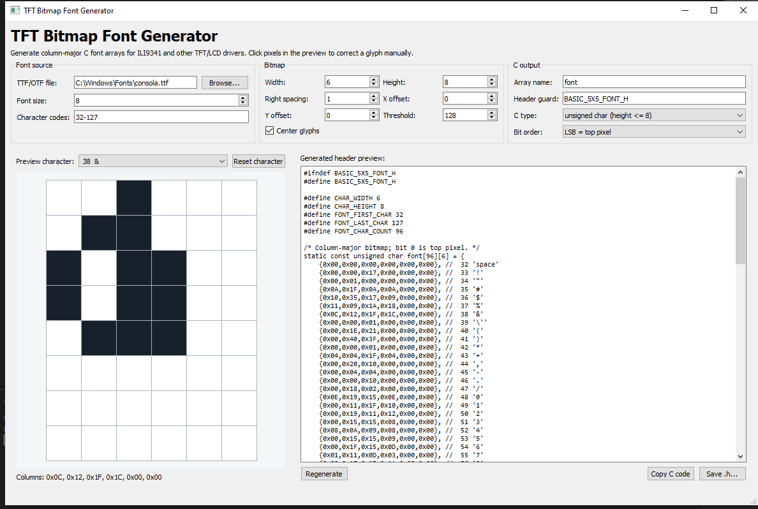
Figure 1. Main window with a 6 x 8 glyph preview and generated C header.

1. Overview
TFT Bitmap Font Generator converts TTF, OTF, and TTC fonts into fixed-size, column-major C arrays for embedded TFT and LCD drivers. The default settings match the 6 x 8 ILI9341 font format.
Default output: 96 entries for character codes 32-127, six columns per glyph, eight rows per column, unsigned char storage, and bit 0 representing the top pixel.

1.1 System requirements
- Python 3.10 or later with PyQt5 and Pillow installed.
- A source font file and permission to use that font in the target product.

1.2 Installation and launch
Run the following commands in PowerShell or Command Prompt on Windows:
py -m pip install PyQt5 Pillow
py tft_font_generator.py
On Linux or macOS, use python3 instead of py. Select Browse if the default font path is empty or incorrect.

1.3 Quick start
- Select a TTF, OTF, or TTC font file.
- Set Character codes to 32-127 for the 96-entry format shown in Figure 1.
- Set Width to 6, Height to 8, and Right spacing to 1.
- Review each important glyph and click cells to correct individual pixels.
- Save the .h file and add it to the embedded project.

2. Interface reference

2.1 Font source
Control | Purpose | Typical value / guidance
TTF/OTF file | Path of the source font used to render every glyph. | Select Consolas or another .ttf, .otf, or .ttc font file.
Font size | Rasterization size passed to Pillow. It affects stroke shape and occupied pixels. | Start at 8 for a 6 x 8 cell.
Character codes | Decimal or hexadecimal codepoints and inclusive ranges. | Examples: 32-127, 32-126,176, or 0x20-0x7F.

Printable ASCII: Use 32-126 for 95 printable characters. Code 127 is DEL and may appear blank or as a missing-glyph box, depending on the selected font.

2.2 Bitmap settings
Control | Purpose | Typical value / guidance
Width | Total number of vertical columns stored for each glyph. | 6 for the current ILI9341 font format.
Height | Number of pixel rows in each column. | 8 with unsigned char; up to 32 with an automatic integer type.
Right spacing | Reserves blank columns at the right side of the cell. | 1 gives five drawing columns plus one blank column.
X offset | Moves the rasterized glyph horizontally inside the cell. | Positive moves right; negative moves left.
Y offset | Moves the common text baseline vertically. | Positive moves down; negative moves up.
Threshold | Converts antialiased gray pixels into on/off bitmap pixels. | Lower values usually make strokes thicker; higher values make them thinner.
Center glyphs | Centers each glyph inside the drawable width before applying X offset. | Enabled for a balanced small-font preview.

2.3 Preview and manual correction
- Preview character selects one codepoint from the generated character set.
- The pixel grid displays enabled pixels in dark color. Click any cell to toggle it.
- Columns displays the packed hexadecimal value of each vertical column.
- Reset character removes the manual override and restores the rasterized glyph.
Manual edits: Choose all font, bitmap, and C output settings before manually editing pixels. Changing a setting regenerates the glyph set and clears manual corrections.

2.4 C output
Control | Purpose | Typical value / guidance
Array name | C identifier used for the generated font array. | font
Header guard | Preprocessor guard preventing repeated inclusion. | BASIC_6X8_FONT_H is clearer for a 6 x 8 cell.
C type | Storage type used for one packed vertical column. | unsigned char for height <= 8; Auto selects uint8_t, uint16_t, or uint32_t.
Bit order | Maps the top pixel to the lowest or highest used bit. | LSB = top pixel matches the default ILI9341 drawing example in this guide.

2.5 Output actions
- Regenerate rebuilds the glyph set and updates the header preview.
- Copy C code places the complete header text on the clipboard.
- Save .h... writes the complete header to a selected file.

3. Recommended generation workflow
- Configure the final cell size and bit order. For the current project, use 6 x 8 and LSB = top pixel.
- Choose a monospace source font. Consolas is a practical Windows starting point.
- Set the character range. Use 32-127 only when the firmware expects exactly 96 sequential entries.
- Tune Font size, Threshold, and Y offset until uppercase, lowercase, digits, and punctuation fit the cell.
- Inspect critical glyphs such as I, l, 0, O, 1, !, :, /, and \ because they reveal alignment and readability problems quickly.
- Apply manual pixel corrections after all global settings are final.
- Save the header, compile the firmware, and verify the result on the actual TFT because physical pixel density can change perceived stroke weight.

3.1 Pre-export checklist
- Uppercase, lowercase, digits, and punctuation remain inside the cell boundaries.
- The final spacing column is blank when Right spacing is set to 1.
- Manual corrections are complete and visible in the header preview.
- The selected C type can store the configured character height.
- The firmware draw loop uses the same LSB/MSB bit order as the generated font.

4. Generated header format
For the default 32-127 range and 6 x 8 cell, the generator creates a 96 x 6 array. Every array row is one character, and every value is one vertical column.
#ifndef BASIC_6X8_FONT_H
#define BASIC_6X8_FONT_H
#define CHAR_WIDTH 6
#define CHAR_HEIGHT 8
#define FONT_FIRST_CHAR 32
#define FONT_LAST_CHAR 127
#define FONT_CHAR_COUNT 96
/* Column-major bitmap; bit 0 is top pixel. */
static const unsigned char font[96][6] = {
{0x00,0x00,0x00,0x00,0x00,0x00}, // 32 'space'
{0x00,0x00,0x17,0x00,0x00,0x00}, // 33 '!'
/* Remaining generated glyphs are written here. */
};
#endif /* BASIC_6X8_FONT_H */
Header name: BASIC_5X5_FONT_H still compiles, but BASIC_6X8_FONT_H describes the actual CHAR_WIDTH and CHAR_HEIGHT values more accurately.

4.1 Character indexing
For one continuous range, locate a glyph with font[(uint8_t)character - FONT_FIRST_CHAR]. Always validate the character before calculating the index.
Non-contiguous ranges: A range such as 32-126,176 is exported in sorted order, but character - FONT_FIRST_CHAR is no longer a valid direct index for code 176. Use separate arrays or add a codepoint lookup table in the firmware.

4.2 Flash-memory note
The generated declaration is static const. Include the generated header from only one implementation file, such as ILI9341_Gfx.c, to avoid creating a private font copy in every translation unit. For a shared global font, move the array definition to a .c file and expose it with an extern declaration in the header.

5. ILI9341 integration example
The following function draws one character when Height is 8, the generated type is unsigned char, and Bit order is LSB = top pixel. Rename ILI9341_Draw_Pixel if the driver uses a different API name.
#include <stdint.h>
#include "basic_6x8_font.h"
void ILI9341_Draw_Char(uint16_t x,
uint16_t y,
char character,
uint16_t color,
uint16_t background)
{
uint8_t code = (uint8_t) character;
if ((code < FONT_FIRST_CHAR) || (code > FONT_LAST_CHAR))
{
return;
}
const unsigned char * glyph = font[code - FONT_FIRST_CHAR];
for (uint8_t column = 0U; column < CHAR_WIDTH; column++)
{
unsigned char bits = glyph[column];
for (uint8_t row = 0U; row < CHAR_HEIGHT; row++)
{
uint16_t pixel_color =
((bits & (1U << row)) != 0U) ? color : background;
ILI9341_Draw_Pixel((uint16_t) (x + column),
(uint16_t) (y + row),
pixel_color);
}
}
}
MSB mode: For an 8-pixel-high glyph generated with MSB = top pixel, test (bits & (1U << (CHAR_HEIGHT - 1U - row))) instead.

6. Troubleshooting
Symptom | Likely cause | Corrective action
Glyph is clipped | Font is too large or offset is outside the cell. | Reduce Font size or adjust X/Y offset.
Glyph is too thin | Threshold is too high. | Decrease Threshold gradually and regenerate.
Glyph is too thick | Threshold is too low. | Increase Threshold gradually and regenerate.
Characters overlap | No blank separator column is reserved. | Set Right spacing to 1 or increase Width.
Characters appear upside down | Firmware bit test does not match generated bit order. | Match LSB/MSB selection with the draw loop.
Some characters show boxes | The source font does not contain those glyphs. | Select another font or remove unsupported codepoints.
Manual fixes disappear | A generation or output setting was changed. | Finalize settings before editing individual pixels.
C build fails above height 8 | unsigned char cannot store more than eight vertical pixels. | Select Auto uint8_t/uint16_t/uint32_t and update the firmware column type.
Wrong glyph after degree symbol | The exported range is non-contiguous. | Use a lookup table or separate ASCII and symbol arrays.

7. Recommended settings for the current project
Control | Purpose | Typical value / guidance
Font | Monospace source font | C:\Windows\Fonts\consola.ttf
Font size | Initial rasterization size | 8
Character codes | 96 sequential entries | 32-127
Cell | Stored bitmap dimensions | Width 6, Height 8, Right spacing 1
Alignment | Initial positioning | X offset 0, Y offset 0, Center glyphs enabled
Threshold | Initial binary conversion level | 128
C output | Storage and packing | unsigned char, LSB = top pixel

Final check: Review the generated digits and punctuation on the physical ILI9341 display before freezing the font table. Small differences that look acceptable on the PC preview may be more visible on the TFT.

